AlNo: 0033

Algorithm Type: Profit and Loss

Complexity Level: 0

Question:

Build the algorithm for calculating the Profit percentage value. The output value displayed on the screen every time.

Program Logic / Steps:

* Use raptor flow charting tool
* User can enter the value for Cost Price cp
* User can enter the value for Selling Price sp
* Formula: Profit = sp – cp
* Formula: pp = (profit \* 100) / cp
* Display formula output.

Raptor Algorithm Solution: (flow chart)

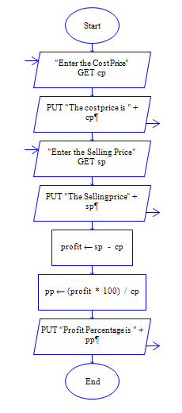

**Screen shot for flowchart and output:**

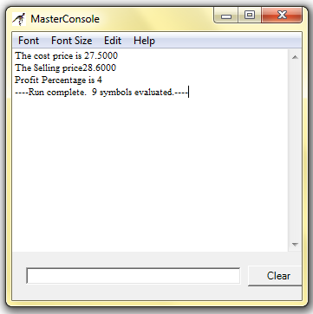

**Raptor file location:**

E:\Projects\Raptor\raptor programs\ProfitAndLoss \ Al0033\_ProfitPercentage.rap

**Click her to download raptor file:**

[Al0032\_ProfitPercentage.rap](E:\\Projects\\Raptor\\raptor programs\\ProfitAndLoss\\ProfitLossDocument\\Al0032_Profit.docx)