InsightAI
Architecture & Data Flow Guide
Mini AI Business Intelligence Assistant
This document explains how InsightAI converts a natural-language business question into a database-backed answer. The diagrams are intended for project documentation, presentation preparation, and technical walkthroughs.

1. Overall System Architecture
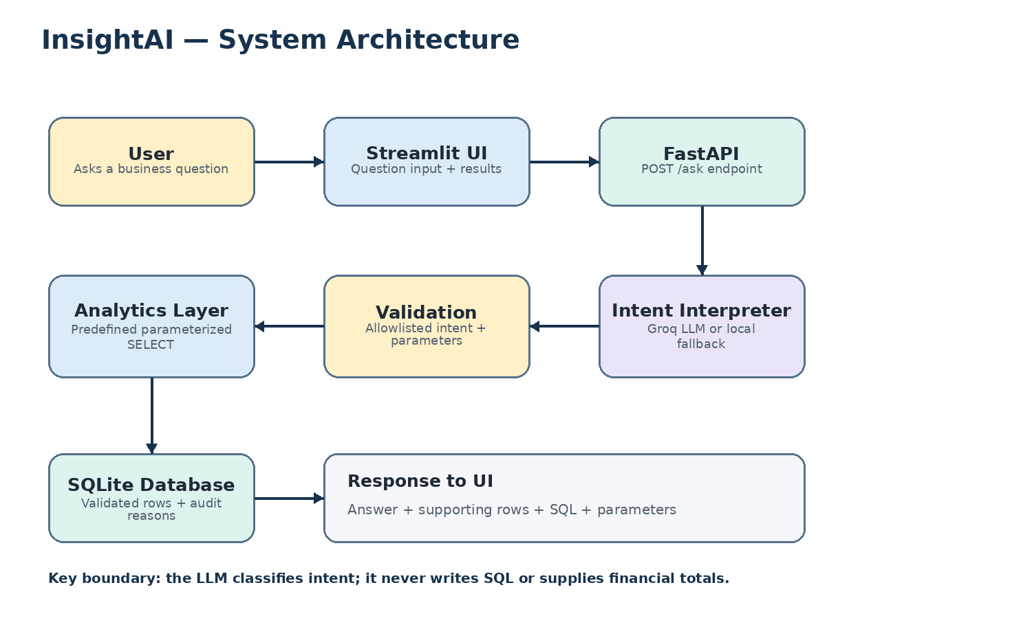
Figure 1. Main application components and the analytics request/response path.
The user enters a question in the Streamlit interface. Streamlit sends it to the FastAPI POST /ask endpoint. The intent interpreter uses Groq when configured or a local fallback otherwise. The resulting intent and parameters are validated before the analytics layer runs a predefined, parameterized SELECT query against SQLite. The API returns the answer together with supporting data and query details for display.

2. Data Ingestion and Quality Flow
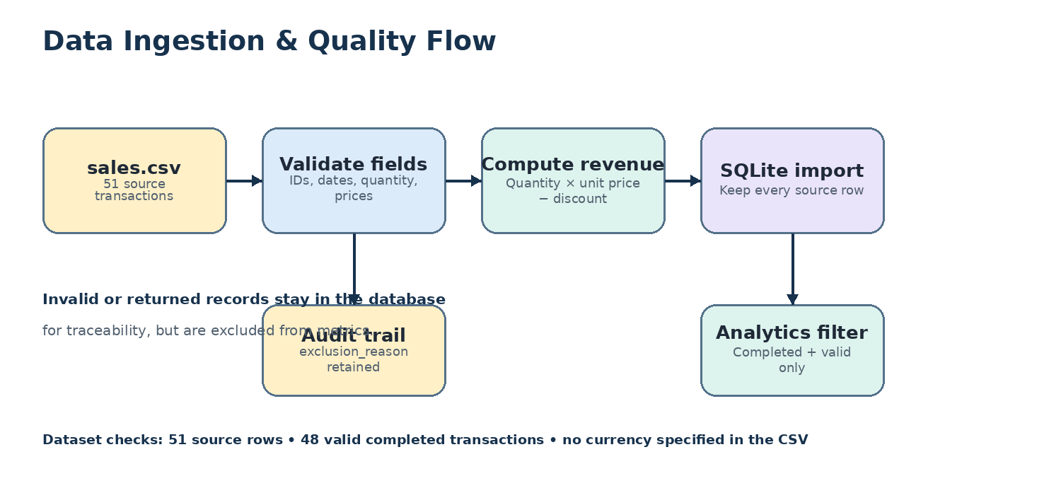
Figure 2. CSV import, validation, revenue calculation, and auditability.
The source file contains 51 transaction rows. The import process validates fields and computes revenue using Quantity × Unit_price − Discount_amount. Rows with problems are retained with an exclusion reason so the source data remains auditable. Analytical metrics include only valid completed transactions; the checked dataset has 48 valid completed transactions. The CSV does not specify a currency, so the application does not assume one.

3. Natural-Language Question Processing
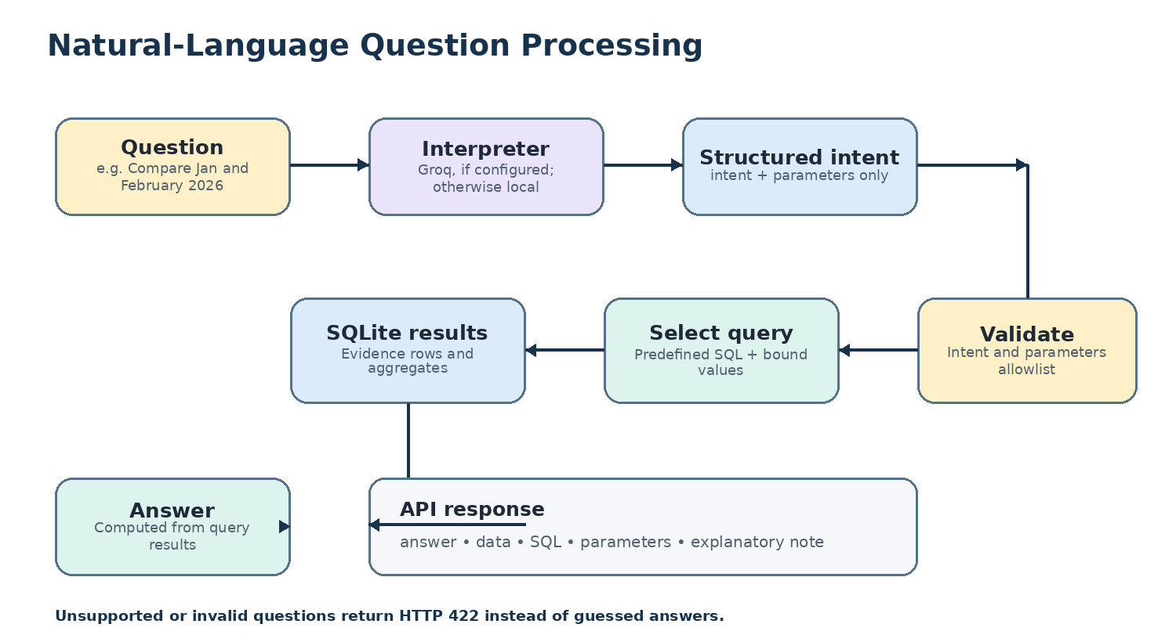
Figure 3. From question wording to a constrained intent and database evidence.
The interpreter maps a question to an allowed intent and parameters—for example, a comparison of two months. Validation checks that the intent and parameters are supported. The analytics layer chooses a predefined SQL query and binds values as parameters. Numeric answers come from query results, not from the language model. Unsupported or invalid questions are rejected with HTTP 422 rather than answered by guessing.

4. AI Safety and Reliability Boundaries
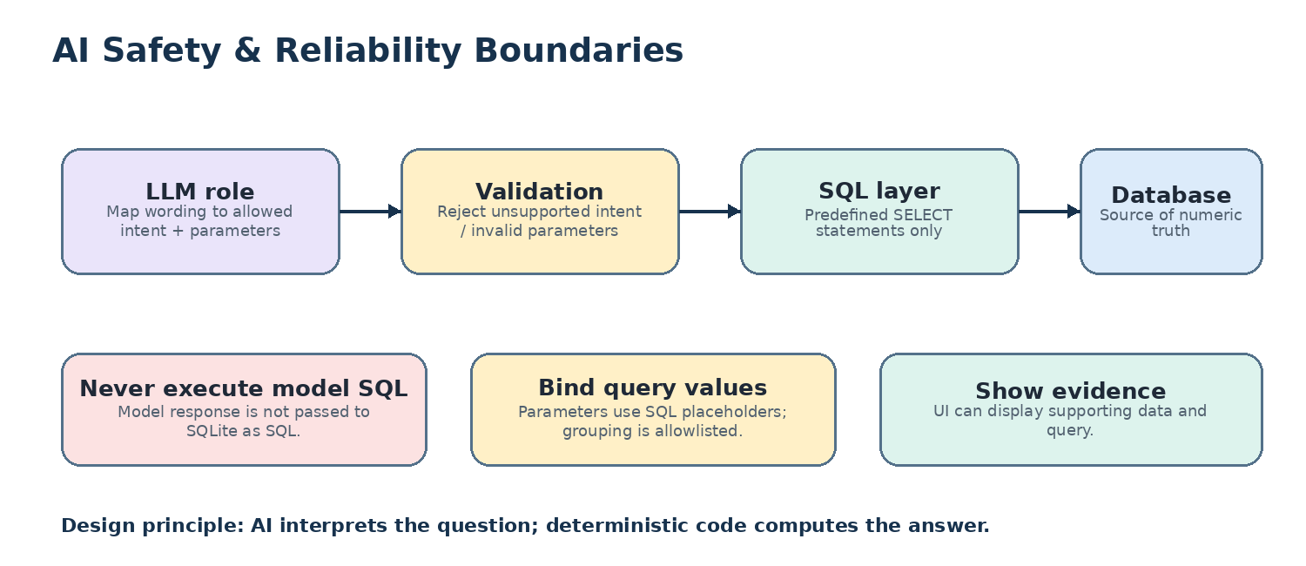
Figure 4. Separation between language interpretation and deterministic analytics.
The optional LLM is used only to interpret question intent. It does not generate executable SQL or provide financial totals. Query templates are predefined, group-by dimensions are allowlisted, and user-provided values are bound through SQL placeholders. This separation reduces the risk of unsafe query execution and makes the returned figures traceable to the database.

Technology Components
Component | Technology | Responsibility
User interface | Streamlit | Collects questions and displays answers/evidence.
API | FastAPI | Receives /ask requests and returns structured JSON.
Question interpretation | Groq (optional) + local fallback | Maps natural language to supported intents and parameters.
Analytics | Python + predefined SQL | Validates selections and computes deterministic results.
Data store | SQLite | Stores imported transaction rows, computed revenue, and exclusion reasons.
Quality checks | pytest | Checks key metrics, parsing, invalid requests, and API behavior.

Request/Response Contract
Example question: “Which product generated the highest revenue?”
The API response includes the interpreted intent, a human-readable answer, supporting data, the SQL query, query parameters, and an explanatory note. Exact response values depend on the question and current dataset.

Verified Dataset Checks
- Source transactions: 51
- Valid completed transactions: 48
- Expected total revenue: 1,439,200
- Top product by revenue: Monitor — 473,000
- Top region by revenue: South — 411,200
- Highest-revenue month: May 2026 — 318,500

Important Scope Notes
- Supported analytics are predefined; this is not unrestricted text-to-SQL.
- Month names without a year are interpreted as 2026 under the current dataset assumptions.
- The optional hosted LLM requires an API key and internet access; local fallback supports common phrasings.
- The project is designed as an assessment/demo application, not a production multi-user service.
- Production deployment should add authentication, rate limiting, monitoring, and read-only database credentials.

