Lightweight Standalone Backend — PoC Architecture
Bana Pele PoC · Independent backend for Peer Connect & Community Voices, decoupled from the hosted Elevate platform

Current Situation & Proposed Approach
Access to the Shikshalokam-hosted Elevate backend (tenant setup, API documentation, sandbox credentials) has not been confirmed, and the demo timeline cannot depend on that response. The frontend, however, only needs two things from any backend: data to search/connect with practitioners, and data to list/bookmark/post community stories.
The proposed approach is to build a small, independent backend that implements only these two use cases — no other Elevate capabilities, no multi-tenant support, no production hardening. It exists solely to unblock the demo and can be discarded once the real Elevate backend is available.

High-Level Backend Architecture
The new backend sits directly behind the existing frontend, in the same place the hosted Elevate backend would have sat. It exposes a small REST API backed by a single database. When the real Elevate backend becomes available, only the frontend's base URL and response mapping need to change — the frontend's page/component structure is unaffected.
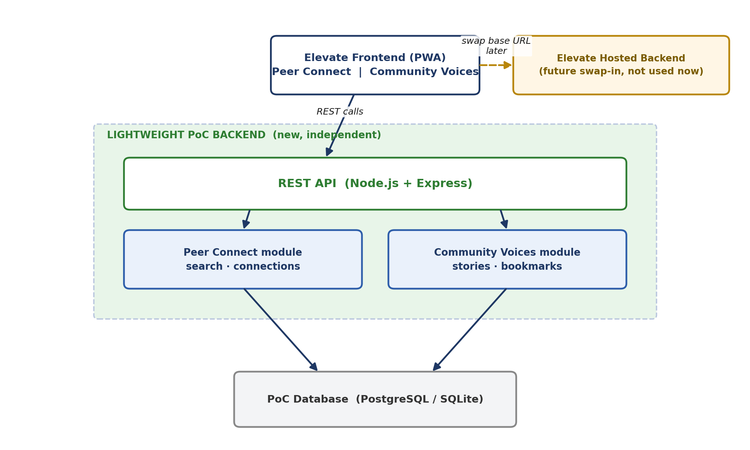

Minimal Backend Services (Modules)
A single lightweight service is sufficient for this PoC — there is no need for separate deployed microservices. Within that one service, logic is split into modules that mirror the two use cases:
Module | Responsibility
Auth / Users | Basic login and current-user profile — enough to identify who is connecting or posting.
Peer Connect | Practitioner search (with distance/type filters) and connection creation/listing.
Community Voices | Story listing (recommended/bookmarked/my stories), story creation, and bookmark toggling.

Required APIs
Kept intentionally minimal — just enough to drive the existing screens:
Method | Endpoint | Purpose
GET | /api/users/me | Current user's profile (name, role, avatar, badge tier, joined date)
GET | /api/practitioners/search | Search practitioners by distance and type; returns ranked results
GET | /api/connections | List the current user's existing connections
POST | /api/connections | Create a new connection to a practitioner
GET | /api/stories?tab= | List stories for Recommended, Bookmarked, or My Stories
POST | /api/stories | Create a new story (title + video link) under My Stories
POST | /api/stories/:id/bookmark | Bookmark or un-bookmark a story

Database Schema
Four tables cover both use cases. Practitioners and mentees are both represented as users, distinguished by a type field, which keeps the schema simple for the PoC.
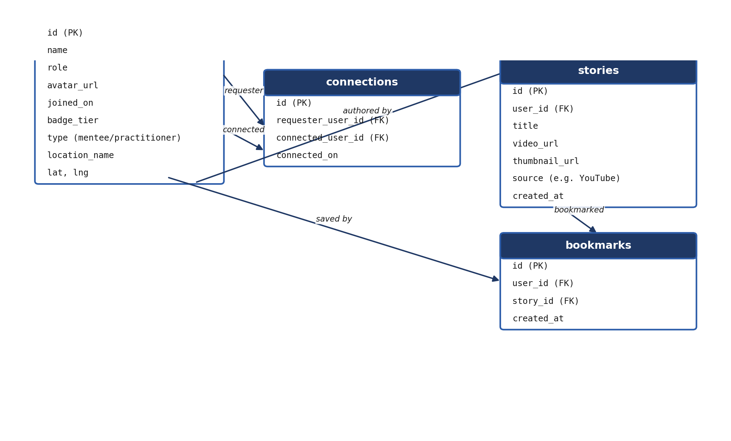

Data Flow
- Peer Connect (search): Frontend sends filters (distance, type) → API queries users where type = practitioner, applying a simple distance calculation → returns a ranked list → frontend renders results as connection cards.
- Peer Connect (connect): Frontend calls connect → API writes a row to connections → subsequent "My Connections" reads join users + connections for the current user.
- Community Voices (browse): Frontend requests a tab (recommended, bookmarked, my stories) → API queries stories, joined with bookmarks for the current user where relevant → returns list for the story-card component.
- Community Voices (post): Frontend submits a title and video link → API inserts a row into stories, owned by the current user → appears immediately under "My Stories."

Recommended Technology Stack
Layer | Recommendation
Runtime / Framework | Node.js + Express — matches the existing JavaScript frontend and keeps the stack simple.
Database | PostgreSQL for a shared demo environment, or SQLite if a single-file, zero-setup database is preferred for a short-lived PoC.
Hosting | A single small instance (e.g. Render, Railway, or a lightweight AWS EC2/Elastic Beanstalk instance) — no orchestration needed for this scope.
Auth | Simple token-based (JWT) login, sufficient for a single-demo environment.

Proposed Project Structure
backend/
├── src/
│ ├── config/ env config, DB connection
│ ├── models/ User, Connection, Story, Bookmark
│ ├── routes/
│ │ ├── auth.routes.js
│ │ ├── users.routes.js
│ │ ├── peerConnect.routes.js
│ │ └── communityVoices.routes.js
│ ├── controllers/ request handling per route
│ ├── services/ business logic (search, matching, bookmarking)
│ ├── middleware/ auth check, error handling
│ ├── db/
│ │ ├── migrations/
│ │ └── seed/ sample users, connections, stories
│ └── app.js
├── package.json
└── README.md

Assumptions & Limitations
- Authentication is simplified (basic token-based login) rather than Elevate's real multi-tenant auth — sufficient for a single-demo PoC, not for production.
- Chat continues to rely on the existing WhatsApp deep link shown in the designs; no real-time chat backend is being built.
- Community Voices stories continue to reference externally hosted video (e.g. YouTube links), matching the current designs; no video upload or streaming pipeline is included.
- Practitioner search uses a straightforward distance calculation on stored coordinates, not a production geo-search index.
- No multi-tenant, organization, or role-management support — single flat dataset, seeded to match the Figma designs.
- This backend is scoped only to Peer Connect and Community Voices; it does not implement Mentoring sessions, Mitra, or any other Elevate capability.

Future Migration Considerations
- Keep API response shapes and field names as close as possible to Elevate's real Mentoring/User service models now, to minimize frontend changes when switching over.
- Isolate all data access behind the REST layer defined here, so the hosted Elevate backend can later be swapped in by changing only the frontend's base URL, not its component logic.
- Treat this backend's schema as a temporary mapping of the same entities Elevate manages (users, connections, stories) so existing PoC data can be manually re-seeded into the real platform if needed later.
- Document this API contract now, so it can be diffed against the actual Elevate API documentation once received, to catch any mismatches early.

