**AWS – 01**

**1) Watch the video and write down notes.**

**2) configure MFA for aws account**

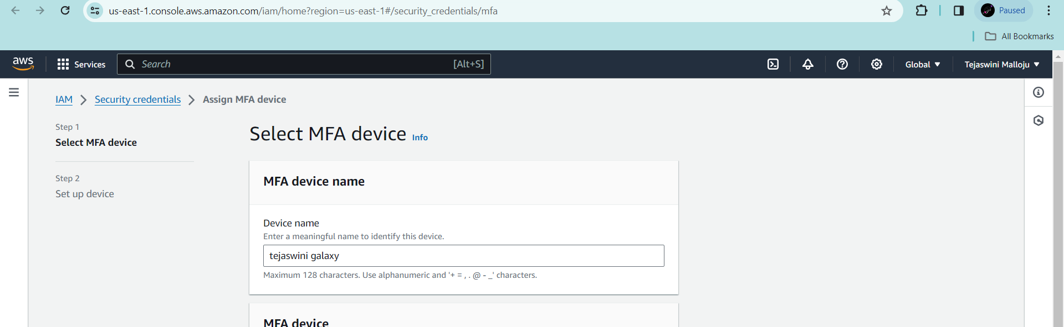

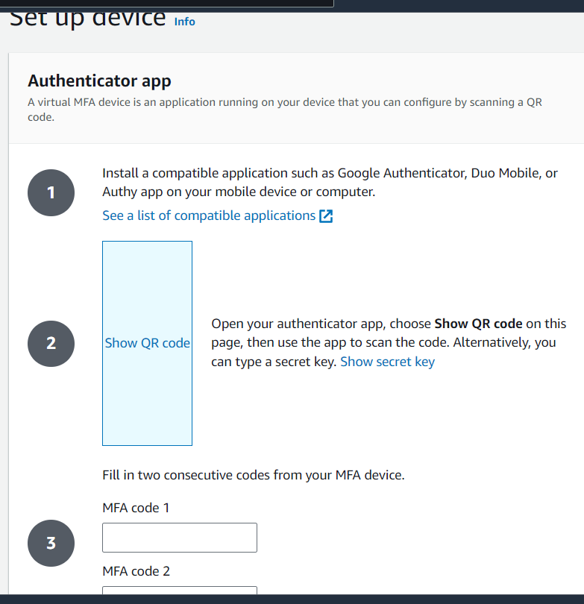

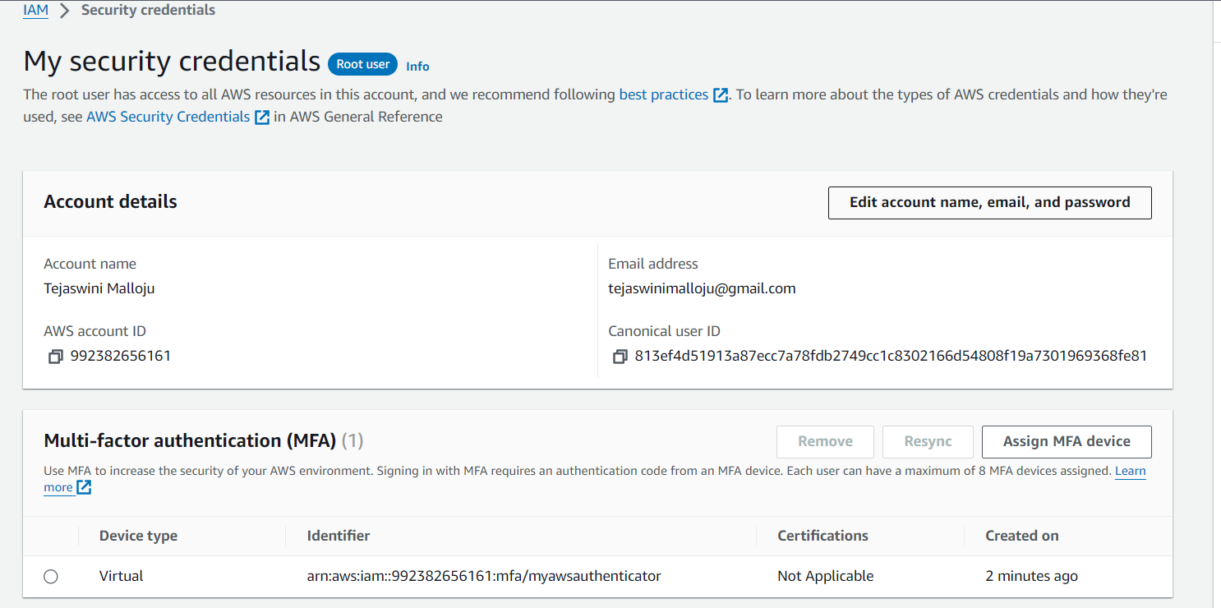

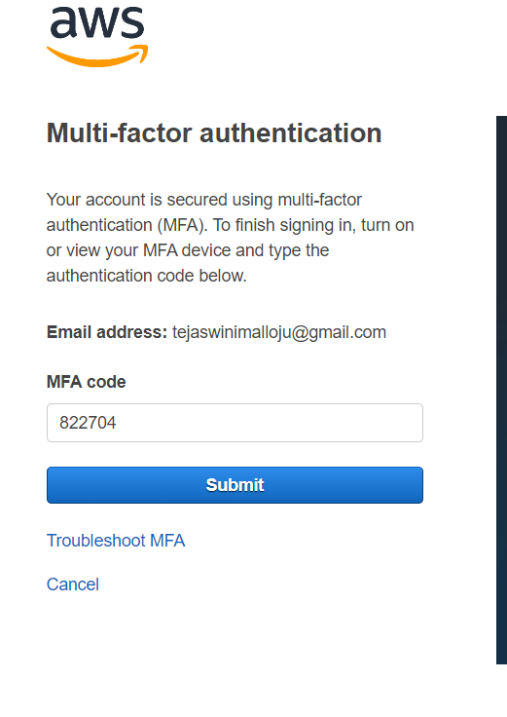

**3) Install aws cli in windows.**

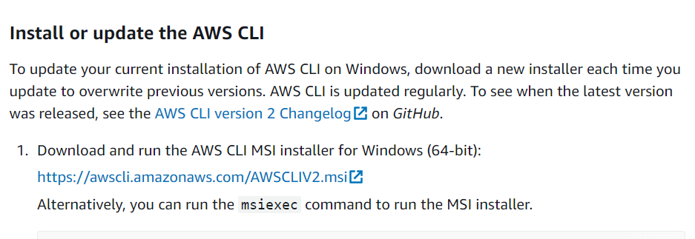

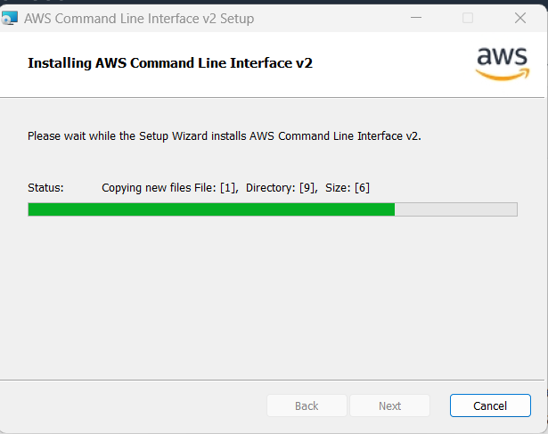

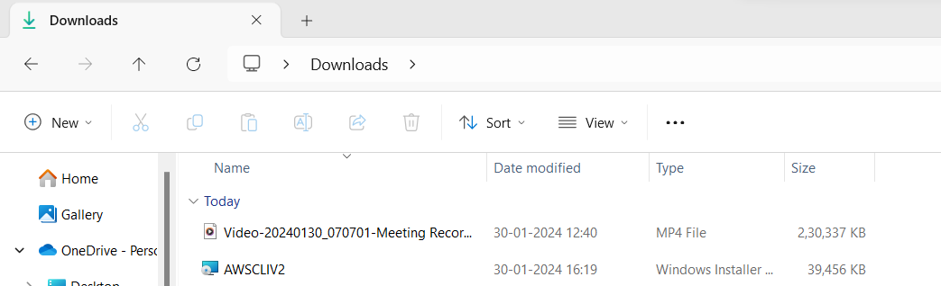

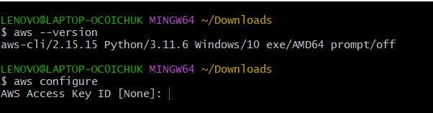

**4) Setup ec2 in N.virginia region using aws cli command.**

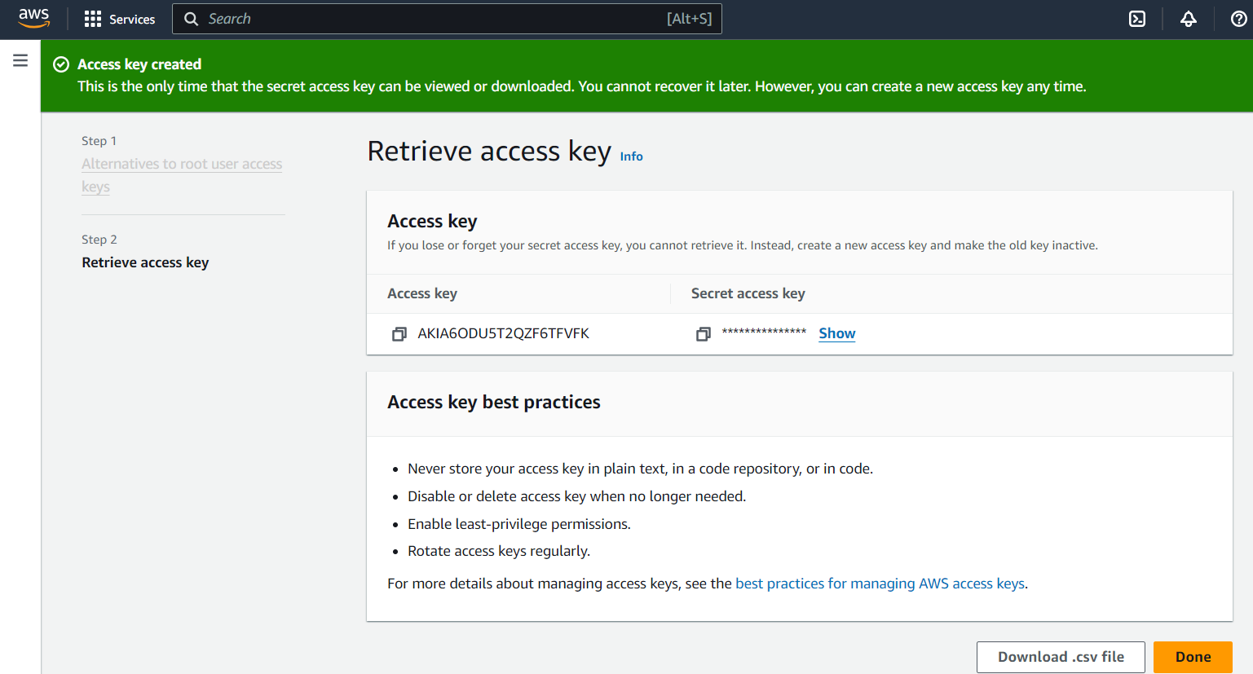



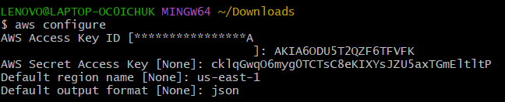

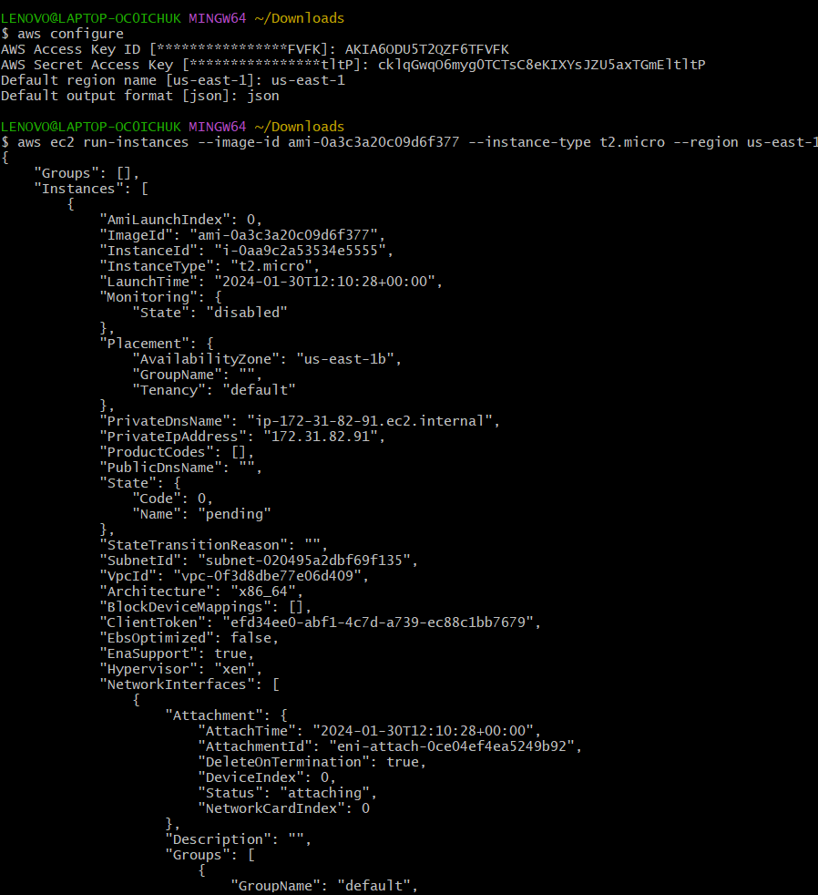

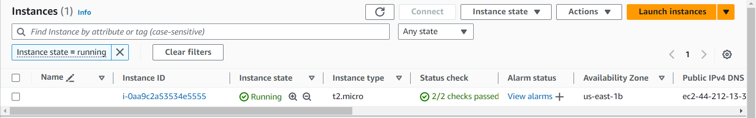

**5) Setup security group in ohio region with name - Techie-sg and open port 22**

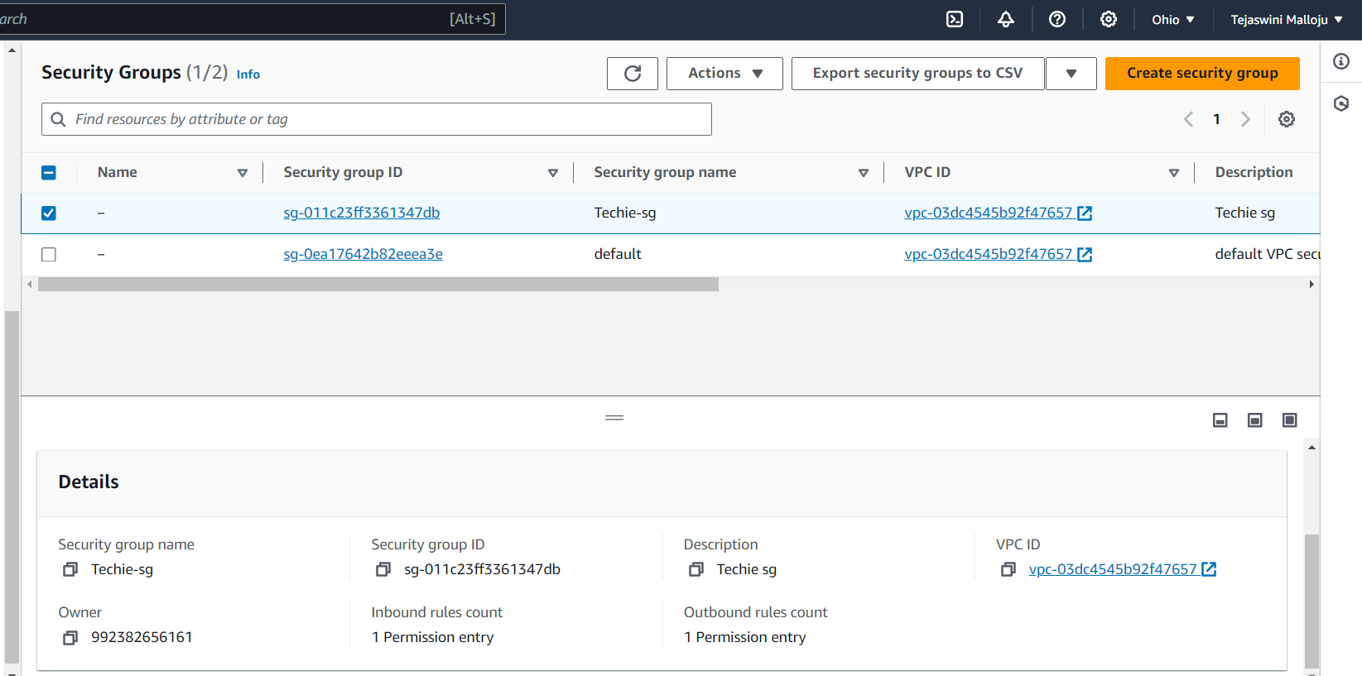

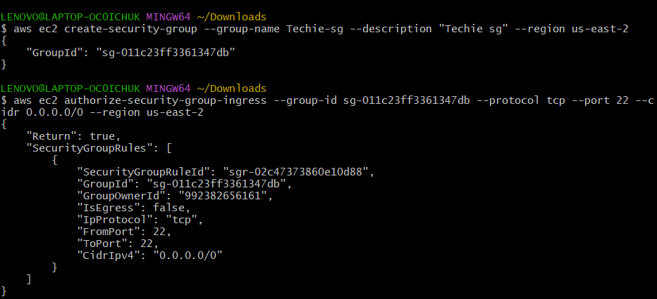

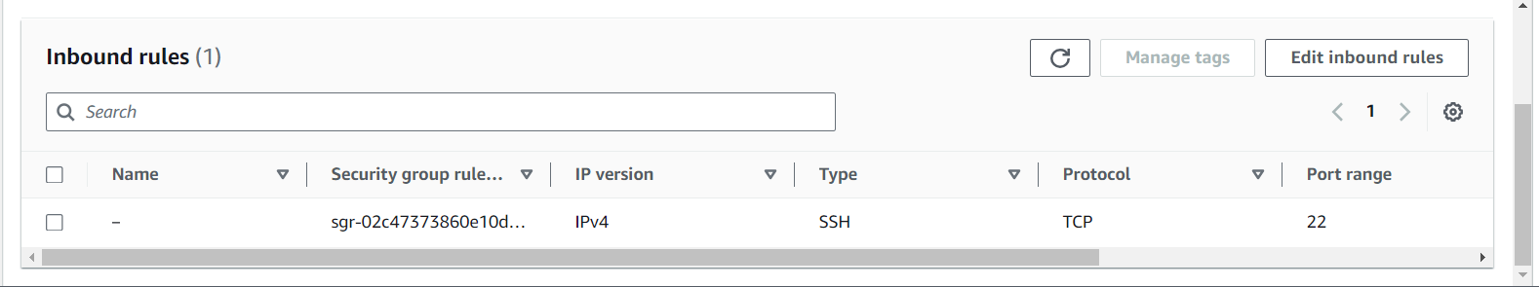

**6) setup ec2,security group in Mumbai region using single aws cli command.**

