**COMMUNITY SERVICE PROJECT**

**ON**

**Real Life Time Weather Reporting System in Akividu**

*A project report submitted in the partial fulfillment of*

*Requirements for the award of the Degree of*

**BACHELOR OF TECHNOLOGY**

**IN**

**COMPUTER SCIENCE AND ENGINEERING**

Name of the Student : V. Tejaswini

Registration Number : **21501A05I5**

Year of Study : **II B.Tech**

Name of the College : **Prasad V. Potluri Siddhartha Institute of Technology**

Period of CSP : **6 weeks** From: **28/11/2022** To: 31**/01/2023**

**Under the Guidance of**

**A.Yuva Krishna, Assistant Professor,**



**Department of Computer Science and Engineering**

**Prasad V. Potluri Siddhartha Institute of Technology**

(Permanently affiliated to JNTU: Kakinada, Approved by AICTE)

(An NBA &NAAC A+ accredited and ISO 9001:2015 certified Institution)

Kanuru,Vijayawada-520007

2022-2023

CERTIFICATE FROMOFFICIALOFTHECOMMUNITY

This is to certify that the community service project entitled “**Real Life Time Weather Reporting System”** is submitted by **Yasaswi B (21501A05J7)**, Department of Computer Science and Engineering, Prasad V. Potluri Siddhartha Institute of Technology underwent community service in **Akividu** from 28/11/2022 to 21/01/2023.

TheoverallperformanceoftheCommunityServiceVolunteerduringhis/hercommunityserviceisfoundtobe_________________*(Satisfactory/Good).*

Authorized Signatory with Date and Seal

**PRASAD V POTLURI SIDDHARTHA INSTITUTE OF TECHNOLOGY**

Autonomous & Permanent Affiliation to JNTUK-Kakinada, AICTE approved

An NBA & NAAC accredited and ISO 9001:2015 Certified Institution

**KANURU, VIJAYAWADA – 520007**

**DEPARTMENT OF COMPUTER SCIENCE AND ENGINEERING**



**CERTIFICATE**

This is to certify that the community service project entitled “**Smart gas leakage detector bot**” is submitted by  **V. Tejaswini (21501A05I5)**, II B.Tech I semester in partial fulfillment of the requirement for the award of **BACHELOR OF TECHNOLOGY** in **COMPUTER SCIENCE AND ENGINEERING** andunderwent community service in **Akividu** from 28/11/2022 to 31/01/2023 (6 Weeks) in the academic year 2022-2023.

**The report submitted on: 28-01-2023.**

**Signature of the Guide Signature of the HOD**

A.Yuva Krishna , Dr. A. Jayalakshmi,

Associate Professor, Professor & HOD,

Dept. of CSE, PVPSIT. Dept. of CSE, PVPSIT.

6 Weeks 28/11/2022 21/01/2023

21501A05J7

Prasad V Potluri Siddhartha Institute of Technology

Yasaswi B

# STUDENT’s DECLARATION

I, **V. Tejaswini**, a student of B.Tech Program, Reg. No. **21501A05I5** of the Department of Computer Science and Engineering, Prasad V. Potluri Siddhartha Institute of Technology do hereby declare that I have completed the mandatory community service from 28/11/2022 to 31/01/2023in **Payakapuram** under the guidance of **A.Yuva Krishna**, Assistant Professor, Department of Computer Science and Engineering, PVPSIT.

**Signature and Date**

**V. Tejaswini**

**(21501A05I5))**

**ACKNOWLEDGMENT**

I would like to thank the **Government of Andhra Pradesh** and **JNTUK Kakinada** for their support and initiation of community service project.

I would like to thank the **Mrs. Kanaka Durga** (**Sarpanch of Singanapudi Gram Panchayat**) for providing a great support for us in completing my community service project.

I would like to take this opportunity to thank our beloved Principal, **Dr. K. Sivaji Babu**, for providing a great support for us in completing my project and for giving us the opportunity of doing the project.

At the same time, we feel elated to thank our Professor and Head of the Department, **Dr. A. Jayalakshmi**, and for inspiring us all the way and arranging all the facilities and resources needed for the project.

We are also thankful for my project In charge **Dr. Ravuri Daniel**, Associative Professor, Computer Science & Engineering, for their constant encouragement and valuable support throughout the course of the project.

It is with the immense pleasure that i would like to express our indebted gratitude to our guide **A.Yuva Krishna, Assistant Professor**, Computer Science & Engineering, who has guided us a lot and encouraged us in every step of the project work. His support throughout the project helped us to complete the project within the time.

I am very much grateful to all the staff and faculty of Department of CSE for their cooperation during the course of this project work. Finally, I would like to express our sincere thanks to each and every one of our college, who have contributed their help and guidance for the successful completion of this project.

**Project Associate**

**V. Tejaswini**

**21501A05I5**

Contents

CHAPTER 1: EXECUTIVE SUMMARY……………………………………..….……07

CHAPTER 2: OVERVIEW OF THE COMMUNITY…………………………….…..08

CHAPTER 3: COMMUNITY SERVICE PART………………………………………09

CHAPTER 4: ACTIVITY LOG.

* 1. ACTIVITY LOG OF FIRST WEEK…………………………………………………..10
     1. DETAILED WEEKLY REPORT……………………………………………………11
  2. ACTIVITY LOG OF SECOND WEEK……………………………………………….12
     1. DETAILED WEEKLY REPORT……………………………………………………13
  3. ACTIVITY LOG OF THIRD WEEK………………………………………………….14
     1. DETAILED WEEKLY REPORT……………………………………………………15
  4. ACTIVITY LOG OF FOURTH WEEK……………………………………………….16
     1. DETAILED WEEKLY REPORT…………………………………………………...17
  5. ACTIVITY LOG OF FIFTH WEEK…………………………………………………..18
     1. DETAILED WEEKLY REPORT……………………………………………………19
  6. ACTIVITY LOG OF SIXTH WEEK………………………………………………….20
     1. DETAILED WEEKLY REPORT…………………………………………………...21

CHAPTER 5: OUTCOMES DESCRIPTION…………………………………………..22

REPORT OF THE MINI-PROJECT WORK DONE IN THE RELATED SUBJECT W.R.T THE HABITATION/VILLAGE…………………………..……….…………….27

CHAPTER 6: RECOMMENDATIONS AND CONCLUSIONS OF THE MINI PROJECT………………………….…………………………………………..………..….32

### CHAPTER 1: EXECUTIVE SUMMARY

*The community service report shall have only a one-page executive summary. It shall include a brief description of the Community and summary of all the activities done by the student in CSP and five or more learning objectives and outcomes.*

I selected payakapuram is a part of Vijayawada in Krishna district of the Indian state of Andhra Pradesh.

Vijayawada is considered to be a [sacred place](https://en.wikipedia.org/wiki/Shrine" \o "Shrine) for residing one of the most visited and famous temples of Andhra Pradesh andIndian,Kanaka Durga Temple of [HinduGoddess](https://en.wikipedia.org/wiki/Devi" \o "Devi) [Durga](https://en.wikipedia.org/wiki/Durga" \o "Durga) residing on the hill named Indrakeeladri. It also serves as the ritual host of [Pushkaram](https://en.wikipedia.org/wiki/Pushkaram" \o "Pushkaram) (a river worshipping ritual in India) of [River Krishna](https://en.wikipedia.org/wiki/Krishna_River" \o "Krishna River). There is a [legend](https://en.wikipedia.org/wiki/Legend" \o "Legend) which says that [Arjuna](https://en.wikipedia.org/wiki/Arjuna" \o "Arjuna), one of the [heroes](https://en.wikipedia.org/wiki/List_of_characters_in_the_Mahabharata" \o "List of characters in the Mahabharata) of the [Indian epic](https://en.wikipedia.org/wiki/Indian_epic_poetry" \o "Indian epic poetry) [Mahabharata](https://en.wikipedia.org/wiki/Mahabharata" \o "Mahabharata), prayed on top of theIndrakeeladri Hill in the city and won the blessings of [LordShiva](https://en.wikipedia.org/wiki/Shiva" \o "Shiva) togetthe [Pashupatastra](https://en.wikipedia.org/wiki/Pashupatastra" \o "Pashupatastra) to win the [Kurukshetra War](https://en.wikipedia.org/wiki/Kurukshetra_War" \o "Kurukshetra War). It was called Vijayavatika (meaning Land of Victory in [Telugu](https://en.wikipedia.org/wiki/Telugu_language" \o "Telugu language)) when [Goddess Durga](https://en.wikipedia.org/wiki/Durga" \o "Durga) killed the demon [Mahishasura](https://en.wikipedia.org/wiki/Mahishasura" \o "Mahishasura) and rested on the Indrakeeladri Hill by the River Krishna establishing the [victory](https://en.wikipedia.org/wiki/Victory" \o "Victory) over [evil](https://en.wikipedia.org/wiki/Mahishasura" \o "Mahishasura) hence the place got its name Vijayavatika, "Vijaya" meaning victory, and "Vatika" meaning place or land in [Telugu](https://en.wikipedia.org/wiki/Telugu_language" \o "Telugu language). Over the years Vijayavatika name changed to Rajendra Chola Pura during [Chola Dynasty](https://en.wikipedia.org/wiki/Telugu_Chodas" \o "Telugu Chodas) and Bezawada during [British rule](https://en.wikipedia.org/wiki/British_Raj" \o "British Raj) and eventually to Vijayawada.

There are many legends behind the origin of the name Vijayawada. It is said that [Goddess Durga](https://en.wikipedia.org/wiki/Durga" \o "Durga) killed [Mahishasura](https://en.wikipedia.org/wiki/Mahishasura" \o "Mahishasura) and relaxed at this place. As she was victorious, the place came to be known as Vijayawada (vijaya translates to victory and wada as place, literally meaning The Place of Victory). The hill was called as Indrekeeladri since it was frequently visited by [Indra](https://en.wikipedia.org/wiki/Indra" \o "Indra) and his affiliates. The epic [Mahabharata](https://en.wikipedia.org/wiki/Mahabharata" \o "Mahabharata) refers to the Indrakiladri hills as the place..

I visited the all near by areas in vijayawada.I go to every home and explain the project ,what are the using of the project how can it help in gas leakage time.In summer time gas leakage saw that time the project very much. In payakapuram 5 years ago one gas leakage saw so many house are in fired due to gas leakage,that time so many people lose there home so we can use the gas leakage it help to detecting the gas leakages .

### CHAPTER 2: OVERVIEW OF THE COMMUNITY

*About the Community/Village/Habitation including historical profile of the community / habitation, community diversity, traditions, ethics and values.*

*Brief note on Socio-Economic conditions of the Community/Habitation.*

Payakapuram is urban area in Vijayawada. Bezawada (as Vijayawada was known then) was founded around 626 A.D. by [Paricchedi](https://en.wikipedia.org/wiki/Pericchedi" \o "Pericchedi) Kings. Vijayawada history reveals that Bezawada (Vijayawada) was ruled by King Madhava Varma (one of the kings of [Vishnukundina dynasty](https://en.wikipedia.org/wiki/Vishnukundina_dynasty" \o "Vishnukundina dynasty)). [Chinese Buddhist scholar](https://en.wikipedia.org/wiki/Chinese_Buddhism" \o "Chinese Buddhism) [Xuanzang](https://en.wikipedia.org/wiki/Xuanzang" \o "Xuanzang) stayed a few years in Bezawada (Vijayawada) in around 640 A.D. to copy and study the [Abhidhamma Pitaka](https://en.wikipedia.org/wiki/Abhidhamma_Pi%E1%B9%ADaka" \o "Abhidhamma Piṭaka), the last of the three pitakas (Pali for baskets) constituting the Pali canon, the scriptures of [Theravada](https://en.wikipedia.org/wiki/Theravada" \o "Theravada) [Buddhism](https://en.wikipedia.org/wiki/Buddhism" \o "Buddhism).

[Mogalrajapuram](https://en.wikipedia.org/wiki/Mogalrajapuram" \o "Mogalrajapuram) hills have five rock-cut temples, built during the fourth–ninth centuries. Some of the caves can be attributed to [Vishnukundina dynasty](https://en.wikipedia.org/wiki/Vishnukundina_dynasty" \o "Vishnukundina dynasty). [Akkana Madanna Caves](https://en.wikipedia.org/wiki/Akkana_Madanna_Caves" \o "Akkana Madanna Caves), at the foot of Indrakeeladri Hill, is a monument of national importance.

At the foot of Indrakeeladri hills is the temple of Malleswara. The temple has inscriptions dating back to ninth century AD to 16th century AD by various kings. There are ten pillars and a mutilated slab (recognised as monuments by [Archaeological Survey of India](https://en.wikipedia.org/wiki/Archaeological_Survey_of_India" \o "Archaeological Survey of India)) with inscriptions in the Telugu language. Of them, the inscriptions issued by Yudhamalla I and II of [Eastern Chalukyas](https://en.wikipedia.org/wiki/Eastern_Chalukyas" \o "Eastern Chalukyas) are important.

In the early 16th century, during the reign of [Qutb Shahi dynasty](https://en.wikipedia.org/wiki/Qutb_Shahi_dynasty" \o "Qutb Shahi dynasty) (also known as Golconda Sultanate), [diamond mines](https://en.wikipedia.org/wiki/List_of_diamond_mines" \o "List of diamond mines) were found near Vijayawada on the banks of [Krishna River](https://en.wikipedia.org/wiki/Krishna_River" \o "Krishna River).

The city is known in the state for its cultural history, whose residents are more often referred to as Vijayawadians. There are many religions, languages, traditions, and festivals. [Durga Pooja](https://en.wikipedia.org/wiki/Durga_Puja" \o "Durga Puja) and a special [Theppotsavam](https://en.wikipedia.org/wiki/Theppotsavam" \o "Theppotsavam) in [Krishna river](https://en.wikipedia.org/wiki/Krishna_River" \o "Krishna River) are important events of the [Hindu](https://en.wikipedia.org/wiki/Hindus" \o "Hindus) festival of [Dussera](https://en.wikipedia.org/wiki/Vijayadashami" \o "Vijayadashami) in the city, mainly due to the existence of self-manifested [Kanaka Durga Temple](https://en.wikipedia.org/wiki/Kanaka_Durga_Temple" \o "Kanaka Durga Temple). Hazarat Bal Mosque is a [Muslim](https://en.wikipedia.org/wiki/Muslims" \o "Muslims) shrine housing the holy relic of the [Prophet Mohammed](https://en.wikipedia.org/wiki/Muhammad" \o "Muhammad). The [Gunadala Mary Matha Church](https://en.wikipedia.org/wiki/St._Mary%27s_Church,_Vijayawada" \o "St. Mary's Church, Vijayawada) is an important shrine for [Christians](https://en.wikipedia.org/wiki/Christians" \o "Christians) and illuminates during [Christmas](https://en.wikipedia.org/wiki/Christmas" \o "Christmas) Eve.

The city corporation organises "Happy Sunday," an event organised on the first Sunday of every month at [M.G. Road](https://en.wikipedia.org/wiki/Mahatma_Gandhi_Road,_Vijayawada" \o "Mahatma Gandhi Road, Vijayawada) for promoting activities such as sports, games, cultural events, and yoga. The clothing of the locals includes traditional men wearing [dhoti](https://en.wikipedia.org/wiki/Dhoti" \o "Dhoti) and women wearing [saree](https://en.wikipedia.org/wiki/Sari" \o "Sari) and [salwar kameez](https://en.wikipedia.org/wiki/Shalwar_kameez" \o "Shalwar kameez). [western clothing](https://en.wikipedia.org/wiki/Western_wear" \o "Western wear) is also predominant.

### CHAPTER 3: COMMUNITY SERVICE PART

*Description of the Activities undertaken in the Community during the Community Service Project. This part could end by reflecting on what kind of values, life skills, and technical skills the student acquired.*

I visited the Krishna river and Durga Amma Temple in the vijayawada area and interacted with the people . Vijayawada is one of the rapidly growing urban markets of the country. The sectors that contribute to the city economy are construction, education, entertainment, food processing, hospitality, registrations, transport, etc. Based on the recommendations of the [Sixth Central Pay Commission](https://en.wikipedia.org/wiki/Sixth_Central_Pay_Commission" \o "Sixth Central Pay Commission), it is classified as one of the Y-grade cities of India. According to one study, the GDP of the city in 2010 was $3 billion (Rs. 18,000 crore) and is expected to grow up to $17 billion (Rs. 1,02,000 crore) by 2025. According to another by Oxford the GDP of the city in 2018 was $5.8 billion and is expected to grow up to $21 billion by 2035.

Andhra Cements (1937) was the first [cement factory](https://en.wikipedia.org/wiki/Cement" \o "Cement) in Andhra Pradesh. Siris Pharmaceuticals was the first [pharma company](https://en.wikipedia.org/wiki/Pharmaceutical_industry" \o "Pharmaceutical industry) in Andhra Pradesh and was established in 1950. The city has trading and exporting markets for agriculture and industrial goods. The Nunna [Mango](https://en.wikipedia.org/wiki/Mango" \o "Mango) Market is one of the largest mango markets in Asia, exporting to major cities in the country. It is also a hub for storage, bottling, and transportation of petroleum products of all major companies like [BPCL](https://en.wikipedia.org/wiki/Bharat_Petroleum" \o "Bharat Petroleum), [HPCL](https://en.wikipedia.org/wiki/Hindustan_Petroleum" \o "Hindustan Petroleum), and [IOC](https://en.wikipedia.org/wiki/Indian_Oil_Corporation" \o "Indian Oil Corporation).

The city is also attracting many international IT companies.

[HCLTechnologies](https://en.wikipedia.org/wiki/HCL_Technologies" \o "HCL Technologies), [Wipro](https://en.wikipedia.org/wiki/Wipro" \o "Wipro),the [Noida](https://en.wikipedia.org/wiki/Noida" \o "Noida)-basedIndian [multinational](https://en.wikipedia.org/wiki/Multinational_corporation" \o "Multinational corporation) is constructing its Vijayawada campus in Kesarapalli village, near to Gannavaram. In the first phase, HCL will provide employment to 5,000 students. There are two major IT parks one at Gannavaram and other in Mangalagiri there are big companies like TechMahindra, HCL, PI Data Center, VSoft, Efftronics, KJ Systems, and EPSoft. The city is also most preferred tier-two city destination for IT/ITES services. There is an APIIC Mega Food Park in Mandavalli near Gannavaram.

The growing population and economy have resulted in rising real estate prices. There is also a cyber security office that is operating by [Tech mahindra](https://en.wikipedia.org/w/index.php?title=Tech_mahindra&action=edit&redlink=1" \o "Tech mahindra (page does not exist)). Vijayawada lies on the banks of [Krishna river](https://en.wikipedia.org/wiki/Krishna_River" \o "Krishna River), covered by hills and canals.

### CHAPTER 4: ACTIVITY LOG

#### 4.1.ACTIVITY LOG FOR THE FIRST WEEK

|  |  |  |  |
| --- | --- | --- | --- |
| **Day**  **&**  **Date** | **Brief description of the daily activity** | **Learning Outcome** | **Person InCharge**  **Signature** |
| Day – 1  28.11.2022 | Selection/Identification of historical profile of the village /community / habitation. | Observed the historical profile of Payakapuram habitation |  |
| Day - 2 | Selection/Identification of historical profile of the village /community / habitation. | Observed the historical profile of Payakapuram  habitation. |  |
| Day – 3 | Identification of the problem(s). | Interacted with the community people and identified the problems facing by the Community. |  |
| Day – 4 | Data collection and statistics related to village /community / habitation. | Collected data on population, number of aquatic ponds, manufacturing companies and other popular areas where weather reporting is required. |  |
| Day – 5 | Solution to the problem. | Exploring the new possibilities of a problem |  |
| Day –6 | Scope and significance of the work. | Identified the horizon of the solution. |  |

**WEEKLY REPORT**

**WEEK–1 (From 28/11/2022 to 03/12/2022)**

|  |
| --- |
| **Objective of the Activity Done : Problem identification and solution** |
| **Detailed Report :**  Fistly, I made a survey to choose a community. Thereby, I found Payakapuram. I interacted with many people in Payakapuram and collected information about their problems. I visited the all near by areas in vijayawada.I go to every home and explain the project ,what are the using of the project how can it help in gas leakage time.In summer time gas leakage saw that time the project very much. In payakapuram 5 years ago one gas leakage saw so many house are in fired due to gas leakage,that time so many people lose there home so we can use the gas leakage it help to detecting the gas leakages .And so I found out construction of “ SMART GAS LEAKAGE DETECTOR BOT” which provides the detecting the gas leakage in kitchen it given buzzer sound and how much level in gas in the air.  There are many advantages with this “SMART GAS LEAKAGE DETECTOR BOT” which are mentioned as follows:   * The objective of this project is to detect any leakage if LGP- based Cars, small-scale factories or in home appliances also. While LGP isan essential need of every household, its leakage could lead to adisaster. Here I have developed an Arduinio based LGP gas leakageDetector. If gas leakage occurs, this system detects it and makes analert. * Gas detectors can be used to detect combustible, flammable and toxic gases, and oxygen depletion. This type of device is used widely in industry and can be found in locations, such as on oil rigs, to monitor manufacturing processes and emerging technologies such as photovoltaic. They may be used in firefighting.   After this project performance, can conclude that detection of the LPG gas leakage is incredible in the project system.  Applicable usefully in the industrial and domestic purpose. In danger situations we are able to save the life by using this |

#### 4.2.ACTIVITY LOG FOR THE SECOND WEEK

|  |  |  |  |
| --- | --- | --- | --- |
| **Day & Date** | **Brief description of the daily activity** | **Learning**  **Outcome** | **Person In-Charge Signature** |
| Day–1  05.12.2022 | Identification of different requirements. | Studied about the requirements by analyzing the solution |  |
| Day–2  06.12.2022 | Identification of different requirements. | Studied about the requirements by analyzing the solution. |  |
| Day–3  07.12.2022 | Specifications of Hardware/Software requirements. | Hardware design was made or established. |  |
| Day–4  08.12.2022 | Specifications of Hardware/Software requirements. | Hardware design was made or established. |  |
| Day–5  09.12.2022 | Specifications of Functional/ Non-functional requirements. | Examinedsystem's operation capabilities and constraints and attempt was done to improve its functionality. |  |
| Day–6  10.12.2022 | Specifications of Functional/ Non-functional requirements | Examinedsystem's operation capabilities and constraints and attempted to improve its functionality |  |

**WEEKLY REPORT**

**WEEK–2 (From 05/12/2022 to 10/12/2022)**

|  |
| --- |
| **Objective of the Activity Done : Gathering of requirements** |
| **Detailed Report :**  After knowing the problem and attained solution I started to study about the requirements that can be used in order to implement the solution successfully. In this process I identified different requirements / resources that are required. I examined the components and their usage and studied the specifications of Hardware/Software requirements. Once I got an idea on components I tried to establish connection of hardware components in “Thinkercad” and did in detailed study on the hardware which can be used in order to implement night patrol robot effectively. I tried many combinations of different types of hardware components. I  Examinedsystem's operation capabilities and constraints and attempt was done to improve its functionality. I followed five steps for identifying and gathering requirements. Those steps are as follows :   * Created a plan * Identified and gathered requirements * Reviewed and prioritized requirements * Finalized Requirements * Management of final requirements |

#### 4.3.ACTIVITY LOG FOR THE THIRD WEEK

|  |  |  |  |
| --- | --- | --- | --- |
| **Day& Date** | **Brief description of the daily activity** | **Learning**  **Outcome** | **Person In-Charge Signature** |
| Day–1  12.12.2022 | System design / architecture / framework | Deriving comprehensive solution |  |
| Day–2  13.12.2022 | Design of Hardware / Software modules | Design and development of components |  |
| Day–3  14.12.2022 | Design of Hardware / Software modules | Design and development of components |  |
| Day–4  15.12.2022 | Design of Hardware / Software modules | Design and development of components |  |
| Day–5  16.12.2022 | Methodology (detailed description of the working of the project) | Fixing of hardware components |  |
| Day–6  17.12.2022 | Methodology (detailed description of the working of the project) | Uploading code in Software applications |  |

**WEEKLY REPORT**

**WEEK–3 (From 12/12/2022 to 17/12/2022)**

|  |
| --- |
| **Objective of the Activity Done : System Design** |
| **Detailed Report:**  System design is the phase that bridges the gap between problem domain and the existing system in a manageable way. System design can be classified into six parts : Identify design goals, system decomposition, identification of concurrency, hardware allocation, data management, software control implementation. I tried to derived comprehensive solution.  After getting an idea on components, I started to focused on Design and development of components which plays an important role in order to make our design / model effective. At first  Started connection the beard board as per circuit diagram . by sensor 1, sensor 2, sensor 3. If any gas is detected the signal of sensors goes low and activate the Arduino UNO. Which send signals to the LCD (“GAS DETECTED AT ZONE), where sensor 1 is for zone 1, sensor 2 for zone 2 and sensor 3 for zone 3 respectively, Buzzer and GSM to alert the people about danger and if no gas is detected then LCD displays “NO” .When the set initial value 100 about that value its given buzzer sound and red light otherwise green light and buzzer sound off at same time in lcd given a  Value of gas level in air.gas detecting successful. |

|  |  |  |  |
| --- | --- | --- | --- |
| **Day& Date** | **Brief description of the daily activity** | **Learning**  **Outcome** | **Person In-Charge Signature** |
| Day–1  19.12.2022 | Implementation of hardware/ software. | Learnt how the hardware components can work in different instances. |  |
| Day–2  20.12.2022 | Implementation of hardware/ software. | Closely examined the linkage of various components. |  |
| Day–3  21.12.2022 | Implementation of hardware/ software. | Learnt the connections of different components |  |
| Day–4  22.12.2022 | Implementation of hardware/ software. | Learnt how to get ideal result in software. |  |
| Day–5  23.12.2022 | Implementation of hardware/ software. | Built a Prototype |  |
| Day–6  24.12.2022 | Implementation of hardware/ software | Examined the Prototype |  |

**4.4ACTIVITY LOG FOR THE FOURTH WEEK**

#### 

#### WEEKLY REPORT

**WEEK–4 (From 19/12/2022 to 24/12/2022)**

|  |
| --- |
| **Objective of the Activity Done : System Implementation** |
| **Detailed Report :**  I focused on these parts of systems implementation :   1. defining how the information system should be built (i.e., physical system design). 2. ensuring that the information system is operational and used. 3. ensuring that the information system meets quality standard (i.e., quality assurance).   I learnt how the hardware components can work in different instances and Closely examined the linkage of various components. I have established connection between components of hardware. I learnt the connections of different components. After building a Prototype I uploaded code into Node MCU. While dealing with software I had gained knowledge on different types of resources which are available with no cost. I was really excited while learning all these technologies and found very interesting.  I explored the usage of Arduino IDE in order to transfer the code. I tested all the possible ways to deploy code into particular hardware component. It’s been exhilarating while learning through Arduino IDE. I have used HTML to display webpage and C for the rest of the code. Working with these kind of softwares was really very informative for me. |
|  |

#### 4.5.ACTIVITY LOG FOR THE FIFTH WEEK

|  |  |  |  |
| --- | --- | --- | --- |
| **Day & Date** | **Brief description of the daily activity** | **Learning**  **Outcome** | **Person In-Charge Signature** |
| Day–1  26.12.2022 | Testing and validation of project results/reports | Studied and verified the specific requirements. |  |
| Day–2  27.12.2022 | Testing and validation of project results/reports | Studied and verified the specific requirements. |  |
| Day–3  28.12.2022 | Testing and validation of project results/reports | verifying procurement specifications and managing risk |  |
| Day–4  29.12.2022 | Testing and validation of project results/reports | verifying procurement specifications and managing risk |  |
| Day–5  30.12.2022 | Testing and validation of project results/reports | Observation of working of Prototype |  |
| Day–6  31.12.2022 | Testing and validation of project results/reports | Observation of working of Prototype |  |

**WEEKLY REPORT**

**WEEK–5 (From 26/12/2022 to 31/12/2022)**

|  |
| --- |
| **Objective of the Activity Done : Results testing and validation** |
| **Detailed Report :**  After uploading the code and testing I found working of this prototype very interesting.  I tested the model with different type of objects kept in front of camera module in order to make sure that it works under all conditions and circumstances. After the development of prototype I have tested the working of site and prototype. Next, I focused on input design and their respective output design. Finally, validated the design with user requirements until it satisfied with the needs.  I even tried testing in room which has also given a successful outcome.The sensors we have used worked properly in all conditions .I tested the sensor using smoke and the results were showed successfully. And the rain drop sensor also indicated the density whenever I kept a few droplets on the sensor. After validation of performance ,I focused on developing the software and hardware and implemented the updated methods and performed tests which were also successful. |

**4.6.ACTIVITY LOG FOR THE SIXTH WEEK**

|  |  |  |  |
| --- | --- | --- | --- |
| **Day & Date** | **Brief description of the daily activity** | **Learning**  **Outcome** | **Person In-Charge Signature** |
| Day–1  16.01.2023 | Preparation of the project report | Evaluation of objectives |  |
| Day–2  17.01.2023 | Preparation of the project report | Evaluation of objectives |  |
| Day–3  18.01.2023 | Preparation of the project report | Organisation of collected data |  |
| Day–4  19.01.2023 | Preparation of the project report | Organisation of collected data |  |
| Day–5  20.01.2023 | Preparation of the project report | Structure of the Report |  |
| Day–6  21.01.2023 | Preparation of the project report | Proof-Reading |  |

**WEEKLY REPORT**

**WEEK–6 (From 16/01/2023 to 21/01/2023)**

|  |
| --- |
| **Objective of the Activity Done: Document preparation** |
| **Detailed Report:**  I had followed five steps in document preparation and those are as follows:   * Step 1: Planning Document. * Step 2: Research and Brainstorming. * Step 3: Outlining the Structure of Document. * Step 4: Writing Document. * Step 5: Editing Document.   Firstly, I planned how to write document which should reflect the creation, modification, and display of textual material. Secondly, I researched on how to present document. Next, I outlined the structure of document. Later, I had written the document which includes detail description of the identification of a community, Collection of data, acquiring of knowledge in both hardware components and software, Implementation of hardware/ software, Testing and validation of project results/reports.  With writing of document I have learnt Evaluation of objectives, organisation of collected data, structure of the Report, proof-Reading. I have learnt documentation encourages knowledge sharing, which empowers a team / people to understand how processes work and what finished projects typically look like. |

**CHAPTER 5: OUTCOMES DESCRIPTION**

**Details of the Socio-Economic Survey of the Village/Habitation Attach the questionnaire prepared for the survey.**

Q. What is the major problem you have been facing in your community?

Q. Is there any issue which I can assure you a solution?

Q. How far people in this community are secured?

Q. Where is your nearby police station?

Q. I have been listening to lot of people problems so can you say me what is major problem of the community?

Q. How have you been secured by the police department?

Q. Is patrolling is done properly?

Q. Do you ever felt any insecurity due to any reason?

Q. How can I help your community?

Q. Can I know the history of your community?

Q. What makes you feel so insecure to go out when it’s night?

Q. Is this area vulnerable towards thefting?

Q. Name some areas which are sensitive in your community?

Q. Can you please roughly say how much is the population of your community?

Q. How many women and children live in your community in order to assure safety and security?

Q. How much area of land does this community withhold?

Q. What are the facilities provided by the government in your community?

Q. How are the facilities provided by government in terms of safety ?

Q. What are the safety measures do you follow during night time?

Q. Do you have the numbers of nearby police station?

#### Describe the problems you have identified in the community

Many problems were identified in the community. Some of them are as mentioned below:

Poor Infrastructure – The infrastructure in village is not good. The roads and bridges are not built properly and this hampers their connectivity with towns and cities which is a hindrance in establishing good business. Schools and hospitals in the villages lack good staff as well as facilities. Many villages do not have a power supply or face a lot of power cuts. Sanitation is another grave problem in village.

Life in rural areas is thought to be slower-paced, resulting in lower levels of anxiety and a greater sense of relaxation. For these and other reasons, rural residents exhibit better mental health on the average than do urban residents.

Patriarchal Structure – In village, men are considered to be the head of the family and the women in the house must follow their instructions. All the decisions are taken by the male members of the family. Women are mostly confined only to the kitchen and other household chores. They are not allowed to go out and work. They cannot even express their feelings or opinions about anything. The cases of female feoticide in the Indian villages are also quite high.

Village Hospital most of important, India is a country where a significant section of the nation's population lives in the village. The progress and development of our country depend on the improved living conditions in rural areas where all the meaningful life supportive facilities, including healthcare facilities, will be adequately available for one and all. The places in Indian villages are surrounded by poverty, diseases, as well as lack of cleanliness. Even there is no proper drainage facility, and most of the drains are squalid. Due to a lack of facilities and improper management in rural areas, people living in villages are suffering a lot due to various chronic diseases.

In India, we can find diversity in clothes, languages, beliefs, religion, art, food, traditions, music, climates, features, population, geographical structures, environment, and living conditions.

Even though the diversity of such a large extent increases our richness in terms of heritage and culture, it adheres with definite complications, too. It primarily creates obstacles in the path of the infrastructural progression of the nation.

Apart from all these problems everyone described safety as their major problem and asked to find a better solution to this. In rural villages, public spaces can pose a serious threat to the safety and well-being of women and girls who live there.  Because of this real or perceived violence women’s and girls’ ability to move around their community is restricted in an attempt to keep them “safe.” As a result, many girls are forced to give up their education after middle school, as traveling outside the village poses too many “risks” to girls’ safety. This lack of mobility leads to inequitable access to education, health care and employment opportunities and participation in civic engagement that undercut efforts to empower women and girls and tackle poverty. Many people stated a complete women safety mechanism is required. Many opined no proper counseling is provided to grownup boys and girls. The girls cannot share their problems with anyone even if they are bullied, harassed.

**Short-term and long-term action plan for possible solutions for the problems identified and that could be recommended to the concerned authorities for implementation.**

**Solutions to Problems**

Here are the solutions to the problems faced by the people living in village

Education and awareness. Educating people, especially businessmen and employers, about the ill effects can help prevent child labor. Talk to them about the impact of child labor on children's mental and physical health and how it can affect their future. Also, inform them about the laws and their penalties.

In health facilities, water, energy, sanitation, hand hygiene, and waste disposal centers ought to all be practical, dependable, and safe. To provide for seclusion and facilitate the provision of quality services, the area must be planned, arranged, and maintained. Medicines, supplies, and equipment must all be insufficient supply at the facilities.

All labor and delivery departments of the hospital should have enough competent, well-trained staff and qualified birth attendants on hand 24 hours a day to

insufficient staffing, and a lack of fully functional facility surroundings are all common hurdles to midwifery personnel providing appropriate care.

Communities must focus on developing gender-sensitive public transport service plans and policies that consider women and girls unique needs in public transportation. Although the list of crimes is very long, we can take measures to ensure women’s safety in our country. Firstly, the government must make stringent laws that ensure the punishment of criminals immediately. Fast track courts must be set so the victim gets justice instantly. This will serve as a great example for other men to not commit crimes against women.

Most importantly, men must be taught to respect women from an early age. They must consider women as equals so they don’t even think of harming them. When you consider someone inferior, you tend to oppress them. If this thinking goes away, half of the crimes will automatically end.

**Description of the Community awareness programme/s conducted w.r.t the problems and their outcomes.**

**COMMUNITY AWARENESS PROGRAMMES :**

During this journey of our Community Service Project, I approached different types of people and interacted with them . I also went to aquatic pond owners nearby Akividu and enquired about the growth techniques and the checking of water temperature in which aquatic animals grow. I learnt community awareness is knowledge created through interaction between community people and its environment, a setting bounded in space and time. I have also learnt it involves states of knowledge as well as dynamic process of perception and action. It is knowledge that must be maintained and kept updated to complete some tasks in the environment. I have also learnt Community networking promotes community awareness of program services and availability by networking with professionals and leaders in the community. I learnt these points from community awareness programme :

* Helps Connect to the Community
* It Benefits Career Prospects.
* Community Service Raises Social Awareness.
* Community Service Establishes Contacts and Friendships.
* Community Service Helps Improve Your Skills.

Also, I felt that more particular safety measures need to be taken during the time of Sankranthi, Ganesh Chathurdhi and Dussera. During these days the traffic is so heavy that the residents feel so inconvenient and there are many chances of accidents. I informed the same to the higher officials are requested them to provide better services to the people and also asked them to improve train services during those special days.

After completion of prototype, I demonstrated the working of “REAL LIFE TIME WEATHER REPORTING SYSTEM” even to the President of the community. They felt very happy for building this kind of model which improves the growth of crops and aquatic life. I also explained the advantages of using this model.

This gave me immense pleasure to make my own solution in order to rectify the major problem been facing by the community.

**Report of the mini-project work done in the related subject w.r.t the habitation/village.**

A mini-project work in the related subject w.r.t the habitation/village. (For ex., a student of Botany may do a project on Organic Farming or Horticulture or usage of biofertilizers or biopesticides or effect of the inorganic pesticides, etc. A student of Zoology may do a project on Aquaculture practices or animal husbandry or poultry or health and hygiene or Blood group analysis or survey on the Hypertension or survey on the prevalence of diabetes, etc.

***The Report shall be limited to 8-10 pages.***

**Implementation Of a Smart Gas Leakage Detector Bot**

Gas leakage is a serious problem and nowadays it is observed in many places like residences, industries, and vehicles like Compressed Natural Gas (CNG), buses, cars, etc. It is noticed that due to gas leakage, dangerous accidents occur. The Liquefied petroleum gas (LPG), or propane, is a flammable mixture of hydrocarbon gases used as fuel in many applications like homes, hostels, industries, automobiles, and vehicles because of its desirable properties which include high calorific value, less smoke, less soot, and meagre harm to the environment. Liquid petroleum gas (LPG) is highly inflammable and can burn even at some distance from the source of leakage. This energy source is primarily composed of propane and butane which are highly flammable chemical compounds. These gases can catch fire easily. In homes, LPG is used mainly for cooking purposes. When a leak occurs, the leaked gases may lead to an explosion. Gas leakage leads to various accidents resulting in both material loss and human injuries. Home fires have been occurring frequently and the threat to human lives and properties has been growing in recent years. The risks of explosion, fire, suffocation are based on their physical properties such toxicity, flammability, etc. The number of deaths due to the explosion of gas cylinders has been increasing in recent years. The Bhopal gas tragedy is an example of accidents due to gas leakage.

The reason for such explosions is due to substandard cylinders, old valves, no regular checking of gas cylinders, worn out regulators and a lack of awareness of handling gas cylinders. Therefore, the gas leakage should be detected and controlled to protect people from danger. An odorant such as ethane thiol is added to LPG, so that leaks can be detected easily by most people. However, some people who have a reduced sense of smell may not be able to rely upon this inherent safety mechanism. A gas leakage detector becomes vital and helps to protect people from the dangers of gas leakage. A number of research papers have been published on gas leakage detection techniques [1–8]. K. Padma Priya et al. proposed the design of a wireless LPG monitoring system. In this paper, the user is alerted about the gas leakage through SMS and the power supply is turned off. Meenakshi Vidya et al. proposed the leakage detection and real time gas monitoring system. In this system, the gas leakage is detected and controlled by means of an exhaust fan. The level of LPG in cylinder is also continuously monitored. Selvapriya et al. proposed the system in which the leakage is detected by the gas sensor and produce the results in the audio and visual forms. It provides a design approach on software as well as hardware [8]. In the existing method, different gas sensing technology is used.

In this paper, semiconductor sensors are used to detect LPG gas. An MQ2 semiconductor sensor is used. Sensitive material of the MQ-2 gas sensor is SnO2, which has lower conductivity in clean air. When the target combustible gas exists, the sensor conductivity increases along with the rising gas concentration. The MQ2 gas sensor has a high sensitivity to Propane, Butane and LPG, and response to Natural gas. The sensor could be used to detect different combustible gasses, especially Methane; it has a low cost and is suitable for different applications. The MQ-2 can detect gas concentrations anywhere from 200 to 10,000 ppm. The sensor’s output is an analog resistance. Figure 1 shows the block diagram of the gas leakage detection and alert system.

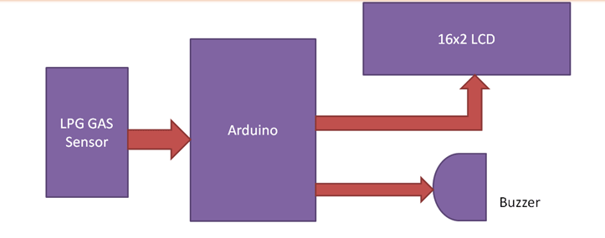

This system is based on the Arduino UNO R3 and MQ-2 gas sensor. When the sensor detects gas in the atmosphere, it will give digital output 1 and if gas in not detected the sensor will give digital output 0. Arduino will receive the sensor output as digital input. If the sensor output is high, then the buzzer will start tuning along with the LCD that will show that “Gas detected: Yes”. If the sensor output is low then buzzer will not be tuning, and the LCD will show that “Gas detected: No”. The buzzer most commonly consists of a number of switches or sensors connected to control unit that determines which button was pushed or whether a pre-set time has lapsed, and usually illuminates a light on the appreciate button or control panel, and sounds a warning in the form of a continuous or intermittent buzzing or beeping sound. For the design of a sensorbased gas leakage detector and alarm system the following components are required. The gas detector system is very cheap and it will cost only 1000rs. The device is portable, light weight, user friendly and efficient with multi-functional features.

* **Arduino ( Uno )**
* **16*2 Lcd Display**
* **USB cable**
* **Mq2 Gas sensor**
* **2 LED’S**
* **Buzzer**
* **1K Resister-1**
* **100R Resistor-3**
* **4.7K Resistor -1**
* **Male to male jumper wires**
* **Connecting wires**
* **Battery clip**
* **9V Battery**
* **Bread board**

**ARDUINO:**

The Arduino Uno is an open-source microcontroller board based on the Microchip ATmega328P microcontroller and developed by Arduino.cc and initially released in 2010. The board is equipped with sets of digital and analog input/output (I/O) pins that may be interfaced to various expansion boards (shields) and other circuits.

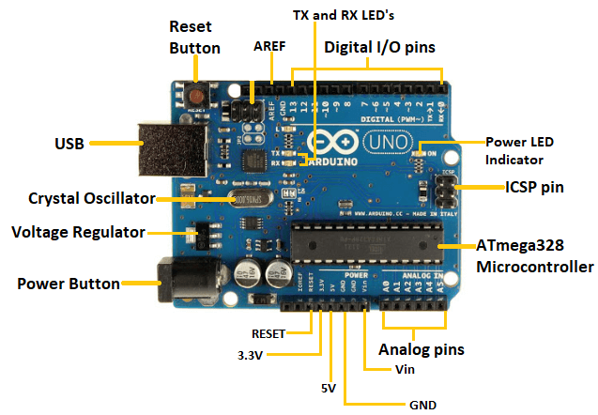

**BUZZER:** A buzzer is understood as a device that creates an audible tone under the influence of an applied external voltage. This output may either be in the form of a buzzing or a beeping sound.

**16*2 LCD DISPLAY:** LCD stands for liquid crystal display it mostly used in different electronic projects and devices to display different values.

 LCD uses liquid crystals for the production of visible image. 16 x 2 liquid crystal display is a basic LCD module used in DIy electronic projects and circuits.

**SENSOR:** MQ2 gas sensor is an electronic sensor used for sensing the concentration of gases in the air such as LPG, propane, methane, hydrogen, alcohol, smoke and carbon monoxide.

MQ2 gas sensor is also known as chemiresistor. It contains a sensing material whose resistance changes when it comes in contact with the gas. This change in the value of resistance is used for the detection of gas.

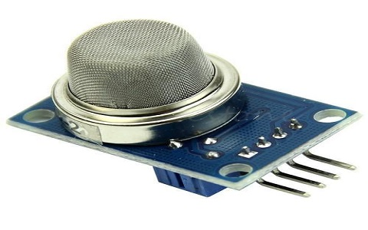

The Proteus Design Suite is a proprietary software tool suite used primarily for electronic design automation. The software is used mainly by electronic design engineers and technicians to create schematics and electronic prints for manufacturing printed circuit boards. Figure 3 shows the circuit diagram that was designed using Proteus libraries. This system is based on Arduino UNO R3 and MQ-6 gas sensor. When the sensor detects gas in atmosphere, it will give a digital output of 1 and if gas is not detected the sensor will give a digital output of 0. Arduino will take the sensor output as the digital input. If sensor output is high, then the buzzer will start tuning and the LCD will show that “Gas detected: Yes”. If sensor output is low then the buzzer will not be tuning, LCD will show that “Gas detected: No”. The detector incorporates a MQ-6 sensor (with gas detection range of 300–10,000 ppm) as the LPG gas sensor, PIC16F690 microcontroller as the control unit, LCD for displaying gas concentration, a buzzer as an alarm and a number of LEDs to indicate the gas leakage status. The microcontroller senses the presence of a gas when the voltages signal from the MQ-6 sensor goes beyond a certain level and gives an audiovisual alarm.

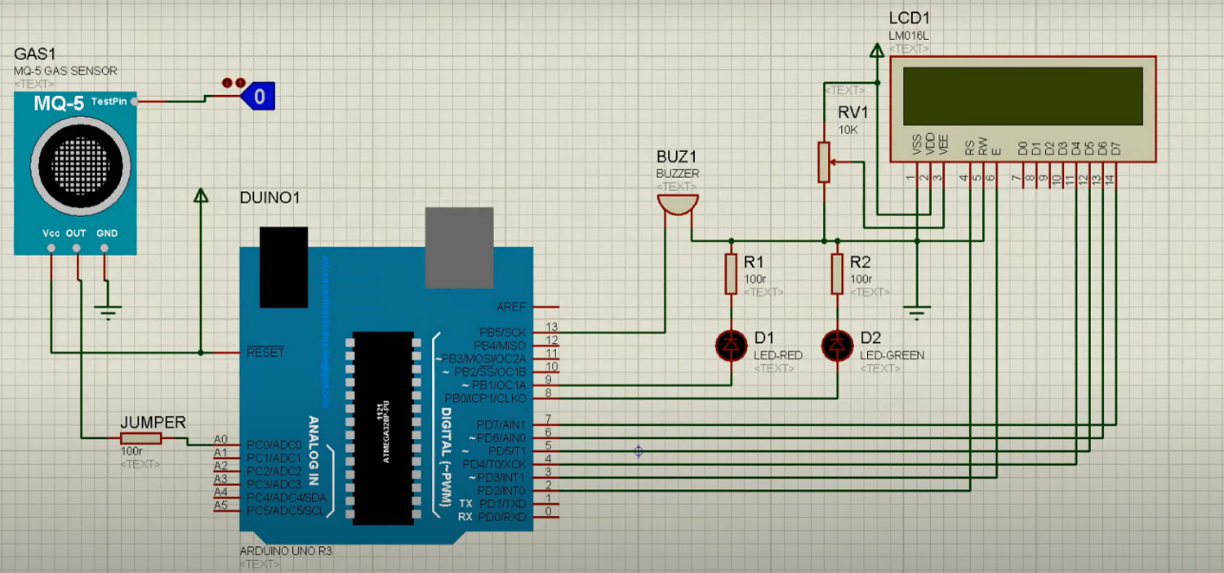

If the system detects the level of gas in the air that exceeds the safety level it will activate the alarm which includes the buzzer to alert the users at home of the abnormal condition and to take any necessary action. The most tell-tale sign of a leak is the smell of gas in the home. However, in the case of a carbon monoxide leak, there are also particular physical symptoms you may suffer from if there is a leak. The output result of this paper is that the leakage will be detected and stopped within 2 s after the leakage starts. This system can even detect the level of gas leakage. This is an efficient method for automatically detecting and controlling the gas leakage. Moreover, the fire accidents are also prevented by switching off the power supply. The idea for gas detection and control can be implemented at a large scale for various industries. This system can be installed in a kitchen, at a hostel cafeteria, and any other areas. This can be helpful in reducing accidents caused by gas leakage in household as well as in any similar commercial set up. In our country there are 180 million people, and due to its low cost this product is affordable and will preventmany accidents and save many properties and human lives.

**CHAPTER 6: RECOMMENDATIONS AND CONCLUSIONS OF THE MINI**

**PROJECT**

The design of a sensor-based automatic gas leakage detector with an alert and control system has been proposed and discussed in this paper. This is a low-cost, low power, lightweight, portable, safe, user friendly, efficient, multi featured and simple system device for detecting gas. Gas leakage detection will not only provide us with significance in the health department but it will also lead to raise our economy, because when gas leaks it not only contaminates the atmosphere but also wastage of gases will hurt our economy. The proposed system will cost only USD 10 which is easily affordable even for poor people. In the open literatures it is noticed that much work has not been done for a smart gas detection system. In future, more advanced features will be integrated with this system which will provide users with more safety and relaxation. The proliferation of handheld devices has led to developments in the field of smart gas sensors, which has considerably widened their scope of application. The need for ensuring safety in workplaces is expected to be the key driving force for the market over the coming years.

#### *Student Self-Evaluation for the Community Service Project*

**Student Name: V. Tejaswini**

**Registration No: 21501A05I5**

**Period of CSP:6 weeks From:28/11/2022 To: 21/01/2023**

**Date of Evaluation:** **31/01/2023**

**Please rate your performance in the following areas:**

**Rating Scale: Letter grade of CGPA calculation to be provided**

|  |  |  |  |  |  |
| --- | --- | --- | --- | --- | --- |
| 1 Oral communication | 1 | 2 | 3 | 4 | 5 |
| 2 Written communication | 1 | 2 | 3 | 4 | 5 |
| 3 Proactiveness | 1 | 2 | 3 | 4 | 5 |
| 4 Interaction ability with community | 1 | 2 | 3 | 4 | 5 |
| 5 Positive Attitude | 1 | 2 | 3 | 4 | 5 |
| 6 Self-confidence | 1 | 2 | 3 | 4 | 5 |
| 7 Ability to learn | 1 | 2 | 3 | 4 | 5 |
| 8 Work Plan and organization | 1 | 2 | 3 | 4 | 5 |
| 9 Professionalism | 1 | 2 | 3 | 4 | 5 |
| 10 Creativity | 1 | 2 | 3 | 4 | 5 |
| 11 Quality of work done | 1 | 2 | 3 | 4 | 5 |
| 12 Time Management | 1 | 2 | 3 | 4 | 5 |
| 13 Understanding the Community | 1 | 2 | 3 | 4 | 5 |
| 14 Achievement of Desired Outcomes | 1 | 2 | 3 | 4 | 5 |
| **15 OVERALL PERFORMANCE** | **1** | **2** | **3** | **4** | **5** |

**Date: Signature of the Student**

#### *Evaluation by the Person in-charge in the Community / Habitation*

**Student Name: V. Tejaswini**

**Registration No: 21501A05I5**

**Period of CSP:6 weeks From:28/11/2022 To: 21/01/2023**

**Date of Evaluation: 31/01/2023**

**Name of the Person in-charge:**

**Address with mobile number:**

Please rate the student’s performance in the following areas:

Please note that your evaluation shall be done independent of the Student’s selfevaluation

Rating Scale: 1 is lowest and 5 is highest rank

|  |  |  |  |  |  |
| --- | --- | --- | --- | --- | --- |
| 1 Oral communication | 1 | 2 | 3 | 4 | 5 |
| 2 Written communication | 1 | 2 | 3 | 4 | 5 |
| 3 Proactiveness | 1 | 2 | 3 | 4 | 5 |
| 4 Interaction ability with community | 1 | 2 | 3 | 4 | 5 |
| 5 Positive Attitude | 1 | 2 | 3 | 4 | 5 |
| 6 Self-confidence | 1 | 2 | 3 | 4 | 5 |
| 7 Ability to learn | 1 | 2 | 3 | 4 | 5 |
| 8 Work Plan and organization | 1 | 2 | 3 | 4 | 5 |
| 9 Professionalism | 1 | 2 | 3 | 4 | 5 |
| 10 Creativity | 1 | 2 | 3 | 4 | 5 |
| 11 Quality of work done | 1 | 2 | 3 | 4 | 5 |
| 12 Time Management | 1 | 2 | 3 | 4 | 5 |
| 13 Understanding the Community | 1 | 2 | 3 | 4 | 5 |
| 14 Achievement of Desired Outcomes | 1 | 2 | 3 | 4 | 5 |
| **15 OVERALL PERFORMANCE** | **1** | **2** | **3** | **4** | **5** |

**Date: Signature of the Supervisor**

**PHOTOS & VIDEO LINKS**

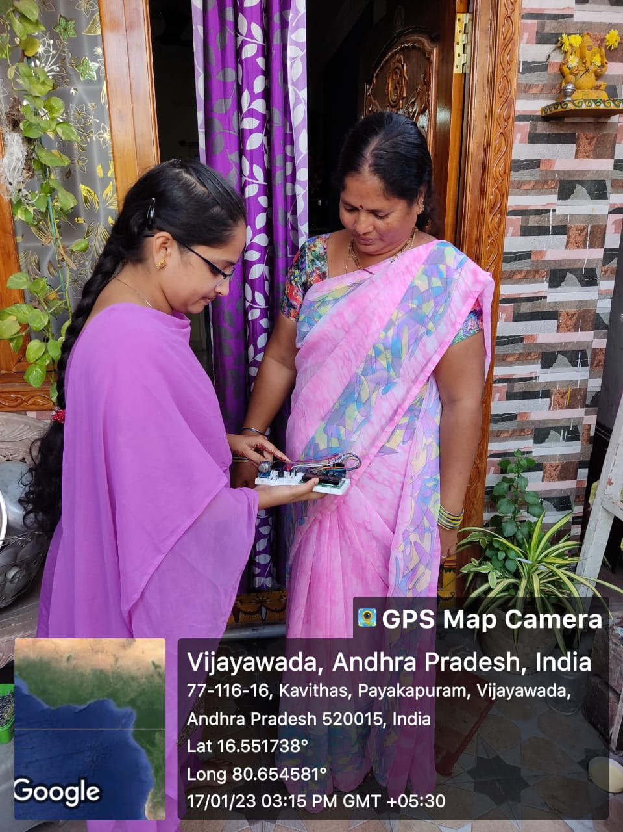 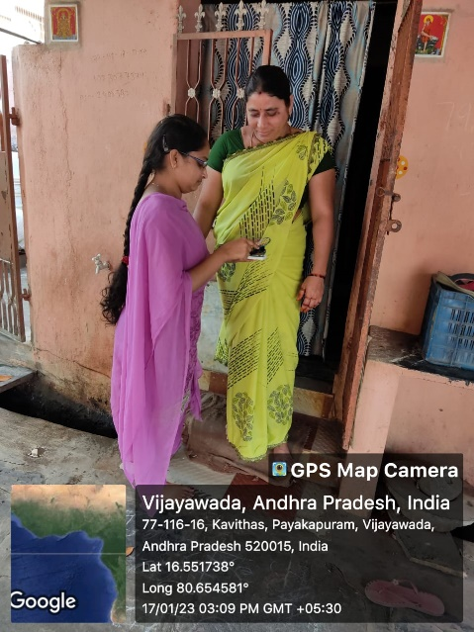

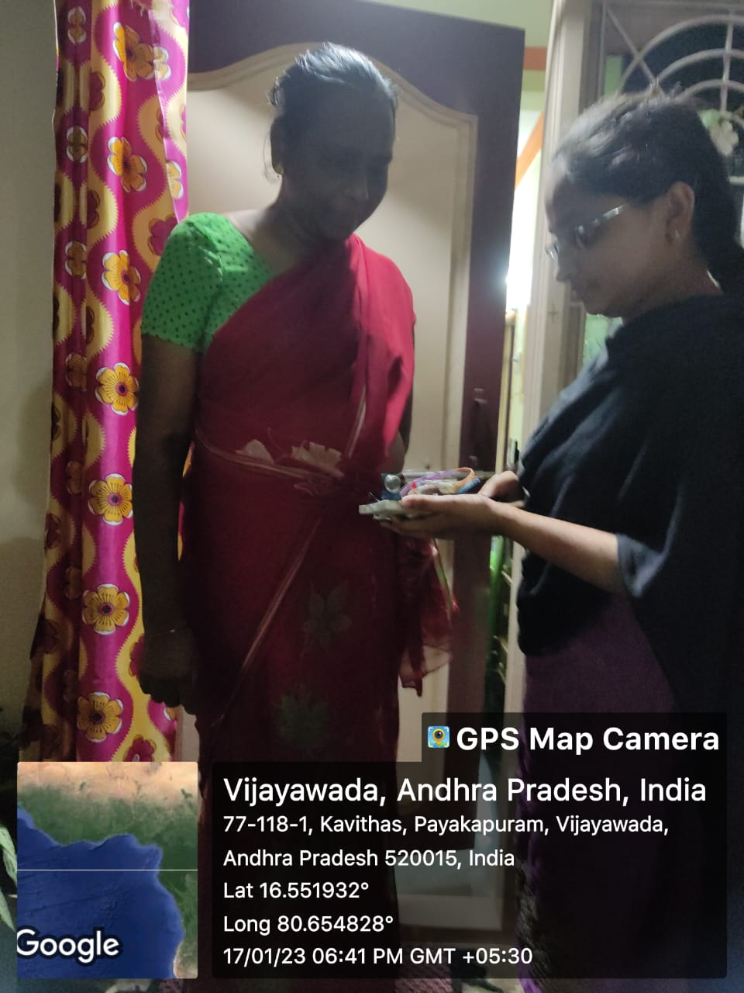

**General guide line for preparing report:**

1. **Page Dimensions and Margin-**The dimensions of the final report should be standard A4 size (297mm x 210mm) paper may be used for preparing the copies. The report should have the following page margins:

Top and Bottom edge : 25 mm (1 inch)

Left side : 38 mm (1.5 inches)

Right side : 25 mm (1 inch)

1. **Alignment** should be done properly by taking left, right, top, bottom gaps into consideration.
2. The normal text should be typed in **12 font size Times New Roman** style in **1.5 line spacing** on one side of A4 size page (Executive Bond) only. Use **16-point** Times New Roman font for major heading and**14-point** Times New Roman font for sub heading.
3. **Page Numbering-**All pages numbers should be typed at the center of page bottom.The preliminary pages of the thesis (such as Title page, certificates, acknowledgement, Table of Contents, List of tables and figures, Notations, abbreviations etc.) should be numbered in lower case Roman numerals.
4. The **captions for figures** should be typed at its bottom. The figure name labeled along with propernumbering(Chapter wise), for example, 4th figure in Chapter 3 should be captioned as Fig. 3.4 title of figure.
5. The **captions for tables** should be typed at its top for e.g. 7th table in Chapter 3 should be captioned as Table. 3.7 title of table.
6. **Numbering of Chapters, Sections and Sub-sections.** The numbering of Chapters, division and sub-divisions should be done using Arabic numerals only and further decimal notation should be used for numbering the divisions and subdivisions within a chapter. For examples sub-division 4 under division 3 belonging to chapter 2 should be numbered as 2.3.4.
7. **No of project report copies to be submitted**: **3**(one copy for department library, one softcopy, and one copy for student (your copy)).
8. **Binding Specifications,** the project report shall be properly bound; the cover page printed on hard cover of **Orange Colour with BlackColour Letters**.
9. **Code of ethics,** prepare project report in your own words.