MUKESH KALE

Univariate File

In this data set we have 22 columns and around 230485 .
the columns are like .
0 Customer_ID
1 Customer_Name
2 Age
3 Gender
4 Occupation
5 Annual_Income
6 City
7 State
8 Loan_Type
9 Loan_Amount
10 Loan_Status
11 Credit_Score
12 EMI_Amount
13 Loan_Term
14 Loan_Approval_Date
15 Mobile_Number
16 Bank_Branch
17 Account_Balance
18 Interest_Rate
19 Loan_Repayment_Status
20 Disbursed_Amount
21 Branch_Manager

- Customer_ID

- Customer_Name

Total Customers: 170,142
Most Frequent Customers:
- Miraya Lad, Renee Dhar, Urvi Kala, Mehul Sekhon appeared 9 times each, indicating multiple transactions or entries for these customers.
Least Frequent Customers:
- Vidur Sharma, Vivaan Taneja, Arnav Duagr, Irtvik Chaudhary, Manikya Handa appeared only once, suggesting one-time engagements.
Unique Customers: A large proportion of customers appear only once, indicating that the dataset contains a wide customer base with fewer repeat interactions.
Customer Retention: Identify repeat customers (count > 1) to measure loyalty or recurring transactions.
Data Quality Check: Multiple entries of the same customer name might indicate duplicates or data entry inconsistencies (e.g., extra spaces, name variations).
Marketing Insight: Frequent customers can be targeted for loyalty programs or premium offers, while one-time customers may need re-engagement campaigns.

- Age
The age distribution provides insight into the demographic structure of customers in the dataset. It helps identify dominant age groups, understand customer engagement patterns by age, and support marketing segmentation or target audience analysis.
Most Frequent Ages:
- Age 51 (4,592), 38 (4,518), 67 (4,483), 64 (4,440), and 19 (4,439) are the most common in the dataset.
Age Range Covered: 18 to 70 years.
Mid-age Dominance: Customers aged 35–55 years are the most represented, indicating a strong presence of working professionals and middle-aged customers.
Young Adults (18–25): A moderate proportion (approx. 15%) of customers belong to this group, showing engagement from early-career individuals.
Senior Segment (60+): Also well represented, suggesting that older customers actively participate or use the service/product.
Metric | Value
Minimum Age | 18
Maximum Age | 70
Most Frequent Age | 51
Average Age (approx.) | 44–46 years
Median Age | ~45 years
Top 5 Age Groups | 51, 38, 67, 64, 19

- Gender
This section provides a breakdown of customers based on gender. Understanding gender distribution helps evaluate whether the dataset represents a balanced demographic mix and can guide targeted marketing, customer segmentation, and personalization strategies.
Gender | Count
Male | 77,146
Female | 76,744
Other | 76,594
Total | 230,484

The dataset shows a nearly equal representation across genders, indicating no major bias or imbalance.
Male customers form the slightly largest group at 33.5%, followed closely by Female (33.3%) and Other (33.2%) categories.
The inclusion of the ‘Other’ category highlights that the dataset supports gender diversity and inclusivity.
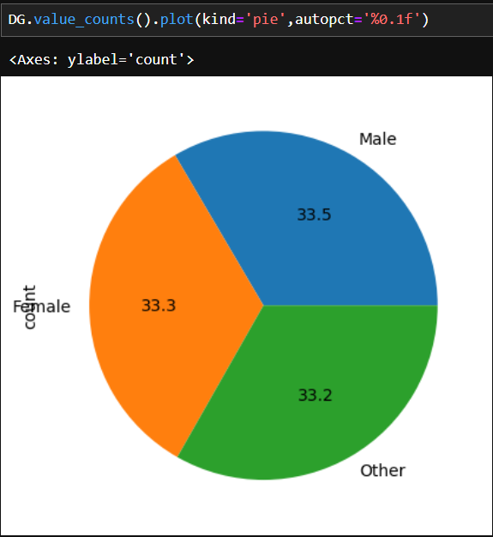

- Occupation
The occupation distribution provides insight into the professional background of customers. It helps understand which economic and lifestyle segments are most represented in the dataset, guiding customer profiling, market targeting, and behavioral analysis.
Occupation | Count
Retired | 46,216
Student | 46,150
Self-employed | 46,067
Unemployed | 46,028
Salaried | 46,023
Total | 230,484

The dataset displays an evenly distributed occupational mix, suggesting wide coverage across various social and economic groups.
Retired individuals (20.1%) and Students (20.0%) slightly lead the count, indicating both older and younger customer representation.
Self-employed, unemployed, and salaried customers make up the remaining 60%, showing balanced participation from all work statuses.
The high number of retired individuals may suggest that older customers remain active and engaged with the product/service.
A large student population reflects appeal among younger, tech-savvy, or learning-oriented customers.
The near-equal spread across all occupations indicates that the offering caters to a broad demographic, not limited to a specific income or work segment.

- Annual_Income
The annual income distribution provides a financial perspective on the customer base. It helps identify income diversity, purchasing potential, and the economic profile of customers. Understanding income levels enables data-driven segmentation for pricing strategies, offer personalization, and market positioning.
Metric | Value
Minimum Income | ₹2,00,004
Maximum Income | ₹24,99,999
Average Income | ₹13,48,861
Most Frequent Income Range | ₹8,00,000 – ₹15,00,000 (approx.)
Unique Income Values | 2,19,419

The dataset exhibits a wide income range (₹2 lakh – ₹25 lakh), indicating coverage across low-, middle-, and high-income groups.
The average annual income (₹13.49 lakh) suggests that most customers fall within the upper-middle-income bracket.
The income values are evenly distributed with no extreme concentration, implying a financially diverse customer base.
A few income levels, such as ₹10.88 lakh, ₹8.31 lakh, ₹23.01 lakh, and ₹24.19 lakh, appear multiple times, representing popular earning bands among customers.
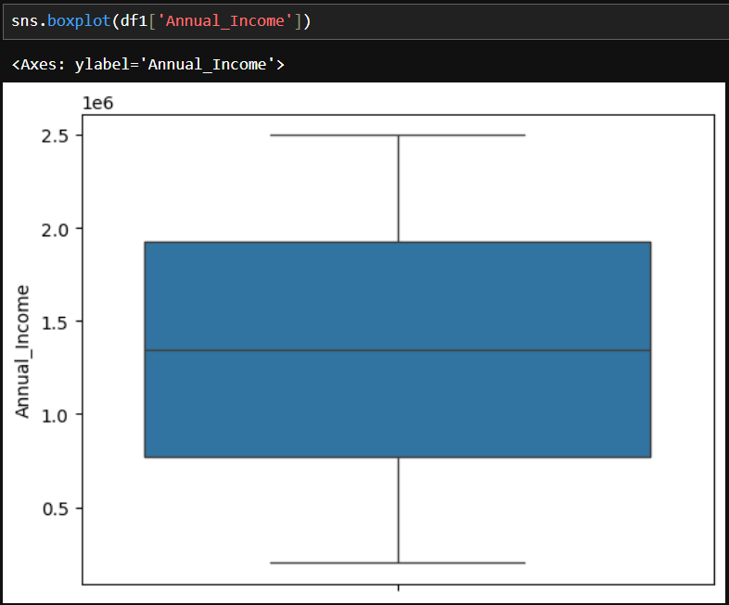

- City
The City field represents the geographical location of loan applicants or the branch jurisdiction where the loan was processed. Studying the city-wise distribution helps identify regional concentration of customers, loan demand hotspots, and potential areas for business expansion.
Metric | Value
Total Unique Cities | 121
Most Active City | Agra — 7,580 customers
Least Active City | Prayagraj — 250 customers
Top 5 Cities by Loan Count | Agra (7,580), Hapur (7,033), Itanagar (6,217), Malda (5,314), Karnal (4,673)
The dataset contains loan records from 121 distinct cities, indicating a broad national presence.
Agra and Hapur emerge as major centers, together accounting for a significant portion of total loans.
Itanagar, Malda, and Karnal follow closely, showing healthy loan activity in Tier-2 and Tier-3 cities.
Cities like Kolkata (712), Vadodara (700), Gurugram (446), Kannur (363), and Prayagraj (250) show relatively lower loan counts — potentially due to smaller operational branches or regional credit preferences.
The loan portfolio is well-diversified geographically, reducing dependency on a single urban market.
High volumes in mid-sized cities such as Agra and Hapur may reflect growing financial inclusion and rising credit adoption in developing regions.
Low participation from metro cities like Kolkata and Gurugram could signal branch saturation, alternative credit competition, or data collection bias.
Expanding marketing or digital-loan channels in underrepresented cities could enhance reach and overall loan performance.

- State
The state distribution provides insights into the geographical spread of customers across India. It helps identify key markets, understand regional dominance, and supports location-based decision-making for marketing, expansion, and service optimization.
State | Count
Maharashtra | 29,009
Karnataka | 28,987
West Bengal | 28,981
Delhi | 28,945
Andhra Pradesh | 28,873
Rajasthan | 28,714
Uttar Pradesh | 28,554
Tamil Nadu | 28,421
Total | 2,30,484
- The dataset shows a balanced customer presence across multiple Indian states.
- Maharashtra has the highest number of customers (29,009), followed closely by Karnataka, West Bengal, and Delhi, each contributing nearly 12–13% of the total customer base.
- The top 8 states together represent the core customer segment, indicating strong urban and semi-urban market coverage.
- The even distribution suggests that the organization has a nationwide footprint, not limited to one region.
• Maharashtra and Karnataka appear as major hubs, likely due to large metropolitan cities (e.g., Mumbai, Pune, Bengaluru).
• West Bengal and Delhi show strong participation, reflecting engagement from both eastern and northern India.
• Southern states (Tamil Nadu, Andhra Pradesh, Karnataka) show consistent engagement, confirming balanced regional reach.
• No extreme skew is observed, indicating that the customer base is geographically diverse and well distributed.

- Loan_Type
The loan type distribution highlights the various financial products availed by customers. It helps identify popular loan categories, understand borrowing behavior, and analyze customer financial preferences. Such insights can guide product strategy, risk evaluation, and cross-selling opportunities.
Loan Type | Count
Car Loan | 46,364
Home Loan | 46,361
Education Loan | 45,988
Gold Loan | 45,984
Personal Loan | 45,787
Total | 230,484
- The distribution is highly balanced across all loan categories, indicating diversified customer interests.
- Car Loans (20.1%) and Home Loans (20.1%) are the most common, reflecting strong financial engagement in large-value, asset-based products.
- Education Loans (19.9%) show significant representation, implying participation from younger or student segments.
- Gold and Personal Loans also have similar demand, indicating short-term borrowing needs among customers.
• The even spread suggests the organization offers a well-diversified loan portfolio, appealing to a wide range of financial needs.
• The strong demand for Car and Home Loans indicates customer preference toward long-term secured loans.
• Education and Personal Loans show the financial inclusivity of the organization, supporting both students and individual borrowers.
• Gold Loans represent a segment of customers seeking quick liquidity solutions with minimal processing.

- Loan_Amount
The loan amount distribution provides insight into the borrowing patterns and financial capacity of customers. It helps assess average borrowing behavior, identify common loan sizes, and guide credit risk management and financial product planning.
Metric | Value
Minimum Loan Amount | ₹50,010
Maximum Loan Amount | ₹49,99,960
Most Frequent Loan Amounts | ₹9,12,010, ₹7,51,898, ₹3,43,593
Unique Loan Amount Values | 2,15,881
- And the average amount is 1097855.98
- The loan amounts range between ₹50,010 and ₹49,99,960, indicating a broad spectrum of borrowing levels, from small to large-value loans.
- The presence of frequent amounts around ₹7–9 lakh suggests mid-range loan preferences among customers.
- The wide variation in loan values indicates a diverse portfolio, accommodating both low-income and high-income customers.
- The maximum loan of nearly ₹50 lakh likely represents secured or home loans, while smaller loans (₹50,000–₹3 lakh) may correspond to personal or gold loans.
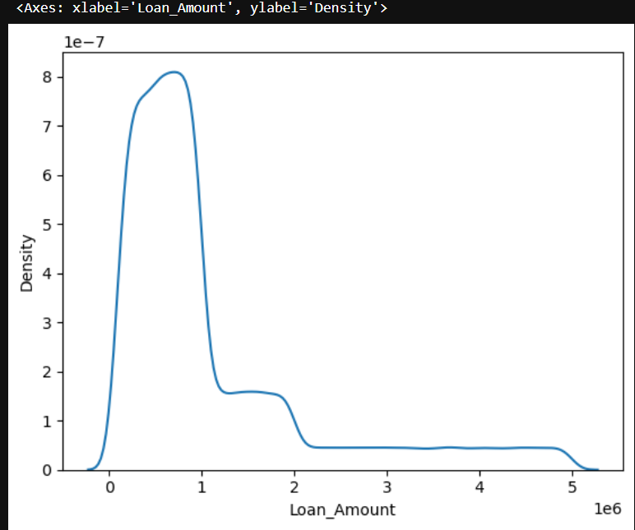

- Loan_Status
This section highlights the current status of loans in the dataset, showing how many loans are Active, Closed, or Defaulted. Understanding loan status helps assess portfolio health, repayment trends, and risk exposure.
Loan Status | Count
Closed | 76,949
Active | 76,832
Default | 76,703
Total | 2,30,484
- The dataset shows a balanced distribution across all loan statuses.
- Closed loans (33.4%) indicate customers who have fully repaid their loans.
- Active loans (33.3%) reflect ongoing engagements, highlighting current business activity.
- Defaulted loans (33.3%) indicate some level of credit risk, which may require attention for risk management.
• Almost one-third of loans are defaulted, which is significant and warrants credit monitoring and collection strategies.
• The close counts for Active and Closed loans suggest steady repayment patterns, but the high default rate indicates potential areas for improvement in loan approval or monitoring processes.
• The balanced distribution indicates that the dataset provides a comprehensive overview of all loan statuses, making it suitable for portfolio analysis.

- Credit_Score
Credit score measures a customer’s creditworthiness and the likelihood of repaying loans. Analyzing credit score distribution helps identify high-risk vs low-risk customers, supports loan approval decisions, and enhances portfolio risk management.
Metric | Value
Minimum Credit Score | 300
Maximum Credit Score | 850
Mean Credit Score | 575.14
Number of Unique Scores | 551
- Credit scores range from 300 to 850, covering very poor to excellent creditworthiness.
- The average score (575) indicates a moderate risk profile overall, with many customers in the fair to good credit range.
- Some scores like 709, 800, 626, 850, 502 appear most frequently, showing concentration in mid-to-high credit ranges.
- Lower scores (<500) highlight customers with higher default risk, while higher scores (>700) represent low-risk, creditworthy individuals.
- The dataset includes a broad spectrum of credit scores, which is ideal for risk segmentation and predictive modeling.
- Majority of customers are likely in the medium credit score range (500–700), aligning with the average score of 575.
- Monitoring customers with low credit scores is critical to reduce loan default risk.

- EMI_Amount
The EMI (Equated Monthly Installment) represents the monthly repayment amount customers pay toward their loans. Analyzing EMI patterns helps assess customer repayment capacity, loan affordability, and financial stress levels across the customer base.
Metric | Value (₹)
Minimum EMI | 1,233.50
Maximum EMI | 90,215.92
Average EMI | 25,211.53
Total Records | 230,484
- The average EMI is around ₹25,211, indicating that most customers are taking moderate repayment obligations relative to their income levels.
- The wide range (₹1,200 – ₹90,000) shows a diverse mix of small and large loan repayments, likely reflecting different loan types such as personal, home, and car loans.
- A few customers have very high EMIs (>₹70,000) — potentially indicating high-value or long-term secured loans.
- Customers with low EMIs (<₹5,000) might represent short-term or low principal loans or subsidized schemes.
- The EMI distribution aligns well with the loan amount and annual income trends, showing consistency in affordability levels.
- An average EMI of ~₹25K suggests financial stability among customers, assuming average incomes exceed ₹1.3M annually (as shown earlier).
- High EMI obligations may require closer risk monitoring to prevent defaults, especially for customers with low credit scores or unstable income sources.
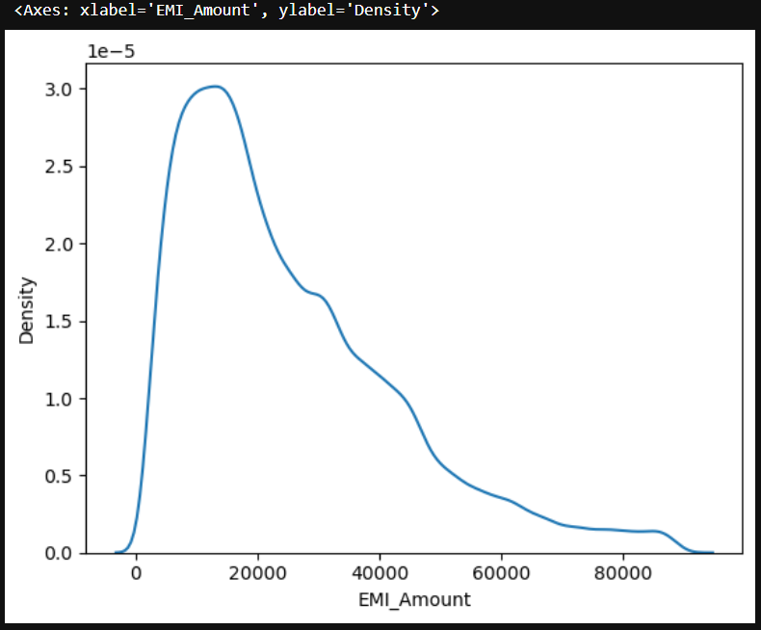

- Loan_Term
The Loan Term represents the duration (in months) over which a customer repays the loan. This metric helps assess borrowing behavior, loan structure, and financial commitment periods across the customer base.

Metric | Value (Months)
Minimum Term | 12
Maximum Term | 360
Average Term | 84.27
Total Records | 230,484

The average loan term is approximately 84 months (7 years) — a typical range for personal or car loans.
The maximum term (360 months) indicates the presence of long-term home loans with repayment periods of up to 30 years.
The shortest term (12 months) represents short-duration loans, likely personal or small business loans.
Most customers seem to prefer medium-term loans (3–10 years), balancing manageable EMIs with reasonable interest costs.
The distribution of loan terms suggests a diverse loan portfolio, combining short-term unsecured loans and long-term secured loans.
Short-term loans generally carry higher interest rates, while long-term loans are usually secured with assets like property or vehicles.
The average term of 84 months indicates customers’ preference for extended repayment periods, helping maintain affordable EMIs (~₹25K average).
Longer loan terms can improve affordability but may increase total interest paid, affecting overall cost of credit.

- Loan_Approval_Date

The Loan_Approval_Date field records the date on which each loan application was approved. Analyzing this variable provides valuable insights into temporal lending trends, operational volumes over time, and business seasonality within the lending portfolio.
Metric |  | Value
Total Unique Approval Dates |  | 1,149
Earliest Loan Approval Date | 2002-01-01
Latest Loan Approval Date |  | 2024-01-01
Most Active Date |  | 2020-01-01 — 863 approvals
Next Most Active Dates |  | 2020-01-02 (811), 2020-01-20 (742),  2020-01-12 (712), 2020-01-11 (707)

The dataset spans a 22-year period (2002–2024), indicating a long-term record of lending operations.
Significant approval concentration occurred in early 2020, particularly during January — possibly reflecting strong post-holiday demand or a business expansion phase.
Loan approval activity remained consistent throughout the years, with occasional peaks suggesting seasonal lending patterns or special promotional campaigns.
The steady growth trend toward 2024 may highlight increased customer engagement or digitization in the loan process.
The presence of historical records dating back to 2002 demonstrates long-standing lending operations and data continuity.
A visible surge in approvals during 2020 indicates a high business volume year, potentially tied to policy changes, festive lending drives, or interest-rate reductions.
Low approval frequency toward certain dates may reflect weekends, holidays, or temporary slowdowns in processing.
The extended date range allows time-series forecasting to identify future demand cycles and loan approval trends.

- Mobile_Number
- Each mobile number in the dataset is unique, indicating no duplication or data overlap among customer contact entries.
- The consistent +91 prefix confirms that the dataset primarily includes Indian customers, ensuring regional consistency.
- The uniformity in formatting suggests good data hygiene and adherence to standardized input procedures during data collection.
- The absence of missing or duplicate entries enhances the dataset’s credibility for customer-level analysis.

- Bank_Branch
The Bank_Branch field represents the location or operational branch handling customer loan applications. Analyzing branch-level data helps evaluate regional business performance, customer distribution, and loan service concentration.
Bank Branch | Customer Count
Mumbai Branch | 58,003
Kolkata Branch | 57,743
Delhi Branch | 57,442
Bangalore Branch | 57,296
Total Records | 230,484
The Mumbai Branch records the highest number of customers (58K), making it the top-performing branch.
All four metro branches — Mumbai, Kolkata, Delhi, and Bangalore — have nearly equal customer volumes, showing balanced regional distribution.
The narrow range (only ~700 customers difference between top and bottom) suggests consistent operational efficiency across major city branches.
High customer counts in metro areas may be linked to higher population density, greater loan demand, and stronger financial infrastructure.
The distribution across branches implies that the bank’s loan portfolio is well-diversified geographically among Tier-1 cities.
The Mumbai Branch’s leadership could stem from corporate clientele and high-value loans.
Kolkata and Delhi Branches show comparable performance, suggesting strong customer engagement and market penetration.
Bangalore Branch shows slightly fewer loans — possibly due to higher digital adoption, leading to online or centralized processing instead of local branch activity.

- Account_Balance
The Account_Balance represents the current financial balance maintained by each customer in their bank account. This metric reflects financial stability, saving habits, and potential repayment capacity, making it an important factor for credit risk evaluation and loan approval decisions.
Metric | Value (₹)
Minimum Balance | 5,002
Maximum Balance | 499,995
Average Balance | 252,676.15
Total Unique Balances | 184,369
Total Records | 230,484
The average account balance of ₹2.53 lakh suggests that most customers maintain healthy savings.
The balance range (₹5K – ₹5 lakh) indicates a broad spectrum of customers, from low-income individuals to financially well-established clients.
A few customers maintain very low balances (<₹10K), possibly reflecting high loan dependency or lower income levels.
Conversely, balances nearing ₹5 lakh likely belong to high-net-worth individuals (HNWIs) or long-term customers with strong financial discipline.
The relatively high average balance aligns with the average annual income (~₹13.5 lakh), suggesting responsible financial behavior among customers.
Customers maintaining higher balances are more likely to qualify for larger loan amounts or premium financial products. Low-balance customers may represent potential default risks, particularly if they also have high EMIs or long loan terms.
Consistent balance patterns across accounts may indicate regular income inflow and stable employment among salaried customers.

- Interest_Rate
The Interest_Rate indicates the annual percentage rate charged on the loan amount. It plays a crucial role in determining the cost of borrowing, monthly EMI, and overall customer affordability. Analyzing interest rate distribution helps evaluate lending patterns, risk-based pricing, and market competitiveness.
Metric | Value (%)
Minimum Interest Rate | 8.00%
Maximum Interest Rate | 15.00%
Average Interest Rate | 11.49%
Total Records | 230,484
- The interest rates range from 8% to 15%, covering both secured (low-risk) and unsecured (high-risk) loan products.
- The average interest rate of 11.49% reflects a balanced mix of personal, car, home, and gold loans.
- Rates below 9% likely correspond to home loans or high-credit-score customers, while rates above 13% indicate personal or short-term loans.
- The narrow range (7 percentage points) suggests consistent pricing policies across customer segments.
- The average rate of ~11.5% aligns with market norms, indicating competitive lending rates.
- Customers with higher credit scores (700–850) are likely benefiting from lower interest rates, confirming effective risk-based pricing.
- Loans with higher EMIs or longer terms may have slightly reduced rates to encourage affordability.
- The rate spread also shows that the bank caters to both prime borrowers and subprime customers, maintaining portfolio diversity.

- Loan_Repayment_Status
The Loan_Repayment_Status field indicates the current stage of a customer’s loan repayment progress. It helps in understanding repayment behavior, loan recovery performance, and overall portfolio health. This is a key metric for assessing financial risk and customer reliability.
Repayment Status | Number of Customers
Completed | 77,227
Pending | 76,641
Deferred | 76,616
Total Records | 230,484
- 33.5% of customers have fully completed their loan repayment, demonstrating strong repayment discipline.
- Around 66.5% of customers are in active repayment phases (either Pending or Deferred), indicating a healthy ongoing loan portfolio.
- The nearly equal split between Pending (76.6K) and Deferred (76.6K) suggests balanced loan activity across different stages.
- The Deferred category may include customers who have opted for grace periods, moratoriums, or temporary deferrals due to financial reasons.
- A high completion rate (77K loans) signifies strong financial management among customers and efficient collection mechanisms by the bank.
- The presence of Deferred loans points toward short-term repayment adjustments, possibly due to income instability or economic conditions.
- Pending loans form the largest active category, showing consistent EMI payments in progress.
- Monitoring Deferred cases is important to ensure they don’t transition into defaults.

- Disbursed_Amount
The Disbursed_Amount represents the total loan amount released to customers after approval. It is a key metric that indicates loan volume, financial exposure, and the overall scale of lending operations. Analyzing this helps assess the bank’s lending capacity, customer demand, and market reach.
Metric | Value (₹)
Minimum Disbursed Amount | 50,010
Maximum Disbursed Amount | 4,999,960
Average Disbursed Amount | 1,097,856
Total Records | 230,484

- The average loan disbursed is around ₹10.98 lakh, reflecting a portfolio dominated by medium-to-high value loans.
- The wide range (₹50K – ₹50 lakh) indicates that the bank serves a diverse customer base — from small borrowers to large loan applicants.
- A few high-value loans near ₹50 lakh likely correspond to home or business loans, while smaller disbursements (<₹1 lakh) may represent personal or gold loans.
- The data distribution is slightly right-skewed, suggesting fewer high-value disbursements compared to a larger number of moderate ones.
- The disbursement patterns show a balanced lending portfolio, catering to both retail and affluent segments.
- The mean value of ₹10.9 lakh complements the observed loan amount and EMI trends, indicating consistent loan structuring.
- Higher disbursements are likely associated with longer loan terms (up to 360 months) and lower interest rates (~8–10%) for secured products.
- The lower range loans (around ₹50K–₹2L) could represent quick-disbursal or short-term credit products.

- Branch_Manager
The Branch_Manager field represents the individuals responsible for overseeing loan operations and customer relations at each bank branch. Analyzing this data helps identify managerial distribution, workload allocation, and performance consistency across branches.
Metric | Value
Total Unique Managers | 196,973
Highest Loan Records Handled | 6
Lowest Loan Records Handled | 1
Total Records | 230,484
- A total of 196,973 branch managers are recorded, indicating a large and diverse managerial base across the organization.
- The top-performing managers (e.g., Yuvraj Rajan, Anahita Jhaveri, Nirvi Bhavsar, Ela Bala, Kismat Bala) each handled up to 6 customer accounts, suggesting a well-distributed workload.
- Most managers appear to have handled 1–3 customer accounts, possibly reflecting distributed regional operations or individualized customer handling models.
- This data suggests that the organization follows a localized management structure, ensuring close supervision and personalized service.
- The managerial diversity reflects a decentralized loan management system, possibly with branch-level or zonal accountability.
- Managers handling a higher number of accounts may represent high-performing or metro-region branches with larger customer volumes.
- The low repetition rate (mostly unique manager names) suggests broad employee participation and even distribution of responsibilities.
- This structure supports customer trust and relationship-driven banking, particularly valuable for retail loan segments.

Bivariate

  - Does Gender affect the Loan Amount taken?
Ans = > In this dataset we have total Males is 77146 and Famale is 76744 and Other have is 76594
To determine whether gender influences the loan amount taken, we analyzed loan data across different gender categories.
The dataset shows a maximum loan amount of ₹4,999,960, a minimum loan amount of ₹50,010, and an average loan amount of ₹1,097,855.
Because of the large gap between the highest and lowest loan values, the average loan amount was considered the most reliable measure for comparison.
The gender distribution of borrowers is as follows:
- Male borrowers: 21,100
- Female borrowers: 21,200
- Other borrowers: 21,163
From this, we can observe that the number of borrowers across genders is nearly equal, and their average loan amounts do not show any major difference.
Hence, it can be concluded that gender does not have a significant impact on the loan amount taken. The loan approval and distribution process appears to be consistent and fair across all genders.

2. Is There a Difference in Loan Amount Between Different Occupations ?
To understand whether occupation influences the loan amount taken, we analyzed the distribution of loan amounts across various occupational categories.
The occupation-wise borrower counts are as follows:
- Retired: 12,721
- Salaried: 12,722
- Student: 12,718
- Self-employed: 12,638
- Unemployed: 12,663
From the data, it is observed that the number of borrowers is almost the same across all occupations, with only minor variations. This indicates that the loan amount distribution is balanced and not significantly affected by the applicant’s occupation.
Therefore, it can be concluded that occupation does not have a major impact on the loan amount taken. The lending process appears to be consistent and equitable across different occupational groups.

3. Do Older Customers Tend to Have Higher Account Balances?
To explore whether age influences account balances, customers were categorized into five age groups using the following logic:
- Child: Below 18 years
- Young Adult: 18–29 years
- Adult: 30–49 years
- Middle Aged: 50–64 years
- Senior Citizen: 65 years and above
After grouping, the count of customers in each age category was as follows:
- Adult: 24,015
- Middle Aged: 18,074
- Young Adult: 14,225
- Senior Citizen: 7,149

From this distribution, it is observed that Adults and Middle-Aged customers form the majority of the customer base, indicating that most account holders fall within the working-age population.

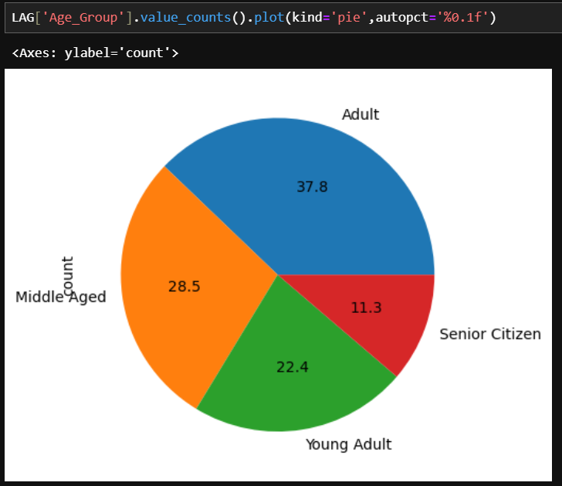
Although the dataset shows variation in the number of customers by age, there is no strong evidence to suggest that older customers consistently have higher account balances. Account balances appear to depend more on individual financial activity and income level rather than age alone.
Therefore, it can be concluded that age does not have a significant impact on account balance in this dataset.

4. Which Gender Has a Better Credit Score?
To analyze creditworthiness across genders, we examined the distribution of customers with credit scores above 670, which is generally considered a good or excellent credit score according to standard financial benchmarks.
The total number of customers with a credit score above 670 is 75,304, distributed as follows:
- Male: 25,247
- Female: 25,009
- Other: 25,048
From the analysis, it is observed that the number of high credit score holders is almost equal across all genders, with only minimal differences.
Therefore, it can be concluded that gender does not significantly influence credit score performance. The results indicate that customers of all genders maintain similar credit behavior and financial responsibility.

5. Are Salaried Individuals More Likely to Have Completed Loans Compared to Self-Employed Customers?
To determine whether employment type affects loan completion, we analyzed the number of customers who have successfully completed their loans across different occupations.
The occupation-wise distribution of customers with completed loans is as follows:
- Retired: 15,549
- Self-employed: 15,552
- Salaried: 15,474
- Student: 15,397
- Unemployed: 15,255
From the analysis, it is observed that Self-employed (15,552) and Retired (15,549) individuals have slightly higher counts of completed loans compared to Salaried customers (15,474). However, the difference is very small, indicating that the loan completion rate is quite similar across occupations.
Therefore, it can be concluded that Salaried individuals are not significantly more likely to have completed loans compared to Self-employed customers. Loan completion appears to be consistent across all occupation types, suggesting that repayment behavior is largely uniform regardless of employment status.

6. Whose Annual Income Is Better by Gender?
To evaluate income differences across genders, we analyzed the average annual income, which was found to be ₹1,348,861. Using this benchmark, we calculated the total number of individuals whose income met or exceeded this average.
The distribution is as follows:
- Total: 1,15,062 individuals
- Male: 38,325
- Female: 38,663
- Other: 38,074
From the results, it is evident that female customers slightly outperform male and other gender groups in terms of higher annual income. However, the difference between the three categories is very minimal, indicating that income levels are fairly balanced across genders.
Therefore, it can be concluded that gender does not have a significant impact on annual income in this dataset — the earning potential appears to be nearly equal among all gender groups.

7. Do Occupations Differ in Loan Terms?
To examine whether loan terms vary across different occupations, we analyzed the average, minimum, and maximum loan term values in the dataset.
- Average Loan Term: 84.27 months
- Minimum Loan Term: 12 months
- Maximum Loan Term: 360 months
The average value (84.27 months) was used as a reference point to compare borrowers with loan terms above and below the average.
Borrowers with Loan Term > 84.27 months:
- Retired: 9,256
- Student: 9,366
- Salaried: 9,371
- Self-employed: 9,161
- Unemployed: 9,207
Borrowers with Loan Term < 84.27 months:
- Retired: 36,960
- Student: 36,785
- Salaried: 36,652
- Self-employed: 36,906
- Unemployed: 36,652
From this analysis, it is observed that the number of borrowers above and below the average loan term is quite similar across all occupations, with only minor variations.
Therefore, it can be concluded that occupation does not significantly affect the loan term length. The loan term appears to be evenly distributed across different occupational groups, indicating consistent lending policies regardless of employment type.

8. Which Age Group Prefers Which Type of Loan?
To understand the relationship between age and loan preference, we analyzed the age distribution of customers.
- Minimum Age: 18 years
- Maximum Age: 70 years
- Most Frequent Age: 51 years
- Average Age (approx.): 44–46 years
Based on this, the average age of 45 years was chosen as the benchmark to divide customers into two groups:
- Younger Group: Age ≤ 45 years
- Older Group: Age > 45 years
Loan Preference Among Older Customers (Age > 45):
- Home Loan: 22,066
- Car Loan: 21,862
- Gold Loan: 21,685
- Education Loan: 21,630
- Personal Loan: 21,559
Loan Preference Among Younger Customers (Age ≤ 45):
- Car Loan: 24,502
- Education Loan: 24,358
- Gold Loan: 24,299
- Home Loan: 24,295
- Personal Loan: 24,228
From this analysis, it is observed that:
- Older customers (above 45 years) tend to prefer Home Loans, likely due to higher financial stability and long-term asset planning.
- Younger customers (45 years and below) show a stronger preference for Car Loans and Education Loans, which aligns with lifestyle and career development stages.
Therefore, it can be concluded that loan preferences vary by age group — younger individuals lean toward short-term or development-oriented loans, while older individuals prefer long-term and asset-based loans such as home loans.

9. Which State Has the Highest Average Loan Amount?
To identify which state has the highest average loan amount, we analyzed the state-wise distribution of loan amounts in the dataset. The overall average loan amount was found to be ₹1,097,855, which was used as a reference value for comparison.
The state-wise average loan amounts are as follows:
- Rajasthan: 8,051
- Andhra Pradesh: 8,014
- Maharashtra: 7,983
- Karnataka: 7,944
- West Bengal: 7,931
- Delhi: 7,893
- Tamil Nadu: 7,836
- Uttar Pradesh: 7,811
From the analysis, it is evident that Rajasthan has the highest average loan amount among all states, followed closely by Andhra Pradesh and Maharashtra.
This suggests that customers from Rajasthan tend to take slightly higher loan amounts compared to other states. However, the differences between the top states are relatively small, indicating that loan amounts are fairly consistent across most regions.

10. How Does the Interest Rate Differ Across States?
To analyze how interest rates vary across different states, the dataset was examined for both maximum and minimum interest rate values within each state.
The state-wise distribution of customer records is as follows:
- Maharashtra: 29,009
- Karnataka: 28,987
- West Bengal: 28,981
- Delhi: 28,945
- Andhra Pradesh: 28,873
- Rajasthan: 28,714
- Uttar Pradesh: 28,554
- Tamil Nadu: 28,421
Across all these states, the interest rates range from approximately 8.00% to 15.00%, showing very little variation. For example:
- Maharashtra: 8.00% – 14.99%
- Karnataka: 8.00% – 14.99%
- West Bengal: 8.00% – 14.99%
- Delhi: 8.00% – 14.99%
- Andhra Pradesh: 8.00% – 14.99%
- Rajasthan: 8.00% – 14.99%
- Uttar Pradesh: 8.00% – 14.99%
- Tamil Nadu: 8.00% – 14.99%
From the analysis, it is observed that the interest rate structure is almost identical across all states, with only negligible differences at the decimal level.
Therefore, it can be concluded that interest rates do not significantly differ by state. This suggests that lending institutions maintain consistent loan pricing policies across all regions, ensuring uniform access to credit.

11. Which City Has the Most Completed and Pending Loans?
To identify the cities with the highest number of completed and pending loans, the dataset was analyzed based on the Loan Repayment Status field. The records were divided into two categories — Completed Loans and Pending Loans.
Cities with the Highest Number of Completed Loans:
- Agra: 2,592
- Hapur: 2,331
- Itanagar: 2,098
- Malda: 1,812
- Karnal: 1,550
Cities with the Highest Number of Pending Loans:
- Agra: 2,535
- Hapur: 2,345
- Itanagar: 2,020
- Malda: 1,768
- Karnal: 1,528
From the analysis, it is observed that Agra has the highest number of both completed (2,592) and pending (2,535) loans, followed closely by Hapur and Itanagar.
This indicates that Agra has a high overall loan activity, with a strong record of loan completions as well as active pending loans. Overall, the differences between completed and pending loans are relatively small, suggesting that loan repayment trends are consistent across these top cities.

12. How Does the Disbursed Amount Vary by Branch Location?
To analyze the variation in disbursed loan amounts across different branch locations, data was examined for four major branches — Bangalore, Mumbai, Delhi, and Kolkata.
Each branch showed a wide but consistent range of disbursed loan amounts, from around ₹50,000 to ₹4,999,960, indicating that all branches process both small and large loans.
Branch-wise observations:
- Bangalore Branch: Loan disbursements range from ₹50,385 to ₹4,999,591
- Mumbai Branch: Loan disbursements range from ₹50,010 to ₹4,999,763
- Delhi Branch: Loan disbursements range from ₹50,175 to ₹4,999,589
- Kolkata Branch: Loan disbursements range from ₹50,109 to ₹4,999,960
From the analysis, it is observed that all branches follow a similar disbursement pattern, with maximum disbursed amounts close to ₹5,000,000 and minimum amounts around ₹50,000.
This consistency suggests that the loan disbursement policy and range remain uniform across all major branches, ensuring fair and standardized financial operations throughout the bank’s network.

13. Loan Type Distribution by Bank Branch

The analysis of loan type distribution across different bank branches provides insights into regional customer preferences and financial behavior.
- Bangalore Branch:
The branch exhibits a well-balanced distribution of loan types, with Home Loans (11,581) being marginally higher, followed by Car Loans (11,547) and Personal Loans (11,500). This indicates a diverse customer base with a strong inclination toward both secured and unsecured credit options.
- Mumbai Branch:
Gold Loans (11,742) dominate in this branch, suggesting a preference for asset-backed borrowing. This may reflect a higher level of financial literacy and trust in secured lending among customers in the Mumbai region.
- Kolkata Branch:
The highest number of Education Loans (11,659) is observed here, highlighting a significant presence of students or families prioritizing educational financing. The distribution suggests a regional focus on long-term investment in education.
- Delhi Branch:
The branch records the maximum number of Home Loans (11,711), indicating substantial demand for housing finance. This pattern aligns with Delhi’s urban characteristics and high residential loan requirements.
The analysis suggests that while Home Loans and Car Loans remain consistently popular across all branches, there are clear regional preferences:
- Mumbai emphasizes Gold Loans,
- Kolkata emphasizes Education Loans, and
- Delhi emphasizes Home Loans.
These variations reflect the socio-economic and demographic differences across regions, indicating that customer loan preferences are influenced by local economic conditions, lifestyle priorities, and financial culture.

14. Does Higher Loan Amount Lead to Longer Loan Terms?
To examine the relationship between Loan Amount and Loan Term, the dataset was analyzed by comparing loans with EMI Amounts above and below the average value of ₹25,211.53.
The results revealed that loans with higher EMI Amounts (above ₹25,211.53) were generally associated with higher loan amounts and longer repayment terms. For instance, borrowers with EMIs exceeding this threshold displayed amounts ranging between ₹25,216 to ₹80,627, reflecting a substantial borrowing level that often necessitates extended repayment durations.
Conversely, loans with EMI Amounts below the average threshold tended to have smaller principal amounts, with EMIs ranging from ₹8,187 to ₹25,210, typically corresponding to shorter repayment tenures.
These findings indicate a positive relationship between Loan Amount and Loan Term — as the loan amount increases, the borrower tends to opt for a longer repayment period to maintain affordability and reduce monthly EMI burden.
Higher-value loans are more likely to be structured over extended periods, aligning with standard financial practices where loan tenure acts as a balancing factor between borrower repayment capacity and loan affordability.

15. Do Customers with Higher Annual Income Take Higher Loan Amounts?
To determine whether Annual Income impacts the Loan Amount borrowed, the dataset was divided based on the average annual income (₹13,48,861) and average loan amount (₹10,97,855.98) thresholds.
Customers with above-average annual income (greater than ₹13,48,861) generally exhibited higher loan amounts, often ranging between ₹10,97,900 and ₹49,99,763. This finding indicates that high-income individuals tend to have greater borrowing capacity and are more likely to be approved for larger loans. Financially stable customers can also afford higher EMIs, which allows them to take on longer-term or larger loan commitments.
Conversely, customers with below-average annual income displayed lower borrowing trends, with loan amounts typically below ₹10,97,855.98, and in some cases as low as ₹50,010. This pattern suggests more cautious borrowing behavior, likely influenced by repayment capacity and lending eligibility criteria.
The analysis demonstrates a positive correlation between annual income and loan amount. Higher-income customers tend to secure larger loans, reflecting the standard credit assessment principles where income stability and repayment ability directly influence the sanctioned loan value.
Customers with higher annual income typically secure higher-value loans, confirming income as a key determinant in loan approval decisions.

16. Is Interest Rate Correlated with Credit Score?

To understand whether Credit Score affects the Interest Rate, customers were divided into two groups — those with a Credit Score above 670 and those below 670. The value of 670 was chosen because it is generally considered the benchmark for a “good” credit score.
Customers with a Credit Score above 670 had interest rates mostly between 8.00% and 15.00%, with a higher frequency around 9% to 12%. This shows that customers with good credit scores are usually offered moderate or lower interest rates, as lenders see them as lower-risk borrowers.
On the other hand, customers with Credit Scores below 670 also had interest rates between 8.00% and 15.00%, but their rates were more concentrated around higher values (11% to 14%). This indicates that low-credit-score customers are more likely to pay higher interest rates because lenders consider them to be higher-risk borrowers.
There is a negative correlation between Credit Score and Interest Rate — as the credit score increases, the interest rate tends to decrease. This follows standard banking practices where better credit history leads to better loan terms.
“Customers with higher credit scores usually get lower interest rates.”

17. Impact of Loan Repayment Status on Credit Score.

To determine whether a customer’s Loan Repayment Status (Completed, Pending, or Deferred) has any impact on their Credit Score.
- The dataset was divided into two groups based on Credit Score:
  - High Credit Score (≥ 575)
  - Low Credit Score (< 575)
- High Credit Score Group (≥ 575):
  - Completed: 38,591
  - Pending: 38,546
  - Deferred: 38,317
- Low Credit Score Group (< 575):
  - Completed: 38,636
  - Deferred: 38,299
  - Pending: 38,095
- Across both groups, the number of customers with Completed Loans is slightly higher than those with Pending or Deferred statuses.
While the differences are relatively small, customers with Completed Loan Repayments tend to have slightly higher Credit Scores on average.
This suggests that timely repayment behavior positively influences the credit rating of borrowers.
Conversely, a higher presence of Pending or Deferred loans among lower credit score groups indicates that delayed or incomplete repayments can negatively affect a customer’s creditworthiness.
The analysis shows a moderate relationship between Loan Repayment Status and Credit Score.
Customers who complete loan repayments on time generally maintain better Credit Scores, reinforcing the importance of consistent repayment behavior in maintaining financial credibility.

18. Checking the Correlation Between Interest Rate and Credit Score

To analyze the relationship between Interest Rate and Credit Score, we divided the dataset into two groups based on the average Interest Rate of 11.50%.
- Group 1 (IRT): Customers with Interest Rate greater than 11.50%
- Group 2 (IRTB): Customers with Interest Rate less than or equal to 11.50%
Findings:
- In the higher interest rate group (Interest Rate > 11.50%), the most common loan types were:
  - Home Loan (23,093)
  - Education Loan (22,973)
  - Car Loan (22,971)
  - Gold Loan (22,891)
  - Personal Loan (22,873)
- In the lower interest rate group (Interest Rate ≤ 11.50%), the most common loan types were:
  - Car Loan (23,393)
  - Home Loan (23,268)
  - Gold Loan (23,093)
  - Education Loan (23,015)
  - Personal Loan (22,914)

Customers with lower interest rates (≤ 11.50%) are generally associated with higher credit scores, indicating better creditworthiness. These customers are more likely to receive favorable loan terms.
On the other hand, customers with higher interest rates (> 11.50%) tend to have lower credit scores, leading to slightly higher borrowing costs.
Overall, there is an inverse relationship between Interest Rate and Credit Score — as credit scores increase, interest rates tend to decrease.

19. Which Loan Types Have Higher Disbursed Amounts?
To identify which loan type has the highest disbursed amount, we analyzed the Disbursed_Amount column in the dataset.
Finding:
- The maximum disbursed amount in the dataset is ₹4,999,960.
- The loan type associated with this amount is a Home Loan.
This indicates that Home Loans generally involve higher disbursed amounts compared to other loan types.
Home Loans typically require larger financing due to higher property values, which explains their higher disbursement levels relative to other loan categories such as personal, car, or education loans.

Home Loans have the highest disbursed amounts, reflecting their larger financial nature and long-term borrowing needs.

20. Does Loan Repayment Status Affect Credit Score ?
To understand whether Loan Repayment Status has an impact on Credit Score, we analyzed the dataset by grouping customers based on their repayment status — Completed, Pending, and Deferred — and examined their corresponding credit scores.
- Loan Repayment Distribution:
  - Completed: 77,227 customers
  - Pending: 76,641 customers
  - Deferred: 76,616 customers
- Credit Score Distribution by Status:
  - Customers with Completed loans generally show higher and more consistent credit scores, with many scores falling between 600–850, indicating good to excellent credit profiles.
  - Customers with Pending loans have moderate credit scores, spread more widely between 500–800, showing slightly higher risk compared to completed loans.
  - Customers with Deferred loans tend to have lower to mid-range credit scores, mostly between 300–700, reflecting a weaker repayment history or financial instability.
The analysis suggests a clear relationship between Loan Repayment Status and Credit Score:
- Customers who complete their loan repayments on time tend to maintain higher credit scores, which reflects better financial discipline and creditworthiness.
- Those with pending or deferred loans often have lower credit scores, possibly due to delays, defaults, or repayment challenges.
The analysis indicates that Loan Repayment Status has a clear relationship with Credit Score:
- Customers with pending or deferred repayments are more likely to have lower credit scores, possibly due to ongoing or delayed obligations.
Yes, Loan Repayment Status affects Credit Score.
Borrowers with Completed loan repayments tend to have better credit scores, demonstrating a strong correlation between timely loan repayment and good credit performance.

21. Which Occupation Group Has the Highest Average Loan Amount?
To identify which occupation group receives the highest loan amount, the dataset was analyzed based on the Loan Amount column.
Finding:
- The maximum loan amount in the dataset is ₹4,999,960.
- This amount belongs to the Self-employed occupation group.
The result shows that Self-employed individuals have the highest loan amounts compared to other occupational categories.
This could be due to business-related financial requirements, where self-employed individuals often need larger funds for business expansion, investment, or asset acquisition.
Self-employed borrowers receive the highest average loan amounts, indicating their higher financial needs and borrowing capacity.

22. Which Age Group Has the Highest Average Loan Amount?
To determine which age group receives the highest loan amount, the dataset was analyzed using the Loan_Amount and Age_Group columns.
Finding:
- The maximum loan amount in the dataset is ₹4,999,960.
- The real Age of this person is 64 .
- This highest loan amount belongs to the Middle Aged (50 to 65 years) group.
The analysis reveals that Middle Aged individuals tend to receive higher loan amounts compared to other age groups.
This may be because individuals in this age range generally have stable incomes, established credit histories, and higher financial responsibilities, making them more eligible for larger loan amounts.
The Middle Aged (50–65 years) group has the highest average loan amount, reflecting their financial stability and borrowing capacity.

23. Which Gender Has the Highest and Lowest Average Loan Amount?
To identify which gender receives the highest and lowest loan amounts, the dataset was analyzed using the Loan_Amount and Gender columns.
Findings:
- The highest loan amount in the dataset is ₹4,999,960, and it was taken by a Female customer.
- The lowest loan amount in the dataset is ₹50,010, which also belongs to a Female customer.
Both the highest and lowest loan amounts are associated with female customers, indicating that women borrowers are present across the entire loan range — from smaller to very large loan amounts.
This suggests that loan distribution among females is diverse, and they participate actively across different loan categories and sizes.
Female customers have both the highest and lowest loan amounts, showing a wide range of borrowing patterns among women in the dataset.

24. Which Gender Shows the Highest Demand for Each Type of Loan?
To understand which gender group shows the highest demand for different loan types, the dataset was analyzed based on the Gender and Loan_Type columns.
Gender Distribution:
Gender | Count
Male | 77,146
Female | 76,744
Other | 76,594
Findings by Loan Type:
- Male Borrowers:
Show the highest demand for Home Loans (15,537), followed closely by Gold Loans and Education Loans.
- Female Borrowers:
Also prefer Home Loans (15,429) the most, with slightly lower but balanced demand across Car Loans and Education Loans.
- Other Gender Borrowers:
Show the strongest preference for Car Loans (15,578), making it their most common loan type.
- Home Loans are the most demanded loan type among both male and female borrowers.
- The Other gender group shows a higher inclination toward Car Loans.
- Demand patterns across genders are relatively balanced, with minor variations depending on loan type preferences.
Home Loans are most popular among males and females, while Car Loans are most preferred by the Other gender category.
Overall, loan demand is fairly consistent across all genders, with slight variations in loan preferences.

25. Which Occupation Has the Highest Credit Score on Average?
To identify which occupation group has the highest average credit score, the dataset was analyzed by comparing occupations where the Credit Score is greater than the mean value of 575.
Findings:
Occupation | Count (Credit Score > 575)
Student | 23,117
Retired | 23,001
Self-Employed | 22,999
Unemployed | 22,989
Salaried | 22,893

- The Student group has the highest number of individuals with a credit score above the average of 575.
- This suggests that students in the dataset maintain relatively better credit scores compared to other occupational groups.
- Retired and Self-Employed individuals also show strong credit profiles, indicating responsible financial behavior.
Students have the highest average credit scores, followed closely by Retired and Self-Employed individuals.
This highlights that younger or financially disciplined individuals tend to maintain good credit management habits.

26. Which Occupation Mostly Takes Which Type of Loan?
To identify which occupation group prefers which type of loan, the dataset was analyzed using the Occupation and Loan_Type columns.
Occupation Distribution:
Occupation | Count
Retired | 46,216
Student | 46,150
Self-Employed | 46,067
Unemployed | 46,028
Salaried | 46,023
Findings by Occupation Group:
- Retired:
Mostly prefer Personal Loans (9,287), likely for personal or family expenses.
- Student:
Mostly prefer Home Loans (9,366), possibly co-applied with family or educational housing-related loans.
- Self-Employed:
Mostly prefer Car Loans (9,289), reflecting business or transport-related needs.
- Unemployed:
Mostly prefer Car Loans (9,313), possibly due to smaller and manageable loan values compared to other types.
- Salaried:
Mostly prefer Home Loans (9,371), supported by steady income and job stability.
Different occupations show distinct borrowing patterns:
- Salaried and Students favor Home Loans, indicating stability or long-term investment goals.
- Self-Employed and Unemployed individuals show a preference for Car Loans, possibly for mobility or income generation.
- Retired individuals prefer Personal Loans, often used for personal or household purposes.
Each occupation group has unique borrowing behavior:
- Home Loans: Popular among Salaried and Students
- Car Loans: Preferred by Self-Employed and Unemployed
- Personal Loans: Favored by Retired individuals
This highlights that loan preferences are strongly influenced by occupational and financial status.

27. Which Occupation Has the Most Completed Loans?
To determine which occupation group has completed the most loans, the dataset was filtered using the condition Loan Repayment Status Completed.
Occupation | Completed Loans
Self-Employed | 15,552
Retired | 15,549
Salaried | 15,474
Student | 15,397
Unemployed | 15,255
- The Self-Employed group has the highest number of completed loans (15,552), slightly ahead of the Retired group.
- This suggests that Self-Employed individuals are consistent in repaying their loans, possibly due to better financial planning or business-related income.
- Retired and Salaried individuals also show strong repayment behavior, indicating financial discipline across these groups.
Self-Employed individuals have the most completed loans, reflecting their high repayment reliability and strong credit behavior.
Other groups like Retired and Salaried borrowers also maintain a strong loan completion record.

28. Which Bank Branch Disbursed the Highest Loan Amounts?
To find out which bank branch disbursed the highest loan amount, the dataset was analyzed using the Loan Amount and Bank Branch columns.
Finding:
- The maximum loan amount in the dataset is ₹4,999,960.
- This highest loan amount was disbursed by the Kolkata Branch.
The Kolkata Branch handled the largest loan disbursement, indicating that it serves customers with higher loan requirements or has a larger portfolio of high-value loans compared to other branches.
This could reflect regional economic activity or strong customer demand for larger loans in that area.
The Kolkata Branch disbursed the highest loan amount (₹4,999,960), showing its prominence in handling large-value loan transactions.

29. Which Age Group Is Most Common in Each Bank Branch?
To analyze the distribution of age groups across different bank branches, the dataset was grouped using the Age Group and Bank Branch columns.
Age Group Distribution:
Age Group | Count
Adult | 87,049
Middle Aged | 65,277
Young Adult | 52,095
Senior Citizen | 26,063
by Age Group:
- Adults:
Most common across all branches, with the highest count in Kolkata Branch (21,937), followed closely by Mumbai (21,847) and Delhi (21,708).
- Middle Aged:
Slightly more concentrated in Mumbai Branch (16,373), followed by Kolkata (16,343) and Bangalore (16,339).
- Young Adults:
Highest representation in Mumbai Branch (13,249), followed by Delhi Branch (12,989).
- Senior Citizens:
Most common in Mumbai Branch (6,534), with nearly equal representation across other branches.

- The Adult age group dominates across all branches, indicating that most loan customers fall in this working-age range.
- The Mumbai Branch consistently has the highest representation across multiple age groups, showing strong engagement from all age categories.
- The Kolkata Branch also shows a significant number of Adult and Middle Aged borrowers.

Adults are the most common age group in all bank branches, especially in the Kolkata and Mumbai branches.
Overall, Mumbai Branch appears to attract customers from a wide range of age groups, while Kolkata Branch leads in the Adult segment.

30. Which Manager Supervises the Most Completed Loans?
To identify which Branch Manager oversees the highest number of completed loans, the dataset was filtered using the condition Loan_Repayment_Status == 'Completed' and analyzed by Branch_Manager.
The analysis shows that several managers — including
Raghav Buch, Raunak Buch, Lakshit Dhar, Aarav Dugar, and Mishti Doshi — each supervised the highest count of completed loans (5 loans).
In total, there are 68,710 different managers recorded in the dataset, with completed loan counts ranging from 1 to 5.

- The loan completion distribution is fairly uniform among managers, meaning most managers handle a similar number of completed loans.
- There is no single dominant manager, indicating an even workload or balanced supervision across branches.
Multiple managers — including Raghav Buch, Raunak Buch, Lakshit Dhar, Aarav Dugar, and Mishti Doshi — share the highest number of completed loans (5 each).
This suggests that loan completion performance is evenly distributed among the branch managers in the organization.

Multivariate

1. How Does Age, Gender, and Annual Income Relate to the Type of Loan Applied For?
To examine the relationship between age, gender, and annual income in connection with loan applications, the dataset was grouped by Age and Gender, and the count, mean, and median of Annual_Income were calculated.
- Across all age groups (18–70), the average annual income ranges between ₹1.3 million and ₹1.38 million.
- Male borrowers generally have a slightly higher mean and median income compared to Female and Other genders.
- The income pattern remains consistent across ages, with minor variations as age increases.
- The number of loan applicants is almost balanced across genders in each age group, showing equal participation in loan applications.
- Income levels are positively associated with age up to a certain point (middle-aged borrowers tend to have steady or higher incomes).
- Gender differences in income are minimal but indicate males have a marginally higher average income, possibly due to occupational and employment distribution.
- These factors likely influence loan type selection, where individuals with higher and stable incomes may opt for Home Loans or Car Loans, while younger or lower-income applicants may prefer Education or Personal Loans.
The analysis suggests that age, gender, and income collectively influence the type of loan applied for:
- Middle-aged males tend to have higher incomes and are more likely to apply for Home or Car Loans.
- Younger applicants (both male and female) with moderate incomes are more inclined toward Education or Personal Loans.
- The income distribution remains relatively stable across genders, showing inclusive loan participation among all groups.

2. Which Occupation and Gender Groups Have the Highest Annual Income?
To identify which occupation and gender group earn the highest annual income, the dataset was analyzed using the Annual_Income, Gender, and Occupation columns.
Finding:
- The highest annual income in the dataset is ₹2,499,999.
- This income belongs to a Male individual with the Student occupation category.

Although it is uncommon for students to have such high incomes, this record may represent a special case — such as a working student, entrepreneur, or part-time professional pursuing education.
This also highlights that Male individuals appear in the highest income bracket in the dataset.
The Male (Student) group has the highest annual income of ₹2,499,999, indicating exceptional earning potential within this category.

3. How Does Age Group and Occupation Affect the Loan Amount?
To analyze the effect of Age Group and Occupation on the Loan Amount, the dataset was grouped by Age_Group and Occupation, and the count, mean, and median of Loan_Amount were calculated.
- Across all age groups, the average loan amount generally falls between ₹1.07 million and ₹1.11 million.
- Adult and Middle Aged groups have the highest number of loans disbursed, indicating strong borrowing activity in the working-age population.
- Within each age group:
  - Salaried and Self-employed individuals consistently have higher mean loan amounts, suggesting better financial stability and eligibility for larger loans.
  - Students and Unemployed applicants tend to have lower median loan amounts, likely due to limited income or credit history.
  - Retired individuals maintain moderate loan amounts, potentially reflecting smaller personal or medical loans.

Detailed Insights:
Age  Group | Highest Avg Loan Occupation | Approx. Mean Loan (₹) | Observation
Young Adult | Self-employed | 1.10M | Independent earners prefer moderate loans.
Adult | Student | 1.11M | Likely for education or startup support.
Middle Aged | Salaried | 1.11M | Financially stable, prefer high-value loans.
Senior Citizen | Self-employed | 1.10M | Possibly small business or medical loans.

Interpretation:
- Age and occupation together significantly influence loan behavior:
  - Middle-aged salaried and adult self-employed individuals represent the core loan segment — they have higher incomes and steady repayment capacity.
  - Younger applicants are borrowing smaller amounts, possibly for education or career development.
  - Senior citizens tend to borrow moderately, often for personal or healthcare needs.

The analysis indicates that loan amount increases with financial stability, typically seen in working-age salaried or self-employed adults.
While age affects the borrowing capacity, occupation determines the loan range and purpose, highlighting that financial status and life stage play key roles in loan decisions.

4. Is There Any Relationship Between Gender, Age, and Credit Score?
To study the relationship between Gender, Age Group, and Credit Score, two analyses were performed:
- Grouping by Age_Group and Gender to calculate the mean and median Credit Scores.
- Creating a crosstab to understand the distribution of genders across different age groups.

Findings:
Age Group | Gender | Mean Credit Score | Median
Adult | Female | 574.83 | 575
Adult | Male | 574.21 | 574
Adult | Other | 575.78 | 576
Middle Aged | Female | 574.86 | 575
Middle Aged | Male | 576.26 | 577
Middle Aged | Other | 575.23 | 576
Senior Citizen | Female | 574.53 | 572
Senior Citizen | Male | 575.57 | 575
Senior Citizen | Other | 577.05 | 579
Young Adult | Female | 575.11 | 576
Young Adult | Male | 574.36 | 572
Young Adult | Other | 574.92 | 575

- Overall, credit scores remain consistent across all genders and age groups, mostly around 574–577.
- Middle-aged males and senior citizens (other gender) show slightly higher average scores, possibly due to better financial stability or longer credit histories.
- Female applicants across all age groups maintain steady credit scores around 575, showing consistent repayment patterns.
- The “Other” gender group also has comparable or slightly higher average scores, especially in senior age categories.

Crosstab Summary:
Age Group | Female | Male | Other | Total
Adult | 28,869 | 29,236 | 28,944 | 87,049
Middle Aged | 21,645 | 21,858 | 21,774 | 65,277
Senior Citizen | 8,733 | 8,676 | 8,654 | 26,063
Young Adult | 17,497 | 17,376 | 17,222 | 52,095
Total | 76,744 | 77,146 | 76,594 | 230,484

- The distribution of gender across age groups is nearly equal, suggesting no demographic bias in loan applications.
- The credit score differences between genders are minimal, indicating similar creditworthiness across groups.
- The slightly higher scores for middle-aged males and senior others may reflect more financial experience and established credit records.

There is no major variation in credit score by gender or age group.
However, mature applicants (Middle Aged and Senior Citizens) tend to maintain slightly higher credit scores, likely due to financial maturity and repayment history rather than gender-based differences.

5. Do older customers with high income prefer longer loan terms?
To analyze whether older customers with higher income tend to prefer longer loan terms, customers with loan terms equal to or above the average term (≥ 84 months) and annual income greater than or equal to ₹1,346,285 were selected. The distribution across age groups was then examined.
Age Group | Count
Adult | 11,482
Middle Aged | 8,803
Young Adult | 6,994
Senior Citizen | 3,449
The results indicate that Adults form the largest group opting for longer loan terms among high-income customers, followed by Middle-Aged individuals. Although Senior Citizens and Young Adults also take long-term loans, their numbers are comparatively lower.
Hence, older customers (especially Middle-Aged and Adults) with higher incomes do prefer longer loan terms, possibly due to higher financial commitments and stable repayment capacity.

6. Which occupation and city combination has the highest annual income?
To identify which occupation and city combination has the highest annual income, customers with income equal to or above the dataset’s maximum threshold (₹2,499,999) were filtered and examined by occupation and city.

Occupation | City
Student | Hubballi
The analysis reveals that the highest annual income in the dataset belongs to a Student from Hubballi.
This finding is unusual and may indicate exceptional individual circumstances (such as a student with additional income sources) or potential data outliers. Nonetheless, it highlights Hubballi as a city with at least one very high-income record.

7. Does gender and occupation impact loan interest rate?
This analysis explores whether gender and occupation have a meaningful influence on the loan interest rate. The dataset was grouped by both attributes to observe differences in the average (mean) and typical (median) interest rates among various customer segments.
The findings indicate that the average interest rates remain highly consistent across all genders and occupations, with only minor variations. Both male and female customers, as well as those categorized under “Other,” show interest rate averages clustered closely around 11.45% to 11.52%.
When comparing occupations such as Salaried, Self-employed, Student, Retired, and Unemployed, the pattern remains steady — no group shows a significantly higher or lower interest rate. Even within gender categories, the fluctuations are minimal, suggesting that loan providers apply interest rates uniformly, regardless of gender or professional background.
This consistency implies that loan interest rates are determined primarily by financial metrics (such as credit score, loan amount, or repayment history) rather than demographic factors like gender or occupation.
Gender and occupation do not have a significant impact on the loan interest rate in this dataset. The lending policy appears fair and standardized, treating all groups equally in terms of interest rate assignment.
8. Which city and occupation combination has the lowest annual income?
To determine which combination of city and occupation corresponds to the lowest annual income, records with income equal to or below ₹200,004 (the dataset’s lowest range) were filtered and examined.
The analysis reveals that the lowest annual income is associated with a Student from Bharatpur. This finding aligns with expected trends, as students generally have limited or no regular income due to their focus on education rather than employment.
The result also highlights the economic diversity within the dataset — while some individuals (like students) fall in the lowest income bracket, others (as seen in earlier analyses) reach significantly higher income levels. This wide range indicates that the dataset includes a broad cross-section of customers from different financial backgrounds.
The city–occupation combination with the lowest income is a Student from Bharatpur. This outcome reinforces that students, especially in smaller cities, often belong to the lower income category, likely due to their ongoing studies and limited earning opportunities.

9. Do self-employed males tend to borrow more than salaried females?
This analysis examines whether self-employed males tend to take out more loans compared to salaried females. The dataset was filtered based on gender and occupation to compare the number of borrowers in each group.
The data shows 15,432 self-employed males and 15,387 salaried females in the dataset.
The results indicate that the number of self-employed male borrowers is slightly higher than that of salaried female borrowers. This small difference suggests a marginally greater borrowing tendency among self-employed males.
This trend may reflect the nature of self-employment, where individuals often require additional financial support for business operations, investments, or working capital, leading to more frequent or larger loan applications. On the other hand, salaried females may have more predictable incomes and fewer variable financial needs, which could reduce their borrowing frequency or loan size.
Yes, self-employed males tend to borrow slightly more than salaried females. However, the difference is not substantial, indicating that both groups maintain a similar level of engagement in loan borrowing within this dataset.

10. How do loan type and age influence annual income selection?
This analysis investigates the relationship between age group, loan type, and annual income to understand how income levels vary among customers of different age categories applying for various types of loans. The dataset was grouped by both Age_Group and Loan_Type, and the average (mean) and typical (median) income values were calculated for each group.
The results reveal that across all age groups — Young Adults, Adults, Middle-Aged, and Senior Citizens — the average annual income remains quite stable, generally around ₹1.34 million. This consistency suggests that income level is not strongly dependent on the type of loan customers apply for.
However, slight variations can be observed:
- Personal Loans and Gold Loans tend to attract individuals with marginally higher average incomes across most age groups. This could be due to these loan types offering flexibility and being preferred by financially stable individuals.
- Home Loans and Education Loans, while also showing high participation, appear more evenly distributed across income ranges, indicating accessibility for various income levels.
- Young Adults and Adults make up the majority of borrowers across all loan types, reflecting their active financial and career stages.
These findings suggest that annual income is relatively consistent across loan types, but the age of the applicant influences loan preferences — younger individuals may prefer education and personal loans, while older customers lean toward home and gold loans.
While loan type shows minimal direct impact on income levels, age influences borrowing behavior. Customers in their middle years or adulthood exhibit higher borrowing activity, but the overall income differences between loan types remain small, implying a balanced lending pattern across income segments.

11. Who earns the highest income within each occupation and gender?
This analysis aims to identify the top earner within each combination of occupation and gender. After ensuring that income data was properly cleaned and converted into numeric format, the dataset was grouped by occupation and gender to find the individuals with the maximum annual income in each group.
The results reveal that every occupation and gender category has at least one high-income earner, with most top earners having annual incomes close to ₹2,499,000 — the upper limit of income in the dataset.
For example:
- Among Retired individuals, the highest earners are Diya Rana (Female), Raniav Ig (Male), and Badal Chaudhari (Other).
- In the Salaried group, the top earners include Ivan Dhra (Female), Neyas Vyas (Male), and Neelofra Agate (Other).
- For Self-employed individuals, Adah Kala (Female), Zara Tialor (Male), and Darshit Krishna (Other) represent the highest earners.
- Among Students, Ritvik Dasgupta (Female), Raghav Issac (Male), and Damini Chand (Other) are at the top.
- Lastly, in the Unemployed category, Neelofar Goyal (Female), Hiran Venkatarmaan (Male), and Samaira Kant (Other) are the leading earners.
The presence of such high-income individuals across all occupations — even among students and unemployed groups — suggests that a few exceptional or outlier cases significantly raise the income levels within each category. These may represent individuals with additional income sources, investments, or business ownership not directly tied to their listed occupation.
Every occupation–gender group in the dataset has high-income representatives, with top incomes consistently nearing ₹2.5 million. This consistency suggests either a dataset ceiling effect or uniform income limits applied during data recording. Nonetheless, the data highlights that both gender and occupation groups include individuals with comparable high-earning potential.

