Automated EDA Report: FashionDataset
Generated: 2025-11-25 13:08:02

1. Dataset Summary
Original shape: (30758, 8)
After cleaning shape: (29427, 8)
Duplicates dropped: 1331

2. Detected Column Types
Numeric (1): SellPrice
Categorical (2): Unnamed: 0, Category
Datetime (0): None
Other (5): BrandName, Deatils, Sizes, MRP, Discount

3. Missing Values & Imputation
Column | Missing Count | Missing % | Imputed With
Unnamed: 0 | 0 | 0.0
BrandName | 0 | 0.0
Deatils | 0 | 0.0
Sizes | 0 | 0.0
MRP | 0 | 0.0
SellPrice | 7 | 0.02 | numeric_median
Discount | 0 | 0.0
Category | 0 | 0.0

4. Univariate Analysis (highlights)

Unnamed: 0
Top categories:
15: 1181
16: 1180
0: 1179
24: 1179
18: 1178
6: 1178
8: 1178
1: 1178
11: 1177
14: 1177
Histogram:
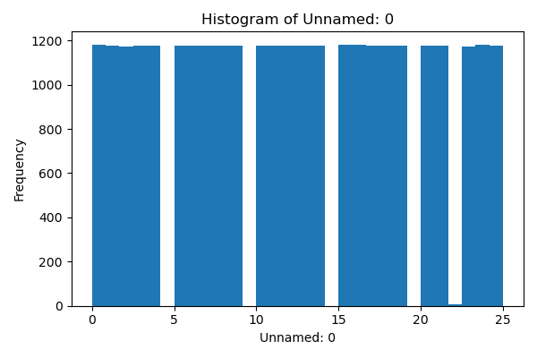
Boxplot:
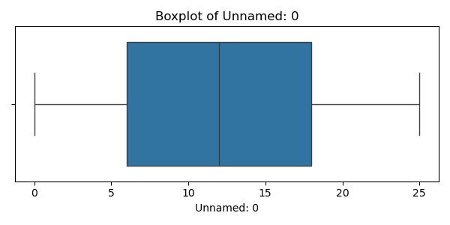

BrandName
Top categories:
Vastranand: 1467
Zink London: 917
Global Desi: 889
Stop: 879
Enamor: 789
Janasya: 747
And: 709
Faballey: 646
W: 627
Life: 625
Histogram:
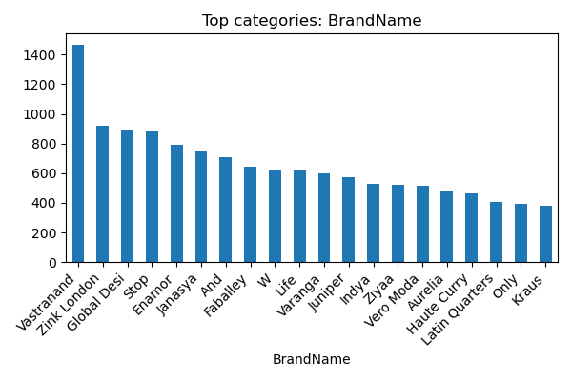

Deatils
Top categories:
Synthetic Womens Casual Sandals - Black: 35
Alloy Metal Gold Color Western Womens Earrings: 27
Structured Zari Silk Blend Festive Wear Womens Regular Saree - Green: 24
Solid Zari Silk Blend Festive Wear Womens Regular Saree - Black: 24
Structured Zari Silk Blend Festive Wear Womens Regular Saree - Pink: 23
Solid Zari Cotton Blend Festive Wear Womens Regular Saree - Cream: 22
Solid Zari Linen Festive Wear Womens Regular Saree - Green: 21
Synthetic Womens Casual Slides - Black: 21
Kanchipuram Weave Zari Border And Rich Zari Pallu With Contrast Blouse Piece - Multi: 21
Solid Zari Silk Blend Festive Wear Womens Regular Saree - Grey: 21
Histogram:
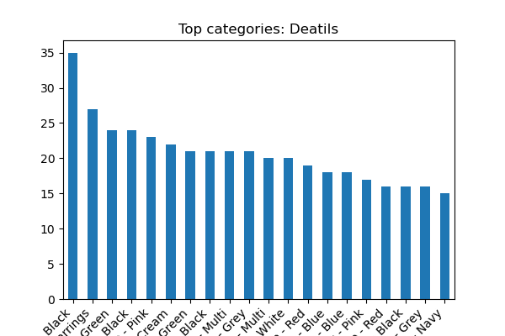

Sizes
Top categories:
Nan: 6201
Size:Large,Medium,Small,X-Large,X-Small: 1970
Size:Large,Medium,Small,X-Large: 1615
Size:Large,Medium,Small,X-Large,X-Small,Xx-Large: 1505
Size:Large,Medium,Small,X-Large,Xx-Large: 1441
Size:Large,Medium,Small,X-Large,Xx-Large,Xxx-Large: 738
Size:Large,Medium,Small,X-Small: 593
Size:Small: 590
Size:Large,Medium,Small: 414
Size:36,37,38,39,40,41: 366
Histogram:
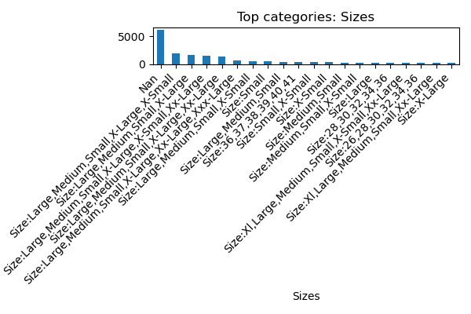

MRP
Top categories:
Nan: 7014
Rs 1499: 925
Rs 1999: 918
Rs 999: 876
Rs 1299: 854
Rs 2499: 693
Rs 1699: 643
Rs 1599: 618
Rs 2999: 584
Rs 1799: 562
Histogram:
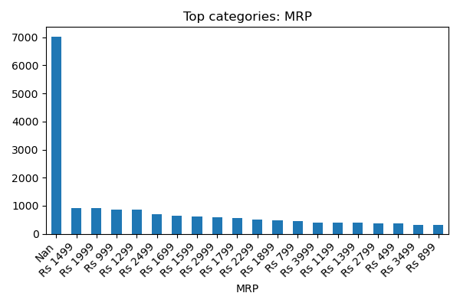

SellPrice
Numeric column — count=29427, mean=1925.170, std=3056.196, min=74.0, 25%=749.0, 50%=1200.0, 75%=2069.0, max=142500.0
Histogram:
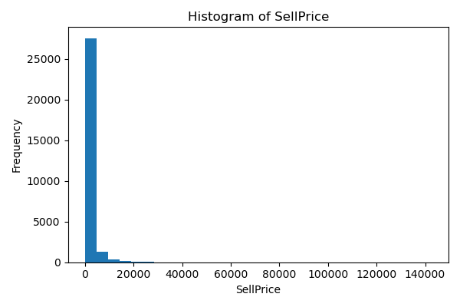
Boxplot:
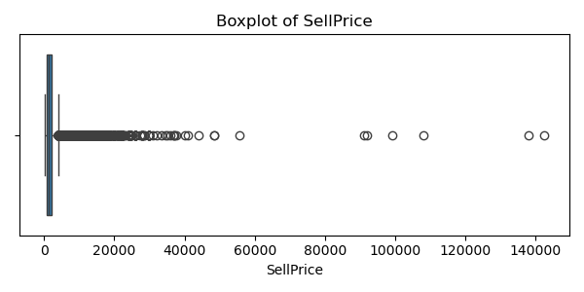

Discount
Top categories:
50% Off: 7557
Nan: 7014
30% Off: 2749
60% Off: 2634
40% Off: 2186
20% Off: 1786
55% Off: 1460
65% Off: 712
70% Off: 580
45% Off: 523
Histogram:
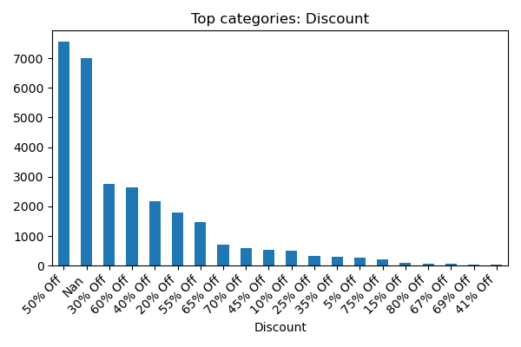

Category
Top categories:
Westernwear-Women: 9962
Indianwear-Women: 9858
Lingerie&Nightwear-Women: 3222
Footwear-Women: 2466
Watches-Women: 1725
Jewellery-Women: 1718
Fragrance-Women: 476
Histogram:
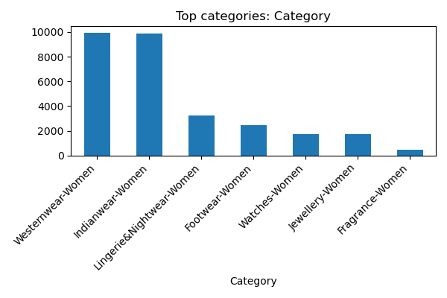

5. Bivariate Analysis (highlights)

SellPrice by Unnamed: 0
Group stats for numeric column 'SellPrice' by category 'Unnamed: 0':
Unnamed: 0 count mean median std
15 1181 1802.644369 1199.0 2273.905731
16 1180 2089.373729 1259.0 3104.723123
0 1179 1966.847328 1259.0 2743.619632
24 1179 1900.448685 1199.0 2652.820671
18 1178 1814.231749 1123.0 2410.487749
6 1178 1952.609508 1299.0 2733.807813
8 1178 1934.910017 1139.0 3969.275883
1 1178 1953.803056 1199.0 2945.372449
11 1177 1847.709431 1249.0 2408.714870
14 1177 1960.299915 1280.0 3631.202543
Plot:
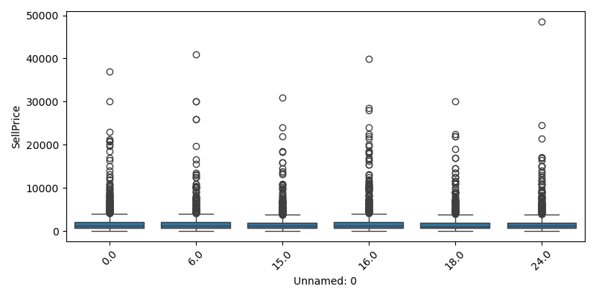

SellPrice by Category
Group stats for numeric column 'SellPrice' by category 'Category':
Category count mean median std
Westernwear-Women 9962 1318.528207 1100.0 841.612358
Indianwear-Women 9858 1480.151856 1299.0 1003.207039
Lingerie&Nightwear-Women 3222 918.534140 719.0 665.668380
Footwear-Women 2466 2197.744931 1679.5 1634.799816
Watches-Women 1725 8653.926377 6349.0 9076.159861
Jewellery-Women 1718 2171.334109 998.0 2960.699848
Fragrance-Women 476 3966.243697 3975.0 2727.818065
Plot:
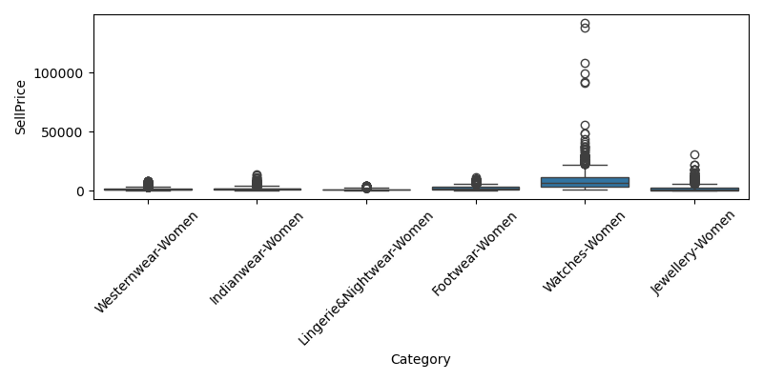

crosstab_Unnamed: 0_vs_Category
Crosstab Unnamed: 0 x Category (top rows):
Category Footwear-Women Fragrance-Women Indianwear-Women Jewellery-Women Lingerie&Nightwear-Women Watches-Women Westernwear-Women
Unnamed: 0
0 99 19 396 69 129 69 398
1 99 19 395 68 129 69 399
2 99 19 390 69 129 69 399
3 99 19 394 69 128 69 399
4 98 19 394 69 129 69 398
5 99 19 394 68 128 69 399
6 99 19 394 69 129 69 399
7 99 19 393 69 129 69 399
8 98 19 396 69 129 69 398
9 98 19 394 67 129 69 399
Plot:
