Automated EDA Report: cancer_data_denmark
Generated: 2025-11-24 14:54:26

1. Dataset Summary
Original shape: (3000, 25)
After cleaning shape: (3000, 25)
Duplicates dropped: 0

2. Detected Column Types
Numeric (5): Patient_ID, Age, Tumor_Size_cm, BMI, Survival_Months
Categorical (16): Gender, Region, Cancer_Type, Stage, Treatment_Type, Lymph_Nodes_Examined, Lymph_Nodes_Positive, Metastasis, Genetic_Mutation, Smoking_Status, Alcohol_Consumption, Comorbidities, Family_History, Relapse, Occupation, Income_Level
Datetime (4): Diagnosis_Date, Treatment_Start_Date, Treatment_End_Date, Followup_Date
Other (0): None

3. Missing Values & Imputation
Column | Missing Count | Missing % | Imputed With
Patient_ID | 0 | 0.0
Age | 0 | 0.0
Gender | 0 | 0.0
Region | 0 | 0.0
Cancer_Type | 0 | 0.0
Stage | 0 | 0.0
Diagnosis_Date | 0 | 0.0
Treatment_Type | 0 | 0.0
Treatment_Start_Date | 0 | 0.0
Treatment_End_Date | 0 | 0.0
Tumor_Size_cm | 0 | 0.0
Lymph_Nodes_Examined | 0 | 0.0
Lymph_Nodes_Positive | 0 | 0.0
Metastasis | 0 | 0.0
Genetic_Mutation | 789 | 26.3 | categorical_mode
Smoking_Status | 0 | 0.0
Alcohol_Consumption | 998 | 33.27 | categorical_mode
BMI | 0 | 0.0
Comorbidities | 606 | 20.2 | categorical_mode
Family_History | 0 | 0.0
Survival_Months | 0 | 0.0
Relapse | 0 | 0.0
Occupation | 0 | 0.0
Income_Level | 0 | 0.0
Followup_Date | 0 | 0.0

4. Univariate Analysis (highlights)

Patient_ID
Numeric column — count=3000, mean=1500.500, std=866.170, min=1.0, 25%=750.75, 50%=1500.5, 75%=2250.25, max=3000.0
Histogram:
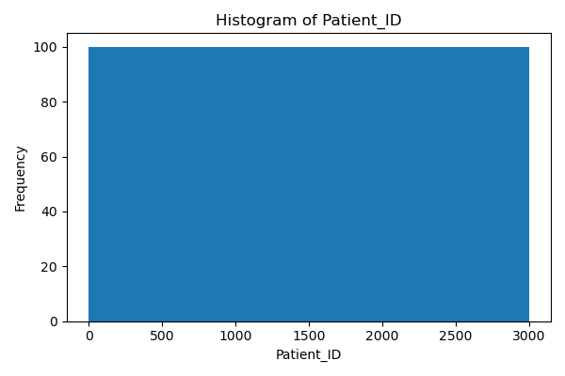
Boxplot:
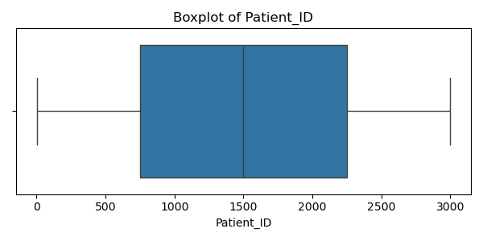

Age
Numeric column — count=3000, mean=53.698, std=20.872, min=18.0, 25%=35.0, 50%=54.0, 75%=72.0, max=89.0
Histogram:
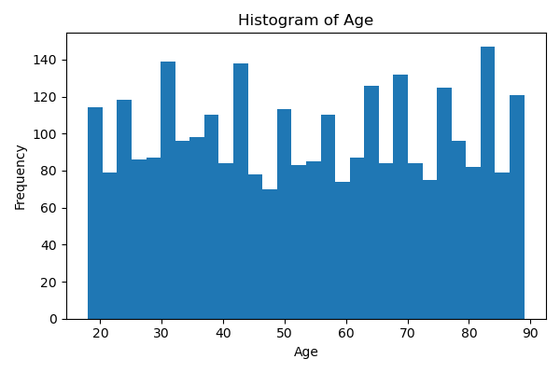
Boxplot:
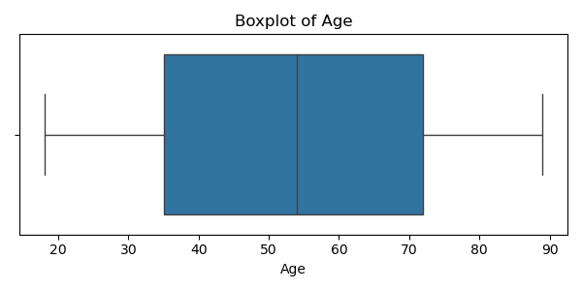

Gender
Top categories:
Male: 1548
Female: 1452
Histogram:
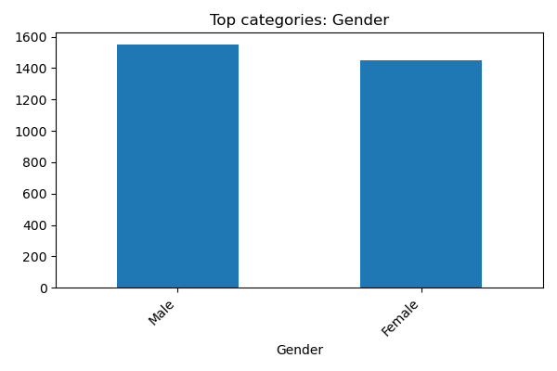

Region
Top categories:
Midtjylland: 624
Nordjylland: 621
Sjælland: 604
Hovedstaden: 581
Syddanmark: 570
Histogram:
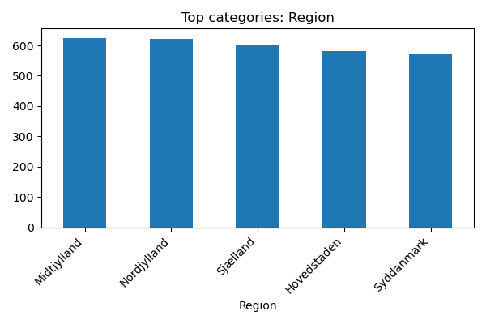

Cancer_Type
Top categories:
Lung: 514
Leukemia: 510
Breast: 507
Colon: 506
Prostate: 488
Skin: 475
Histogram:
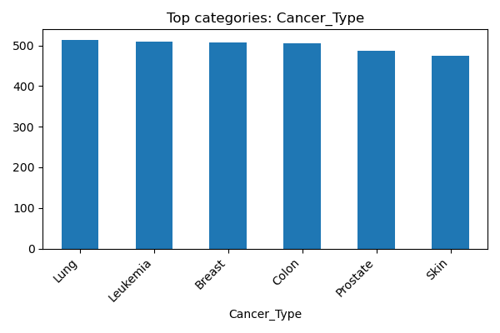

Stage
Top categories:
III: 769
I: 755
IV: 753
II: 723
Histogram:
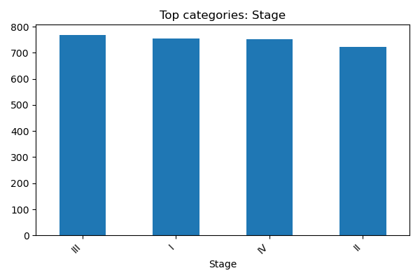

Diagnosis_Date
Top categories:
2017-01-21 00:00:00: 6
2018-04-27 00:00:00: 5
2023-11-10 00:00:00: 5
2019-03-31 00:00:00: 5
2015-05-24 00:00:00: 5
2024-10-26 00:00:00: 5
2019-01-27 00:00:00: 4
2025-03-12 00:00:00: 4
2022-05-14 00:00:00: 4
2015-07-30 00:00:00: 4
Histogram:
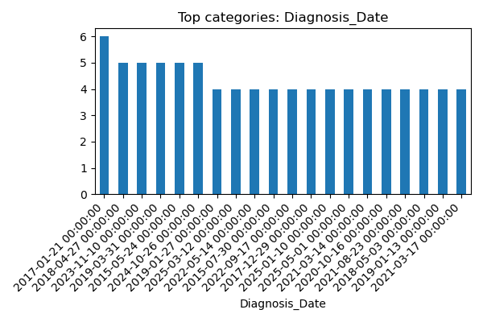

Treatment_Type
Top categories:
Immunotherapy: 612
Chemotherapy: 611
Surgery: 597
Radiation: 594
Hormone Therapy: 586
Histogram:
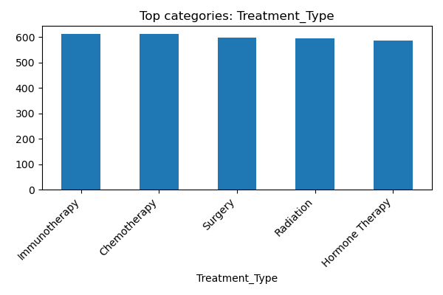

Treatment_Start_Date
Top categories:
2025-05-22 00:00:00: 9
2025-05-17 00:00:00: 8
2025-05-12 00:00:00: 8
2025-05-18 00:00:00: 8
2025-04-27 00:00:00: 8
2025-05-01 00:00:00: 8
2025-04-21 00:00:00: 8
2025-05-09 00:00:00: 8
2025-04-07 00:00:00: 7
2024-12-21 00:00:00: 7
Histogram:
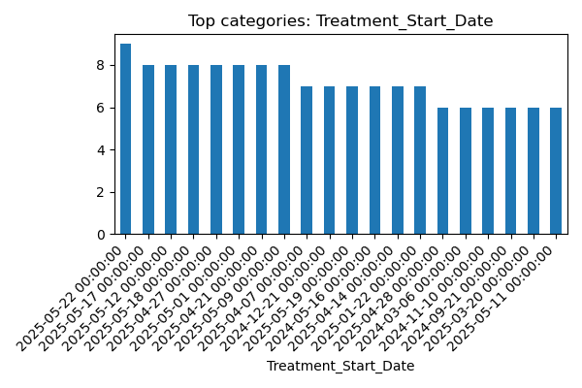

Treatment_End_Date
Top categories:
2025-05-22 00:00:00: 45
2025-05-18 00:00:00: 26
2025-05-19 00:00:00: 23
2025-05-21 00:00:00: 20
2025-05-14 00:00:00: 18
2025-05-12 00:00:00: 18
2025-05-20 00:00:00: 17
2025-05-17 00:00:00: 17
2025-05-06 00:00:00: 17
2025-05-16 00:00:00: 17
Histogram:
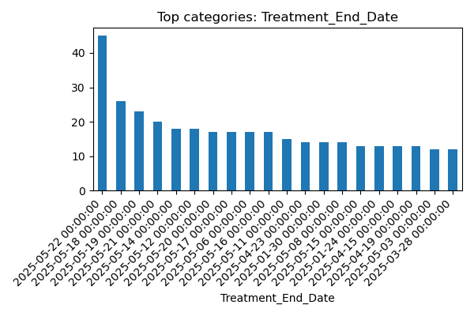

Tumor_Size_cm
Numeric column — count=3000, mean=5.224, std=2.719, min=0.5, 25%=2.94, 50%=5.23, 75%=7.512499999999999, max=10.0
Histogram:
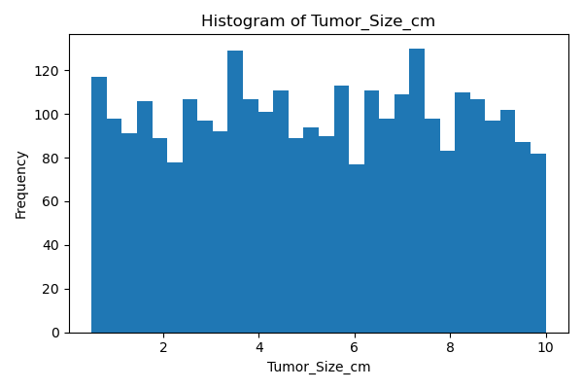
Boxplot:
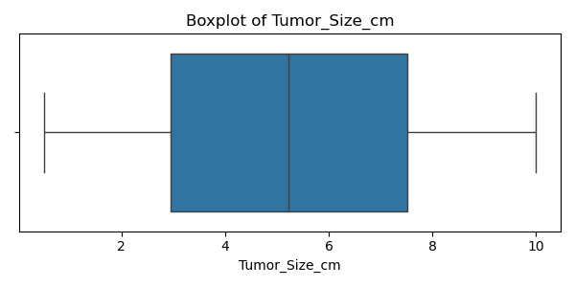

Lymph_Nodes_Examined
Top categories:
16: 181
12: 166
3: 161
6: 157
1: 157
15: 156
14: 154
2: 153
5: 153
8: 151
Histogram:
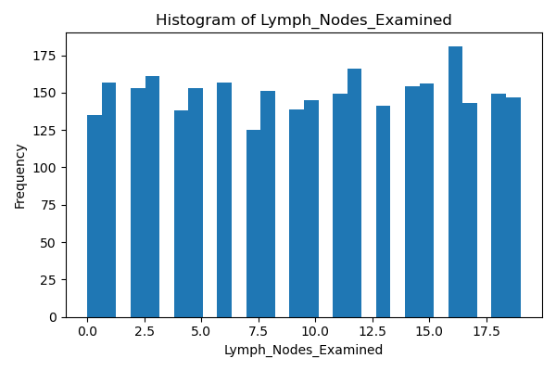
Boxplot:
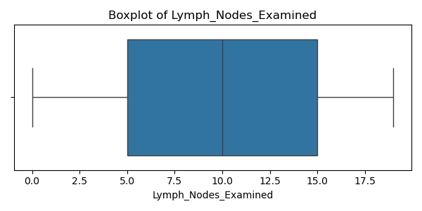

Lymph_Nodes_Positive
Top categories:
0: 548
1: 391
2: 300
3: 262
4: 216
5: 190
6: 175
7: 152
8: 149
9: 106
Histogram:
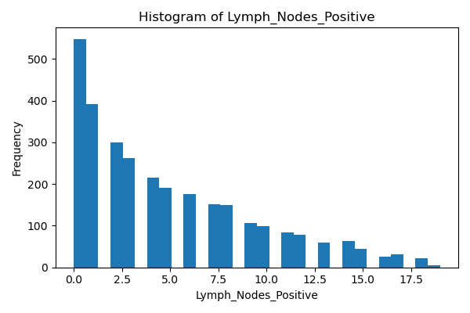
Boxplot:
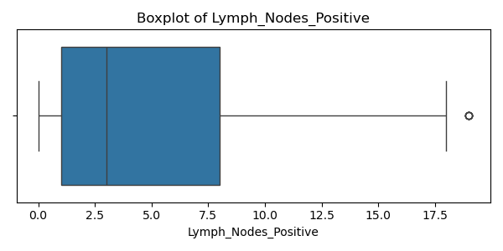

Metastasis
Top categories:
Yes: 1506
No: 1494
Histogram:
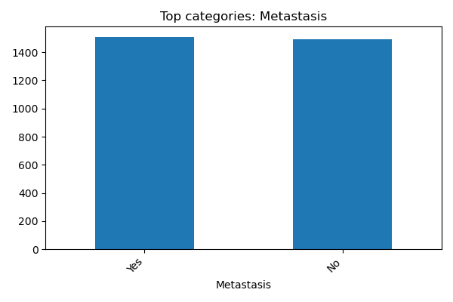

Genetic_Mutation
Top categories:
BRCA2: 1543
TP53: 743
BRCA1: 714
Histogram:
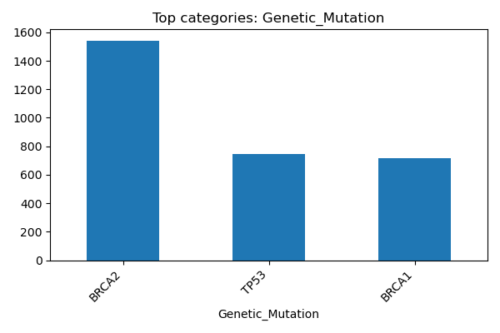

Smoking_Status
Top categories:
Never: 1032
Former: 991
Current: 977
Histogram:
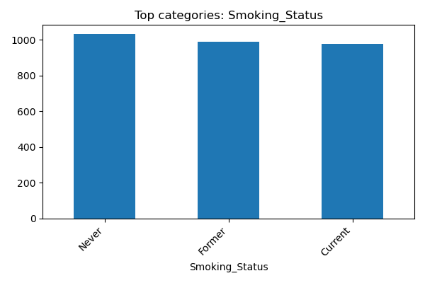

Alcohol_Consumption
Top categories:
Moderate: 2001
Heavy: 999
Histogram:
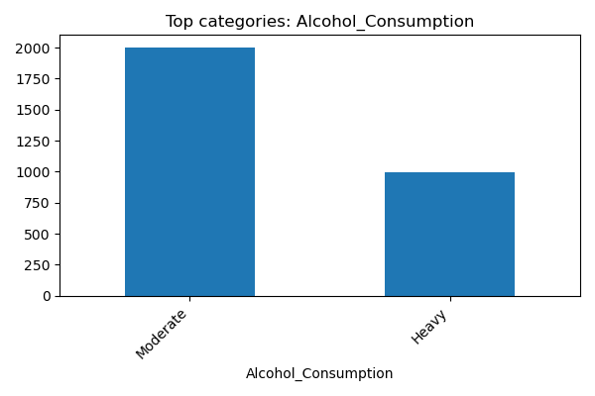

BMI
Numeric column — count=3000, mean=25.050, std=5.071, min=9.8, 25%=21.5, 50%=25.1, 75%=28.6, max=44.3
Histogram:
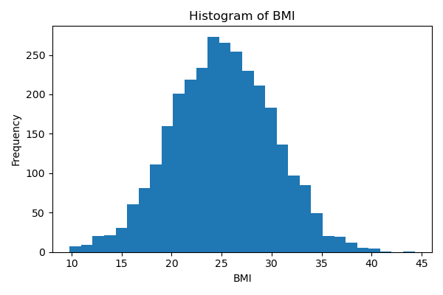
Boxplot:
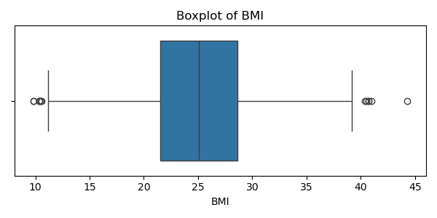

Comorbidities
Top categories:
Cardiovascular: 1233
Hypertension: 617
Multiple: 584
Diabetes: 566
Histogram:
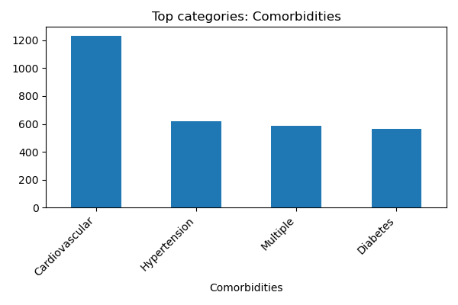

Family_History
Top categories:
Yes: 1516
No: 1484
Histogram:
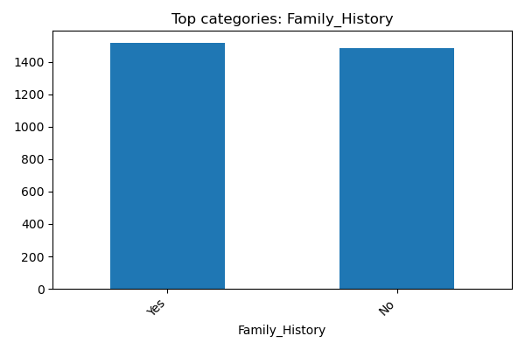

Survival_Months
Numeric column — count=3000, mean=59.478, std=33.988, min=1.0, 25%=30.0, 50%=59.0, 75%=88.0, max=119.0
Histogram:
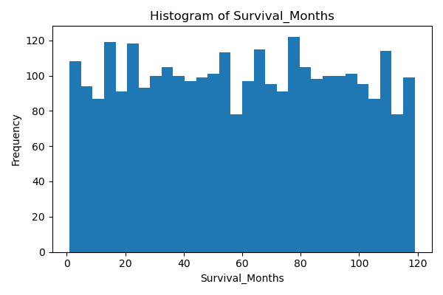
Boxplot:
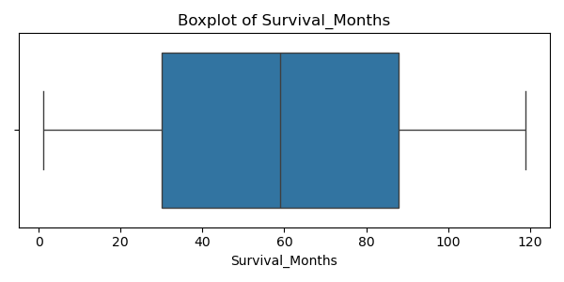

Relapse
Top categories:
Yes: 1501
No: 1499
Histogram:
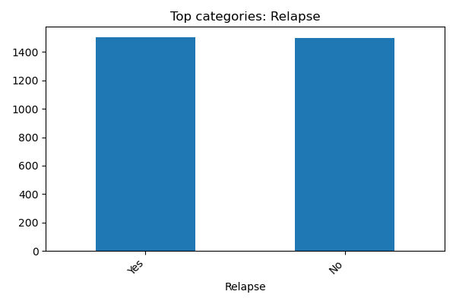

Occupation
Top categories:
Unemployed: 621
Healthcare: 610
Office Worker: 603
Manual Labor: 584
Retired: 582
Histogram:
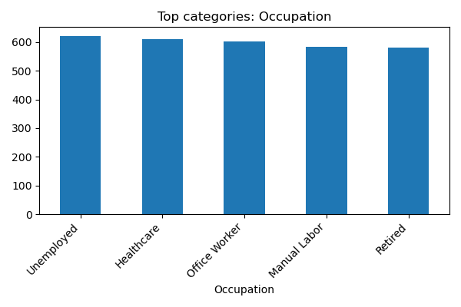

Income_Level
Top categories:
Medium: 1021
High: 1001
Low: 978
Histogram:
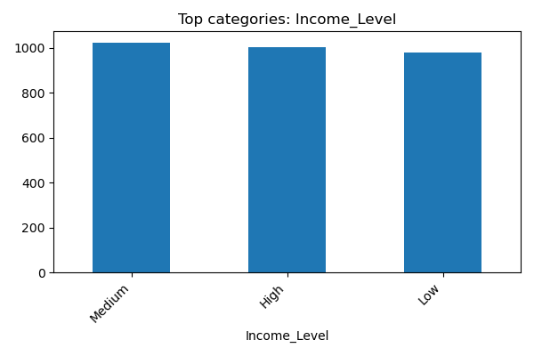

Followup_Date
Top categories:
2025-05-22 00:00:00: 100
2025-05-20 00:00:00: 65
2025-05-19 00:00:00: 58
2025-05-21 00:00:00: 54
2025-05-18 00:00:00: 42
2025-05-17 00:00:00: 35
2025-05-12 00:00:00: 35
2025-05-16 00:00:00: 31
2025-05-15 00:00:00: 29
2025-05-13 00:00:00: 27
Histogram:
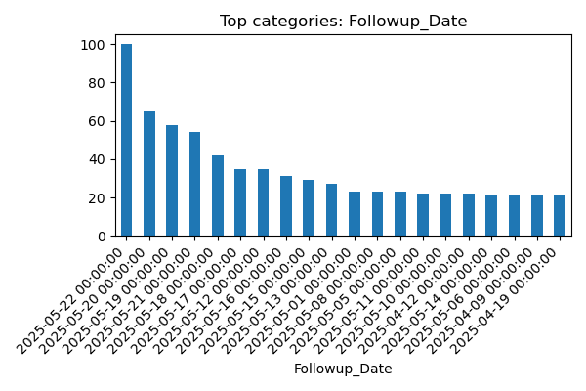

5. Bivariate Analysis (highlights)

Numeric Correlation Matrix
Pearson correlation matrix for numeric columns
Plot:
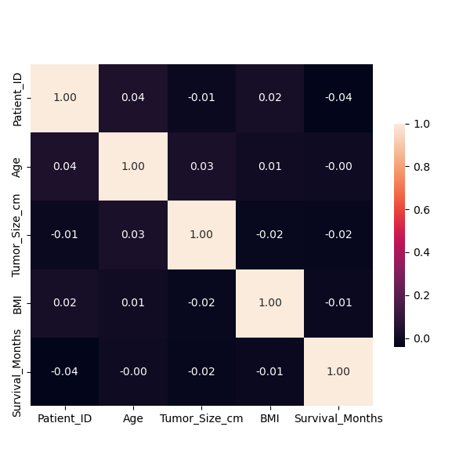

Survival_Months vs Patient_ID
Scatter: correlation -0.040
Plot:
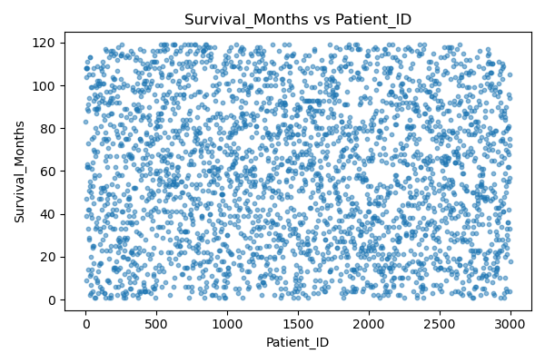

Age vs Patient_ID
Scatter: correlation 0.039
Plot:
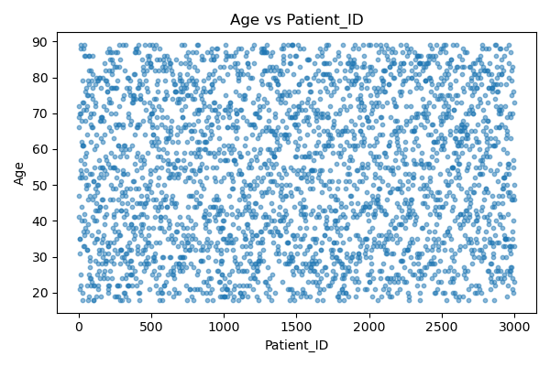

Tumor_Size_cm vs Age
Scatter: correlation 0.031
Plot:
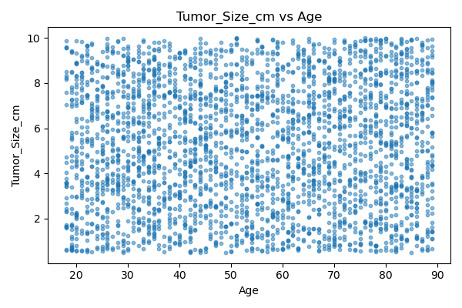

Survival_Months vs Tumor_Size_cm
Scatter: correlation -0.023
Plot:
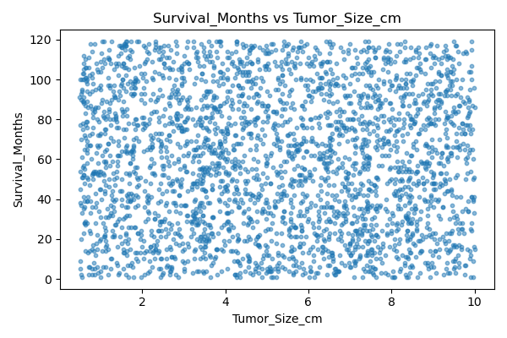

BMI vs Patient_ID
Scatter: correlation 0.021
Plot:
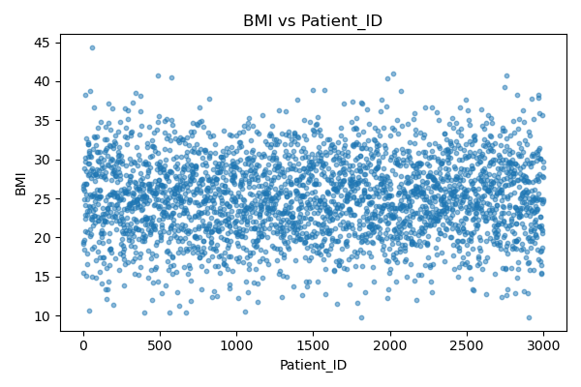

Tumor_Size_cm vs BMI
Scatter: correlation -0.016
Plot:
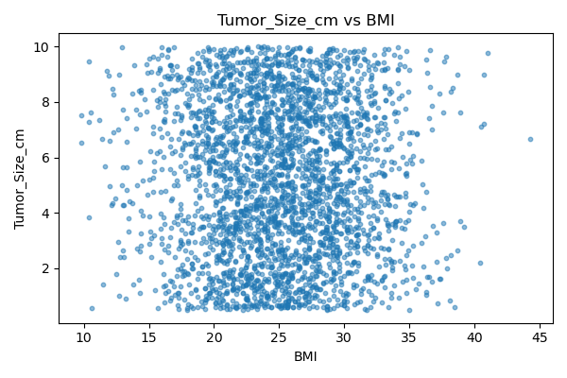

Patient_ID by Gender
Group stats for numeric column 'Patient_ID' by category 'Gender':
Gender count mean median std
Male 1548 1483.465116 1459.0 869.110103
Female 1452 1518.661157 1535.5 862.952759
Plot:
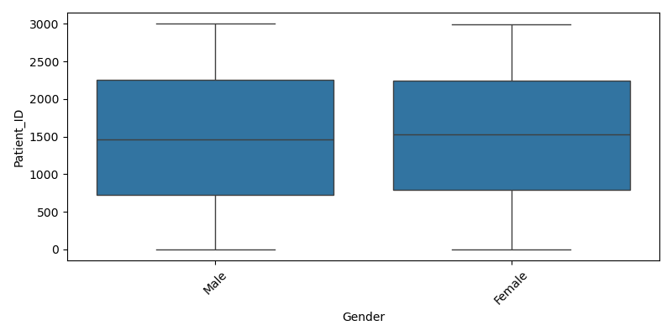

Age by Gender
Group stats for numeric column 'Age' by category 'Gender':
Gender count mean median std
Male 1548 53.326873 53.0 20.539784
Female 1452 54.094353 55.0 21.220221
Plot:
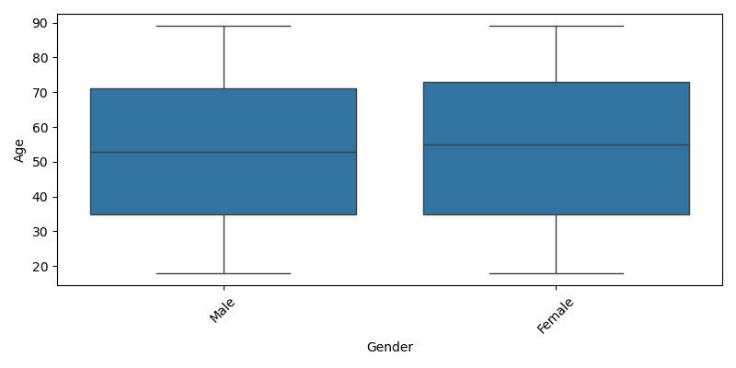

Tumor_Size_cm by Gender
Group stats for numeric column 'Tumor_Size_cm' by category 'Gender':
Gender count mean median std
Male 1548 5.265891 5.275 2.732600
Female 1452 5.179766 5.175 2.703978
Plot:
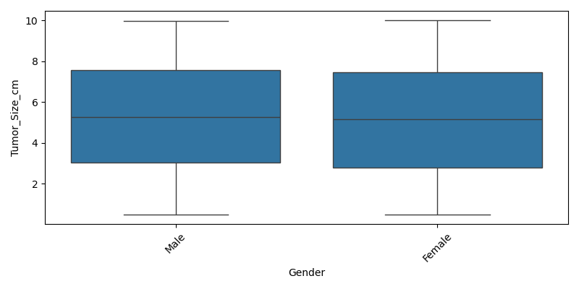

BMI by Gender
Group stats for numeric column 'BMI' by category 'Gender':
Gender count mean median std
Male 1548 24.97823 24.9 4.963429
Female 1452 25.12741 25.2 5.183640
Plot:
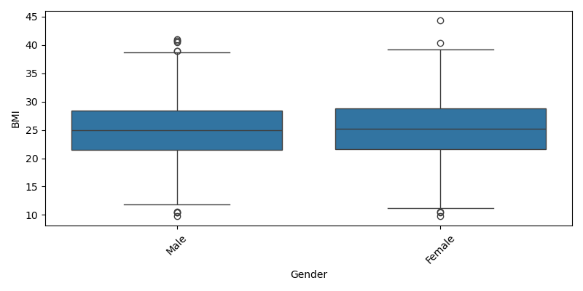

Survival_Months by Gender
Group stats for numeric column 'Survival_Months' by category 'Gender':
Gender count mean median std
Male 1548 60.296512 61.0 33.634090
Female 1452 58.605372 58.0 34.350956
Plot:
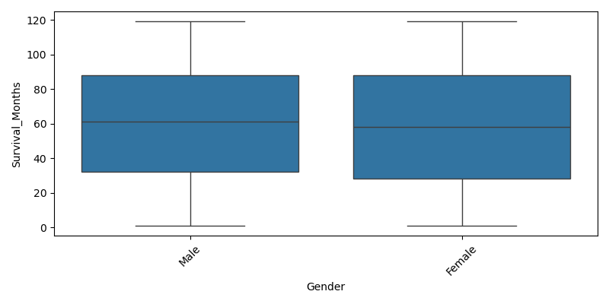

Patient_ID by Region
Group stats for numeric column 'Patient_ID' by category 'Region':
Region count mean median std
Midtjylland 624 1457.918269 1428.5 862.367890
Nordjylland 621 1492.188406 1487.0 862.090326
Sjælland 604 1558.728477 1620.5 845.933119
Hovedstaden 581 1519.089501 1482.0 870.540672
Syddanmark 570 1475.521053 1487.0 890.359713
Plot:
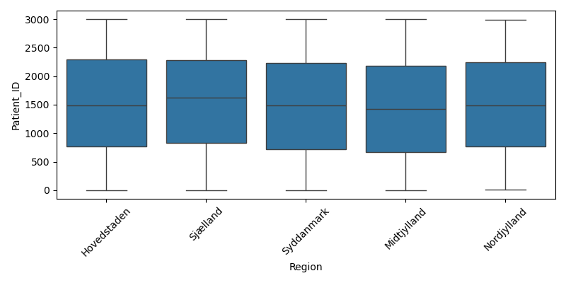

Age by Region
Group stats for numeric column 'Age' by category 'Region':
Region count mean median std
Midtjylland 624 54.932692 55.0 20.618727
Nordjylland 621 53.502415 54.0 20.650441
Sjælland 604 53.456954 53.5 21.212808
Hovedstaden 581 52.898451 53.0 21.298252
Syddanmark 570 53.631579 54.0 20.597602
Plot:
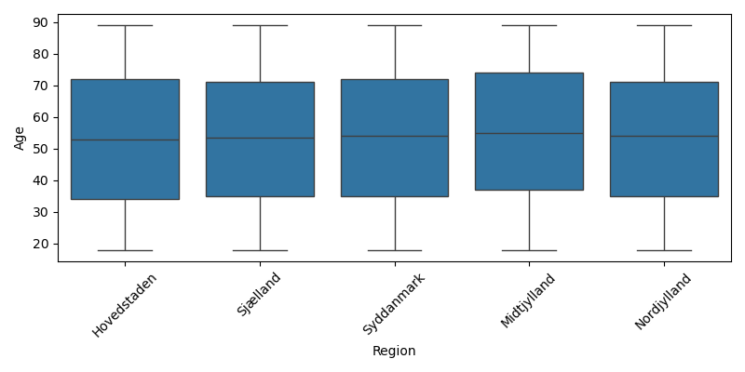

Tumor_Size_cm by Region
Group stats for numeric column 'Tumor_Size_cm' by category 'Region':
Region count mean median std
Midtjylland 624 5.361170 5.380 2.693517
Nordjylland 621 5.036957 4.810 2.740961
Sjælland 604 5.195745 5.275 2.663041
Hovedstaden 581 5.392169 5.470 2.654621
Syddanmark 570 5.137228 5.020 2.834013
Plot:
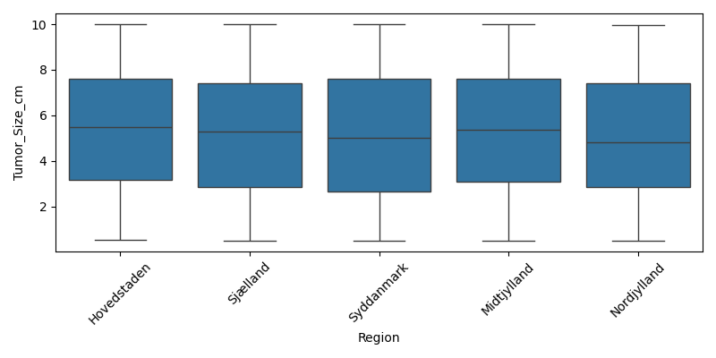

BMI by Region
Group stats for numeric column 'BMI' by category 'Region':
Region count mean median std
Midtjylland 624 24.999679 24.8 4.872832
Nordjylland 621 24.832045 24.7 5.177637
Sjælland 604 25.321026 25.4 4.921254
Hovedstaden 581 25.169191 25.2 5.245681
Syddanmark 570 24.936140 25.1 5.142581
Plot:
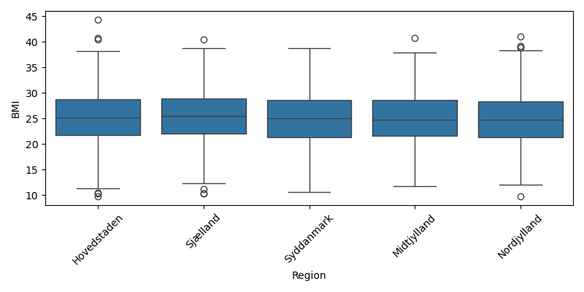

Survival_Months by Region
Group stats for numeric column 'Survival_Months' by category 'Region':
Region count mean median std
Midtjylland 624 58.860577 60.0 34.643260
Nordjylland 621 58.760064 58.0 32.881048
Sjælland 604 59.182119 59.0 34.820839
Hovedstaden 581 61.793460 63.0 33.356311
Syddanmark 570 58.889474 55.0 34.210812
Plot:
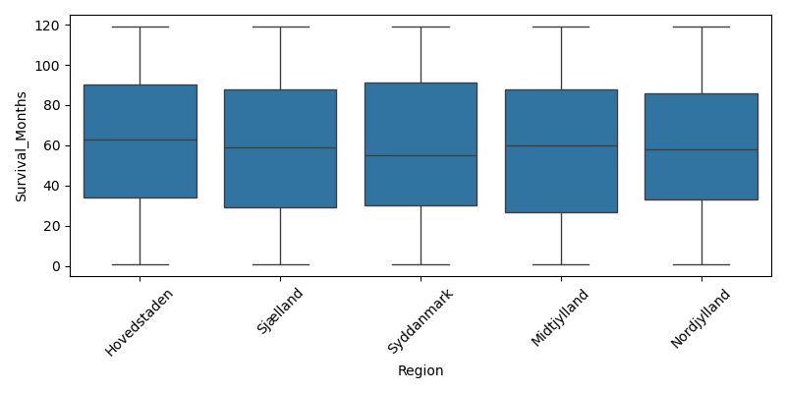

Patient_ID by Cancer_Type
Group stats for numeric column 'Patient_ID' by category 'Cancer_Type':
Cancer_Type count mean median std
Lung 514 1485.169261 1476.5 875.528688
Leukemia 510 1451.272549 1394.0 869.205584
Breast 507 1531.684418 1578.0 849.004448
Colon 506 1527.017787 1519.0 863.151808
Prostate 488 1535.047131 1514.5 865.987575
Skin 475 1472.917895 1508.0 874.948162
Plot:
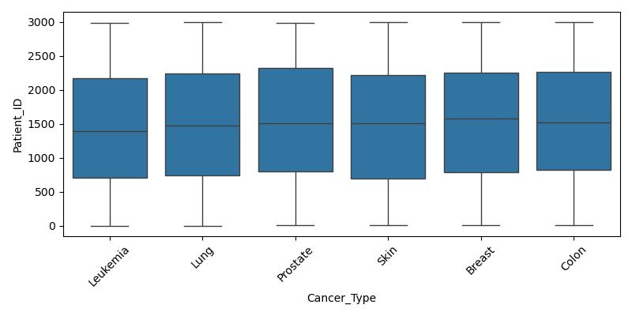

Age by Cancer_Type
Group stats for numeric column 'Age' by category 'Cancer_Type':
Cancer_Type count mean median std
Lung 514 52.891051 53.0 20.695787
Leukemia 510 53.284314 53.0 21.038078
Breast 507 52.873767 53.0 20.671529
Colon 506 53.636364 52.5 21.356803
Prostate 488 54.829918 55.0 20.672715
Skin 475 54.800000 55.0 20.786944
Plot:
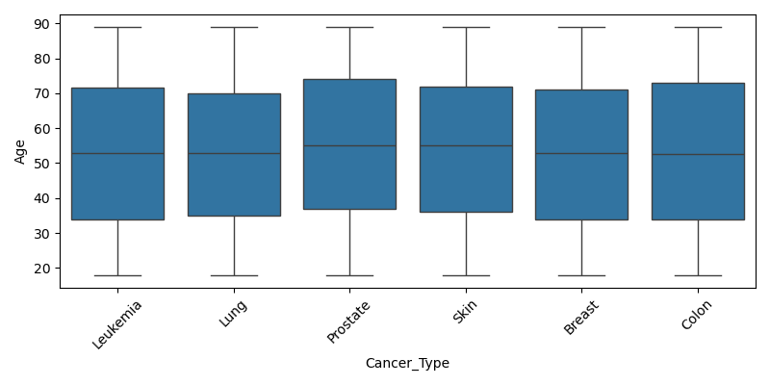

Tumor_Size_cm by Cancer_Type
Group stats for numeric column 'Tumor_Size_cm' by category 'Cancer_Type':
Cancer_Type count mean median std
Lung 514 5.019630 4.780 2.684010
Leukemia 510 5.487235 5.625 2.702231
Breast 507 5.327574 5.320 2.672376
Colon 506 5.165771 5.095 2.751777
Prostate 488 5.232930 5.150 2.728928
Skin 475 5.106126 5.230 2.763093
Plot:
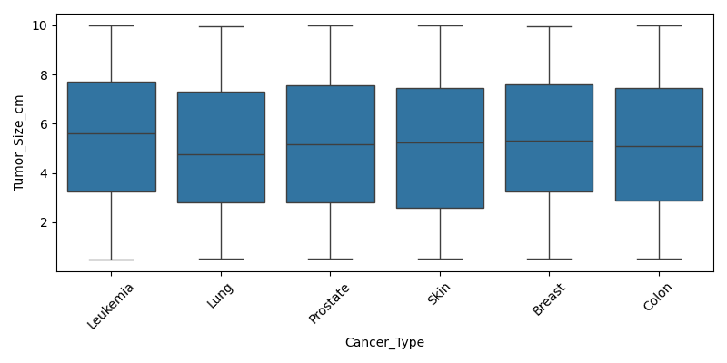

BMI by Cancer_Type
Group stats for numeric column 'BMI' by category 'Cancer_Type':
Cancer_Type count mean median std
Lung 514 25.244163 25.2 5.055765
Leukemia 510 24.792157 24.9 5.240152
Breast 507 25.244379 25.3 4.915055
Colon 506 24.769170 24.8 4.997678
Prostate 488 25.034836 25.1 5.249611
Skin 475 25.226737 25.2 4.955879
Plot:
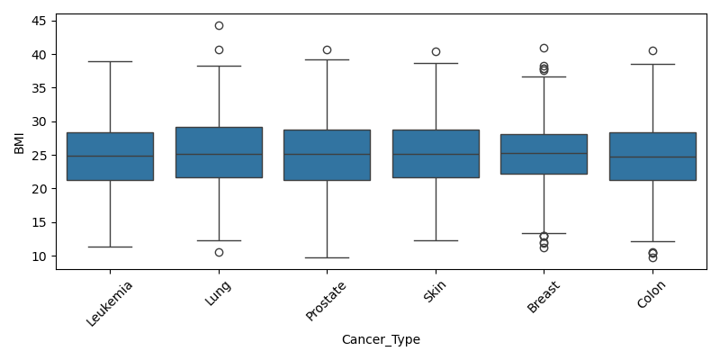

Survival_Months by Cancer_Type
Group stats for numeric column 'Survival_Months' by category 'Cancer_Type':
Cancer_Type count mean median std
Lung 514 61.725681 63.0 33.765165
Leukemia 510 60.413725 60.0 34.220070
Breast 507 60.775148 63.0 33.994081
Colon 506 59.241107 60.0 33.738264
Prostate 488 58.872951 59.0 33.867059
Skin 475 55.530526 51.0 34.181209
Plot:
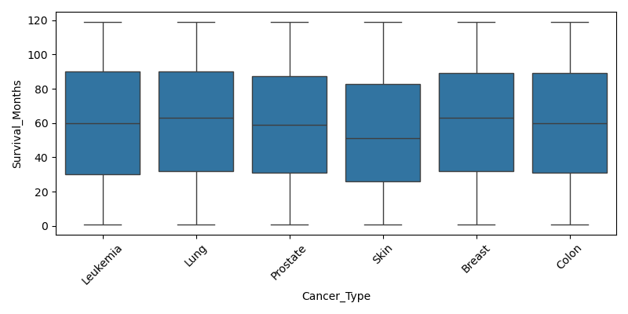

Patient_ID by Stage
Group stats for numeric column 'Patient_ID' by category 'Stage':
Stage count mean median std
III 769 1497.743823 1503.0 881.058985
I 755 1517.961589 1481.0 856.607989
IV 753 1494.354582 1487.0 864.902799
II 723 1491.597510 1534.0 862.981126
Plot:
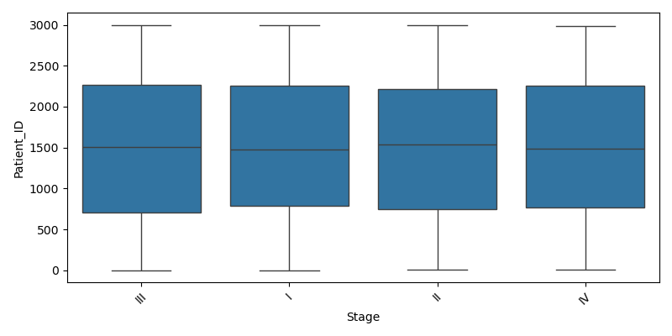

Age by Stage
Group stats for numeric column 'Age' by category 'Stage':
Stage count mean median std
III 769 52.608583 53.0 20.545401
I 755 54.642384 55.0 20.480030
IV 753 54.333333 55.0 20.877853
II 723 53.210235 53.0 21.578756
Plot:
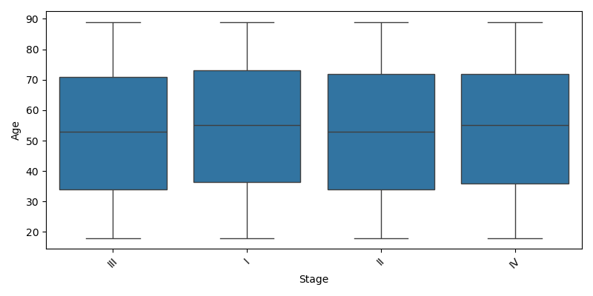

Tumor_Size_cm by Stage
Group stats for numeric column 'Tumor_Size_cm' by category 'Stage':
Stage count mean median std
III 769 5.180546 5.23 2.648976
I 755 5.314477 5.37 2.669144
IV 753 5.150292 5.05 2.776298
II 723 5.253361 5.18 2.784170
Plot:
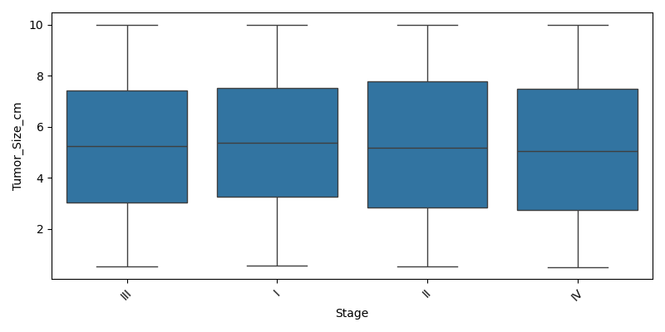

BMI by Stage
Group stats for numeric column 'BMI' by category 'Stage':
Stage count mean median std
III 769 24.927828 25.2 5.026677
I 755 24.889536 24.9 5.075536
IV 753 25.482337 25.4 5.010977
II 723 24.899032 24.9 5.159034
Plot:
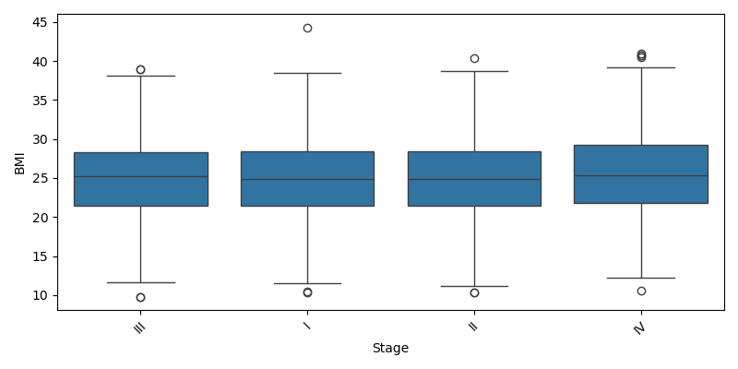

Survival_Months by Stage
Group stats for numeric column 'Survival_Months' by category 'Stage':
Stage count mean median std
III 769 58.014304 58.0 34.302971
I 755 59.529801 58.0 34.265852
IV 753 59.861886 62.0 33.359455
II 723 60.580913 61.0 34.024556
Plot:
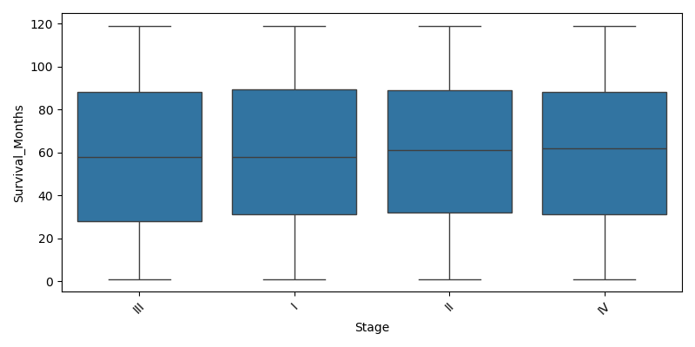

Patient_ID by Treatment_Type
Group stats for numeric column 'Patient_ID' by category 'Treatment_Type':
Treatment_Type count mean median std
Immunotherapy 612 1519.647059 1528.0 873.323906
Chemotherapy 611 1465.487725 1452.0 836.935288
Surgery 597 1471.862647 1477.0 873.404314
Radiation 594 1558.127946 1539.5 859.372582
Hormone Therapy 586 1487.769625 1501.5 887.317003
Plot:
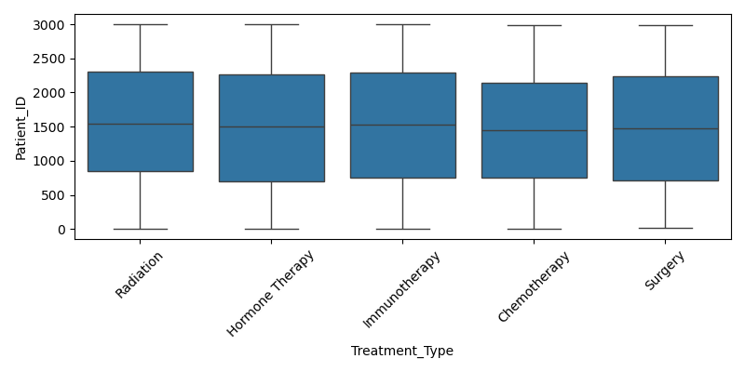

Age by Treatment_Type
Group stats for numeric column 'Age' by category 'Treatment_Type':
Treatment_Type count mean median std
Immunotherapy 612 54.406863 54.0 21.318706
Chemotherapy 611 53.085106 54.0 21.010207
Surgery 597 53.964824 54.0 20.381276
Radiation 594 53.664983 54.0 20.648031
Hormone Therapy 586 53.360068 52.0 21.019691
Plot:
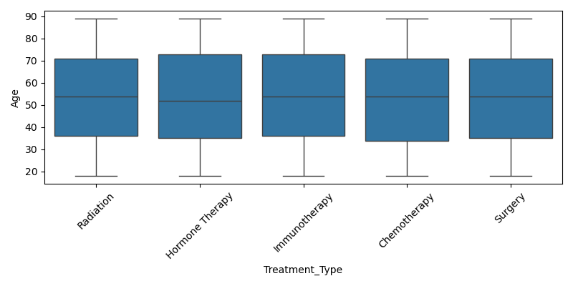

Tumor_Size_cm by Treatment_Type
Group stats for numeric column 'Tumor_Size_cm' by category 'Treatment_Type':
Treatment_Type count mean median std
Immunotherapy 612 5.322958 5.225 2.780130
Chemotherapy 611 5.249198 5.280 2.698407
Surgery 597 5.270436 5.320 2.733401
Radiation 594 5.156195 5.300 2.708251
Hormone Therapy 586 5.116860 5.015 2.673850
Plot:
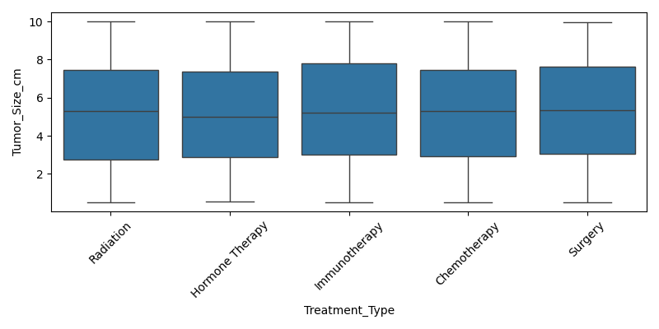

BMI by Treatment_Type
Group stats for numeric column 'BMI' by category 'Treatment_Type':
Treatment_Type count mean median std
Immunotherapy 612 25.216503 25.30 5.034419
Chemotherapy 611 25.051555 24.90 5.148561
Surgery 597 25.002513 25.20 4.911657
Radiation 594 24.977609 25.05 5.069974
Hormone Therapy 586 24.998464 25.00 5.199748
Plot:
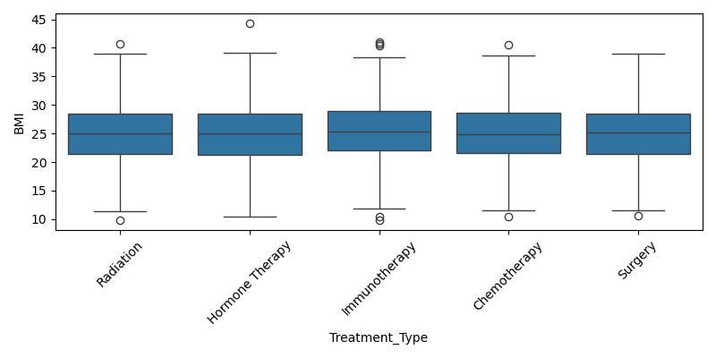

Survival_Months by Treatment_Type
Group stats for numeric column 'Survival_Months' by category 'Treatment_Type':
Treatment_Type count mean median std
Immunotherapy 612 60.563725 62.0 34.718096
Chemotherapy 611 59.144026 58.0 34.031647
Surgery 597 60.326633 61.0 33.573502
Radiation 594 59.092593 59.0 34.195498
Hormone Therapy 586 58.218430 57.5 33.434770
Plot:
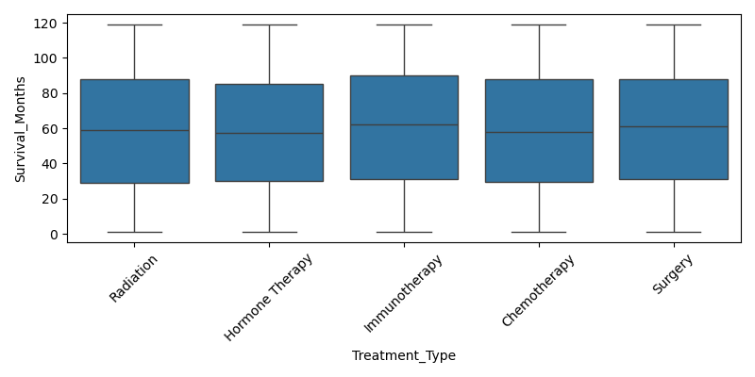

Patient_ID by Lymph_Nodes_Examined
Group stats for numeric column 'Patient_ID' by category 'Lymph_Nodes_Examined':
Lymph_Nodes_Examined count mean median std
16 181 1383.817680 1351.0 901.573486
12 166 1484.692771 1532.5 876.564905
3 161 1420.919255 1423.0 843.529897
6 157 1520.388535 1446.0 853.711757
1 157 1463.840764 1344.0 891.539180
15 156 1503.224359 1397.0 810.418996
14 154 1489.363636 1592.0 906.549602
2 153 1355.836601 1212.0 879.233417
5 153 1444.104575 1502.0 857.032274
8 151 1622.377483 1770.0 812.930548
Plot:
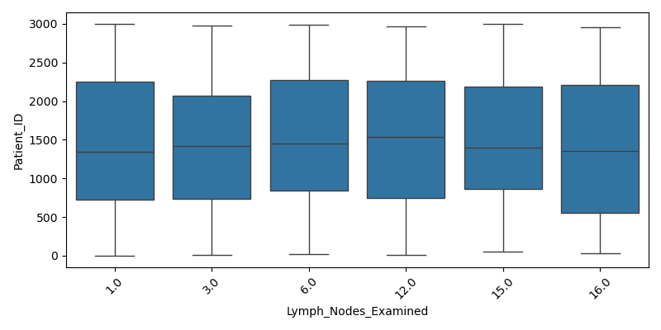

Age by Lymph_Nodes_Examined
Group stats for numeric column 'Age' by category 'Lymph_Nodes_Examined':
Lymph_Nodes_Examined count mean median std
16 181 52.801105 53.0 21.479815
12 166 55.355422 57.0 21.250887
3 161 54.378882 55.0 20.348201
6 157 52.445860 53.0 20.713056
1 157 54.942675 54.0 20.987555
15 156 53.858974 54.0 20.689860
14 154 54.915584 55.0 22.155113
2 153 52.941176 52.0 20.043123
5 153 52.542484 55.0 20.937874
8 151 55.317881 57.0 21.290803
Plot:
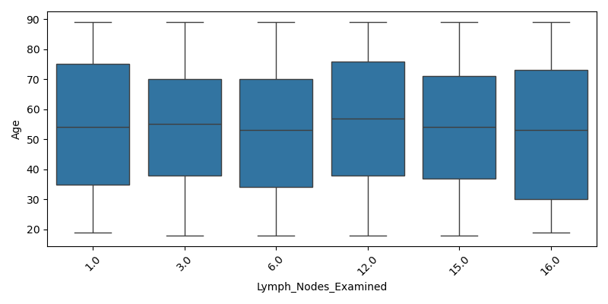

Tumor_Size_cm by Lymph_Nodes_Examined
Group stats for numeric column 'Tumor_Size_cm' by category 'Lymph_Nodes_Examined':
Lymph_Nodes_Examined count mean median std
16 181 4.912044 4.590 2.802332
12 166 5.642229 5.605 2.639761
3 161 5.205963 5.240 2.676934
6 157 4.943694 4.900 2.807306
1 157 5.197134 5.220 2.602994
15 156 5.367756 5.400 2.754925
14 154 5.306169 5.200 2.786458
2 153 5.055425 4.880 2.651749
5 153 4.962418 4.880 2.825308
8 151 5.428212 5.340 2.667691
Plot:
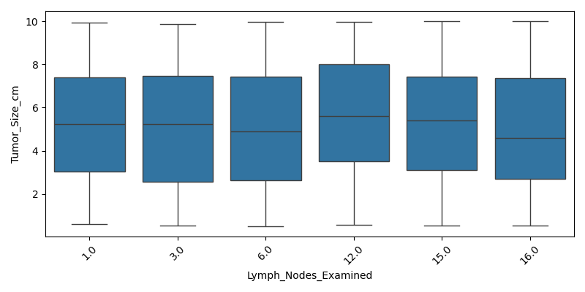

BMI by Lymph_Nodes_Examined
Group stats for numeric column 'BMI' by category 'Lymph_Nodes_Examined':
Lymph_Nodes_Examined count mean median std
16 181 24.941989 25.60 5.255907
12 166 25.012651 24.80 5.167851
3 161 24.608696 24.50 5.505808
6 157 24.989809 25.00 4.666166
1 157 25.640764 25.80 5.604988
15 156 24.762821 24.75 5.247884
14 154 24.811039 24.80 4.992695
2 153 25.698039 25.90 4.786830
5 153 25.263399 25.40 4.878535
8 151 25.447682 25.10 4.871165
Plot:
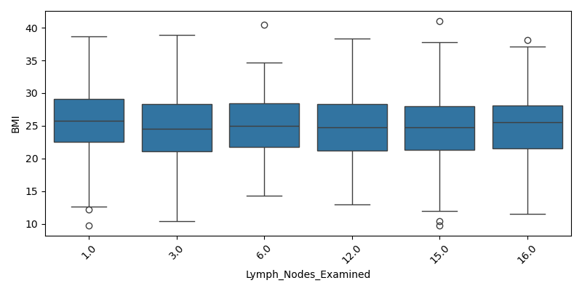

Survival_Months by Lymph_Nodes_Examined
Group stats for numeric column 'Survival_Months' by category 'Lymph_Nodes_Examined':
Lymph_Nodes_Examined count mean median std
16 181 54.817680 53.0 32.462712
12 166 62.469880 65.5 35.504788
3 161 54.695652 56.0 34.096745
6 157 58.815287 58.0 32.610330
1 157 62.420382 64.0 33.457039
15 156 59.397436 59.0 35.061546
14 154 55.032468 48.0 33.686641
2 153 60.738562 64.0 33.616211
5 153 57.300654 56.0 32.715497
8 151 61.728477 66.0 34.641388
Plot:
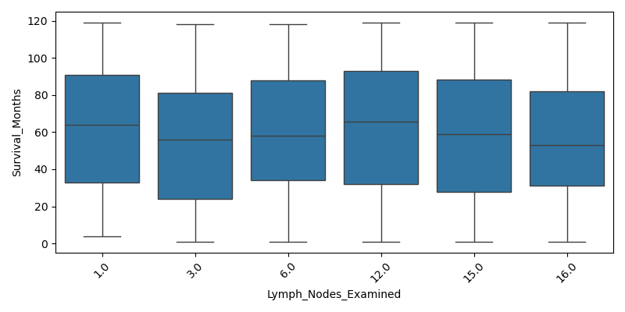

crosstab_Gender_vs_Region
Crosstab Gender x Region (top rows):
Region Hovedstaden Midtjylland Nordjylland Sjælland Syddanmark
Gender
Female 281 295 296 288 292
Male 300 329 325 316 278
Plot:
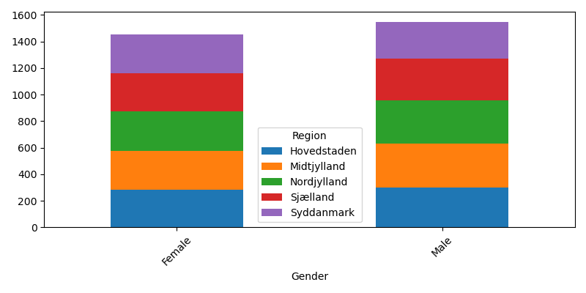

crosstab_Gender_vs_Cancer_Type
Crosstab Gender x Cancer_Type (top rows):
Cancer_Type Breast Colon Leukemia Lung Prostate Skin
Gender
Female 240 237 235 255 229 256
Male 267 269 275 259 259 219
Plot:
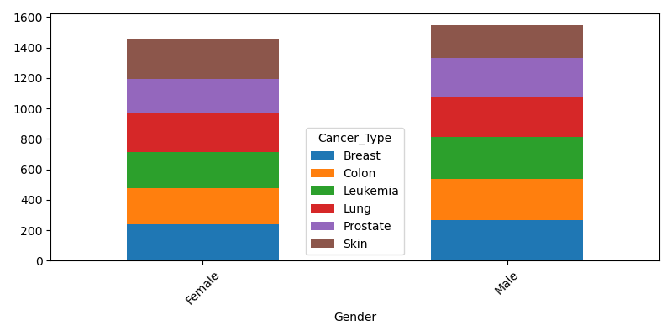

crosstab_Gender_vs_Stage
Crosstab Gender x Stage (top rows):
Stage I II III IV
Gender
Female 380 343 349 380
Male 375 380 420 373
Plot:
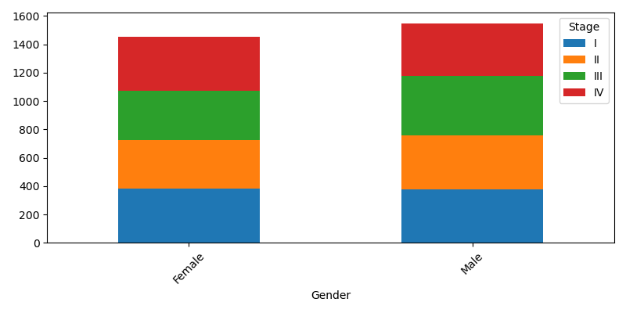

crosstab_Region_vs_Cancer_Type
Crosstab Region x Cancer_Type (top rows):
Cancer_Type Breast Colon Leukemia Lung Prostate Skin
Region
Hovedstaden 100 101 98 105 94 83
Midtjylland 111 110 118 95 97 93
Nordjylland 98 113 100 99 100 111
Sjælland 109 102 94 116 95 88
Syddanmark 89 80 100 99 102 100
Plot:
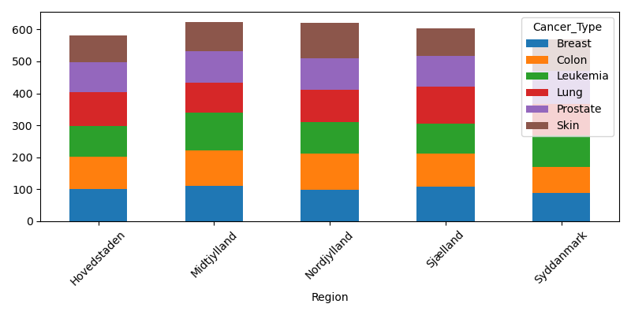

crosstab_Region_vs_Stage
Crosstab Region x Stage (top rows):
Stage I II III IV
Region
Hovedstaden 133 154 155 139
Midtjylland 154 151 162 157
Nordjylland 148 152 152 169
Sjælland 172 146 150 136
Syddanmark 148 120 150 152
Plot:
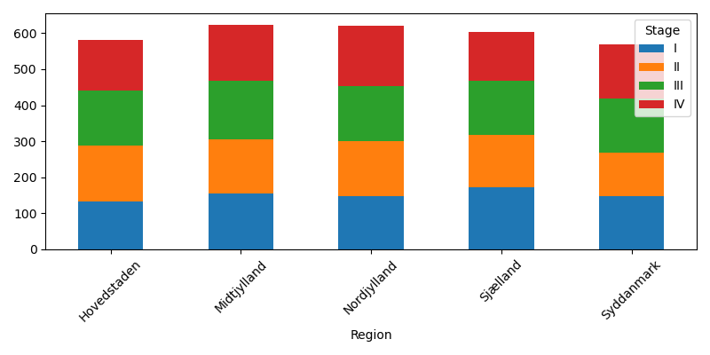

crosstab_Cancer_Type_vs_Stage
Crosstab Cancer_Type x Stage (top rows):
Stage I II III IV
Cancer_Type
Breast 126 118 148 115
Colon 130 122 126 128
Leukemia 125 128 132 125
Lung 132 117 143 122
Prostate 118 117 113 140
Skin 124 121 107 123
Plot:
