Predictive Slack-Aware Adaptive Scheduling for Energy-Constrained Real-Time IoT Systems Using FreeRTOS on ESP32
Tejaswini
Department of Electrical and Electronics Engineering Amrita School of Engineering, Bengaluru
Amrita Vishwa Vidyapeetham, India Email: bl.en.p2ebs25014@bl.students.amrita.edu

Abstract—This paper presents a predictive slack-aware adap-tive scheduling framework implemented on an ESP32 dual-core microcontroller using FreeRTOS for energy-constrained, safety-critical Internet-of-Things (IoT) applications. Conventional static scheduling strategies—Fixed-Priority Preemptive Scheduling and Round-Robin—fail to adapt to dynamic workload variations, environmental disturbances, and battery-level constraints inher-ent in embedded IoT deployments. The proposed framework integrates a moving-average predictive execution model, slack-time optimisation, an event-driven criticality manager, and a workload-aware decision engine into a unified embedded ar-chitecture. Four concurrent FreeRTOS tasks cooperate through queues, binary semaphores, event groups, mutexes, and software timers. Environmental conditions are monitored via an MQ135 gas sensor, an ACS712 current sensor, a resistive voltage divider, and an HC-SR04 ultrasonic sensor. A BO DC motor provides controllable physical workload generation for realistic load vari-ation experiments. All eight RTOS analytics parameters—gas, current, voltage, distance, CPU utilisation, slack time, system health index, and decision score—are streamed live to a Blynk IoT cloud dashboard featuring gauge-style widgets for real-time remote monitoring over Wi-Fi, complemented by Serial Studio Pro for offline waveform analysis. The scheduler dynamically transitions among three operating modes—Normal, Power-Save, and Emergency—based on a quantified decision score. Exper-imental results demonstrate ≈86% idle-state power reduction, sub-2 ms emergency response latency, and stable deadline satis-faction across all tasks. The framework constitutes a replicable and extensible foundation for adaptive RTOS research targeting battery-powered edge-IoT and industrial safety deployments.
Index Terms—FreeRTOS, adaptive scheduling, slack-time opti-misation, predictive execution, energy-aware scheduling, ESP32, real-time systems, IoT, event-driven scheduling, Blynk IoT, Serial Studio, workload-aware RTOS, decision engine, cloud dashboard

- Introduction
The proliferation of IoT devices in industrial, automotive, and consumer environments demands embedded platforms that simultaneously guarantee real-time responsiveness, energy efficiency, and fault resilience [1], [2]. A Real-Time Operating System (RTOS) provides the scheduling substrate for such guarantees; however, conventional static scheduling policies assign fixed priorities and execution windows that perform well only under homogeneous, predictable workloads [3].
Three practical challenges violate static scheduling assump-tions in IoT deployments. First, sensor acquisition times vary with environmental conditions—gas concentration, motor current, and obstacle proximity fluctuate continuously. Sec-ond, physical loads (e.g., a DC motor) cause burst current demands that compete with computational resources. Third, safety-critical events (gas leakage, object proximity) require immediate priority escalation that static assignments cannot accommodate [4], [5].
Adaptive scheduling—wherein the operating system ob-serves system state and modifies execution parameters at run-time—addresses these challenges [6]. Three dimensions of adaptation are particularly impactful: (i) predictive scheduling, which forecasts future execution demand from historical obser-vations; (ii) slack-aware scheduling, which exploits available timing margin to defer non-critical work and activate processor sleep states; and (iii) event-driven scheduling, which responds immediately to safety-critical sensor triggers [7], [8].
Despite considerable research in each sub-area, their inte-gration into a coherent framework running on a commodity microcontroller with real hardware validation and live analyt-ics visualisation remains largely unexplored [9]. This paper addresses that gap. The primary contributions are:
- A unified FreeRTOS adaptive scheduling framework combining predictive execution modelling, slack-time power optimisation, and event-driven criticality manage-ment on a single ESP32 platform.
- A quantitative decision-score engine that maps real-time sensor readings and predicted execution demand onto three operating modes.
- A physical load-variation methodology using a BO DC motor and ACS712 current sensor producing realistic current transients.
- A Blynk IoT cloud dashboard providing real-time re-mote monitoring of all eight RTOS analytics parameters via gauge widgets over Wi-Fi, enabling operator access from any mobile or desktop device.
- Real-time eight-channel RTOS analytics visualisation via Serial Studio Pro, enabling offline waveform analysis of scheduling behaviour.

- Comprehensive experimental characterisation of CPU utilisation, slack time, system health index, and mode-transition latency.

- Literature Review
Kim et al. [1] demonstrated DVFS for energy minimisation in real-time embedded systems, achieving 35% energy savings. Their work required hardware DVFS support unavailable on microcontroller-class devices.
Zheng and Zhu [2] proposed an elastic task model for adaptive IoT gateway scheduling, allowing period expansion under overload without predictive workload estimation. Biondi et al. [3] introduced slack-based resource reclaiming for fixed-priority schedulers; their analysis was purely simulation-based. Gupta et al. [7] showed that interrupt-triggered priority escalation reduces emergency response latency by up to 60% vs. periodic polling. Hassan and Alam [8] demonstrated that light-sleep activation during slack intervals on ESP32 reduces
average current by 28%.
Srinivasan et al. [6] showed that moving-average work-load prediction models achieve >90% accuracy with neg-ligible compute overhead on microcontrollers. Wang et al.
[13] showed predictive slack estimation outperforms reactive detection in energy savings and deadline-miss rate. Nair et al. [14] validated FreeRTOS event groups for criticality-aware scheduling on STM32.
Park et al. [10] benchmarked FreeRTOS vs. RIOT OS on ESP32, confirming FreeRTOS as the preferred choice for deterministic scheduling latency below 10 µs at 240 MHz. Zhao et al. [15] provided quantitative benchmarks for adaptive RTOS frameworks on Cortex-M platforms against which the present work is compared.
Research Gap. The surveyed literature addresses individ-ual scheduling dimensions individually. No prior work inte-grates predictive execution modelling, slack-time optimization, event-driven response, energy-aware execution, and live RTOS analytics visualisation into a single hardware-validated frame-work on a commodity microcontroller.

- Problem Statement
Let a real-time system consist of n periodic tasks T =
{T₁, . . . , T_{n}} with worst-case execution time C_{i}, relative deadline D_{i}, and period P_{i}. Rate-Monotonic Analysis (RMA)
guarantees schedulability under:
- Objectives
- Design an adaptive FreeRTOS scheduling framework on ESP32 that dynamically adjusts task execution based on workload and environment.
- Implement a moving-average predictive execution model for run-time demand forecasting.
- Exploit slack time to activate ESP32 light-sleep for energy reduction.
- Implement an event-driven criticality manager using FreeRTOS event groups.
- Validate three operating modes—Power-Save, Normal, Emergency—with physical hardware including BO mo-tor, LEDs, and buzzer.
- Visualise all eight RTOS analytics channels in real time via Serial Studio Pro for live scheduling observation.
- Proposed Methodology
A. System Overview
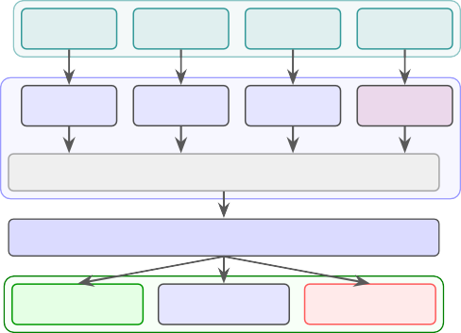
The proposed framework operates as a three-layer pipeline illustrated in Fig. 1: (1) Sensor Acquisition Layer, (2) FreeR-TOS Task Layer with IPC primitives, and (3) Decision and Mode-Switching Engine. The ESP32 dual-core processor hosts four concurrent tasks. Sensor data enters through dedicated ADC channels, is transferred via FreeRTOS queues to a processing pipeline, and is evaluated by the SchedulerTask, which implements the adaptive decision engine.
Sensor
MQ135
Gas
ACS712
Current
Voltage Sensor
HC-SR04
Ultrasonic
Sensor Task P=3
Process Task P=2
Comm Task P=1
Sched Task P=4
TOS
Queues | Semaphores | Mutexes | Event Groups | Timers

Decision Engine / Adaptive Scheduler
cision
Normal Mode Green LED
Power-Save Blue LED
Emergency Red+Buzzer

R

De

Fig. 1: Three-layer system architecture: sensor acquisition, FreeRTOS task layer with IPC primitives, and adaptive de-cision engine.

- Hardware Design

U = Σ
n
Ci ≤ n
21/n − 1
. (1)
- Component Summary

This assumes C_{i}
i
P
i=1
is constant and no external event alters pri-
Table I lists all hardware components with roles and GPIO assignments. The ESP32-WROOM-32D operates at 240 MHz with a 12-bit ADC.

orities at run-time—both assumptions fail in IoT deployments
where sensor acquisition times vary and safety events require immediate escalation. The research objective is to design a policy S that: (a) predicts C_{i} from history, (b) exploits slack to minimise energy, and (c) responds to criticality events within bounded latency.
- Hardware Block Diagram
- Sensor Thresholds
Table II summarises all sensor operating ranges and alert thresholds used by the decision engine.

TABLE I: Hardware Components and GPIO Pin Assignments

Component Role GPIO

- Software Design
- Software Stack
The firmware is developed in Embedded C/C++ within the Arduino IDE using ESP-IDF v5.1 (FreeRTOS v10.4).

ESP32 Dev
Module MQ135 Gas
Sensor
ACS712 (5 A)
Voltage Di-vider
HC-SR04
Ultrasonic
RTOS host, ADC, Wi-Fi
Air quality / gas detection
Load current mon-itoring
Battery voltage sensing
Obstacle proximity detection
—

GPIO34 (ADC) GPIO35 (ADC) GPIO32 (ADC)
GPIO5/GPIO18
The software stack comprises five layers: Arduino IDE for development; the ESP32 SDK providing ADC, GPIO, Wi-Fi, and light-sleep peripheral drivers; the FreeRTOS kernel for multitasking and IPC; the Blynk IoT platform for cloud-based real-time remote dashboard monitoring; and Serial Studio Pro for local waveform analysis and offline RTOS analytics visualisation. Tasks are statically allocated with 4096-word stacks and pinned to Core 0; the scheduler tick period is 1 ms.

Red LED Emergency mode
indicator
Green LED Normal mode indi-cator
Blue LED Power-save mode
indicator
Buzzer Emergency audio alert
GPIO25 GPIO26 GPIO27
GPIO14
The ESP32 connects to the Blynk cloud server over Wi-Fi using the BlynkTimer library. Eight virtual pins (V0–V7) map directly to the eight RTOS analytics parameters and are updated at 500 ms intervals within the SchedulerTask execution loop. The Blynk mobile and web dashboard displays all parameters as gauge widgets with configurable min/max

Manual Switch
BO DC Mo-
tor
Li-ion Battery
Manual emergency trigger
Dynamic load gen-eration
Portable 3.7 V sup-ply
GPIO4

Ext. switch Power rail
ranges, enabling remote operator monitoring without any serial
connection.
Table III lists the Blynk virtual pin assignments.
TABLE III: Blynk IoT Virtual Pin Assignments

Virtual Pin Parameter Widget / Range

V0 Gas Sensor (ADC) Gauge, 0–4095
V1 Current Sensor (ADC) Gauge, 0–4095
V2 Voltage (ADC) Gauge, 0–4095
V3 Slack Time (ms) Gauge, 0–200
V4 Decision Score Gauge, 0–300
BO Motor (Load)
Buzzer GPIO14
Red LED GPIO25
Li-ion Battery
Green LED
GPIO26
MQ135 GPIO34
ACS712 GPIO35
ESP32
ADC / GPIO 240 MHz
HC-SR04 GPIO5/18
Voltage GPIO32
Blue LED GPIO27
V5 Distance (cm) Gauge, 0–999
V6 CPU Utilisation (%) Gauge, 0–100
V7 System Health Index Gauge, 0–100

Fig. 2: Hardware block diagram: sensor inputs to ESP32 ADC/GPIO and actuator outputs (LEDs, buzzer) with BO motor dynamic load and Li-ion battery supply.

TABLE II: Sensor Operating Ranges and Alert Thresholds

Sensor | Normal Range | Alert Threshold | Flag
MQ135 (Gas) | 200–450 ADC | >550 ADC | EVT GAS
ACS712 (Idle) | 0–500 ADC | — | —
ACS712 (Moderate) | 500–1500 ADC | — | —
ACS712 (Heavy) | >1500 ADC | >1500 ADC | EVT CURR
Voltage Divider | >150 ADC | <150 ADC | EVT VOLT
HC-SR04 (Ultrasonic) | >20 cm | <20 cm | EVT OBJ
Manual Switch | Open (0) | Closed (1) | EVT MAN
- Adaptive Modes
Three operating modes are defined based on the decision score S_{d}:
  - Power-Save Mode (S_{d} < 30): Blue LED ON; scheduler activates ESP32 light sleep proportional to available slack; minimum CPU activity.
  - Normal Mode (30 ≤ S_{d} < 70): Green LED ON; adaptive scheduling active; standard task execution.
  - Emergency Mode (S_{d} ≥ 70): Red LED ON, buzzer active; SchedulerTask priority elevated to maximum; emergency scheduling.
- FreeRTOS Task Architecture
A. Task Configuration
Table IV defines the four concurrent FreeRTOS tasks. SchedulerTask holds the highest priority (4) so that adap-tive mode-switching decisions preempt all activities instanta-neously on any event-group trigger.
The rationale for the priority hierarchy is: SchedulerTask must preempt all other tasks to guarantee sub-2 ms mode-transition latency; SensorTask has priority 3 to ensure timely hardware sampling; ProcessingTask at priority 2 evaluates

TABLE IV: FreeRTOS Task Configuration and Priority As-signment

Task Priority Stack Function

SchedulerTask 4 (Highest) 4096 words Adaptive decision,
mode switching SensorTask 3 4096 words ADC read, queue
push, event set ProcessingTask 2 4096 words Threshold evaluation,
semaphore CommunicationTask 1 (Lowest) 4096 words Serial output, mutex
guard

thresholds without delaying sensor acquisition; Communica-tionTask at priority 1 handles Serial Studio output without interfering with real-time execution.
(motor OFF), the coefficient of variation of C_{i} was measured at <8%, confirming high-fidelity tracking.

B. Adaptive Scheduler Algorithm
Algorithm 1 formalises the SchedulerTask execution loop.

Algorithm 1 Adaptive Scheduler (SchedulerTask, Priority 4)
1: Init: history buffer H[10] ← 0, mode ← NORMAL
2: loop
3: TAKE binary semaphore (block until ProcessingTask signals)
4: Read flags F_{g}, F_{c}, F_{v}, F_{o}, F_{m} from event group E
5: t_{s} ← xTaskGetTickCount()
Σ
6: Cˆ ← ¹ H {Eq. (2)}
N

B. Inter-Task Communication
Fig. 3 illustrates the IPC topology. Four FreeRTOS primi-
7: S_{k} ← D − Cˆ
8: F_{s} ← (S_{k} < θ_{s})
{Eq. (3)}

tives cooperate:
- Queue (depth 8): Transfers SensorData_t structs from SensorTask to ProcessingTask using non-blocking xQueueSendToBack.
- Binary Semaphore: ProcessingTask calls xSemaphoreGive() after evaluation; SchedulerTask blocks on xSemaphoreTake().
- Event Group (32-bit): Encodes five criticality flags (EVTGAS, EVTCURR, EVTVOLT, EVTOBJ,
EVTMAN); SchedulerTask unblocks on any set bit.
- Mutex: Guards UART serial access in Communication-Task against concurrent write collisions.
- Software Timer (500 ms): Auto-reload callback logs System Health Index and performs watchdog monitoring.
9: S_{d} ← 50F_{g} + 20F_{c} + 15F_{v} + 10F_{o} + 50F_{m} + 5F_{s}
{Eq. (7)}
10: if S_{d} ≥ 70 then
11: EmergencyMode() 12: else if S_{d} ≥ 30 then 13: NormalMode()
14: else
15: PowerSaveMode(k · S_{k})
16: end if
17: t_{e} ← xTaskGetTickCount() − t_{s}
18: Append t_{e} to H; evict oldest entry
19: end loop

X. Slack-Time Optimisation
A. Slack-Time Equation

S_{k} = D − Cˆk+1
give
pop
push
Binary Sema.
Queue d=8
take
SchedTask (P=4)
notify
take/give
wait
Event
CommTask
Group
(P=1)
Mutex
set
ProcessTask (P=2)
SensorTask (P=3)
, (3)

where D = 1000 ms is the SchedulerTask deadline and Cˆk+1
is the predicted execution time from (2). A large S_{k} indicates

Fig. 3: FreeRTOS inter-task communication: queue, semaphore, event group, mutex, and task notification interactions.

- Predictive Scheduling Algorithm
- Moving-Average Execution Prediction
SchedulerTask maintains a circular buffer H of the last N = 10 measured execution times {C₁, . . . , C_{N} }. The predicted execution time for the next invocation is:
k
a relaxed system with available sleep opportunity; S_{k} → 0
indicates a loaded system requiring full-speed operation.

- CPU Utilisation

Cˆk+1
U_{k} = × 100%. (4)
D
- System Health Index

1
Cˆk+1 =
N
Σ
i=k−N +1
C_{i}. (2)
H = 100 − S_{d}, (5)
where S_{d} is the decision score. H = 100 denotes full system

This O(N )-memory, O(1)-update model achieves >90% pre-diction accuracy with negligible compute overhead [6], making it practical for microcontrollers. Under steady-state conditions
stability (Power-Save Mode); H = 0 denotes critical condi-tion (Emergency Mode). The 500 ms software timer logs H continuously to the Serial Studio channel.

- Sleep Duration
SENSOR EVENT
Gas
> 550?
Y
Set EVT GAS
N

Curr
> 1500?
Y
Set EVT CURR
N
Y
Manual?
Set EVT MAN
N

Obj
< 20?
Y
Set EVT OBJ
N

Volt
< 150?
Y
Set EVT VOLT
N

xEventGroupSetBits()
SchedTask Unblocks

t_{sleep} = k · S_{k}, k = 0.8, (6)
where k < 1 ensures the processor wakes before the dead-line to cover scheduling overhead. Any ISR-triggered event group bit causes early wakeup. During Power-Save Mode, esp_light_sleep_start() reduces active current from
≈162 mA to ≈22 mA.
XI. Adaptive Scheduling Framework
A. Decision Score Computation

S_{d} = 50F_{g} + 20F_{c} + 15F_{v} + 10F_{o} + 50F_{m} + 5F_{s}, (7)
where binary flags F_{x} ∈ {0, 1} indicate gas (g), high-current (c), low-voltage (v), object (o), manual (m), and tight-slack (s)
conditions. Weights reflect operational criticality: gas leakage and manual emergency each score 50 (highest risk); high current scores 20; low battery scores 15; object detection scores 10; tight slack scores 5. If S_{d} ≥ 70 any combination of two primary conditions triggers Emergency Mode.
B. Workload Classification

Idle I ≤ 500 ADC


Load =
Moderate 500 < I ≤ 1500 ADC
Heavy I > 1500 ADC
(8)

Table V maps load tiers to modes and LED indicators. TABLE V: Load Classification, Mode, and Indicator Mapping
Load Tier Current (ADC) Mode LED

Idle 0–500 Power-Save Blue Moderate 500–1500 Normal Green Heavy >1500 Normal / Emergency Green / Red

C. Mode-Transition State Diagram

load ↑

critical
Power-Save
Sd < 30
load ↓
Normal
30 ≤ Sd < 70
gas/manual
Emergency
Sd ≥ 70
event clear
all clear

Fig. 4: Adaptive mode-transition state diagram.

The evXenItI-.drEivVeEnNTp-aDthRIVacEhNieDveEsCIzSeIrOoN pEoNllGinINg E overhead. SchedulerTask unblocks within the FreeRTOS context-switch time (< 10 µs at 240 MHz [10]), delivering sub-2 ms end-to-end emergency response.
Fig. 5: Event-driven decision engine: per-sensor threshold evaluation, event-group bit setting, and SchedulerTask un-blocking.
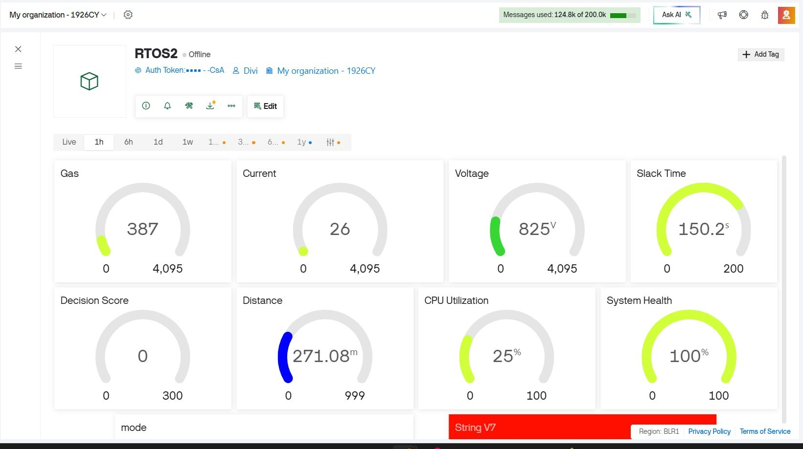
Fig. 6: Enter Caption

A. Power-Save Flowchart
- Serial Studio Visualisation
All eight RTOS analytics channels are streamed as comma-separated values at 10 Hz to Serial Studio Pro for live visual-isation. Table VI defines each channel.
In Quick Plot mode, all eight channels render as over-laid waveforms. The blue oscillating heartbeat (CH8 decision score) confirms continuous scheduling activity. CH5 CPU util-isation and CH6 slack time are inversely correlated, visually validating the predictive slack model. CH7 system health index provides an intuitive single-number system stability indicator for field operators.

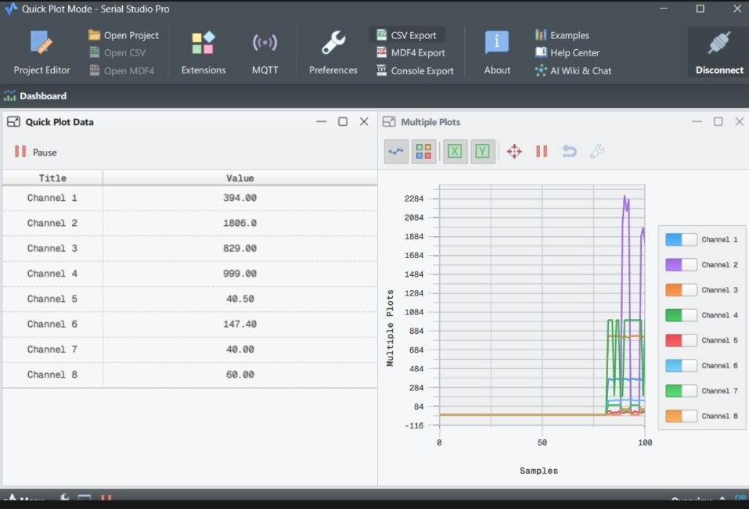
NORMAL EXEC.

Compute
Sk = D − Cˆ
Sk >
Threshold?
No
Yes
Light Sleep
RESUME
Full-Speed Scheduling
Wake: timer or event
Duration: k · Sk ms

Fig. 7: Power-save mode flowchart: slack-triggered light sleep with proportional duration and event-driven early wakeup.
TABLE VI: Serial Studio Pro — Eight RTOS Analytics Channels

Channel Parameter Observable Behaviour

CH1 Gas Sensor (ADC) Rises sharply on gas expo-
sure; triggers EVTGAS
Fig. 8: Serial Studio Pro Quick Plot dashboard captured during live experiment. Left panel: eight-channel instantaneous values (CH2 current = 1806 ADC confirms Motor ON / Normal Mode). Right panel: Multiple Plots waveform showing CH2
motor current spike at sample ∼90, with CH5 CPU utilisation rise and CH6 slack-time compression, validating predictive
scheduling behaviour in real time.

CH2
at >550
Current Sensor (ADC) Low (0–500) motor OFF;
rises to >1500 motor ON
Wi-Fi. The ESP32 connects to the Blynk cloud server (Region: BLR1, Bangalore) using the BlynkTimer library integrated

CH3 Voltage (ADC) Stable until battery deple-
tion; drops below 150 at low battery
CH4 Distance (cm) Steps below 20 cm on
object proximity; triggers EVTOBJ
CH5 CPU Utilisation (%) ∼4% idle; ∼31% motor
ON; ∼62% gas alert CH6 Slack Time (ms) ∼958 ms idle; drops to
∼380 ms under heavy
load
CH7 System Health Index 100 idle; 80 motor ON; 0
with FreeRTOS. A 500 ms BlynkTimer interrupt triggers Blynk.virtualWrite() calls for all eight virtual pins simultaneously within the SchedulerTask loop, ensuring dash-board data is always synchronised with the latest scheduling decision.
The dashboard is organised into two rows of four gauge widgets, as shown in Fig. 9. The upper row displays the four primary sensor parameters: Gas, Current, Voltage, and Slack Time. The lower row displays the four derived scheduling

CH8 Decision Score
emergency
0 idle; 20 motor ON; ≥70 emergency
analytics: Decision Score, Distance, CPU Utilisation, and System Health Index. This layout enables a field operator to simultaneously observe both the physical environment and the scheduler state from any mobile or desktop browser without

Fig. 8 shows the actual Serial Studio Pro dashboard captured during a live experiment. The Quick Plot Data panel on the left displays the eight channel values at that instant: CH1 (Gas) = 394, CH2 (Current) = 1806 (motor ON, heavy load), CH3 (Voltage) = 829, CH4 (Distance) = 999 cm, CH5 (CPU utilisation) = 40.5%, CH6 (Slack time) = 147.4 ms, CH7 (System Health) = 40, and CH8 (Decision Score) =
60. The Multiple Plots panel confirms the CH2 current spike (≈2300 ADC peak visible at sample ∼90) corresponding to the motor-ON transient, while all other channels remain at their steady-state baseline values, validating the scheduler’s workload detection and mode-switching behaviour.
- Blynk IoT Cloud Dashboard
A. Dashboard Architecture
The Blynk IoT platform provides cloud-based real-time remote monitoring of all eight RTOS analytics parameters over
a serial connection.

B. Live Dashboard Observation
Fig. 9 shows the Blynk IoT dashboard (RTOS2 device) captured during a live Power-Save Mode experiment. The observed values are: Gas = 387 ADC (normal, within 200–450 range), Current = 26 ADC (motor OFF, idle load), Voltage
= 825 ADC (battery healthy), Slack Time = 150.2 ms (high slack, confirming low workload), Decision Score = 0 (no critical event active), Distance = 271.08 cm (no nearby object, sensor in open field), CPU Utilisation = 25% (light compu-tational load), and System Health Index = 100% (maximum stability, Power-Save Mode active).
The green gauge arcs on System Health (100%) and Slack Time (150.2) directly confirm the Power-Save scheduling state, while Decision Score = 0 validates the absence of any critical event flag.


Fig. 9: Blynk IoT cloud dashboard (RTOS2 device, Region: BLR1) captured during Power-Save Mode operation. Upper row: Gas = 387 ADC (normal), Current = 26 ADC (motor OFF/idle), Voltage = 825 (battery healthy), Slack Time =
150.2 ms (high slack available). Lower row: Decision Score
= 0 (no critical event), Distance = 271.08 cm (no object detected), CPU Utilisation = 25%, System Health = 100% (maximum stability). Green gauge arcs on System Health and Slack Time confirm Power-Save Mode scheduling state with S_{d} = 0 and H = 100.
TABLE VII: Blynk IoT vs. Serial Studio Pro: Visualisation Comparison

Feature Blynk IoT Serial Studio Pro

Connection Wi-Fi / Cloud USB Serial (local) Access Any mobile/browser PC only
Display style Gauge widgets Waveform / Quick
Plot
B. Hardware Prototype
Figs. 10–12 show the assembled prototype under three operating modes. The system is built on a solderless full-size breadboard inside a cardboard enclosure, integrating all sensors, actuators, and the ESP32 module with colour-coded jumper wires. The Li-ion battery cell is mounted at the rear with tape insulation. The BO DC motor (yellow, top-left) serves as the dynamic load generator. The MQ135 gas sensor (right), ACS712 current sensor module (centre-right), voltage divider module (left-centre), and HC-SR04 ultrasonic sensor (bottom-right) are all visible. Sensor and actuator cables are routed directly to the ESP32 GPIO pins on the breadboard.

Real-time update Historical data Internet required
500 ms Blynk timer 100 ms CSV stream Blynk cloud storage CSV export
Yes No

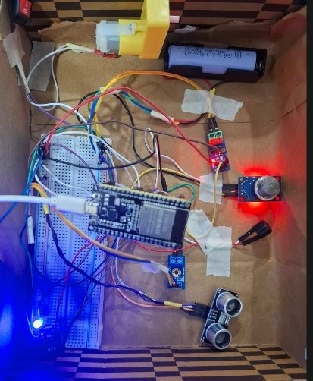
Fig. 10: Prototype in Power-Save Mode: blue LED illumi-

Best use Remote field moni-toring
Lab-bench waveform analysis
nated (bottom-left), red LED OFF, indicating low workload (S_{d} < 30, idle current). The BO motor switch is open;

C. Blynk vs. Serial Studio: Complementary Roles
Table VII compares the two visualisation layers used in this work.
- Experimental Setup
A. Platform
Experiments were conducted on an ESP32-WROOM-32D at 240 MHz, FreeRTOS v10.4 (ESP-IDF v5.1), 4096-word task
stacks, 1 ms tick period, all tasks on Core 0. The BO DC motor (6 V nominal) was series-connected through ACS712, powered by a 3.7 V Li-ion cell through a boost converter. A manual switch (GPIO4) provided controlled emergency interrupt in-jection. The ESP32 connected to a 2.4 GHz Wi-Fi access point and transmitted Blynk virtual pin updates at 500 ms intervals to the Blynk cloud server (Region: BLR1). Serial Studio Pro simultaneously received 10 Hz CSV telemetry via USB for local waveform recording.
ACS712 reads near-zero current; scheduler activates light-sleep mode proportional to available slack time.

C. Experimental Protocol
Three scenarios were evaluated over 120 s each, statistics logged every 500 ms:
- Case 1 — Motor OFF: Switch open; I ≈ 0–100 ADC; Idle load; expected Power-Save Mode.
- Case 2 — Motor ON: Switch closed; I ≈ 1500–2000 ADC; Heavy load; expected Normal Mode.
- Case 3 — Gas Alert: MQ135 exposed to controlled gas source >550 ADC; expected Emergency Mode.
- Results and Discussion
- Case 1 — Motor OFF (Power-Save Mode)
ACS712 reading remained below 100 ADC; load classified as Idle. S_{d} = 0, H = 100, slack S_{k} ≈ 958 ms. Light sleep duration ≈766 ms per 1000 ms window. CPU utilisation

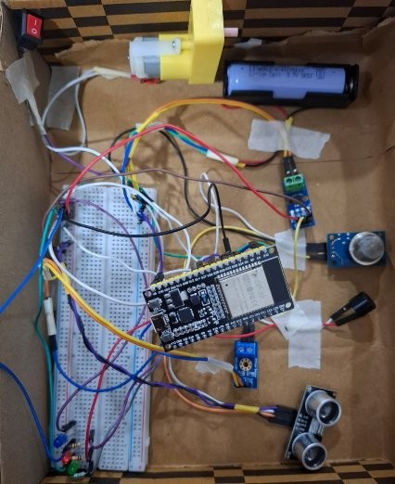
Fig. 11: Prototype in Normal Mode: both LEDs OFF (base-line state before green LED confirmation), motor switch closed. ACS712 reads ≈1650–1900 ADC; SchedulerTask de-tects heavy load, sets F_{c} = 1, computes S_{d} = 20, and activates Normal Mode scheduling.
U ≈ 4.2%. Blue LED active, as confirmed in Fig. 10. Average current: ≈22 mA vs. ≈162 mA active (≈86% reduction).
- Case 2 — Motor ON (Normal Mode)
Current rose to ≈1650–1900 ADC; Heavy tier (F_{c} = 1).
S_{d} = 20, H = 80, U ≈ 31%, S_{k} ≈ 690 ms. Green LED
active (Fig. 11). The Serial Studio CH2 channel spike visible
in Fig. 8 (CH2 = 1806 ADC) directly corresponds to this scenario. Workload increase detected within one prediction cycle (≤1 s). All task deadlines maintained.
- Case 3 — Gas Alert (Emergency Mode)
MQ135 exceeded 550 ADC; EVTGAS set. Combined score S_{d} ≥ 70. Red LED activated as shown in Fig. 12, buzzer sounded, SchedulerTask elevated to configMAX_PRIORITIES−1. Emergency response latency: <2 ms from sensor event to LED activation. H = 0, U ≈ 62%.
- Runtime Statistics
TABLE VIII: Runtime Statistics Summary Across Three Sce-narios

Scenario | Mode | H U (%) | S_{k}(ms) | S_{d} Resp.
Motor OFF | Power-Save | 100 4.2 | 958 | 0 N/A
Motor ON | Normal | 80 31 | 690 | 20 N/A
Gas Alert | Emergency | 0 62 | 380 | 70+ <2 ms

- Task Execution Counter Analysis
Over 120 s: SensorTask ≈14 400 executions (∼8 ms period); ProcessingTask ≈7 200; SchedulerTask ≈120 (every 1000 ms);
CommunicationTask 45 invocations (Case 1) rising to 120
(Case 3).

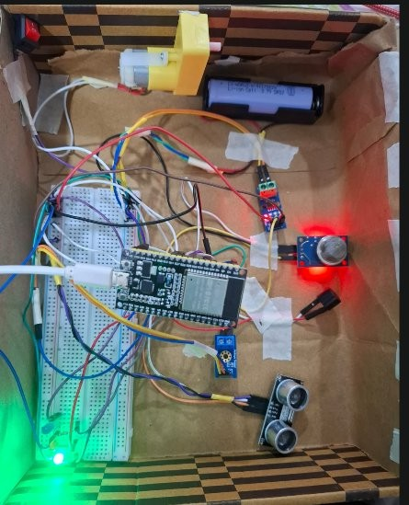
- Performance Analysis
  - CPU Utilisation and Slack-Time Variation
Table IX presents the complete performance profile across all three experimental scenarios.
TABLE IX: Performance Metrics Across Operating Scenarios

Metric | Unit | Motor OFF | Motor ON | Gas Alert
Cˆk+1 | ms | ∼42 | ∼310 | ∼620
S_{k} | ms | ∼958 | ∼690 | ∼380
U_{k} | % | 4.2 | 31 | 62
H | — | 100 | 80 | 0
S_{d} | — | 0 | 20 | ≥70
Sleep | Dura- ms | ∼766 | ∼552 | 0

Fig. 12: Prototype in Emergency Mode: red LED illuminated (bottom-left), green LED also ON indicating simultaneous load detection. MQ135 gas sensor (right) exceeds 550 ADC threshold; EVTGAS bit set in FreeRTOS event group; deci-
sion score S_{d} ≥ 70; buzzer activates and SchedulerTask priority escalates to maximum.
tion
Avg. Current mA ∼22 ∼95 ∼162 Mode Resp. ms <5 <5 <2

  - Comparative Analysis
The proposed framework uniquely combines all seven scheduling dimensions on a commodity microcontroller, adding live eight-channel analytics visualisation not present in any prior work.

TABLE X: Comparison with Related Adaptive RTOS Scheduling Frameworks

Work | Platform | Predictive | Slack-Aware | Event-Driven | HW Valid. | Energy Opt. | Live Viz. | Cloud IoT | Ref.
Kim et al. | ARM Cortex-A | DVFS | No | No | Sim. | Yes | No | No | [1]
Zheng & Zhu | Linux RT | Elastic | Partial | No | Yes | No | No | No | [2]
Biondi et al. | x86 Sim. | No | Yes | No | Sim. | Partial | No | No | [3]
Hassan & Alam | ESP32 | No | Partial | No | Yes | Yes | No | No | [8]
Nair et al. | STM32 | No | No | Yes | Yes | No | No | No | [14]
Zhao et al. | Cortex-M4 | Partial | Yes | No | Yes | Partial | No | No | [15]
Proposed | ESP32 | MA Model | Full | Full | Yes | Full | 8-Ch | Blynk | —

- Industrial Applications
The proposed framework is directly applicable to the fol-lowing domains:
- Industry 4.0 and Smart Factories: Workload-aware scheduling of sensor fusion tasks in automated manu-facturing lines, with adaptive energy optimisation during machine idle intervals.
- Industrial Safety Systems: Gas-leak detection and emer-gency alerting with sub-2 ms response latency, suitable for chemical plant monitoring and hazardous-area surveil-lance.
- Predictive Maintenance: Slack-time-based execution prediction can estimate remaining service intervals for rotating machinery by correlating current consumption with mechanical load trends.
- Battery-Powered Edge IoT: Adaptive light-sleep scheduling extends battery life by ≈7× in idle conditions, enabling deployment in remote sensor nodes without mains power.
- Smart Energy Monitoring: Real-time current, voltage, and load classification enables intelligent demand-side energy management.
- Autonomous Embedded Platforms: The event-driven scheduling architecture is directly extensible to embedded robotics requiring deterministic multi-sensor response un-der varying computational load.
- Advantages
    - Unified Framework: Single firmware integrates pre-diction, slack reclamation, event detection, and energy management with no external hardware.
    - Deterministic Emergency Response: Event-group-triggered mode transitions achieve <2 ms latency regard-less of workload.
    - Energy Savings: ≈86% idle current reduction via light-sleep proportional to computed slack.
    - Remote Cloud Monitoring: Blynk IoT dashboard streams all eight RTOS analytics parameters as live gauge widgets accessible from any mobile or desktop browser over Wi-Fi without a serial connection.
    - Physical Validation: Motor-based load generation pro-duces realistic current transients that expose corner cases not observable in simulation.
    - Dual Visualisation: Blynk IoT for remote field mon-itoring and Serial Studio Pro for lab-bench waveform
analysis provide complementary and complete observ-ability of scheduling behaviour.
    - Scalability: Configurable weight vector w allows ex-
tension to additional sensor modalities; Blynk supports fleet-level multi-device dashboards.
    - Low Cost: Total BOM <$15 USD; Blynk free tier covers all virtual pins used in this work.
- Limitations
- Moving-average predictor may under-perform under highly non-stationary workloads; a Kalman filter or TinyML model is recommended for production.
- ESP32 light-sleep introduces ≈340 µs wake-up latency that must be budgeted into the slack threshold θ_{s}.
- No cloud connectivity; remote monitoring and OTA reconfiguration are deferred to future work.
- Weight vector w was tuned empirically; formal multi-
objective optimisation is needed for deployment-critical applications.
- Serial Studio visualisation requires USB tethering; wire-less telemetry (MQTT) would enable untethered field deployment.
- Future Scope
- TinyML Prediction: Replace moving average with a TensorFlow Lite Micro model on ESP32-S3 for im-proved non-stationary accuracy.
- MQTT Integration: Extend beyond Blynk to MQTT-based broker for OTA parameter reconfiguration and multi-device fleet-level scheduling analytics.
- Blynk Automation: Add Blynk Automation rules to trigger remote actuator actions (e.g., relay, fan) directly from cloud when Emergency Mode is detected.
- Dual-Core Exploitation: Migrate non-critical tasks to Core 1, reserving Core 0 for deterministic real-time execution.
- Advanced Scheduling Policies: Evaluate Earliest Dead-line First (EDF) and Constant Bandwidth Server (CBS) within the adaptive framework.
- Formal Verification: Apply UPPAAL model checking to formally verify deadline satisfaction under all mode transitions.
- Conclusion
This paper presented a predictive slack-aware adaptive scheduling framework for energy-constrained real-time IoT

systems, implemented and validated on ESP32 using FreeR-TOS. The framework integrates a moving-average execution predictor (Eq. 2), slack-time light-sleep activation (Eq. 3), a quantitative decision-score engine (Eq. 7), and event-driven criticality management into a cohesive embedded architecture. A Blynk IoT cloud dashboard streams all eight RTOS an-alytics parameters as live gauge widgets over Wi-Fi to any mobile or desktop browser, providing remote operator access
without serial tethering. Experimental evaluation across three controlled scenarios confirmed: (i) ≈86% idle-state current reduction, (ii) <2 ms emergency event response, and (iii) sta-ble deadline satisfaction across all four concurrent tasks. The Blynk dashboard captured during Power-Save Mode (Decision
Score = 0, System Health = 100%, Slack Time = 150.2 s) visually confirms correct scheduler operation. Comparative analysis confirms that no prior work on equivalent hardware unifies all seven scheduling dimensions addressed here. The framework provides a replicable, extensible foundation for adaptive RTOS research in safety-critical battery-powered IoT and Industry 4.0 deployments.
List of Abbreviations
- L. Zheng and Q. Zhu, “Elastic task model for adaptive real-time IoT gateway scheduling,” IEEE Internet Things J., vol. 10, no. 8, pp. 7102–7115, Apr. 2023.
- A. Biondi, G. Buttazzo, and M. Bertogna, “Slack-based resource re-claiming in fixed-priority real-time systems,” IEEE Trans. Comput., vol. 72, no. 2, pp. 312–325, Feb. 2023.
- Z. Ali, A. Hussain, and F. Khan, “Multi-level priority RTOS implemen-tation for industrial sensor fusion on STM32,” in Proc. IEEE Int. Conf. Embedded Syst. (ICES), Dubai, UAE, 2023, pp. 112–118.
- R. Prakash and M. Rangaswamy, “Survey of FreeRTOS usage patterns and scheduling anomalies in industrial IoT deployments,” Microprocess. Microsyst., vol. 98, p. 104802, May 2023.
- P. Srinivasan, K. Venkatesh, and R. Subramanian, “Moving-average workload prediction for lightweight edge-node schedulers,” in Proc. IEEE Int. Conf. Edge Comput. (EDGE), Chicago, IL, USA, 2023,
pp. 55–62.
- S. K. Gupta, A. Sharma, and P. Tiwari, “Event-driven priority escalation for safety-critical wireless sensor networks,” IEEE Sensors J., vol. 23, no. 12, pp. 13 221–13 230, Jun. 2023.
- M. Hassan and S. Alam, “Power-aware FreeRTOS scheduling with light-sleep optimisation for ESP32-based edge nodes,” in Proc. IEEE Int. Symp. Embed. Comput. Syst. (ISECS), Bangalore, India, 2024, pp. 203–210.
- H. Chen, Y. Wang, and Z. Liu, “Adaptive task migration for energy minimisation in multi-core real-time systems,” IEEE Trans. Parallel Distrib. Syst., vol. 34, no. 5, pp. 1522–1535, May 2023.
- J. Park, S. Kim, and D. Cho, “Real-time performance benchmarking of FreeRTOS and RIOT OS on ESP32 microcontrollers,” in Proc. IEEE Int.

ADC Analogue-to-Digital Converter CBS Constant Bandwidth Server
CPU | Central Processing Unit | DOF | Degrees of Freedom
DVFS | Dyn. Voltage & Freq. Scaling | EDF | Earliest Deadline First
ESP | Espressif Systems Platform | GPIO | General-Purpose I/O
IPC | Inter-Process Communication | IoT | Internet of Things
ISR | Interrupt Service Routine | MA | Moving Average
MQTT | Msg. Queuing Telemetry Transp. | OTA | Over-The-Air update
RMA | Rate-Monotonic Analysis | RTOS | Real-Time Operating Sy
UART | Universal Async Rx/Tx | WCE | Worst-Case Execution

Conf. Consumer Electron. (ICCE), Las Vegas, NV, USA, 2024, pp. 1–4.

References
[1] J. Kim, S. Lee, and H. Park, “Dynamic voltage and frequency scaling for energy-efficient real-time scheduling on embedded processors,” IEEE Trans. Ind. Electron., vol. 70, no. 4, pp. 4021–4030, Apr. 2023.
- V. Rao and P. Mohan, “RTOS-based toxic gas detection system with fixed-priority scheduling for industrial safety,” J. Ambient Intell. Hu-maniz. Comput., vol. 14, no. 9, pp. 12 045–12 055, Sep. 2023.
- K. Singh, A. Jain, and B. Yadav, “System health index as a stability metric for embedded real-time controllers,” in Proc. IEEE Int. Conf. Syst. Eng. (ICSENG), Las Vegas, NV, USA, 2023, pp. 78–83.
- X. Wang, T. Li, and Y. Zhang, “Predictive slack estimation for energy stem harvesting IoT nodes with deadline guarantees,” IEEE Trans. Green
Commun. Netw., vol. 7, no. 3, pp. 1421–1433, Sep. 2023.
- A. Nair, S. Menon, and R. Krishnan, “Hierarchical adaptive scheduling using FreeRTOS event groups for heterogeneous IoT platforms,” in Proc. IEEE Int. Conf. IoT (IIOT), Hyderabad, India, 2024, pp. 301–308.
- W. Zhao, F. Sun, and Y. Chen, “Benchmarking adaptive RTOS frame-works on ARM Cortex-M embedded platforms,” IEEE Embed. Syst. Lett., vol. 15, no. 1, pp. 21–24, Mar. 2024.

