***SQL ASSIGNMENT***

***The objective of this assignment is to find the murderer from the given data set***

1. To find and understand the tables in the given data set.

**CODE:**

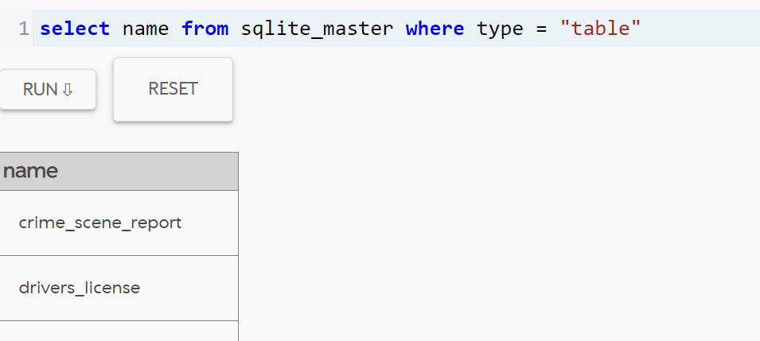

**SOLUTION:**

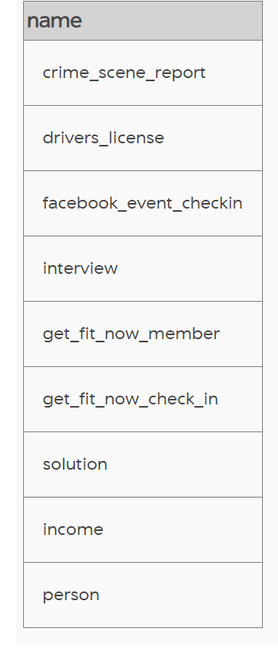

1. To find if we can get any other clues from the hints given in the introduction i.e., the crime that happened is a murder in SQL city on January 15, 2018, we take the crime report table because it provides us with the type of murder, data, city, and description.

**CODE & SOLUTION:**

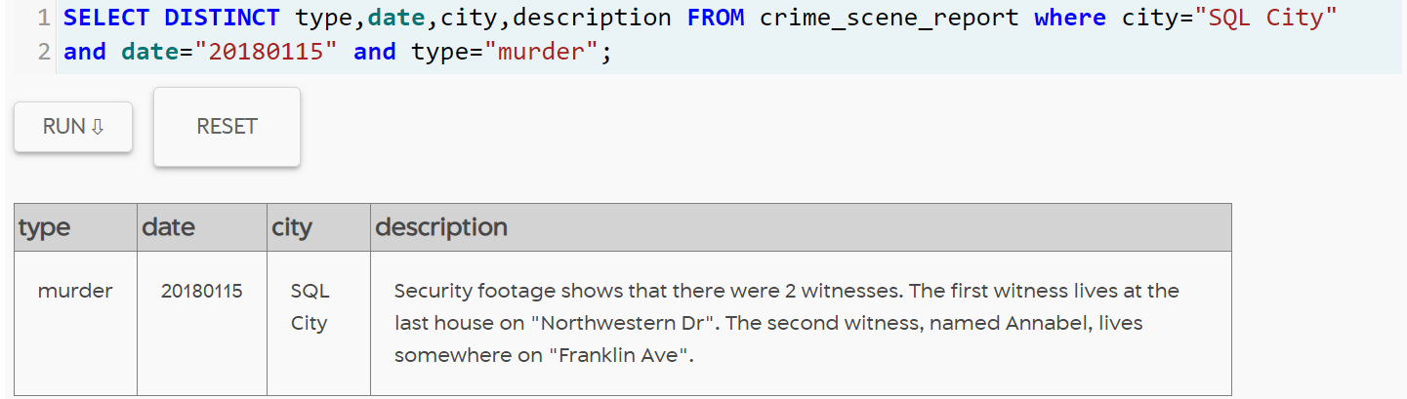

From this, we got hints that there are two witnesses and the locations they live in, with these hints we run further queries.

Now we take the witnesses’ information from the table.

**CODE & SOLUTION:**

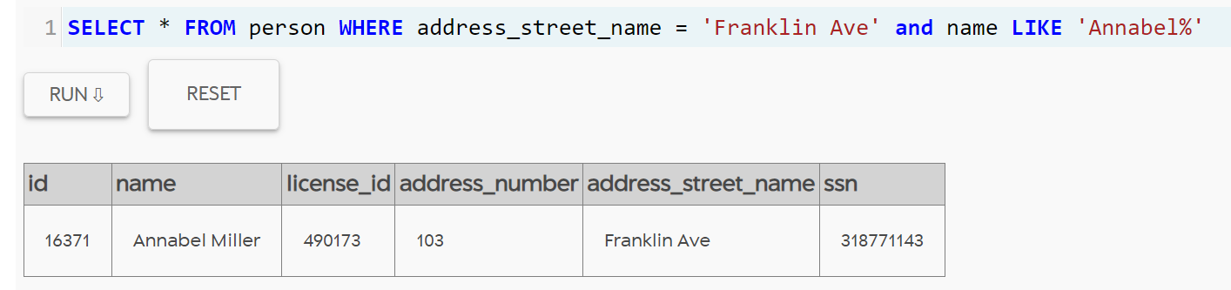

1. And then we have taken interview table to see the transcript, from the second witness we got a clue about the murder

**CODE & SOLUTION:**

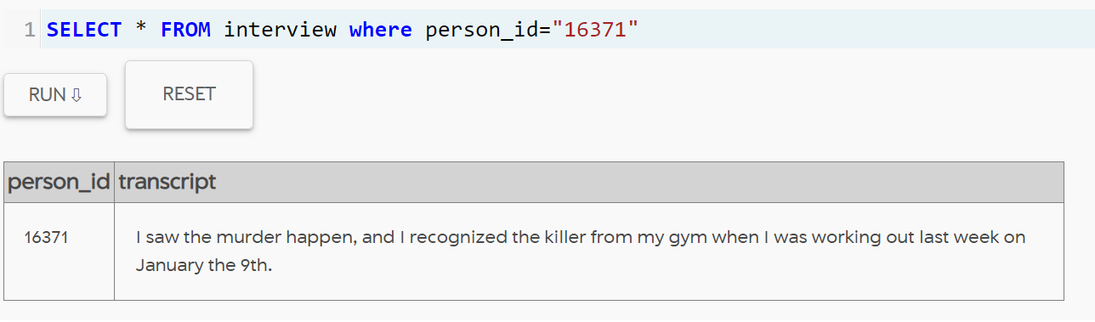

1. From the above information we will now look into get fit now membership, and check-in details we got the id of that person i.e., 67318. Now we will see the interview transcript.

**CODE & SOLUTION**

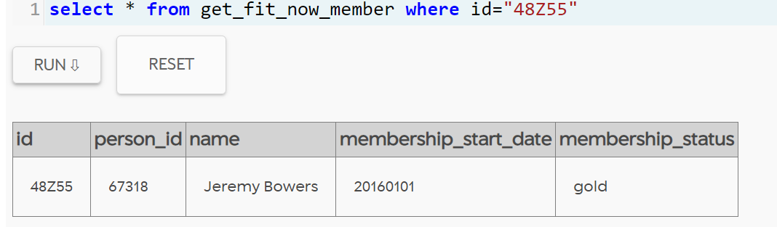

1. We got the murderer but we have to find the person who gave a ransom to the murderer

**CODE & SOLUTION**

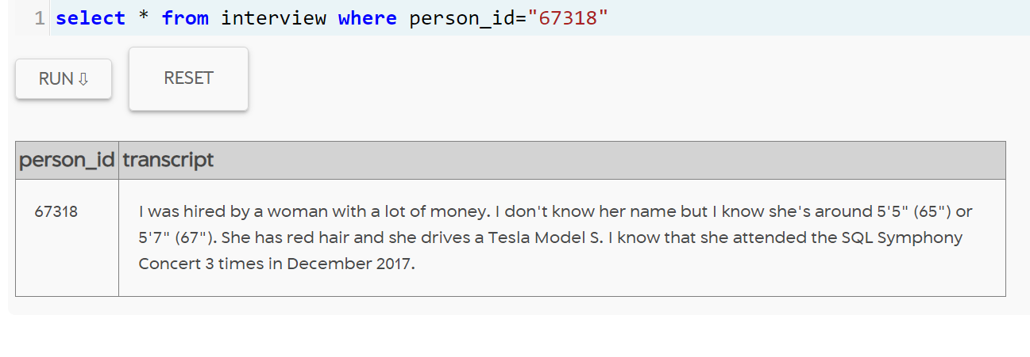

From the above information, we found the person behind the murder by taking the Facebook event check-in table.

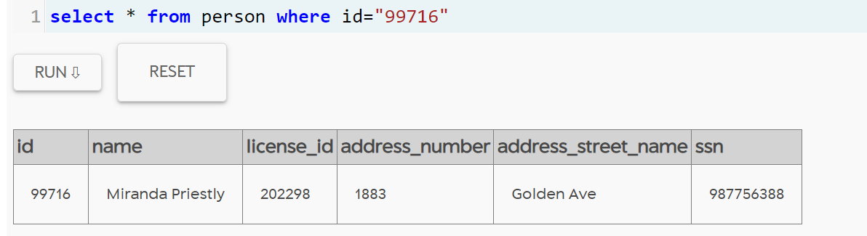

1. We finally found the person behind the murder.

**CODE & SOLUTION:**

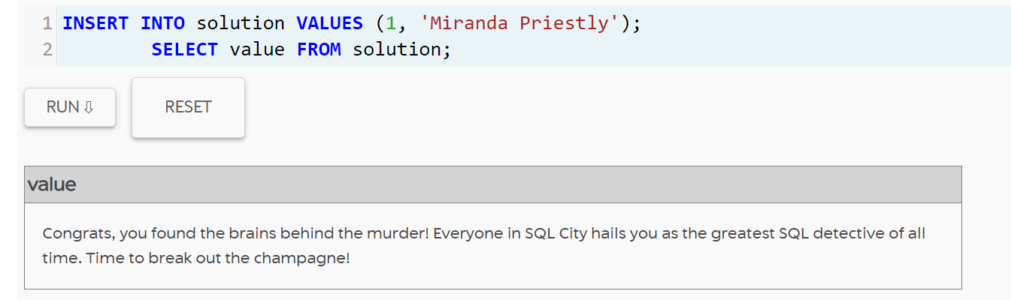

1. Inner join between get_fit_now_member table and person table to get license id and membership id at the same time.

**CODE & SOLUTION:**

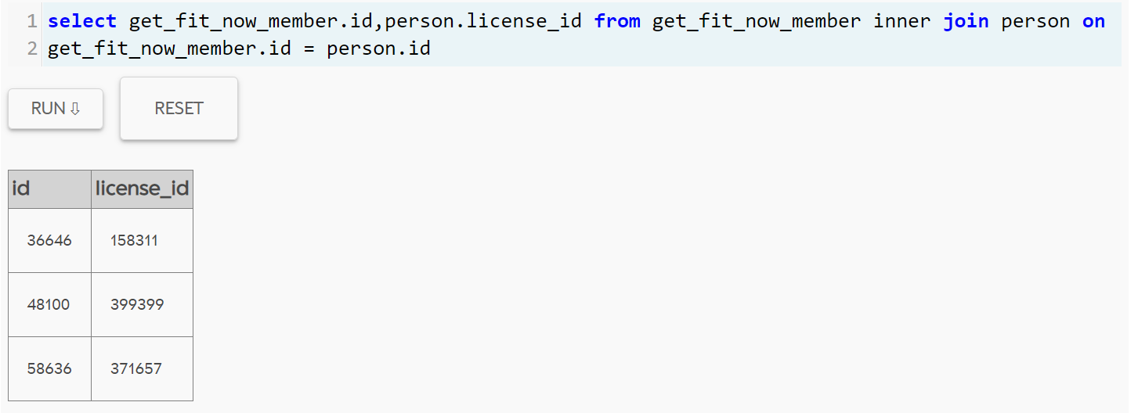

1. Left join to see the annual income of a person and his/her name whose income is more than 4,50,000

**CODE & SOLUTION:**

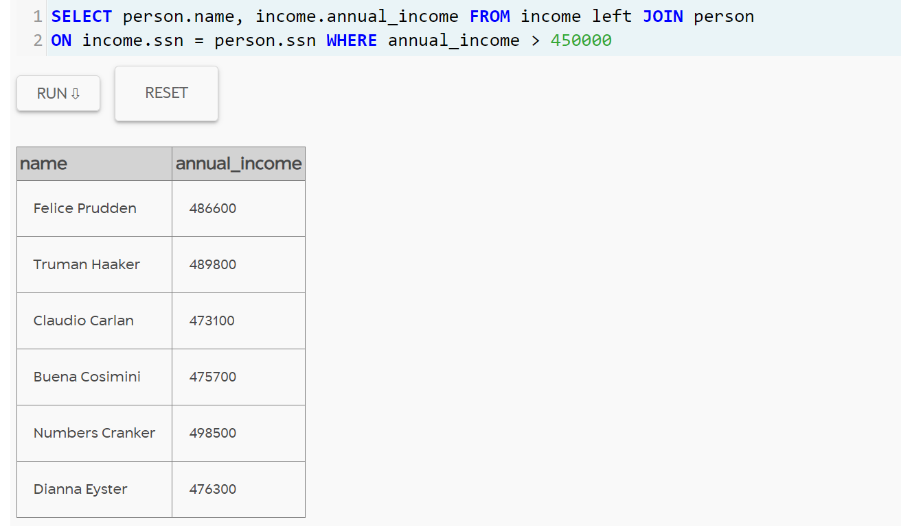

1. Now we will also see the person’s gender along with the income level of more than 4,80,000

**CODE & SOLUTION**

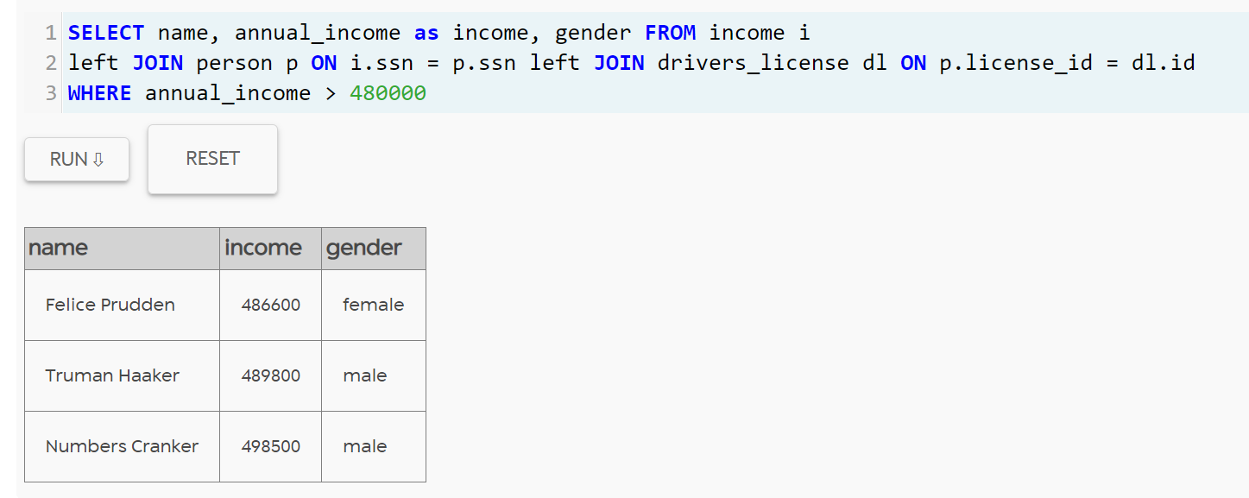

1. Let us see how many females earn more than 3,00,000 and have their hair color black

**CODE & SOLUTION**

