EXPERIMENT-3: E-Commerce Mobile App Prototype using Figma

Aim
To design an E-Commerce Mobile Application prototype using Figma for presenting the application's features and obtaining stakeholder feedback on the user interface, navigation, and overall user experience.

Procedure
- Open Figma and create a new design file.
- Create a suitable mobile application frame for the e-commerce app.
- Design the Login/Sign-up screen with fields for:
  - Email/Mobile Number
  - Password
  - Login button
  - Sign-up option
- Design the Home screen containing:
  - Search bar
  - Product categories
  - Promotional banner
  - Featured products
- Create a Product Listing screen displaying products with:
  - Product image
  - Product name
  - Price
  - Rating
  - Add to Cart button
- Design a Product Details screen with:
  - Product image
  - Product description
  - Price
  - Quantity selection
  - Add to Cart/Buy Now buttons
- Create a Shopping Cart screen showing selected products, quantities, prices, and total amount.
- Design a Checkout screen containing:
  - Delivery address
  - Order summary
  - Payment method
  - Place Order button
- Create an Order Confirmation screen displaying the order ID, product details, total amount, and delivery information.
- Use Figma's Prototype feature to connect all screens and define suitable interactions.
- Test the navigation by following the complete flow:
Login → Home → Product → Cart → Checkout → Order Confirmation
- Share the prototype with stakeholders or team members for feedback.
- Collect feedback regarding design, usability, navigation, and functionality.
- Make necessary improvements to the prototype based on the feedback.
- Save the final Figma design and capture screenshots for the lab record.
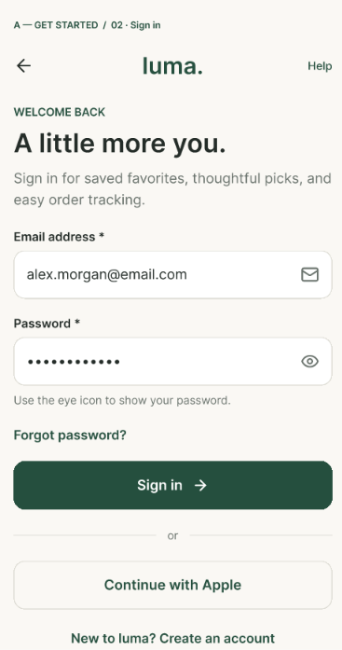
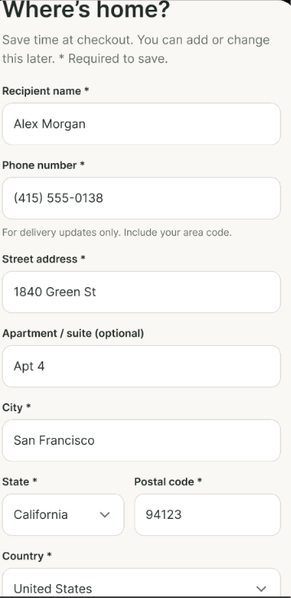

Output:
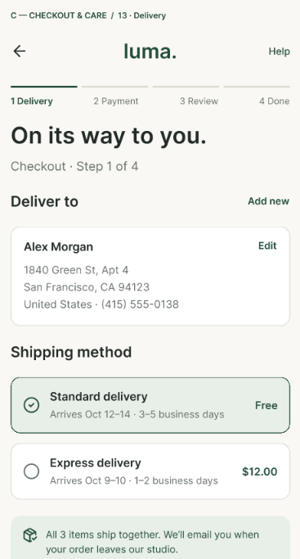
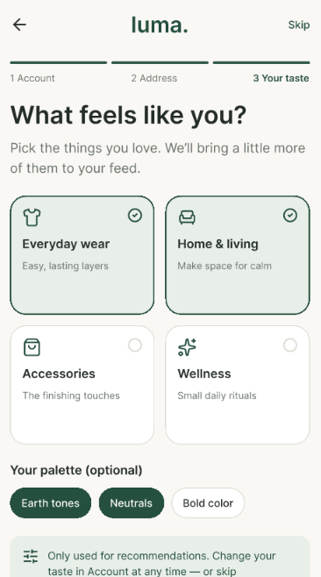
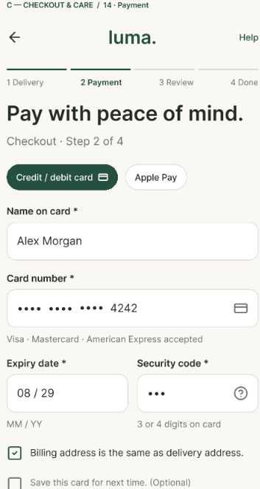
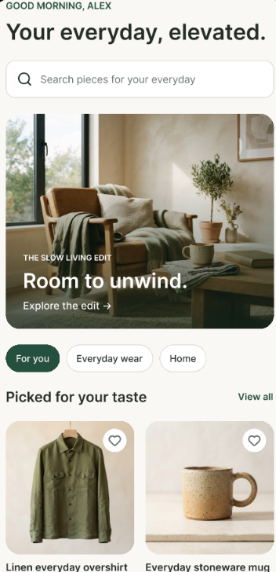
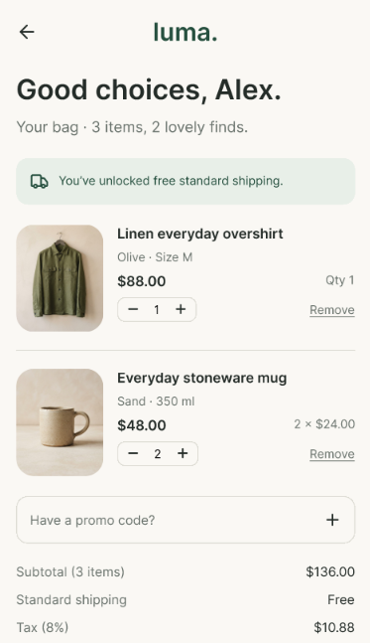
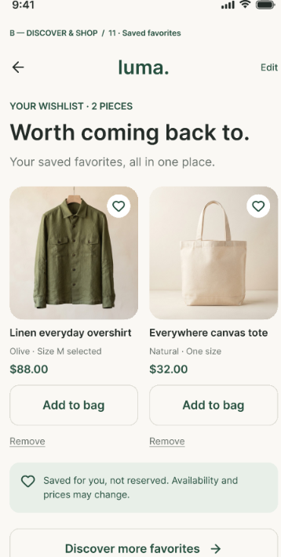
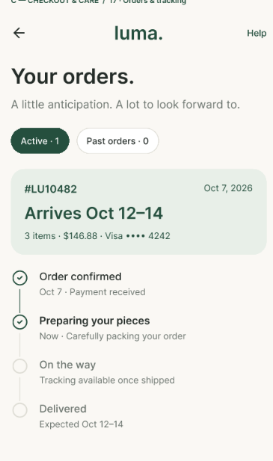
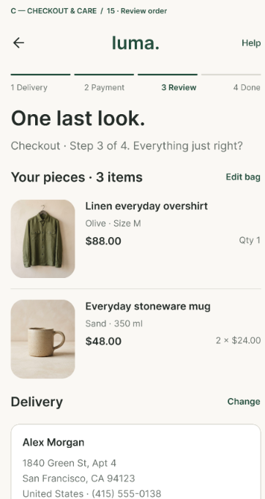
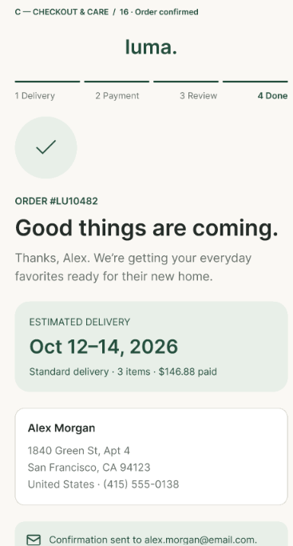

Result
An E-Commerce Mobile Application prototype was successfully designed using Figma. The prototype demonstrates the complete shopping workflow from product browsing to order confirmation. The prototype was presented for stakeholder feedback, and the feedback can be used to improve the application's user interface, navigation, and overall user experience.

