EXPERIMENT-2: Bus Ticket Booking Prototype using Figma

Aim
To design a simple Bus Ticket Booking System prototype using Figma that allows users to search for buses, select seats, enter passenger details, and confirm a bus ticket through an interactive user interface.

Procedure
- Open Figma and create a new design file.
- Create a mobile application frame suitable for the bus booking system.
- Design the Home/Search screen with the following fields:
  - From
  - To
  - Journey Date
  - Search Buses button
- Create a Bus Search Results screen displaying available buses with:
  - Bus name
  - Departure and arrival time
  - Duration
  - Ticket price
  - Select button
- Design a Seat Selection screen showing the available, selected, and occupied seats.
- Create a Passenger Details screen containing:
  - Passenger name
  - Age
  - Gender
  - Mobile number
- Design a Payment screen with suitable payment options such as:
  - UPI
  - Card
  - Net Banking
- Create a Booking Confirmation screen displaying:
  - Passenger name
  - Bus details
  - Seat number
  - Journey date
  - Ticket amount
  - Booking ID
- Use Figma's Prototype feature to connect the screens.

- Set interactions such as:
  - Search Buses → Bus Results
  - Select Bus → Seat Selection
  - Continue → Passenger Details
  - Proceed to Payment → Payment
  - Confirm Booking → Booking Confirmation
- Run the prototype using Present/Play mode and test the navigation between screens.
- Make necessary changes to improve the layout, usability, and consistency of the design.
- Save the Figma project and capture screenshots of the completed prototype.
Output:
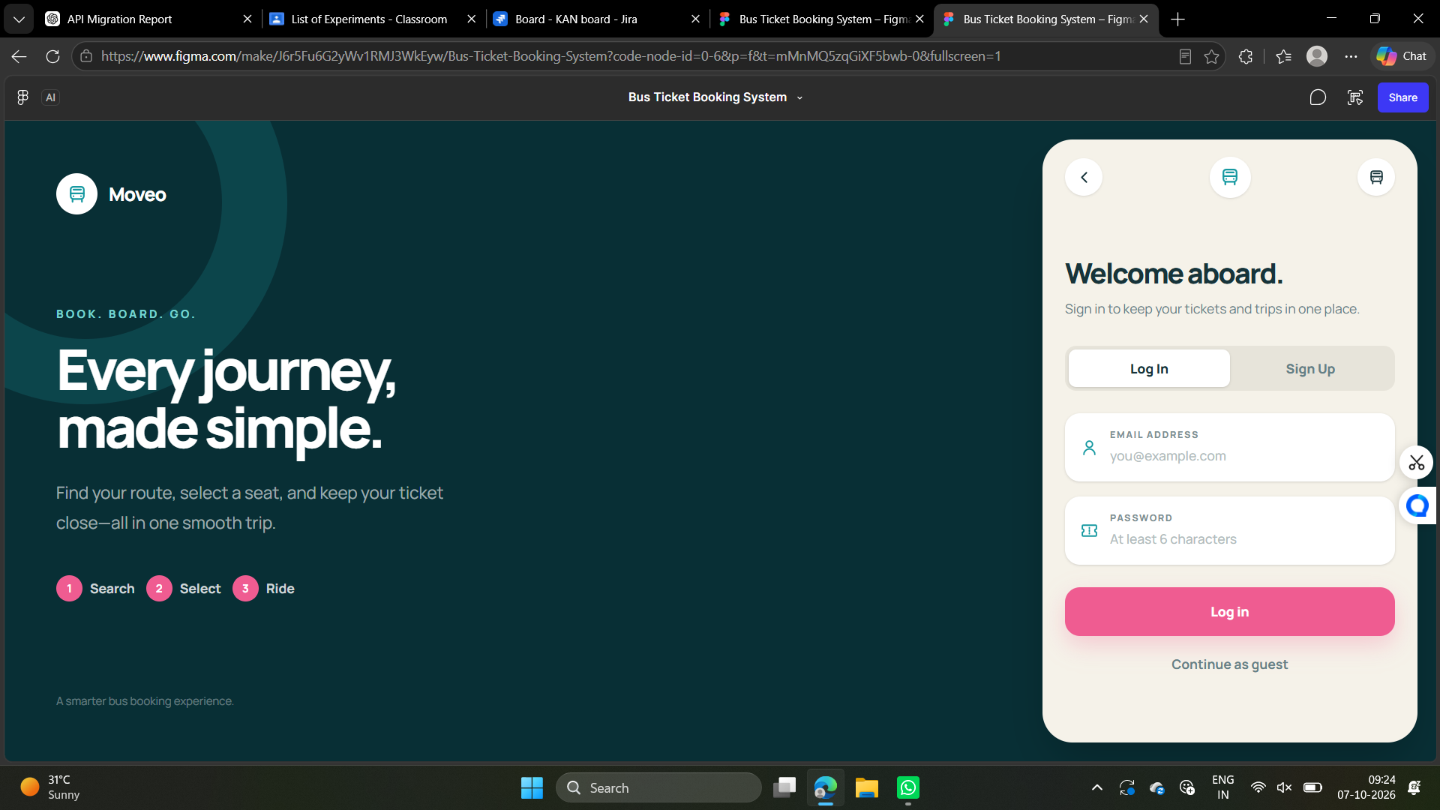

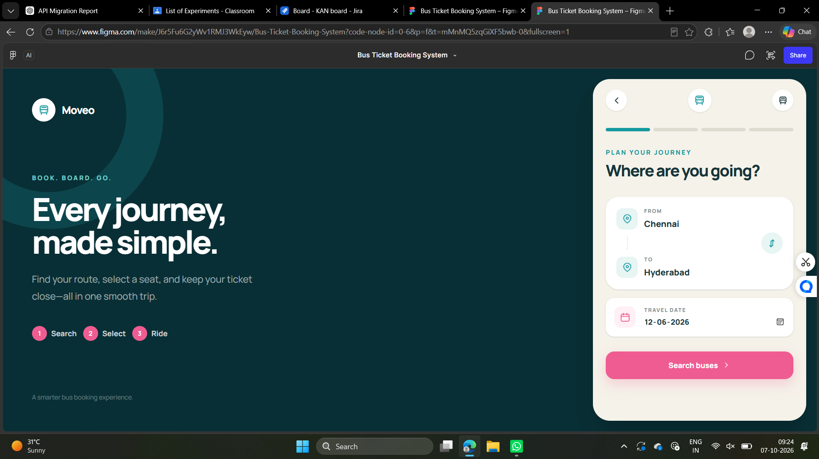
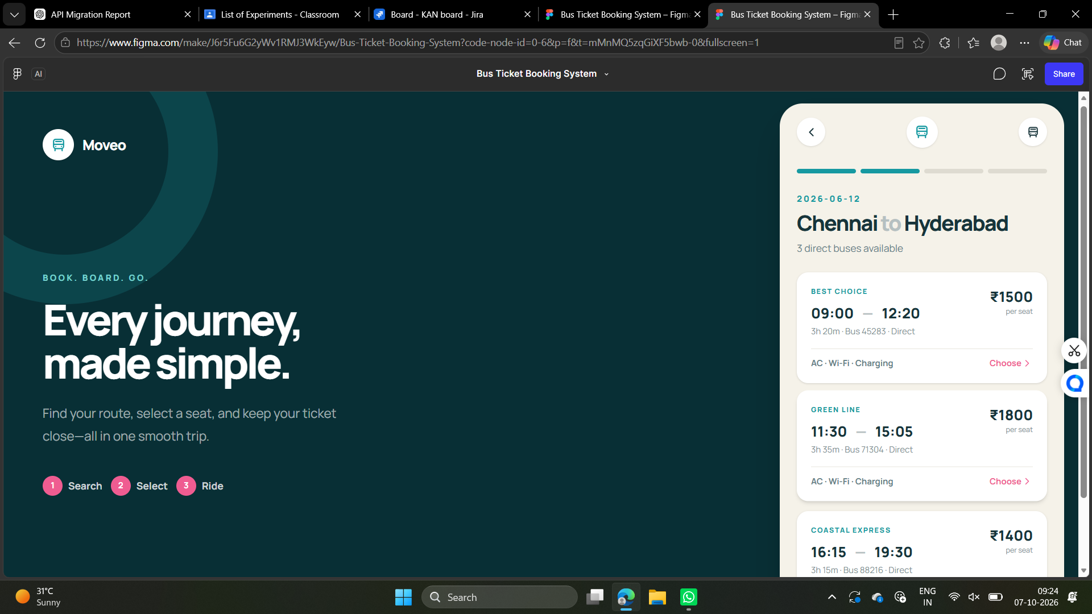
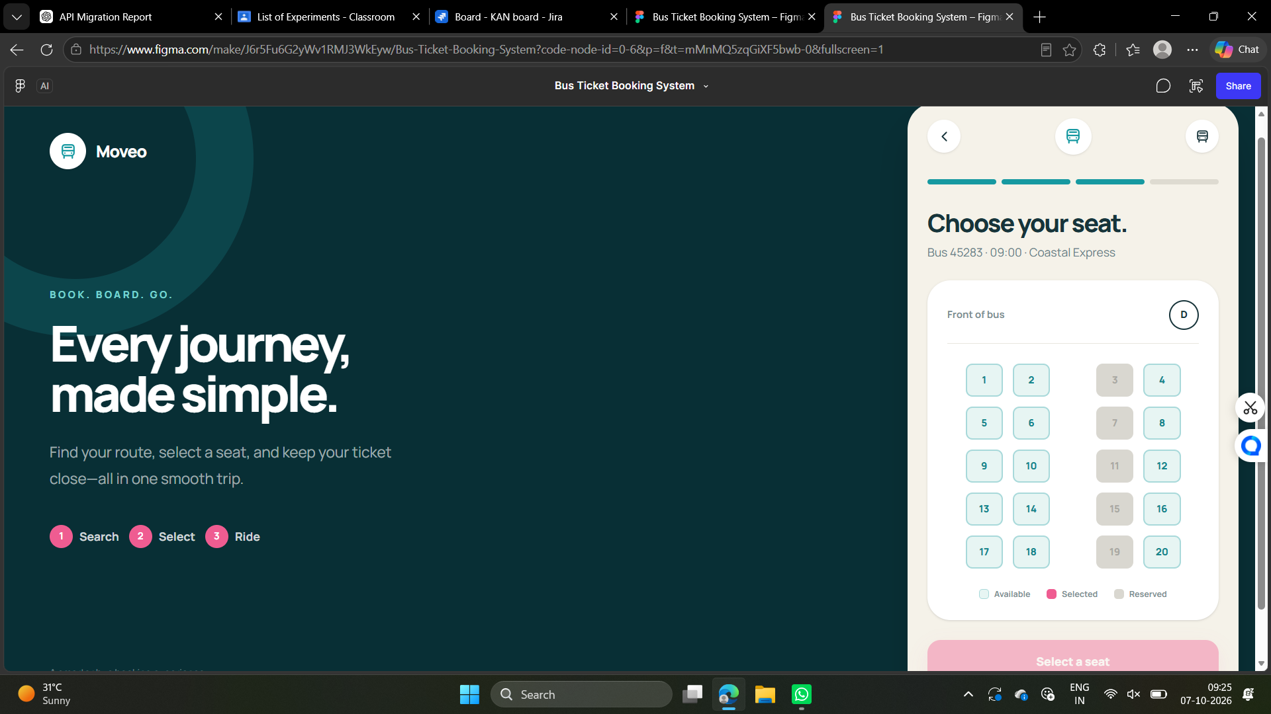
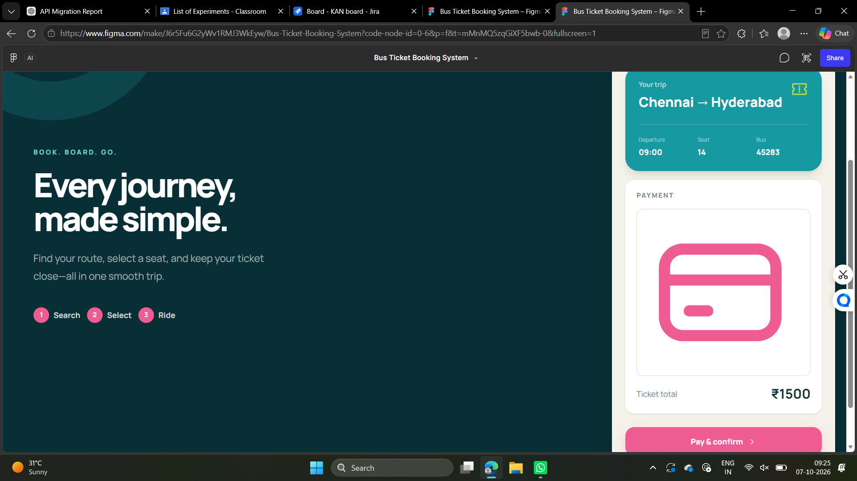
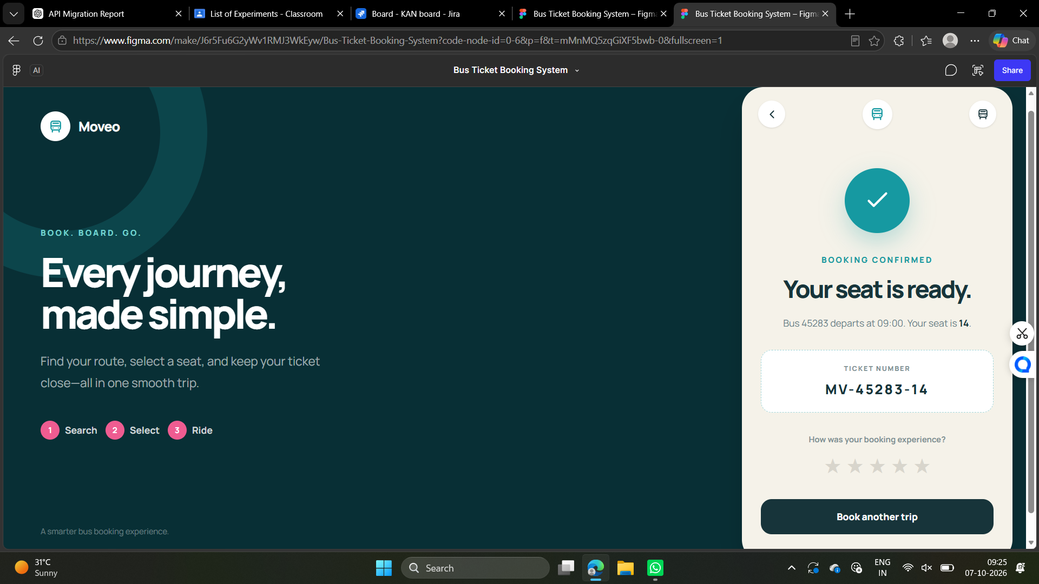

Result
A Bus Ticket Booking System prototype was successfully designed using Figma. The prototype provides an interactive flow for searching buses, selecting seats, entering passenger details, making payment, and receiving booking confirmation.

