Level -6
Major Project
Web Application
By
Tejbir Singh

Table of Contents
Table of Contents 2
Project Proposal 3
Project Scope 3
Project Specifications 3
Target Audience 4
Project Deliverables 4
Deliverable : 4
Resource Requirements 4
Tasks for the project and Achievements 5
Project Assumptions 5
Project Report 6
Functional and Non-Functional 6
Detail Design 7
Home Page 7
Login Page 7
Registration Page 8
Customer Page 9
Staff Page 11
Food Page 12
Store Page 13
Order Page 13
Login 14
Project Testing 15
Usability Testing 15
Testing 15
User Manual 15
System Summary 15
System Configuration 15

Project Proposal

Goals and Objectives
The main purpose of this project is to incorporate the Grand Haveli an online web application. With the assistance of this application, clients can easily choose their favourite food. Admin can exist in this ASP.net programme. The administrator can register new restaurants, edit, delete and access the information. By editing, removing and accessing their data, the admin may handle clients. The administrator may also view the Customer, staff and food information. Users can access restaurant information and can also edit and view restaurant information. The new client will be able to sign up for the application. New admins for the web application may be registered by current administrators.

Project Scope
This is a project for 20 days. This project aims to develop an online web application called Grand Haveli. Users can choose their favourite food by using this application.

Project Specifications

- Admin login.
- Register new restaurants, edit, delete and view existing restaurant information by admin.
- Admin can edit, delete and check customer information.
- Admin can check the restaurant's order and staff data.
- User can select type of food whatever they want and can place their order.

Target Audience
The audience for this project will be people who enjoy eating food and promoting the places from which they can get delicious food and want to promote their restaurants. The age group can begin at 7 and can go up to a hundred plus.

Project Deliverables

Deliverable:
- Final Report- This will be the project's final full analysis.
- Coding- In this section, all the project code will go.
- Documentation- This will explain how the programme and the user manuals are going to work.
- Testing- This section will illustrate the project's test information.

Resource Requirements
Following the methods of technology and development:
- Identity framework- ASP.
- Microsoft word processor.
- Windows Operating System.
- Asp.net MVC Framework.
- 64-bit Processor and 8 GB or more RAM.

Tasks for the project and Achievements
The table below shows the project tasks and achievements:
Weeks | Tasks
1 | Brainstorming and Investigation.
1 | Planning and consultation & meetings  Documentation for proposal.
1 | Database Design- Plan and Implementation.
2 | Identity framework Implementation
2 | Coding- Admin Part
2 | Coding – Customer part
3 | Testing
4 | Final Documentation

Project Assumptions
- While the App is designed and implemented, an admin and a user exist.
- Admin must have valid credentials.
- Only the admin will add new administrators and handle the client's application.
- The app admin must have valid credentials.
- User-friendly and open sources will be available.

Project Report

Functional and Non-Functional

Users | Functional | Non- Functional
Admin | - Login/Logout  - Manage restaurant registration.  - Edit, delete and check details of the customers.  - Can check details of order. | The non-functional requirements of the project are:  - The project will run on all browsers and devices.  - The project will be secure.  - The load time will be fast.  - Admin will have full access of the system.

Detail Design

Home Page
This is the main landing page of the application. On the navigation menu there are- home, Customer, Staff, Food, Store, Order, Register, Login.
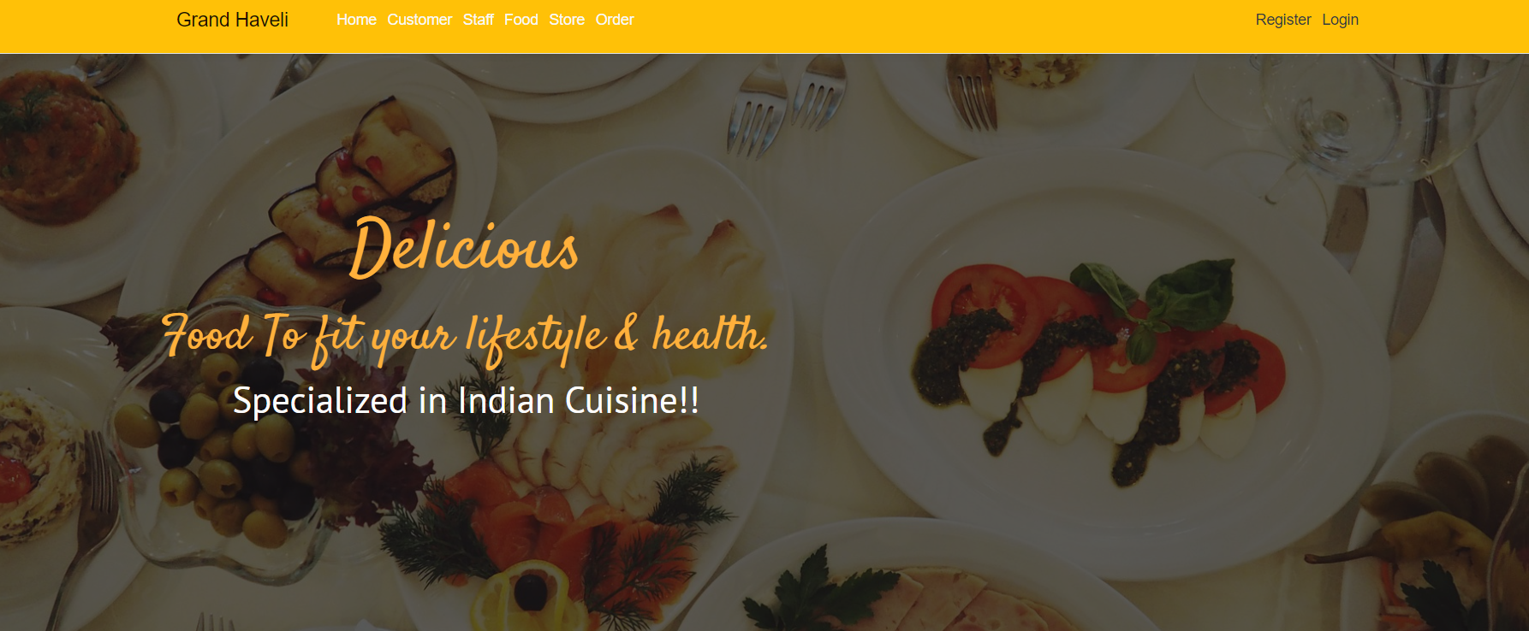

Login Page
With the help of this page registered admin can login to the system by using their valid credentials
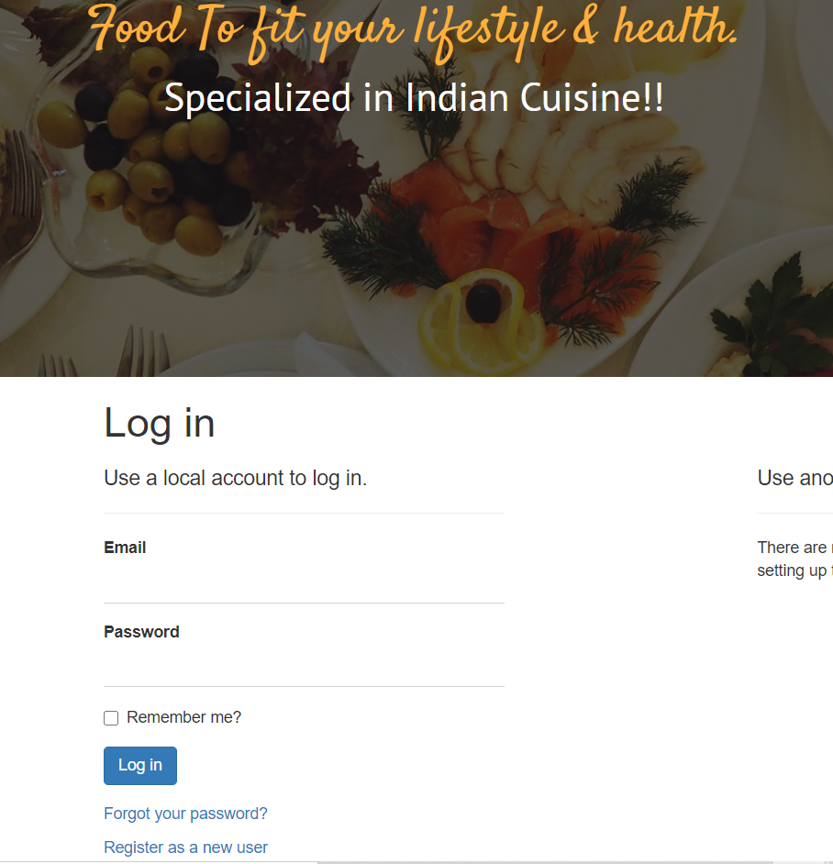

Registration Page
This page will help Users to get register their accounts by which they can access all features of application.

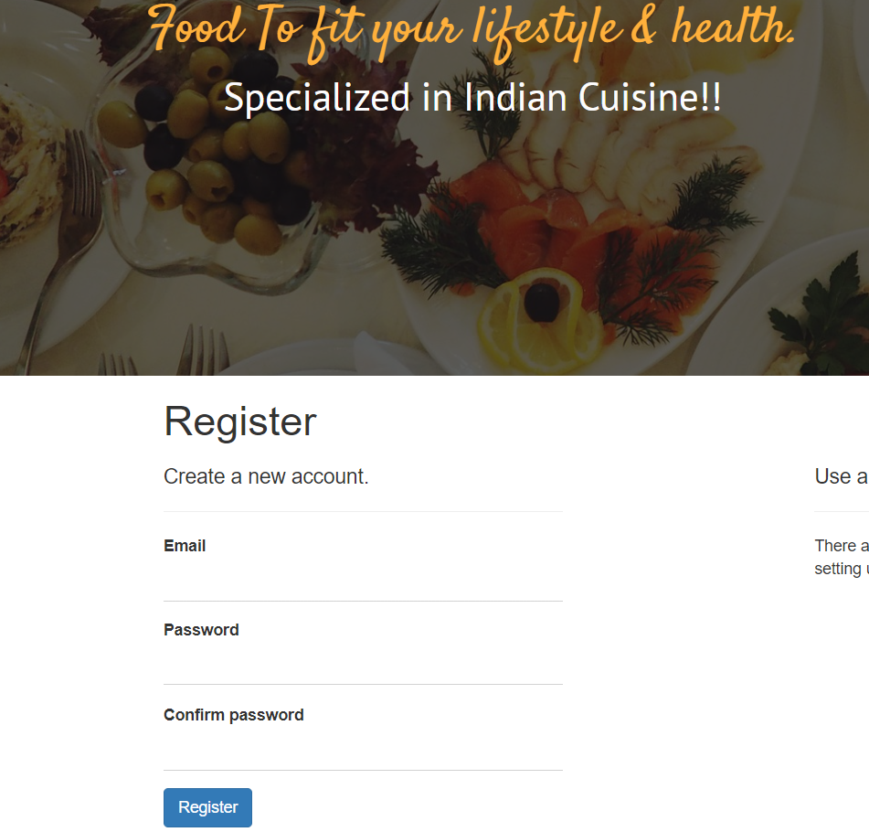

Customer Page
With the help of this page, User can create, edit, delete and view their details.
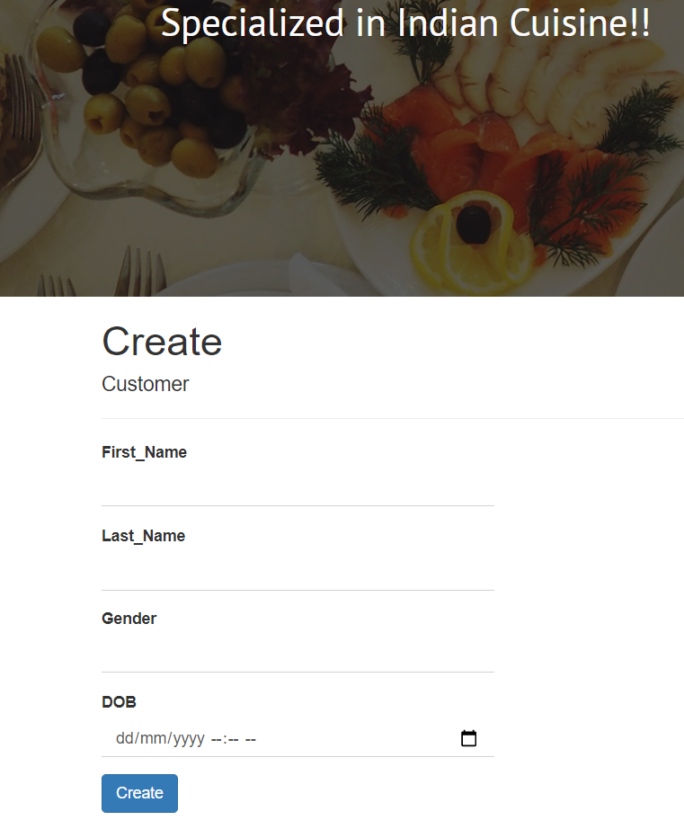

Staff Page
With the help of this page, User can create, edit, delete and view their details.
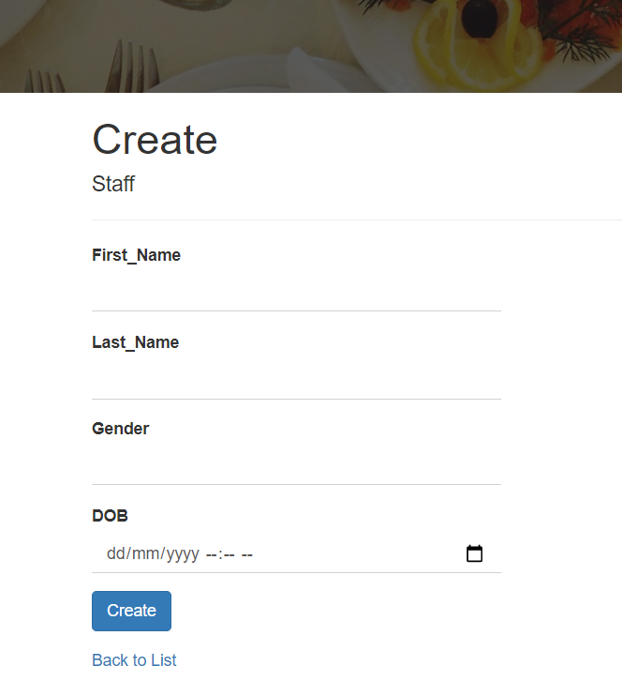

Food Page
In this page there will be food details like Food name, type, quantity and price to which user can change it.
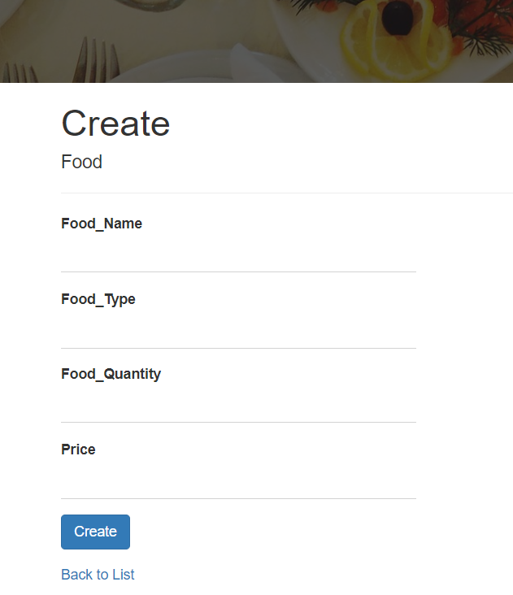

Store Page
In this page there will be store details by which user can create new details and can change.
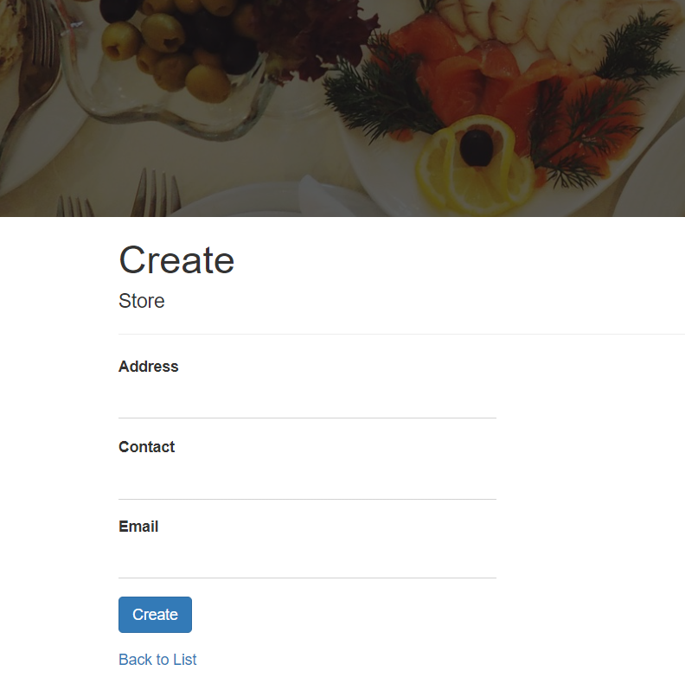

Order Page
In this page data of Customer, staff, food and store will be there like from which staff member their order done, what was the order, and from which store they place order.
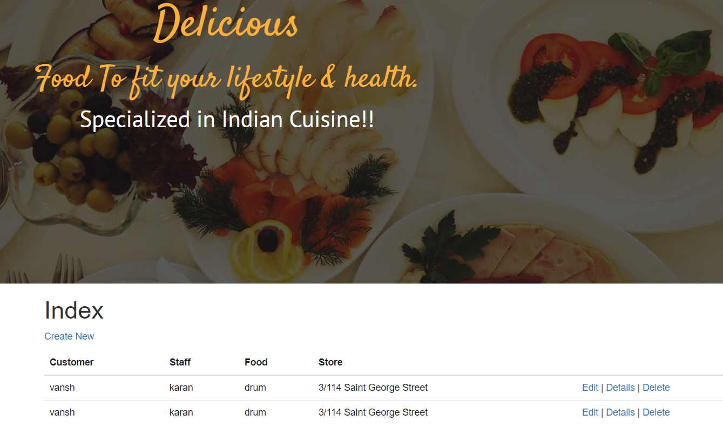

Login
In this page users can login their accounts by which they will get full access.
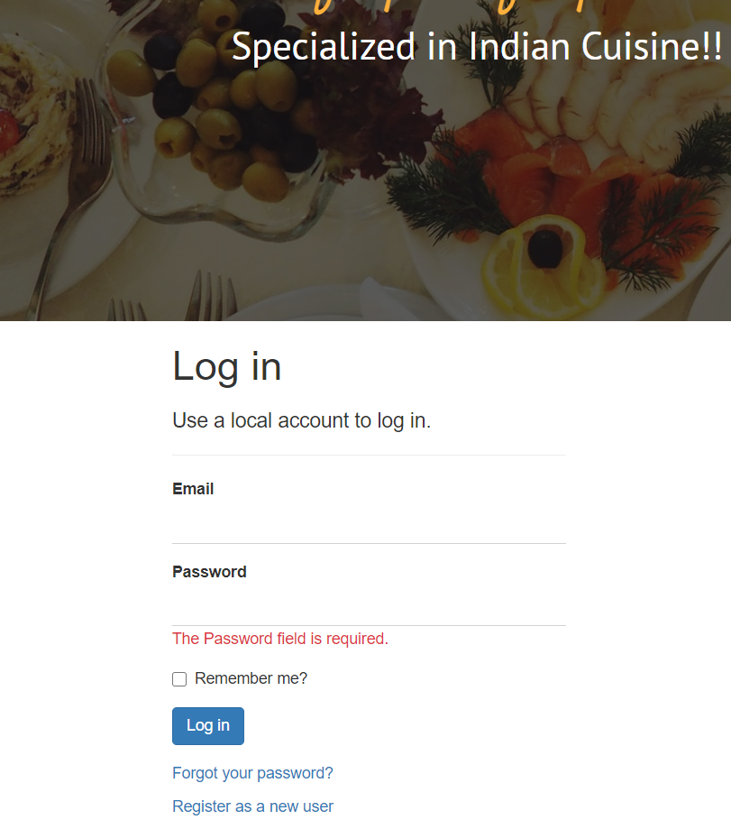

Project Testing

Usability Testing

Testing
 | Testing | Scale
No. | Question | Good, very good, bad, neutral
1 | Is there any inconsistency? | Very Good
2 | Do you think you need the support of a technical person to use this system? | Good
3 | Integration is good | Neutral
4 | Lot of knowledge is required to run the system | Neutral
5 | I found the system complicated | Good

User Manual
With the help of Grand Haveli application user can access all features like they can create, edit, delete and view customer, staff data. Moreover, they can manage food section like what’s type of food, quantity they needed.

System Summary

System Configuration
The Grand Haveli application will help user to select their favourite food.

