**MINI PROJECT – I**

(2018-19)

**QR BOD**

**SRS**



**Institute of Engineering & Technology**

**Members**

Tejbir Singh (161500584)

Arpita Singh (161500126)

Supervised By:

Mr. Pankaj Kapoor

(Technical Trainer)

Table of Contents

Revision History I

Document Approval II

1. Introduction 1

1.1 Purpose 1

1.2 Scope 1

1.3 Definitions, Acronyms, and Abbreviations 2

1.4 Tools used 2

1.5 References 3

1.6 Overview 3

2. Specific Requirements 4

2.1 External Interface Requirements 4

2.1.1 Hardware Interfaces 4

2.1.2 Software Interfaces 4

2.2 Non-Functional Requirements 4

2.2.1 Performance 4

2.2.2 Scalability 4

2.2.3 Capability 4

2.2.5 Availability 4

2.2.6 Maintainability 4

2.2.6 Portability 4

3. Analysis Models 5

3.1 Sequence Diagram 5

3.2 Data Flow Diagram 6

**1. Introduction**

## 1.1 Purpose

A QR code (quick response code) is a type of 2D barcode that is used to provide easy access to information through a smartphone. In this process, known as mobile tagging, the smartphone's owner points the phone at a QR code and opens a barcode reader app which works in conjunction with the phone's camera. QR codes store data using patterns of black dots and white spaces, arranged in a square grid. These patterns can be scanned and translated into human readable information, with the help of an imaging device, like a camera or a scanner, although the most common way to scan QR codes nowadays is to use your smartphone's camera and a specialized app for reading QR codes.

**1.2 Scope**

* **QR Codes on bus stops, train stations and subway stations:** A quick scan would give you real time information on when the next bus, train or subway would arrive.
* **E-learning.**Have your QR code generate an email that starts an autoresponder, sending daily emails filled with lessons and related information.

**1.3 Definitions, acronyms and abbreviations**

**QR Code-** Quick Response Code

**User-** It is the person who will give video as an input and polarity analysis as an output.

**UML-**Unified Modeling Language is a standard language for writing software blueprints. The UML may be used to visualize, specify, construct and document.

* 1. **Tools Used**

**JAVA-**Java is a general-purpose programming language that is class-based, object-oriented, and specifically designed to have as few implementation dependencies as possible. It is intended to let application developers "write once, run anywhere" (WORA), meaning that compiled Java code can run on all platforms that support Java without the need for recompilation. Java applications are typically compiled to "bytecode" that can run on any Java virtual machine (JVM) regardless of the underlying computer architecture**.**

**1.5 References**

* <https://www.github.com>
* Wikipedia -www.wikipedia.comSoftware Engineering, seventh edition, Roger S. Pressman.
* Software Engineering, Seventh Edition, Ian Somerville.
* Hans van Vliet. Software Engineering: Principles and Practice (Second Edition). Wiley, 1999.
* Encyclopaedia of Software Engineering” by LaPlante.

## 1.6 Overview

The rest of the SRS examines the specifications of the QR BOD in details. Section 2 outlines the detailed, performance, system, non-functional, inverse and other related requirements along with design constraint of the QR BOD.

The final section i.e. Section 3 contains Data Flow Diagrams (D.F.D.), Sequence Diagram, Activity Diagram. This section is highly useful in analysis phase of model.

* The user can easily create the QR Code of its required thing by simply copy and paste its required text or link.
* User has to enter link or text in the text field where the QR Code is generated.

# 2. Specific Requirements

# External Interface Requirements

# 2.1.1 Hardware Interfaces

1) Minimum 4 GB RAM.

2) Minimum i5 processor.

### 2.1.2 Software Interfaces

1. Any windows-based operating system.
2. Java Language and some other java libraries.

2.2 Non-Functional Requirements

Non-functional requirements cover all the remaining requirements.

### Performance: For example, Response Time, Throughput. There is no need for the internet connection and other operations are done on time.

* **Scalability:** There is no limit of data i.e., no constraint related to size of the data.

### Capacity: It can analyse all type of videos

* **Availability:** It is offline software; software does not need any internet connection.
* **Maintainability:** There is no such maintenance needed.
* **Portability:** The application can be run on any operating system.

# 3. Analysis Models

## 3.1 Sequence Diagrams

User

QR Code scan and get information

Link/Text to QR Code Generators

QR Code Generator to QR Code Image

Copy Link

Write Text

Generate QR

Code

QR Code

Scan the code

X X X X

**Fig. 3.1 Sequence Diagram**

## 3.2 Data Flow Diagrams

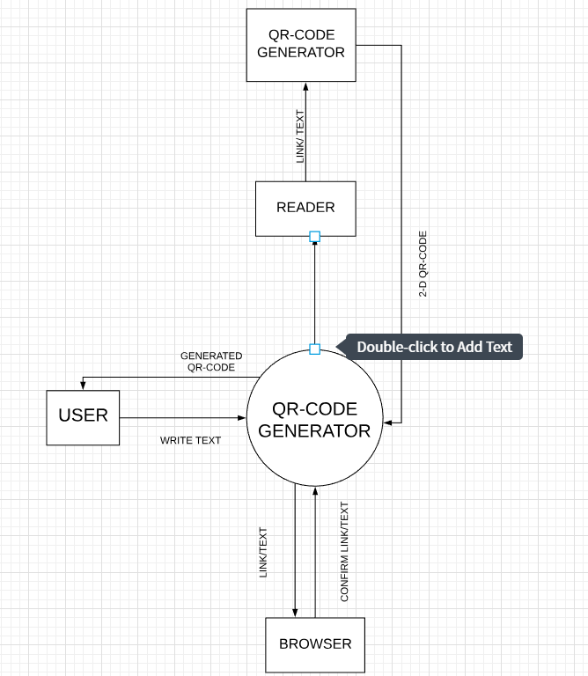

Fig.3.2 : 0-Level DFD