Report :

- In part (a) the number of cache lines required in 64kb/4b = 16kb.
The hit rates are :
gcc.trace - 93.5678%
gzip.trace - 66.7055%
mcf.trace - 01.0316%
swim.trace - 92.4962%
twolf.trace - 98.7161%

Graphical representation of hit ratio for the trace files:
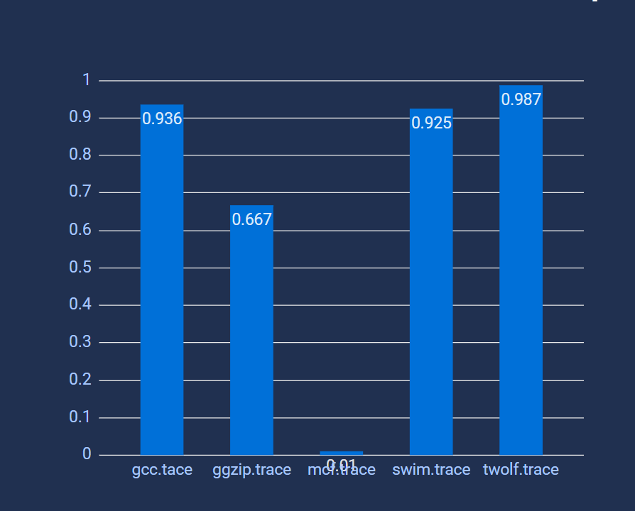
- In part (b) the hit rates for a cache with size 0f 512kb and block size of 4 bytes:
gcc.trace - 93.8259%
gzip.trace - 66.7055%
mcf.trace - 01.0320%
swim.trace - 92.5938%
twolf.trace - 98.7463%

Graphical representation of hit ratio for part (b) for the trace files:
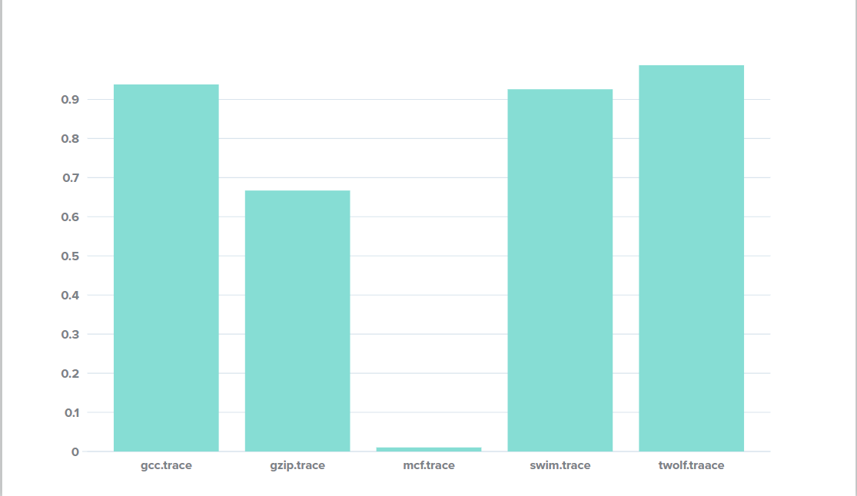

- From parts (a) and (b), we can observe, hit rates increased and miss rates decreased when we increased the cache size while keeping the block size same.

- In part (c), we changed block sizes to different values (1byte, 2bytes, 4bytes, 8bytes, 16bytes, 32 bytes) and cache size is fixed to 64Kb. In this part, when we increased the block size, number of hits increased and number of misses decreased.

Below is the table which shows the different hit ratios for different block sizes for each trace file:
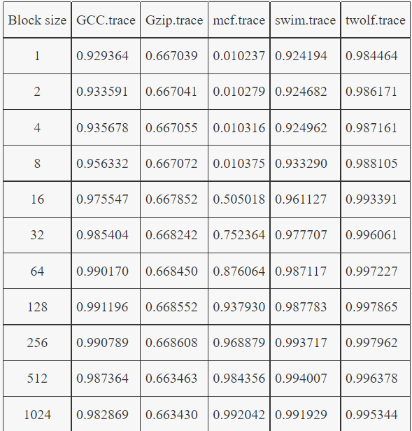

- So, we can conclude one point from these. Hit ratio and (hits/misses)ratio will increase when miss ratio decrease and vice versa.
- When we also start changing block size to different values (64bytes, 128bytes, 256bytes, 512bytes, 1024 bytes), then miss ratio started to increase with the increase in block size for some trace files(gzip, swim, gcc, twolf).
For gcc file the block size greater than or less than 128 has greater miss ratio than that with block size 128.
For gzip file the block size greater than or less than 256 has greater miss ratio than that with block size 256.
For swim file the block size greater than or less than 512 has greater miss ratio than that with block size 512.
For twolf file the block size greater than or less than 256 has greater miss ratio than that with block size 256.

Observation:
- The order of files with max hit rates are twolf.trace > gcc.trace > swim.trace > gzip.trace > mcf.trace.
- We can observe that with increase in block size initially the hit rates increased then we reach a max block size where we observe a max hit rate but upon increasing the block size further we saw a decrease in hit rates.
- With increased cache size if there is more spatial locality over temporal locality then the hit rates increase. Where as if there is more temporal locality over spatial locality then the hit rates decrease.

