INDIAN INSTITUTE OF INFORMATION TECHNOLOGY KOTTAYAM
Department of Computer Science and Engineering
PROJECT REPORT
HYBRID QUANTUM GRAPH NEURAL NETWORK FOR MOLECULAR PROPERTY PREDICTION
HyQCGNN — A gradient-free hybrid quantum-classical graph neural network for predicting the formation energy of ABO3 oxide perovskites
Submitted in partial fulfilment of the requirements for the course: IEG 313 — QUANTUM COMPUTING FOR ENGINEERS
Base paper: M. Vitz, H. Mohammadbagherpoor, S. Sandeep, A. Vlasic, R. Padbury and A. Pham, “Hybrid Quantum Graph Neural Network for Molecular Property Prediction,” arXiv:2405.05205, 2024.
Submitted by: [TEAM NAME]
Tejendra Dronadula — 2024BCD0052
[Member name] — [Roll number]
[Member name] — [Roll number]
[Member name] — [Roll number]
[Member name] — [Roll number]
Under the guidance of: [Guide name], [Co-guide name] — Department of Computer Science and Engineering, Indian Institute of Information Technology Kottayam
Academic Year: 2026–27

ABSTRACT
Graph neural networks can predict materials properties far faster than density functional theory, and hybrid quantum-classical models have been proposed as a way to add quantum feature encoding to them. This project re-implements and evaluates the gradient-free Hybrid Quantum-Classical Graph Neural Network (HyQCGNN) of Vitz et al. (2024) for predicting the DFT formation energy of ABO3 oxide perovskites.
Each of 246 crystals from the MatBench/Castelli perovskite data set is encoded as a 5-node, fully connected graph with 7 electronic node features and 4 bond features. A GENConv graph layer compresses the graph into a 5×5 matrix whose 25 entries are amplitude-encoded into a 5-qubit Qiskit circuit with a trainable RX–RY–RZZ ansatz and a trainable read-out layer. The five qubit expectation values are scaled to an energy. The hybrid model (128 parameters) and a classical GENConv counterpart (118 parameters) are trained without gradients using Nevergrad’s NGOpt for 2,000 iterations on 196 crystals, selected on 25 and tested on 25, and compared with XGBoost on identical data.
Over five random seeds, the hybrid reaches a test R² of 0.43 ± 0.20 (MAE 0.40 eV), ahead of the classical GNN at 0.29 ± 0.16 (MAE 0.48 eV) on 4 of 5 seeds, while XGBoost reaches 0.66 ± 0.12 (0.73 ± 0.14 when tuned) and wins on every seed. A frozen-circuit ablation shows that the hybrid’s advantage does not come from training the quantum parameters: with its 30 circuit angles fixed at random values it scores 0.41 ± 0.15. Measuring with 1,024 shots lowers the mean R² by less than 0.01. With all 2,652 ABO3 oxides, XGBoost reaches R² 0.96 and the classical GNN (0.57) overtakes the hybrid (0.55).
The results confirm that a gradient-free hybrid quantum GNN is trainable and competitive with its classical counterpart on small data, but they attribute its benefit to the bounded, normalised quantum feature map acting as a regulariser rather than to quantum learning. They also show that single 25-crystal test splits vary by up to 0.6 in R², which explains much of the gap to the published values.
Keywords: Quantum machine learning, hybrid quantum-classical neural network, graph neural network, GENConv, amplitude encoding, variational quantum circuit, gradient-free optimisation, Nevergrad, perovskites, formation energy, Qiskit.

TABLE OF CONTENTS
ABSTRACT
1. INTRODUCTION
- 1.1 Background
- 1.2 Problem Statement
- 1.3 Motivation
- 1.4 Objectives
- 1.5 Scope of the Project
2. LITERATURE REVIEW
- 2.1 Machine Learning for Materials Discovery
- 2.2 Graph Neural Networks and GENConv
- 2.3 Quantum Machine Learning and Amplitude Encoding
- 2.4 Gradient-Free Optimisation
- 2.5 The Base Paper (Vitz et al., 2024)
- 2.6 Research Gap
3. NOVELTY AND PROJECT CONTRIBUTION
- 3.1 Project Contribution
- 3.2 Distinguishing Features
- 3.3 Difference from a Basic Re-implementation
4. METHODOLOGY AND SYSTEM DESIGN
- 4.1 Overall Workflow
- 4.2 Dataset and Problem Formulation
- 4.3 Crystal-to-Graph Featurisation
- 4.4 Classical Encoder: GENConv and Graph Reduction
- 4.5 Quantum Layer
- 4.6 Output Head and Target Scaling
- 4.7 Gradient-Free Training
- 4.8 XGBoost Baseline
- 4.9 Evaluation Metrics
- 4.10 Experimental Design
5. IMPLEMENTATION
- 5.1 Software and Tools
- 5.2 Project Structure
- 5.3 Experiment Execution
- 5.4 Efficient Simulation of the Quantum Layer
- 5.5 Testing and Validation
6. RESULTS AND DISCUSSION
- 6.1 Data Set
- 6.2 Training Behaviour
- 6.3 Test-Set Performance (Seed 42)
- 6.4 Robustness Across Seeds
- 6.5 Does the Quantum Layer Matter? (Frozen-Circuit Ablation)
- 6.6 Shot Noise
- 6.7 Optimiser, Feature Set and Data Size
- 6.8 Feature Importance
- 6.9 Why Our Numbers Differ from the Paper
- 6.10 Interpretation of Results
7. CONCLUSION AND FUTURE WORK
- 7.1 Conclusion
- 7.2 Limitations
- 7.3 Future Work
8. TEAM CONTRIBUTIONS
9. REFERENCES
10. APPENDICES
- Appendix A — Experimental Configuration
- Appendix B — Per-Seed Results
- Appendix C — Model Parameter Counts
- Appendix D — Reproducibility and Run Commands

1. INTRODUCTION

1.1 Background
Discovering a new material usually means computing its properties before anyone makes it in a laboratory. Density functional theory (DFT) is the standard tool for this, but its cost grows steeply with system size, so screening thousands of candidate compounds is slow and expensive.
Machine learning offers a shortcut. A model trained on existing DFT results can predict a property such as the formation energy of a new compound in milliseconds instead of hours. Graph neural networks (GNNs) are especially suited to this task, because a crystal is naturally a graph: atoms are nodes and the interactions between them are edges.
In parallel, quantum machine learning asks whether parameterised quantum circuits can act as layers inside such models. One attraction is amplitude encoding: n qubits can hold 2^n numbers as the amplitudes of a quantum state, so data can be loaded very compactly.
This project re-implements and studies the hybrid quantum-classical graph neural network (HyQCGNN) proposed by Vitz et al. (2024). The model joins a classical GENConv graph layer to a 5-qubit Qiskit circuit and is trained entirely without gradients, using the Nevergrad NGOpt optimiser. The task is to predict the DFT formation energy of ABO3 oxide perovskites.

1.2 Problem Statement
The base paper reports that a gradient-free hybrid quantum GNN is competitive with a classical GNN and with XGBoost. However, it reports a single train/validation/test split of only 25 test crystals, it does not publish code, and several design details are left open.
The problem addressed in this project is:
Can the HyQCGNN pipeline be rebuilt from the paper’s description, and, when it is evaluated fairly against a classical GNN and XGBoost under identical data, features and training budget, does the quantum layer contribute measurable predictive value?

1.3 Motivation
Perovskites (ABO3) are used in solar cells, fuel cells, catalysts and ferroelectric devices, and their formation energy is a first indicator of whether a compound is stable enough to synthesise. A fast and reliable predictor therefore has direct practical value.
From the quantum-computing side, the hybrid model is small enough (5 qubits, 30 circuit parameters) to simulate exactly on a laptop and to run on current NISQ hardware. This makes it a good test case for an honest question: does a quantum layer help, or does it only look competitive because a single small test split is noisy?
Gradient-free training is also interesting in its own right. It avoids the parameter-shift rule, which needs two extra circuit evaluations per parameter for every gradient, and it sidesteps vanishing gradients (barren plateaus) in variational circuits.

1.4 Objectives
- Build a reproducible data pipeline that downloads the Castelli perovskite data set from MatBench, keeps the ABO3 oxides and turns each crystal into a graph with the paper’s node and edge descriptors.
- Implement the classical GENConv model, the hybrid quantum model and an XGBoost baseline that all use the same split, features and standardisation.
- Implement the 5-qubit quantum layer (amplitude encoding, trainable ansatz and trainable read-out) in Qiskit, and verify it against a full circuit simulation.
- Train both GNNs with Nevergrad NGOpt for 2,000 iterations, select the model on the validation set and score the untouched test set once.
- Repeat every experiment over five random seeds to measure how much a 25-crystal test score varies.
- Run ablations that isolate the quantum layer (frozen circuit), the optimiser, the feature set, shot noise and the amount of training data.
- Compare the results with the paper and explain the differences.

1.5 Scope of the Project
The study uses classical simulation of the quantum circuit: exact statevector expectation values for training, and 1,024-shot sampling to estimate the effect of measurement noise. It does not run on quantum hardware and does not model gate errors or decoherence.
The main experiments use the paper’s data size (246 crystals, split 196/25/25). An additional study uses all 2,652 ABO3 oxides in the data set. The project makes no claim of quantum advantage; its aim is a careful, reproducible comparison.

2. LITERATURE REVIEW

2.1 Machine Learning for Materials Discovery
Data-driven models now predict many materials properties close to DFT accuracy at a tiny fraction of the cost. Benchmarks such as MatBench [3] collect standard tasks so that models can be compared fairly. One of them, matbench_perovskites, contains 18,928 cubic perovskites with DFT formation energies from the Castelli data set [2]. This project uses that task, restricted to the 2,652 ABO3 oxides.
The descriptors used here follow established chemistry. Electronegativity and electron affinity are known to matter for formation energies of binary compounds, ionisation potential and ionic radii predict perovskite stability, and Ewald site energies capture long-range electrostatics [1]. All of them are computed with pymatgen [8].

2.2 Graph Neural Networks and GENConv
Crystal graph networks such as CGCNN [9] showed that learning directly on atom-and-bond graphs beats hand-built feature vectors for many properties. GENConv, from the DeeperGCN work [4], adds two ideas used in this project:
- Generalised aggregation. Messages from neighbours are combined with a softmax whose inverse temperature t is learned. A small t behaves like mean aggregation and a large t like max aggregation, so the model chooses its own pooling.
- Message normalisation. The aggregated message is normalised and rescaled by a learnable factor s before it is added to the node’s own features, which stabilises training and lets edge features enter the update.

2.3 Quantum Machine Learning and Amplitude Encoding
A variational quantum circuit (VQC) is a sequence of parameterised gates whose angles are trained like neural-network weights. To use one inside a classical network, classical data must first be loaded into a quantum state. Amplitude encoding writes a normalised vector of 2^n numbers into the amplitudes of an n-qubit state. Five qubits can therefore hold 32 numbers, enough for the 25 entries of a 5×5 matrix.
The circuit output is a set of expectation values such as ⟨Z_i⟩, each between −1 and +1. Training a VQC with gradients needs the parameter-shift rule, which costs two circuit evaluations per parameter per step [15], and deep random circuits suffer from barren plateaus where gradients vanish exponentially [10].

2.4 Gradient-Free Optimisation
Gradient-free (black-box) optimisers only need the value of the loss for a proposed parameter vector. Nevergrad [5] is an open-source library of such methods. Its default, NGOpt, is an “algorithm-selection wizard” that picks and combines strategies (for example CMA-ES, differential evolution or (1+1) evolution strategies) according to the dimension and budget of the problem [6]. Black-box methods scale poorly to millions of weights, but the models here have only about 120 parameters, which is well within their range.

2.5 The Base Paper (Vitz et al., 2024)
Vitz et al. [1] build HyQCGNN in five steps: featurise each perovskite as a graph, compress it with a GENConv layer into a symmetric weight matrix, flatten that matrix, amplitude-encode it into a 5-qubit circuit with a trainable ansatz and read-out, and scale the measured expectation values to a formation energy. Both the hybrid and a purely classical GENConv model are trained with NGOpt for 2,000 iterations on 196 crystals, selected on 25 validation crystals and scored on 25 test crystals. XGBoost [7] serves as a baseline and for feature-importance analysis.
The paper reports these test R² values (linear fit of true vs predicted):
Model | R² reported (Fig. 3)
Classical GENConv | 0.759
Hybrid HyQCGNN | 0.626
XGBoost | 0.861
The abstract quotes R² = 0.674 for the hybrid, which differs from the 0.626 printed in its own Figure 3b. The paper concludes that the hybrid is competitive but does not beat the classical models, and that the A-site first ionisation energy is the most important feature.

2.6 Research Gap
The paper leaves several questions open that matter for judging the quantum layer:
- One split, 25 test points. With so few test crystals, R² can move by 0.1 or more between random splits. No error bars are reported.
- No ablation of the circuit. It is not shown whether training the 30 circuit angles helps, or whether the GENConv layer does all the work.
- Unclear evaluation set for XGBoost. The paper’s XGBoost parity plot shows far more than 25 points, so it may not be scored on the same 25 test crystals as the GNNs.
- Unspecified details. Node ordering, how GENConv output becomes a 5×5 matrix, how 25 values fill 32 amplitudes and how ⟨Z⟩ values become an energy are not described, and no code is released.
This project fills these gaps with an open, documented implementation, a five-seed study and targeted ablations.

3. NOVELTY AND PROJECT CONTRIBUTION

3.1 Project Contribution
The main contribution is an open, end-to-end and tested re-implementation of HyQCGNN, together with an evaluation that is stricter than the original paper’s. All three models share one data pipeline, one split per seed, one standardisation and one test protocol, so any difference between them comes from the model and not from the setup.

3.2 Distinguishing Features
- Faithful hybrid architecture. GENConv with learnable softmax temperature and message scaling, a 5×5 graph reduction, amplitude encoding on 5 qubits, an RX–RY–RZZ-ring ansatz and a trainable RX–RY–RZ read-out, as in the paper’s Figure 2.
- Fully gradient-free training with Nevergrad NGOpt for both GNNs, with validation-based model selection and a single, final test evaluation.
- Fast, verified quantum simulation. The input-independent part of the circuit is turned into one 32×32 unitary per parameter set and applied to all crystals with a single matrix product. A unit test checks that this equals the full Qiskit circuit.
- Multi-seed evaluation. Every main result is repeated over five seeds (42, 1, 2, 3, 4), each giving a new split, initialisation and optimiser run, and is reported as mean ± standard deviation.
- Frozen-circuit ablation. The hybrid is retrained with the 30 circuit angles fixed at random values, which isolates what training the quantum layer adds.
- Shot-noise evaluation. The trained hybrid is also scored with 1,024 measurement shots per circuit, as on a real device.
- Further ablations. Five optimisers, a reduced feature set (the paper’s Figure 4 features), longer training (10,000 iterations), a tuned XGBoost and the full 2,652-crystal data set.
- Robust featurisation. A fallback for oxidation states when pymatgen cannot charge-balance a hypothetical compound, which otherwise silently zeroes the Ewald energies and ionic radii for about a third of the crystals.

3.3 Difference from a Basic Re-implementation
A basic re-implementation would train each model once and compare three numbers with the paper. This project instead asks how stable those numbers are, which part of the hybrid is responsible for its performance, and why the reproduced values differ from the published ones. It also documents every design choice the paper left open (Section 4), so the work can be checked and extended.

4. METHODOLOGY AND SYSTEM DESIGN

4.1 Overall Workflow
The pipeline has seven stages: download and filter the data, featurise each crystal as a graph, split and standardise, build the three models, train the two GNNs without gradients, score the test set once, and analyse the results across seeds and ablations.
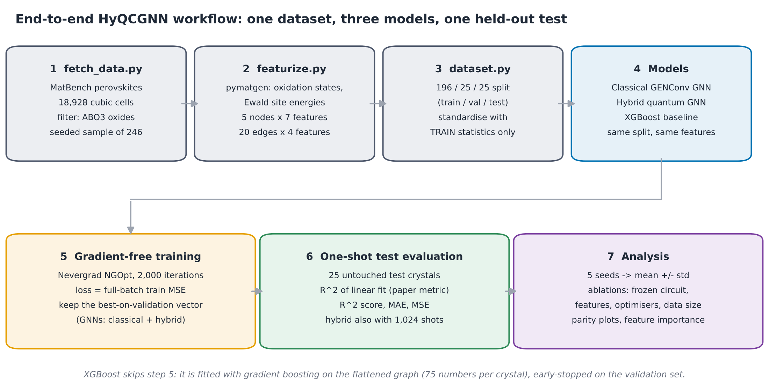
Figure 1: End-to-end workflow. Steps 1–3 are shared by all models; XGBoost is fitted directly on the flattened graphs instead of step 5.

4.2 Dataset and Problem Formulation
The data come from matbench_perovskites [3], which packages the Castelli perovskite data set [2]: 18,928 five-atom cubic perovskite cells with DFT formation energies in eV per cell. Following the paper, only oxides with formula ABO3 are kept (one A cation, one B cation, three oxygens), which leaves 2,652 structures. A seeded random sample of 246 of them (seed 42) forms the paper-sized data set.
The task is regression. Given the crystal structure S, predict its formation energy E:
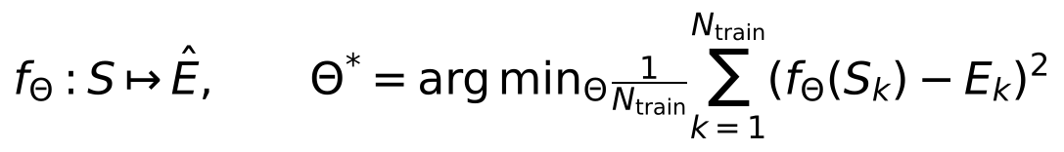
The 246 crystals are split 196 / 25 / 25 into training, validation and test sets, exactly as in the paper. Each seed draws a different permutation, so each seed is a different split.

4.3 Crystal-to-Graph Featurisation
Every ABO3 primitive cell has exactly five atoms, so every crystal becomes a fully connected graph with 5 nodes and 20 directed edges. The node order is fixed to [A, B, O, O, O]. The A site (12-fold cage) and B site (octahedral) are taken from the data set’s own site order, which was checked against the geometry of every undistorted cell. A fixed order is what makes “atom 0” mean the A cation in every crystal, which both the 5×5 matrix and the XGBoost table rely on.
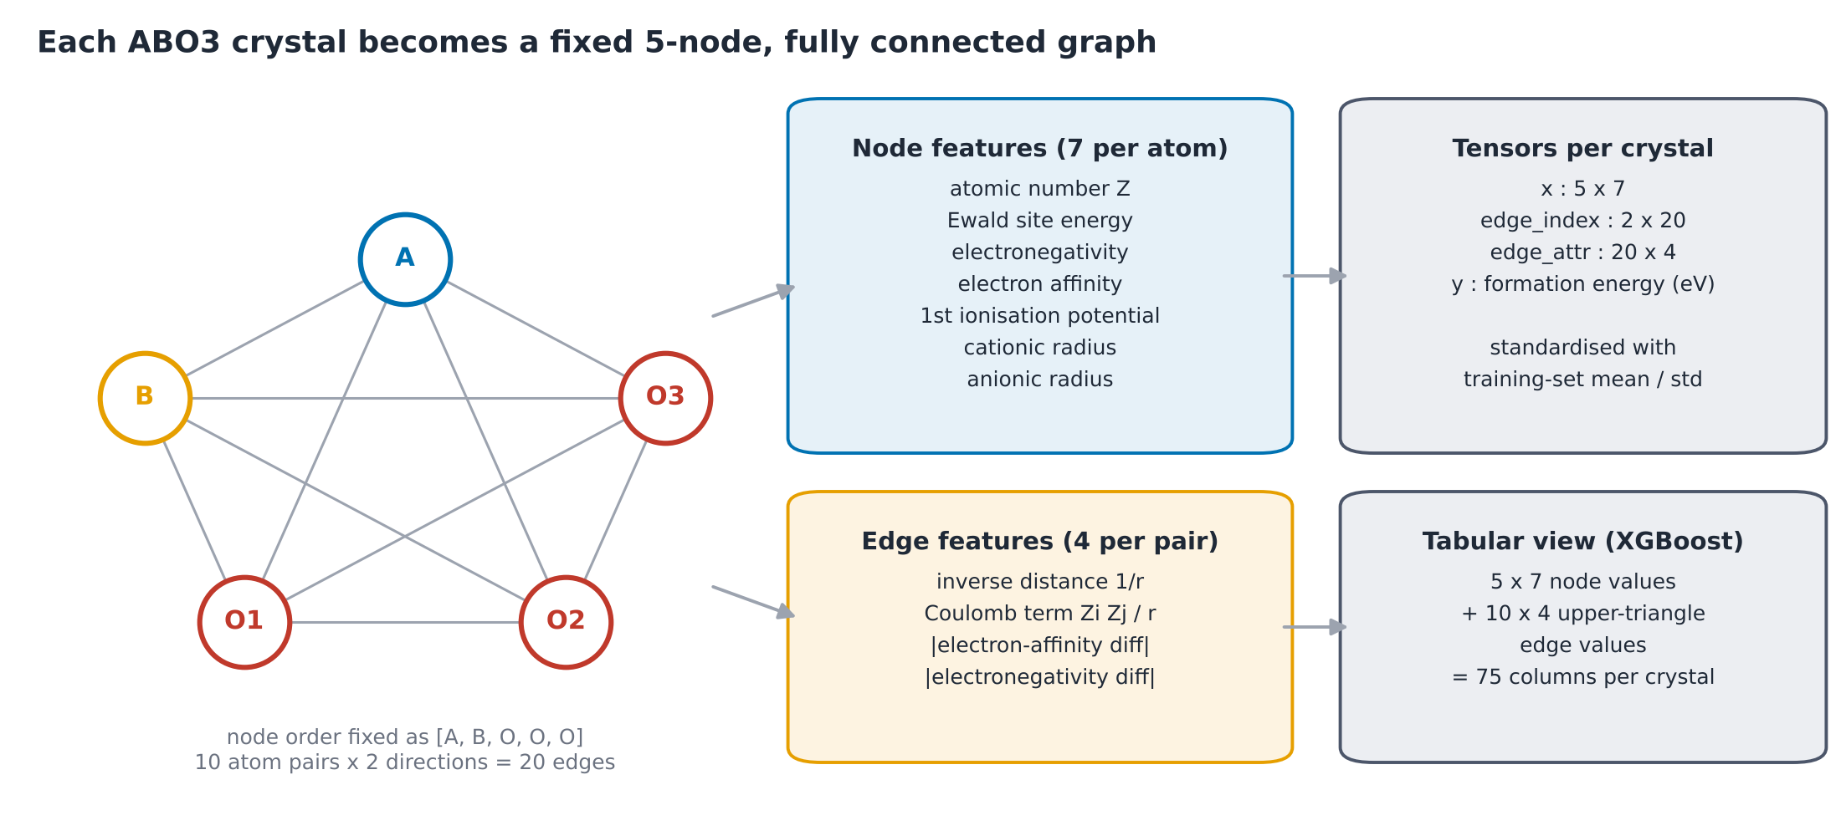
Figure 2: Each crystal becomes a 5-node fully connected graph with 7 node features and 4 edge features.
Type | Feature | How it is computed
Node | Atomic number Z | pymatgen Element
Node | Ewald site energy | pymatgen EwaldSummation on the oxidation-decorated cell
Node | Electronegativity | Pauling scale
Node | Electron affinity | tabulated value
Node | First ionisation potential | first entry of the element’s ionisation energies
Node | Cationic radius | Shannon ionic radius if the ion is a cation, else 0
Node | Anionic radius | Shannon ionic radius if the ion is an anion, else 0
Edge | Inverse distance | 1 / r with periodic minimum-image distance r (Å)
Edge | Coulomb potential | Z_i · Z_j / r (off-diagonal Coulomb-matrix term)
Edge | Electron-affinity difference | absolute difference of the two atoms
Edge | Electronegativity difference | absolute difference of the two atoms
Oxidation-state fallback. Ewald energies and ionic radii need oxidation states. pymatgen’s charge-balanced guess fails for 76 of the 246 sampled crystals, because many Castelli compounds are hypothetical (for example CaScO3 cannot reach +6 on its cations). Without a fix, every state silently stays at 0, which zeroes the Ewald energies and radii for those crystals. The implementation fixes O at −2 and picks the pair of known cation states whose sum is closest to +6, preferring common states. 30 of the 76 then balance exactly; the remaining 46 keep the closest possible charge.
All node and edge features are standardised to zero mean and unit variance using statistics from the training graphs only, so no information leaks from the validation or test sets.

4.4 Classical Encoder: GENConv and Graph Reduction
One GENConv layer [4] maps the 7 node features to a hidden width of 4. For a node v with neighbours u, the message from u includes the edge features, messages are combined with a learnable-temperature softmax, normalised, and added back:
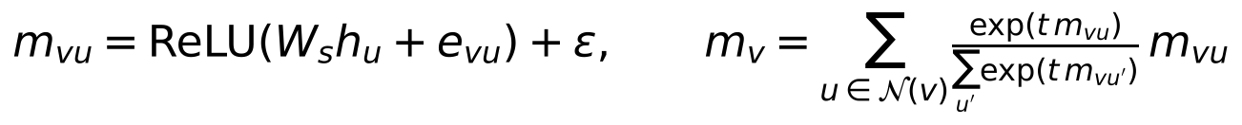
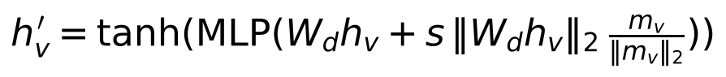
Here t (inverse temperature) and s (message scale) are learned. The MLP is a single linear layer, as in the paper’s footnote.
The paper says GENConv produces “an intermediate graph with one node feature and one edge feature” that is represented as a symmetric weight matrix, but does not say how. This implementation uses two small heads:
- a node head (linear 4 → 1) gives one scalar per atom, placed on the diagonal;
- an edge head (linear on [h_u, h_v, e_uv], 12 → 1) gives one scalar per edge, placed off the diagonal.
The matrix is symmetrised, W = (W + Wᵀ)/2, and flattened row by row into a vector x of 25 numbers. This is the input to the quantum layer.

4.5 Quantum Layer
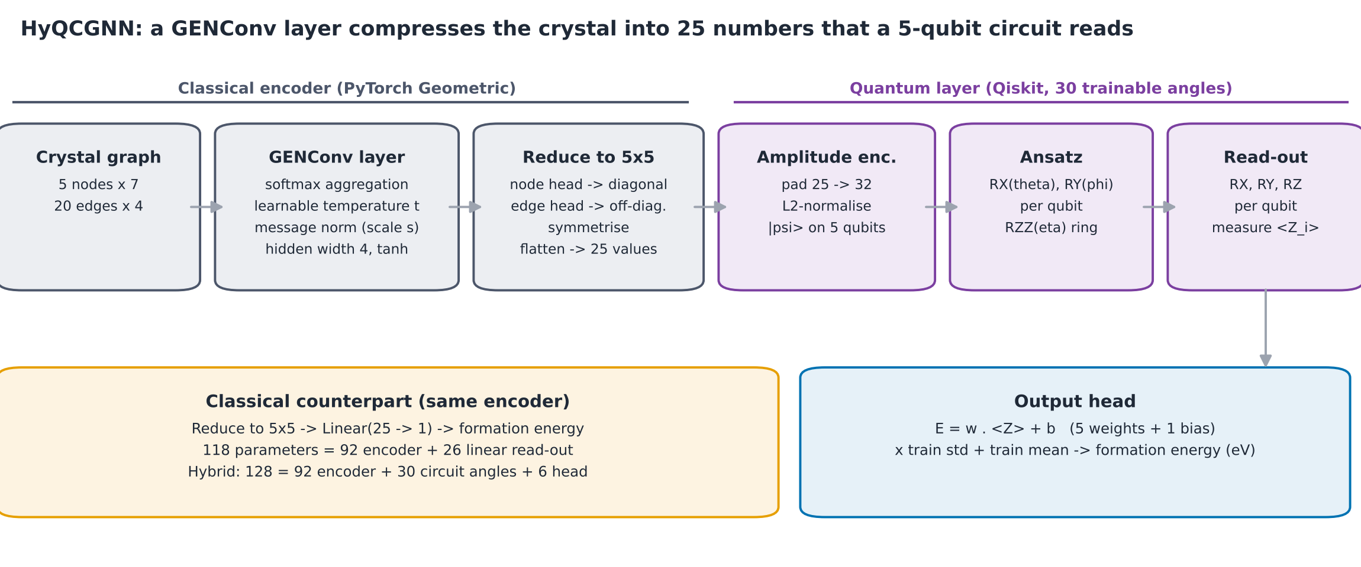
Figure 3: The classical encoder compresses each crystal to 25 numbers; the 5-qubit circuit turns them into five expectation values.
The quantum layer has four parts (Figure 4).
1. Amplitude encoding. The 25 numbers are zero-padded to 32 = 2^5 and normalised, then written into the amplitudes of a 5-qubit state:
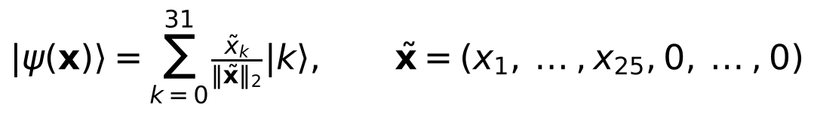
2. Trainable ansatz. An RX(θ_q) and RY(φ_q) rotation on every qubit, followed by a ring of entangling RZZ(η_q) gates on the pairs (0,1), (1,2), (2,3), (3,4) and (4,0).
3. Trainable read-out. RX(α_q), RY(β_q) and RZ(λ_q) on every qubit. Because these rotations come just before measurement, they let the model choose which observable it effectively measures.
4. Measurement. The expectation value ⟨Z_q⟩ of each qubit, computed from the outcome probabilities p(b) of the 32 basis states:
The circuit has 30 trainable angles (6 per qubit), 30 gates after encoding (10 RX, 10 RY, 5 RZ, 5 RZZ) and a depth of 10 after encoding.
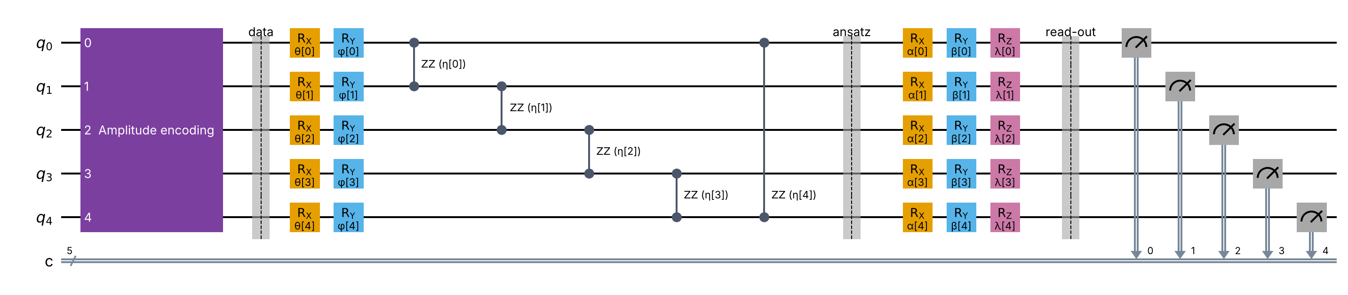
Figure 4: The 5-qubit circuit drawn with Qiskit: amplitude encoding, the RX–RY–RZZ-ring ansatz, the RX–RY–RZ read-out and Z-basis measurement.

4.6 Output Head and Target Scaling
The five expectation values are combined with five trainable weights and one bias. The model learns the standardised target, and its output is mapped back to electron-volts with the training-set mean μ_y and standard deviation σ_y:
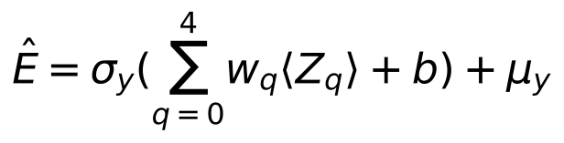
Target scaling matters because ⟨Z_q⟩ lies in [−1, 1] while formation energies span about −0.3 to 3.2 eV. All reported errors are in eV.
The classical model uses the same encoder but replaces the circuit and head with one linear layer from the 25 matrix entries to the energy. It has 118 parameters; the hybrid has 128 (Appendix C), so the comparison is close to like-for-like in size.

4.7 Gradient-Free Training
Nevergrad optimises one flat vector that holds every trainable number: GENConv weights, temperature, message scale, the two heads, the 30 circuit angles and the output weights. Each iteration follows the paper’s eight-step workflow (Figure 5):
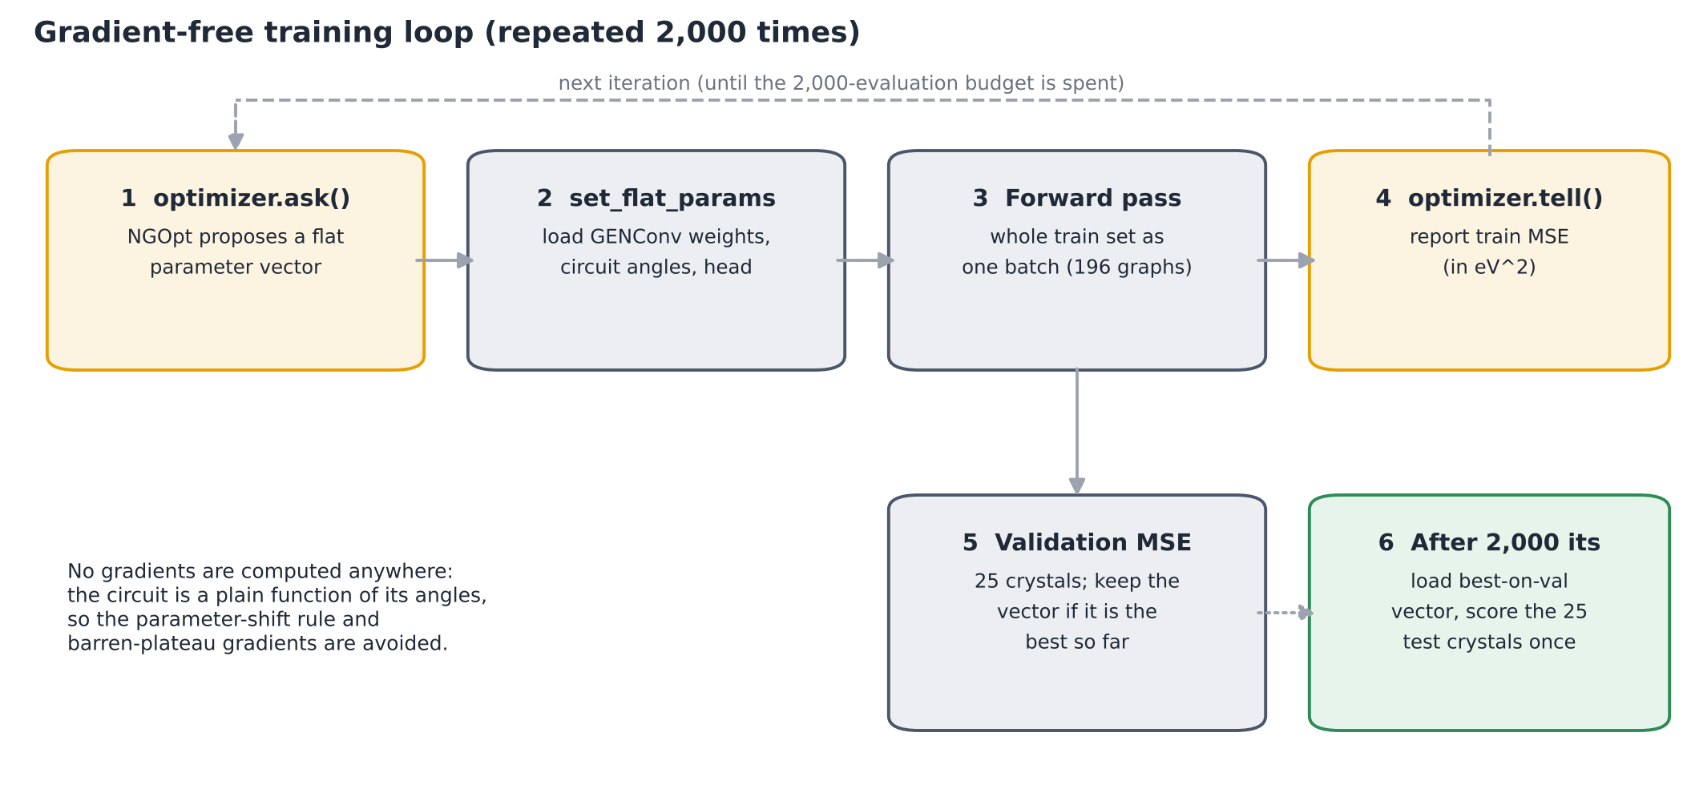
Figure 5: One NGOpt iteration. The optimiser sees only the training loss; the validation loss is used only to remember the best vector.
- NGOpt proposes a candidate vector (ask).
- The vector is loaded into the model.
- The training MSE is computed on all 196 training crystals as one batch and reported back (tell).
- The validation MSE is computed; if it is the best so far, the vector is saved.
After 2,000 iterations the best-on-validation vector is loaded and scored on the 25 test crystals exactly once. The optimiser, data split and model initialisation all use the same seed.

4.8 XGBoost Baseline
Because every graph has the same size and node order, it can be flattened into a table row: 5 × 7 node values plus 10 × 4 edge values for the upper-triangle pairs, 75 columns in all. XGBoost [7] is trained on the 196 training rows (1,000 trees, learning rate 0.05, maximum depth 4, subsample 0.9, column sample 0.9) with early stopping after 50 rounds without improvement on the 25 validation rows. A tuned variant picks hyper-parameters by 60-candidate random search with 5-fold cross-validation on the training rows only.

4.9 Evaluation Metrics
The paper’s figure of merit is the R² of a simple linear fit between true and predicted energies, which equals the squared Pearson correlation. It rewards a correct ranking even if predictions are shifted or scaled, so this report also gives the stricter coefficient of determination and the mean absolute error:
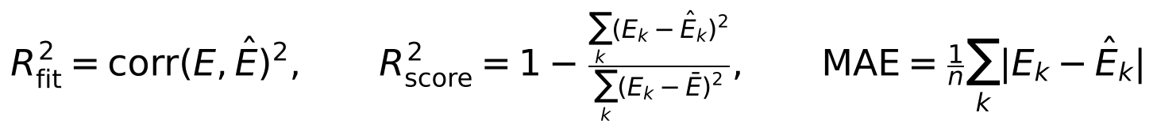

4.10 Experimental Design
Experiment | Models | Seeds | Purpose
Main comparison (2,000 iterations) | XGBoost, classical GNN, hybrid | 42, 1, 2, 3, 4 | Reproduce the paper with error bars
Tuned baseline | XGBoost (random search) | 5 seeds | Check the baseline is not under-tuned
Frozen circuit | Hybrid with circuit angles fixed | 5 seeds | Does training the quantum layer help?
Shot noise | Trained hybrid, 1,024 shots, 20 repeats | 5 seeds | Effect of measurement sampling
Longer training (10,000 iterations) | Classical GNN, hybrid | 5 seeds | Is 2,000 iterations enough?
Optimiser comparison | Hybrid: NGOpt, CMA, TwoPointsDE, PSO, (1+1)-ES | 42 | Sensitivity to the optimiser
Reduced features | All three models, Figure 4 features only | 42 | Do the extra descriptors help?
Full data set (2,652 crystals, 80/10/10) | All three models | 42 | Effect of training-set size
Learning curve | XGBoost, 196 to 2,152 training crystals, 500 fixed test crystals | 5 seeds | How R² grows with data

5. IMPLEMENTATION

5.1 Software and Tools
Purpose | Library | Version used for the results in this report
Language | Python | 3.13
Data set download | matminer | —
Crystal structures, oxidation states, Ewald sums | pymatgen | —
Tensors and modules | PyTorch (CPU) | 2.14.1
Graph layers (GENConv) and batching | PyTorch Geometric | 2.8.1
Quantum circuit, unitary, statevector checks | Qiskit | 2.6.0
Gradient-free optimisation (NGOpt and others) | Nevergrad | 1.0.12
Baseline | XGBoost | 3.4.1
Metrics, cross-validation | scikit-learn | 1.9.1
Plots | Matplotlib | 3.11
Tests | pytest | —
Library references: PyTorch [13], PyTorch Geometric [11], Qiskit [12], Nevergrad [5], XGBoost [7], pymatgen [8], matminer [14].
The data download and featurisation were run once on the project machine; the stored graphs (data/graphs.pt, data/graphs_all.pt) were then reused for every experiment, so all models see byte-identical inputs.

5.2 Project Structure
The code is about 1,300 lines of Python split into single-purpose files. Every constant from the paper (split sizes, feature names, 2,000 iterations, shot counts, seeds) lives in config.py, so the other files contain no magic numbers.
File | Role
config.py | Paths, seeds, split sizes, feature names and subsets, iteration and shot counts
fetch_data.py | Downloads matbench_perovskites, keeps ABO3 oxides, draws the seeded 246-crystal sample (--all keeps all 2,652)
featurize.py | Oxidation states with fallback, Ewald energies, node and edge features, one PyG graph per crystal
dataset.py | Seeded 196/25/25 split (or 80/10/10), train-only standardisation, feature-subset selection, flattening for XGBoost
models/classical_gnn.py | GENConv layer, node and edge heads, 5×5 reduction, classical linear read-out
models/quantum_layer.py | Amplitude encoding, ansatz and read-out circuit in Qiskit, fast batched evaluation, optional shot sampling
models/hybrid_gnn.py | Encoder → quantum layer → scaled output; flat-vector get/set helpers for Nevergrad
train_gradient_free.py | NGOpt loop, validation model selection, one-shot test scoring, shot-noise scoring, all ablation flags
baseline_xgboost.py | XGBoost baseline and feature-importance chart
tune_xgboost.py | Random-search tuning of XGBoost with 5-fold cross-validation on the training rows
xgboost_learning_curve.py | XGBoost on 196 to 2,152 training crystals with a fixed 500-crystal test set
summarize_seeds.py | Mean ± std of test metrics over the five seeds
evaluate.py | Parity plots of true vs predicted energy
tests/test_quantum_layer.py | Checks the fast quantum layer against full Qiskit circuits
make_report_figures.py | Result figures and numbers of this report (Figures 8–12)

5.3 Experiment Execution
All experiments are command-line runs of the scripts above; Appendix D lists the exact commands. Each run writes four files to results/: a metrics JSON, the test predictions, the best parameter vector and the training and validation loss curves. The file name carries every non-default option (for example hybrid_frozenq_s3_metrics.json), so runs never overwrite each other.
For this report every model was re-trained from scratch with the current code: 5 seeds × (XGBoost, tuned XGBoost, classical GNN, hybrid, frozen-circuit hybrid, 10,000-iteration classical and hybrid), plus the optimiser, feature-set and full-data runs, 45 training runs in all. The XGBoost learning curve (Section 6.7) comes from the project machine’s run of xgboost_learning_curve.py on the same featurised data.

5.4 Efficient Simulation of the Quantum Layer
A naive simulation would build and run one Qiskit circuit per crystal per iteration: 221 crystals × 2,000 iterations is about 440,000 circuit executions per training run.
The implementation avoids this. The trainable part of the circuit (ansatz and read-out) does not depend on the input, so for each candidate parameter vector its 32×32 unitary U is built once with Qiskit’s Operator. All encoded inputs are then evolved together with one matrix product, ψ′ = ψ Uᵀ, and the ⟨Z_q⟩ values come from a fixed sign table applied to |ψ′|². The last unitary is cached, because the training and validation passes of one iteration share the same parameters. A full 2,000-iteration hybrid run takes well under a minute on a laptop CPU.
For the shot-noise evaluation, each crystal’s 32 outcome probabilities are sampled with a multinomial draw of 1,024 shots, exactly as a QASM simulator or real device would report counts.

5.5 Testing and Validation
The test suite (pytest tests/ -q) passes all 4 tests:
- Encoding is normalised: amplitude vectors have unit norm and length 32.
- Fast path equals the full circuit: for random inputs and angles, the batched ⟨Z_q⟩ values match a full Qiskit circuit (StatePreparation + ansatz + read-out) simulated with Statevector, to within 10⁻⁸.
- Unitary cache is correct: the same angles return the cached unitary; new angles rebuild it.
- Outputs are physical: every expectation value lies in [−1, 1].
The pipeline also guards against data leakage: feature statistics and the target mean and standard deviation come from training crystals only, model selection uses only the validation set, and the test set is scored once per run.

6. RESULTS AND DISCUSSION
All numbers below come from re-running every model with the final code. Unless stated otherwise, R² means the paper’s metric (R² of the linear fit of true vs predicted energy), “mean ± std” is over the five seeds, and energies are in eV per 5-atom cell.

6.1 Data Set
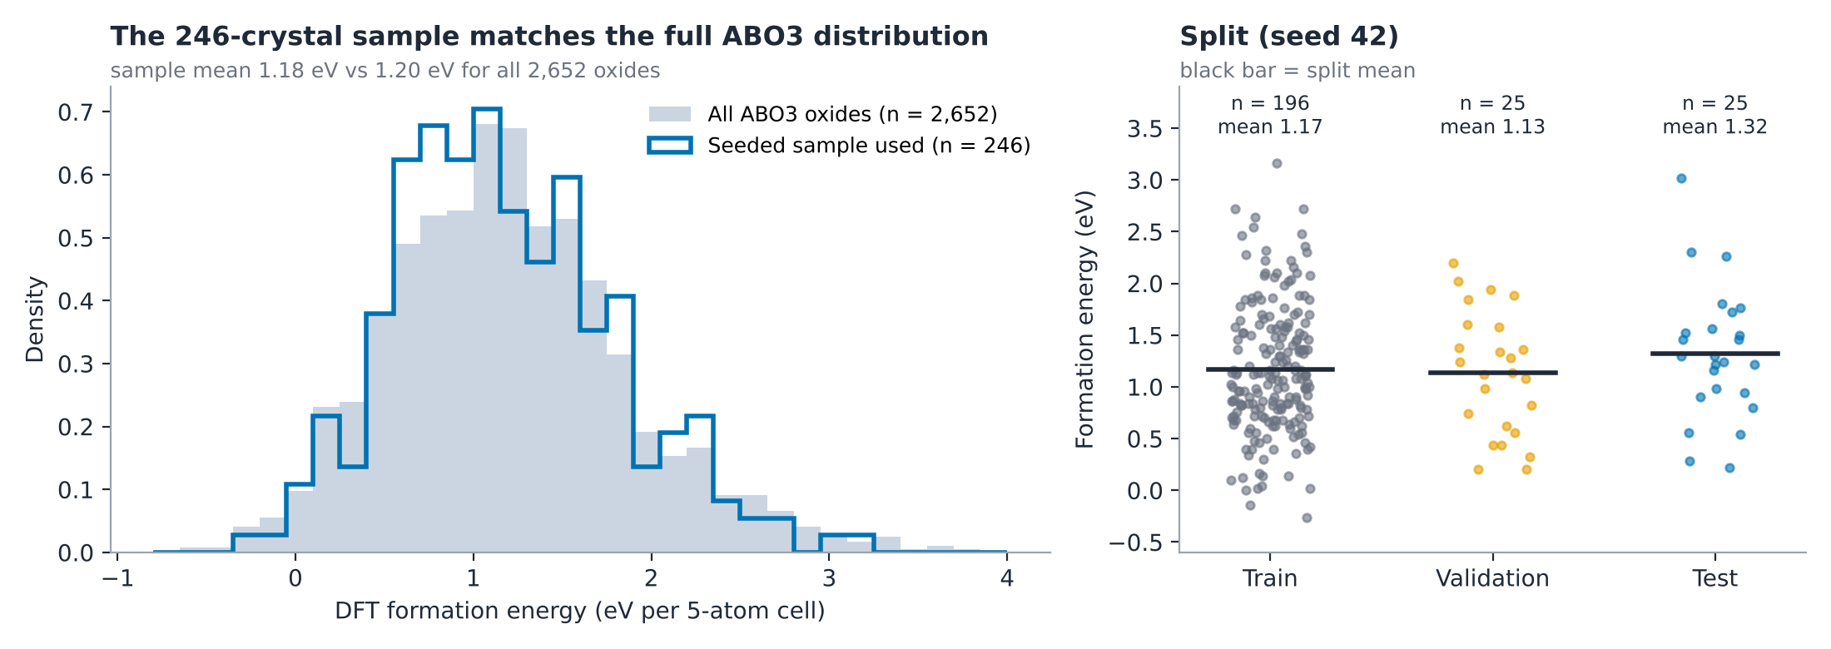
Figure 6: Left, the 246-crystal sample (blue outline) against all 2,652 ABO3 oxides (grey). Right, the seed-42 split.
The sample is representative of the full set: mean 1.18 eV (std 0.62, range −0.26 to 3.16) against 1.20 eV (std 0.67, range −0.64 to 3.98) for all 2,652 oxides. 52 different cation elements appear in the sample, so the models must generalise across chemistry rather than memorise a few elements.
The seed-42 test set is slightly harder than the training set: its mean is 1.32 eV against 1.17 eV for training, and it contains one crystal at 3.0 eV, near the top of the range. With only 25 test crystals, single outliers like this move R² noticeably.

6.2 Training Behaviour
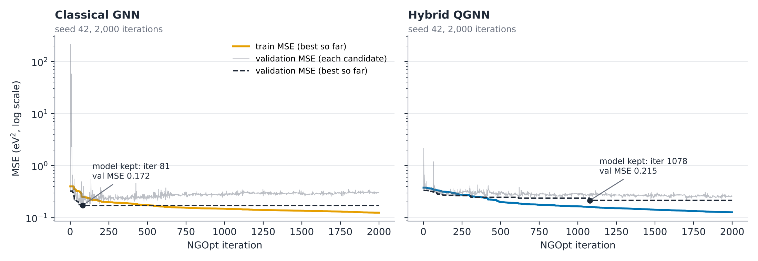
Figure 7: Best-so-far training MSE (coloured), validation MSE of every candidate (grey) and best-so-far validation MSE (dashed), seed 42.
Both models drive the training MSE from about 0.38–0.40 eV² down to about 0.125 eV² in 2,000 iterations, so NGOpt optimises both effectively despite having no gradients.
The validation curves differ. The classical model reaches its best validation MSE (0.172) at iteration 81, after which its validation error drifts upward while training error keeps falling: a clear sign of overfitting to 196 crystals. The hybrid improves on validation much more slowly and keeps improving until iteration 1,078 (validation MSE 0.215). Its output passes through bounded expectation values in [−1, 1], which appears to limit how quickly it can fit noise.
A 2,000-iteration run takes about 14 s for the classical model and 20 s for the hybrid (2-core cloud CPU, exact simulation).

6.3 Test-Set Performance (Seed 42)
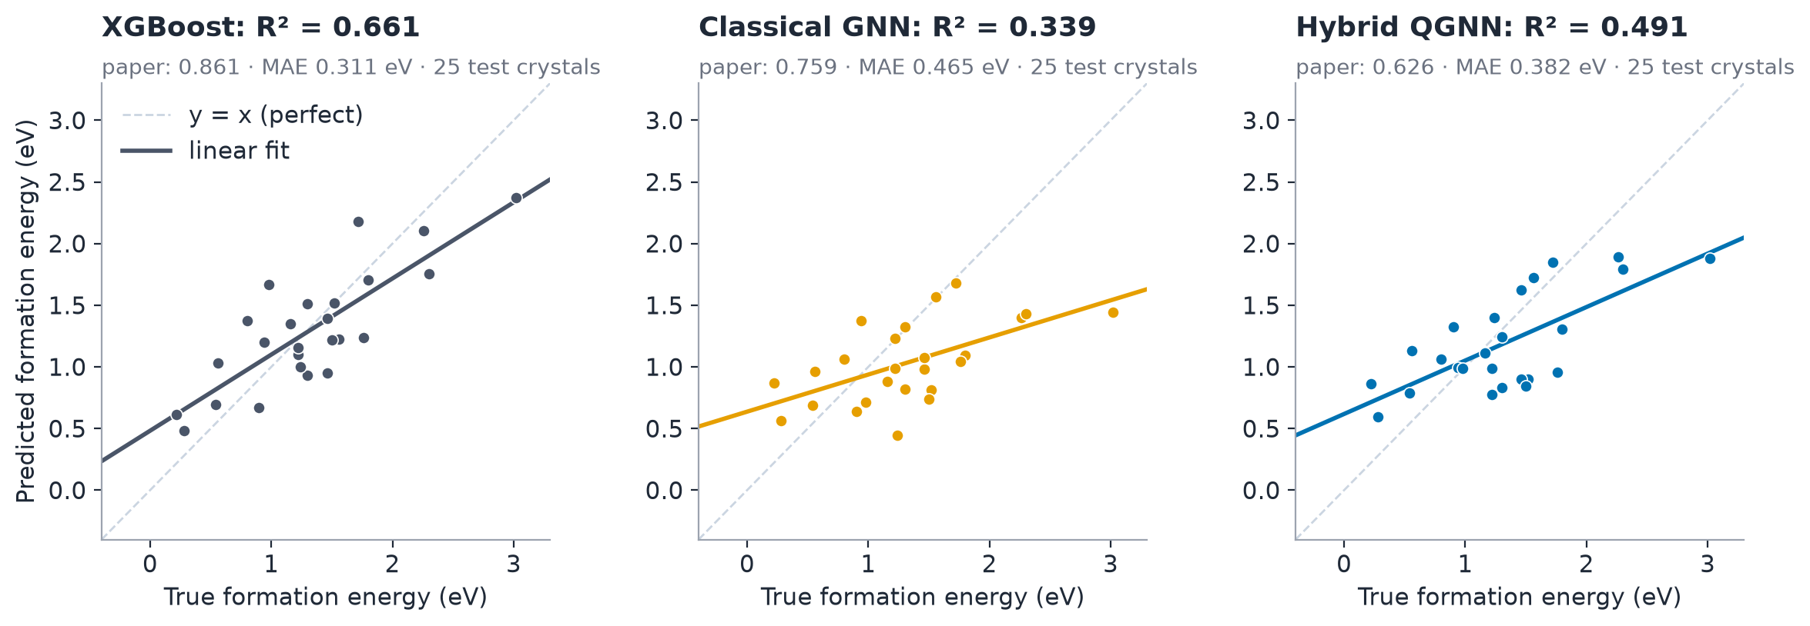
Figure 8: True vs predicted formation energy on the 25 seed-42 test crystals. Dashed: perfect prediction; solid: linear fit.
Model | R² (linear fit) | R² score | MAE (eV) | Paper R²
XGBoost (tuned) | 0.827 | 0.816 | 0.226 | —
XGBoost | 0.661 | 0.657 | 0.311 | 0.861
Hybrid QGNN | 0.491 | 0.441 | 0.382 | 0.626
Classical GNN | 0.339 | 0.124 | 0.465 | 0.759
XGBoost is clearly best. The hybrid beats the classical GNN on every metric for this seed. Both GNNs compress their predictions toward the mean (their fitted lines are flatter than the diagonal), which is typical of an under-fitted regressor: they rank crystals better than they predict absolute values, so their R² score is lower than their linear-fit R².

6.4 Robustness Across Seeds
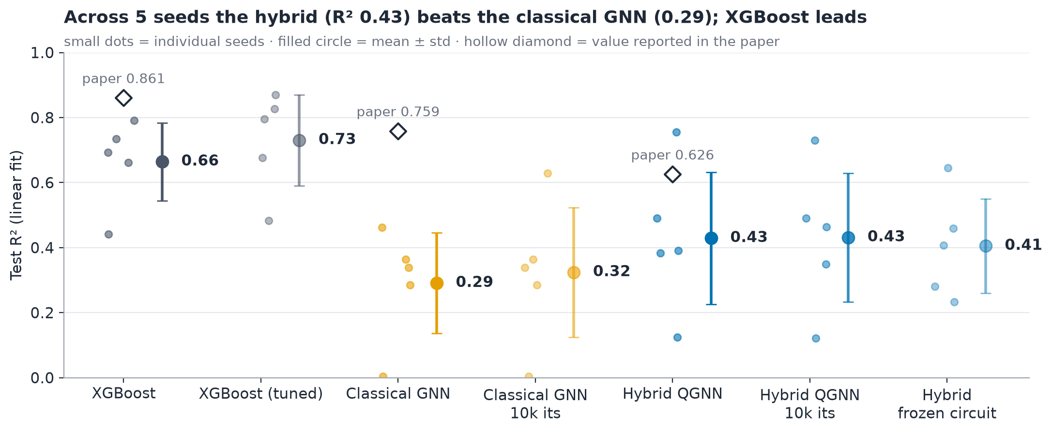
Figure 9: Test R² for each seed (small dots), mean ± std (large dot with bar) and the value reported in the paper (hollow diamond).
Model | R² (linear fit) | R² score | MAE (eV) | Trainable parameters
XGBoost (tuned) | 0.730 ± 0.140 | 0.701 ± 0.139 | 0.278 ± 0.068 | —
XGBoost | 0.664 ± 0.120 | 0.631 ± 0.107 | 0.313 ± 0.049 | —
Hybrid QGNN | 0.429 ± 0.203 | 0.379 ± 0.203 | 0.398 ± 0.059 | 128
Hybrid, 10,000 iterations | 0.431 ± 0.198 | 0.375 ± 0.206 | 0.397 ± 0.043 | 128
Hybrid, frozen circuit | 0.405 ± 0.145 | 0.354 ± 0.127 | 0.400 ± 0.026 | 98
Classical GNN, 10,000 iterations | 0.324 ± 0.199 | 0.179 ± 0.280 | 0.468 ± 0.075 | 118
Classical GNN | 0.291 ± 0.155 | 0.144 ± 0.237 | 0.482 ± 0.051 | 118
Three findings hold across seeds:
- XGBoost beats the hybrid on every seed, by 0.04 to 0.57 in R². Tuning it adds another 0.07 on average.
- The hybrid beats the classical GNN on 4 of 5 seeds, by 0.14 R² on average, and has a lower MAE (0.40 vs 0.48 eV). This is the opposite of the paper’s ordering.
- The spread is large. The hybrid ranges from R² 0.12 (seed 3) to 0.75 (seed 4) and the classical GNN from 0.00 to 0.46. A single 25-crystal test split can therefore move a model’s score by more than the gap between models, so single-split comparisons, including the paper’s, should be read with caution.
Training five times longer (10,000 iterations) changes almost nothing: for seed 42 both models select exactly the same parameters as at 2,000 iterations, because the best validation score was already found earlier.

6.5 Does the Quantum Layer Matter? (Frozen-Circuit Ablation)
The key ablation keeps the 30 circuit angles at their random starting values and lets NGOpt train only the classical parts (98 parameters). If the trained circuit were doing useful learning, this model should be clearly worse.
It is not. The frozen-circuit hybrid scores R² 0.405 ± 0.145 against 0.429 ± 0.203 for the fully trained hybrid. The trained version wins on only 3 of 5 seeds and by 0.024 on average, well inside the seed-to-seed noise. Both versions are clearly ahead of the classical GNN.
The interpretation is that the hybrid’s advantage over the classical GNN comes from its structure, not from training the circuit. Amplitude encoding normalises the 25-number vector and the circuit maps it to five bounded, non-linear features (⟨Z_q⟩ values). Even a random circuit acts as a fixed non-linear feature map, and the bounded output appears to regularise gradient-free training on a very small data set. Training the angles adds little on top. This is an important qualification of the paper’s claim and was not tested there.

6.6 Shot Noise
Training used exact expectation values. Scoring the same trained hybrids with 1,024 measurement shots per circuit (20 independent draws each) lowers the mean R² only from 0.429 to 0.423. For seed 42 it goes from 0.491 to 0.478 ± 0.023. At this circuit size, sampling noise from 1,024 shots is small compared with the differences between seeds, so the model would be usable on a shot-based simulator or device without retraining (gate noise was not modelled).

6.7 Optimiser, Feature Set and Data Size
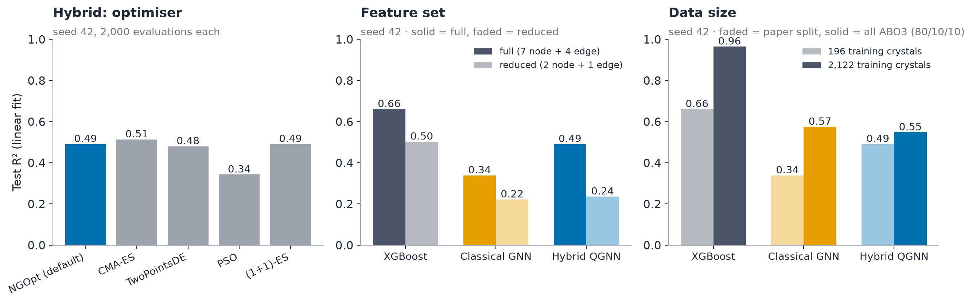
Figure 10: Left, hybrid R² with five gradient-free optimisers. Centre, full vs reduced feature set. Right, paper-sized vs full data set. All seed 42.
Optimiser. With the same 2,000-evaluation budget, CMA-ES (0.514), NGOpt (0.491), (1+1)-ES (0.491) and TwoPointsDE (0.480) give similar results; NGOpt and (1+1)-ES give identical scores. Only PSO is clearly worse (0.343). NGOpt is a sound default.
Feature set. The paper’s Figure 4 shows only ionisation energy, Ewald site energy and Coulomb potential, so a reduced set with just those three types was tested. Every model gets worse: XGBoost 0.661 → 0.503, classical 0.339 → 0.222, hybrid 0.491 → 0.236. The full 7 + 4 descriptor set is needed.
Data size. Training on the full data set (2,122 training and 265 test crystals, 80/10/10 split) raises every model, but not equally:
Model | R², 196 training crystals | R², 2,122 training crystals | MAE, 2,122 (eV)
XGBoost | 0.661 | 0.965 | 0.090
Classical GNN | 0.339 | 0.575 | 0.346
Hybrid QGNN | 0.491 | 0.548 | 0.362
With ten times more data, XGBoost becomes very accurate (MAE 0.09 eV) and the classical GNN overtakes the hybrid. The hybrid’s advantage is therefore a small-data effect: its bounded, normalised representation helps when overfitting is the main problem, but its 5-number bottleneck limits it when data are plentiful.
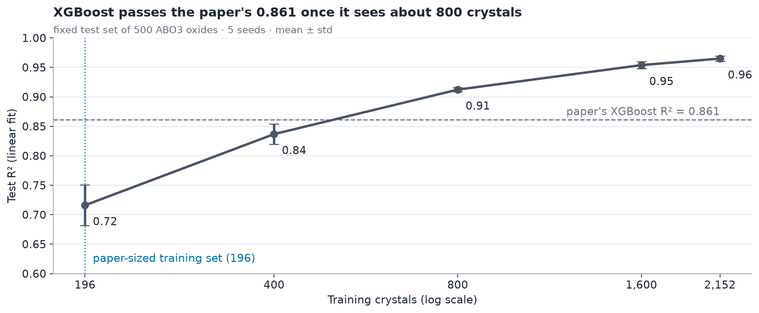
Figure 11: XGBoost test R² against training-set size on a fixed test set of 500 ABO3 oxides (5 seeds).
The learning curve makes the data effect explicit: XGBoost rises from 0.72 ± 0.03 with 196 training crystals to 0.84 with 400, 0.91 with 800 and 0.96 with 2,152. The paper’s XGBoost value of 0.861 sits between 400 and 800 training crystals on this curve.

6.8 Feature Importance
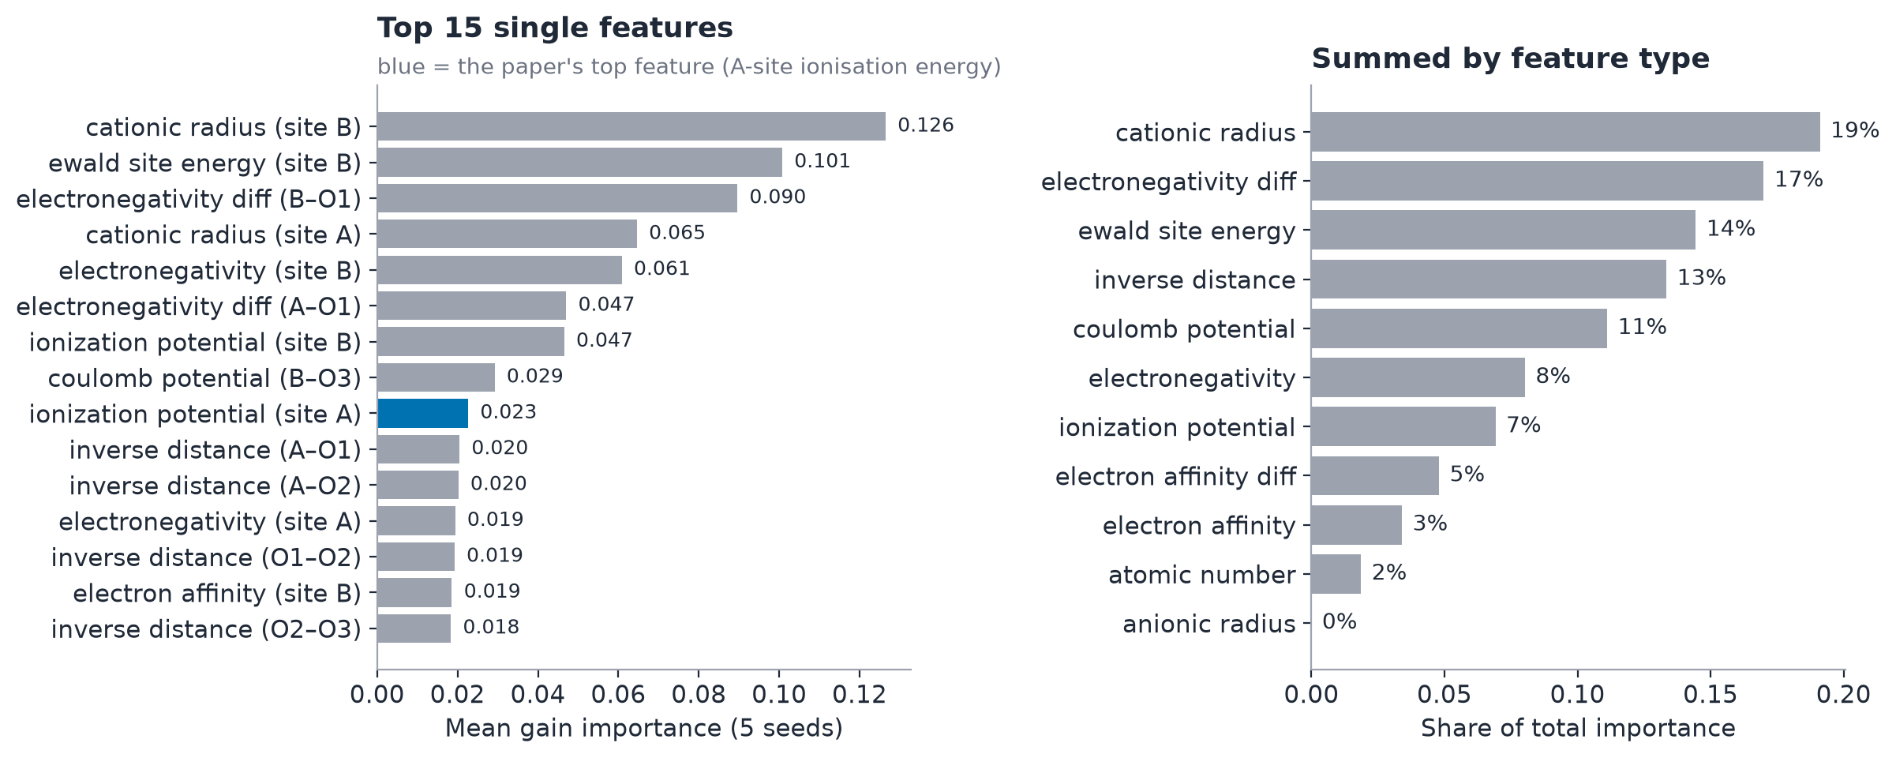
Figure 12: XGBoost gain importance averaged over five seeds; left, the 15 most important single features; right, summed by feature type.
The most important single features are the B-site cationic radius (0.126), the B-site Ewald site energy (0.101), the B–O electronegativity difference (0.090) and the A-site cationic radius (0.065). By type, cationic radius carries 19% of the total importance, followed by electronegativity difference (17%), Ewald energy (14%) and inverse distance (13%).
This is physically sensible. Ionic radii decide whether the A and B cations fit the perovskite lattice (the idea behind the Goldschmidt tolerance factor), and Ewald and Coulomb terms measure electrostatic stability. Anionic radius carries no importance because it is 0 for every cation and identical for every oxygen, so it never varies; atomic number carries only 2%, since the oxygen values are constant and the cation identity is already described by the other descriptors.
The paper’s top feature, the A-site first ionisation energy, ranks 9th here (0.023). One plausible reason is the oxidation-state fallback (Section 4.3): with correct oxidation states, ionic radii and Ewald energies become informative for all crystals and take over much of the signal.

6.9 Why Our Numbers Differ from the Paper
The reproduced R² values are lower than the paper’s for all three models. Several factors, most of them outside this implementation, explain this:
- Different 246 crystals. The paper does not say which 246 of the 2,652 oxides it used. Section 6.4 shows that a different 25-crystal test set alone can change R² by 0.2 or more.
- XGBoost was probably scored on more crystals. The paper’s XGBoost parity plot (Fig. 3c) shows well over 100 points, several times more than 25. If it was trained and tested on a larger set, the learning curve (Figure 11) shows that 0.861 is exactly what XGBoost reaches with 400–800 training crystals.
- Open design details. How GENConv output becomes the 5×5 matrix, how ⟨Z⟩ values become an energy and how the node order is fixed are not given. This project made documented choices (Sections 4.3–4.6) that may differ from the authors’.
- Simulator. The paper used Qiskit’s EstimatorQNN with the QASM simulator; this project used exact statevector values for training and shot sampling only for scoring.
- An internal inconsistency in the paper. The hybrid’s R² is 0.674 in the abstract and 0.626 in Figure 3b.

6.10 Interpretation of Results
- The pipeline works. A gradient-free hybrid quantum GNN can be built and trained end to end on a laptop, and its circuit simulation is verified against Qiskit.
- The hybrid is competitive with the classical GNN, as the paper claims, and on the paper-sized data set it is actually better on average (R² 0.43 vs 0.29).
- But the gain is not from quantum learning. A circuit with frozen random angles performs about as well, so the benefit comes from the normalised, bounded quantum feature map acting as a regulariser, not from training the quantum parameters.
- Classical gradient boosting remains clearly stronger at every data size tested, and the gap widens as data grow.
- Small test sets make single numbers unreliable. Standard deviations of 0.1–0.2 in R² mean that any comparison on 25 test crystals needs multiple seeds or larger test sets.

7. CONCLUSION AND FUTURE WORK

7.1 Conclusion
This project rebuilt the HyQCGNN model of Vitz et al. from its published description and evaluated it more strictly than the original study. The full pipeline (MatBench download, pymatgen featurisation with an oxidation-state fallback, GENConv encoder, 5-qubit amplitude-encoded Qiskit circuit, gradient-free NGOpt training and an XGBoost baseline) runs end to end, and its fast circuit simulation is verified against full Qiskit circuits.
On the paper’s data size (196 training crystals), the hybrid reaches a mean test R² of 0.43 ± 0.20 across five seeds, above the classical GENConv model (0.29 ± 0.16) on 4 of 5 seeds. XGBoost remains clearly better (0.66 ± 0.12, or 0.73 when tuned) and wins on every seed. Shot noise from 1,024 measurements barely matters, and five times more optimiser iterations change nothing.
The frozen-circuit ablation is the most important result. A hybrid whose 30 circuit angles stay at random values performs as well as the trained one (0.41 vs 0.43). The hybrid’s edge over the classical GNN therefore comes from the normalised, bounded quantum feature map regularising gradient-free training on very little data, not from learning in the quantum layer. With ten times more data that edge disappears: the classical GNN overtakes the hybrid, and XGBoost reaches R² 0.96.
In short, the paper’s qualitative claim holds (a gradient-free hybrid quantum GNN is trainable and competitive with a classical GNN), but there is no evidence of a quantum advantage, and comparisons on a single 25-crystal test split are too noisy to rank models reliably.

7.2 Limitations
- Small data. The main experiments use 246 crystals and 25-crystal test sets, which gives R² standard deviations of 0.1–0.2.
- Five seeds. Enough to show the spread, too few for formal significance tests on small differences such as trained vs frozen circuit.
- Simulation only. No quantum hardware was used and gate noise, decoherence and readout errors were not modelled; only shot noise was.
- Interpretation choices. The 5×5 reduction, zero-padding to 32 amplitudes and the weighted ⟨Z⟩ output head are reasonable readings of the paper, not confirmed copies of the authors’ code.
- Different sample. The exact 246 crystals used in the paper are unknown, so the numbers cannot be compared one to one.
- Exact state preparation. Amplitude encoding is simulated as an exact state. On hardware it needs a deep state-preparation circuit, which would add noise and cost.
- One small circuit. Only one ansatz with one layer and 5 qubits was studied.

7.3 Future Work
- Hardware and noise models. Run the trained circuit on a Qiskit noise model and on an IBM Quantum device to measure the effect of gate errors, and compare with the 1,024-shot result.
- Larger and repeated test sets. Use cross-validation or the full 2,652-crystal set with many seeds, so model differences can be tested statistically.
- Deeper or different circuits. Try several ansatz layers, data re-uploading or angle encoding, and check whether a trained circuit then beats a frozen one.
- Hybrid with stronger classical parts. Add more GENConv layers or a wider hidden size; with more data, gradient-based training of the classical part (with parameter-shift or simultaneous perturbation for the circuit) could also be compared.
- Quantum graph embedding. Encode the graph structure itself into the circuit (for example one qubit per atom with entangling gates along bonds) instead of amplitude-encoding a flattened matrix, as the paper suggests.
- Other properties and materials. Apply the same pipeline to band gaps or to other MatBench tasks to test whether the conclusions generalise.

8. TEAM CONTRIBUTIONS
Fill in each member’s name; the work packages below follow the structure of the code.
Member | Roll number | Work package | Main files
Tejendra Dronadula | 2024BCD0052 | [Work package] | [Files]
\[Member name] | [Roll number] | Data pipeline: download, filtering, oxidation-state fallback, featurisation | fetch_data.py, featurize.py, dataset.py
\[Member name] | [Roll number] | Classical GENConv encoder and graph reduction | models/classical_gnn.py
\[Member name] | [Roll number] | Quantum layer in Qiskit, fast simulation, shot sampling and tests | models/quantum_layer.py, tests/
\[Member name] | [Roll number] | Gradient-free training, ablations, XGBoost baseline, analysis and report | train_gradient_free.py, baseline_xgboost.py, tune_xgboost.py, summarize_seeds.py

9. REFERENCES
- M. Vitz, H. Mohammadbagherpoor, S. Sandeep, A. Vlasic, R. Padbury and A. Pham, “Hybrid Quantum Graph Neural Network for Molecular Property Prediction,” arXiv:2405.05205, 2024. https://arxiv.org/abs/2405.05205
- I. E. Castelli, D. D. Landis, K. S. Thygesen et al., “New cubic perovskites for one- and two-photon water splitting using the computational materials repository,” Energy & Environmental Science, 5, 9034–9043, 2012.
- A. Dunn, Q. Wang, A. Ganose, D. Dopp and A. Jain, “Benchmarking materials property prediction methods: the Matbench test set and Automatminer reference algorithm,” npj Computational Materials, 6, 138, 2020.
- G. Li, C. Xiong, A. Thabet and B. Ghanem, “DeeperGCN: All You Need to Train Deeper GCNs,” arXiv:2006.07739, 2020.
- J. Rapin and O. Teytaud, “Nevergrad — A gradient-free optimization platform,” GitHub repository, 2018. https://github.com/facebookresearch/nevergrad
- L. Meunier, H. Rakotoarison, P. K. Wong et al., “Black-Box Optimization Revisited: Improving Algorithm Selection Wizards Through Massive Benchmarking,” IEEE Transactions on Evolutionary Computation, 26(3), 490–500, 2022.
- T. Chen and C. Guestrin, “XGBoost: A Scalable Tree Boosting System,” Proc. 22nd ACM SIGKDD, 785–794, 2016.
- S. P. Ong, W. D. Richards, A. Jain et al., “Python Materials Genomics (pymatgen): A robust, open-source python library for materials analysis,” Computational Materials Science, 68, 314–319, 2013.
- T. Xie and J. C. Grossman, “Crystal Graph Convolutional Neural Networks for an Accurate and Interpretable Prediction of Material Properties,” Physical Review Letters, 120, 145301, 2018.
- J. R. McClean, S. Boixo, V. N. Smelyanskiy, R. Babbush and H. Neven, “Barren plateaus in quantum neural network training landscapes,” Nature Communications, 9, 4812, 2018.
- M. Fey and J. E. Lenssen, “Fast Graph Representation Learning with PyTorch Geometric,” ICLR Workshop on Representation Learning on Graphs and Manifolds, 2019.
- A. Javadi-Abhari et al., “Quantum computing with Qiskit,” arXiv:2405.08810, 2024. https://www.ibm.com/quantum/qiskit
- A. Paszke et al., “PyTorch: An Imperative Style, High-Performance Deep Learning Library,” NeurIPS, 2019.
- L. Ward, A. Dunn, A. Faghaninia et al., “Matminer: An open source toolkit for materials data mining,” Computational Materials Science, 152, 60–69, 2018.
- M. Schuld, V. Bergholm, C. Gogolin, J. Izaac and N. Killoran, “Evaluating analytic gradients on quantum hardware,” Physical Review A, 99, 032331, 2019.

10. APPENDICES

Appendix A — Experimental Configuration
Setting | Value
Source data | matbench_perovskites (Castelli et al.), 18,928 cubic perovskites
Filter | ABO3 oxides (exactly one A, one B, three O): 2,652 structures
Paper-sized sample | 246 crystals, drawn with seed 42
Split | 196 train / 25 validation / 25 test (new permutation per seed)
Full-data split | 80 / 10 / 10 % of 2,652 (2,122 / 265 / 265)
Target | DFT formation energy, eV per 5-atom cell
Graph | 5 nodes [A, B, O, O, O], 20 directed edges, fully connected
Node features | 7: Z, Ewald site energy, electronegativity, electron affinity, 1st ionisation potential, cationic radius, anionic radius
Edge features | 4: 1/r, Z_i Z_j / r, |Δ electron affinity|, |Δ electronegativity|
Reduced feature set | ionisation potential and Ewald site energy (nodes), Coulomb potential (edges)
Standardisation | per feature, training-set mean and std; target also standardised for the GNNs
GENConv | 1 layer, hidden width 4, softmax aggregation with learnable t (init 1.0), message norm with learnable scale, tanh
Graph reduction | node head 4→1 (diagonal), edge head 12→1 (off-diagonal), symmetrised 5×5, flattened to 25
Qubits | 5 (one per atom)
Encoding | amplitude encoding, 25 values zero-padded to 32, L2-normalised
Ansatz | RX(θ) and RY(φ) per qubit, then RZZ(η) ring (0-1, 1-2, 2-3, 3-4, 4-0)
Read-out layer | RX(α), RY(β), RZ(λ) per qubit
Circuit parameters | 30, initialised uniformly in [0, 2π)
Observable | ⟨Z_q⟩ for q = 0…4, combined by 5 weights (init 0.2) + 1 bias (init 0)
Training simulation | exact statevector expectation values
Shot-noise evaluation | 1,024 shots per circuit, averaged over 20 independent draws
Optimiser | Nevergrad NGOpt, budget 2,000 (10,000 in the long-training study)
Loss | full-batch mean squared error on the training set (eV²)
Model selection | lowest validation MSE seen during training
Seeds | 42, 1, 2, 3, 4 (split, initialisation and optimiser)
XGBoost | 1,000 trees, learning rate 0.05, depth 4, subsample 0.9, colsample 0.9, early stopping 50 rounds, 1 CPU thread
Tuned XGBoost | 60-candidate random search, 5-fold CV on training rows

Appendix B — Per-Seed Results
Each seed is a different 196/25/25 split, initialisation and optimiser run. “Mean ± std” uses the population standard deviation over the five seeds.
Table B.1 — Test R² (linear fit)
Model | Seed 42 | Seed 1 | Seed 2 | Seed 3 | Seed 4 | Mean ± std
XGBoost | 0.661 | 0.735 | 0.441 | 0.693 | 0.791 | 0.664 ± 0.120
XGBoost (tuned) | 0.827 | 0.796 | 0.483 | 0.676 | 0.870 | 0.730 ± 0.140
Classical GNN | 0.339 | 0.463 | 0.284 | 0.004 | 0.364 | 0.291 ± 0.155
Classical GNN, 10k its | 0.339 | 0.628 | 0.284 | 0.004 | 0.364 | 0.324 ± 0.199
Hybrid QGNN | 0.491 | 0.384 | 0.391 | 0.124 | 0.755 | 0.429 ± 0.203
Hybrid QGNN, 10k its | 0.491 | 0.463 | 0.350 | 0.122 | 0.730 | 0.431 ± 0.198
Hybrid, frozen circuit | 0.459 | 0.407 | 0.280 | 0.233 | 0.645 | 0.405 ± 0.145
Hybrid QGNN, 1,024 shots | 0.478 | 0.380 | 0.385 | 0.125 | 0.744 | 0.423 ± 0.199
Hybrid QGNN, 10k its, 1,024 shots | 0.478 | 0.462 | 0.341 | 0.122 | 0.715 | 0.423 ± 0.193
Hybrid, frozen circuit, 1,024 shots | 0.453 | 0.388 | 0.259 | 0.232 | 0.615 | 0.389 ± 0.139
Table B.2 — Test R² score (coefficient of determination)
Model | Seed 42 | Seed 1 | Seed 2 | Seed 3 | Seed 4 | Mean ± std
XGBoost | 0.657 | 0.631 | 0.435 | 0.676 | 0.758 | 0.631 ± 0.107
XGBoost (tuned) | 0.816 | 0.715 | 0.462 | 0.656 | 0.858 | 0.701 ± 0.139
Classical GNN | 0.124 | 0.387 | 0.182 | −0.292 | 0.317 | 0.144 ± 0.237
Classical GNN, 10k its | 0.124 | 0.564 | 0.182 | −0.292 | 0.317 | 0.179 ± 0.280
Hybrid QGNN | 0.441 | 0.378 | 0.364 | 0.038 | 0.674 | 0.379 ± 0.203
Hybrid QGNN, 10k its | 0.441 | 0.434 | 0.320 | 0.025 | 0.656 | 0.375 ± 0.206
Hybrid, frozen circuit | 0.382 | 0.349 | 0.235 | 0.227 | 0.576 | 0.354 ± 0.127
Table B.3 — Test MAE (eV per cell)
Model | Seed 42 | Seed 1 | Seed 2 | Seed 3 | Seed 4 | Mean ± std
XGBoost | 0.311 | 0.295 | 0.406 | 0.264 | 0.291 | 0.313 ± 0.049
XGBoost (tuned) | 0.226 | 0.254 | 0.408 | 0.276 | 0.227 | 0.278 ± 0.068
Classical GNN | 0.465 | 0.402 | 0.496 | 0.560 | 0.486 | 0.482 ± 0.051
Classical GNN, 10k its | 0.465 | 0.332 | 0.496 | 0.560 | 0.486 | 0.468 ± 0.075
Hybrid QGNN | 0.382 | 0.420 | 0.429 | 0.468 | 0.294 | 0.398 ± 0.059
Hybrid QGNN, 10k its | 0.382 | 0.388 | 0.426 | 0.459 | 0.331 | 0.397 ± 0.043
Hybrid, frozen circuit | 0.377 | 0.406 | 0.448 | 0.384 | 0.387 | 0.400 ± 0.026
Table B.4 — Single-seed ablations (seed 42, test R² linear fit)
Run | XGBoost | Classical GNN | Hybrid QGNN
Full features, 196 training crystals (baseline) | 0.661 | 0.339 | 0.491
Reduced features | 0.503 | 0.222 | 0.236
All 2,652 oxides (2,122 training) | 0.965 | 0.575 | 0.548
Hybrid optimiser comparison (seed 42): NGOpt 0.491, CMA-ES 0.514, TwoPointsDE 0.480, PSO 0.343, (1+1)-ES 0.491.

Appendix C — Model Parameter Counts
Component | Parameters | Detail
GENConv source / target linear maps | 28 + 28 | 7 → 4 each, no bias
GENConv MLP | 16 | 4 → 4, no bias
Softmax temperature t, message scale s | 1 + 1 | learnable scalars
Node head | 5 | 4 → 1 with bias
Edge head | 13 | 12 → 1 with bias
Shared encoder total | 92
Classical read-out | 26 | 25 → 1 with bias
Classical GNN total | 118
Circuit angles | 30 | θ, φ, η, α, β, λ (5 each)
Output weights and bias | 6 | 5 + 1
Hybrid total | 128 | 98 classical + 30 quantum
Frozen-circuit hybrid (trainable) | 98 | circuit angles fixed at their random start

Appendix D — Reproducibility and Run Commands
pip install -r requirements.txt
# data (once)
python fetch_data.py --all # 246-crystal sample + all 2,652 ABO3 oxides
python featurize.py # data/graphs.pt
python featurize.py --all # data/graphs_all.pt
# main comparison, one seed (repeat with --seed 1, 2, 3, 4)
python baseline_xgboost.py --seed 42
python tune_xgboost.py --seed 42
python train_gradient_free.py --model classical --seed 42
python train_gradient_free.py --model hybrid --seed 42
# ablations
python train_gradient_free.py --model hybrid --freeze-quantum --seed 42
python train_gradient_free.py --model hybrid --iterations 10000 --seed 42
python train_gradient_free.py --model hybrid --optimizer CMA # also TwoPointsDE, PSO, OnePlusOne
python train_gradient_free.py --model hybrid --features reduced
python train_gradient_free.py --model hybrid --dataset all
python xgboost_learning_curve.py
# summaries, plots, tests
python summarize_seeds.py
python evaluate.py
python make_report_figures.py
pytest tests/ -q
Every run writes <tag>_metrics.json, <tag>_predictions.npz, <tag>_best_params.npy and <tag>_curves.npz to results/. Exact timings depend on the machine; all numbers in this report are deterministic for a given seed and library version.
— End of report —

