AssignmentNumber:9.4
Name:J.Tejesh Hall:2303a51812
Batch-26
 |  | 1 | Lab 9 – Documentation Generation: Automatic Documentation and Code Comments  Lab Objectives  - To use AI-assisted coding tools for generating Python documentation and code comments.  - To apply zero-shot, few-shot, and context-based prompt engineering for documentation creation.  - To practice generating and refining docstrings, inline comments, and module-level documentation.  - To compare outputs from different prompting styles for quality analysis.  Lab Outcomes  - Generate structured code documentation using AI tools  - Apply appropriate documentation styles to different code contexts  - Improve code readability through selective commenting  - Convert informal developer comments into professional documentation  - Analyze and refine AI-generated documentation | Week 5

Task 1: Auto-Generating Function Documentation in a Shared Codebase

Scenario
You have joined a development team where several utility functions are already implemented, but the code lacks proper documentation. New team members are struggling to understand how these functions should be used.

Task Description
You are given a Python script containing multiple functions without any docstrings.
Using an AI-assisted coding tool:
- Ask the AI to automatically generate Google-style function docstrings for each function
- Each docstring should include:
  - A brief description of the function
  - Parameters with data types
  - Return values
  - At least one example usage (if applicable)
Experiment with different prompting styles (zero-shot or context-based) to observe quality differences.

Expected Outcome
- A Python script with well-structured Google-style docstrings
- Docstrings that clearly explain function behavior and usage
- Improved readability and usability of the codebase

Promt:
##Generate Google-style docstrings for the following Python functions.
#Include:
#- Brief description
#- Parameters with data types
#- Return value
#- Example usage
Code:
def add(a, b):
"""
Adds two numbers and returns the result.

Args:
a (int or float): First number.
b (int or float): Second number.

Returns:
int or float: Sum of the two numbers.

Example:
>>> add(2, 3)
5
"""
return a + b

add(5, 10)
def is_even(n):
"""
Checks whether a number is even.

Args:
n (int): Input number.

Returns:
bool: True if even, False otherwise.

Example:
>>> is_even(6)
True
"""
return n % 2 == 0
# Example usage of the add function
print(add(5, 10)) # Example usage of the add function
print(is_even(4)) # Example usage of the is_even function
Output:
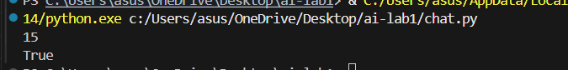

Task 2: Enhancing Readability Through AI-Generated Inline Comments

Scenario
A Python program contains complex logic that works correctly but is difficult to understand at first glance. Future maintainers may find it hard to debug or extend this code.

Task Description
You are provided with a Python script containing:
- Loops
- Conditional logic
- Algorithms (such as Fibonacci sequence, sorting, or searching)
Use AI assistance to:
- Automatically insert inline comments only for complex or non-obvious logic
- Avoid commenting on trivial or self-explanatory syntax
The goal is to improve clarity without cluttering the code.

Expected Outcome
- A Python script with concise, meaningful inline comments
- Comments that explain why the logic exists, not what Python syntax does
- Noticeable improvement in code readability
Promt:
#Add inline comments only for complex or non-obvious logic.
#Do not comment on simple or self-explanatory syntax.

Code:
def fibonacci(n):
a, b = 0, 1 # Initialize first two Fibonacci numbers
for _ in range(n):
# Move forward in the Fibonacci sequence
a, b = b, a + b
return a
print(fibonacci(10)) # Output: 55

Output:
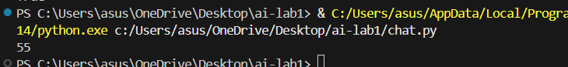

Task 3: Generating Module-Level Documentation for a Python Package

Scenario
Your team is preparing a Python module to be shared internally (or uploaded to a repository). Anyone opening the file should immediately understand its purpose and structure.

Task Description
Provide a complete Python module to an AI tool and instruct it to automatically generate a module-level docstring at the top of the file that includes:
- The purpose of the module
- Required libraries or dependencies
- A brief description of key functions and classes
- A short example of how the module can be used
Focus on clarity and professional tone.

Expected Outcome
- A well-written multi-line module-level docstring
- Clear overview of what the module does and how to use it
- Documentation suitable for real-world projects or repositories
Promt:
#Generate a professional module-level docstring.
#Include:
#- Purpose of the module
#- Dependencies
#- Description of functions
#- Example usage

Code:

"""
math_utils.py

This module provides basic mathematical utility functions.

Dependencies:
None

Functions:
add(a, b): Returns the sum of two numbers.
subtract(a, b): Returns the difference of two numbers.

Example:
>>> from math_utils import add
>>> add(4, 5)
9
"""

def add(a, b):
return a + b

def subtract(a, b):
return a - b
print(add(4, 5))
print(subtract(10, 3))

Output:
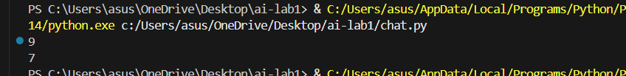

Task 4: Converting Developer Comments into Structured Docstrings

Scenario
In a legacy project, developers have written long explanatory comments inside functions instead of proper docstrings. The team now wants to standardize documentation.

Task Description
You are given a Python script where functions contain detailed inline comments explaining their logic.
Use AI to:
- Automatically convert these comments into structured Google-style or NumPy-style docstrings
- Preserve the original meaning and intent of the comments
- Remove redundant inline comments after conversion

Expected Outcome
- Functions with clean, standardized docstrings
- Reduced clutter inside function bodies
- Improved consistency across the codebase
Promt:
#Convert inline developer comments into Google-style docstrings.
#Removeredundant comments after conversion.
#Preserve the original meaning.

Code:
def divide(a, b):
"""
Divides one number by another.

Args:
a (int or float): Numerator.
b (int or float): Denominator.

Returns:
float or None: Division result or None if division by zero.
"""
if b == 0:
return None
return a / b

Output:
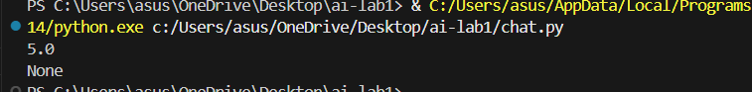

Task 5: Building a Mini Automatic Documentation Generator

Scenario
Your team wants a simple internal tool that helps developers start documenting new Python files quickly, without writing documentation from scratch.

Task Description
Design a small Python utility that:
- Reads a given .py file
- Automatically detects:
  - Functions
  - Classes
- Inserts placeholder Google-style docstrings for each detected function or class
AI tools may be used to assist in generating or refining this utility.
Note: The goal is documentation scaffolding, not perfect documentation.

Expected Outcome
- A working Python script that processes another .py file
- Automatically inserted placeholder docstrings
- Clear demonstration of how AI can assist in documentation automation

Promt:
#Create a Python utility that detects functions and classes
and inserts placeholder Google-style docstrings.
Focus on documentation scaffolding.

Code:
import ast
def generate_docstrings(file_path):
with open(file_path, "r") as file:
tree = ast.parse(file.read())
for node in tree.body:
if isinstance(node, ast.FunctionDef):
print(f'Function: {node.name}')
print('"""')
print("Description:")
print("\nArgs:")
for arg in node.args.args:
print(f" {arg.arg} (type): description")
print("\nReturns:")
print(" type: description")
print('"""')
print()
Output:

Note: Report should be submitted a word document for all tasks in a single document with prompts, comments & code explanation, and output and if required, screenshots

