Assignment Number: 4.3
Hall:2303A51812 Name:Tejesh batch-26
 | Q.No. | Question | Expected Time  to complete
 | 1 | Lab 4: Advanced Prompt Engineering – Zero-shot, One-shot, and Few-shot Techniques  Lab Objectives  - To explore and apply different levels of prompt examples in AI-assisted code generation  - To understand how zero-shot, one-shot, and few-shot prompting affect AI output quality  - To evaluate the impact of context richness and example quantity on AI performance  - To build awareness of prompt strategy effectiveness for different problem types  Lab Outcomes (LOs)  After completing this lab, students will be able to:  - Use zero-shot prompting to instruct AI with minimal context  - Use one-shot prompting with a single example to guide AI code generation  - Apply few-shot prompting using multiple examples to improve AI responses  - Compare AI outputs across different prompting strategies  Task 1: Zero-Shot Prompting – Leap Year Check  Scenario  Zero-shot prompting involves giving instructions without providing examples.  Task Description  Use zero-shot prompting to instruct an AI tool to generate a Python function that:  - Accepts a year as input  - Checks whether the given year is a leap year  - Returns an appropriate result  Note: No input-output examples should be provided in the prompt.  Expected Output  - AI-generated leap year checking function  - Correct logical conditions  - Sample input and output  - Screenshot of AI-generated response (if required)  Promt: // generate a leap year checker program in Java  Code:  // generate a leap year checker program in Java  import java.util.Scanner;  public class Main {  public static void main(String[] args) {  Scanner scanner = new Scanner(System.in);  System.out.print("Enter a year: ");  int year = scanner.nextInt();  if (isLeapYear(year)) {  System.out.println(year + " is a leap year.");  } else {  System.out.println(year + " is not a leap year.");  }  scanner.close();  }  public static boolean isLeapYear(int year) {  if (year % 4 == 0) {  if (year % 100 == 0) {  return year % 400 == 0;  }  return true;  }  return false;  }  }  Output:  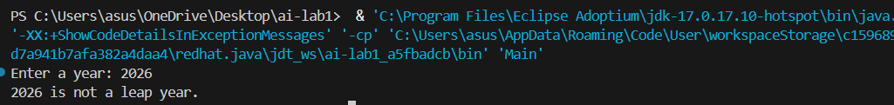  Understanding:  1.The year which is divisible by 4 and divisible by 100 and 400 is leap year  2.The Year which is not divisible by 4 is not a Leap Year  Task 2: One-Shot Prompting – Centimeters to Inches Conversion  Scenario  One-shot prompting guides AI using a single example.  Task Description  Use one-shot prompting by providing one input-output example to generate a Python function that:  - Converts centimeters to inches  - Uses the correct mathematical formula  Example provided in prompt:  Input: 10 cm → Output: 3.94 inches  Expected Output  - Python function with correct conversion logic  - Accurate calculation  - Sample test cases and outputs  Promt: // generate a code Input: 10 cm → Output: 3.94 inches  Code:  // generate a code Input: 10 cm → Output: 3.94 inches  import java.util.Scanner;  public class Main {  public static void main(String[] args) {  Scanner scanner = new Scanner(System.in);  System.out.print("Enter length in centimeters: ");  double cm = scanner.nextDouble();  double inches = cm / 2.54;  System.out.printf("%.2f cm is equal to %.2f inches.%n", cm, inches);  scanner.close();  }  }  Output:  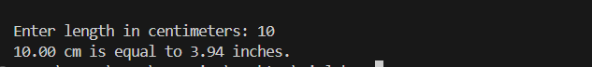  Understanding:  1.The code is generated using input and output example which is oneshot promting  2.To convert cm to inches we need to do cm/2.54 gives inches for centimeter  Task 3: Few-Shot Prompting – Name Formatting  Scenario  Few-shot prompting improves accuracy by providing multiple examples.  Task Description  Use few-shot prompting with 2–3 examples to generate a Python function that:  - Accepts a full name as input  - Formats it as “Last, First”  Example formats:  - "John Smith" → "Smith, John"  - "Anita Rao" → "Rao, Anita"  Expected Output  - Well-structured Python function  - Output strictly following example patterns  - Correct handling of names  - Sample inputs and outputs  Promt: // generate a code example1-"John Smith" → "Smith, John"example2-"Anita Rao" → "Rao, Anita"  Code:  // generate a code example1-"John Smith" → "Smith, John"example2-"Anita Rao" → "Rao, Anita"  public class Main {  public static void main(String[] args) {  String name1 = "John Smith";  String name2 = "Anita Rao";  System.out.println(reformatName(name1)); // Output: Smith, John  System.out.println(reformatName(name2)); // Output: Rao, Anita  }  public static String reformatName(String fullName) {  String[] parts = fullName.split(" ");  if (parts.length != 2) {  throw new IllegalArgumentException("Input must be a first and last name separated by a space.");  }  return parts[1] + ", " + parts[0];  }  }  Output:  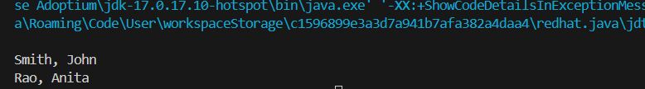  Understanding:  1.In this I had given few shot promt where I had given two examples to generate code  2.In this it string and converted into string array and with index the word reversed  Task 4: Comparative Analysis – Zero-Shot vs Few-Shot  Scenario  Different prompt strategies may produce different code quality.  Task Description  - Use zero-shot prompting to generate a function that counts vowels in a string  - Use few-shot prompting for the same problem  - Compare both outputs based on:  - Accuracy  - Readability  - Logical clarity  Expected Output  - Two vowel-counting functions  - Comparison table or short reflection paragraph  - Conclusion on prompt effectiveness  Zero shot promt: // generate a code for to find count of vowels in a given string  Code:  // generate a code for to find count of vowels in a given string  import java.util.Scanner;  public class Main {  public static void main(String[] args) {  Scanner scanner = new Scanner(System.in);  System.out.print("Enter a string: ");  String input = scanner.nextLine();  int vowelCount = countVowels(input);  System.out.println("Number of vowels in the given string: " + vowelCount);  scanner.close();  }  public static int countVowels(String str) {  int count = 0;  String vowels = "aeiouAEIOU";  for (int i = 0; i < str.length(); i++) {  char ch = str.charAt(i);  if (vowels.indexOf(ch) != -1) {  count++;  }  }  return count;  }  }  Output:  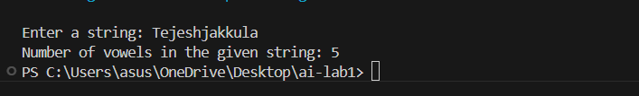  Few shot Promt: //generate a code example1-input:tejesh output:2 example2-input:aakash Vowelcountoutput:3  Code:  //generate a code example1-input:tejesh output:2 example2-input:aakash Vowelcountoutput:3  public class Main {  public static void main(String[] args) {  String input1 = "tejesh";  String input2 = "aakash";  System.out.println("Vowel count in '" + input1 + "': " + countVowels(input1));  System.out.println("Vowel count in '" + input2 + "': " + countVowels(input2));  }  public static int countVowels(String str) {  int count = 0;  String vowels = "aeiouAEIOU";  for (char c : str.toCharArray()) {  if (vowels.indexOf(c) != -1) {  count++;  }  }  return count;  }  }  Output:  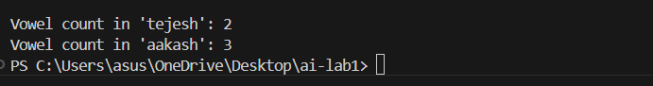  Understanding:  Zero shot: the code is generate without example with direct method name  Few shot: I had provided two example where I didn’t mentioned the methode according to example the code is generated  Task 5: Few-Shot Prompting – File Handling  Scenario  File processing requires clear logical understanding.  Task Description  Use few-shot prompting to generate a Python function that:  - Reads a .txt file  - Counts the number of lines in the file  - Returns the line count  Expected Output  - Working Python file-processing function  - Correct line count  - Sample .txt input and output  - AI-assisted logic explanation  Promt: // Generate a code function to count lines in a text file.Example:File contains 3 lines Output: 3  Code:  // Generate a code function to count lines in a text file.Example:File contains 3 lines Output: 3  import java.io.BufferedReader;  import java.io.FileReader;  import java.io.IOException;  public class Main {  public static void main(String[] args) {  String filePath = "C:\\Users\\asus\\Downloads\\sample.txt";// Replace with your file path  try {  int lineCount = countLinesInFile(filePath);  System.out.println("Number of lines in the file: " + lineCount);  } catch (IOException e) {  System.err.println("An error occurred while reading the file: " + e.getMessage());  }  }  public static int countLinesInFile(String filePath) throws IOException {  int lineCount = 0;  try (BufferedReader reader = new BufferedReader(new FileReader(filePath))) {  while (reader.readLine() != null) {  lineCount++;  }  }  return lineCount;  }  }  Output:  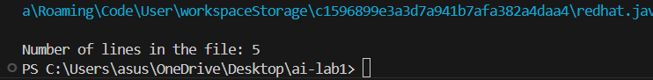  Understanding:  Overall Conclusion  - Zero-shot prompting works well for simple logic  - One-shot prompting improves accuracy using guidance  - Few-shot prompting produces the best quality code  - More context → better AI output  Note: Report should be submitted as a word document for all tasks in a single document with prompts, comments & code explanation, and output and if required, screenshots. | Week2 - Wednesday

