NextXR Digital Twin Platform
AWS Architecture Document
Version 1.0 | July 2026 | GoalCert Engineering

1. Introduction
This document defines the AWS cloud architecture for the NextXR Digital Twin Platform. NextXR is an ontology-driven industrial digital-twin platform built on FastAPI that lets organisations stand up live, semantically-governed twins of facilities and machines, drive them from real field telemetry, reason about their condition, and act on them through an embedded AI copilot.
The system is a single-container monolith: one FastAPI process serves 136 REST endpoints across 12 routers and the built React UI, with the GPU reconstruction step offloaded to an external RunPod endpoint. The image is deliberately Fargate-ready — non-root, $PORT-driven, healthchecked, and serving its own frontend, so a first deploy needs no S3 or CloudFront for static hosting.
Section numbers in the deployment runbook (R6, AWS_DEPLOYMENT.md) are stable and referenced by the Dockerfile, .env.example and the auth notes; this document mirrors that structure.

2. Architecture Overview
Route 53 fronts an optional CloudFront distribution and an Application Load Balancer, which targets an ECS Fargate service running N copies of the nextxr-twin container on port 8080. The task is stateless; all durable state lives in four shared stores.

2.1 Infrastructure Architecture
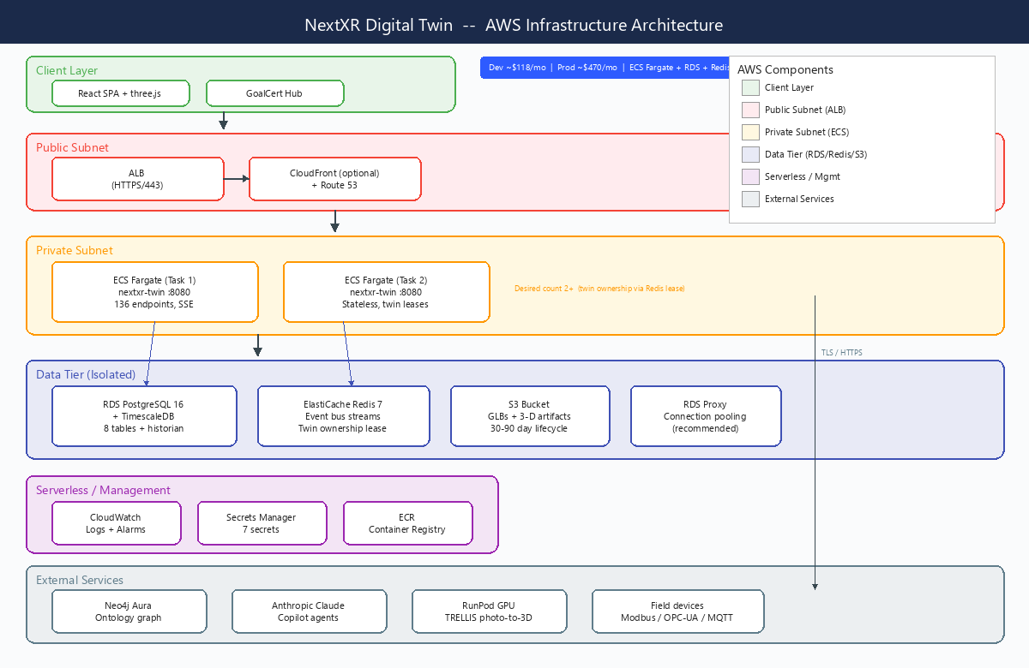
Figure 1: NextXR AWS Infrastructure Architecture

2.2 Core Components
Component | Description
ECS Fargate | The nextxr-twin container: 136 API endpoints, the React UI, the 1 Hz machine-twin runtime, the connector supervisor and the embedded copilot. Desired count 2+.
RDS PostgreSQL 16 | Records and the telemetry historian: 8 platform tables plus the measurements hypertable and its three rollups. Multi-AZ; db.t4g.medium + gp3 is ample.
ElastiCache Redis 7 | The live event bus (one stream per tenant), twin ownership leases and per-tenant command queues.
S3 | Blobs: generated GLBs and 3-D job artifacts, addressed by key so any task serves any model.
Neo4j Aura | The twin's graph: entities, relationships and findings. Managed outside AWS (or self-hosted on EC2 with an EBS volume).
ALB | HTTPS termination and health checks on GET /api/v1/health. Idle timeout raised for SSE.
RDS Proxy | Optional but recommended: multiplexes the fleet's connections, survives failover without the fleet reconnecting in lockstep, and can hold IAM credentials.
CloudWatch | Container logs (the four posture lines reach stdout) and alarms on the health payload's degraded status.
RunPod (external) | Serverless GPU running TRELLIS for photo-to-3-D reconstruction. Deliberately off AWS — ECS-GPU / g5 instances are expensive for a bursty workload.

2.3 Component Architecture
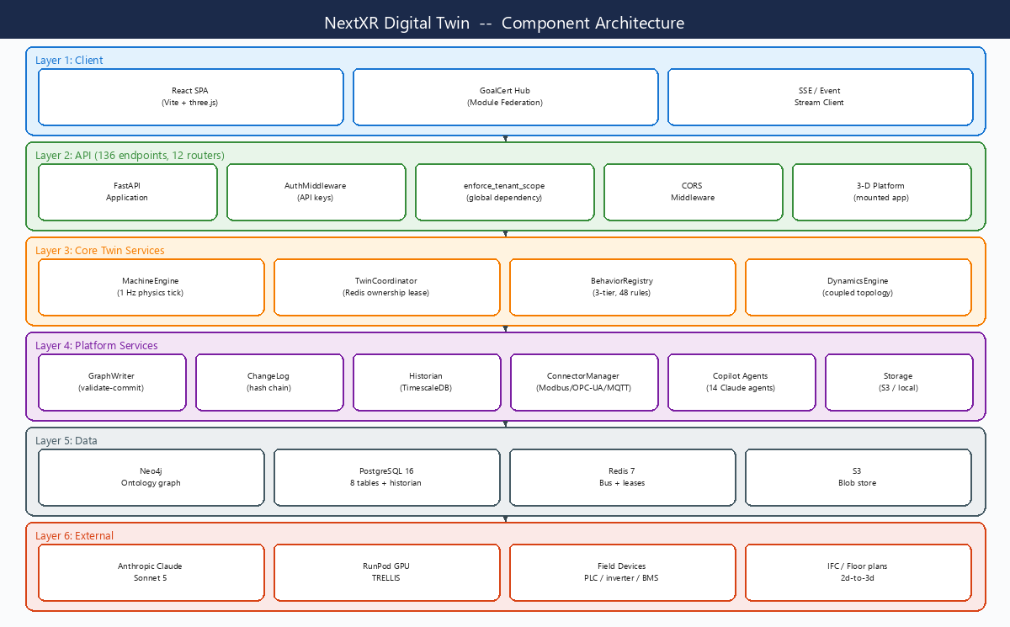
Figure 2: NextXR Component Architecture

2.4 Request Flow
Client → ALB (HTTPS/443) → ECS Fargate (:8080) → Neo4j / RDS / ElastiCache / S3. SSE connections (/api/v1/bus/stream) are long-lived HTTP streams held open by the ALB with an idle timeout of 300 seconds. Blob downloads bypass the API: GET /api/jobs/{id}/result returns a 302 to a presigned S3 URL, so a 20 MB GLB streams from S3 rather than occupying an API worker.

2.5 Data Flow
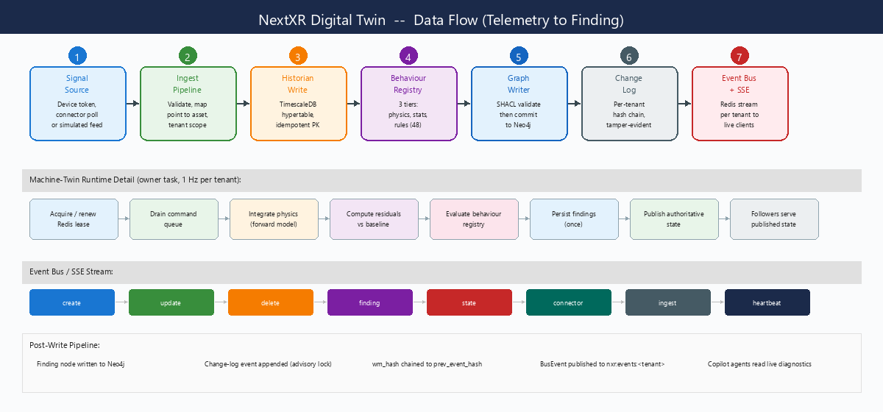
Figure 3: NextXR Telemetry-to-Finding Data Flow

2.6 Build and Image
docker build -t nextxr-twin . produces a multi-stage image:
- Stage 1 — node:20-slim builds frontend/dist (Vite, Module Federation remote).
- Stage 2 — python:3.12-slim installs requirements.txt, copies nextxr-ontology/ and the built dist, runs as non-root uid/gid 10001, exposes :8080 and healthchecks GET /api/v1/health.
The container serves the UI at /, so the first deploy needs no static hosting. Add CloudFront only when federating the UI into the GoalCert Hub — then VITE_REMOTE_BASE must be set at build time to the CloudFront origin, or hub-embedded assets 404.

3. Network Architecture

3.1 VPC Layout
Single VPC (10.0.0.0/16) across two availability zones:
Subnet | CIDR | AZ | Resources
Public Subnet A | 10.0.1.0/24 | eu-west-1a | ALB, NAT gateway
Public Subnet B | 10.0.2.0/24 | eu-west-1b | ALB (multi-AZ)
Private Subnet A | 10.0.10.0/24 | eu-west-1a | ECS Fargate tasks, RDS primary, RDS Proxy
Private Subnet B | 10.0.20.0/24 | eu-west-1b | ECS Fargate tasks, RDS standby, ElastiCache

RDS (5432) and ElastiCache (6379) live in the private/isolated subnets and are never publicly addressable. Add an S3 gateway VPC endpoint so blob traffic skips the NAT gateway's per-GB charge — with GLB payloads this is a material saving, not a rounding error.

3.2 Security Groups
Security Group | Attached To | Rules
sg-alb | ALB | Inbound: 443 from 0.0.0.0/0; Outbound: 8080 to sg-ecs
sg-ecs | ECS Fargate tasks | Inbound: 8080 from sg-alb; Outbound: 5432 to sg-rds, 6379 to sg-redis, 443 to Neo4j Aura / Anthropic / RunPod, plus the field protocol ports a deployment actually polls
sg-rds | RDS PostgreSQL 16 | Inbound: 5432 from sg-ecs and sg-rdsproxy; Outbound: none
sg-redis | ElastiCache Redis 7 | Inbound: 6379 from sg-ecs; Outbound: none
sg-rdsproxy | RDS Proxy | Inbound: 5432 from sg-ecs; Outbound: 5432 to sg-rds

4. Service Configuration

4.1 ECS Task Definition
Parameter | Dev/Staging | Production
CPU | 512 (0.5 vCPU) | 1024 (1 vCPU)
Memory | 1024 MB | 2048 MB
Container Port | 8080 | 8080
Container User | uid/gid 10001 (baked into the image) | uid/gid 10001
Desired Count | 1 | 2+ across two AZs
Health Check | GET /api/v1/health | GET /api/v1/health
Volumes | None required | None required (EFS optional — §5.5)
Logging | awslogs → CloudWatch, PYTHONUNBUFFERED=1 | awslogs → CloudWatch

Two distinct IAM identities: the execution role pulls the image and injects secrets; the task role is the application's own identity and carries S3 object access on the blob bucket.

4.2 Environment Variables
Plain environment (task definition environment: block):
Variable | Value | Notes
PORT | 8080 | ALB target port
NEO4J_URI | neo4j+s://<aura-id>.databases.neo4j.io | Managed Neo4j
NEO4J_USER | neo4j | Password is a secret
NXR_S3_BUCKET | nextxr-twin-blobs | Blob store; access via the task role
NXR_S3_PREFIX | prod | Optional — share one bucket across environments
NXR_REDIS_URL | redis://...cache.amazonaws.com:6379/0 | Event bus and ownership leases
NXR_REQUIRE_DB | 1 | Refuse to start on the SQLite fallback
NXR_REQUIRE_S3 | 1 | Refuse to start on local-disk blobs
NXR_REQUIRE_REDIS | 1 | Refuse to start on the in-memory bus
NXR_REQUIRE_TIMESCALE | 1 | Refuse to start on a plain (non-hypertable) historian
NXR_REQUIRE_AUTH | 1 | Reject keyless /api calls even before keys load
NXR_DB_POOL_MAX | 10 | Per-task ceiling; server-side total is tasks x this
NXR_DB_SSLMODE | require | Unless already in the URL
NXR_CORS_ORIGINS | https://app...,https://hub... | Explicit allow-list
NXR_CLAUDE_MODEL | claude-sonnet-5 | Copilot model override
NXR_INGEST_BEHAVIOURS | 1 | Drive the behaviour registry from ingested telemetry

4.3 Auto-Scaling
Parameter | Dev/Staging | Production
Minimum Tasks | 1 | 2
Maximum Tasks | 2 | 6
Scale-out metric | CPU > 70% | CPU > 60% OR RequestCount > 1000/min
Scale-in metric | CPU < 30% | CPU < 25%
Sticky sessions | Not required | Not required — agent checkpoints are in PostgreSQL
Simulation load | Single task owns every twin | Ownership is per tenant, so simulation spreads across the fleet

Multi-task is safe because the task is stateless and live physics has exactly one owner per tenant (a short Redis lease). That was the single biggest architectural constraint in the earlier SQLite/EFS design and it is gone.

5. Data Tier

5.1 RDS PostgreSQL 16
Parameter | Value
Engine | PostgreSQL 16.x, plain RDS (not Aurora): cheaper at this size, flat I/O pricing, and the same engine runs on-prem for a customer who needs it
Instance (Dev) | db.t4g.small (2 vCPU, 2 GB)
Instance (Prod) | db.t4g.medium (2 vCPU, 4 GB) + gp3 — ample for metadata and an audit log
Storage | 20 GB gp3 (dev), 100 GB gp3 (prod), autoscaling enabled
Multi-AZ | No (dev), Yes (prod)
Backups | Automated with PITR — the change log is an audit record, which is the point
Encryption | AES-256 via KMS at rest; sslmode=require in transit
Extensions | timescaledb (required in production), pgvector and postgis (optional, python -m db.schema --extensions)
Schema | 8 platform tables + measurements hypertable + 3 continuous aggregates (see R4)
Pooling | Per-task pool 1–10; RDS Proxy in front, sized against the instance's max_connections with headroom for migrations and bastion sessions

5.2 TimescaleDB (the telemetry historian)
The historian is an extension on the RDS instance above, not a second database. That property matters more than raw benchmark numbers: a dedicated time-series database is faster in isolation and strictly worse to operate, and an architecture review will ask about operations.
Parameter | Value
Hypertable | measurements, 1-day chunks, partitioned on ts
Continuous aggregates | measurements_1m, _1h, _1d — count and sum rather than avg
Compression | After 7 days; segment by (tenant_id, asset_id, signal), order by ts DESC — 10–20x
Retention | raw 30 d, 1m 400 d, 1h 1095 d, 1d indefinite; all overridable per deployment
Storage impact | At 5,000 signals @ 1 Hz, compression is the difference between ~4 GB/day and ~50 GB/day
Provisioning | python -m tools.historian_provision --extension (needs rds_superuser); --check reports and changes nothing
Guard | NXR_REQUIRE_TIMESCALE=1 — without the extension the historian works, never compresses and never expires anything, so the disk fills silently

5.3 ElastiCache Redis 7
Parameter | Value
Engine | Redis 7.x (OSS), Multi-AZ
Node Type | cache.t4g.micro (dev), cache.t4g.small (prod)
Use Cases | Per-tenant event streams (nxr:events:<tenant_id>), twin ownership leases, per-tenant command queues, connector ownership leases
Encryption | TLS in transit
Guard | NXR_REQUIRE_REDIS=1 — without Redis every task believes it owns every twin, which duplicates every finding and every change-log event

5.4 S3 Bucket
Parameter | Value
Bucket | nextxr-twin-blobs (NXR_S3_PREFIX separates environments)
Key space | <prefix>/threed/jobs/<job_id>/input/<original> and <prefix>/threed/jobs/<job_id>/artifacts/<stage>/model.glb
Access | ECS task role: s3:GetObject, s3:PutObject, s3:DeleteObject on arn:aws:s3:::<bucket>/* and s3:ListBucket on the bucket. No access keys in the environment
Public access | Block Public Access ON — presigned URLs still work
Encryption | Default SSE-S3 (AES-256); versioning optional
Lifecycle | Expire threed/jobs/*/artifacts/ after 30–90 days — intermediate stage images are debugging aids, not product data
Health probe | GET /api/v1/health puts, reads back and deletes a probe object, because a bucket you can list but not write to is the usual IAM mistake and reads fine until the first upload
Guard | NXR_REQUIRE_S3=1 — without it, the task that ran a reconstruction has the GLB and every other task 404s a model the user just watched being generated

5.5 Neo4j and optional EFS
- Neo4j Aura is recommended (least operations): set NEO4J_URI to the neo4j+s:// endpoint and put NEO4J_PASSWORD in Secrets Manager. Neo4j on EC2/ECS with an EBS volume is the alternative — more control, more operations.
- Rotate off the local-development default password baked into graph/connection.py and docker-compose.yml.
- Reads degrade to empty and writes return 503 while Neo4j is unreachable. A deploy is not done while /api/v1/health reports degraded.
- EFS is optional once S3 is configured — nothing durable is left on the volume. Keep it only to let 3-D scratch survive a mid-job task replacement (the job does not resume anyway). If mounted, the access point must use uid/gid 10001 or the first write to /data fails.

6. Security

6.1 IAM Roles
Role | Permissions
ECS Task Execution Role | ecr:GetAuthorizationToken, ecr:BatchGetImage, ecr:GetDownloadUrlForLayer, logs:CreateLogStream, logs:PutLogEvents, secretsmanager:GetSecretValue, ssm:GetParameters
ECS Task Role | s3:GetObject, s3:PutObject, s3:DeleteObject on arn:aws:s3:::<bucket>/*; s3:ListBucket on the bucket. Optionally rds-db:connect for RDS IAM authentication
CodeBuild Role | ecr:PutImage, ecr:BatchCheckLayerAvailability, s3:GetObject, logs:*
Deployment Role | ecs:RegisterTaskDefinition, ecs:UpdateService, iam:PassRole (scoped to the two task roles)

6.2 Secrets Manager
All sensitive configuration is injected through the task definition's secrets: block — never in environment:, where it shows in the console and in describe-task-definition, and never baked into the image (.dockerignore already excludes .env files).
Secret Name | Description
nextxr/database-url | PostgreSQL connection string — a secret because it embeds the password. Alternatively use RDS IAM authentication, or store only the password and assemble the URL in an entrypoint
nextxr/api-keys | NXR_API_KEYS — the JSON array of {key, tenant, role, name} that closes the fail-open hole
nextxr/neo4j-password | Neo4j Aura password
nextxr/anthropic-api-key | Claude API key for the copilot layer
nextxr/runpod-api-key | RunPod API key for GPU reconstruction
nextxr/runpod-endpoint-id | RunPod serverless endpoint id
nextxr/replicate-api-token | Optional alternative reconstruction backend

6.3 Security Posture Checklist
Control | Detail
API keys mandatory | With NXR_API_KEYS unset the service is OPEN — every /api call, including the LLM-billing copilot endpoints, is served without a key. Set the keys and NXR_REQUIRE_AUTH=1
Demo keys never in production | The built-in demo keys load only when NXR_API_KEYS is unset, i.e. never in a correctly-configured deployment
Tenant isolation | A single application-level dependency checks the tenant in query, path and body on every /api route; covered by a dedicated 25-test module
Device credentials | Telemetry devices use X-Device-Token, not API keys — one verb, one tenant, individually revocable, hash-only storage
CORS | Default is *; set NXR_CORS_ORIGINS to the real frontend and hub origins
Database in transit | sslmode=require — without it psycopg2 quietly accepts an unencrypted connection
Database at rest | Private/isolated subnets, security group open to the task SG only, KMS encryption, password rotated through Secrets Manager or replaced by IAM auth
S3 | Block Public Access ON; task-role object access scoped to one bucket
Health alarm | The health check never 503s by design, so add a CloudWatch alarm on the payload's degraded status — it reports database, blobs, bus, historian and neo4j separately, so the alarm can say which
Copilot spend | Set a budget cap on any deployment reachable by people you do not control — copilot traffic bills to your key, and the cap is the only thing that bounds it

7. Cost Estimation
Indicative monthly figures, eu-west-1 on-demand pricing, excluding data-transfer spikes. Neo4j Aura and RunPod are billed outside AWS and shown separately.

7.1 Development/Staging (~$118/month)
Resource | Monthly Cost
ECS Fargate (0.5 vCPU, 1 GB, 1 task) | $18
RDS db.t4g.small (single-AZ, 20 GB gp3, incl. TimescaleDB) | $28
ElastiCache cache.t4g.micro | $12
ALB (minimal traffic) | $17
S3 + CloudWatch + ECR + Secrets + data transfer | $14
Neo4j Aura (free / smallest paid tier) | $0–65
Subtotal, AWS only | ~$89
Total with a small Aura instance | ~$118

7.2 Production (~$470/month)
Resource | Monthly Cost
ECS Fargate (1 vCPU, 2 GB, 2 tasks) | $72
RDS db.t4g.medium (Multi-AZ, 100 GB gp3, incl. TimescaleDB) | $130
RDS Proxy | $22
ElastiCache cache.t4g.small (Multi-AZ) | $36
ALB (moderate traffic) | $25
NAT Gateway (1 AZ; S3 gateway endpoint keeps blob traffic off it) | $32
S3 + CloudWatch + ECR + Secrets + data transfer | $43
Neo4j Aura Professional | $110
Subtotal, AWS only | ~$360
Total with Aura | ~$470

Not included and usage-based: (1) Anthropic API for the copilot — Sonnet 5 at roughly $3/MTok input and $15/MTok output; moderate operator use across a handful of twins is approximately $40–120/month, and the budget cap in copilot/spend.py is what bounds it. (2) RunPod serverless GPU for reconstruction — billed per second of GPU time, typically a few cents per model. (3) Historian storage growth — with compression and the retention policies the raw tier is bounded; without the TimescaleDB extension it is not.

8. Deployment Pipeline
CI/CD uses AWS-native services: CodePipeline, CodeBuild, ECR and ECS rolling deployments. Rehearse the whole shape locally first — docker compose runs the same three shared stores (PostgreSQL 16, Redis 7, MinIO) plus Neo4j, so the production posture can be exercised before it is trusted.
Stage | Description
1. Source | GitHub webhook on push to the release branch
2. Build | docker build (multi-stage: Vite frontend, then the Python runtime), tag with the git SHA, push to ECR
3. Test | pytest — 171 tests covering De Soto physics, ingest/historian, point maps, the solar specification and tenant isolation
4. Provision | python -m db.schema and python -m tools.historian_provision from a bastion or ECS-exec session inside the VPC (RDS is not publicly reachable); both idempotent
5. Deploy | ECS rolling update: register the new task definition, drain old tasks
6. Verify | ALB health check must pass, then read the four posture lines in CloudWatch: [auth], [db], [blobs], [bus]
7. Confirm ownership | Check twin_runtime.owned across tasks — no tenant should appear in two tasks' lists at the same time
8. Alarms | CloudWatch alarms on the health payload's degraded status, on bus.scale_safe and historian.scale_safe, on ECS task CPU/memory and on RDS connections

Rollback is an ECS service update back to the previous task definition. Because schema provisioning is additive and idempotent, a rollback of the application does not require a schema rollback. Migrating an existing SQLite deployment is a separate, one-time step: python -m db.migrate --dry-run, then python -m db.migrate, before traffic is pointed at the new stack.

NextXR Digital Twin Platform -- AWS Architecture Document v1.0

