GoalCert
NextXR Digital Twin Platform
High-Level Design (HLD)
Architecture · Ontology · Domain packs · Tech stack · NFRs

FastAPI · Neo4j · PostgreSQL/TimescaleDB · Redis · S3 · Anthropic Claude · Docker
Commercial in Confidence · © 2026 GoalCert. All rights reserved.

Document Control
Field | Value
Document Title | NextXR Digital Twin Platform — High-Level Design (HLD)
Document Type | High-Level Design (HLD)
Project | NextXR — Ontology-Driven Industrial Digital Twin Platform
Version | 1.0
Status | Draft for Review
Prepared By | GoalCert — Product Engineering
Date | 28 July 2026
Classification | Commercial in Confidence

Version History
Version | Date Created | Description | Prepared By | Approved By | Date Approved
1.0 | 28 July 2026 | Initial issue covering full platform architecture, the four-layer ontology, 11 machine-twin domains, module map, tech stack, integrations and NFRs. | GoalCert Eng | — | —

Reference Documents
Ref | Document
R1 | NextXR Digital Twin Platform — Functional Requirements Document (FRD)
R2 | NextXR Digital Twin Platform — High-Level Design (HLD)
R3 | NextXR Digital Twin Platform — Low-Level Design (LLD)
R4 | NextXR Digital Twin Platform — Data Requirements Document (DRD)
R5 | NextXR Digital Twin Platform — AWS Architecture Document
R6 | AWS_DEPLOYMENT.md — the authoritative deployment runbook (section numbers are stable)
R7 | GoalCert Hub — Module Federation Architecture
R8 | Enterprise Solar Digital Twin Specification (§2.1–§5.3)

Table of Contents
The contents below are a live Word field. On open, Word refreshes the page numbers automatically; you can also right-click → “Update Field”.
Table of contents — update in Microsoft Word (F9) to populate page numbers.

1. Introduction
This High-Level Design describes the architecture of NextXR — an ontology-driven industrial digital-twin platform built by GoalCert. NextXR lets an organisation stand up a live, semantically-governed twin of a physical facility or machine, drive it from real field telemetry, reason about its condition with physics and statistics, visualise it in 3-D, and act on it through an embedded AI copilot.

1.1 Purpose
This document provides the architectural blueprint for the NextXR platform. It covers the system architecture, the four-layer ontology and its closed taxonomy, module decomposition, the domain-pack extension model, the technology stack, integration points and non-functional requirements. It is the contract between the FRD (R1) and the LLD (R3).

1.2 Scope
The scope covers the NextXR backend platform — the FastAPI application, its ontology and graph layer, the machine-twin physics runtime, the telemetry historian, the field-protocol connectors, the embedded copilot, the 3-D generation platform — together with the React front end that ships inside the same container and the Docker/ECS deployment architecture. The GoalCert Hub that federates the UI is referenced but documented separately (R7).

1.3 Audience
Engineering leads, solution architects, DevOps engineers, ontology engineers and stakeholders reviewing the system design. Familiarity with FastAPI, async Python, property graphs, OWL/SHACL and industrial control protocols is assumed.

2. System Overview
NextXR is a multi-tenant digital-twin platform. A “twin” is one isolated instance, keyed by tenant_id, whose entities live in a Neo4j property graph shaped by the NextXR ontology. Around that graph the platform runs four things that turn it from a data model into a twin:
- A live physics runtime — each machine-twin domain ships a forward model that is integrated at 1 Hz. Wear accumulates, heat soaks, and an injected fault persists, so the twin is a stateful simulation rather than a cache of the last reading.
- A three-tier behaviour registry — 48 behaviours across Tier A (physics residuals), Tier B (statistical baselines) and Tier C (deterministic rules). Each consumes telemetry samples and emits Findings; the registry itself is domain-agnostic and never touches Neo4j.
- A telemetry historian — TimescaleDB on the same PostgreSQL instance, holding raw measurements plus incrementally-maintained 1-minute, 1-hour and 1-day rollups, so a 90-day trend reads pre-computed rows instead of scanning millions.
- An embedded AI copilot — 14 Claude agents that run in-process against the same live state the 3-D scene renders, producing diagnoses, work orders, procurement lists, incident reports, repair procedures and operator chat.
Eleven machine-twin domains ship in the box (turbine, wire EDM, metro rail, rolling stock, tram network, hospital campus, EV charging network, EV battery pack, military base, warship and enterprise solar PV). Four further packs (BIM, CFP, HVAC, datacenter) are ontology-and-behaviour packs consumed by the plan→ 3-D and simulated-feed paths.
Telemetry arrives three ways: HTTP ingest authenticated by a per-device token, field-protocol connectors polling Modbus / OPC-UA / MQTT equipment, or a deterministic simulated feed used for demonstrations and tests. All three converge on the same pipeline, so a rule written for the simulator fires unchanged against a real inverter.

3. Architecture Overview

3.1 Architecture Principles
- Ontology first — the data model is OWL + SHACL, not an ORM. Four layers: imported upper ontologies (BFO, SOSA), the NextXR core, the closed governance taxonomy, and domain packs. A pack extends within the taxonomy and can never introduce an eleventh category; that rule is machine-checked by nxr:TaxonomyClosureShape against the ontology itself.
- Validate then commit — every graph mutation goes through the Graph Writer, which SHACL-validates the payload, commits to Neo4j, appends a change-log event and publishes a bus event. There is no back door: twin seeding, agent authoring and the write API all use it, so a seeded twin honours every platform guarantee the moment it is born.
- Multi-tenancy enforced centrally — tenant scope is a FastAPI application-level dependency (enforce_tenant_scope), not a per-route check, so it covers the tenant wherever it appears: query string, path parameter or request body. It cannot be forgotten by a route added later.
- One owner per twin — live physics is a stateful integrator, so exactly one task holds a short Redis lease per tenant. The owner ticks, evaluates behaviours and persists findings once; every other task serves the published state and forwards control actions through a per-tenant command queue. Ownership is per tenant, so load still spreads across the fleet.
- Stateless tasks, shared stores — records in RDS, blobs in S3, live events in ElastiCache, graph in Neo4j. Nothing durable is left on the container, which is what makes desired count 2+ and rolling deploys safe.
- Loud failure over silent degradation — each shared store has a task-local fallback that is correct at one task and quietly wrong at two. Four required-flags (NXR_REQUIRE_DB / _S3 / _REDIS / _TIMESCALE) turn that misconfiguration into a failed boot rather than a fleet that serves half the twins.
- Degrade, never crash, on optional dependencies — with no Anthropic key every copilot agent falls back to a deterministic stub and reports ai.backend = "stub", so the product keeps working keyless and a stub answer is never presented as real reasoning.

3.2 High-Level Architecture Diagram
The diagram below illustrates the infrastructure architecture, showing all AWS components and their relationships:
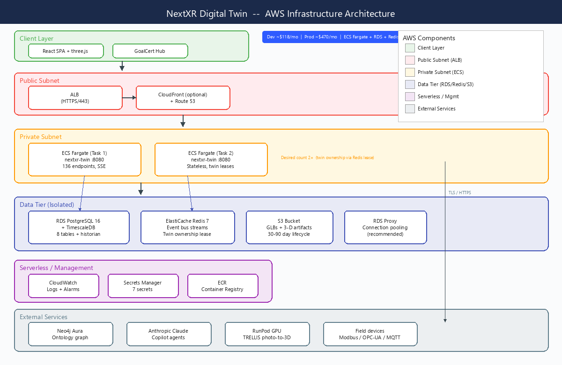
Figure 1: NextXR AWS Infrastructure Architecture

The system consists of four layers:
- API Layer — a single FastAPI application on port 8080 with CORS and API-key authentication middleware and a global tenant-scope dependency. 136 endpoints are grouped into 12 routers plus the mounted 3-D sub-application.
- Service Layer — MachineEngine (1 Hz physics), TwinCoordinator (Redis ownership leases), BehaviorRegistry (48 behaviours in 3 tiers), DynamicsEngine (coupled topology simulation), GraphWriter, ChangeLog, Historian, ConnectorManager, IngestPipeline, EventBus, Storage, CapabilityBundle registry and the copilot agent layer.
- Data Layer — Neo4j (the ontology graph), PostgreSQL 16 with TimescaleDB (8 platform tables plus the measurements hypertable and its three rollups), Redis 7 (event bus and ownership leases) and S3 (generated GLBs and 3-D job artifacts).
- External Services — Anthropic Claude (Sonnet 5), RunPod serverless GPU running TRELLIS for photo-to-3-D reconstruction, and customer field equipment reached over Modbus, OPC-UA and MQTT.

3.3 Component Architecture
The component architecture shows the layered structure of the NextXR application:
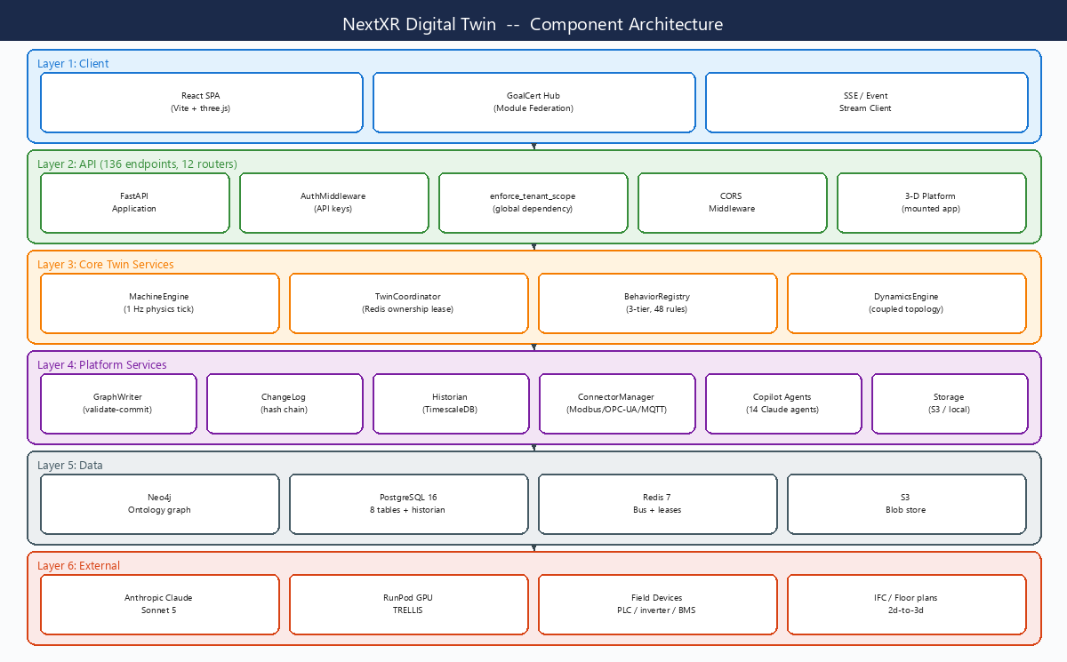
Figure 2: NextXR Component Architecture

3.4 Service Decomposition
NextXR is a single-process modular monolith. server/main.py assembles CORS and authentication middleware, the global tenant-scope dependency, a Neo4j-down exception handler and twelve routers into one FastAPI instance, then mounts the 3-D generation platform as a sub-application at /api/v1/threed and serves the built React SPA from / with a catch-all fallback for client routing.
The deployment unit is a single Docker container. A multi-stage build compiles the front end with node:20-slim and runs it from python:3.12-slim as non-root uid/gid 10001, exposing :8080 with a container health check on GET /api/v1/health. The same image serves the API and the UI, which is what makes the deployment a genuine one-URL deploy with no separate static hosting.

4. Module Map
The contract between the FRD (R1) and this design. Each functional module maps to route and service packages in the codebase.

4.1 Ontology Module
The ontology is four layers of Turtle under platform/ and packs/, loaded by rdflib and enforced with pySHACL:
Layer | Files | Content
Layer 1 — Imported upper ontologies | imports/bfo.ttl, imports/sosa.ttl | Basic Formal Ontology continuant/occurrent distinctions and the SOSA sensor/observation vocabulary
Layer 2 — NextXR core | platform/nxr-classes.ttl, nxr-properties.ttl, nxr-units.ttl | The core entity classes, observable and object properties, and the unit vocabulary
Layer 3 — Governance | platform/nxr-taxonomy.ttl, nxr-governance.ttl, nxr-base-shape.ttl, nxr-shapes.ttl | The closed ten-category taxonomy, the closure-enforcement shape, and the base/entity SHACL shapes
Layer 4 — Domain packs | packs/<domain>/<domain>-classes.ttl + -shapes.ttl | Per-domain OWL classes, observable properties, failure modes and SHACL node/property shapes
The ten categories are fixed at platform version v3. Every entity class must declare exactly one via nxr:taxonomyCategory; structural classes (StateMachine, State, Transition, QuantitativeResult) are marked nxr:isStructural and are exempt.
Category | Definition | Representative classes
PhysicalAsset | Fixed, durable material things: equipment and sensors. | AirHandler, PVArray, Inverter, Chiller, Transformer
MobileAsset | Material things whose normal operation involves moving. | RollingStock, Tram, Vehicle, Aircraft, Vessel
Actor | Humans, teams, or organisational units that take action. | Technician, ClinicalTeam, OperationsUnit
Location | Bounded places: sites and spaces. | Site, Space, Zone, Ward, Platform
Process | Activities that unfold over time. | MaintenanceTask, Surgery, ChargingSession, Mission
Observation | Timestamped measurements of observable properties. | TemperatureObservation, IrradianceObservation
Finding | Atomic anomaly signals from behaviour models. | Finding (severity, behaviourId, evidence)
Incident | Correlated groups of findings — the unit the operator acts on. | Incident (rolls up related findings)
Document | Copyable information artefacts, including diagnoses and recommendations. | Diagnosis, WorkOrder, Procedure, IncidentReport
Capability | The platform's self-model: bundles, adapters, models, ports, failure modes. | CapabilityBundle, BehaviourModel, FailureMode, Adapter

4.2 Domain Packs Module
Every domain vertical lives in one self-contained folder under packs/<domain>/, co-locating its ontology and its runtime code. A machine-twin pack ships <domain>-classes.ttl, <domain>-shapes.ttl, physics.py (component engines and the forward model), behaviors.py (the tiered registry builder), predict.py (subsystem health and RUL) and an __init__.py exposing a self-describing SPEC.
Twin key | Label | Pack | Control input | Subsystems
turbine-engine | Gas Turbine Engine | turbine | throttle | Compressor, Combustor, Turbine, Rotor & Bearings, Lubrication
edm-machine | Wire EDM Machine | edm | intensity | Wire feed, Dielectric, Servo axes, Generator
railway-metro | Metro Rail Network | railway | service_level | Track circuits, Third rail, Signalling, Stations, Depot
railway-trainset | Rolling Stock (Train Set) | railway | throttle | Traction, Bogies, Doors, HVAC, Brakes
tram-network | Tram / Light-Rail Network | fleet | service_level | Vehicles, Depot, Line sections, Substations
hospital-campus | Hospital Campus | hospital | patient_load | Beds, Operating theatres, Medical gas, Cold chain, Infection control
ev-charging-network | EV Charging Network | ev | demand_level | Chargers, Grid connection, Load balancing, V2G
ev-battery-pack | EV Battery Pack | ev | c_rate | Cells, Modules, Thermal management, BMS
defence-base | Military Base (C4ISR) | defence | readiness | Perimeter, Power, Ammunition, Aircraft, Comms
defence-warship | Warship | defence | speed_demand | Propulsion, Damage control, Sensors, Weapons, Power
solar-pv-array | Enterprise Solar PV Array | solar | curtailment | PV Modules (soiling), Strings & Combiners, Cell degradation, Inverter, Sensors
Discovery is declarative: twins/runtime.py load_specs() imports packs.<domain> and reads its SPEC or SPECS list. Adding a pack name to that tuple makes it a live machine-twin domain — state, diagnostics, predict, network and the Build-a-Twin UI — with no other wiring. Ontology files are registered in tools/ontology_graph.py and loaded by the SHACL gate; seeding templates live in twins/service.py; relationship CURIE prefixes are registered in graph/writer.py.
Four further packs are ontology-and-behaviour packs rather than machine twins: bim (building information models for the plan→ 3-D path), cfp (a 1,034-line common facility platform vocabulary of 82 classes), hvac and datacenter. They are consumed by the plan→ 3-D and simulated-feed paths.

4.3 Behaviour Registry Module
A behaviour declares three things — watches (the signal keys it reacts to), reads (the graph inputs it consumes) and emits (the Finding it produces) — and implements one method, evaluate(sample, query) → list[Finding]. The registry routes each incoming TelemetrySample to every behaviour whose watches set contains the sample's signal and returns the findings to the caller. The registry itself never touches Neo4j and never writes.
Tier | Kind | Examples
Tier A | Physics — a residual between measurement and a forward model | ThermalPhysicsBehavior, TurbineEGTDivergence, SymmetricOutputDrop, TractionEnergyResidual, NetworkFlowResidual
Tier B | Statistical / learned — a baseline, z-score or trend | TemperatureZScoreBaseline, ChillerCOPBaseline, PumpVibrationBaseline, ShuntResistanceDecay, TurbineVibTrend, DelayTrend, LoadTrend
Tier C | Deterministic rules — thresholds and state transitions | UPSOnBatteryRule, GeneratorFuelLowRule, SmokeAlarmRule, LeakDetectedRule, DoorForcedRule, MedicalGasLowPressure, RailOvervoltage
48 behaviours ship across the platform and its packs. Findings are edge-latched — a behaviour emits on the transition into a condition, not on every sample — so a sustained fault produces one Finding rather than one per second.

4.4 Machine-Twin Runtime Module
twins/runtime.py holds the domain-agnostic LiveTwin and MachineEngine:
- load_specs() discovers the domains from their SPECs; a missing or broken pack is skipped so one bad module can never take the runtime down.
- Each tick advances the pack's forward model, computes residuals against the clean-machine baseline, derives per-subsystem component_health, and evaluates the pack's behaviour registry.
- A _FrameQuery gives Tier-A cross-signal rules a read-only view of the co-located signals of the latest frame, so they can read siblings without a Neo4j round trip.
- Control surfaces: throttle/setpoint (the pack's declared control), fault injection, start/stop, what-if projection and network state for the network-shaped domains.

4.5 Twin Coordinator Module
twins/coordinator.py gives each tenant's simulation exactly one owner:
- The owning task holds a short Redis lease, ticks the physics, evaluates behaviours and persists findings once, then publishes the authoritative state every second.
- Follower tasks never tick and never persist — they serve the published state, so every task reports identical values, and they forward control actions (throttle, fault injection, start/stop) to the owner through a per-tenant command queue.
- If an owner dies the lease expires after roughly eight seconds and another task adopts the published state, continuing the simulation rather than restarting it.
- GET /api/v1/health reports this task's twin_runtime.owned list; across the fleet each tenant should appear exactly once.

4.6 Graph, Change Log and Event Bus Module
- GraphWriter (graph/writer.py) is the only path that mutates Neo4j: validate → commit → changelog → bus. Relationship predicates are CURIEs resolved from a registered prefix table.
- ChangeLog (changelog/service.py) appends a per-tenant hash chain: each event carries a ULID event_id, the field-level diff, prev_event_hash and wm_hash. Changing any stored field of an old event breaks every wm_hash after it, which is what makes the log tamper-evident. Appends take a PostgreSQL advisory lock per tenant so a chain cannot fork under concurrent writers.
- EventBus (bus/event_bus.py) publishes one Redis Stream per tenant, nxr:events:<tenant_id>, so a consumer reading one tenant's stream cannot see another's. A BusEvent mirrors the change-log event, and consumer groups are created per stream for agent consumers.

4.7 Telemetry Module (Ingest, Connectors, Historian)
- Ingest (ingest/pipeline.py, server/ingest_routes.py) accepts single and bulk telemetry authenticated by X-Device-Token. A device credential grants exactly one verb in exactly one tenant and can be revoked on its own — deliberately not an API key, which would let a gateway in a plant room read every asset and bill the LLM endpoints. Only the token hash is stored; the plaintext is returned once at creation.
- Connectors (connectors/) supervise durable Modbus TCP/RTU, OPC-UA and MQTT (Sparkplug B) workers with seven built-in point-map profiles. Ownership uses the same lease pattern as the twin coordinator, because polling one inverter from three tasks triples device load and puts three masters on an RS-485 segment.
- Historian (historian/) writes to a TimescaleDB hypertable with a (tenant_id, asset_id, signal, ts) primary key that makes replay idempotent, plus 1m/1h/1d continuous aggregates that store count and sum rather than avg so a mean is correct at any resolution.

4.8 Copilot Module
copilot/ hosts fourteen Claude agents that run in-process against the machine-twin runtime — a native twin feature, not a proxy to an external agent service. Every agent takes plain dicts, never raises, and records on agent_trace() whether the call actually reached Claude.
Endpoint | Agent | Responsibility | Model policy
build-twin/message | Build-a-Twin conversation | Turns a free-text conversation into a twin specification | Sonnet 5, thinking off
build-twin/spec | Vision to twin spec | Photo or floor plan → structured TwinSpec (assets, relationships) | Sonnet 5, vision
narrate | Sensor narration | One-paragraph plain-English reading of the live sensor frame | Sonnet 5, thinking off
asset | Asset status | Explains one asset's condition from its live properties | Sonnet 5, thinking off
predict-alert | Predictive alert | Turns an RUL/health forecast into an actionable warning | Sonnet 5, thinking off
diagnosis | Diagnosis agent | Root-cause reasoning over live diagnostics and findings | Sonnet 5, adaptive thinking
analysis | Analysis agent | Combines diagnostics and prediction into an engineering assessment | Sonnet 5, adaptive thinking
cascade | Cascade analysis | Projects how a fault propagates through coupled subsystems | Sonnet 5, adaptive thinking
work-order | Work order generation | Produces a structured maintenance work order from a diagnosis | Sonnet 5, adaptive thinking
procurement | Parts procurement | Derives the parts list and lead times for a work order | Sonnet 5, adaptive thinking
incident-report | Incident report | Formal incident narrative from findings and diagnostics | Sonnet 5, adaptive thinking
procedure | Repair procedure | Step-by-step repair procedure for a named fault | Sonnet 5, adaptive thinking
troubleshoot | Troubleshoot chat | Multi-turn mechanic chat grounded in live diagnostics | Sonnet 5, thinking off
dashboard-chat | Dashboard chat | Multi-turn operator chat grounded in a twin snapshot | Sonnet 5, thinking off
Spend is bounded: copilot/spend.py tracks running cost, tokens, per-agent ranking, prompt-cache hit rate and the share of requests answered without an API call, and enforces an optional budget cap past which agents fall back to their stubs. All of it is reported on GET /api/v1/copilot/health.

4.9 Agentic Build Module
agents/ implements a zero-dependency, LangGraph-compatible StateGraph executor with a PostgreSQL-backed CheckpointSaver, so a run interrupted for human approval on one task resumes on another. Five graphs ship:
Graph | Module | Purpose
Twin builder | agents/twin_graph.py | Conversational twin authoring — free text, a photo or a floor plan becomes a seeded twin
Bundle author | agents/bundle_graph.py | Authors a capability bundle (classes, entity templates, Tier-C rules) and publishes it to the registry
Operational | agents/operational_graph.py | Diagnosis, analysis and cascade reasoning over a running twin
Plugin | agents/plugin_graph.py | Extends a live twin with a new pack or adapter
Accelerator | agents/accelerator_graph.py | Guided vertical accelerators that assemble a domain twin from templates
The Capability Bundle registry (agents/registry.py) unifies built-in bundles (the shipped HVAC pack) with bundles published by the Bundle Author, persisted to the shared relational store — so on PostgreSQL a bundle published by one task is immediately visible to the rest.

4.10 3-D and Visualisation Module
- server/threed_platform is the object-photo → GLB pipeline, mounted in-process at /api/v1/threed. Reconstruction is offloaded to a RunPod serverless GPU endpoint running TRELLIS; if RUNPOD_API_KEY and RUNPOD_ENDPOINT_ID are unset the stage stubs.
- The 2d-to-3d parser turns a floor plan into a BIM scene graph; agents/ifc_parser.py ingests IFC models. Resulting scenes are cached in the scene_cache table, not on task disk, which is what keeps the 3-D viewer correct at desired count above one.
- The React front end renders the scene with three.js and overlays live signal values, health status and click-to-inspect equipment panels; domain-specific views ship for hospital, railway, EV, defence and solar.

4.11 Auth and Tenancy Module
Authentication is API-key based (server/auth.py), with three roles — admin (all tenants), write (read + write within their tenant) and read (read-only within their tenant). Keys are configured as a JSON array in NXR_API_KEYS; the built-in demo keys load only when that variable is unset.
Tenant authorisation is separate and central (server/tenancy.py). It is an application-level FastAPI dependency rather than middleware, because middleware runs before routing where request.path_params is still empty — the exact blind spot that let a key scoped to one tenant reach another tenant's twin through a path parameter or a request body. Four scoping forms are supported, most specific first:
Form | Meaning | Notes
{"tenant": "acme"} | Exactly one tenant | The narrowest and preferred form
{"tenant_prefix": "acme-"} | Every tenant id under a prefix | The only form that can create twins — the new id must land inside the creator's own scope
{"tenants": ["acme", "acme-2"]} | An explicit set | Expresses “this customer owns 50 twins” without granting *
{"tenant": "*"} | Admin — all tenants | Handing one to a customer hands them every other customer's data

5. Technology Stack
Layer | Technology
Application Framework | FastAPI (Python 3.12) with Pydantic models; Uvicorn ASGI server on :8080
Ontology / Semantics | OWL 2 + SHACL in Turtle (rdflib, pySHACL); 4-layer ontology with a closed 10-category taxonomy
Graph Database | Neo4j 5 (official Python driver); one uniqueness constraint and updatedAt index per taxonomy category
Relational Store | PostgreSQL 16 (psycopg2 pool) with a SQLite fallback for offline development; 8 platform tables
Telemetry Historian | TimescaleDB extension on the same PostgreSQL instance — hypertable, 1m/1h/1d continuous aggregates, compression, retention
Event Bus | Redis 7 Streams, one stream per tenant (nxr:events:<tenant_id>), with an in-memory fallback
Blob Store | AWS S3 (boto3) or any S3-compatible endpoint (MinIO); local filesystem fallback
Field Protocols | Modbus TCP/RTU (pymodbus), OPC-UA (asyncua), MQTT + Sparkplug B (paho-mqtt)
AI / LLM | Anthropic Claude (Sonnet 5 default, Opus configurable) via the embedded copilot layer, with deterministic stubs when keyless
Agent Runtime | In-house LangGraph-compatible StateGraph executor with a PostgreSQL-backed CheckpointSaver
3-D Reconstruction | TRELLIS on RunPod serverless GPU (CUDA 12.1, 24 GB VRAM); 2d-to-3d floor-plan parser; IFC parser
Frontend | React 18 + Vite, three.js / react-three-fiber, Module Federation remote for the GoalCert Hub
Containerisation | Multi-stage Docker (node:20-slim build → python:3.12-slim runtime), non-root uid/gid 10001
Testing | pytest — 171 tests across De Soto physics, ingest/historian, point maps, solar specification and tenant isolation

6. Integration Points

6.1 Neo4j (the ontology graph)
- Connection is a shared singleton driver (graph/connection.py) reading NEO4J_URI, NEO4J_USER and NEO4J_PASSWORD; Neo4j Aura over neo4j+s:// is the recommended production form.
- graph/schema.py parses the ontology, discovers the taxonomy categories and applies one uniqueness constraint on (tenantId, id) and one updatedAt index per category, plus the ChangeLog label's constraints — so the graph schema always matches the ontology.
- Neo4j being unreachable is handled once, globally: ServiceUnavailable, SessionExpired and AuthError are converted to a 503 with operator guidance, so every DB-backed route degrades the same friendly way instead of returning a raw 500.

6.2 Anthropic Claude API
- Claude Sonnet 5 is the default model (NXR_CLAUDE_MODEL overrides it; Opus is a supported alternative), with adaptive thinking on the heavy reasoning agents and thinking explicitly disabled on the short latency-sensitive ones.
- Prompt caching is used on the system prompts; the cache hit rate and the share of requests answered with no API call at all are reported by copilot/spend.py.
- Without ANTHROPIC_API_KEY every agent degrades to a deterministic stub and the response's ai.backend field reports "stub". Nothing breaks and nothing lies about its provenance.

6.3 GoalCert Hub (Module Federation)
- The React front end is built as a Module Federation remote and mounted by the GoalCert Hub; server/hub_routes.py exposes the hub-facing prediction and AR-overlay surface.
- The hub authenticates with an X-API-Key that must be one of the configured NXR_API_KEYS.
- CORS defaults to * for local development and the federated hub; NXR_CORS_ORIGINS locks it to an explicit allow-list in production.

6.4 Field protocols
- Modbus TCP and RTU via pymodbus, OPC-UA via asyncua, MQTT with Sparkplug B via paho-mqtt and protobuf. Protocol modules are imported lazily so a missing optional dependency disables one protocol rather than the service.
- Seven built-in point-map profiles (sunspec_inverter_3ph, string_combiner, revenue_meter, ct_clamp_panel, weather_station, mqtt_gateway, opcua_inverter) turn a device model into a signal map without hand-writing registers; POST /profiles/{key}/build previews the result.
- SunSpec discovery (POST /connectors/discover/sunspec) and OPC-UA address-space browsing (POST /connectors/{id}/browse) support commissioning.

6.5 RunPod (GPU reconstruction)
- apps/trellis-worker is a RunPod serverless GPU container (CUDA 12.1, 24 GB VRAM) deployed on RunPod rather than AWS; the platform is a thin HTTPS client.
- Finished artifacts are published to the blob store as each stage completes; GET /api/jobs/{id}/result redirects to a presigned S3 URL so a 20 MB GLB streams from S3 instead of occupying an API worker.

6.6 Storage (S3 / local)
- One blob layer (storage/core.py) with two backends behind the same interface: S3 (or any S3-compatible endpoint such as MinIO) when NXR_S3_BUCKET is set, otherwise the local filesystem under NXR_DATA_DIR/blobs.
- Blobs are addressed by key, never by path: <prefix>/threed/jobs/<job_id>/input/<file> and <prefix>/threed/jobs/<job_id>/artifacts/<stage>/model.glb.
- The health endpoint exercises the write path — put, read back, delete a probe object — because a bucket you can list but not write to is the usual IAM mistake and reads fine right up until the first upload.

7. Non-Functional Requirements

7.1 Performance
- The physics runtime ticks at 1 Hz per owned tenant and publishes authoritative state every second; follower tasks serve that state with no simulation cost.
- Historian reads are served from continuous aggregates, so a 90-day chart reads roughly two thousand pre-computed rows rather than aggregating millions of raw samples.
- Compression gives 10–20x on telemetry — at 5,000 signals at 1 Hz that is the difference between about 4 GB/day and about 50 GB/day of RDS storage.
- Connection pooling is per task (NXR_DB_POOL_MIN/MAX, default 1–10); RDS Proxy multiplexes the fleet's connections and survives failover without every task reconnecting in lockstep.
- The DDL cache in db/schema.py means re-constructing a store object costs nothing, because ChangeLog() is constructed inside request handlers and a DDL round trip per construction would be a real cost against RDS.

7.2 Security
- API keys are mandatory in production. With NXR_API_KEYS unset the service is open — every /api call, including the LLM-billing copilot endpoints, is served without a key. NXR_REQUIRE_AUTH=1 rejects keyless calls even before keys load.
- Tenant isolation is enforced by a single application-level dependency covering path, query and body, and is backed by a dedicated test module (tests/test_tenant_isolation.py, 25 tests).
- Device tokens are stored only as hashes, are looked up by a unique hash index, carry an optional expiry and an asset prefix, and can be revoked individually.
- Connector credentials live inside the config JSON column and are allow-listed on the way out by ConnectorConfig.redacted(), so a field added later cannot leak a customer's PLC password by omission.
- TLS in transit is enforced for RDS (sslmode=require, without which psycopg2 will quietly accept an unencrypted connection) and for Neo4j Aura (neo4j+s://); S3 buckets have Block Public Access on and are reached through the ECS task role, not access keys.
- The change log is tamper-evident by construction, and appends serialise per tenant under a PostgreSQL advisory lock so a chain cannot fork.

7.3 Scalability
- Tasks are stateless once RDS, S3 and ElastiCache are configured, so desired count 2+ across two availability zones and rolling deploys are safe.
- Simulation load spreads across the fleet because ownership is per tenant — there is no singleton simulation service to keep alive.
- Sticky sessions are not required: agent checkpoints are in PostgreSQL, so a run interrupted for human approval on one task resumes on another.
- The known bound on write throughput is deliberate: a single tenant's change-log writes serialise under its advisory lock. Tenants never block each other, and that is the correct trade for a tamper-evident ledger.

7.4 Observability
- GET /api/v1/health always returns 200 and carries component-level truth: neo4j, database, blobs, bus, historian and twin_runtime.owned, with an overall healthy/degraded status. It never 503s by design, so a database blip cannot roll the fleet — which is why the deployment adds a CloudWatch alarm on the degraded status.
- The bus and historian both report scale_safe, the one field an operator can alarm on before scaling out: an in-memory bus and a non-hypertable historian both report working while being wrong at two tasks.
- Four startup posture lines — [auth], [db], [blobs], [bus] — state the configuration in plain words on stdout and reach CloudWatch, and are the fastest way to catch a bad deploy.
- GET /api/v1/stats, /api/v1/bus/stats and /api/v1/bus/events expose graph, event and throughput counters for dashboards.

8. Deployment Architecture
Locally, docker-compose brings up the same shared stores the deploy uses so the production posture can be rehearsed before it is trusted:
Service | Image | Port | Role
neo4j | neo4j:5-community | 7474 / 7687 | The ontology graph
postgres | timescale/timescaledb:2.17.2-pg16 | 5432 | Records and the telemetry historian
redis | redis:7-alpine | 6379 | Event bus and twin ownership leases
minio (+ minio-init) | minio/minio, minio/mc | 9000 | S3-compatible blob store for exercising the real code path
nextxr-twin | Custom multi-stage Dockerfile | 8080 | API + built React UI, health check GET /api/v1/health
On AWS the same image runs on ECS Fargate behind an ALB at desired count 2+ across two availability zones, with RDS PostgreSQL 16 (Multi-AZ, optionally through RDS Proxy), an S3 bucket, ElastiCache Redis 7 and a managed Neo4j Aura instance. Secrets are injected from Secrets Manager through the task definition's secrets block; the task role carries the S3 permissions. See R5 and R6 for the full runbook.
- Provisioning: python -m db.schema creates every relational table; python -m tools.historian_provision --extension enables and configures TimescaleDB; python -m graph.schema applies the Neo4j constraints and indexes. All three are idempotent.
- Migration: python -m db.migrate --dry-run then python -m db.migrate moves an existing SQLite deployment into PostgreSQL before traffic is pointed at the new stack.
- Guards: NXR_REQUIRE_DB, NXR_REQUIRE_S3, NXR_REQUIRE_REDIS and NXR_REQUIRE_TIMESCALE turn each per-task fallback into a loud startup failure. Set all four for any multi-task service.
Design details are indicative and confirmed during implementation.

