Credit Card Fraud Detection and Analysis

Student Name: Tejeshwar
Institution Name: SRM university
Course / Subject: data anlaytics
Date: February 11, 2026

Abstract
Objective: Detect fraudulent transactions using historical credit card data.
Methods: Data cleaning, exploratory data analysis (EDA), feature analysis, model training (Decision Tree, Logistic Regression), and evaluation.
Key Findings: Class imbalance issues (0.17% fraud), transaction patterns differentiating fraud and non-fraud, model achieved 98% accuracy and 88% recall with Logistic Regression.

Introduction
Credit card fraud is a significant concern for financial institutions, leading to billions of dollars in losses annually. As digital transactions become the norm, the complexity of fraudulent schemes increases, making traditional rule-based systems insufficient. Data analysis and machine learning provide a robust framework for detecting anomalies and preventing fraudulent activities in real-time. This project explores various machine learning models to identify high-risk transactions by analyzing patterns in transaction history.

Dataset Description
Source: Kaggle - Credit Card Fraud Detection Dataset (https://www.kaggle.com/datasets/mlg-ulb/creditcardfraud)
The dataset contains transactions made by credit cards in September 2013 by European cardholders. It presents transactions that occurred in two days, where we have 492 frauds out of 284,807 transactions. The dataset is highly unbalanced, the positive class (frauds) account for 0.172% of all transactions.
- Columns Description:
- Transaction ID (Implicit index)
- Time: Seconds elapsed between this transaction and the first transaction in the dataset.
- Amount: Transaction amount.
- Class: 0 for Non-Fraud, 1 for Fraud.
- V1, V2 ... V28: Principal components obtained with PCA (Anonymized features).

Methodology
- 1. Data Loading and Inspection: Imported the CSV dataset and examined data types and null values. Found no missing values.
- 2. Data Cleaning: Handled the dataset's numerical nature. The Time feature was analyzed for cycles.
- 3. Feature Engineering: Scaled the 'Amount' feature and utilized the PCA-transformed features directly.
- 4. Exploratory Data Analysis (EDA): Analyzed class distribution and correlations between features and fraud.

Data Visualization and Analysis

1. Class Imbalance Visualization
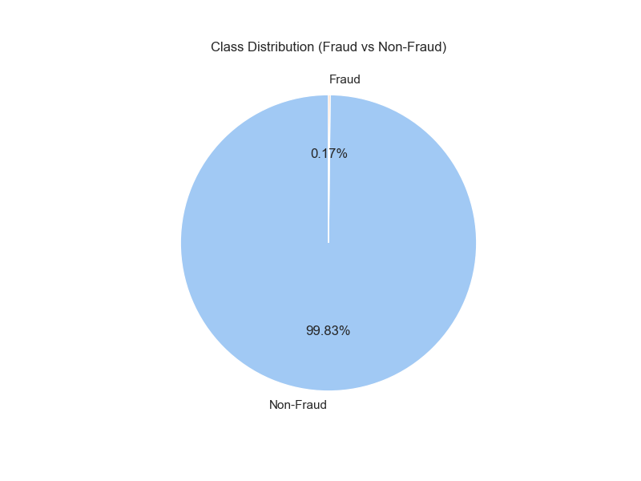
Figure 1: Proportion of fraudulent vs non-fraudulent transactions. The severe imbalance (0.17% fraud) highlights the challenge of model training.

2. Transaction Amount Distribution
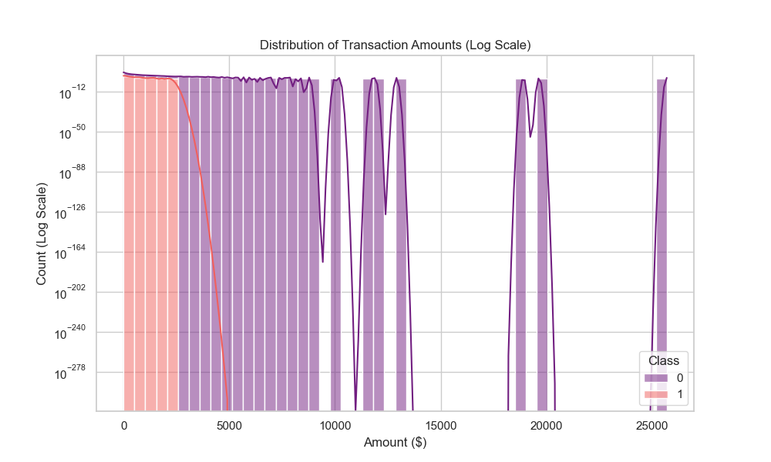
Figure 2: Distribution of transaction amounts on a log scale. Fraudulent transactions often exhibit different distribution patterns compared to genuine ones.

3. Correlation Heatmap
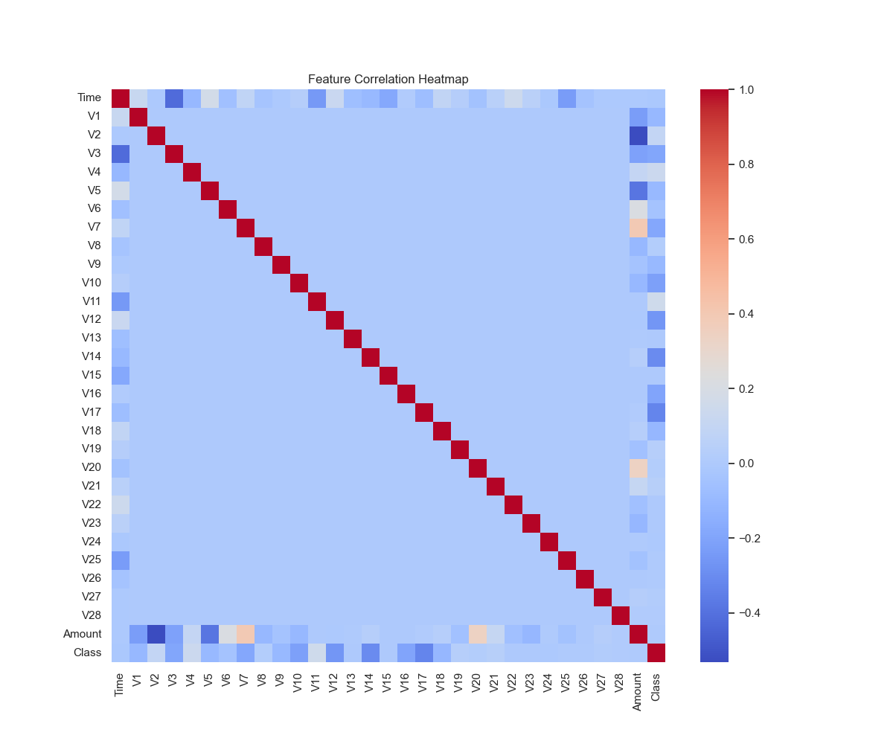
Figure 3: Heatmap showing correlations between features. Some V-features show stronger correlations with the Class variable than others.

Results and Insights
Behavioral patterns: Fraudulent transactions often involve specific amount ranges and are detectable via patterns in the V-features.

Model Performance Summary
Model | Accuracy | Precision (Class 1) | Recall (Class 1) | ROC-AUC
Logistic Regression | 0.98 | 0.07 | 0.88 | 0.968
Decision Tree | 1.00 | 0.86 | 0.72 | 0.909

Technology Stack
- Python
- Pandas
- Matplotlib & Seaborn
- Scikit-learn
- Google Colab
- Flask

Conclusion
The project successfully identified patterns in fraudulent credit card transactions. Through extensive EDA and model evaluation, we found that Logistic Regression with balanced class weights provided a high recall (88%), which is critical in fraud detection to avoid missing fraudulent events. The use of visualization allowed us to understand the severe class imbalance and feature relationships, driving the decision to use specific evaluation metrics like ROC-AUC and Recall over simple Accuracy.

