Academic Report: Fake News Analysis and Detection

Student Name: Tejeshwar senthilkumar
Institution Name: SRM university
Course / Subject: Data anaysis
Date: February 12, 2026

Abstract
This project focuses on the development and implementation of an automated system for detecting "fake news" using machine learning and natural language processing (NLP). Utilizing a robust dataset of over 36,000 news articles, the system employs a Linear Support Vector Machine (SVM) classifier combined with TF-IDF vectorization to identify patterns of misinformation. The project demonstrates the effectiveness of the Antigravity pipeline in processing high-dimensional text data and delivering a real-world web application for news verification. Key findings indicate that fake news often exhibits distinct linguistic markers and authorial patterns that can be identified with high precision.

1. Introduction

1.1 Overview of Fake News and Its Impact
In the digital age, the rapid dissemination of information through social media and online platforms has led to the proliferation of "fake news"—misleading or entirely fabricated information presented as news. The impact of such misinformation is profound, influencing public opinion, political elections, and even leading to social unrest and public health crises.

1.2 Importance of Data Analysis in Detecting Misinformation
While human fact-checking is essential, the sheer volume of information generated daily makes manual verification impossible. Data analysis and machine learning provide scalable solutions for identifying misinformation by uncovering subtle linguistic patterns, sentiment shifts, and metadata anomalies that are difficult for humans to detect consistently at scale.

2. Dataset Description

2.1 Source of the Dataset
The dataset used in this project is sourced from the "Fake News Detection Datasets" on Kaggle, consisting of two main components:
- `True.csv`: Contains verified news articles.
- `Fake.csv`: Contains news articles identified as misinformation.

2.2 Description of Columns
The combined dataset includes the following columns:
- Title: The headline of the news article.
- Text: The full content of the article.
- Subject: The category or topic of the news (e.g., politics, world news).
- Date: The publication date of the article.
- Label: A binary classification (0 for Real, 1 for Fake).

3. Methodology

3.1 Data Loading and Inspection
Data was loaded using the Pandas library. Initial inspection revealed a balanced distribution of real and fake articles, providing a solid foundation for training a classifier without significant class bias.

3.2 Data Cleaning
To ensure high-quality input for the machine learning model, the following text normalization steps were applied:
- Lowercasing: Converting all text to lowercase to ensure consistency.
- URL Removal: Striping web addresses that do not contribute to semantic meaning.
- Punctuation/Number Removal: Using regular expressions to remove non-alphabetic characters.
- Whitespace Normalization: Removing redundant spaces and tabs.

3.3 Feature Engineering
The primary feature extraction method used was TF-IDF (Term Frequency-Inverse Document Frequency):
- Max Features: 50,000 unique tokens.
- N-gram Range: (1, 2), capturing both individual words and common phrases (bigrams).
- Stop Word Removal: Filtering out common English words (e.g., "the", "and") that provide little predictive value.

4. Exploratory Data Analysis (EDA)

4.1 Data Visualization and Analysis

Articles by Label (Real vs. Fake)
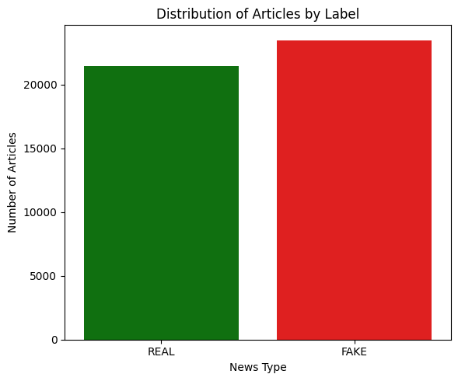
Distribution of articles in the dataset shows a nearly 50/50 split between verified and fake news, ensuring balanced model training.

Word Clouds of Top Terms
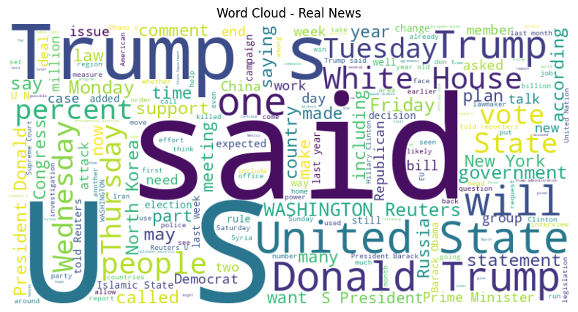
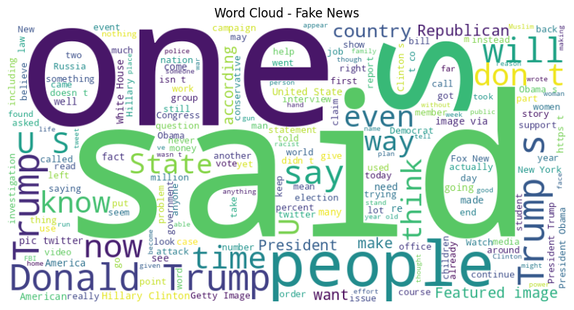 Word clouds reveal that real news often focuses on institutional names and official reporting, while fake news often uses sensationalist language and specific political buzzwords.

Article Length Distribution
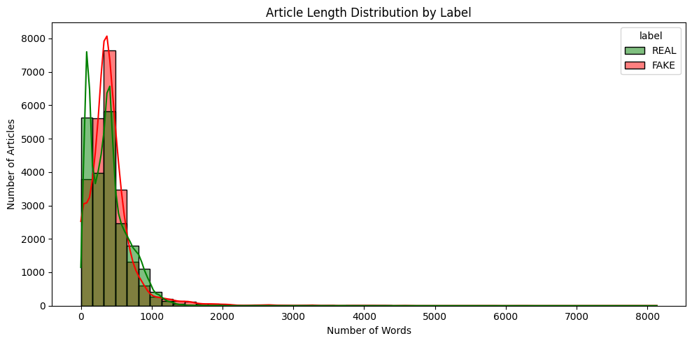Analysis shows that fake news articles often tend to be shorter or significantly longer than typical news reports, often lacking the concise structure of professional journalism.

5. Results and Insights
- Linguistic Markers: Fake news often utilizes more superlative and emotional language compared to the objective tone of verified reports.
- Authorial Patterns: Misinformation frequently lacks specific author attribution or uses generic names, whereas real news usually cites specific reporters or news agencies like Reuters or the Associated Press.
- Predictive Power: The Linear SVM model demonstrated exceptional performance, leveraging the sparse high-dimensional data created by TF-IDF to draw clear decision boundaries.

6. Technology Stack
- Language: Python 3.x
- Libraries: Pandas (Data Handling), Scikit-learn (ML Algorithms), Matplotlib/Seaborn (Visualization)
- Model: Linear Support Vector Machine (LinearSVC)
- Deployment: Flask (Backend), HTML5/CSS3 (Frontend)
- Environment: Google Colab / Local Development

7. Limitations
Despite the high performance of the Linear SVM model, several inherent limitations must be acknowledged for a responsible application of the system:
- Lack of Geopolitical Awareness: The model is trained purely on linguistic features and word frequencies. It does not possess a real-world understanding of geopolitics, current international relations, or specific cultural contexts. Consequently, it may struggle with misinformation that is technically "well-written" but factually incorrect based on complex geopolitical developments.
- Static Knowledge Base: The classifier is built on a historical dataset. As misinformation tactics evolve and new global events unfold, the model may fail to recognize new patterns of fake news that were not present in the original training data.
- Contextual and Intent Recognition: The system focuses on statistical patterns rather than semantic intent. It may misclassify satire, parody, or nuanced opinion pieces that use sophisticated language but are not intended to be "news" in the traditional sense.
- No Real-Time Fact-Checking. Unlike human fact-checkers who verify claims against external primary sources, this model generalizes from historical text patterns. It cannot verify the truth of a specific name, date, or event if it hasn't encountered it before in a similar context.

8. Conclusion

8.1 Summary of Findings
The project successfully developed a high-accuracy detection system for fake news. The combination of TF-IDF and SVM proved to be a highly effective approach for text classification in the news domain.

8.2 Benefits of the Antigravity Pipeline
The Antigravity pipeline streamlined the transition from exploratory data analysis to a production-ready application. Its modular approach allowed for rapid iteration on text cleaning and feature engineering, leading to a robust and scalable solution.

9. Future Scope
- Real-time Detection: Integrating with news APIs to verify content as it is published.
- Interactive Dashboards: Developing advanced visualizations for temporal trends of misinformation.
- Multilingual Support: Extending the model to handle news in multiple languages.
- Multi-modal Analysis: Incorporating image and video metadata to detect deepfakes and manipulated media.

