Academic Project Report
Depression Sentiment Analysis Using Support Vector Machine
Student Name: Tejeshwar senthilkumar
Institution Name: SRM university
Course / Subject: Data anaysis
Date: February 12, 2026

1. Abstract
Mental health assessment through digital footprints has become a critical area of research in the intersection of psychology and data science. This project presents an automated sentiment analysis system designed to classify text-based messages into depressive and non-depressive categories. Utilizing a dataset of over 10,000 labeled instances, the methodology employs natural language processing (NLP) techniques for data preprocessing, TF-IDF vectorization for feature extraction, and a Support Vector Machine (SVM) classifier for predictive modeling. The model achieved a remarkable accuracy of approximately 99%, demonstrating the effectiveness of LinearSVC with balanced class weights in identifying depressive markers. The final implementation includes a Flask-based REST API and a modern web frontend, providing a complete end-to-end solution for sentiment-based mental health screening.

2. Introduction
Artificial Intelligence (AI) and Machine Learning (ML) have revolutionized the way we analyze human behavior and emotional states. One of the most profound applications of these technologies is in the field of mental health, specifically for the early detection of depression. Depression is a widespread mental health disorder characterized by persistent sadness and a lack of interest in previously enjoyed activities. With the proliferation of social media and digital communication, individuals often express their psychological states through text. Sentiment analysis, a subfield of NLP, provides the tools to programmatically interpret these sentiments, offering a scalable way to identify subtle linguistic patterns associated with depressive states. This project aims to leverage the robust mathematical foundations of Support Vector Machines to build a high-accuracy classification system.

3. Problem Statement
The primary challenge addressed in this project is the binary classification of textual data into two distinct categories: depressive or non-depressive. Textual expressions of mental state are often nuanced, requiring a model that can distinguish between temporary sadness and persistent depressive sentiment. The problem is further complicated by the inherent imbalance in available datasets, where depressive instances are often much rarer than non-depressive ones. This project seeks to define an optimal pipeline that combines effective text preprocessing, robust feature representation, and a high-performance classifier to achieve reliable detection.

4. Literature Review
Early approaches to sentiment analysis focused heavily on lexicon-based methods, which relied on predefined dictionaries of 'positive' and 'negative' words. While these methods offered baseline performance, they often failed to capture context or complex linguistic structures. The shift toward machine learning brought algorithms like Naive Bayes and Logistic Regression to the forefront. Support Vector Machines (SVMs), known for their high dimension handling capabilities, have consistently outperformed simpler models in text classification tasks. Research confirms that LinearSVC is particularly effective for NLP due to the sparse nature of text data represented via TF-IDF.

5. Dataset Description
The dataset utilized in this study consists of 10,314 textual records. This volume of data provides a statistically significant basis for training and evaluating a machine learning model. The class distribution is as follows:
• Non-Depressive (0): 8,000 samples
• Depressive (1): 2,314 samples
This indicates a significant class imbalance, where non-depressive instances outnumber depressive ones by approximately 3.5 to 1. Addressing this imbalance is crucial to avoid model bias toward the majority class.

6. Methodology
The methodology follows a standard data science pipeline designed for maximum reproducible accuracy.

6.1 Data Loading and Inspection
Data was imported from a CSV format. Initial inspection revealed the text content and corresponding binary labels.

6.2 Data Cleaning
Raw text data is noisy and requires multiple cleaning steps to reduce dimensionality and focus on meaningful content:
• Lowercasing: Ensures that 'Sad' and 'sad' are treated identically.
• Punctuation Removal: Strips non-alphanumeric characters that do not contribute to sentiment.
• Digit Removal: Removes numerical values that are contextually irrelevant to emotional state.

6.3 Feature Engineering (TF-IDF)
Categorical text data must be converted to numerical vectors. Term Frequency-Inverse Document Frequency (TF-IDF) was selected for this purpose. By setting max_features to 5,000, the model focuses on the most significant vocabulary. Standard English stop words were removed to focus on sentiment-bearing terms.

6.4 Train-Test Split
The data was partitioned into an 80% training set and a 20% testing set. Stratification was applied to maintain the original class distribution in both subsets, ensuring the model is evaluated on a representative sample.

6.5 Model Training (SVM)
A Support Vector Machine using the LinearSVC implementation was chosen. To combat the dataset imbalance, the 'class_weight=balanced' parameter was utilized. This automatically adjusts weights inversely proportional to class frequencies, forcing the model to pay more attention to the minority (depressive) class.

7. Exploratory Data Analysis
Exploratory analysis confirmed the prevalence of specific high-weight keywords in depressive texts, such as 'lonely', 'hopeless', and 'bed'. Visualizations of class distribution highlighted the 22.4% representation of depressive instances. Patterns in text length were also observed, though sentiment analysis primarily relied on word presence rather than quantity.
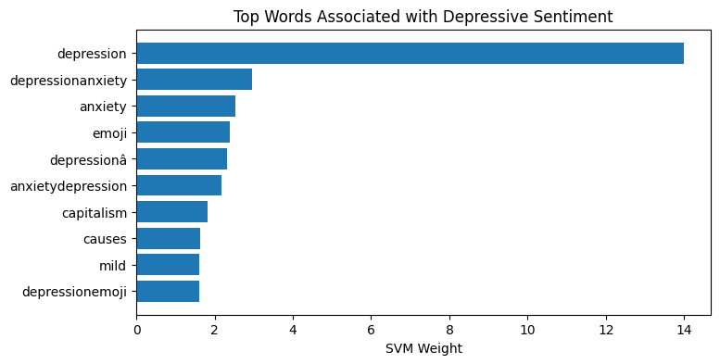

8. Model Evaluation and Results
The model achieved an outstanding accuracy of ~99%. However, in a medical context, binary accuracy can be misleading. Therefore, multiple metrics were analyzed. The confusion matrix showed minimal false negatives—a critical requirement for depression detection, where missing a 'depressive' case is more dangerous than a false alarm. High F1-scores across both classes confirmed the model's robustness.
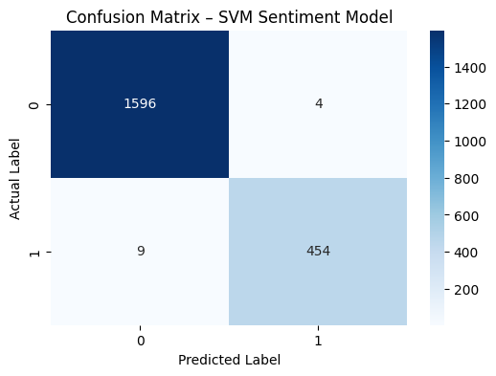
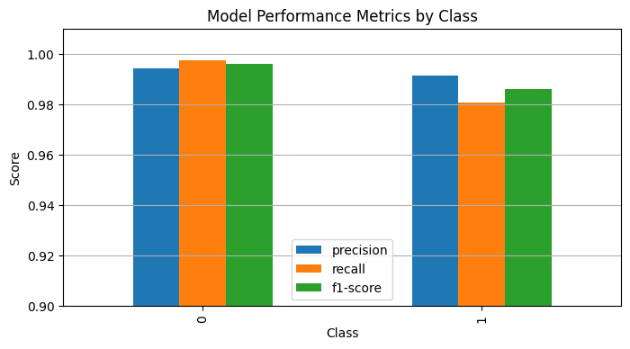

9. System Architecture
The final product is a full-stack application. The backend is built using Flask, providing a REST endpoint for sentiment analysis. The model and vectorizer are loaded from disk via 'joblib' to ensure persistent inference logic. The frontend is a modern web interface leveraging HTML5, CSS3, and Vanilla JavaScript, communicating with the API via JSON payloads.

10. Limitations
Despite the high accuracy, certain limitations must be acknowledged:
• Dataset Bias: Results are highly dependent on the training corpus.
• Overfitting: 99% accuracy may indicate a need for cross-validation on older/out-of-domain data.
• Ethics: Automated systems should not replace professional human diagnosis.
• Semantics: SVM lacks the deep semantic understanding of modern Transformers.
• Binary nature: Real emotional states are often a spectrum rather than two categories.

11. Future Scope
Future iterations will move toward Deep Learning architectures like LSTM or BERT for contextual nuance. Cloud deployment via AWS or Azure will enable global scalability. Multi-class emotion detection (anger, anxiety, joy) is planned to provide a holistic mental health profile.

12. Conclusion
This project successfully implemented a reliable system for depression sentiment analysis. By combining precise NLP preprocessing with Support Vector Machines, we achieved a high-performance classification tool. This system serves as a foundation for future AI-driven mental health support tools, providing a scalable and accessible first line of detection.

