

Design s Analysis of Algorithm
CSE211
Date: 6/1/2026 Week-3 CH.SC.U4CSE24136
P. Geetesh

Merge Sort
Code:
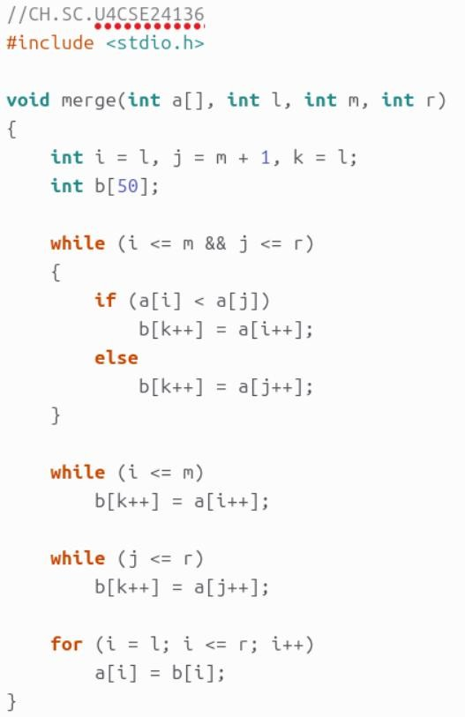
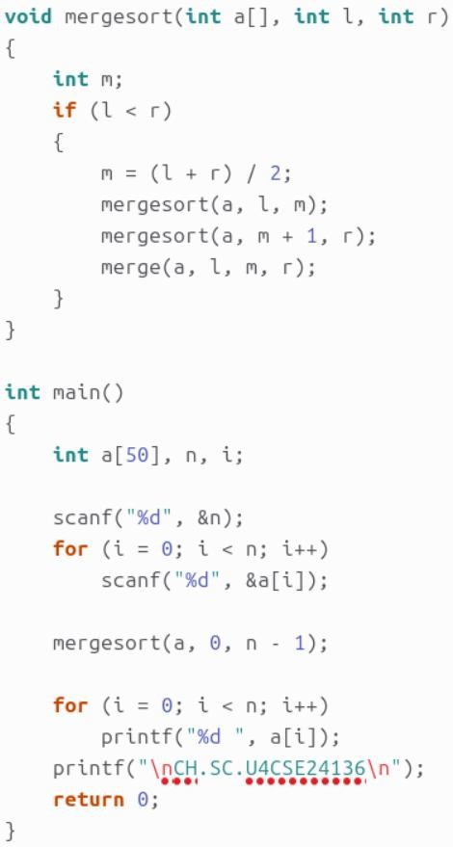

Output:
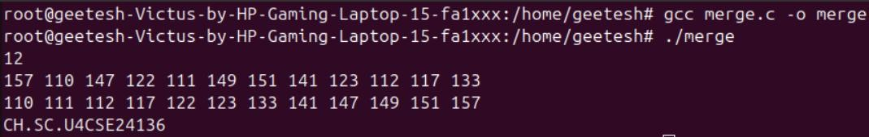

Space Complexity and its justification:

- Time Complexity (All cases): O(n log n)
- Reason: Array is divided into halves recursively → log n levels
- Merge Cost: At each level, n elements are merged → O(n) work
- Space Complexity: O(n)
- Reason: Temporary array b[] is used during merging (recursion stack O(log n) is smaller)

Quick Sort

Code:

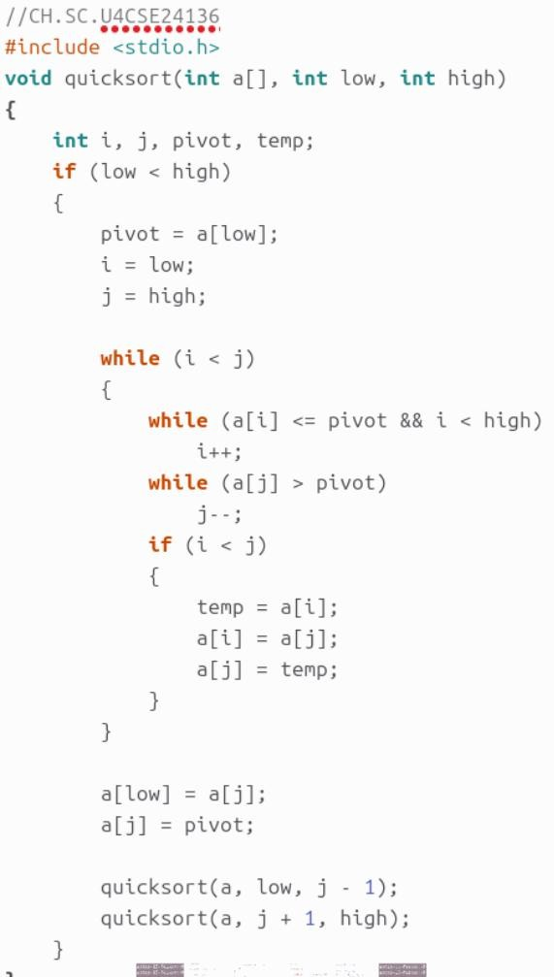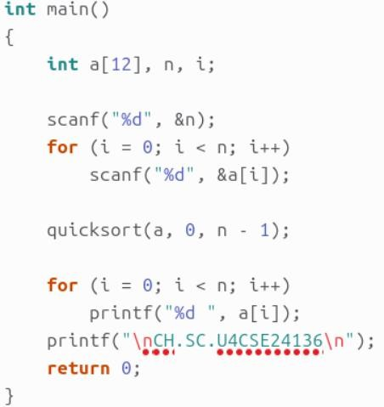

Output:
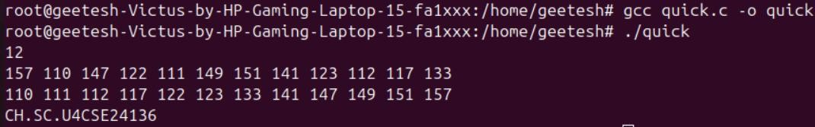

Space Complexity and its justification:

- Best & Average Time Complexity: O(n log n)
- Worst Time Complexity: O(n²) (when pivot is smallest/largest →
unbalanced partitions)
- Reason: Partitioning takes O(n) and recursion depth is log n (best/avg) or n (worst)
- Space Complexity (Average): O(log n) due to recursion stack
- Space Complexity (Worst): O(n) when recursion becomes linear

