

Design s Analysis of Algorithm
CSE211
Date: 27/11/2025 Week-1
CH.SC.U4CSE24136
P.Geetesh

- Write a program to find sum of first n natural numbers using user defined function.
Code:
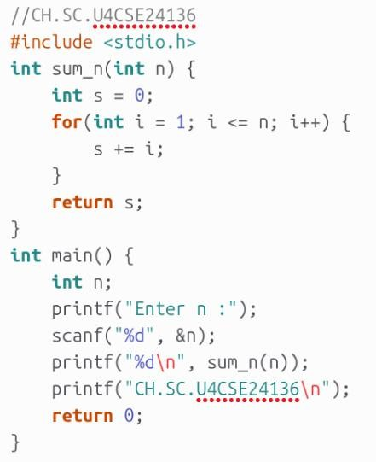

Output:
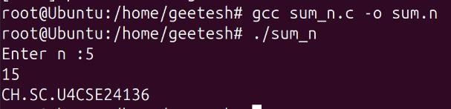

Space Complexity and it’s justification:
  - Space Complexity: O(1) because only a fixed number of variables are used.
  - In main(), there is only one int variable (n).
  - In sum_n(), only two int variables (s and i) are used.
  - No arrays or dynamic memory → space stays constant.

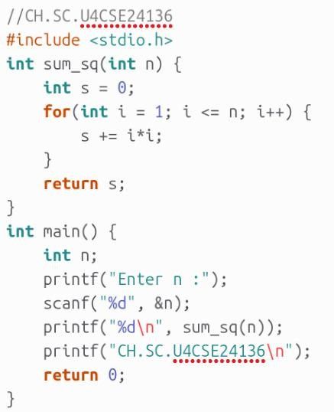

Output:
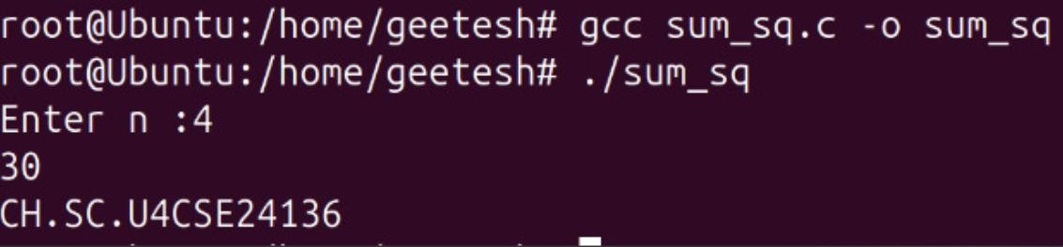

Space Complexity and it’s justification:
  - Space Complexity: O(1)
  - main() uses only one int (n).
  - sum_sq() uses two ints (s, i).
  - No arrays → constant memory.

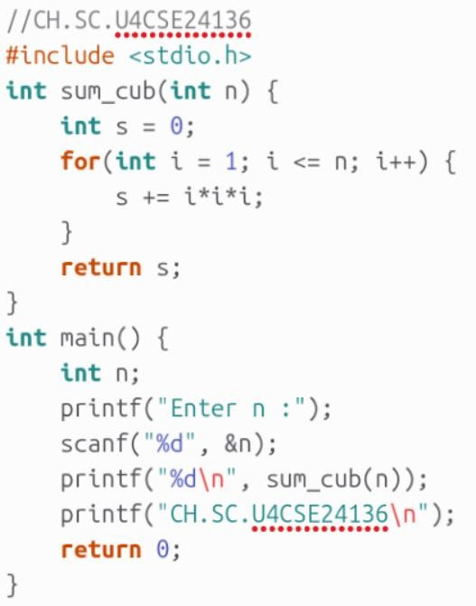

Output:
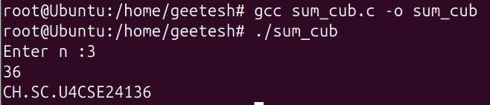

Space Complexity and it’s justification:
  - Space Complexity: O(1)
  - Only one int in main().
  - Only two or three ints inside the function.
  - Memory stays constant.

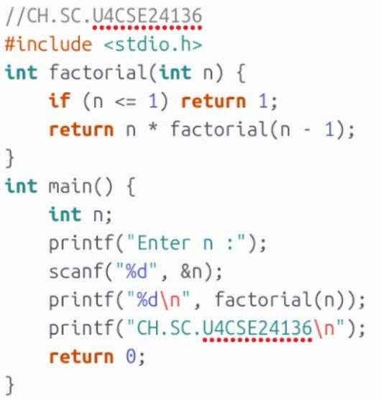

Output:
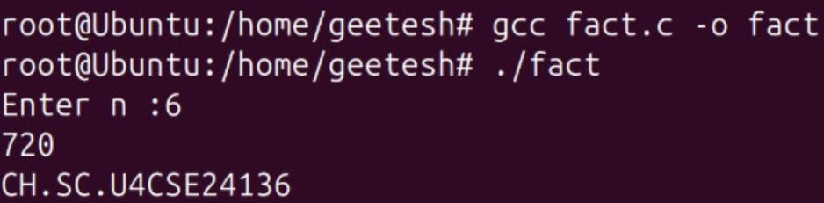

Space Complexity and it’s justification:
- Space Complexity: O(n)
- Each recursive call adds one frame to the stack.
- Maximum depth is n.
- So space grows linearly with input.

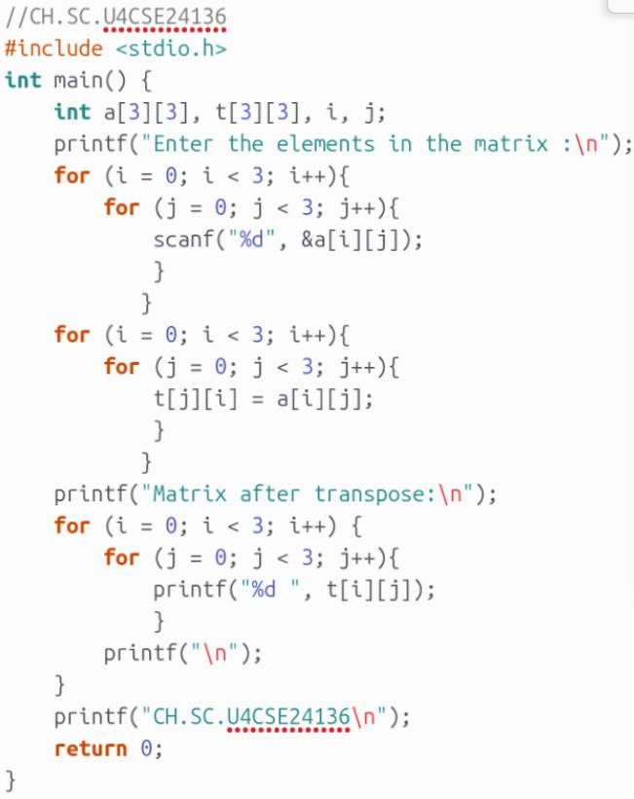

Output:
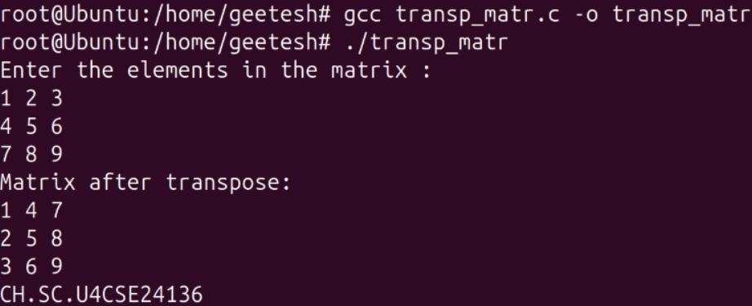

Space Complexity and it’s justification:
- Space Complexity: O(1) (because matrix size is fixed 3×3)
- Uses two fixed 3×3 arrays (a and t).
- Total memory stays constant (not dependent on input).
- No dynamic allocation.

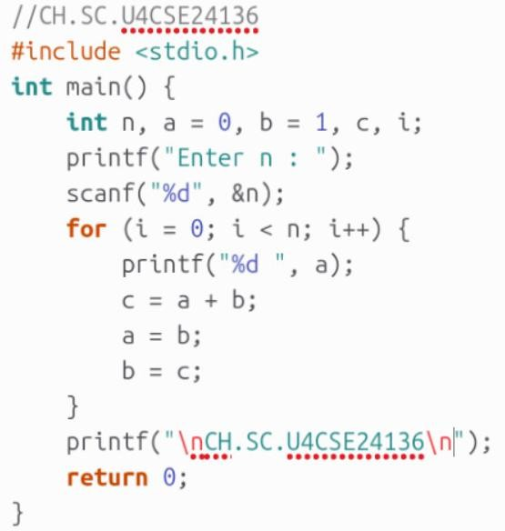

Output:
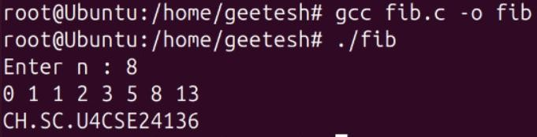

Space Complexity and it’s justification:
- Space Complexity: O(1)
- Uses only a few ints (a, b, c, i, n).
- No arrays or recursion.
- Memory fixed ⇒ constant space.

