

Design s Analysis of Algorithm CSE211
Date: 14/12/2025 Week-2
CH.SC.U4CSE24136
P. Geetesh

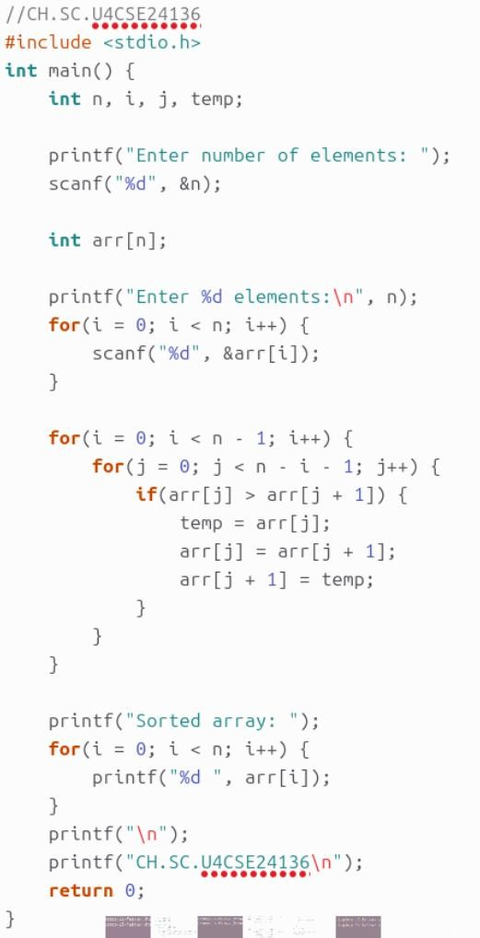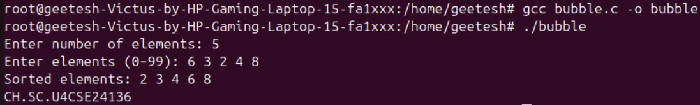

Space Complexity and it’s Justification:
Time Complexity
- Best case: O(n²)
→ No optimization (no early break used).
- Average case: O(n²)
- Worst case: O(n²)
→ Nested loops compare all adjacent pairs.
Space Complexity
- O(1)
→ Only one temporary variable used (in-place sorting).

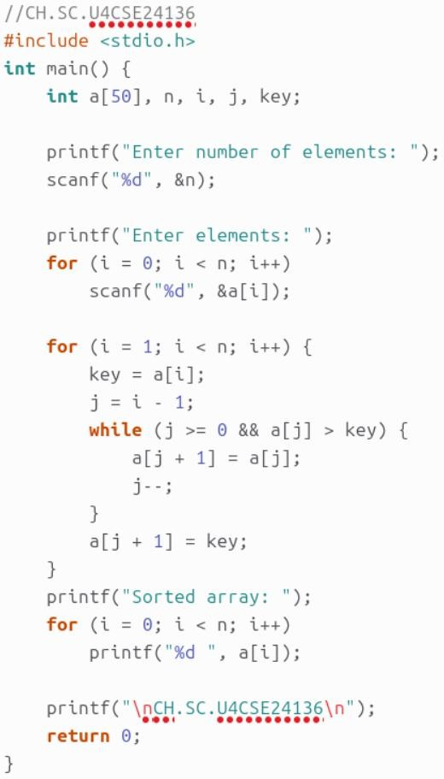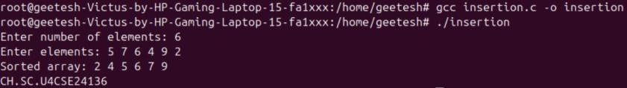

Space Complexity and it’s Justification:
Time Complexity
- Best: O(n)
Fustification:
  - Already sorted array → only one comparison per element
- Average / Worst: O(n²)
Fustification:
  - Each element may shift through the entire sorted part Space Complexity
- O(1)
Fustification:
  - Uses only one temporary variable (key)

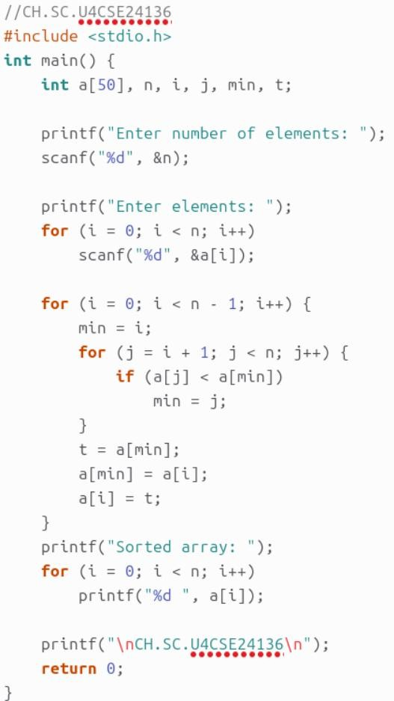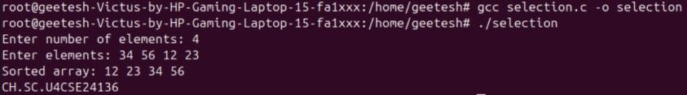

Space Complexity and it’s Justification:
Time Complexity
- Best / Average / Worst: O(n²)
Fustification:
  - Always compares every element to find minimum
  - Number of comparisons does not depend on input order
Space Complexity

O(1)
Fustification:
  - Sorting done in-place, no extra memory used

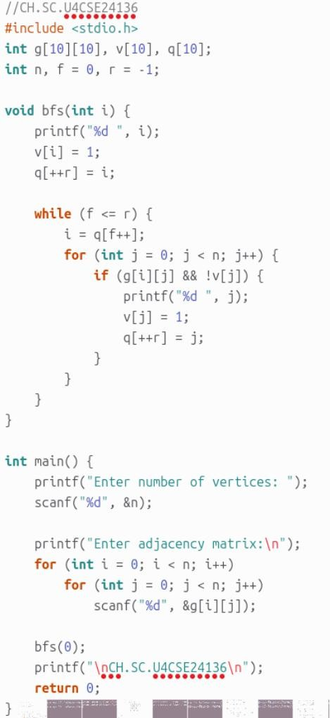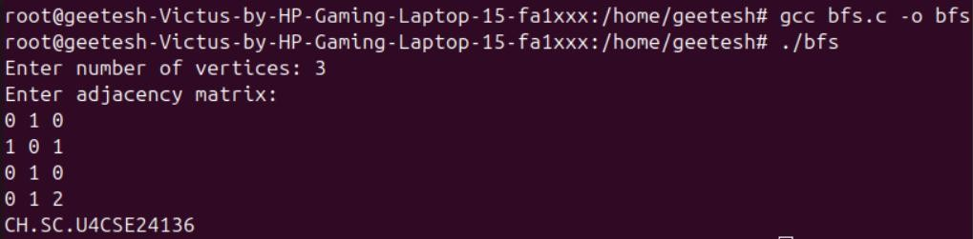

Space Complexity and it’s Justification:
Time Complexity

O(V²)
Fustification:
  - Uses adjacency matrix
  - For each vertex, all V vertices are checked
Space Complexity

O(V)
Fustification:
  - Queue array + visited array store at most V vertices

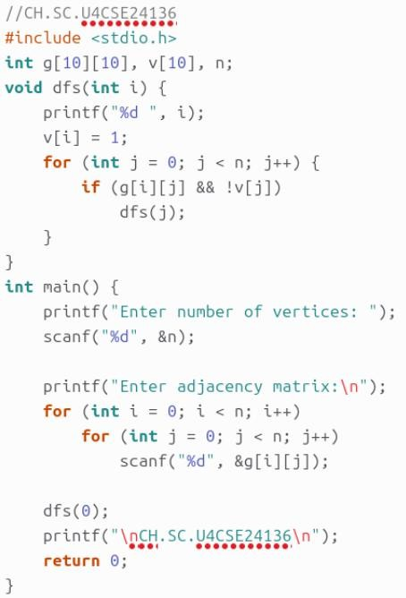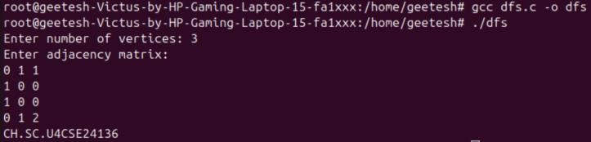

Space Complexity and it’s Justification:
Time Complexity
- O(V²) Justification:
  - Adjacency matrix representation
  - Each DFS call scans all vertices Space Complexity
- O(V)
Justification:
  - Recursive call stack + visited array

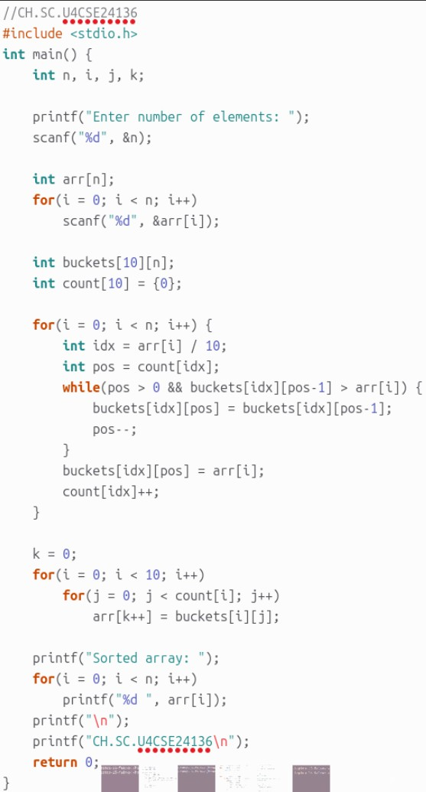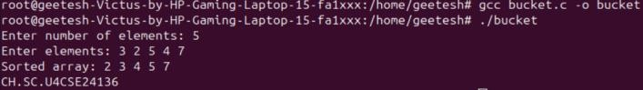

Space Complexity and it’s Justification:
Time Complexity
- Best case: O(n)
→ Elements uniformly distributed, minimal shifting inside buckets.
- Average case: O(n)
→ Each bucket has few elements; insertion is fast.
- Worst case: O(n²)
→ All elements fall into one bucket → insertion sort behavior.
Space Complexity
- O(n)
→ Buckets array buckets[10][n] + count array.

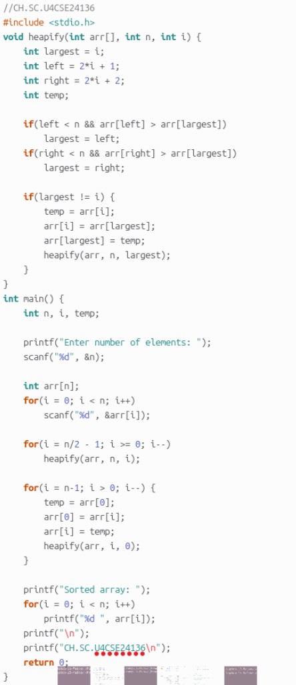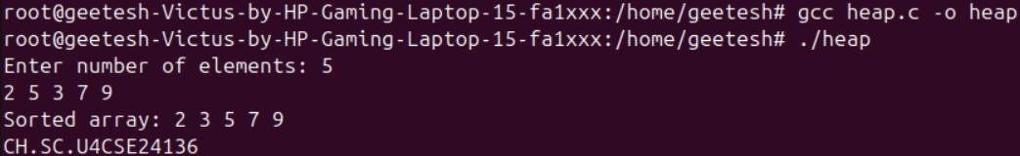

Space Complexity and it’s Justification:
Time Complexity
- Best case: O(n log n)
- Average case: O(n log n)
- Worst case: O(n log n)
→ Heap construction O(n) + n heapify operations O(log n).
Space Complexity
- O(log n)
→ Due to recursive heapify() call stack.

