1) Write a program to find the sum of n natural using a user defined function Code:
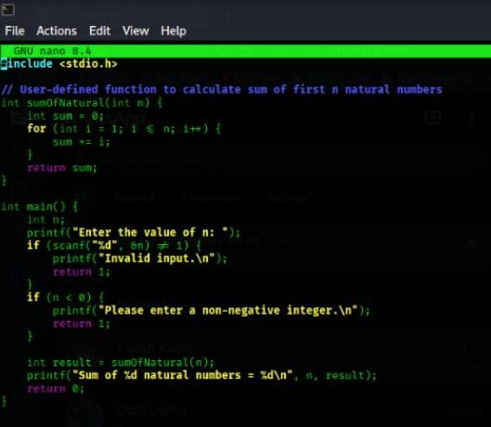
Output:
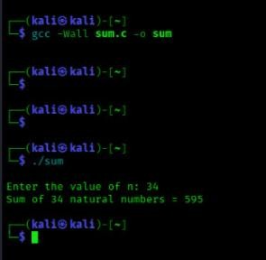

SPACE COMPLEXITY:
- The loop uses only two variables (s and i), and no extra memory grows with n.
- So, the memory used stays constant no matter the input size.
- Therefore, the space complexity is O(1).

2)Write a program to find the sum of squares of n natural numbers
Code:
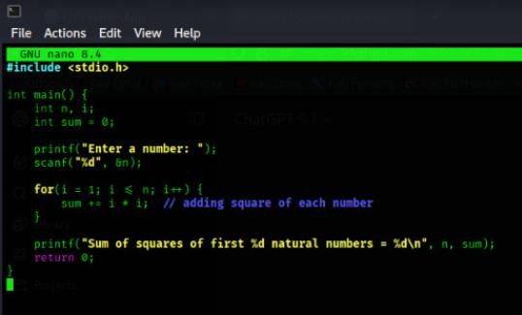
OUTPUT:
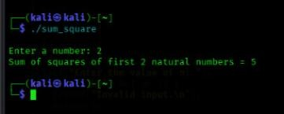
SPACE COMPLEXITY:
- The program uses only a few variables, and this number does not increase when n becomes bigger.
- Since the memory used stays the same all the time, the space complexity is O(1).

3)Write a program to find the sum of cubes of n natural the sum of cubes of n natural numbers
CODE:
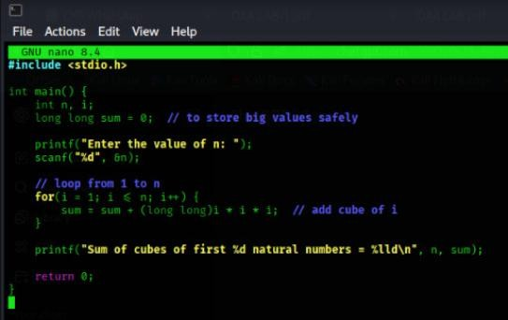
OUTPUT:
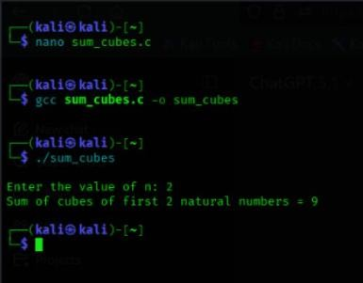
SPACE COMPLEXITY:
- The loop doesn’t create new memory again and again — it just reuses the same variables.
- Because the memory doesn’t grow when n grows, the space stays constant.
- So it is O(1) space.

4)Write a program to find the factorial of a given number using recursion
CODE:
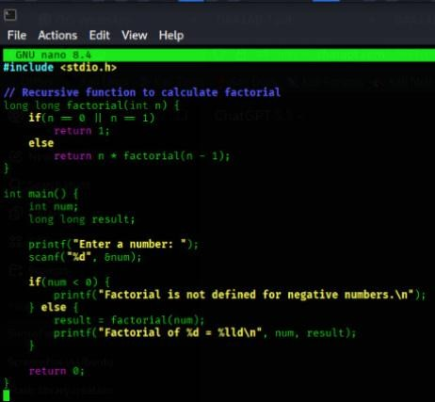
OUTPUT:
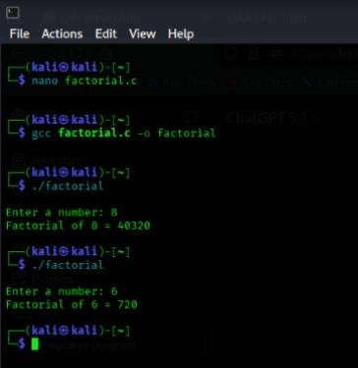
SPACE COMPLEXITY:
- The function calls itself many times, and each call uses some memory.
- More calls mean more memory is used, so memory increases with n.
- That's why the space complexity is O(n).

5)Write a program to transpose a 3x3 matrix
CODE:
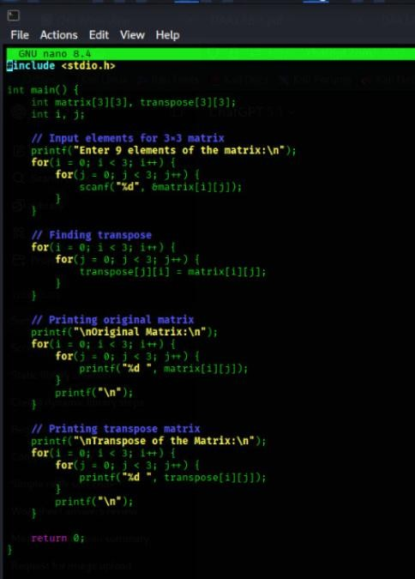
OUTPUT:
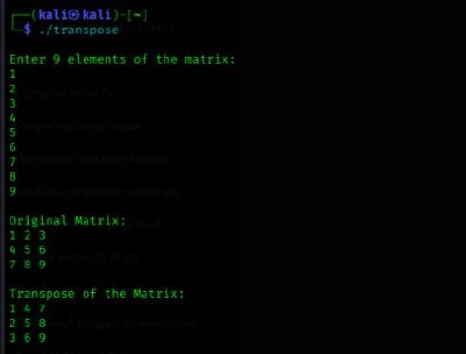
SPACE COMPLEXITY:
- The program creates a 3×3 array, which is fixed in size and does not grow.
- You only use a few extra variables for loops.
- So the space complexity is O(1) 6. Write a program to find the Fibonacci series
6) Write a program to find the Fibonacci series
CODE:
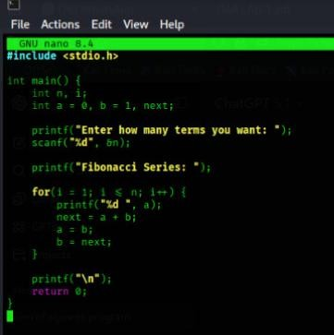
OUTPUT:
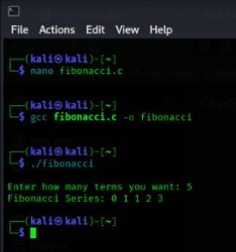
SPACE COMPLEXITY:
- The program only uses a few variables (a, b, sum, temp) and these do not increase when n increases.
- No extra memory grows with the loop.
- So the space complexity is O(1).

