#1

import numpy as np

import pandas as pd

import matplotlib.pyplot as plt

from sklearn.model_selection import train_test_split

from sklearn.neighbors import KNeighborsClassifier

from sklearn.metrics import confusion_matrix, precision_score, recall_score, f1_score

dataset = pd.read_csv("diabetes.csv")

class_0 = dataset[dataset['Outcome'] == 0].drop(columns=['Outcome'])

class_1 = dataset[dataset['Outcome'] == 1].drop(columns=['Outcome'])

centroid_0 = class_0.mean(axis=0)

centroid_1 = class_1.mean(axis=0)

spread_0 = class_0.std(axis=0)

spread_1 = class_1.std(axis=0)

interclass_distance = np.linalg.norm(centroid_0- centroid_1)

print("Centroid Class 0:\n", centroid_0)

print("Centroid Class 1:\n", centroid_1)

print("Spread Class 0:\n", spread_0)

print("Spread Class 1:\n", spread_1)

print("Interclass Distance:", interclass_distance)

**OUTPUT:**

Centroid Class 0:

Pregnancies 3.298000

Glucose 109.980000

BloodPressure 68.184000

SkinThickness 19.664000

Insulin 68.792000

BMI 30.304200

DiabetesPedigreeFunction 0.429734

Age 31.190000

dtype: float64

Centroid Class 1:

Pregnancies 4.865672

Glucose 141.257463

BloodPressure 70.824627

SkinThickness 22.164179

Insulin 100.335821

BMI 35.142537

DiabetesPedigreeFunction 0.550500

Age 37.067164

dtype: float64

Spread Class 0:

Pregnancies 3.017185

Glucose 26.141200

BloodPressure 18.063075

SkinThickness 14.889947

Insulin 98.865289

BMI 7.689855

DiabetesPedigreeFunction 0.299085

Age 11.667655

dtype: float64

Spread Class 1:

Pregnancies 3.741239

Glucose 31.939622

BloodPressure 21.491812

SkinThickness 17.679711

Insulin 138.689125

BMI 7.262967

DiabetesPedigreeFunction 0.372354

Age 10.968254

dtype: float64

Interclass Distance: 45.24310842710197

#2

feature = 'Glucose'

hist_values, bin_edges = np.histogram(dataset[feature], bins=10)

plt.figure(figsize=(8, 5))

plt.hist(dataset[feature], bins=10, edgecolor='black', alpha=0.7)

plt.xlabel(feature)

plt.ylabel("Frequency")

plt.title(f"Histogram of {feature}")

plt.grid(True)

plt.show()

mean_value = np.mean(dataset[feature])

variance_value = np.var(dataset[feature])

print(f"Mean of {feature}: {mean_value}")

print(f"Variance of {feature}: {variance_value}")

**OUTPUT:**

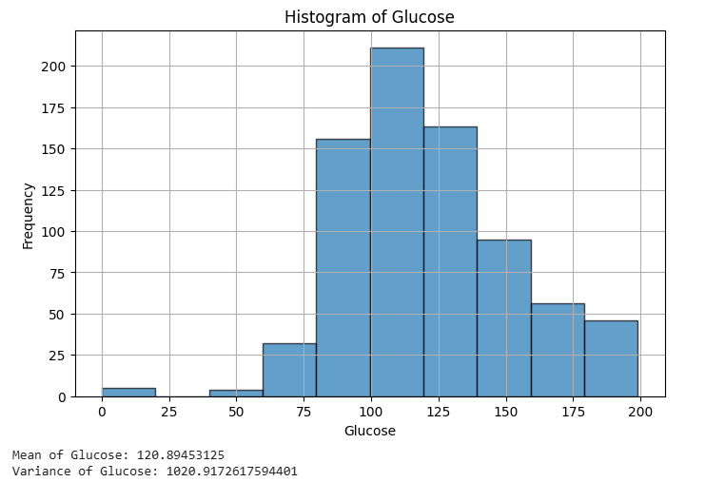

#3

vector1 = dataset.iloc[2, :-1].values # First row (excluding Outcome)

vector2 = dataset.iloc[3, :-1].values # Second row (excluding Outcome)

r_values = np.arange(1, 11)

minkowski_distances = [np.sum(np.abs(vector1- vector2) ** r) ** (1/r) for r in

r_values]

plt.figure(figsize=(8, 5))

plt.plot(r_values, minkowski_distances, marker='o', linestyle='-')

plt.xlabel("r (Minkowski Parameter)")

plt.ylabel("Minkowski Distance")

plt.title("Minkowski Distance vs. r")

plt.grid(True)

plt.show()

print(minkowski_distances)

**OUTPUT:**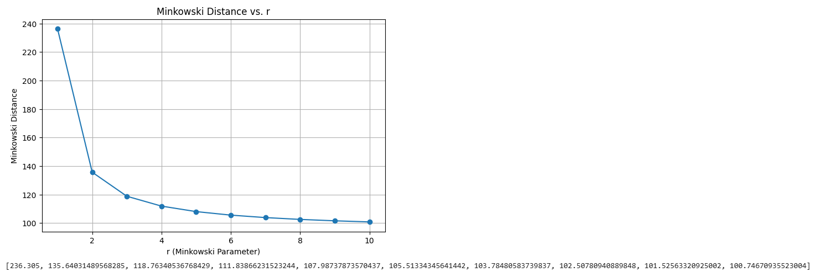

#4

X = dataset.drop(columns=['Outcome'])

y = dataset['Outcome'] # Target variable

X_train, X_test, y_train, y_test = train_test_split(X, y, test_size=0.3,

random_state=42)

print("Training features shape:", X_train.shape)

print("Test features shape:", X_test.shape)

print("Training target shape:", y_train.shape)

print("Test target shape:", y_test.shape)

**OUTPUT:**

**Training features shape: (537, 8)**

**Test features shape: (231, 8)**

**Training target shape: (537,)**

**Test target shape: (231,)**

#5

knn_classifier = KNeighborsClassifier(n_neighbors=3)

knn_classifier.fit(X_train, y_train)

train_accuracy = knn_classifier.score(X_train, y_train)

print(f"Training Accuracy: {train_accuracy}")

**OUTPUT:**

Training Accuracy: 0.8435754189944135

#6

test_accuracy = knn_classifier.score(X_test, y_test)

print(f"Test Accuracy: {test_accuracy}")

**OUTPUT:**

Test Accuracy: 0.6753246753246753

#7

predictions = knn_classifier.predict(X_test)

print("Predictions for the test set:")

print(predictions)

test_vector = X_test.iloc[0].values.reshape(1,-1)

predicted_class = knn_classifier.predict(test_vector)

print(f"Predicted class for the given test vector: {predicted_class[0]}")

**OUTPUT:**

Predictions for the test set:

[0 1 0 1 1 1 0 0 1 1 0 1 0 0 0 1 0 0 1 1 1 0 1 0 1 1 0 0 0 0 1 0 1 1 0 1 1

0 0 1 0 1 1 1 0 0 0 0 0 1 0 1 1 0 0 0 0 0 0 1 1 1 1 0 0 0 0 1 0 1 1 0 0 0

0 1 0 0 0 0 1 0 0 1 0 1 1 0 0 0 0 0 0 0 1 1 1 0 1 0 1 0 0 0 1 1 0 1 0 1 0

1 0 1 1 1 1 0 0 0 0 0 1 0 1 1 0 1 1 1 1 0 1 1 1 1 0 1 1 0 0 0 0 1 0 0 0 0

1 1 0 0 0 0 0 0 0 0 0 0 1 1 0 0 0 1 0 1 1 0 1 0 0 1 1 0 0 0 1 0 0 0 1 1 0

0 0 0 1 0 0 0 1 0 0 0 0 0 0 1 0 0 1 0 1 0 0 0 1 0 0 0 0 0 1 0 1 1 0 1 1 0

0 0 0 1 0 0 0 0 0]

Predicted class for the given test vector: 0

#8

def evaluate_knn_accuracy(X_train, y_train, X_test, y_test):

k_values = np.arange(1, 12)

accuracies = []

for k in k_values:

knn_classifier = KNeighborsClassifier(n_neighbors=k)

knn_classifier.fit(X_train, y_train)

accuracy = knn_classifier.score(X_test, y_test)

accuracies.append(accuracy)

return k_values, accuracies

k_values, accuracies = evaluate_knn_accuracy(X_train, y_train, X_test, y_test)

plt.figure(figsize=(8, 5))

plt.plot(k_values, accuracies, marker='o', linestyle='-', color='b')

plt.xlabel('k (Number of Neighbors)')

plt.ylabel('Accuracy')

plt.title('kNN Accuracy vs. k (1 to 11)')

plt.grid(True)

plt.show()

for k, accuracy in zip(k_values, accuracies):

print(f"Accuracy for k={k}: {accuracy}")

**OUTPUT:**

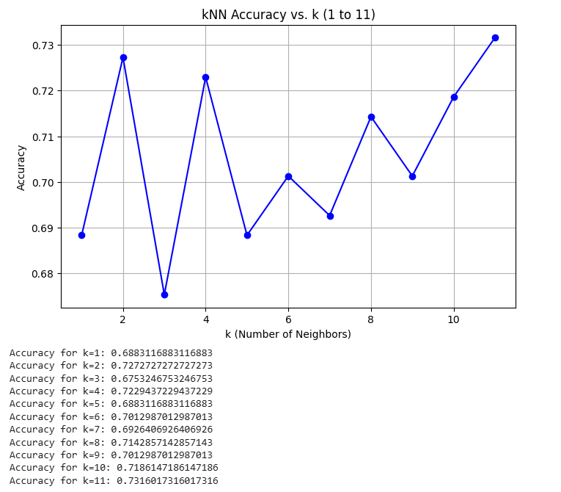

#9

y_train_pred = knn_classifier.predict(X_train)

y_test_pred = knn_classifier.predict(X_test)

train_conf_matrix = confusion_matrix(y_train, y_train_pred)

print("Confusion Matrix (Training Set):")

print(train_conf_matrix)

test_conf_matrix = confusion_matrix(y_test, y_test_pred)

print("Confusion Matrix (Test Set):")

print(test_conf_matrix)

train_precision = precision_score(y_train, y_train_pred)

train_recall = recall_score(y_train, y_train_pred)

train_f1 = f1_score(y_train, y_train_pred)

test_precision = precision_score(y_test, y_test_pred)

test_recall = recall_score(y_test, y_test_pred)

test_f1 = f1_score(y_test, y_test_pred)

print("\nPerformance Metrics (Training Set):")

print(f"Precision: {train_precision}")

print(f"Recall: {train_recall}")

print(f"F1-Score: {train_f1}")

print("\nPerformance Metrics (Test Set):")

print(f"Precision: {test_precision}")

print(f"Recall: {test_recall}")

print(f"F1-Score: {test_f1}")

if train_f1 > test_f1:

print("\n The dataset is overfitting.")

elif train_f1 < test_f1:

print("\n The dataset is underfitting.")

else:

print("\n The dataset is regular fit.")

**OUTPUT:**

Confusion Matrix (Training Set):

[[316 33]

[ 51 137]]

Confusion Matrix (Test Set):

[[108 43]

[ 32 48]]

Performance Metrics (Training Set):

Precision: 0.8058823529411765

Recall: 0.7287234042553191

F1-Score: 0.7653631284916201

Performance Metrics (Test Set):

Precision: 0.5274725274725275

Recall: 0.6

F1-Score: 0.5614035087719298

The dataset is overfitting.