***Git***

***Assignment1***

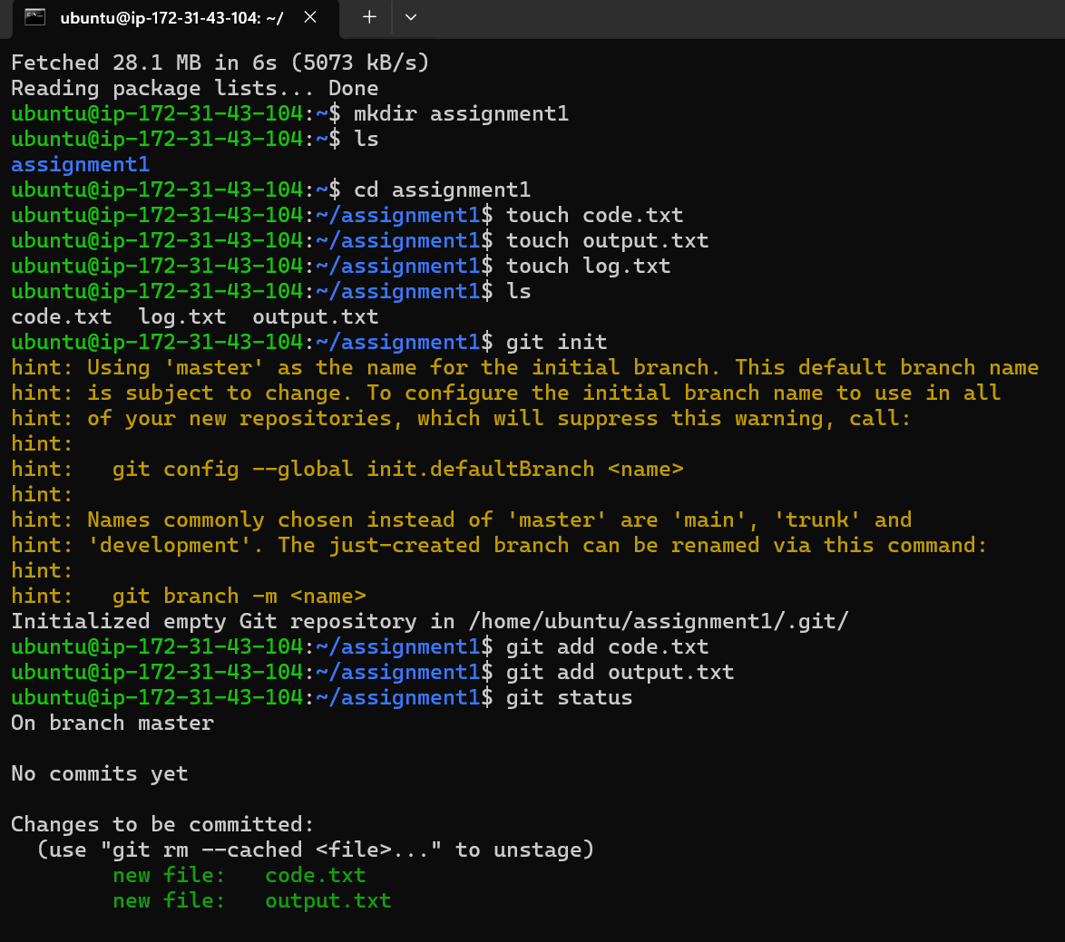

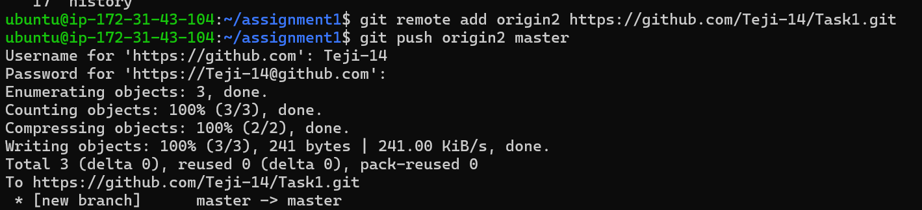

Commands

1 sudo apt-get install git

2 sudo apt-get update

3 mkdir assignment1

4 ls

5 cd assignment1

6 touch code.txt

7 touch output.txt

8 touch log.txt

9 ls

10 git init

11 git add code.txt

12 git add output.txt

13 git status

14 git commit -m "First commit"

15 git remote add origin2 https://github.com/Teji-14/Task1.git

16 git push origin2 master

***Assignment-2***

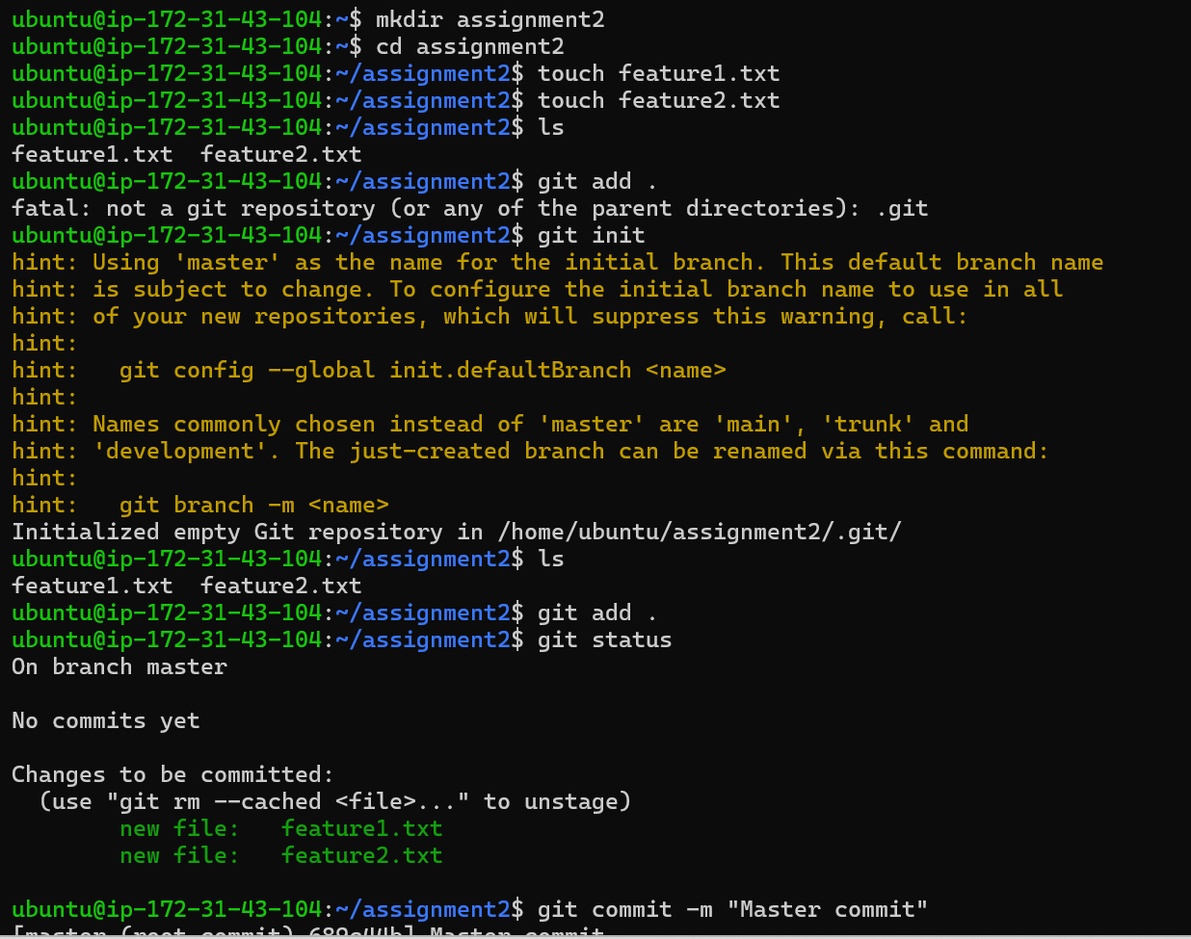

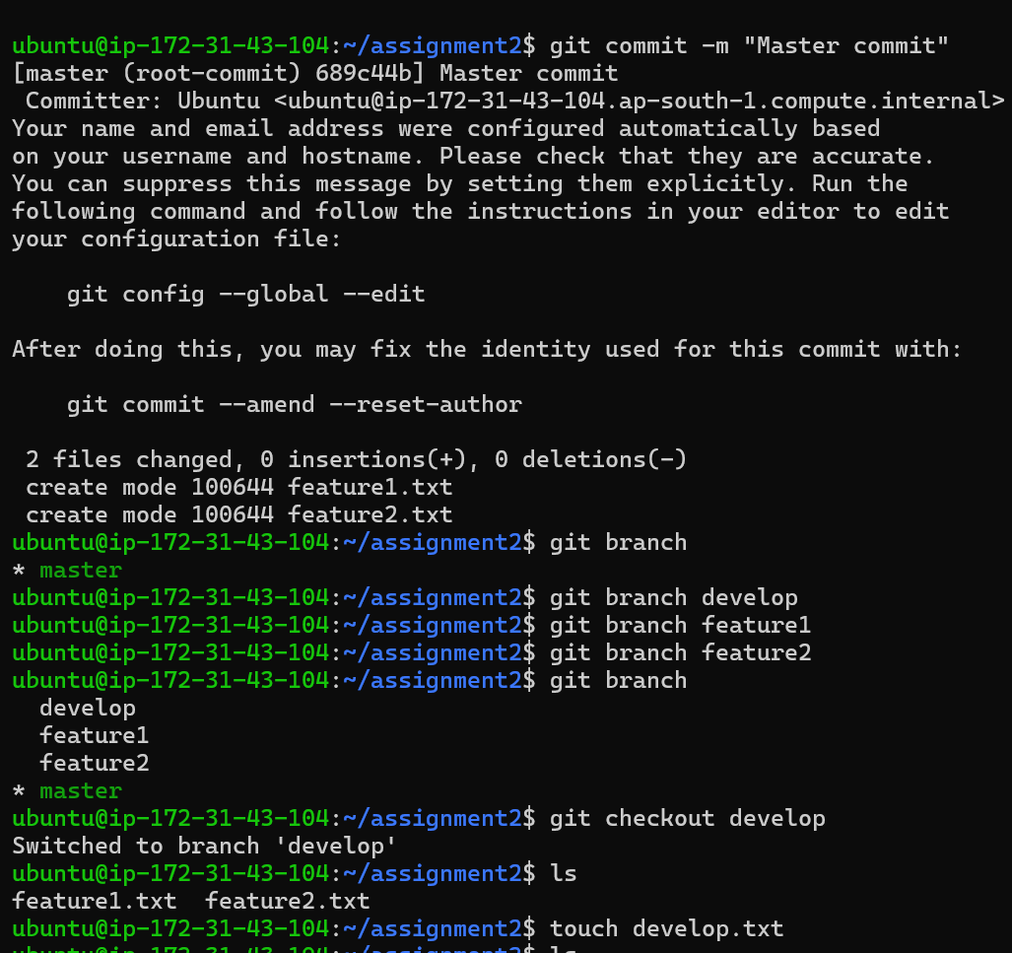

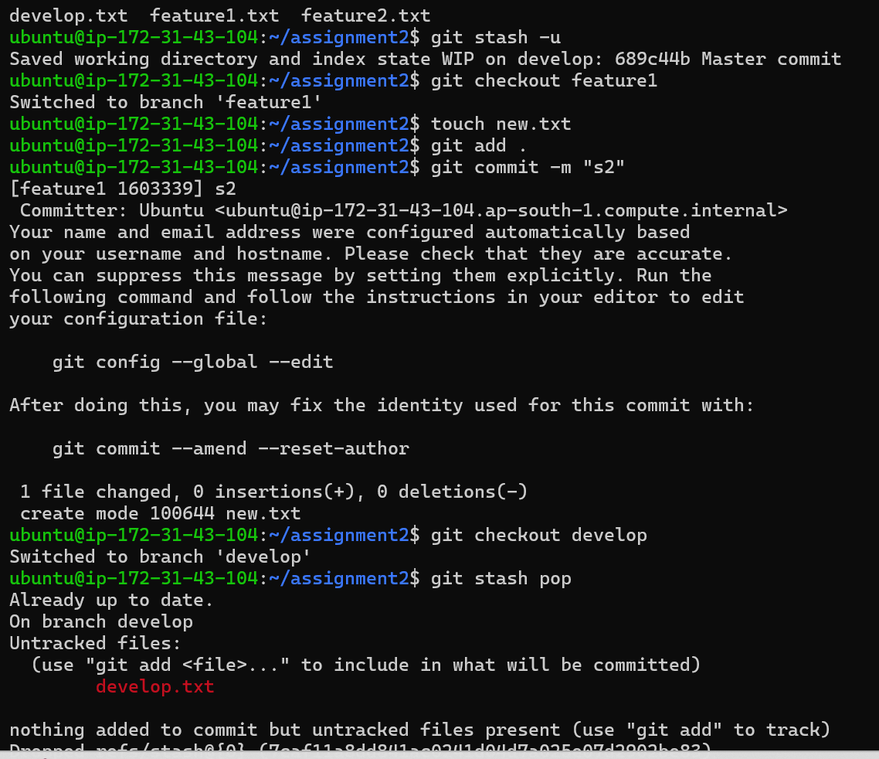

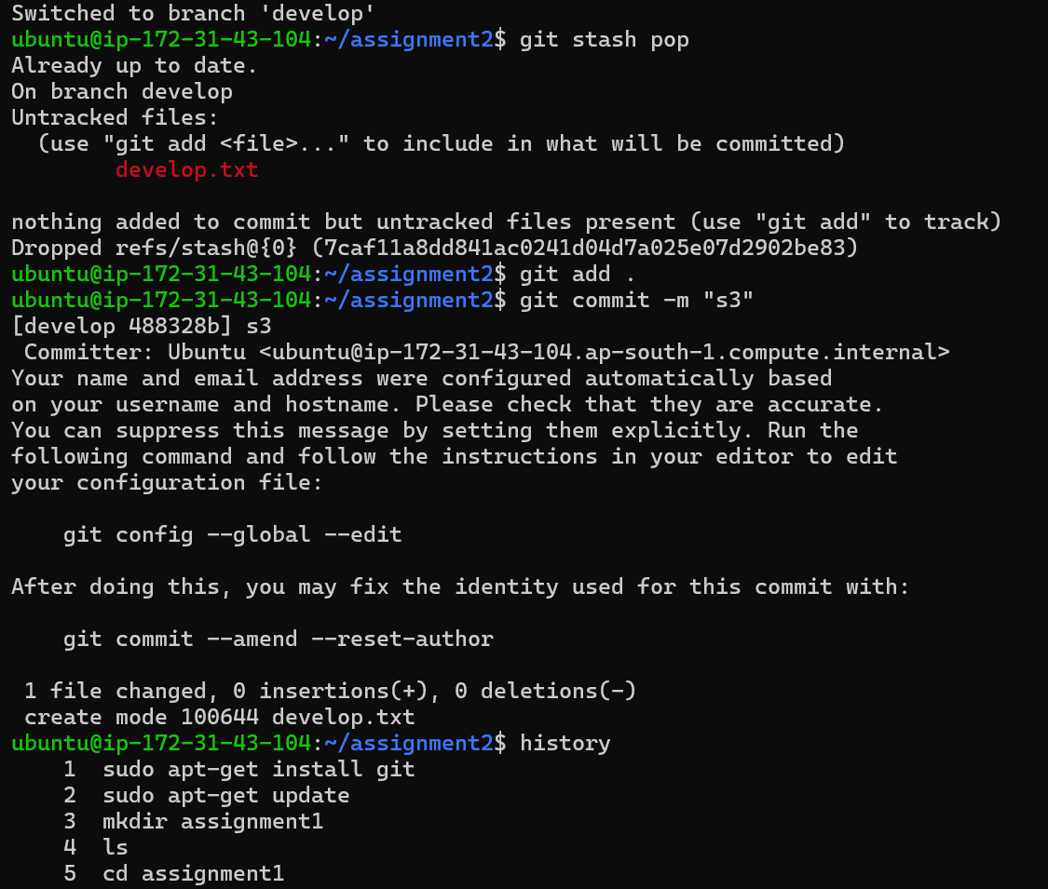

21 mkdir assignment2

22 cd assignment2

23 touch feature1.txt

24 touch feature2.txt

25 ls

26 git add .

27 git init

28 ls

29 git add .

30 git status

31 git commit -m "Master commit"

32 git branch

33 git branch develop

34 git branch feature1

35 git branch feature2

36 git branch

37 git checkout develop

38 ls

39 touch develop.txt

40 ls

41 git stash -u

42 git checkout feature1

43 touch new.txt

44 git add .

45 git commit -m "s2"

46 git checkout develop

47 git stash pop

48 git add .

49 git commit -m "s3"

***Assignment-3***

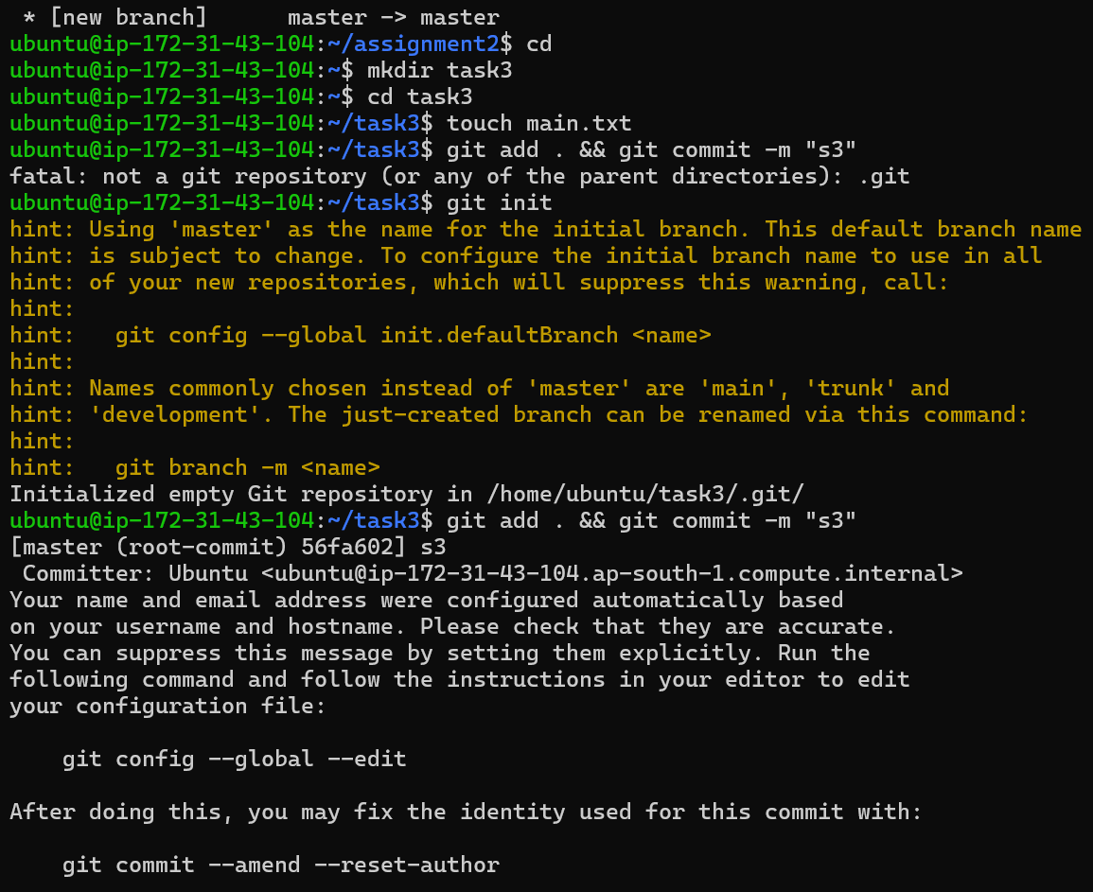

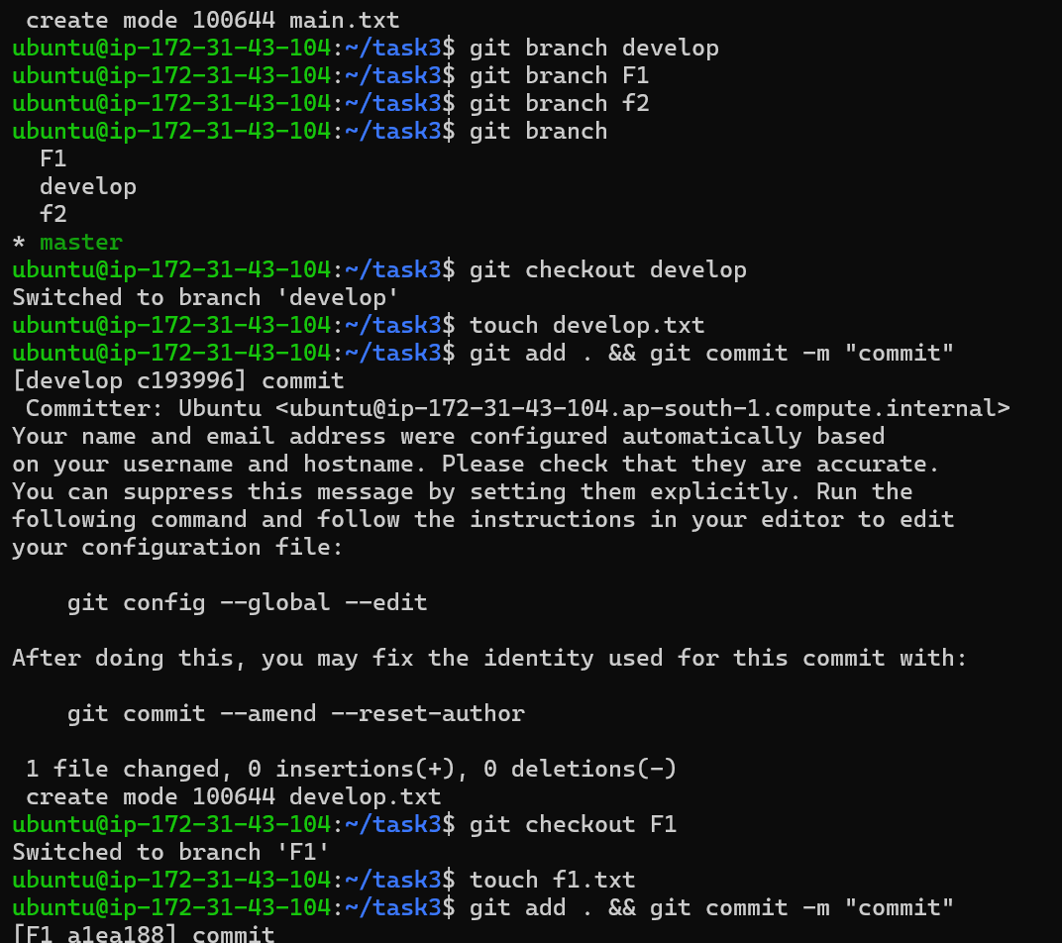

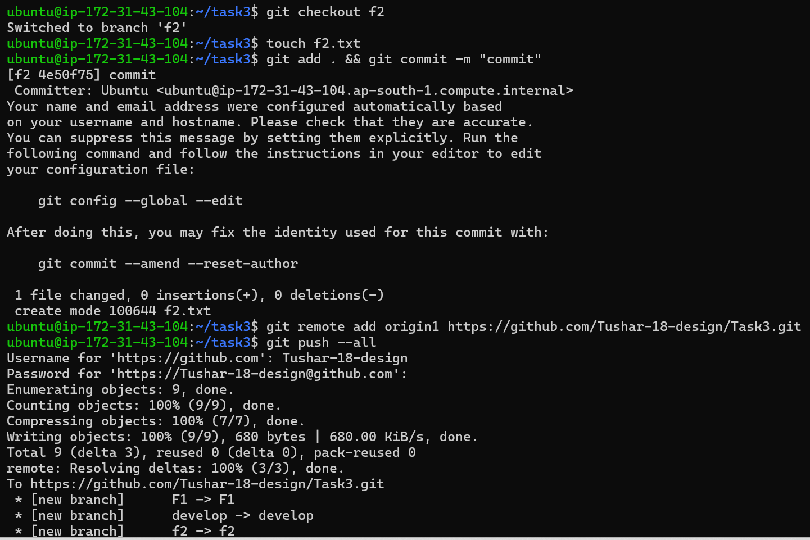

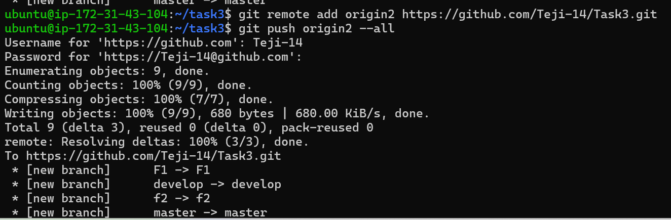

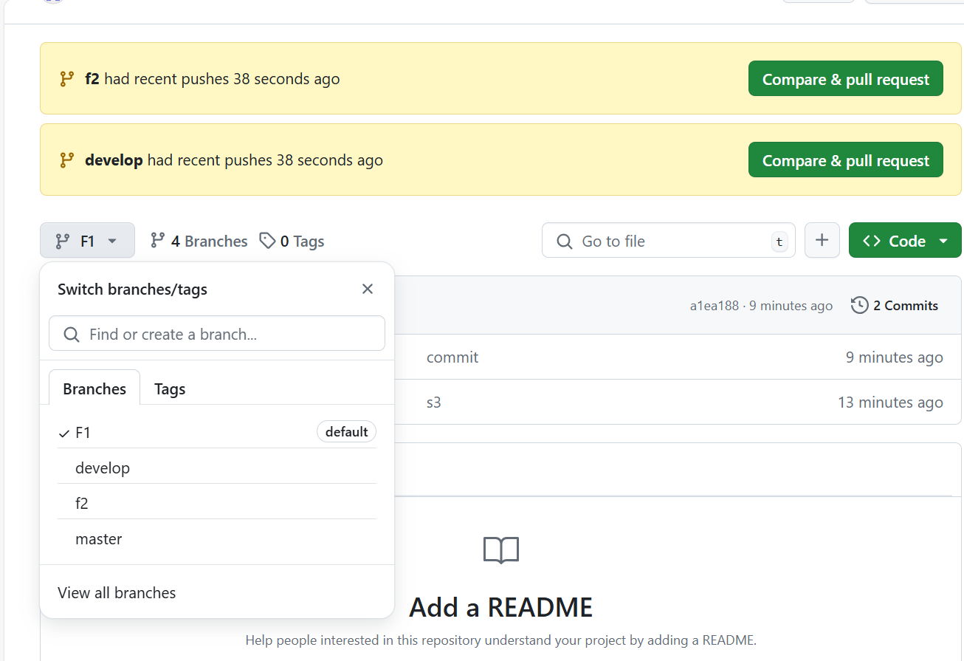

mkdir task3

57 cd task3

58 touch main.txt

59 git add . && git commit -m "s3"

60 git init

61 git add . && git commit -m "s3"

62 git branch develop

63 git branch F1

64 git branch f2

65 git branch

66 git checkout develop

67 touch develop.txt

68 git add . && git commit -m "commit"

69 git checkout F1

70 touch f1.txt

71 git add . && git commit -m "commit"

72 git checkout f2

73 touch f2.txt

74 git add . && git commit -m "commit"

75 git remote add origin2 https://github.com/Teji-14/Task3.git

76 git push origin2 –all

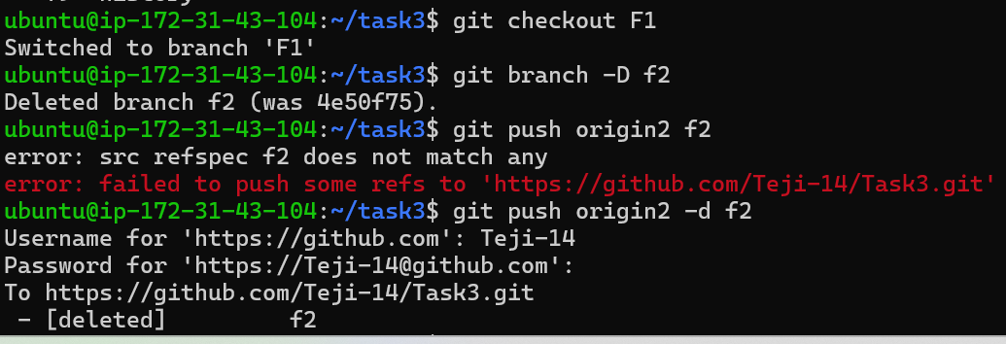

***Assignment-4***

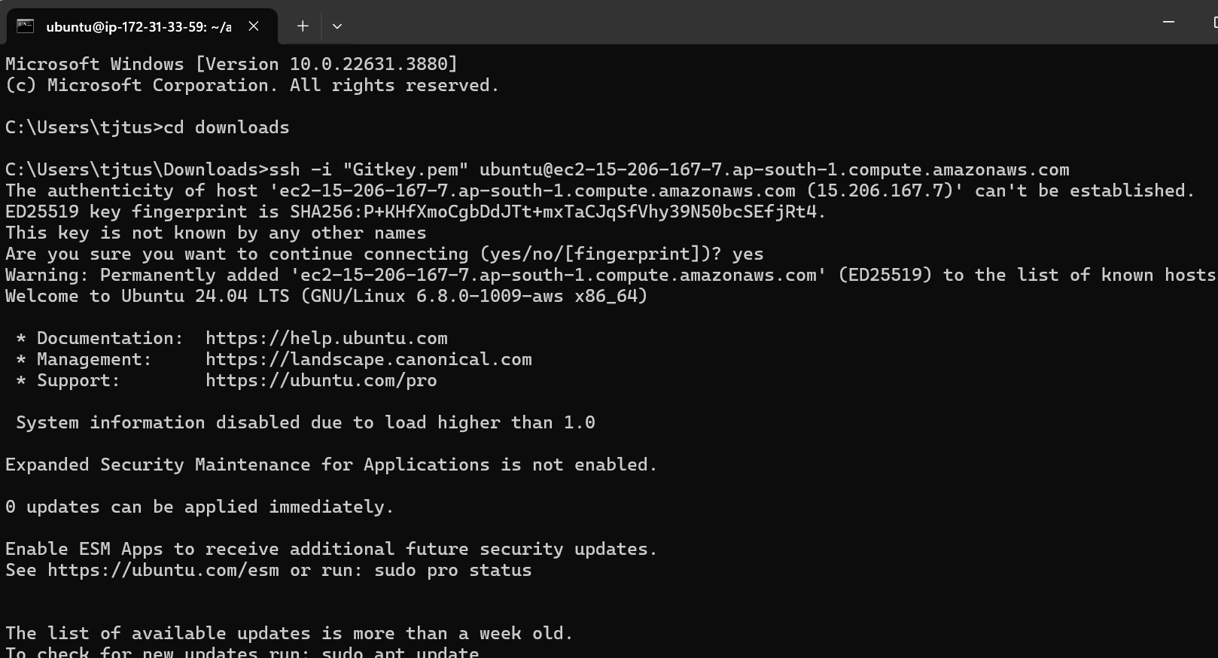

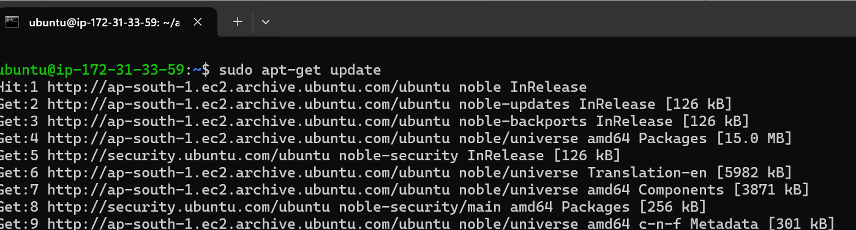

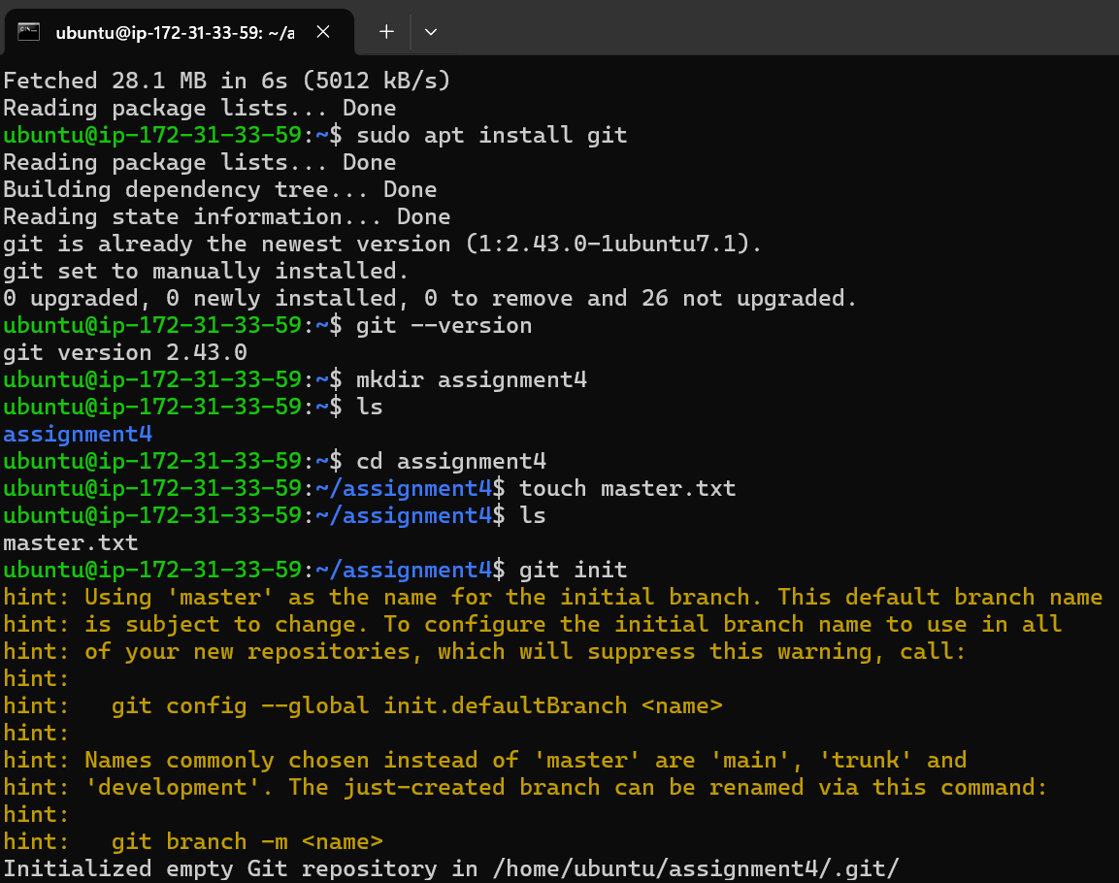

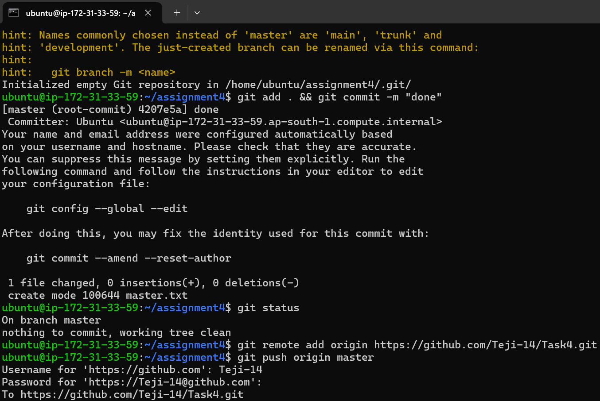

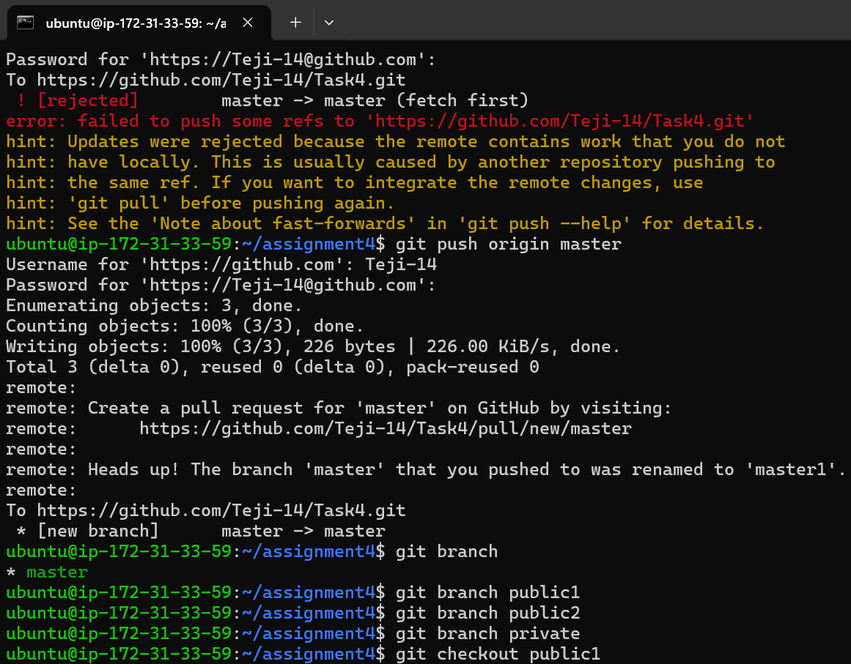

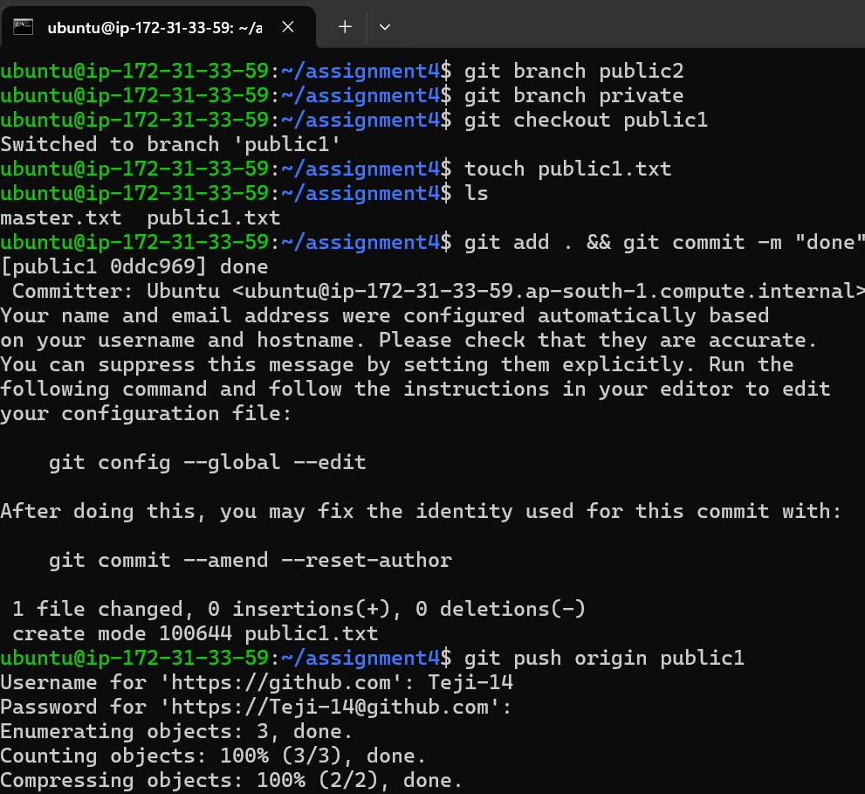

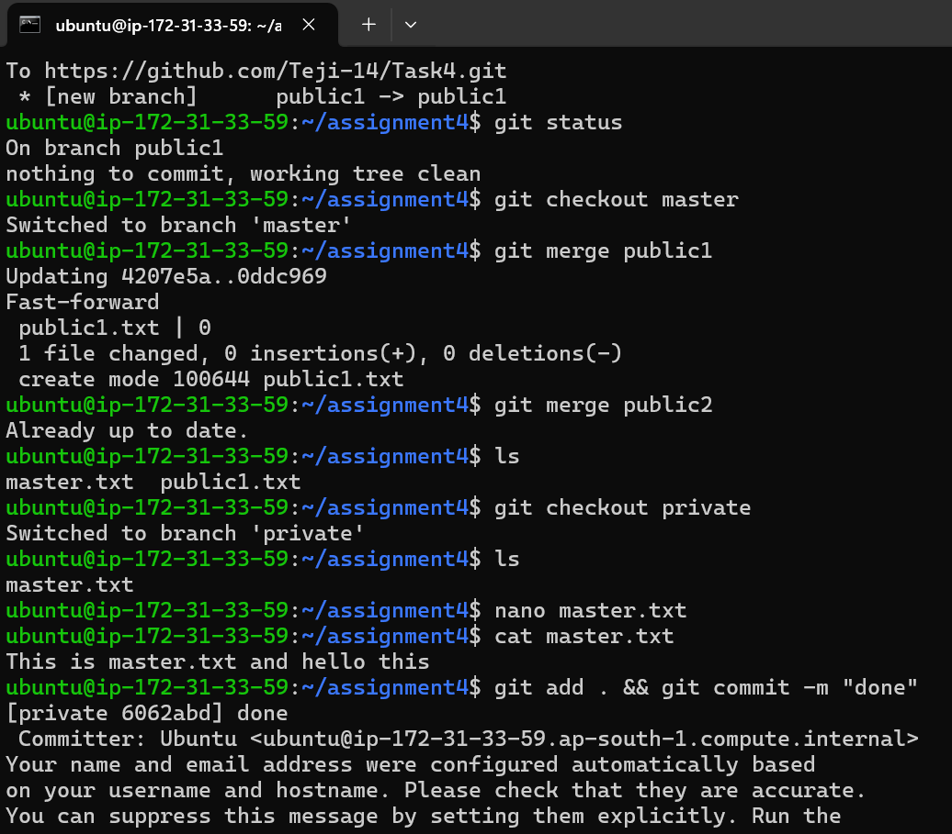

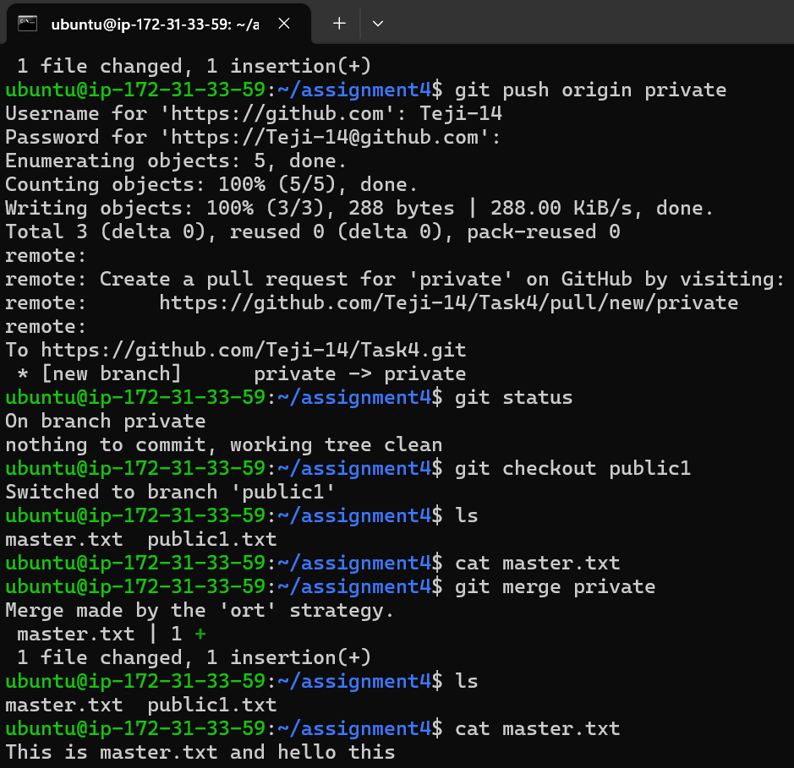

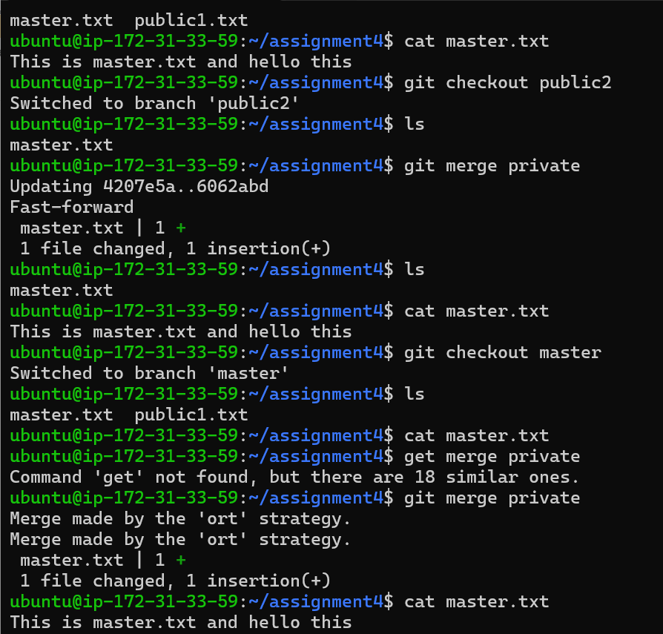

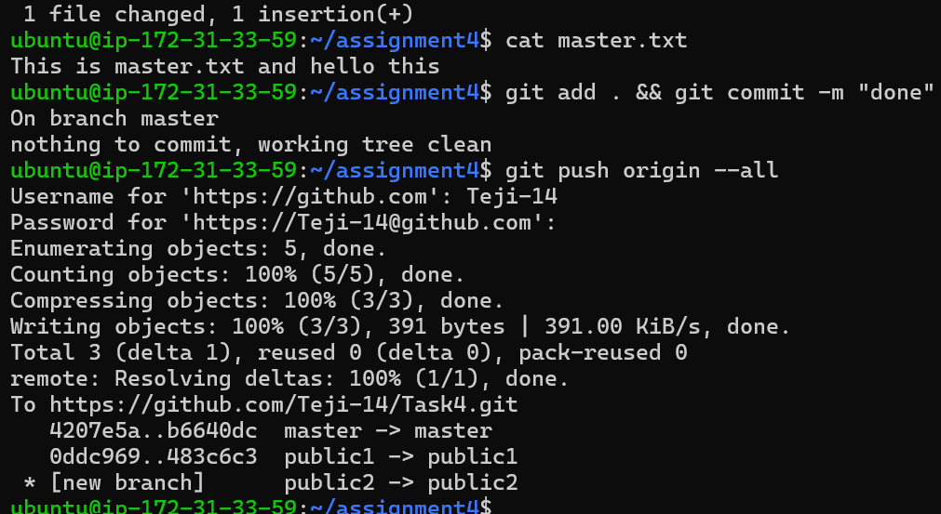

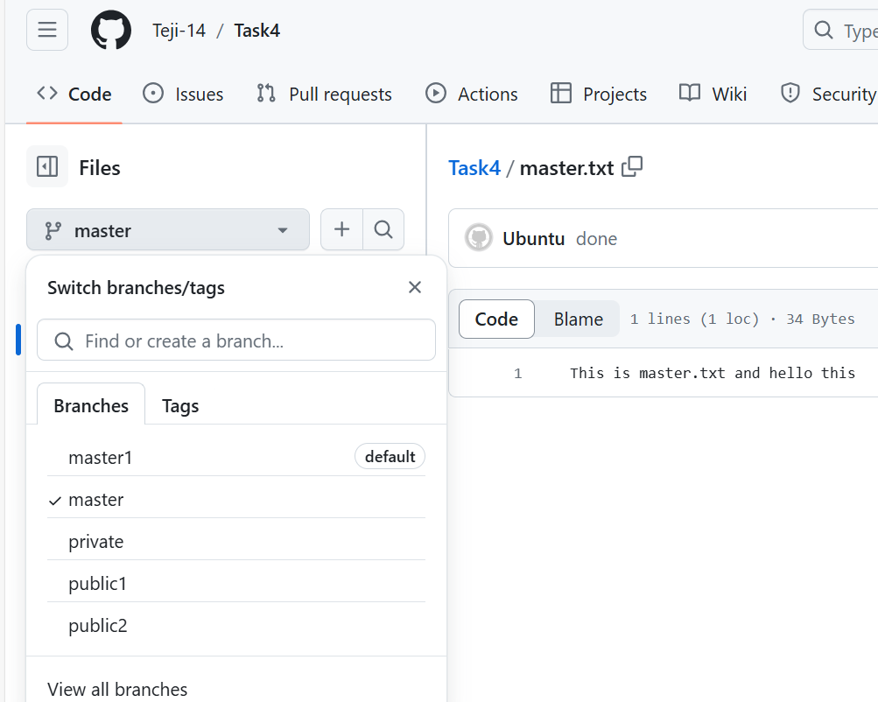

1 sudo apt-get update

2 sudo apt install git

3 git --version

4 mkdir assignment4

5 ls

6 cd assignment4

7 touch master.txt

8 ls

9 git init

10 git add . && git commit -m "done"

11 git status

12 git remote add origin https://github.com/Teji-14/Task4.git

13 git push origin master

14 git branch

15 git branch public1

16 git branch public2

17 git branch private

18 git checkout public1

19 touch public1.txt

20 ls

21 git add . && git commit -m "done"

22 git push origin public1

23 git status

24 git checkout master

25 git merge public1

26 git merge public2

27 ls

28 git checkout private

29 ls

30 nano master.txt

31 cat master.txt

32 git add . && git commit -m "done"

33 git push origin private

34 git status

35 git checkout public1

36 ls

37 cat master.txt

38 git merge private

39 ls

40 cat master.txt

41 git checkout public2

42 ls

43 git merge private

44 ls

45 cat master.txt

46 git checkout master

47 ls

48 cat master.txt

49 get merge private

50 git merge private

51 cat master.txt

52 git add . && git commit -m "done"

53 git push origin –all

***Assignment 5***

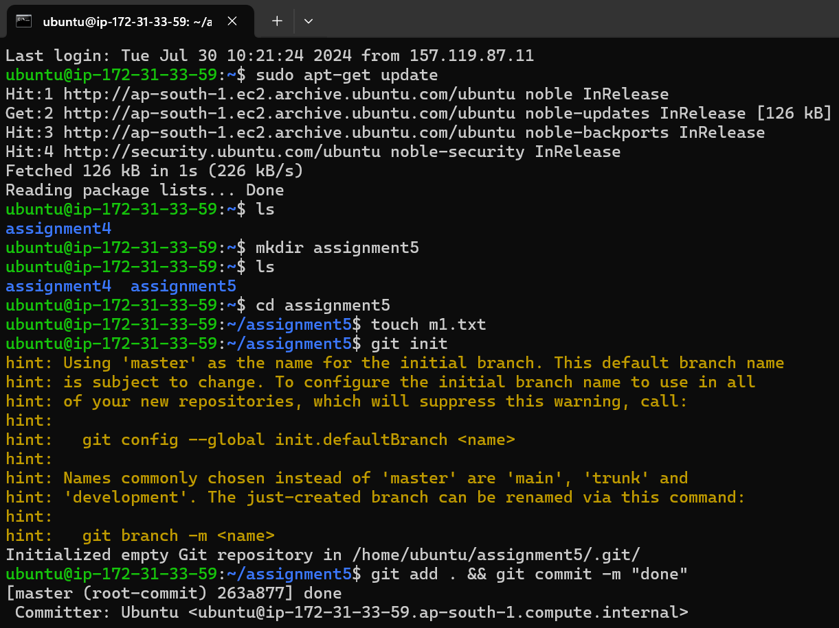

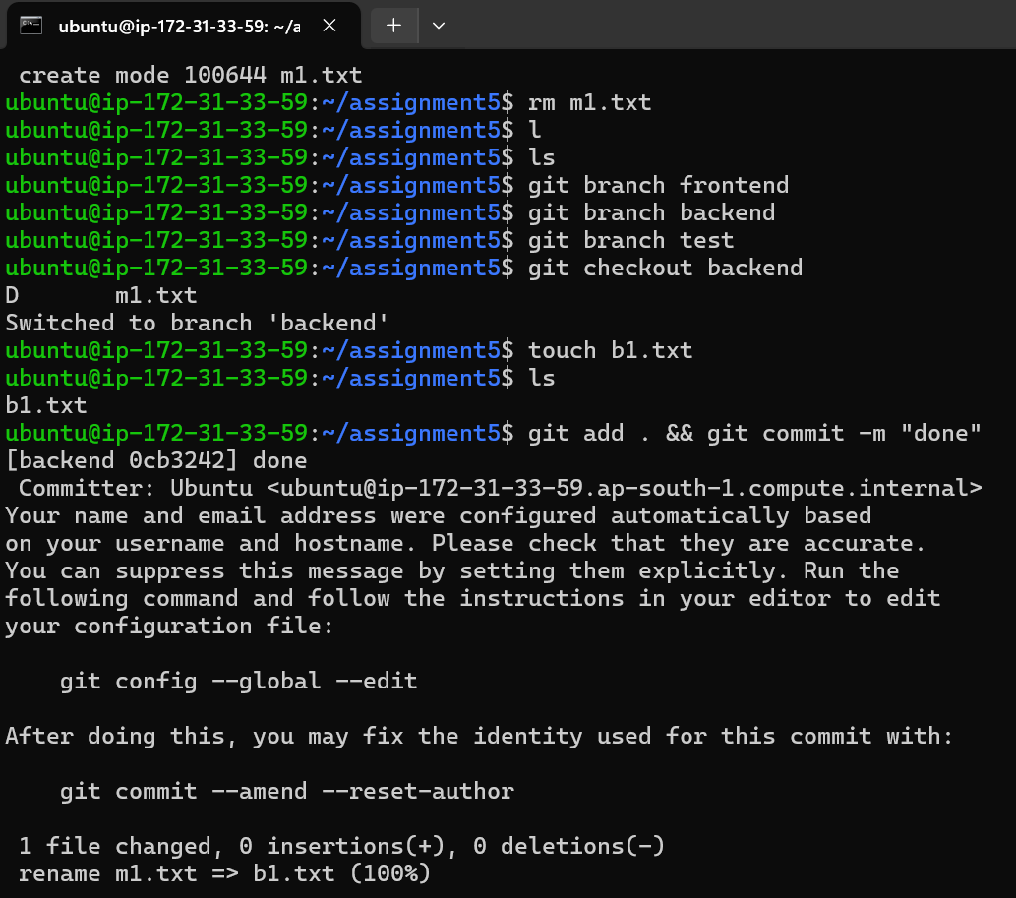

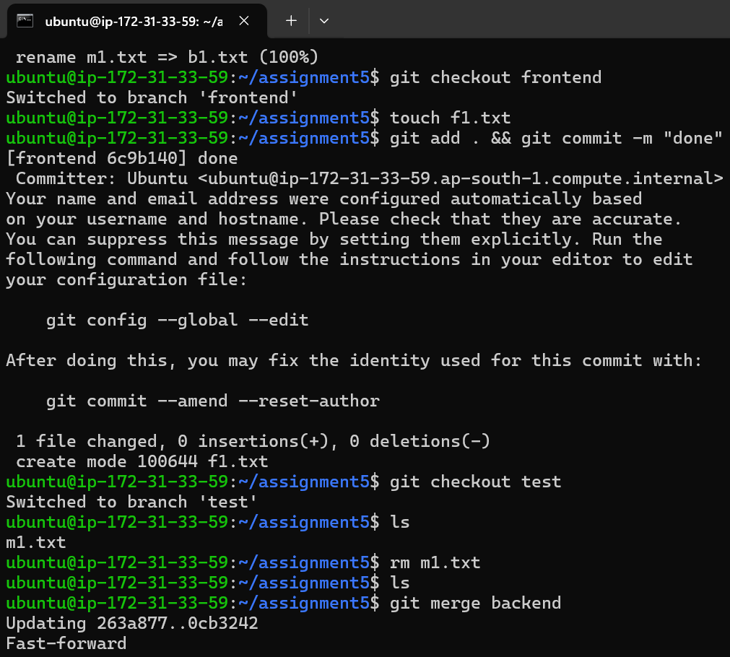

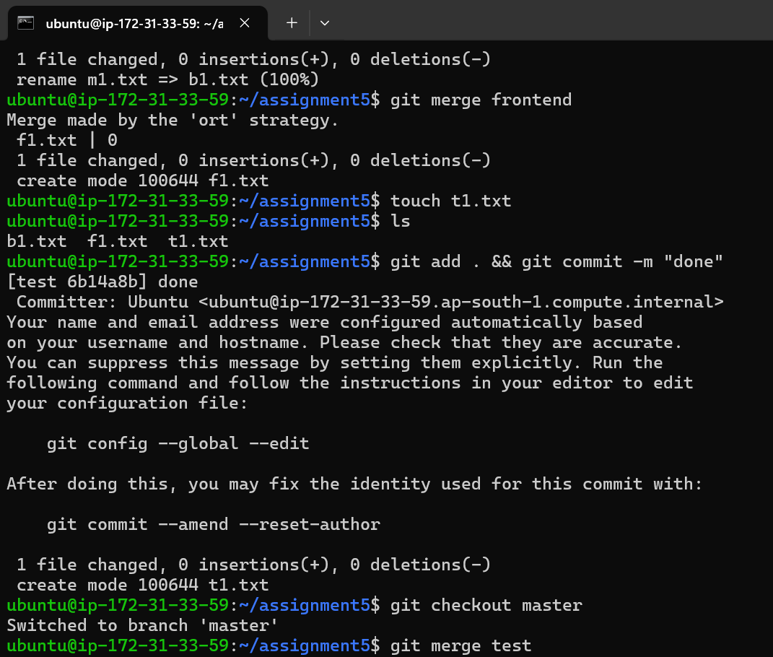

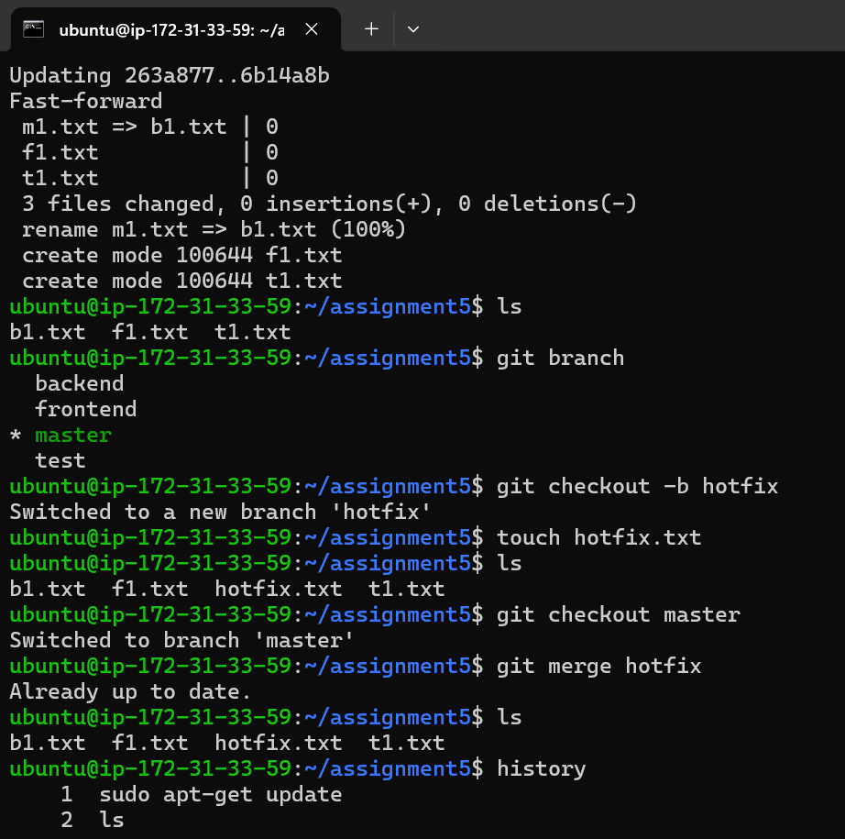

1 sudo apt-get update

2 ls

3 mkdir assignment5

4 ls

5 cd assignment5

6 touch m1.txt

7 git init

8 git add . && git commit -m "done"

9 rm m1.txt

10 l

11 ls

12 git branch frontend

13 git branch backend

14 git branch test

15 git checkout backend

16 touch b1.txt

17 ls

18 git add . && git commit -m "done"

19 git checkout frontend

20 touch f1.txt

21 git add . && git commit -m "done"

22 git checkout test

23 ls

24 rm m1.txt

25 ls

26 git merge backend

27 git merge frontend

28 touch t1.txt

29 ls

30 git add . && git commit -m "done"

31 git checkout master

32 git merge test

33 ls

34 git branch

35 git checkout -b hotfix

36 touch hotfix.txt

37 ls

38 git checkout master

39 git merge hotfix

40 ls