**Module-3: Docker – I Assignment – 1**

● Pull ubuntu container

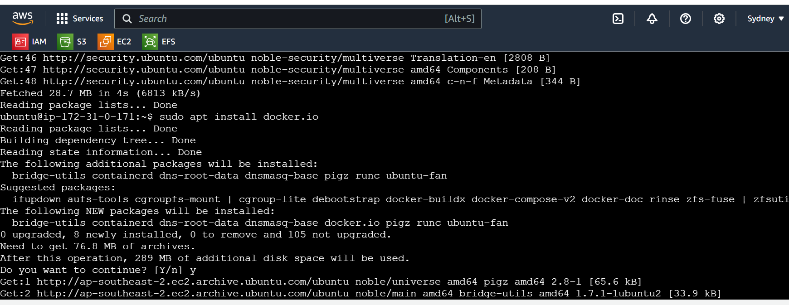

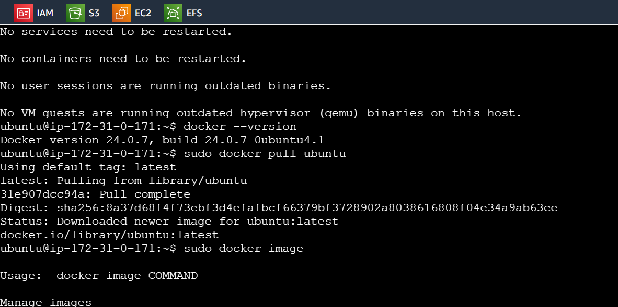

● Run this container, and map port 80 on the local

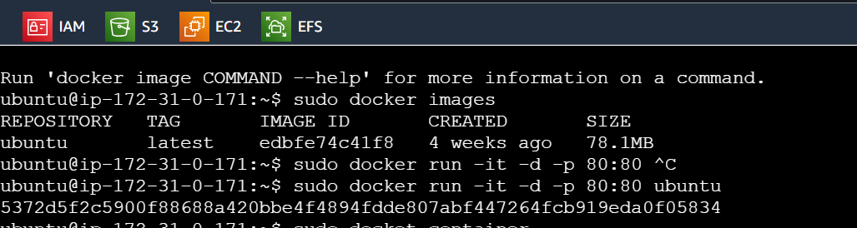

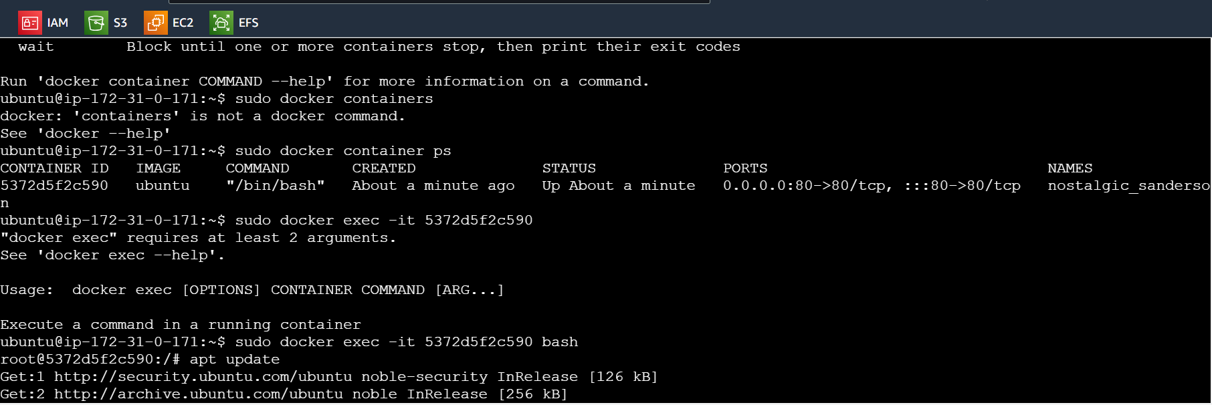

● Install apache2 on this container

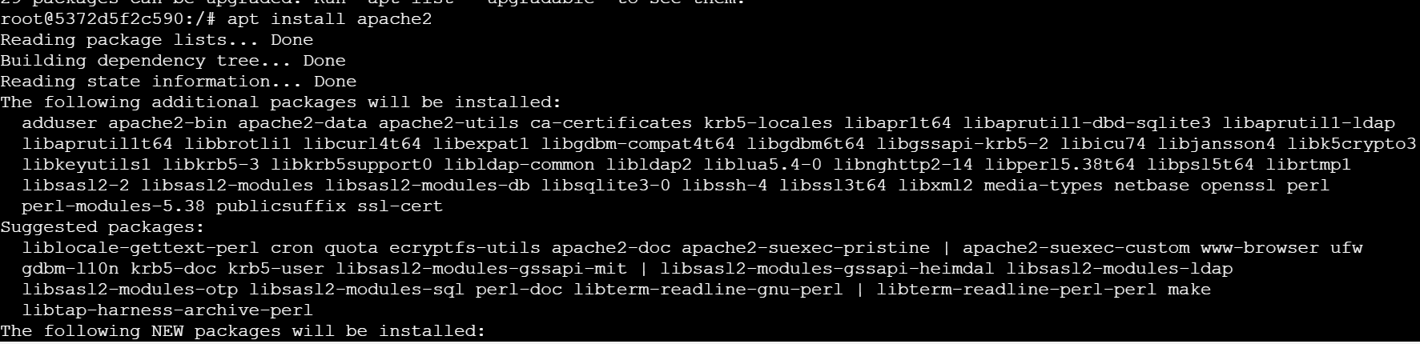

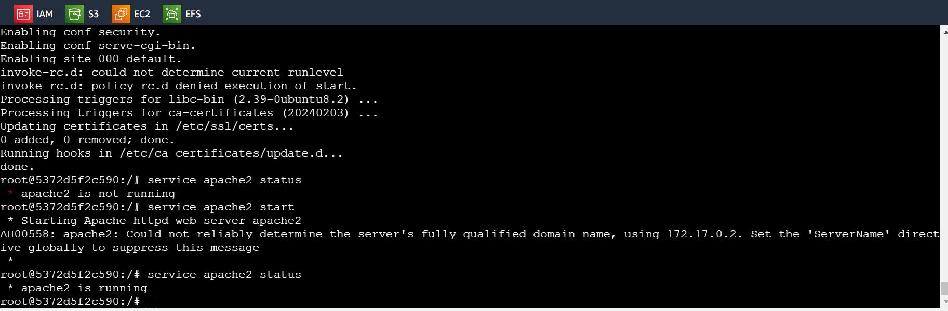

● Check if you are able to access the apache page on your browser

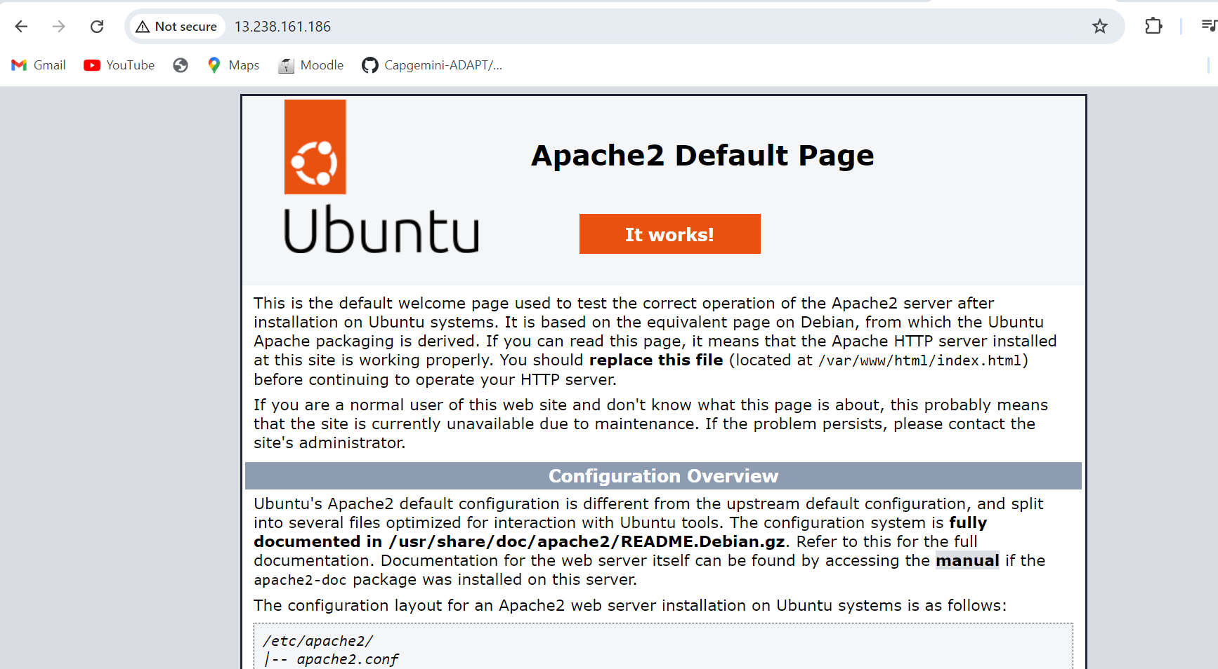

1 sudo apt get update

2 sudo apt-get update

3 sudo apt install docker.io

4 docker --version

5 sudo docker pull ubuntu

6 sudo docker image

7 sudo docker images

8 sudo docker run -it -d -p 80:80 ubuntu

9 sudo docket container

10 sudo docker container

11 sudo docker containers

12 sudo docker container ps

13 sudo docker exec -it 5372d5f2c590

14 sudo docker exec -it 5372d5f2c590 bash

15 history

**Module-3: Docker – I Assignment – 2**

Save the image created in Assignment 1 as a Docker image ●

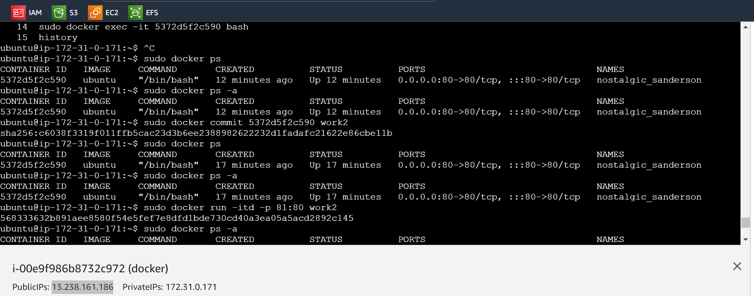

Launch container from this new image and map the port to 81 ●

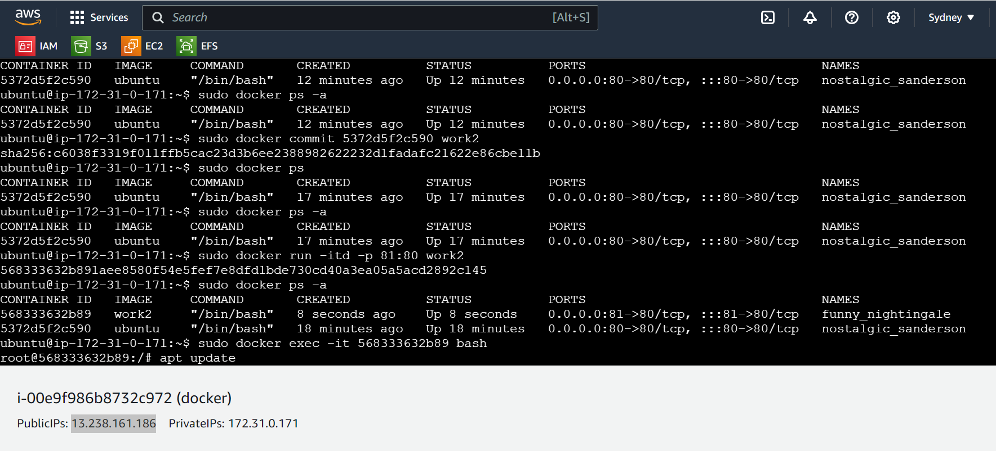

Go inside the container and start the apache2 service ●

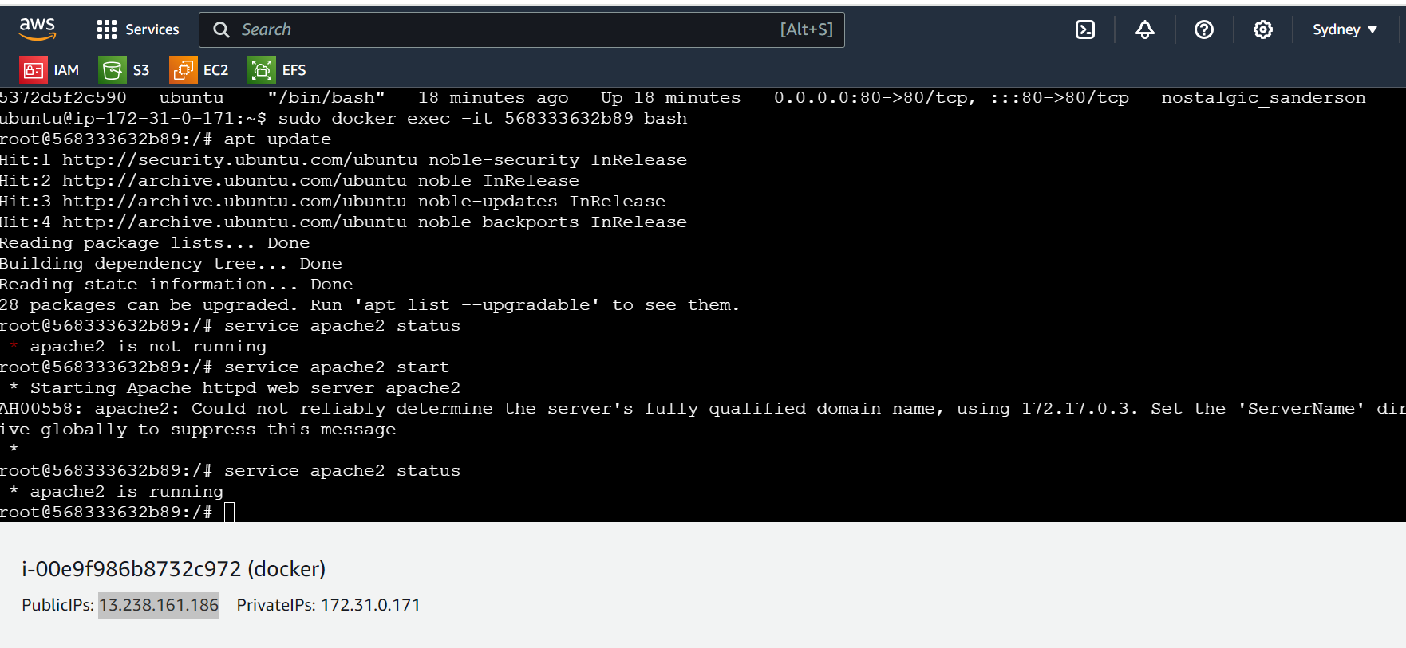

Check if you are able to access it on the browser

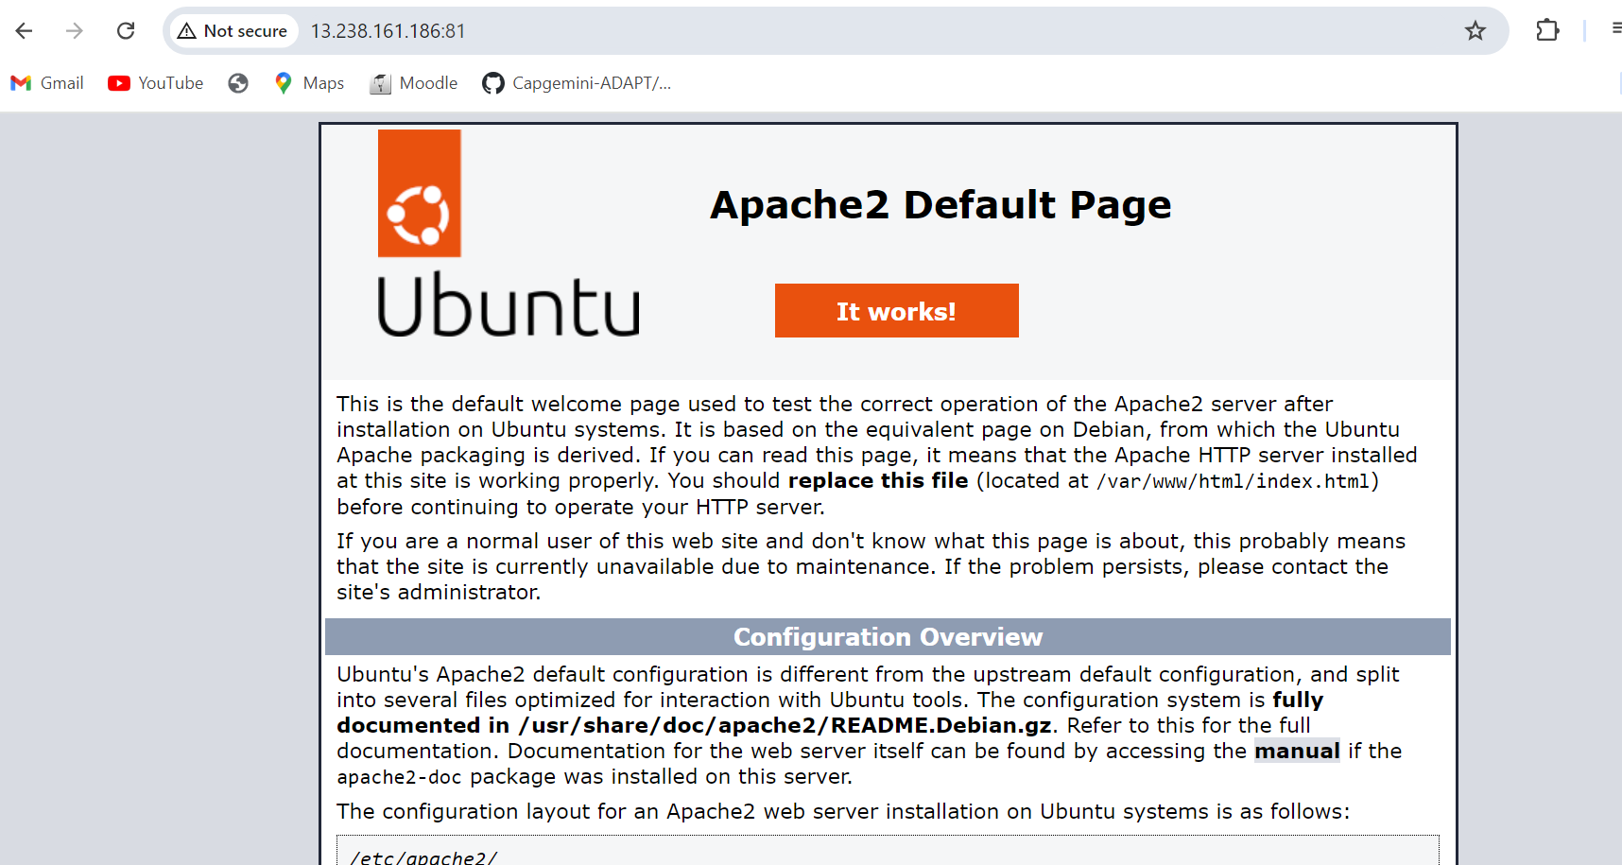

16 sudo docker ps

17 sudo docker ps -a

18 sudo docker commit 5372d5f2c590 work2

19 sudo docker ps

20 sudo docker ps -a

21 sudo docker run -itd -p 81:80 work2

22 sudo docker ps -a

23 sudo docker exec -it 568333632b89 bash

24 history

**Module-3: Docker – I Assignment – 3**

Use the saved image in the previous assignment

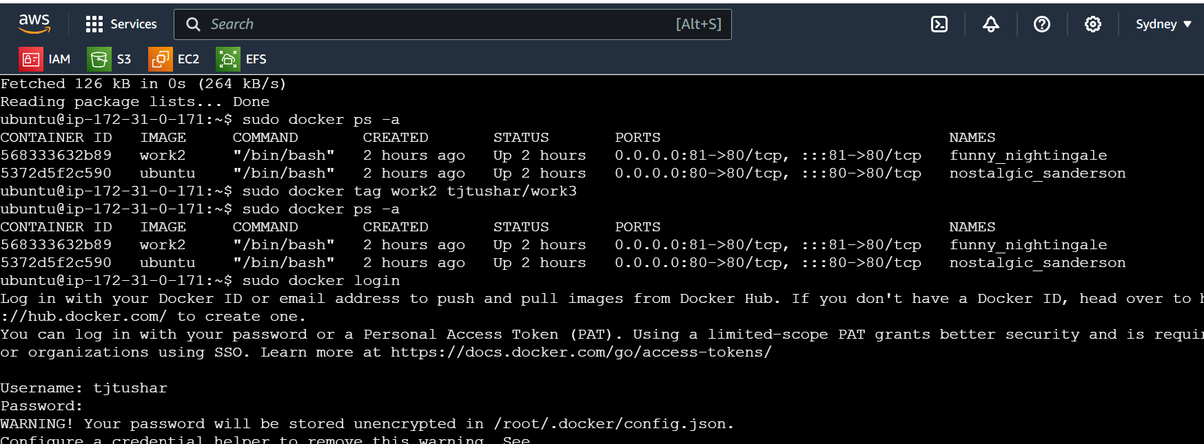

● Upload this image on Dockerhub

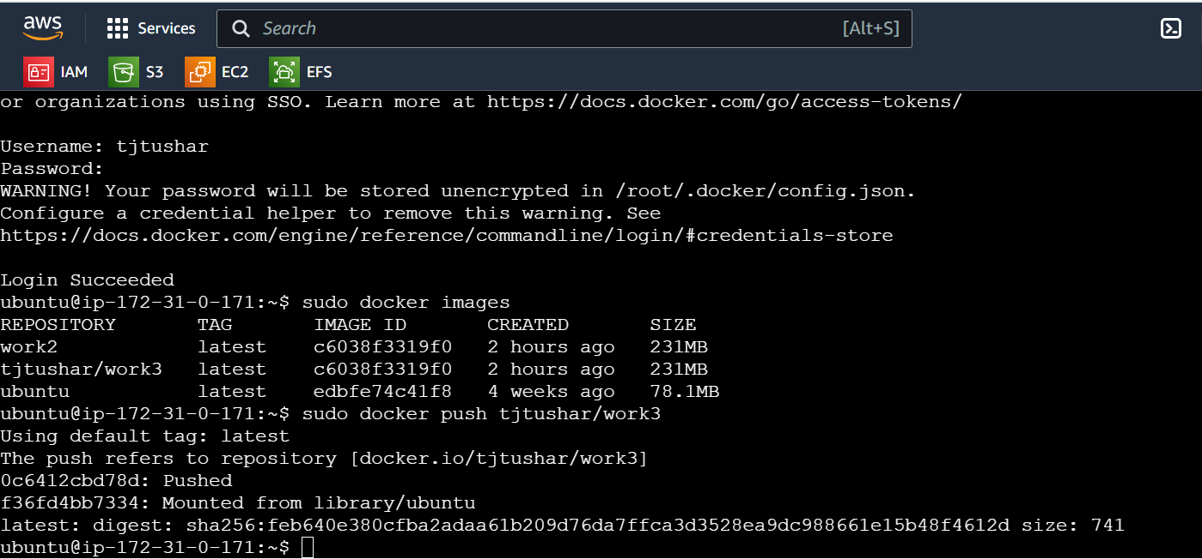

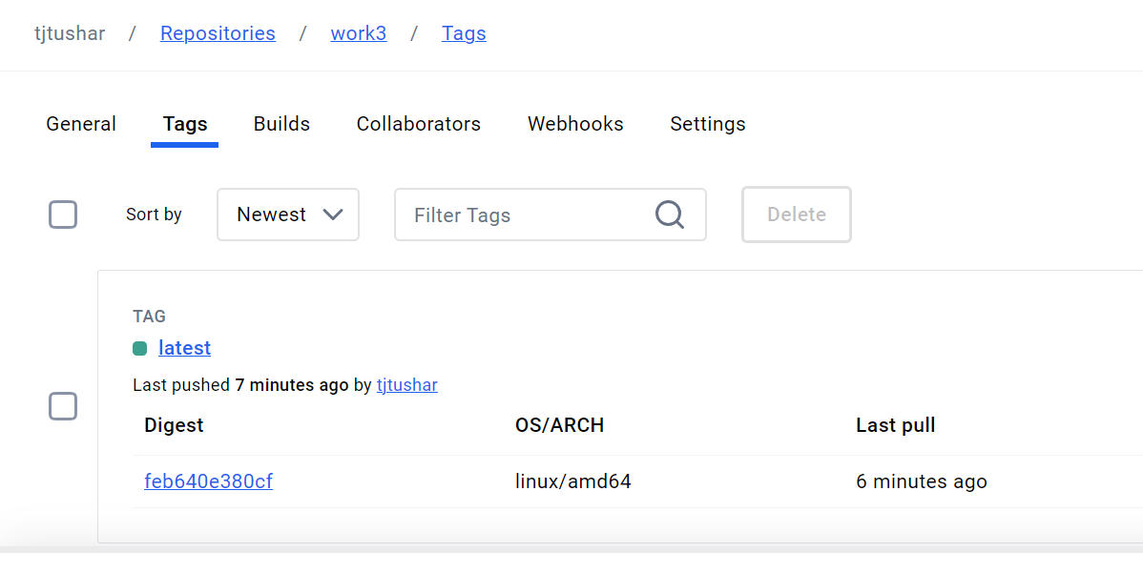

● On a separate machine pull this dockerhub image, and launch it on port 80

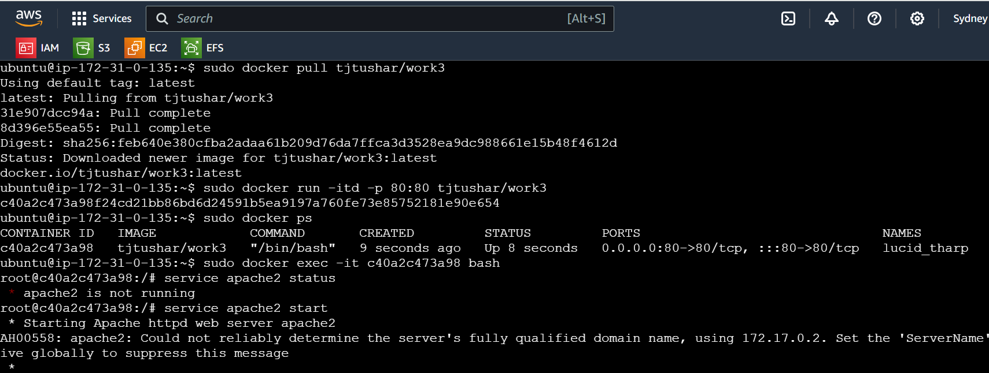

● Start the apache2 service

● Verify if you are able to see the apache2 service

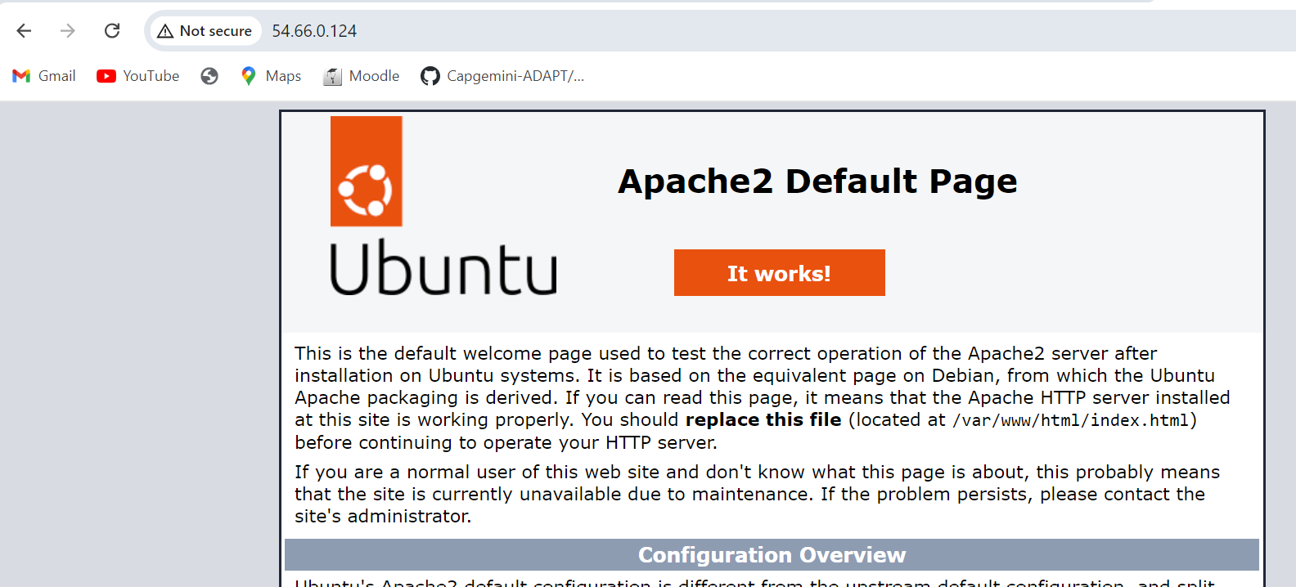

**Module-3: Docker – I Assignment – 4**

Create a dockerfile with the following specs:

● Ubuntu container ● Apache2 installed

● Apache2 should automatically run once the container starts

Submit the dockerfile, for assignment completion

**Module-3: Docker – I Assignment – 4**

Create a dockerfile with the following specs:

● Ubuntu container

● Apache2 installed

● Apache2 should automatically run once the container starts

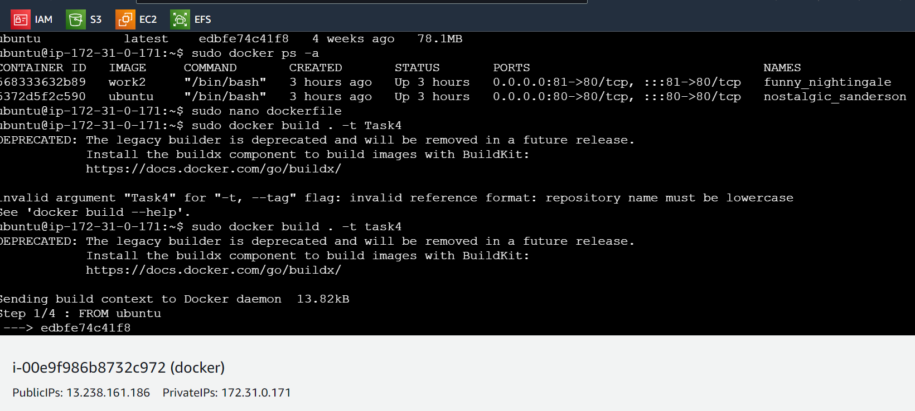

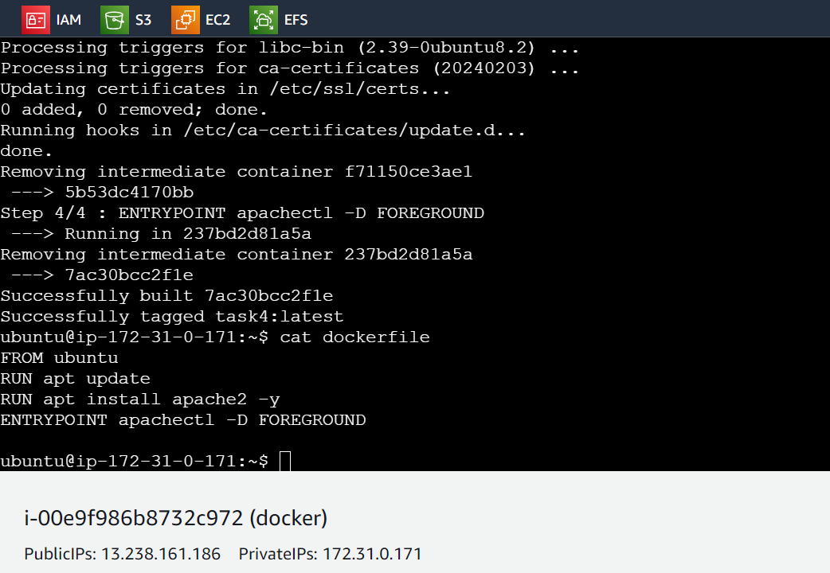

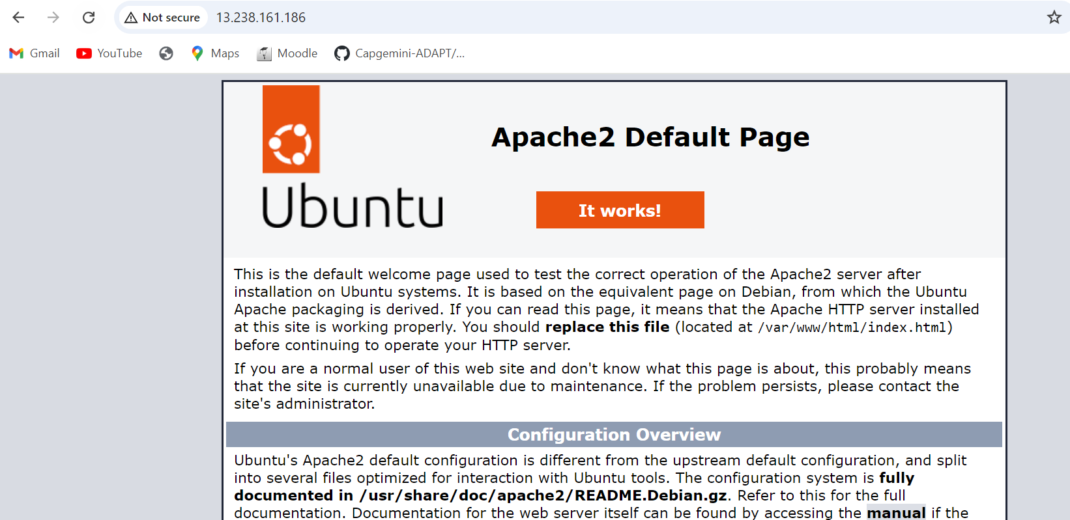

25 sudo apt-get update

26 sudo docker ps -a

27 sudo docker tag work2 tjtushar/work3

28 sudo docker ps -a

29 sudo docker login

30 sudo docker images

31 sudo docker push tjtushar/work3

32 sudo docker images

33 sudo docker ps -a

34 sudo nano dockerfile

35 sudo docker build . -t Task4

36 sudo docker build . -t task4

37 cat dockerfile

38 history

**Module-3: Docker – I Assignment – 5**

● Create a sample HTML file

● Use the Dockerfile from the previous task

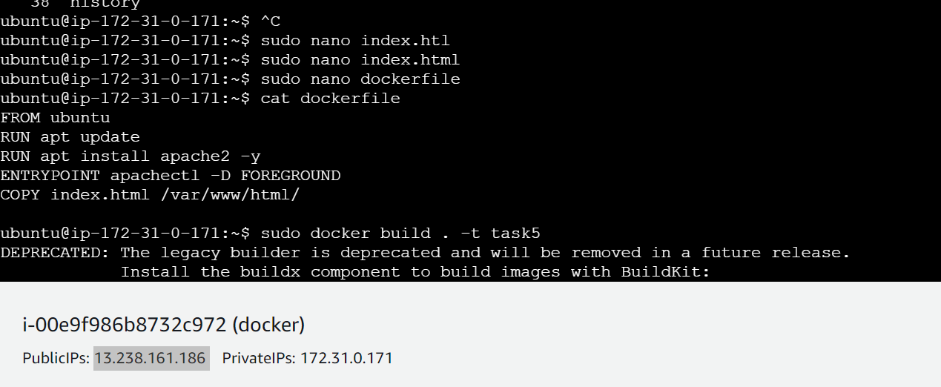

● Replace this sample HTML file inside the docker container with the default page

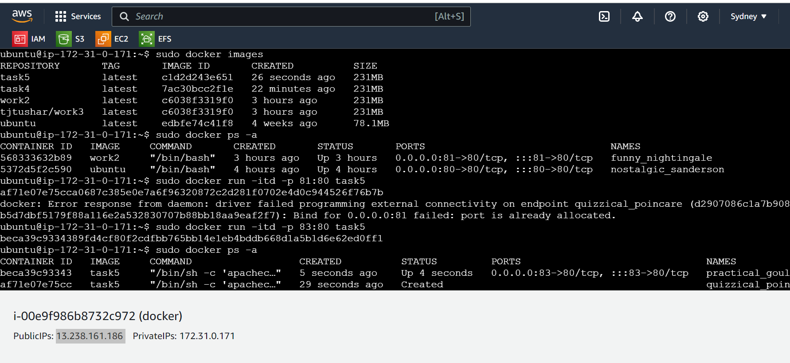

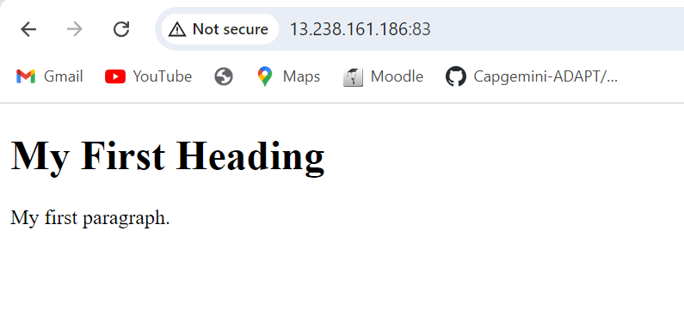

sudo nano index.htl

40 sudo nano index.html

41 sudo nano dockerfile

42 cat dockerfile

43 sudo docker build . -t task5

44 sudo docker image

45 sudo docker images

46 sudo docker ps -a

47 sudo docker run -itd -p 81:80 task5

48 sudo docker run -itd -p 83:80 task5

49 sudo docker ps -a