**Module-8: Jenkins Assignment – 1**

● Trigger a pipeline using Git when push on Develop branch

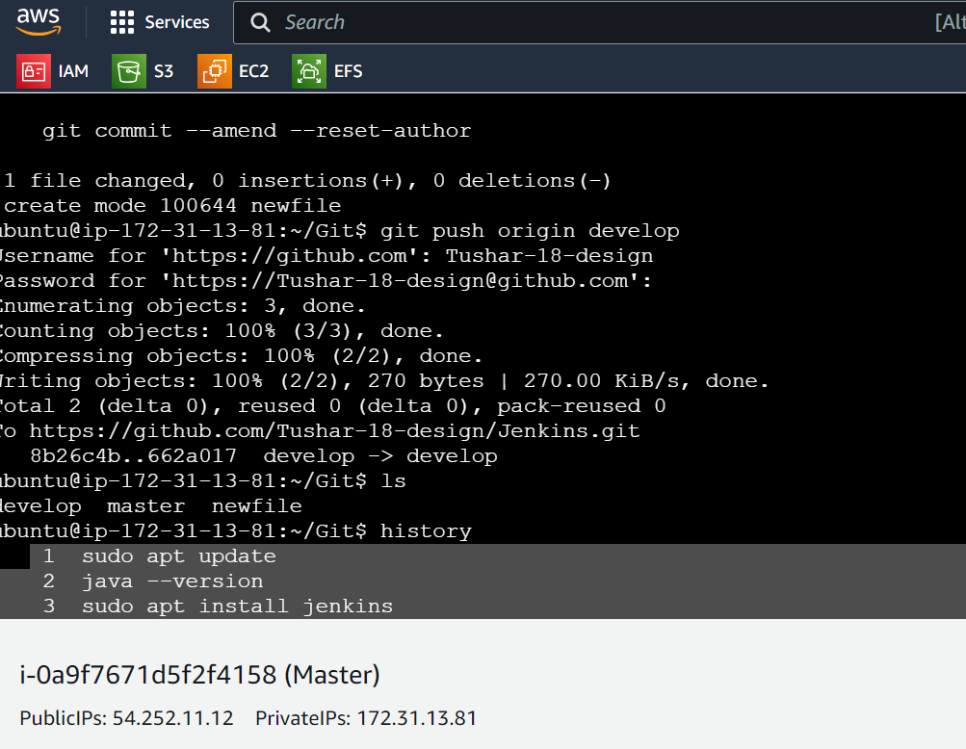

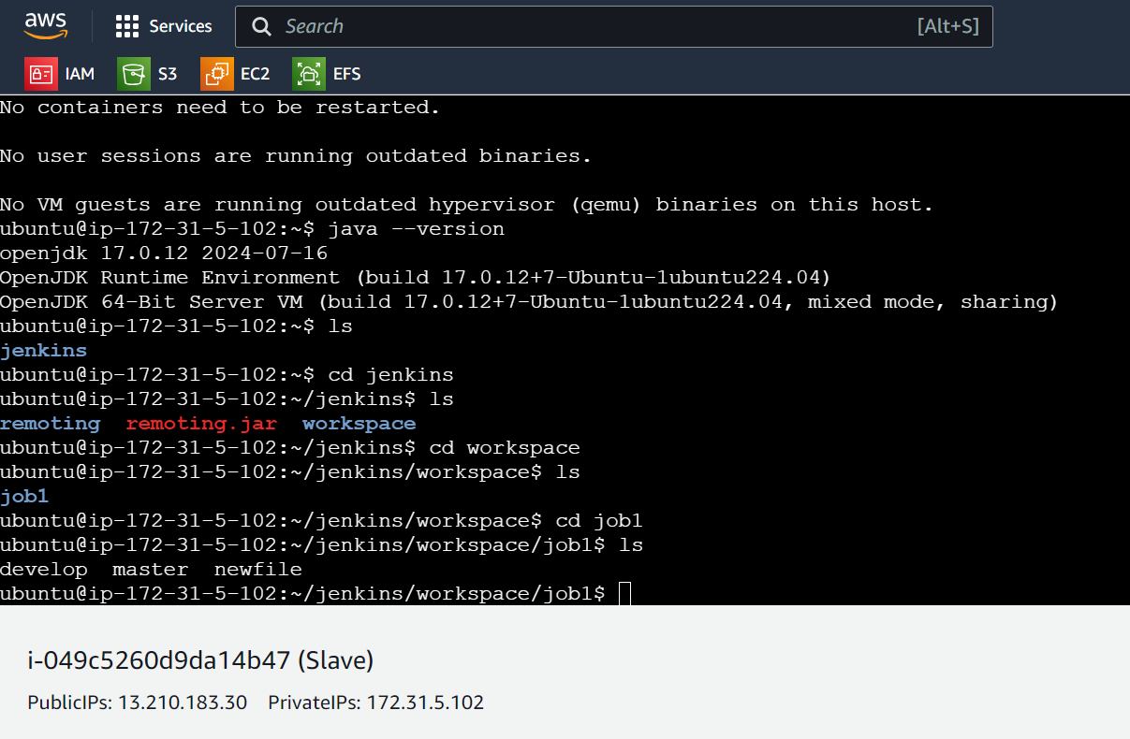

Installed Jenkins on master instance only and Java on both master and slave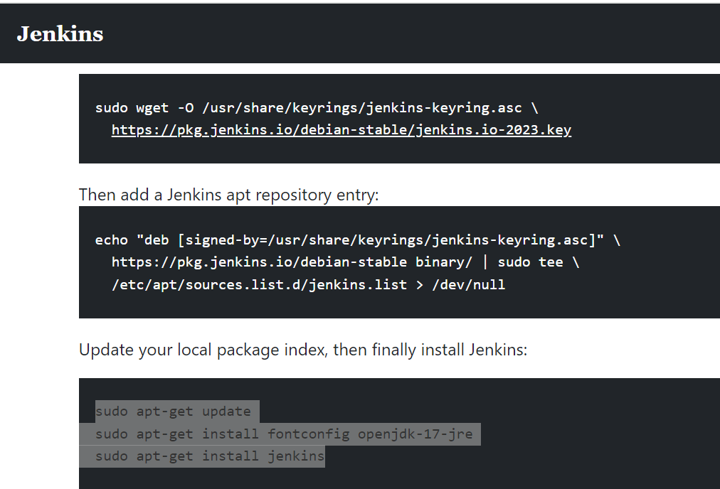

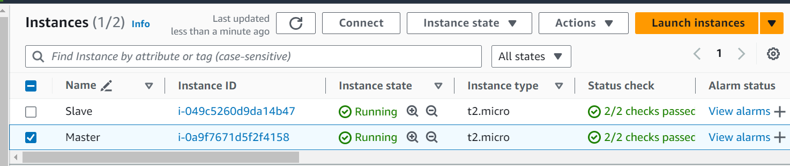

Build job on Jenkins

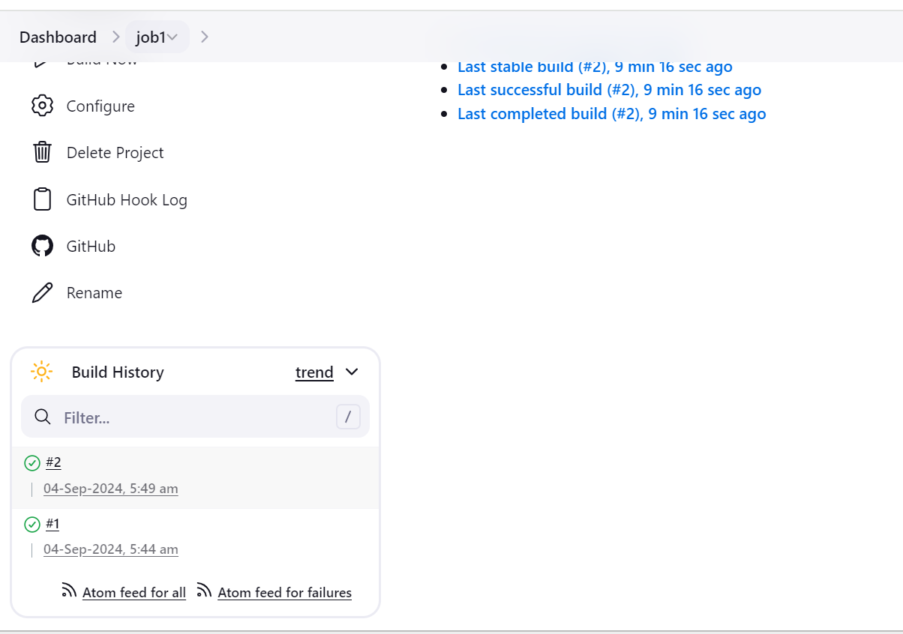

Build

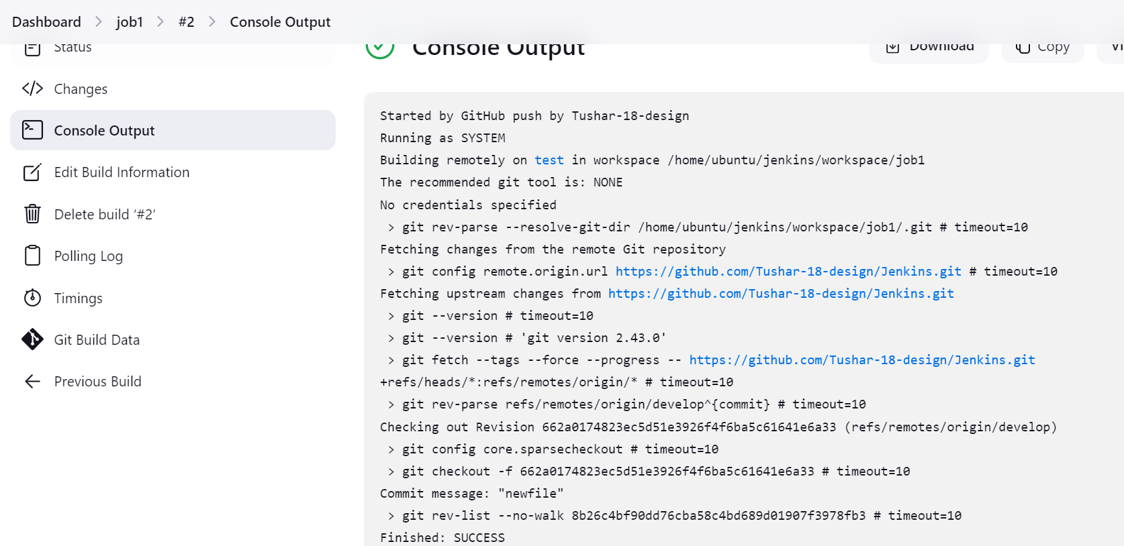

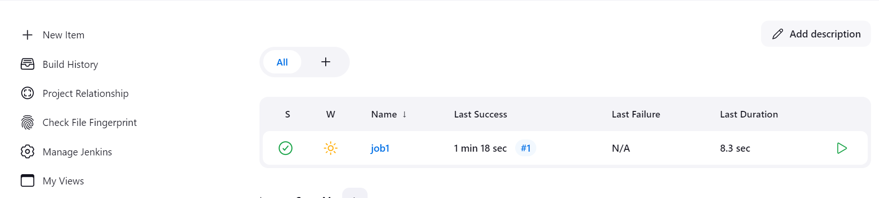

● Pipeline should pull git content to a folder

Content pulled

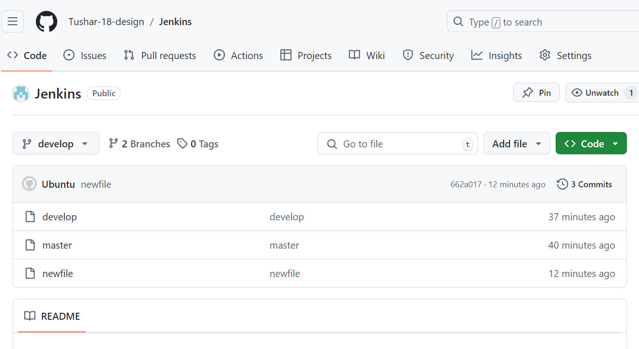

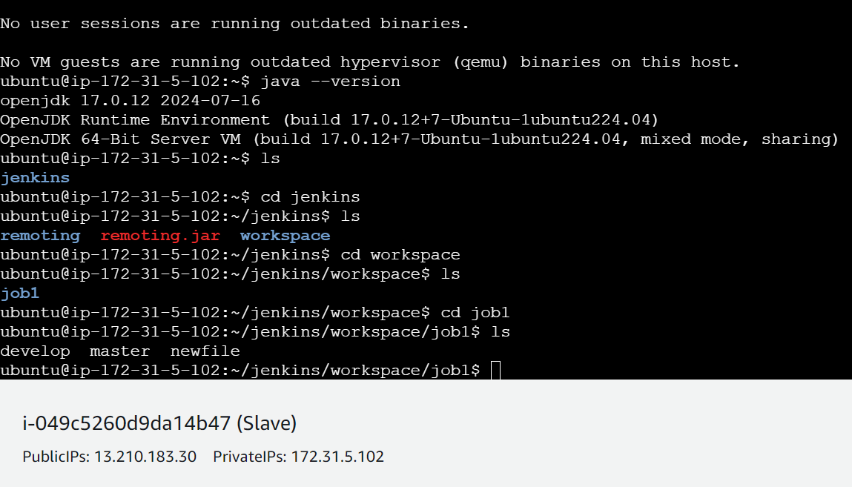

1 sudo apt update

2 java --version

3 sudo apt install jenkins

4 sudo apt-get update

5 jenkins --version

6 sudo apt-get update

7 jenkins --version

8 sudo cat /var/lib/jenkins/secrets/initialAdminPassword

9 git --version

10 mkdir

11 mkdir Git

12 cd Git/

13 touch master

14 git init

15 git add master

16 git commit -m "master"

17 git branch

18 git branch develop

19 git branch

20 git checkout develop

21 touch develop

22 git add develop

23 git commit -m "develop"

24 ls

25 git remote add origin https://github.com/Tushar-18-design/Jenkins.git

26 git push origin --all

27 git branch

28 touch newfile

29 git add newfile

30 git commit -m "newfile"

31 git push origin develop

32 ls

33 history

**Module-8: Jenkins Assignment – 2**

● Add 2 nodes to Jenkins master

Added nodes as slave and prod, installed Jenkins, java on master and java on both nodes slave,prod

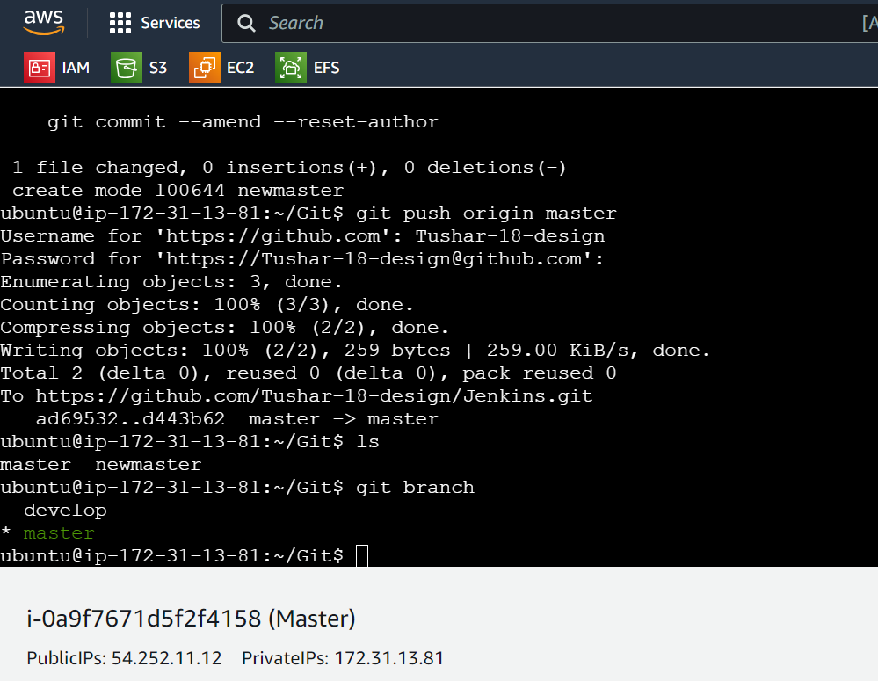

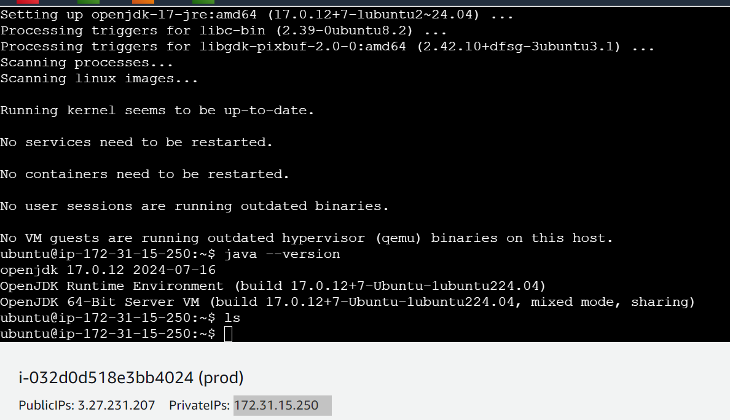

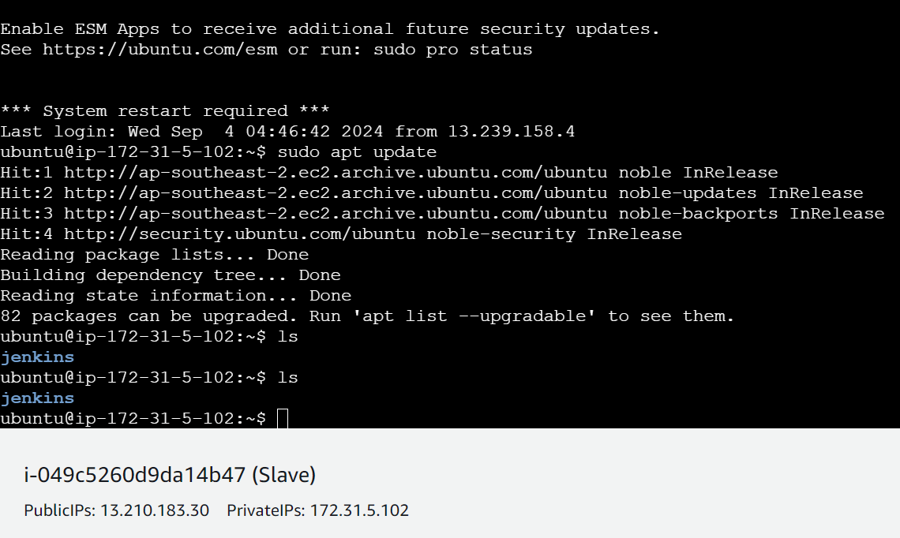

● Create 2 jobs with the following jobs:

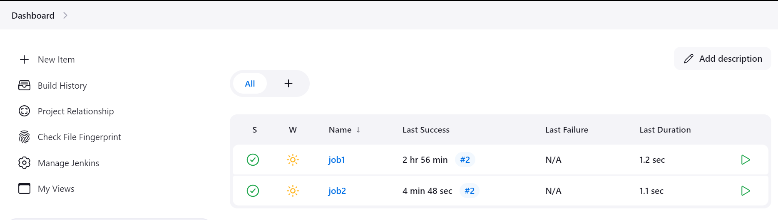

○ Push to test

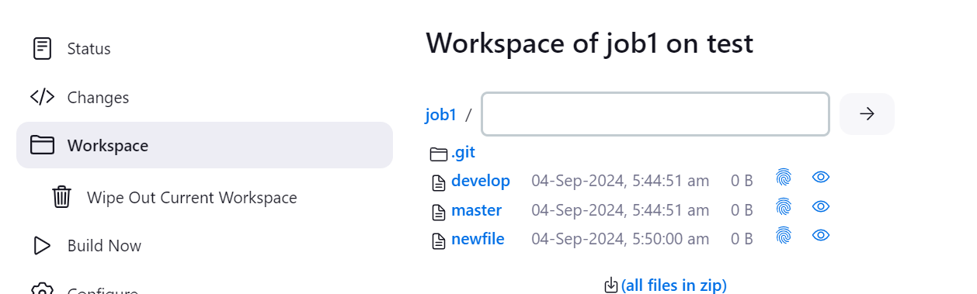

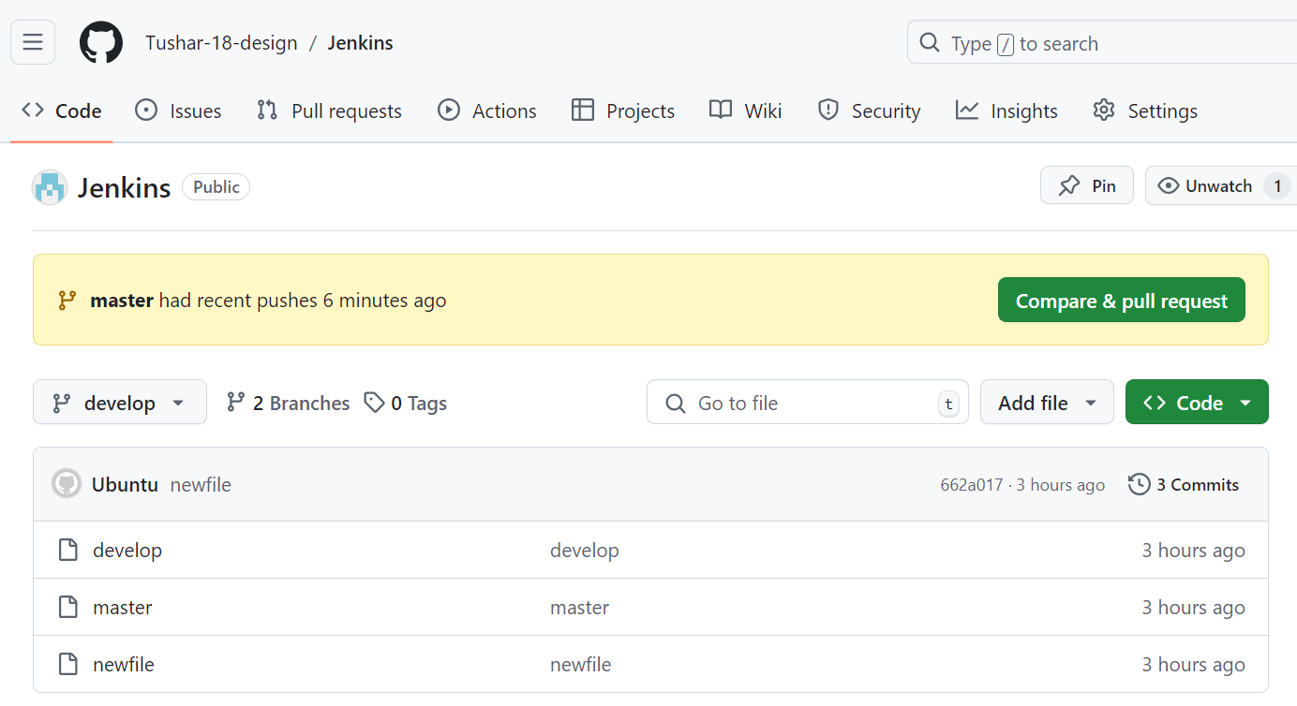

○ Push to prod

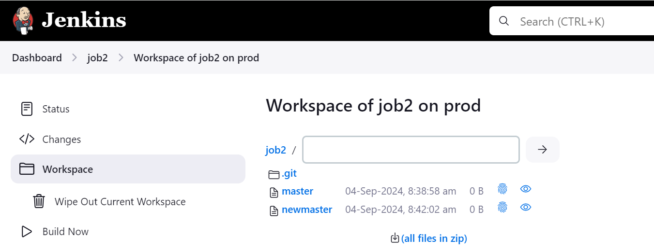

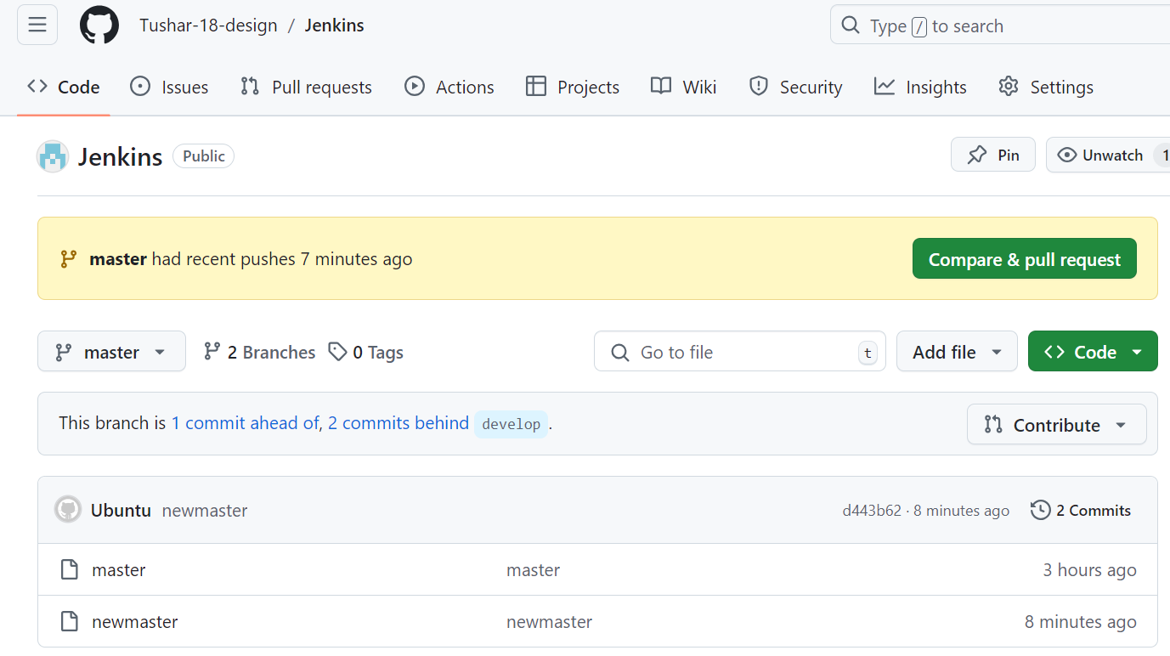

● Once a push is made to test branch copy git files to test server

● Once a push is made to master branch copy git files to prod server

Build is successful and we can see the files on git as well.

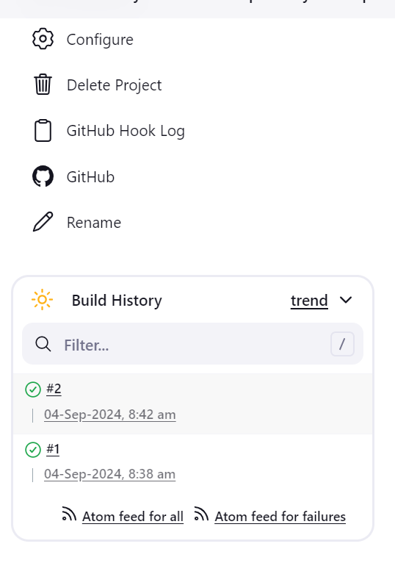

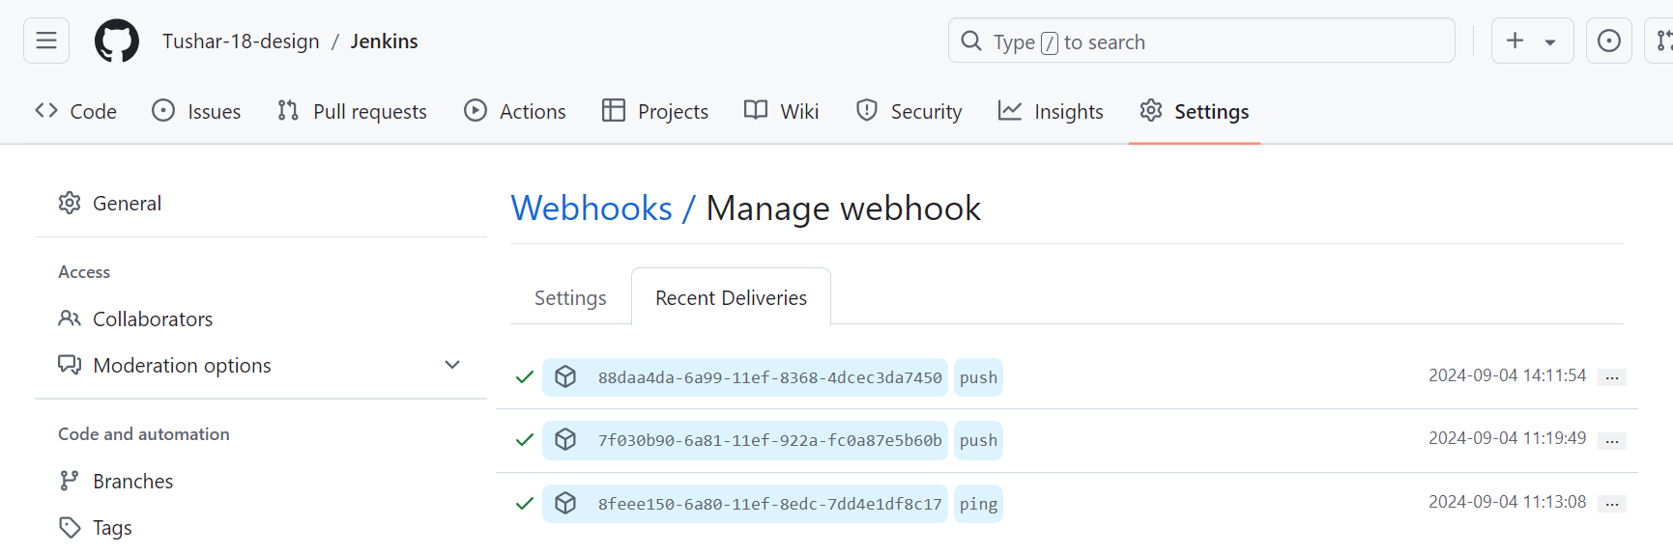

34 sudo apt-update

35 sudo apt update

36 ls

37 cd Git

38 ls

39 git branch

40 ls

41 git checkout develop

42 ls

43 git checkout master

44 ls

45 touch newmaster

46 git init

47 git add newmaster

48 git commit -m "newmaster"

49 git push origin master

50 ls

51 git branch

52 history

**Module-8: Jenkins Assignment – 3**

● Create a pipeline in jenkins

● Once push is made to “develop” branch in git, trigger job “test”. This will copy git files to test node ● If test job is successful, then prod job should be triggered

● Prod jobs should copy files to prod node

Build a pipeline to schedule job2 only after job1 is successful

