

ORACLE
CONSUMER PHYSICAL QUALITY EVALUATION (CPQE)

CONTENT PAGE

1. | RATIONALE | 2
2. | OBJECTIVES | 2
3. | OUTLINE OF THE METHOD | 2
4. | METHODOLOGY | 2
4.1. | QUALITATIVE STAGE | 2
4.1.1. | GROUP MODERATION PROTOCOL | 3
4.2. | QUANTITATIVE STAGE | 5
4.2.1. | ATTRIBUTES | 6
5. | SAMPLING | 6
6. | ANALYSIS | 6
7. | APPENDICES | 8
7.1. | QUESTIONNAIRE AND STIMULI EXAMPLES | -
7.2. | FULL CASE EXAMPLE | -

LEGAL NOTICE
Where any reference is made in this document to ‘adult’ or ‘young adult’, the term is defined as anyone who is 18 years or over or such higher age as the local law and/or industry code in any particular country requires. Any reference in this document to ‘ASU30’, ‘consumer’, ‘target consumers’, ‘smokers’, ‘target audience’, or any similar term shall mean smokers who are adults.

ORACLE
CONSUMER PHYSICAL QUALITY EVALUATION (CPQE)

1. Rationale

In-house standards of physical quality may differ from consumer expectations. The ORACLE Consumer Physical Quality Evaluation method (CPQE) is designed to analyse the consumer's perceived physical quality performance, assessing the relative frequency of occurrence of product quality defects and the annoyance that they may cause.

2. Objectives

n Understand the consumer perception of product quality and its importance in brand selection, identifying the most important product quality attributes.

n Categorise product quality defects regarding frequency of occurrence and annoyance caused, in order to focus quality efforts on those aspects that yield competitive advantages.

3. Outline of the Method

The method is divided in two stages:

n Qualitative Stage

Based on focus groups, it determines which attributes relate to consumer judgement of product quality and thus develops a comprehensive consumer driven product quality attribute set to be subsequently used in the Quantitative Stage.

n Quantitative Stage

Based on the Problem Detection Analysis (PDA) method, it quantifies from the consumer's perspective the frequency of occurrence and the annoyance caused by product quality defects.

4. Methodology

4.1. Qualitative Stage

Approximately 8-12 qualitative group discussions with each group consisting of 8 smokers of a variety of brands. The groups should be split by age, sex and socio-economic classification and should cover a range of locations/distribution areas.

The objective is to understand what are the main attributes that drive consumers' perception of product quality and to build a comprehensive list of attributes, divided in three areas: Pack, Cigarettes (physical) and Cigarettes (while smoking).

4.1.1. Group Moderation Protocol()

n Individual quality definitions()

Beginning with the broadest frame of reference, every consumer should be given a sheet of paper with the following heading :

Please write down your definition of what 'quality' means to you and describe a typical situation where quality would be important to you.

n Quality definitions used to stimulate quality discussion

Each consumer should read what s/he has written to the group and the group should be then led into a general discussion on what quality means and how such a concept bears on everyday life.

n Quality as applied to cigarettes

The possible relevance of the idea of quality to the purchase/evaluation and use of cigarettes should be probed in order to determine whether quality per se is actually relevant to the cigarette as a commodity relative to other commodities.

n Quality vocabulary: Salient attributes relating to product and packaging quality; definitions and relative rankings()

On the assumption that quality is seen as relevant to the cigarette commodity, a detailed probe of those attributes considered important to the judgement of quality should be made. Once a vocabulary set has been elicited, the group should be required to define each attribute clearly. Finally the list of attributes should be subjected to consensus listing, placing items in order of importance of contribution to the judgement of cigarette quality.

n Causal quality relationships

The group should then be probed to elicit any subjective 'theories' regarding causal relationships between attributes relating to product quality.

n Historical trends in cigarette quality and pricing

This section should focus on an open probe on consumer perception of any shifts in product quality with the passage of time (i.e. from as far back as subjects can reliable recall). In addition it should include an open probe on consumer perception of the relative cost of cigarette usage with the passage of time

n Quality relationship to price

This section should be based on an open probe on whether consumers perceive cigarette product quality to be directly related to price paid (i.e. in the sense of a direct / linear correlation).

n Price / quality trade-off

This section should include an individual probe on the extent to which each consumer is prepared to trade level of product quality against pricing level.

n Quality image in relation to quality reality

This section should be based on an open probe on consumers beliefs regarding the extent to which quality promises implied by imagery are generally reflected in the reality of the product (in the case of cigarettes compared with other commodities).

n Examples of high and low quality

This section should focus on a detailed probe on cigarette brands considered to exemplify good and bad quality, including extended discussion justifying reasons and amplifying disagreements.

n Open letter to the manufacturer()

At the end of the qualitative group, each respondent should be invited to write to the manufacturer of his/her own brand and suggest product quality improvements. Each respondent is given a sheet of paper with the following heading :

Dear Sir,

I am a smoker of your products and I think you should...

4.2. Quantitative Stage

This Stage will be based on individual interviews. The objective is to quantify the level of occurrence and annoyance of quality defects, based on the relevant list produced in the Qualitative Stage.

SCREENING | è | Questions to ensure that the respondents fulfil the quota requirements, and are not aware of the product category/brand under research..
SMOKING BEHAVIOUR | è | Time with habit, Regular Brand, Time with Regular Brand, Alternative Brand, Previous Brand, Reasons for Switching.
BRAND EVALUATION | è | Frequency of occurrence of quality defects (spontaneous and prompted), level of annoyance.
OVERALL BRAND QUALITY | è | Overall quality, quality variability, comparative quality.

Each main product quality attribute/problem generated from the pre-qualitative research is rated in the following manner:

E.G. Filter Collapse

I would like you to think back over your recent experience of smoking (own brand)

How frequently do you experience a problem with Filter Collapse. By Filter Collapse I mean (definition).

FREQUENCY | CODE
It Always occurs | 4
It Often occurs | 3
It Seldom occurs | 2
It Never occurs () | 1

When you experience a problem with Filter Collapse, how annoying is it to you.

ANNOYANCE | CODE
Extremely annoying | 4
Fairly annoying | 3
Slightly annoying | 2
Not at all annoying | 1

At the analysis stage it will be possible to cross-check the frequency of occurrence and the level of annoyance of each quality defect.

4.2.1. Attributes

The prompted attributes to be used in the quantitative stage will be derived from the Qualitative stage. The following list of attributes shows a typical set.

ATTRIBUTES
PACK | CIGARETTES (PHYSICAL) | CIGARETTES (WHILE SMOKING)
Tear strip malfunction | Tobacco Firmness | Burn Rate (too low/fast)
Pack damaged (crushed) | Filter Firmness | Ash fall out
Pack dirty | Filter Collapse | Hot collapse
Opening/closing malfunction | Stem Inclusions | Cigarette stops burning by itself
Pack Print damaged | Cigarette Paper wrinkled | Off aroma
Cigarette misplaced | Cigarette not filled up to the tip | Difference in taste
Other Brand inside pack | Cigarette perforated / torn | Things popping/crackling while smoking
Cigarettes missing in pack | Cigarette stained / spotted
Cigarettes upside down in pack | Die print damaged
Loose tobacco at bottom of pack | Filter tip not glued
Cellophane torn | Old/Dry tobacco appearance
Aluminium foil damaged (HL)

5. Sampling

CPQE should be conducted with a minimum of 100 smokers of each of the brands of interest (i.e. key volume own and competitor brands).

Sample composition must reflect typical brand profile in terms of demographic classification (age, sex, S.E.L., geographic location, etc.) and buying behaviour (pack/stick, daily/less often, usual outlet, etc.) derived from GCS.

If further breakdown analysis (e.g. by age group) has to be performed, the absolute minimum sub-sample is 100 respondents. This means that if, for example, a brand is to be evaluated analysing two age groups (18-24 and 25-34) the sample composition will be 200 respondents (i.e. 100 18-24 and 100 25-34).

6. Analysis

For each group of smokers simple mean scores should be calculated per attribute for the frequency and the annoyance rating on each attribute. These scores should then be used to construct a problem detection matrix for each brand.

Taking an hypothetical example, the problem detection matrix below represents smokers ratings of quality problems experienced with their own brand.

Quality Defects | Frequency  (Mean scores) | Annoyance  (Mean scores)
Dirty | 1.3 | 2.1
Creased pack | 1.3 | 2.7
Filter collapse | 1.4 | 1.6
Filter Not Glued | 1.4 | 3.3
Loose ends | 1.9 | 2.8
Hot collapse | 1.9 | 3.2
Perforated cigarette | 2.0 | 2.0
Off aroma | 2.4 | 1.7
Stems | 2.4 | 3.3
Cellophane torn | 2.6 | 1.9

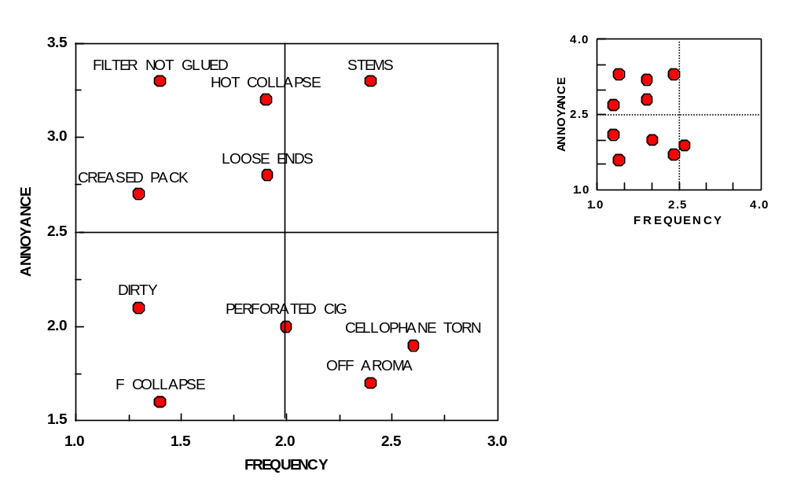

The charts above represent the performance of the attributes for a given brand. The left bottom corner represents the lower ratings and the right and top corners the higher ratings. The small chart (Right) shows the absolute performance, i.e. using the full scale (1-4 for Frequency and Annoyance). The large chart (Left) reduces the scale to magnify the spread of results.

The matrix can be divided in four quadrants that will be ranked by priority level.

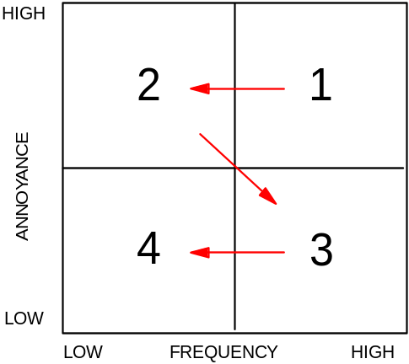
Attributes lying in quadrant 1 (i.e. High Frequency and Annoyance) are the highest priority for in-house quality control, as they imply both high frequency of defects and risk of losing franchise loyalty. Attributes in quadrant 4 (i.e. Low Frequency and Annoyance), however, are unlikely to require remedial in-house quality control action.

In Addition to this, it is also useful to cross-compare the proportion of consumers that actually have experienced quality defects.

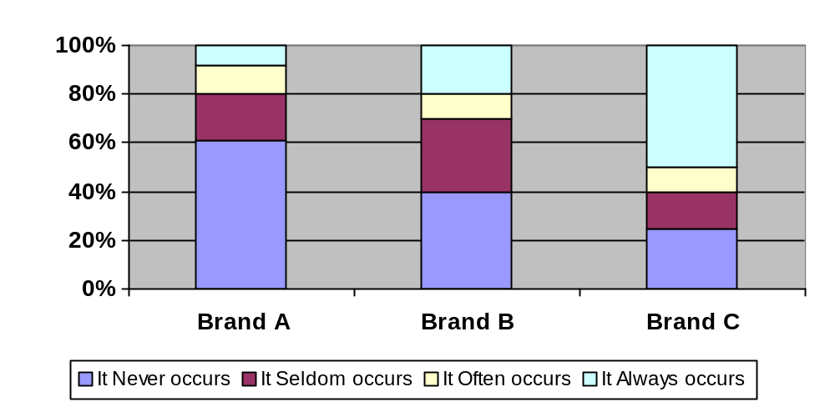FILTER COLLAPSE

The analysis of this information, together with the Overall Brand Quality questions will provide useful information relating to the actual level of consumer satisfaction.

0000.doc 08/11/2026

(?) Consumers should not be pre-sensitised to the fact that cigarettes are the research focus.
(?) This section can be modified to suit non-literate groups.
(?) This is the key component of the exercise.
(?) This section can also be modified to suit non-literate groups.
(?) The evaluation of quality problems is based on actual recollected experience. Therefore consumers are only asked about annoyance level for those problems actually experienced.

