ORACLE PRODUCT EVALUATION METHODS

Achieving superior product quality is a prime British American Tobacco objective. Therefore, product sensory and physical quality testing is a fundamental tool to ensure that our key products meet the consumer expectations. On-going monitoring of sensory / physical product quality performance vs. Key competitors is fundamental to:

n Confirm competitive positioning of product performance

n Detect erosion of product quality consistency

n Indicate improvement potential/directions

n Detect changing consumer requirements

n Detect competitor product modifications

The following diagram describes the Oracle Product Evaluation methods.

These will be divided in two categories: Product Sensory Evaluation and Product Physical Evaluation:

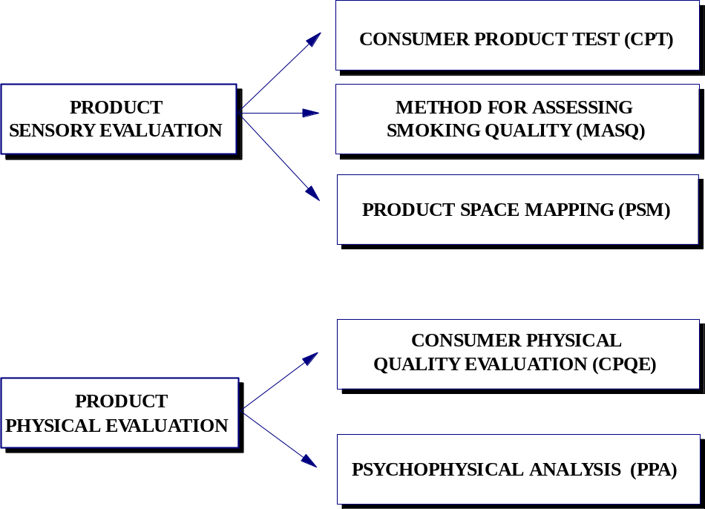

LEGAL NOTICE

Where any reference is made in this document to ‘adult’ or ‘young adult’, the term is defined as anyone who is 18 years or over or such higher age as the local law and/or industry code in any particular country requires. Any reference in this document to ‘ASU30’, ‘consumer’, ‘target consumers’, ‘smokers’, ‘target audience’, or any similar term shall mean smokers who are adults.

