**D.Tej kiran**

**192110625**

**Experiment-1**

Create a simple cloud software application and provide it as a service using any Cloud Service Provider to demonstrate Software as a Service (SaaS).

**IMPLEMENTATION:**

**Step-1:**

Go to zoho.com.

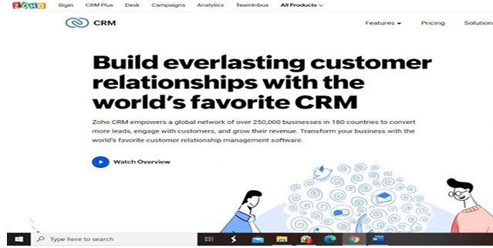

**Step-2:**

Log into the zoho.com

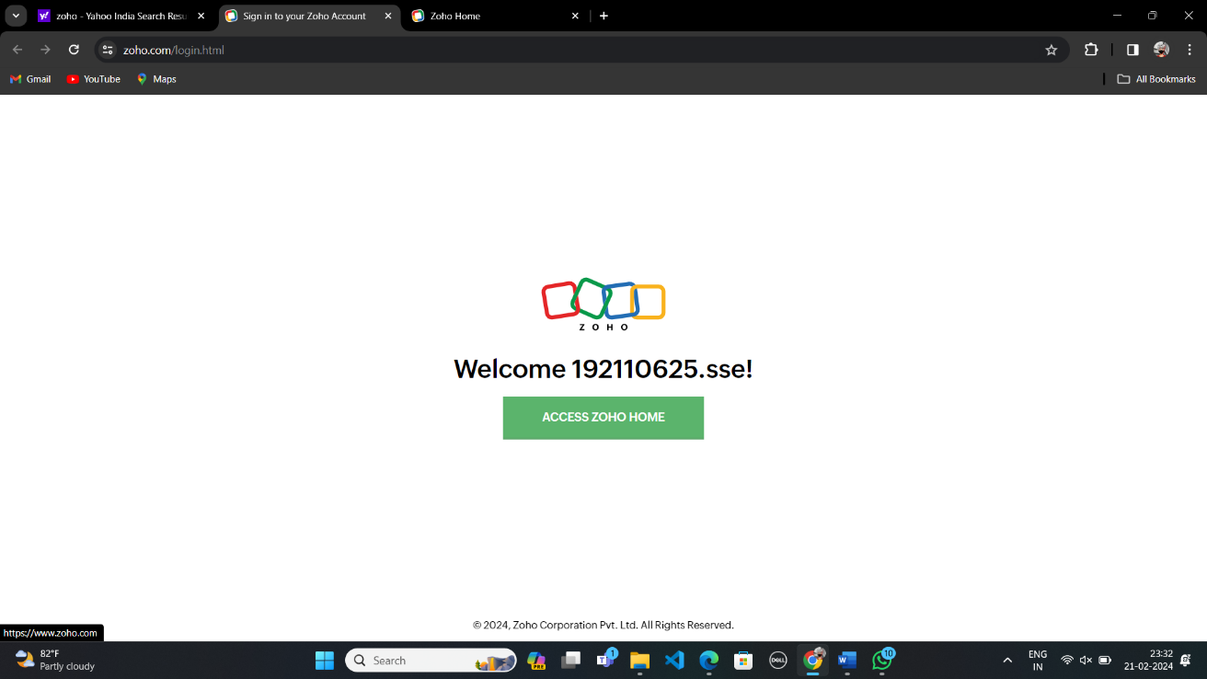

**Step-3:**

Select one application step.

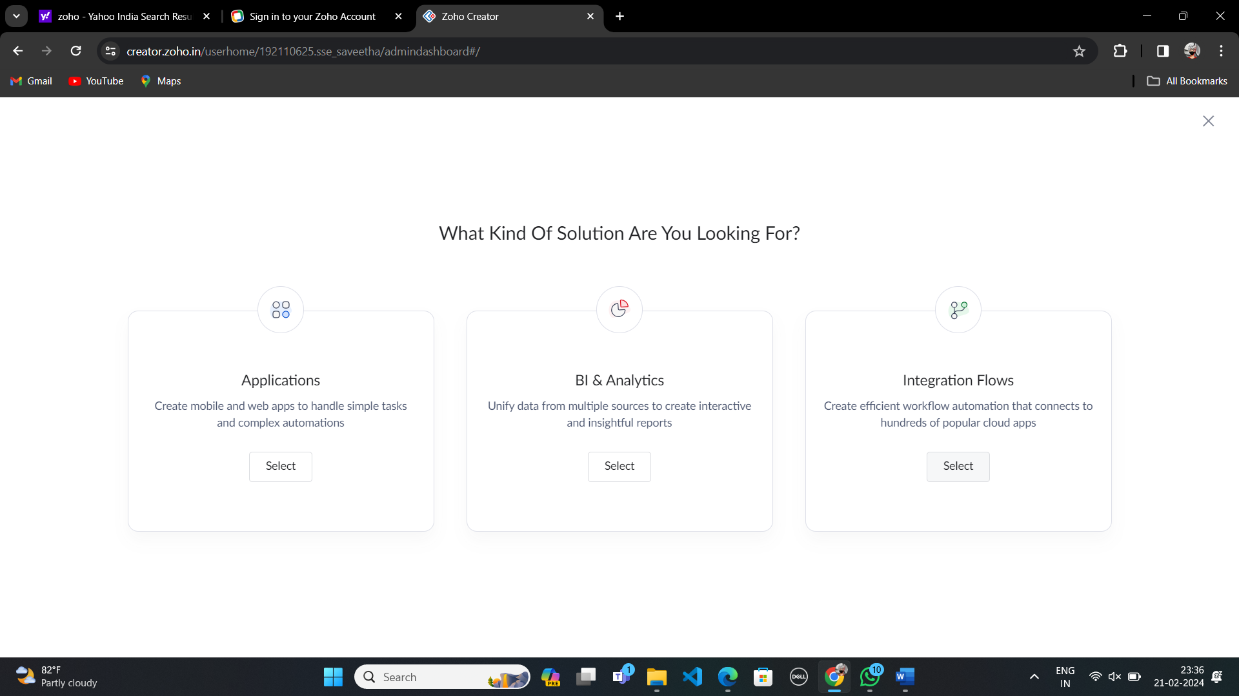

**Step-4:**

Enter application name as Course Booking.

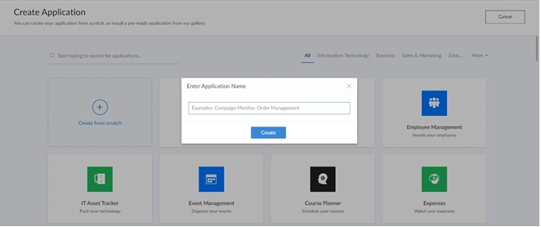

**Step-5:**

Select one form.

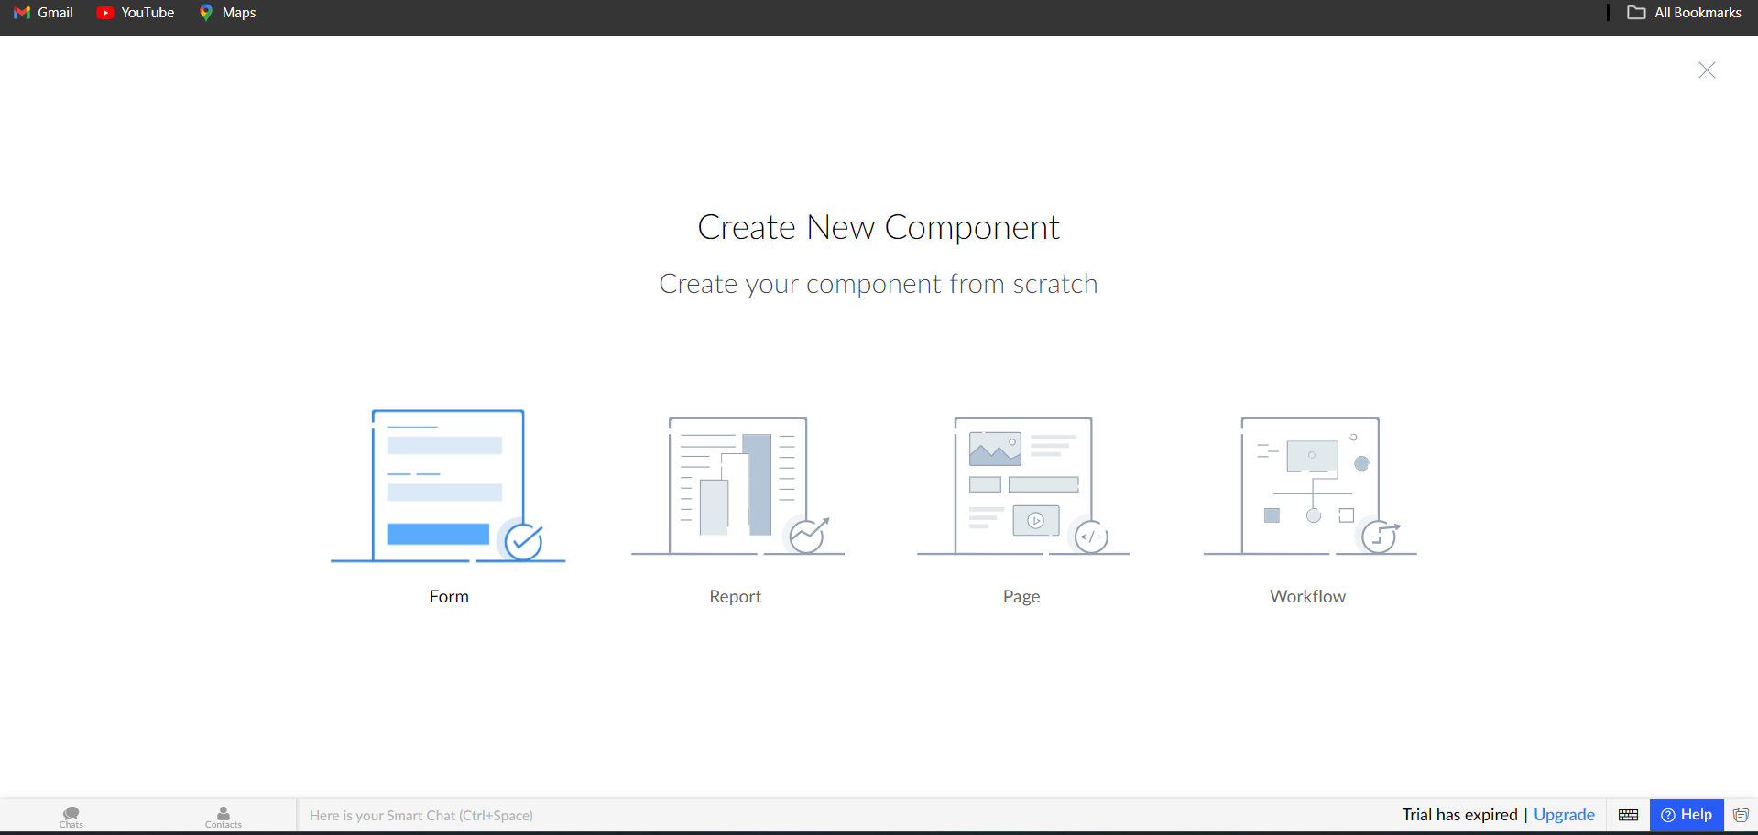

**Step-6:**

Enter name form name as Login.

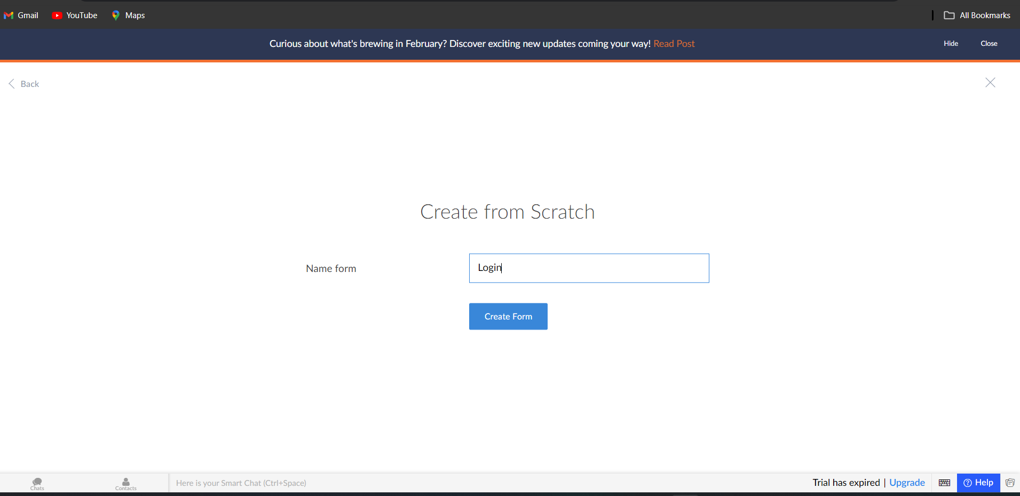

**Step-7:**

Create login form.

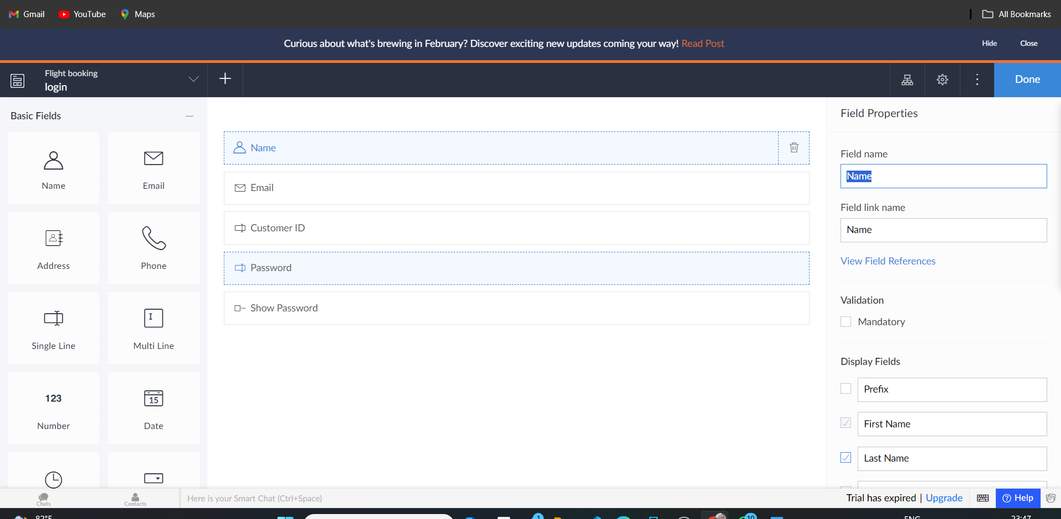

**Step-8:**

Create a new form and name it as Register a course.

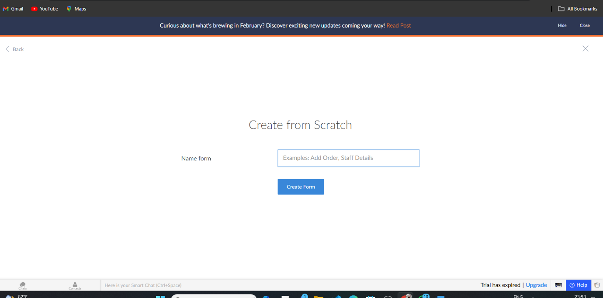

**Step-9:**

Create Register a course form.

