**Product Dissection for YouTube:** 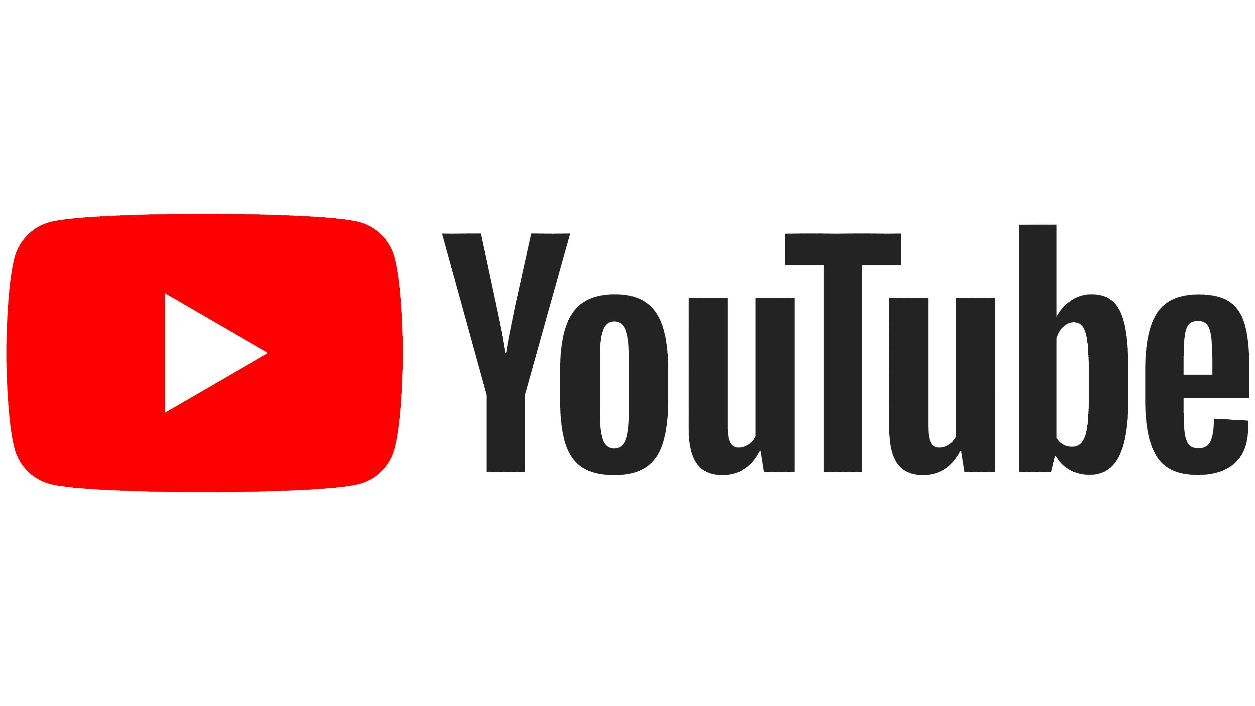

**Company Overview:**

YouTube, founded in February 2005 by Steve Chen, Chad Hurley, and Jawed Karim, has become the largest and most widely used video-sharing platform on the internet. Acquired by Google in November 2006, YouTube has played a transformative role in how people consume, share, and create video content. With millions of content creators and billions of users, YouTube has become a cornerstone of online video culture, offering a diverse range of content spanning entertainment, education, and more.

**Product Dissection and Real-World Problems Solved by YouTube:**

**1. Video Hosting and Sharing:**

- Problem Solved: Before YouTube, sharing and hosting videos online were complex and required technical skills.

- Features:

- Easy-to-use video upload interface.

- High-quality video hosting with reliable streaming.

- Shareable video links and embedding options.

**2. Content Discovery and Accessibility:**

- Problem Solved: Users struggled to find diverse and relevant video content easily.

- Features:

- Recommendation algorithms providing personalized content suggestions.

- Trending sections showcasing popular videos.

- Accessibility across various devices, making content available anytime, anywhere.

**3. Monetization for Content Creators:**

- Problem Solved: Content creators lacked effective ways to monetize their videos and sustain their creative efforts.

- Features:

- YouTube Partner Program enabling creators to earn revenue from ads.

- Super Chat and Channel Memberships for direct viewer support.

- Merchandise shelf for selling products and merchandise.

**4. Global Community Building:**

- Problem Solved: Bridging cultural and geographical gaps to create a global platform for content creators and audiences.

- Features:

- Multi-language support with subtitles and closed captions.

- A diverse range of content representing global perspectives.

- Collaborations between creators from different parts of the world.

**5. Engagement and Interaction:**

- Problem Solved: Viewers wanted to engage with content and creators beyond passive watching.

- Features:

- Comment sections for discussions and feedback.

- Like, dislike, and share buttons for user interaction.

- Community features for direct communication between creators and fans.

**6. Educational Resources:**

- Problem Solved: Users sought a platform for learning through video content.

- Features:

- Educational channels offering tutorials, lectures, and how-to videos.

- YouTube Learning featuring educational content.

- Integration with educational institutions for online courses.

**7. Live Streaming:**

- Problem Solved: Addressing the demand for real-time content and interactive experiences.

- Features:

- YouTube Live for live video streaming.

- Real-time chat for audience interaction.

- Scheduled live events and notifications.

**8. Mobile Accessibility:**

- Problem Solved: Adapting to the shift towards mobile devices for video consumption.

- Features:

- Mobile app with a user-friendly interface.

- Offline mode for downloading videos for on-the-go viewing.

- Mobile-friendly video editing tools.

**9. Music and Entertainment**:

- Problem Solved: Artists needed a platform to share music videos and exclusive content.

- Features:

- Dedicated music section with official music videos.

- YouTube Originals for exclusive entertainment content.

- Playlists for curated content experiences.

**10. Data and Analytics**:

- Problem Solved: Creators lacked insights into their audience and video performance.

- Features:

- Analytics dashboard providing data on views, demographics, and engagement.

- Tools for creators to understand their audience and tailor content.

**YouTube: A Platform Analysis**

**Introduction**

YouTube, founded in 2005 and later acquired by Google, has become a global hub for video content sharing and consumption. This analysis delves into the platform's key features, real-world problem-solving mechanisms, and its underlying schema design.

**Case Study: Content Discovery Overload**

**Problem: Users overwhelmed by information, leading to a diminished user experience.**

Users are facing a content overload on the YouTube platform, resulting in a diminished user experience. Navigating through an overwhelming amount of videos has become challenging, and users are struggling to find content aligned with their preferences and interests.

**Solution:**

**1. Recommendation Algorithm:**

- Description: YouTube employs a sophisticated recommendation algorithm powered by machine learning and artificial intelligence.

- How it Works: The algorithm analyzes vast amounts of user data, including watch history, search queries, and engagement metrics, to understand individual preferences.

- Outcome: The recommendation algorithm generates personalized content suggestions for each user based on their unique viewing patterns.

**2. User Behavior Analysis:**

- Description: The recommendation system deeply analyzes user behavior to gain insights into content preferences and viewing habits.

- How it Works: By understanding what users watch, how long they engage with specific content, and their interactions (likes, shares, comments), the system builds a comprehensive profile of each user.

- Outcome: The algorithm becomes adept at predicting what type of content a user is likely to enjoy, creating a more tailored content discovery experience.

**3. Personalized Suggestions on the Homepage:**

- Description: YouTube ensures that users are greeted with a personalized homepage showcasing relevant content recommendations.

- How it Works: The algorithm curates a selection of videos based on the user's historical data, presenting a diverse yet personalized array of content.

- Outcome: Users encounter content that aligns with their interests right from the moment they access the platform, reducing the effort required to find enjoyable videos.

**4. Notification System:**

- Description: To keep users engaged, YouTube extends personalized content suggestions through a notification system.

- How it Works: Users receive notifications about new videos or live streams that match their preferences, encouraging continued engagement.

- Outcome: The notification system serves as a proactive approach to content discovery, ensuring that users are aware of and can access relevant content as soon as it becomes available.

**5. Alleviating Challenges:**

- Description: YouTube's solution effectively addresses the challenges associated with content discovery overload.

- How it Works: By combining advanced algorithms, user behavior analysis, and proactive notifications, the platform streamlines the content discovery process.

- Outcome: Users experience a more enjoyable and personalized journey on the platform, leading to increased satisfaction and prolonged engagement.

**Conclusion:**

YouTube's approach to tackling content discovery overload through a sophisticated recommendation system, user behavior analysis, personalized suggestions, and a proactive notification system has proven successful. This solution not only alleviates the challenges users face in finding relevant content but also enhances their overall experience on the platform. By prioritizing personalization and user engagement, YouTube has managed to create a more user-friendly and satisfying content discovery process, solidifying its position as a leader in the online video streaming industry.

**Top Features of YouTube:**

**1. Video Upload and Sharing:**

**-** Users can easily upload and share their videos on the platform, making it a versatile space for content creators.

**2. Recommendation Algorithm:**

**-** YouTube uses a sophisticated recommendation algorithm that suggests personalized content based on a user's watch history, preferences, and engagement patterns.

**3. Subscription System:**

**-** Users can subscribe to their favorite channels to receive updates and notifications when new content is uploaded.

**4. Search and Discovery:**

**-** Robust search functionality allows users to discover a wide range of content, and the platform offers curated recommendations through the "Home" and "Trending" sections.

**5. Playlists:**

**-** Users can create and share playlists, allowing them to organize videos around specific themes or topics**.**

**6. Live Streaming:**

- Content creators can live-stream their videos, fostering real-time interaction with viewers through live chat.

**Schema Design Overview**

**Entities and Relationships:**

User:

* UserID (PK)
* Username
* Email
* Subscriptions
* WatchHistory

Video:

* VideoID (PK)
* Title
* Description
* Views
* Likes
* Dislikes
* UploadDate
* CreatorID (FK)

Creator:

* CreatorID (PK, FK referencing User Entity)
* ChannelName
* Subscribers
* Videos

Comment:

* CommentID (PK)
* VideoID (FK)
* UserID (FK)
* Text
* CommentDate

**Rationale Behind the Design**

User-Centric Approach: Prioritizing the User and Creator entities emphasizes YouTube's commitment to providing a great viewer experience while empowering content creators.

Content-Driven Relationships: The Video entity and its relationships highlight YouTube's core function of video content sharing, viewership, and engagement.

Recommendation Algorithm Integration: The schema supports YouTube's recommendation algorithm, ensuring a personalized experience for users.

**YouTube ER Diagram:**

In order to visually comprehend the intricate data model that underlies YouTube's functionality, let's construct an Entity-Relationship (ER) diagram. This diagram will illuminate the relationships and attributes of key entities within YouTube's ecosystem. The primary entities include **User**, encapsulating essential details such as **UserID**, Username, Email, Subscriptions, and **WatchHistory**. Another pivotal entity is Video, featuring attributes like **VideoID**, Title, Description, Views, Likes, Dislikes, **UploadDate**, and **CreatorID**. The Creato entity, intricately linked to the User entity, encompasses details such as **ChannelName**, Subscribers, and a collection of Videos. Lastly, the Comment entity, tied to both User and Video, holds **CommentID**, Text, and **CommentDate**. This ER diagram visually captures the dynamic relationships between these entities, providing a comprehensive overview of YouTube's data structure and functionality.

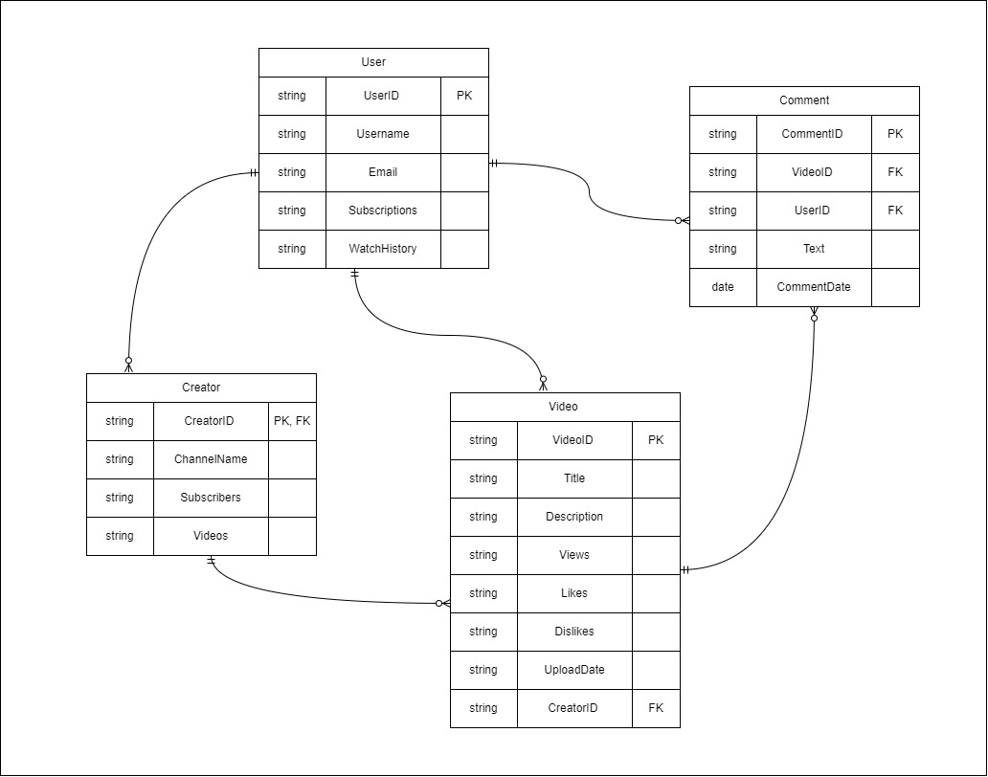

**Conclusion**

This case study has provided an in-depth exploration of the schema and Entity-Relationship diagram of YouTube, a platform that has significantly transformed the landscape of online video sharing and consumption. YouTube's data model serves as the backbone for its diverse functionalities, allowing users to upload, share, and engage with a vast array of videos. The core entities include users, videos, creators, and comments, each playing a crucial role in shaping the platform's dynamics. The relationships between these entities, such as user-video associations, creator-subscriber dynamics, and the interaction through comments, contribute to the seamless experience that millions of users worldwide enjoy. By unraveling the intricacies of YouTube's schema, we gain valuable insights into how the platform efficiently manages user interactions and content dissemination, solidifying its position as a global leader in online video content.