# WELCOME

{SALUTATION}

{STUDENT_FNAME}

{STUDENT_LNAME}{u18}

Flight Arrival Date: {ARRIVAL_DATE} Flight Arrival Time: {ARRIVAL_TIME} Flight Number: {FLIGHT_NO}

Homestay Address: {FAMILY_NAME} {HOMESTAY_ADDRESS}

Telephone: {HOMESTAY_PHONE} Mobile: {HOMESTAY_MOBILE}

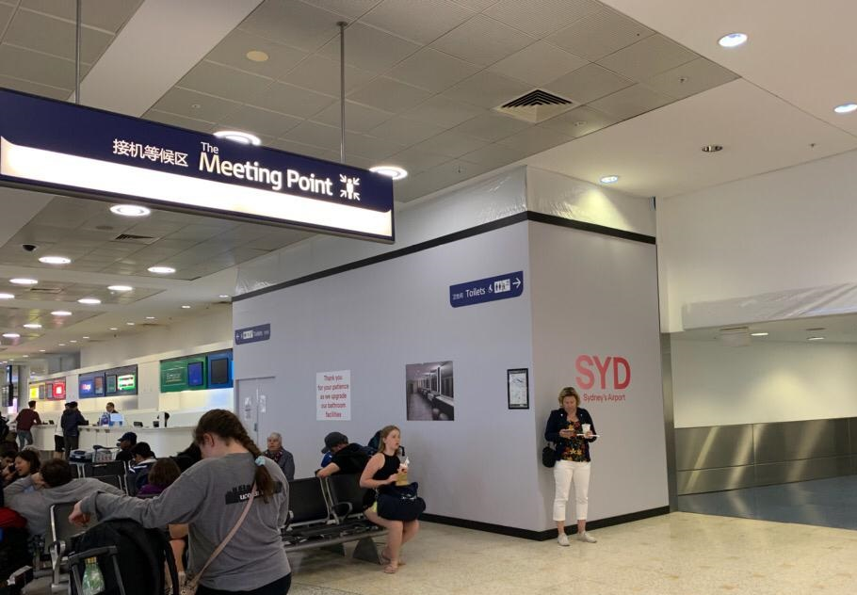

If you arrive at the International Airport:

Once you come out of the

Customs area, please go to

the ‘Meeting Point’

between Exit A and Exit B,

inside the terminal

and your driver will meet you there

If you arrive at the Domestic Airport:

Please wait for your driver at the 'luggage area' as your driver will meet you there

In case of Emergency please contact:

Castle Tour: {APU_CONTACT_NUMBER}

Global experience emergency number: (+61) 430 008 448

Email: [change@globalexperience.com.au](mailto:change@globalexperience.com.au)

PLEASE DO NOT LEAVE THE AIRPORT, WAIT FOR YOUR DRIVER