# WELCOME

{SALUTATION}

{STUDENT_FNAME}

{STUDENT_LNAME} {u18}

Flight Arrival Date: {ARRIVAL_DATE} Flight Arrival Time: {ARRIVAL_TIME} Flight Number: {FLIGHT_NO}

Homestay Address: {FAMILY_NAME} {HOMESTAY_ADDRESS}

Mobile: {HOMESTAY_MOBILE}

Once you arrive at Darwin Airport

When you come out of Customs, please wait for your host outside the gate (check the map circled in red) where your driver/host will wait for you there

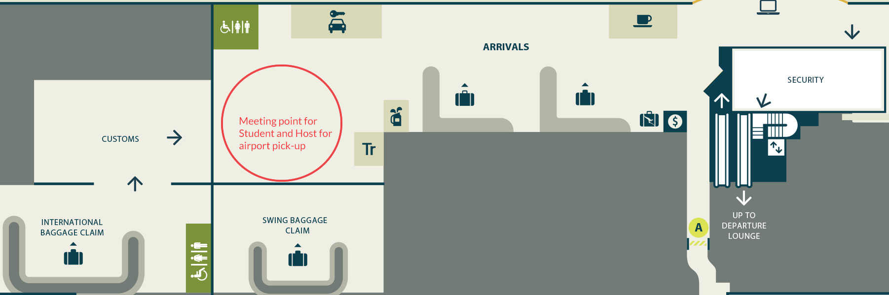

In case of Emergency please contact:

Your Host: 0415 375 005

Global experience Emergency Number: (+61) 430 008 448

PLEASE DO NOT LEAVE THE AIRPORT, WAIT FOR YOUR DRIVER