Frequency

0

10

20

30

Frequency

0

5

10 15 20 25 30 35

Frequency

0

5

10

15

20

25

30

Frequency

0

5

10

20

30



Petal Length

1

2

3

4

5

6

7



Petal Width

0.5

1.0

1.5

2.0

2.5



Sepal Length

4.5

5.5

6.5

7.5



Sepal Width

2.0

2.5

3.0

3.5

4.0

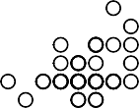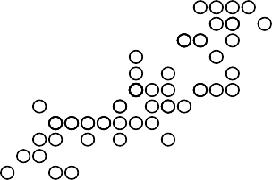

Petal Width

0.5

1.0

1.5

2.0

2.5

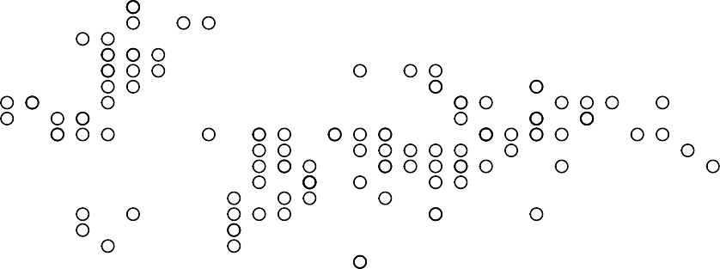

Sepal Width

2.0

2.5

3.0

3.5

4.0