-
ASSIGNMENT-02
Bachelor of Computer Application
Semester – lll

Subject: Database Management System
Topic: Designing a complete ER Diagram and converting it into a Relational Schema.

Submitted By:
TEJASWINI M

Submitted To:
Faculty Name: RENITA JOY

Mentor/Faculty Signature_____________

Department of Computer Application
Alliance University
Chandapura - Anekal Main Road, Anekal
Bengaluru - 562 106

Introduction

A Hotel Management System is designed to computerize and streamline the day-to-day operations of a hotel. It manages guest information, room inventory and availability, reservations and check-in/check-out activities, billing and payments, hotel staff records, and additional guest services such as laundry, spa, or room dining. The database helps maintain accurate and quickly retrievable records for hotel operations.

Entities and Attributes

Entity | Attributes
Guests | guest_id (PK), first_name, last_name, email (Unique), phone, address, id_proof_type, id_proof_number
RoomTypes | room_type_id (PK), type_name, base_price, max_occupancy, description
Rooms | room_id (PK), room_number (Unique), floor_number, room_type_id (FK), status
Staff | staff_id (PK), first_name, last_name, designation, phone, shift
Reservations | reservation_id (PK), guest_id (FK), room_id (FK), staff_id (FK), check_in_date, check_out_date, num_guests, booking_status
Payments | payment_id (PK), reservation_id (FK), amount, payment_date, payment_mode, payment_status
Services | service_id (PK), service_name, price
ServiceOrders | service_order_id (PK), reservation_id (FK), service_id (FK), quantity, order_date

ER Diagram

Insert your final ERDPlus ER diagram screenshot here. The diagram must show all eight entities, their attributes, primary keys, relationships, and 1:M cardinalities. Use the ERDPlus diagram you created for this assignment.
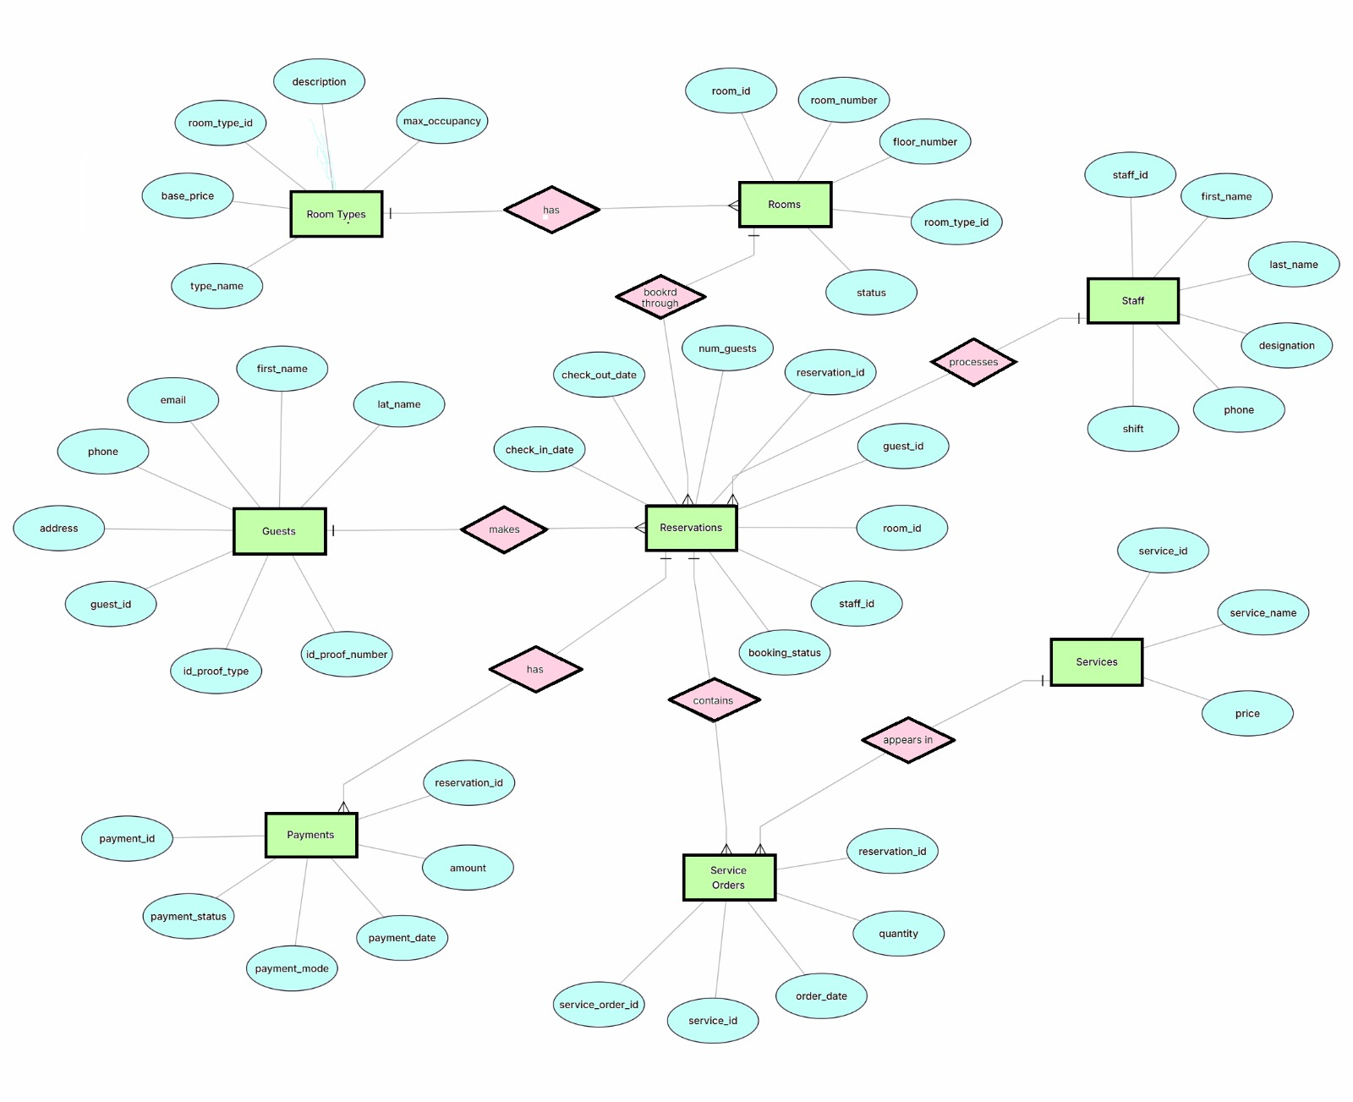

Relationships and Cardinalities

Table A | Table B | Cardinality | Explanation
RoomTypes | Rooms | 1 : M | One room type can apply to many physical rooms; each room belongs to one room type.
Guests | Reservations | 1 : M | One guest can make many reservations over time; each reservation belongs to one guest.
Rooms | Reservations | 1 : M | One room can be booked across many reservations on different dates; each reservation is for one room.
Staff | Reservations | 1 : M | One staff member can process many reservations; each reservation is handled by one staff member.
Reservations | Payments | 1 : M | One reservation can have one or more payment records; each payment belongs to one reservation.
Reservations | ServiceOrders | 1 : M | One reservation can include many service orders; each service order belongs to one reservation.
Services | ServiceOrders | 1 : M | One service can be ordered many times across different stays; each service order refers to one service.

Relational Schema

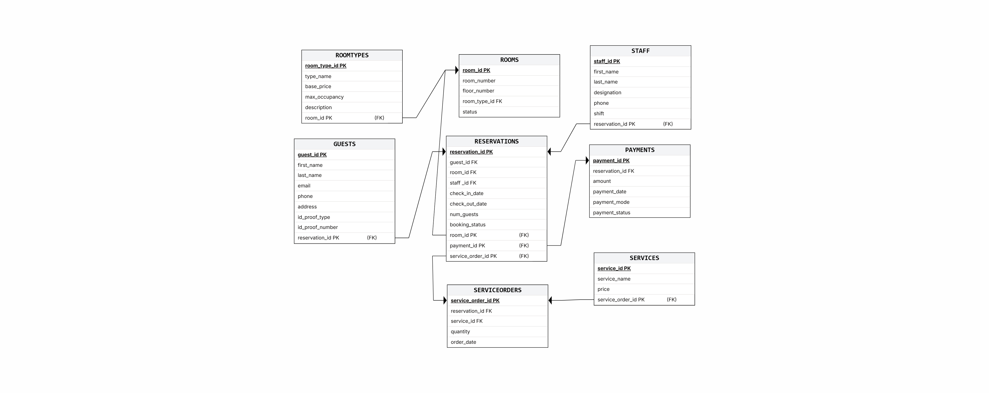

Relational Schema Explanation

1 GUESTS
GUESTS(guest_id PK, first_name, last_name, email, phone, address, id_proof_type, id_proof_number)

2 ROOMTYPES
ROOMTYPES(room_type_id PK, type_name, base_price, max_occupancy, description)

3 ROOMS
ROOMS(room_id PK, room_number, floor_number, room_type_id FK, status)

4 STAFF
STAFF(staff_id PK, first_name, last_name, designation, phone, shift)

5 RESERVATIONS
RESERVATIONS(reservation_id PK, guest_id FK, room_id FK, staff_id FK, check_in_date, check_out_date, num_guests, booking_status)

6 PAYMENTS
PAYMENTS(payment_id PK, reservation_id FK, amount, payment_date, payment_mode, payment_status)

7 SERVICES
SERVICES(service_id PK, service_name, price)

8 SERVICEORDERS
SERVICEORDERS(service_order_id PK, reservation_id FK, service_id FK, quantity, order_date)

Primary Keys and Foreign Keys
Table | Primary Key (PK) | Foreign Key (FK)
Guests | guest_id | —
RoomTypes | room_type_id | —
Rooms | room_id | room_type_id → RoomTypes(room_type_id)
Staff | staff_id | —
Reservations | reservation_id | guest_id → Guests; room_id → Rooms; staff_id → Staff
Payments | payment_id | reservation_id → Reservations(reservation_id)
Services | service_id | —
ServiceOrders | service_order_id | reservation_id → Reservations; service_id → Services
Primary Key: A primary key uniquely identifies each record in a relation.
Foreign Key: A foreign key references the primary key of another relation and establishes a link between the relations.

Explanation of Relationships

1 RoomTypes – Rooms (1:M)
A single room type can be associated with many physical rooms. Each physical room belongs to one room type. room_type_id in Rooms references RoomTypes.

2 Guests – Reservations (1:M)
A guest can make multiple reservations over time. Each reservation is associated with one guest. guest_id in Reservations references Guests.

3 Rooms – Reservations (1:M)
A room can appear in multiple reservations on different dates. Each reservation is made for one room. room_id in Reservations references Rooms.

4 Staff – Reservations (1:M)
A staff member can process many reservations. Each reservation records the staff member who handled it. staff_id in Reservations references Staff.

5 Reservations – Payments (1:M)
A reservation can have multiple payment records. Each payment belongs to one reservation. reservation_id in Payments references Reservations.

6 Reservations – ServiceOrders (1:M)
A reservation can contain multiple service orders. Each service order belongs to one reservation. reservation_id in ServiceOrders references Reservations.

7 Services – ServiceOrders (1:M)
A service can be ordered many times across different stays. Each service order refers to one service. service_id in ServiceOrders references Services.

8 Many-to-Many Relationship and Associative Entity
Reservations and Services have a conceptual many-to-many (M:N) relationship. One reservation can include multiple services, and one service can be requested in many different reservations.
This M:N relationship is resolved using the ServiceOrders associative (junction) table. ServiceOrders contains reservation_id and service_id as foreign keys and also stores quantity and order_date.
Therefore, the M:N relationship is represented as two 1:M relationships: Reservations → ServiceOrders and Services → ServiceOrders.

Complete Relational Schema Summary

Relation | Primary Key | Foreign Keys
GUESTS | guest_id | —
ROOMTYPES | room_type_id | —
ROOMS | room_id | room_type_id
STAFF | staff_id | —
RESERVATIONS | reservation_id | guest_id, room_id, staff_id
PAYMENTS | payment_id | reservation_id
SERVICES | service_id | —
SERVICEORDERS | service_order_id | reservation_id, service_id

`

Conclusion

The Hotel Management System has been modelled using eight entities: Guests, RoomTypes, Rooms, Staff, Reservations, Payments, Services, and ServiceOrders. The ER diagram represents the entities, attributes, keys, relationships, and cardinalities. The ER model is converted into a relational schema using primary keys and foreign keys. The many-to-many relationship between Reservations and Services is resolved through the ServiceOrders associative table. The resulting database structure reflects the core hotel workflow described in Assignment–01.

