## **AWS IoT Device Management**

As many IoT deployments consist of hundreds of thousands to millions of devices, it is essential to track, monitor, and manage connected device fleets. You need to ensure your IoT devices work properly and securely after they have been deployed. You also need to secure access to your devices, monitor health, detect and remotely troubleshoot problems, and manage software and firmware updates.

## **Benefits of using AWS IoT Device Management**

### Fast device registration

### Simple IoT device organization

### Locate connected devices quickly

### Easy remote device management

## **How AWS IoT Device Management works**

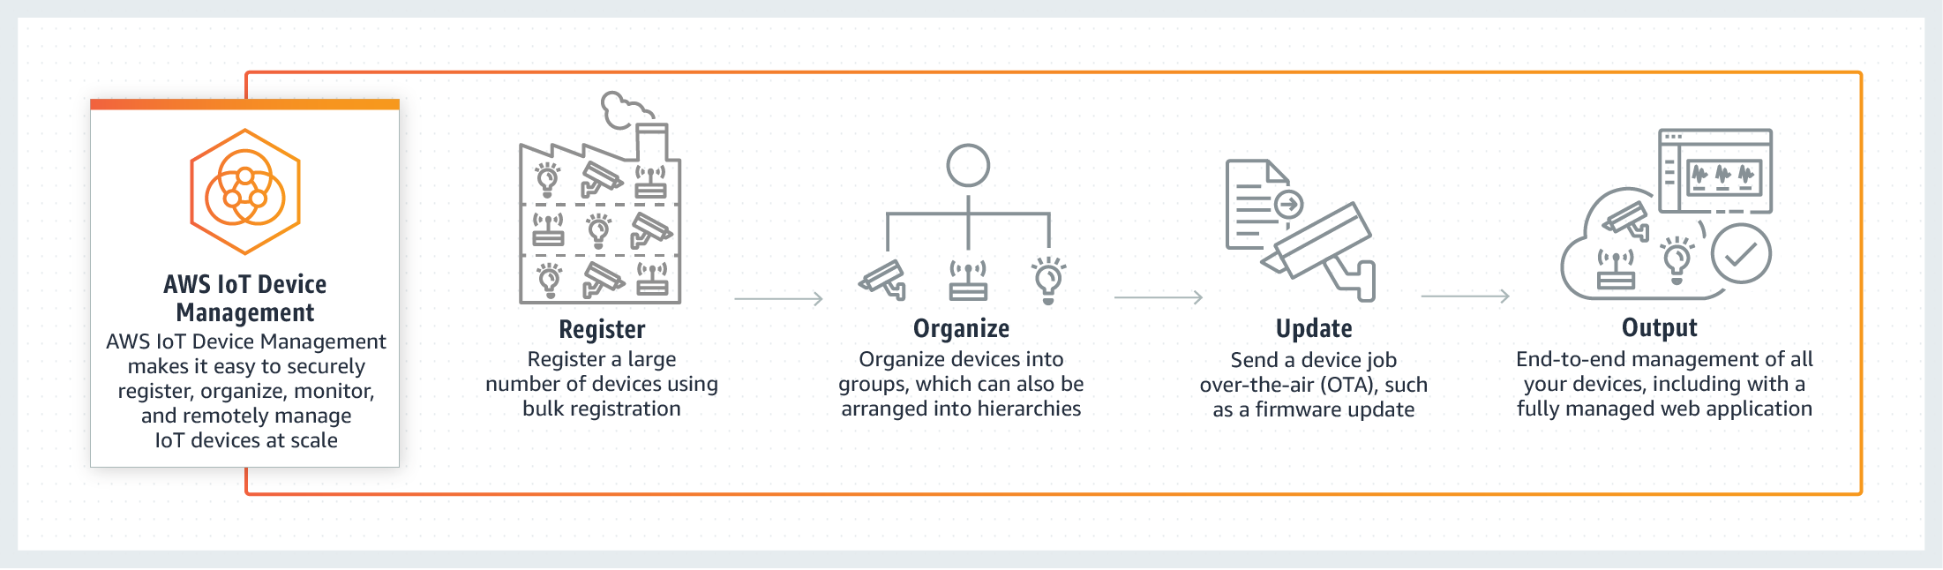

## **When to use AWS IoT Device Management**

Industrial Applications

Consumer Applications

Commercial Applications