CODE VENUE: A WEB-BASED LIVE CODING EXAMINATION PLATFORM
A PROJECT REPORT
Submitted by
Tejveer Singh (24BCA10210)
Akashdeep Singh (24BCA10222)
Aditya Rangta (24BCA10156)
Danish Gupta (24BCA10138)
in partial fulfillment for the award of the degree of
BACHELOR OF COMPUTER APPLICATIONS
IN
[ BRANCH OF STUDY ]

Chandigarh University
[ MONTH & YEAR ]

BONAFIDE CERTIFICATE
Certified that this project report “CODE VENUE: A WEB-BASED LIVE CODING EXAMINATION PLATFORM” is the bonafide work of “Tejveer Singh, Akashdeep Singh, Aditya Rangta and Danish Gupta” who carried out the project work under my supervision.
SIGNATURE  [ Name of the Head of the Department ]  HEAD OF THE DEPARTMENT  [ Department ] | SIGNATURE  Mr. Arvinder Singh  SUPERVISOR  [ Academic designation ]  [ Department ]

Submitted for the project viva-voce examination held on [ date ]
INTERNAL EXAMINER | EXTERNAL EXAMINER

TABLE OF CONTENTS
List of Figures iii
List of Tables iii
List of Standards iv
ABSTRACT v
GRAPHICAL ABSTRACT vi
ABBREVIATIONS vii
SYMBOLS vii
CHAPTER 1. INTRODUCTION 1
1.1. Identification of Client/Need/Relevant Contemporary Issue 1
1.2. Identification of Problem 1
1.3. Identification of Tasks 2
1.4. Timeline 2
1.5. Organization of the Report 2
CHAPTER 2. LITERATURE REVIEW/BACKGROUND STUDY 3
2.1. Timeline of the Reported Problem 3
2.2. Existing Solutions 3
2.3. Bibliometric Analysis 4
2.4. Review Summary 4
2.5. Problem Definition 5
2.6. Goals/Objectives 5
CHAPTER 3. DESIGN FLOW/PROCESS 6
3.1. Evaluation & Selection of Specifications/Features 6
3.2. Design Constraints 6
3.3. Analysis of Features and Finalization Subject to Constraints 7
3.4. Design Flow 8
3.5. Design Selection 9
3.6. Implementation Plan/Methodology 9
CHAPTER 4. RESULTS ANALYSIS AND VALIDATION 13
4.1. Implementation of the Solution 13
4.2. Testing and Validation 14
4.3. Screenshots of the System 16
CHAPTER 5. CONCLUSION AND FUTURE WORK 17
5.1. Conclusion 17
5.2. Future Work 17
REFERENCES 18
APPENDIX 19
1. Plagiarism Report 19
2. Design Checklist 19
USER MANUAL 20

List of Figures
Figure 1.1: Gantt chart of the project schedule 2
Figure 3.1: Design A: conventional REST server with a relational database 8
Figure 3.2: Design B: React client with a Convex backend (selected design) 8
Figure 3.3: Data model of Code Venue 10
Figure 3.4: Flowchart of joining a room and resolving the attempt 10
Figure 3.5: Flowchart of violation handling 11
Figure 3.6: Export procedure using single-use tickets 12
Figure 4.1: Examiner sign-in page 16
Figure 4.2: Create room form 16
Figure 4.3: Monitoring tab during an exam 16
Figure 4.4: Submissions tab with the code viewer 16
Figure 4.5: Student join page 16
Figure 4.6: Student exam page with a warning banner 16
Figure A.1: First page of the plagiarism report 19

List of Tables
Table 1.1: Evidence supporting the need 1
Table 1.2: Project tasks and dates 2
Table 2.1: Timeline of the reported problem and related events 3
Table 2.2: Comparison of existing approaches 4
Table 3.1: Candidate features and their priority 6
Table 3.2: Design constraints and their effect on the design 6
Table 3.3: Changes to the feature list 7
Table 3.4: Comparison of Design A and Design B 9
Table 4.1: Tools and technologies used 13
Table 4.2: Test plan with expected results 14
Table 4.3: Measurements from testing 15
Table 5.1: Objectives, implementation and test outcome 17
Table A.1: Plagiarism report details 19
Table A.2: Design checklist 19

List of Standards (Mandatory for Engineering Programs)
Standard | Publishing Agency | About the standard | Page no.
RFC 7519  JSON Web Token (JWT) | IETF | Defines a compact, signed token format. Examiner sessions are carried as JWTs. | 7
OpenID Connect Discovery 1.0 | OpenID Foundation | Describes metadata that lets a service find how tokens are issued and checked. | 7
FIPS PUB 180-4  Secure Hash Standard (SHS) | NIST | Specifies the SHA-2 hash functions. Export tickets are stored as SHA-256 hashes. | 7
RFC 3629  UTF-8 | IETF | Defines the UTF-8 encoding. Exported submission files are UTF-8 text. | 7
Fetch Standard | WHATWG | Defines how browsers make cross-origin requests. The export route sets its headers accordingly. | 7
The Digital Personal Data Protection Act, 2023 is a law, not a technical standard, so it is discussed in Section 3.2 and not listed here. Page numbers show where each standard is first used.

ABSTRACT
Practical programming exams are usually supervised by walking between computers. The examiner sees a few lines of each screen, nothing is recorded, and a crashed browser can wipe out a student’s work. This project presents Code Venue, a browser-based platform for running timed coding exams.
An examiner signs in with an emailed one-time code and creates a room with a question, a time limit, a seat limit and an optional violation limit. Students join with a short room code and no account, write code in an editor that saves automatically, and submit before the timer ends. The server logs tab switches, copies, pastes and rejoins with their times, never stores what was copied, and can submit a student’s work automatically once the limit is crossed. The examiner follows everything on a live dashboard and downloads submissions as single files or as a ZIP.
Code Venue is built with React, TypeScript and Convex, chosen after comparing it with a conventional REST server design. It follows the duties set out in the Digital Personal Data Protection Act, 2023. It records behaviour but cannot prevent it, and it does not run or grade code. Checks run against the deployed backend on 30 October 2026 confirmed the room-code format and no-room messages, the export route's 400 and 401 replies with the expected CORS headers, and the refusal of examiner-only functions to unauthenticated callers; the cases that still need a signed-in session are marked with their status in Table 4.2.
Keywords: online examination, coding assessment, academic integrity, event monitoring, data protection, web application.

GRAPHICAL ABSTRACT
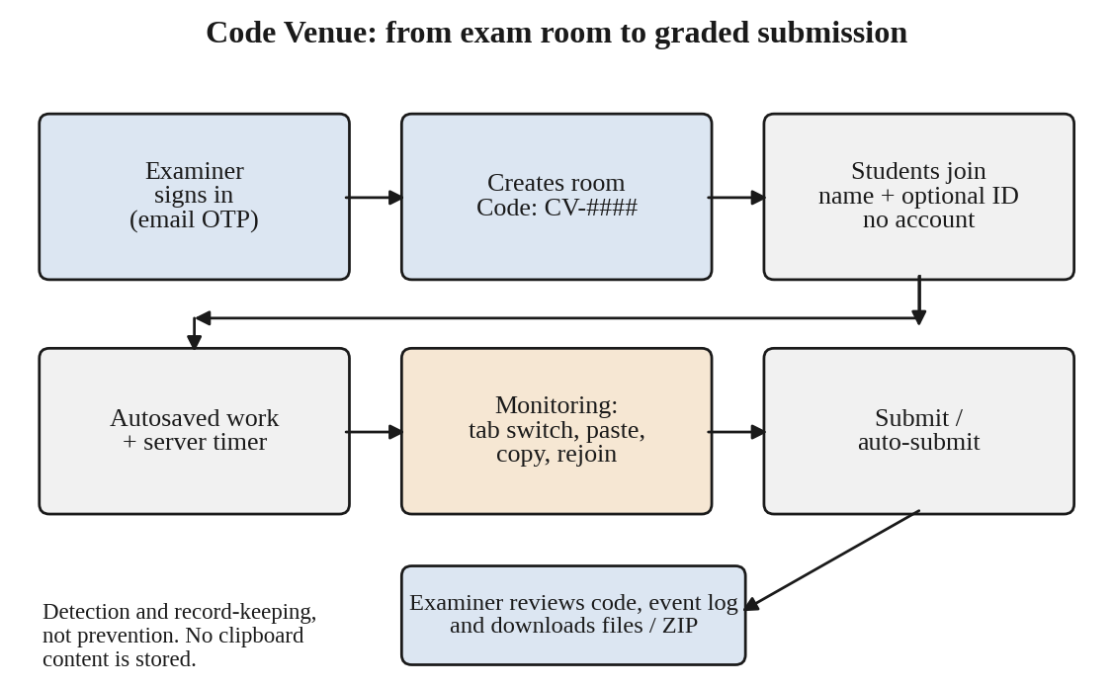
Code Venue in one view: the examiner opens a room, students join and write code, events are logged, and the examiner reviews and downloads the results.

ABBREVIATIONS
Abbreviation | Meaning
API | Application Programming Interface
CU | Chandigarh University
CSS | Cascading Style Sheets
DPDP | Digital Personal Data Protection
FIPS | Federal Information Processing Standard
HTTP | Hypertext Transfer Protocol
IETF | Internet Engineering Task Force
JWT | JSON Web Token
MeitY | Ministry of Electronics and Information Technology
NIST | National Institute of Standards and Technology
OTP | One-Time Password (the six-digit sign-in code)
REST | Representational State Transfer
RFC | Request for Comments
SHA | Secure Hash Algorithm
UI | User Interface
UID | Unique ID issued by the university to a student
WHATWG | Web Hypertext Application Technology Working Group

SYMBOLS
Symbol | Meaning | Unit
L | Violation limit set for a room (0 means flag only, no automatic submission) | count
c | Counted violation events for one student (rejoins are not counted) | count
D | Room duration | minutes
S | Room start time, set when the room is created | time
E | Room end time, E = S + D | time

CHAPTER 1.
INTRODUCTION

1.1. Identification of Client/Need/Relevant Contemporary Issue
Code Venue has two kinds of users. The client is the examiner, a teacher or lab instructor who runs practical programming tests. The other users are the students who sit them. The project was carried out at Chandigarh University under the supervision of Mr. Arvinder Singh, and the need was first noticed in the department's programming laboratories, where semester practical examinations are taken on shared lab machines.
Picture a typical practical exam. The examiner walks along the rows, reads a few lines on each screen, and later gives marks from that short look or from files copied off the lab machines. Nothing records what a student actually did during the exam, and if a browser or computer crashes, unsaved work is simply gone.
This is part of a bigger shift towards digital assessment. A review of 80 studies (2014–2024) found that the pandemic pushed many institutions from in-person to digital exams, and that keeping online assessment fair is still hard [1]. A review of 33 online proctoring systems found weak spots in privacy and security, and often no explanation of what part artificial intelligence plays when a violation is flagged [2]. The law matters too: India’s Digital Personal Data Protection (DPDP) Act, 2023 [3] and the DPDP Rules, 2025 [4] cover digital personal data, and an exam platform holds student names, IDs and behaviour logs. Table 1.1 sums up the evidence. The rows for our own surveys will be filled once that data is collected.
Table 1.1: Evidence supporting the need
Source | Finding | Reference
Systematic review of AI-based proctoring | 80 studies (2014–2024); the pandemic moved exams to digital platforms | [1]
Review of 33 online proctoring systems | Weak privacy and security; role of AI in decisions often unclear | [2]
DPDP Act 2023 and Rules 2025 | Legal duties apply to digital personal data; Rules notified 13 Nov 2025 | [3], [4]
Surveys of examiners and students; institution report | [ respondents, main findings and report details ] | [ ref ]

1.2. Identification of Problem
Running and marking a practical programming exam gets harder as the group grows. Five problems stand out:
- Supervision works by sampling; one examiner cannot watch every screen all the time.
- Work reaches the examiner in uneven ways (files, pen drives, messages) and is lost if a machine or browser fails.
- Nothing is recorded afterwards, such as a student leaving the exam window or pasting outside text.
- Attempts get mixed up when students share names or machines, or reopen the page.
- Names, IDs and activity logs are personal data and must be handled lawfully.
Put simply: how can an examiner run a timed programming exam for a group, collect everyone’s work reliably, and review what happened, without handling student data carelessly?

1.3. Identification of Tasks
We split the work into six tasks, which also set the order of this report.
- Study the need from the literature and from examiners and students.
- Review existing approaches (Chapter 2).
- Fix the requirements: choose features, then drop or change those that clash with privacy, cost or technical limits (Chapter 3).
- Compare two designs and pick one (Chapter 3).
- Build the backend and the interfaces (Chapter 4).
- Test, deploy and document (Chapter 4 and the User Manual).

1.4. Timeline
Table 1.2 shows the planned and actual dates for each task. The dates below come from the repository's own commit history (10 September to 30 October 2026) and from the access dates recorded in the reference list. Figure 1.1 is a Gantt chart drawn from them.
Table 1.2: Project tasks and dates
No. | Task | Planned start | Planned end | Actual end
1 | Study the need and collect evidence | 10 Sep 2026 | 13 Sep 2026 | 13 Sep 2026
2 | Literature review | 14 Sep 2026 | 30 Sep 2026 | 27 Oct 2026
3 | Requirements and constraints | 14 Sep 2026 | 20 Sep 2026 | 20 Sep 2026
4 | Design comparison and selection | 21 Sep 2026 | 27 Sep 2026 | 27 Sep 2026
5 | Backend and interface implementation | 10 Sep 2026 | 24 Oct 2026 | 25 Oct 2026
6 | Testing, deployment, manual and report | 28 Sep 2026 | 30 Oct 2026 | 30 Oct 2026

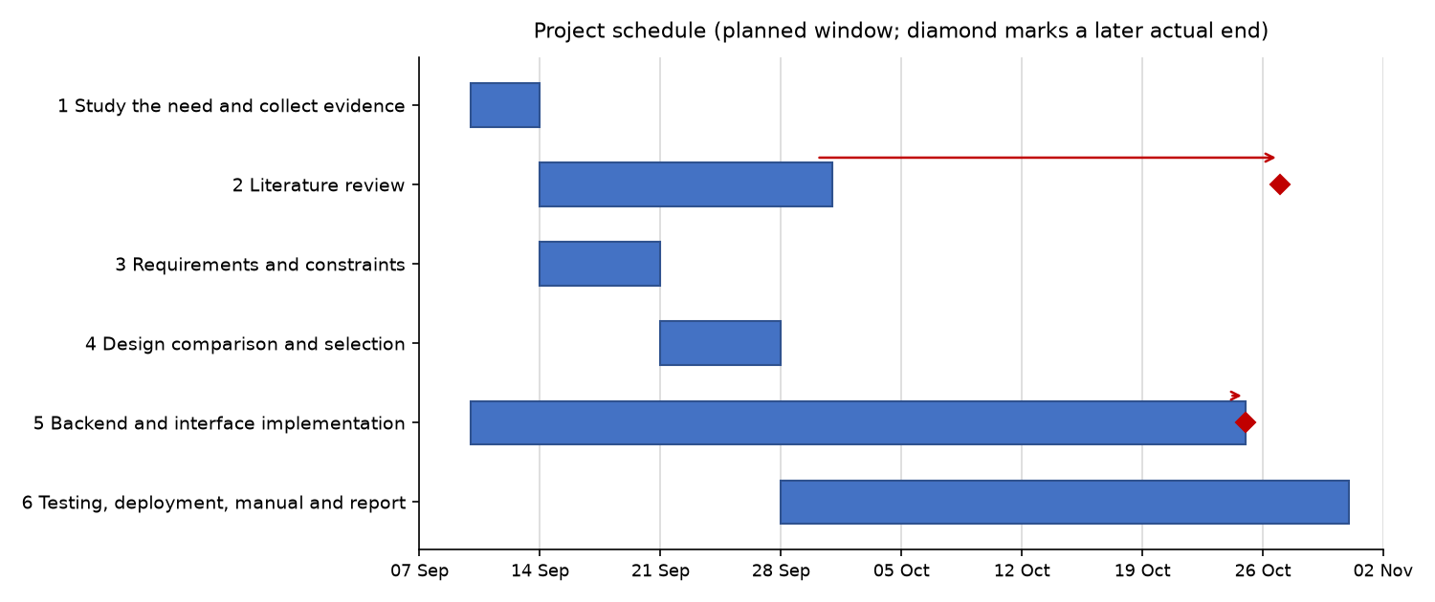
Figure 1.1: Gantt chart of the project schedule

1.5. Organization of the Report
Chapter 1 explains the need, the problem and the plan. Chapter 2 reviews existing work and ends with the problem definition and objectives. Chapter 3 compares two designs and explains the chosen one. Chapter 4 covers the implementation, tests and screenshots. Chapter 5 gives the conclusion and future work. The references, an appendix and a short user manual follow.

CHAPTER 2.
LITERATURE REVIEW/BACKGROUND STUDY

2.1. Timeline of the Reported Problem
Worry about cheating in unsupervised or lightly supervised exams is older than online learning, but the sources we used tie its growth to the move of exams onto digital platforms. Table 2.1 lists the dated events we could confirm from published sources. The last row is left for incidents from our own institution.
Table 2.1: Timeline of the reported problem and related events
Year | Event | Source
2014–2024 | Period covered by a systematic review of 80 studies on AI-based proctoring in higher education | [1]
2020–2021 | Pandemic years: exams move online and proctoring tools are adopted in a hurry | [1], [2]
11 Aug 2023 | DPDP Act 2023 receives presidential assent | [3]
13 Nov 2025 | DPDP Rules 2025 notified by MeitY | [4]
[ year ] | [ incident or report from our institution ] | [ ref ]

2.2. Existing Solutions
Five kinds of solution exist today. They differ in what they ask of the student’s device and in how much personal data they collect.
In-person invigilation. Invigilators watch students who write by hand. The review in [1] calls this time-consuming and notes that dishonesty continues even so. For programming exams it also leaves the examiner without the student’s work in digital form.
Lockdown browsers. A lockdown browser takes over the device’s usual escape routes for the length of the exam [5]. The idea that matters to us is the difference between blocking an action and allowing it but logging it: a reviewer can see how often a tab switch happened without removing a candidate for one stray click [5]. The same source admits that a lockdown browser cannot see things like another person in the room. It is a vendor page, so we use it for definitions and not as proof that it works.
Camera and microphone proctoring. Most academic work studies webcam and microphone systems. The 80-study review groups them into machine learning, deep learning and sensor-based approaches, with features such as face verification, gaze tracking and voice detection [1]. It also lists their problems: false alarms and missed cases, models trained on narrow data, privacy worries about constant audio and video, and unfair results for students with weak connections or older devices [1].
Interaction-log analysis. A lighter idea is to use events the exam software already sees. As reported in [1], Garg et al. used response times, answer revisions and tab-switch counts from Moodle quizzes and reached about 85% accuracy with a random forest. Nabil et al. recorded mouse clicks and keyboard input and reached about 91%. Both studies covered a single course or exam, so the numbers show that these signals carry information, not how they would behave elsewhere.
Coding-assessment platforms. Dedicated platforms for coding tests also exist. Comparing them properly needs their documentation and a trial of each, which we have not done yet: vendor documentation checked on 30 October 2026: HackerRank records copy and paste actions and how often and for how long a candidate leaves the test window, and with Proctor Mode also logs webcam images every five seconds, screen shots every fifteen seconds and code similarity against other submissions; Codility logs focus changes and paste events on a session timeline and runs a similarity check against its submission library, with video proctoring as an optional setting; CodeSignal combines paste events, cross-submission and web similarity and typing telemetry into a suspicion score, alongside recorded video, audio and screen; TestDome documents copy/paste protection, webcam and screen recording and no similarity check. These are vendor descriptions rather than trial results, and no platform was trialled for this project..

2.3. Bibliometric Analysis
The review in [1] explains how it chose its studies: 348 records found, 68 duplicates removed, 280 titles and abstracts screened, 143 full texts checked and 80 studies included. The review in [2] used a different method and judged 33 systems from their public descriptions. Table 2.2 compares the approaches. The accuracy figures come from the original studies as reported in [1]. They cannot be compared directly, because the data, tasks and measures differ.
Table 2.2: Comparison of existing approaches
Approach | Key features | Reported effectiveness | Drawbacks
Lockdown browser [5] | Takes over OS escape routes; can block or only log tab changes | No figures in the source | Cannot see other people; vendor description
Webcam-only detector (Li et al., in [1]) | Webcam, with peer review and a committee for unclear cases | Recall 78.6%, precision 84.6%, accuracy 83.3% | Extra gaze and EEG sensors raised recall but lowered precision and need special hardware
Interaction logs and random forest (Garg et al., in [1]) | Response times, answer revisions, tab-switch counts | About 85% accuracy | Needs labelled data; tested in lab-based assessments
Mouse and keyboard behaviour (Nabil et al., in [1]) | Mouse clicks and key input, classified with machine learning | About 91% accuracy | Data from one microprocessor exam
Survey of 33 proctoring systems [2] | Public descriptions; most systems flag window switching, lost camera focus or voices | Not applicable | Weak privacy and security; unclear use of AI

2.4. Review Summary
Four lessons from the literature shaped what we built.
- Camera, microphone and eye-tracking methods need hardware and bandwidth, collect sensitive data and raise false alarms [1]. On shared lab machines those costs are high.
- Methods that read browser events are lighter. Tab-switch counts and input behaviour show up as useful signals in several studies [1], and a tab switch can be logged instead of blocked [5].
- The review of 33 systems warns about privacy, security and unclear use of AI [2]. A tool that stores only event types and times, and leaves the decision to the examiner, avoids the AI problem by design.
- The larger review says a framework that balances accuracy, privacy and context is still missing [1]. We do not claim to supply one. We test a narrower idea: an event log without media capture, built into a coding-exam tool.

2.5. Problem Definition
What to build. A web application where an examiner creates a timed room for a programming question, students join and write code in the browser, and the examiner can see who joined, who submitted and what events were recorded. Each submission must be downloadable exactly as the student wrote it.
How. It runs in the browser with no installation. The server keeps the official record of attempts, saves, events and submissions, and checks every action that changes data. Personal data is kept to what the exam needs, and consent and data-rights requests are recorded.
What not to do. The system does not try to block tab switching or copying, because a web page cannot. It does not use the camera or microphone, store copied text, run or grade code, or decide that someone cheated. It reports events and the examiner interprets them.

2.6. Goals/Objectives
Each objective below is specific enough to be checked in the tests of Chapter 4.
- A signed-in examiner can create a room with a name, a question, a duration (1–1440 minutes), a capacity (1–500 students) and a violation limit, and gets a unique code such as CV-1234.
- A student can join with the code and a name, without an account. Different name-and-ID combinations always get separate attempts, and one browser can never take over another student’s attempt.
- Code is saved while the student types, and reloading the page restores the latest draft.
- Tab switches, pastes, copies and rejoins are recorded with their times, and clipboard content is never stored.
- When a room has a violation limit, the work is submitted automatically once the count passes it.
- An examiner can download one submission or all of them, and the files match the stored code exactly.
- Input limits and rate limits are enforced on the server, and examiners can reach only their own rooms.
- Consent records, data-rights requests and account erasure are available in the application.

CHAPTER 3.
DESIGN FLOW/PROCESS

3.1. Evaluation & Selection of Specifications/Features
The review in [1] describes proctoring systems through four feature groups: authentication, browsing tolerance, remote control and report generation. We used them as a checklist. Table 3.1 lists the candidate features and marks each as required, desirable, or considered and left out.
Table 3.1: Candidate features and their priority
ID | Feature | Basis | Priority
F1 | Examiner sign-in with an emailed one-time code | Authentication [1] | Required
F2 | Room with unique code, question, duration and capacity | Remote control [1] | Required
F3 | Student joins with a name and optional ID, no account | Shared lab machines; quick start | Required
F4 | Autosave and restore of the draft | Loss of work during exams | Required
F5 | Recording of tab switches, pastes, copies and rejoins | Browsing tolerance [1], [5] | Required
F6 | Warnings, then automatic submission at a limit | Remote control [1] | Desirable
F7 | Live examiner dashboard with counts and flags | Report generation [1] | Required
F8 | Read-only code viewer; download one file or a ZIP | Report generation [1] | Required
F9 | Consent records, data-rights requests, erasure | DPDP Act and Rules [3], [4] | Required
F10 | Server-side input limits and rate limits | Abuse and cost control | Required
F11 | Webcam, microphone or face verification | Common in the literature [1] | Left out
F12 | Running and auto-grading student code | Typical of coding platforms | Left out
F13 | Several questions per exam | Larger exams | Left out

3.2. Design Constraints
Table 3.2 lists what limited the design and how we responded. The technical standards we rely on are named in the table and collected in the List of Standards at the front. The DPDP Act is a law rather than a technical standard, so it is treated here as a regulation [3].
Table 3.2: Design constraints and their effect on the design
Constraint | What applies | Effect on the design
Regulations | DPDP Act 2023 [3]; DPDP Rules 2025 [4]. One secondary source says the main duties start on 13 May 2027; this should be confirmed from the Rules. | Collect only a name and an optional ID from students. Store consent with the policy version. Offer a data-rights form and erasure of an examiner’s data.
Technical standards | JSON Web Token, RFC 7519 [6]; OpenID Connect Discovery 1.0 [7]; Secure Hash Standard, FIPS 180-4 [8]; UTF-8, RFC 3629 [9]; WHATWG Fetch Standard [10]. | Sessions travel as JWTs. Export tickets are stored as SHA-256 hashes. Exported files are UTF-8. The export route answers cross-origin requests as Fetch requires.
Browser limits | A web page cannot stop tab switching or clipboard use. | The system records events. It does not claim to prevent them.
Professional and ethical | Event counts are indicators, not proof of misconduct. | The examiner sees counts and times and decides. The system never labels a student as guilty.
Social | Students may have unstable connections or shared devices [1]. | Autosave retries. A late submission is kept and marked late. No camera or microphone is needed.
Safety and security | Exam content and student work must stay separate between rooms and examiners. | Every examiner request checks room ownership. Student actions need a secret token. Exports need a one-use ticket.
Economic and cost | Vercel Hobby, Convex Free and Resend Free - each $0 (Rs 0) per month, taken from the providers' own pricing pages checked on 30 October 2026. | No plan bills automatically: exceeding a free-tier limit caps usage instead of charging (Vercel Hobby: 100 GB transfer and 1 million function invocations a month; Convex Free: 1 million function calls and 0.5 GB database storage; Resend Free: 3,000 e-mails a month and 100 a day). Those caps, not a budget, bound this project, and Vercel's free plan is restricted to non-commercial personal use.
Environmental, health and build | Software only, so no manufacturing; hosting energy is not measured. Long timed sessions on a screen. Built from source with one build command. | No environmental effect identified. A countdown changes style when time is low. Settings live in environment variables, listed in the User Manual.

3.3. Analysis of Features and Finalization Subject to Constraints
The constraints changed the feature list in the ways shown in Table 3.3. The biggest decision was to drop the camera: it needs hardware and bandwidth, collects sensitive data and produces false alarms [1], [2].
Table 3.3: Changes to the feature list
Feature | Decision | Reason
F11 Camera, microphone, face check | Removed | Needs hardware and bandwidth, collects sensitive data, and the literature reports false alarms and privacy problems [1], [2].
F12 Run and grade code | Removed | Running unknown code safely is a separate security job. The examiner can read the code and run it elsewhere.
F13 Several questions | Deferred | One question and one code buffer per student keeps the data model small. Listed under future work.
F5, F6 Event recording and violation handling | Modified | Only the event type and time are stored; clipboard text is never read. A browser cannot block events, so the response is a warning and, at the limit, automatic submission. A limit of zero flags silently.
Attempt identity | Added | Two students on one browser must not open each other’s work, so an attempt is tied to a secret token, the student ID and a browser identifier.
Late submission | Added | Work sent after the deadline is kept and marked late, so a clock difference does not lose it.
Export tickets | Added | Downloads use a plain HTTP route, so a short-lived, single-use ticket replaces an open file link.
Security event log | Added | Suspicious access, such as an export attempt on another examiner’s room, is logged for review.

3.4. Design Flow
We worked out two alternative designs for the same final feature list and compared them on paper. Design A was not built.

3.4.1. Design A: conventional server with a relational database
In Design A the team would write and host its own REST server. Browsers call it over HTTP, and the server runs the sign-in service, talks to a relational database and sends the one-time code through an email provider. Because the examiner dashboard has to show new joins quickly, a WebSocket endpoint or a polling loop would be added beside the REST API (Figure 3.1).
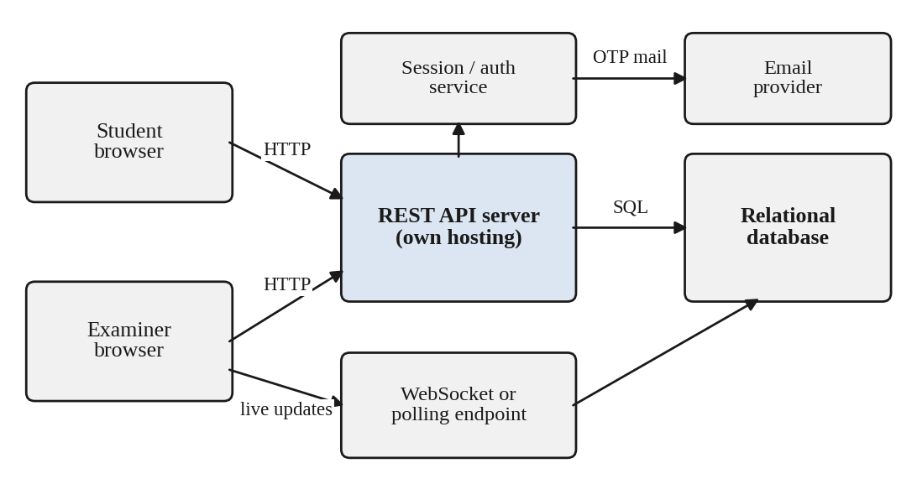
Figure 3.1: Design A: conventional REST server with a relational database

3.4.2. Design B: reactive backend service with a single-page client
In Design B the interface is a single-page React app served as static files, and all server logic runs as queries and mutations on Convex. Queries are reactive: a page that reads one updates by itself when the data changes, so the dashboard needs no polling code. Convex Auth handles sessions, a rate-limiter component guards the busy actions and a small HTTP route serves downloads. Resend sends the one-time code (Figure 3.2).
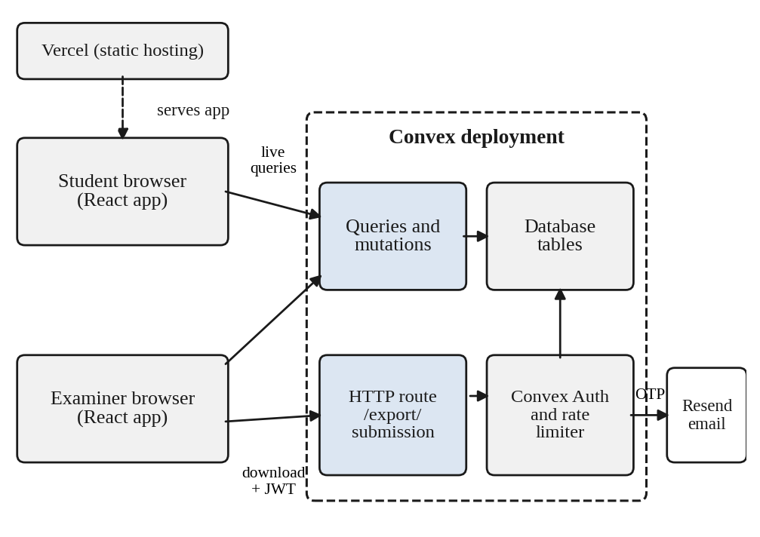
Figure 3.2: Design B: React client with a Convex backend (selected design)

3.5. Design Selection
Table 3.4 compares the two designs on the criteria that mattered most.
Table 3.4: Comparison of Design A and Design B
Criterion | Design A | Design B
Live dashboard | Needs a separate WebSocket or polling part | Reactive queries update the page without extra code
Server-side checks | Written in each route; easy to miss one | Every function runs on the server and can call one shared owner check
Operations | Team hosts and patches servers, database and session store | Managed services; the team supplies configuration
Effort for a four-person team | Higher: more parts to build and connect | Lower: one language and one set of types end to end
Vendor dependence | Low | Higher: depends on Convex, Vercel and Resend
Cost | Estimate: no licence cost, but a server of their own would be needed - a small virtual server runs to roughly Rs 500-800 a month, plus the team's time to patch and run it. | Estimate: Rs 0 while the free tiers hold (Convex, Vercel, Resend); beyond them the providers' published usage rates apply.
We chose Design B. The deciding points were the live dashboard, the amount of server code a small team would otherwise write and maintain, and using one language on both sides. The price is dependence on three hosted services: if one changes its terms, parts of the app would need rework. Testing locally also needs a Convex development deployment. To limit the rework, the data model uses plain tables and relies on little beyond the Convex API.

3.6. Implementation Plan/Methodology
This section follows a student’s path through the chosen design, from the data it keeps to the files an examiner downloads.

3.6.1. Data model
The database has a table for each kind of record, plus the user and session tables supplied by Convex Auth. An examiner owns many rooms, a room has many student attempts, and each attempt has at most one submission. Events, export tickets, consent records, data-rights requests and security events sit in their own tables (Figure 3.3). Limits such as a 120-character room name, a 10,000-character question and a 64,000-character submission are enforced in server code, not only in the interface.
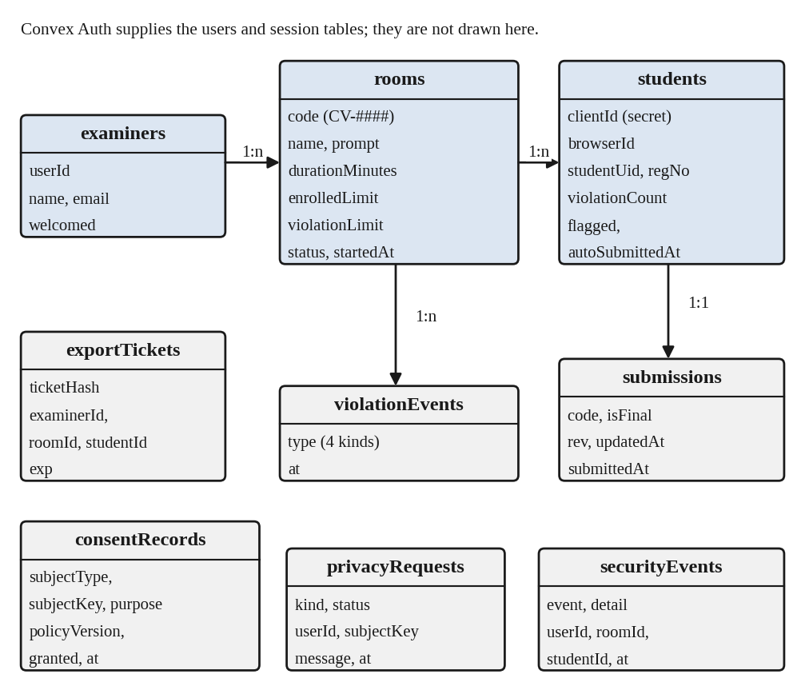
Figure 3.3: Data model of Code Venue

3.6.2. Joining a room
A student sends the room code, a name, an optional ID, a saved token if there is one, and a browser identifier. The server first applies the rate limits and checks that the room exists and is live. It then decides whether this person is coming back to an earlier attempt or starting a new one (Figure 3.4). A saved token is accepted only if it belongs to the same room, the same student ID and the same browser. Without that rule, a second student on the same browser could reopen the first student’s attempt. A new attempt gets a secret 128-bit random token and a public student code of the form S-XXXXXX, which is what the examiner sees.
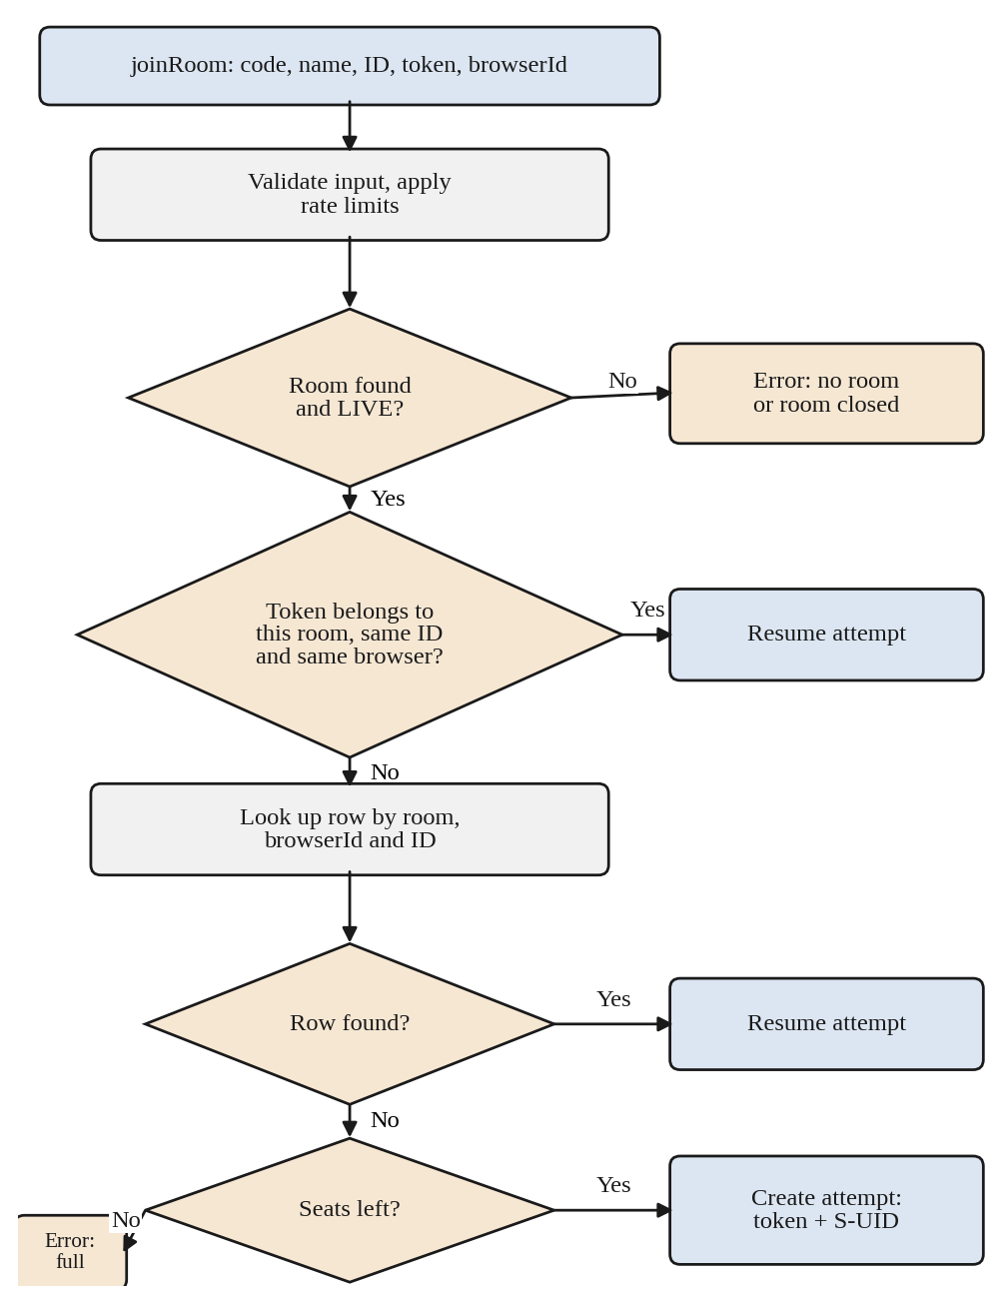
Figure 3.4: Flowchart of joining a room and resolving the attempt

3.6.3. Timer, autosave and submission
Each room stores a start time S, and its end time is E = S + D, where D is the duration. The student page shows E minus the current time. In the current build S is set when the room is created, so the clock starts then and not when each student joins. Chapter 5 returns to this point.
Autosave sends the code with a revision number that goes up with every edit, and the server ignores any save older than the one it already holds. A slow, late request therefore cannot overwrite newer text. After a final submission the attempt is locked and later saves are refused. If the exam ends first, whether the examiner ended the room or the timer reached zero, the student page submits the current code automatically.

3.6.4. Monitoring and enforcement
The student page watches for the window losing focus, for paste and for copy, and reports each as an event. Let L be the room’s violation limit and c the number of counted events for a student (Figure 3.5). If L is 0, the first counted event flags the student silently. If L is above 0, the student sees “n of L warnings”, and the work is submitted automatically when c goes above L. Rejoins are stored but never counted, because reloading a page is not leaving it.
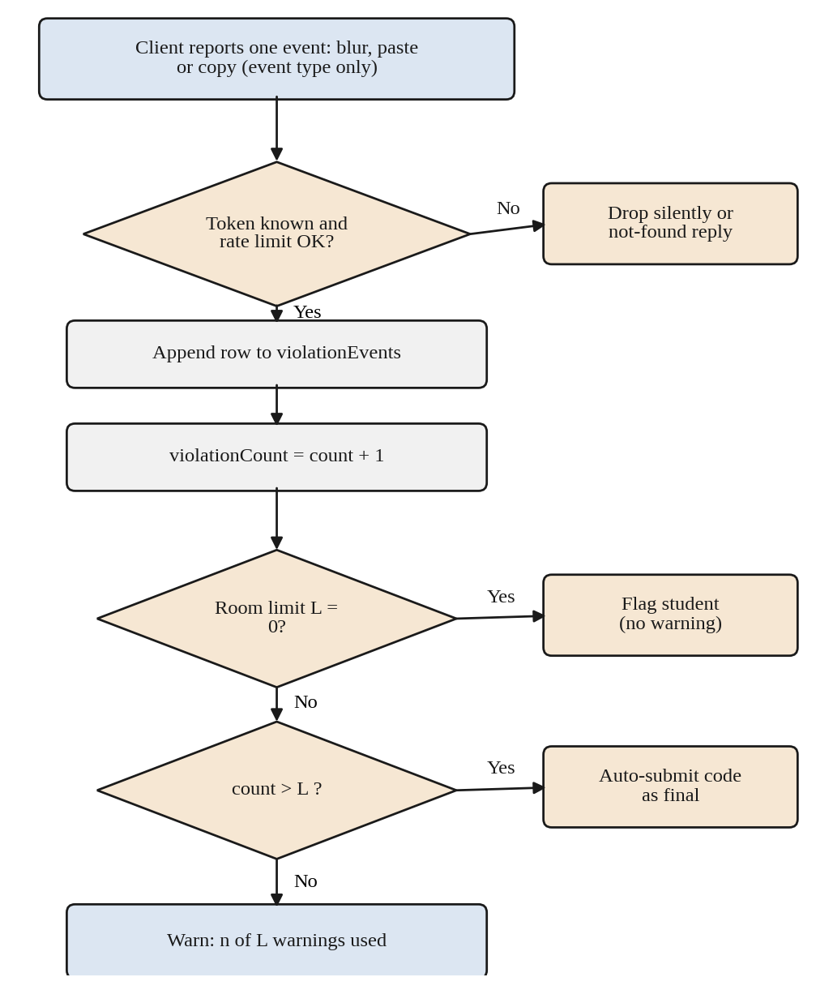
Figure 3.5: Flowchart of violation handling

3.6.5. Exporting submissions
Downloads use a plain HTTP route, which cannot carry the examiner’s normal session, so we use one-use tickets (Figure 3.6). The examiner’s page asks for one ticket per file. The server checks that the examiner owns the room, creates a random ticket and stores only its SHA-256 hash [8], valid for 90 seconds. The page then calls the export route with the ticket. The route uses up the ticket so it cannot be used twice, checks ownership again and returns the code as UTF-8 text [9]. A wrong, expired or used ticket gets a 404 reply, and a missing or invalid session gets a 401.
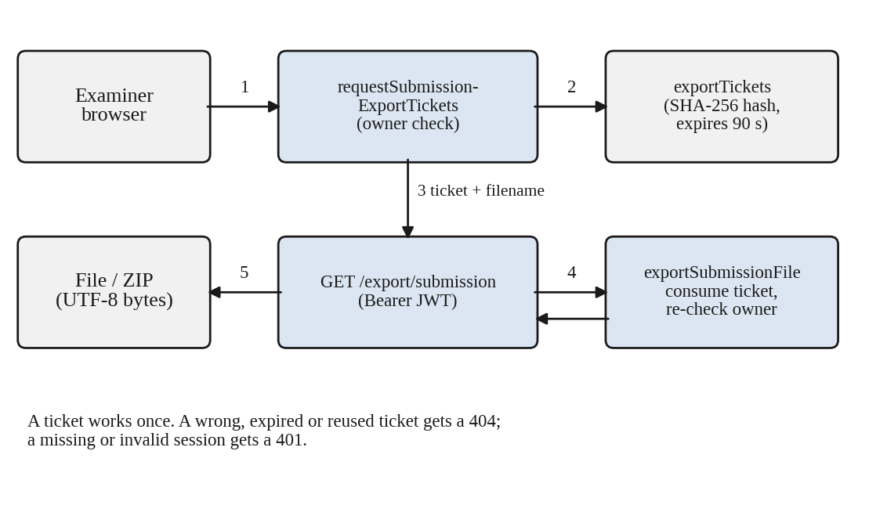
Figure 3.6: Export procedure using single-use tickets

3.6.6. Rate limits
Every busy action has a rate limit, for example 5 sign-in codes per 10 minutes for one address, 60 saves a minute per student, 10 join attempts a minute per session and 20 new rooms an hour per examiner. If the limiter itself fails, the action is allowed, so a fault never stops an exam. One weakness remains: a room code has only 10,000 possible values, and at the global join limit of 1,200 attempts a minute, trying every code once would take about 8.3 minutes. The per-code limit and the need for a live room slow guessing further, but the small code space is a known weakness, listed in Section 5.2.

CHAPTER 4.
RESULTS ANALYSIS AND VALIDATION

4.1. Implementation of the Solution
We implemented the selected design as a TypeScript project of about 10,900 lines, plus about 4,700 lines of CSS. Most of the server logic sits in one file. The source is in a public GitHub repository [19] and the deployed application is at [20].

4.1.1. Tools and technologies
Table 4.1 lists the main tools, with versions taken from the project’s package file.
Table 4.1: Tools and technologies used
Area | Tool (version) | Use in the project
Interface | React 19 [13], React Router 7 | Pages for the site, sign-in, examiner portal and exam
Build | Vite 7 [14], TypeScript 5.9 | Dev server, type checking, production build
Styling | Tailwind CSS 4 [16] | Layout and visual theme
Code editor | CodeMirror 6 [15] | Highlighting for Python, C/C++, Java, JavaScript and SQL
Backend | Convex 1.30 [11], Convex Auth 0.0.95 [12] | Database, server functions, export route, examiner sessions and one-time-code sign-in
Email | Resend [17] | Sends the six-digit sign-in code
Hosting | Vercel [18] | Static hosting of the built interface
Other | JSZip 3.10; Git and GitHub [19] | ZIP archives in the browser; version control
Quality tools | ESLint 9, Prettier, Playwright 1.63 | ESLint 9 checks the source with npm run lint, Prettier formats it, and Playwright 1.63 was used to capture page screenshots during development; no automated suite is wired into the build yet (Section 5.2).

4.1.2. Examiner portal
An examiner enters an email address and receives a six-digit code that is valid for 15 minutes. First-time users are asked once for a name. The sign-in page remembers its step, so someone who switches to a mail app on a phone and comes back lands on the code step with the address filled in.
Creating a room checks every field and requires a name that is unique among that examiner’s rooms. The server draws a code such as CV-1234 and tries again if it is taken. A room can be edited only while it is live. Ending a room is final, and deleting one removes its students, submissions and events together.

4.1.3. Student exam page
A student enters a name, an optional ID and the room code, then ticks a consent box after reading the notice. The exam page shows the question above the editor, a countdown that changes style in the last five minutes, and the save status. The editor picks its language from the question text and falls back to plain text. The browser asks for confirmation before the page is closed or reloaded, and a final submission asks for confirmation before it locks the editor.
Identity is kept per room code in browser storage and is never worked out from the name, since two students can share one. On reload the page presents its stored token and browser identifier, and the server resumes the same attempt as described in Section 3.6.2.

4.1.4. Monitoring and downloads
The room page has four tabs. Overview shows the code, counts and controls. Monitoring is a live table of students with join status, event counts and flags, and it updates only while its tab is open. Submissions holds a read-only viewer marked Final or Draft, with the download buttons. Settings is for editing and deleting the room.
An examiner can download one file per student, or use Download All to get a ZIP built in the browser. Drafts are included and marked with a “-draft” suffix in the file name. One batch of tickets covers up to 100 files.

4.1.5. Privacy features
The privacy module stores consent records with the policy version, accepts data-rights requests and erases an examiner’s rooms and then the account. Pages for the privacy notice, terms, cookies, data rights and grievance contact are part of the interface, and the policy text is versioned in a single file.

4.2. Testing and Validation
The project has no automated tests, so validation depends on manual runs. Table 4.2 lists the planned tests. The “Expected result” column says what the code is written to do. The “Actual result” and “Status” columns record what each check produced: on 30 October 2026 three checks were run against the deployed backend over its HTTP interface, and the cases that need a signed-in examiner session or a browser are marked “Not run” for the team's manual pass.
Table 4.2: Test plan with expected results
ID | Scenario | Expected result | Actual result | Status
T01 | Ask for a sign-in code with a valid email; ask for more than three in quick succession | Code arrives and works for 15 minutes; extra requests are refused with a “too many codes” message | Not run in this pass - sending sign-in codes needs a mailbox the team controls and spends the provider's e-mail quota. | Not run
T02 | Create a room with valid values; then try a room with the same name and one with a name over 120 characters | First room is live with a unique CV-#### code; the other two are rejected | Not run in this pass - creating rooms needs a signed-in examiner session. | Not run
T03 | Join with a wrongly formatted code (CV-12) and with a code that does not exist | Messages explain the format, then say no room was found | Run against the deployed backend on 30 Oct 2026: the malformed code CV-12 was rejected with “Room codes look like CV-1234. Double-check it with your examiner.” and the non-existent code CV-7319 with “No room found with code CV-7319.” Each reply came back in under 0.5 s. | Pass
T04 | Join a room that is already full | New students are refused; enrolled students can still resume | Not run in this pass - filling a room to its seat limit needs several joiners. | Not run
T05 | Type some code, then reload the page | Latest draft is restored and the same attempt resumes | Not run in this pass - needs a browser session on the exam page. | Not run
T06 | Two students with different IDs use one browser in turn | Separate attempts; the second cannot open the first student’s code | Not run in this pass - needs two joins on one browser. | Not run
T07 | Switch tabs in a room with limit 0, then three times in a room with limit 2 | Limit 0: flagged silently. Limit 2: warnings “1 of 2” and “2 of 2”, then automatic submission | Not run in this pass - needs a live room and a browser. | Not run
T08 | Paste text, then reload repeatedly | A paste event with a time is stored but not the pasted text; rejoins are stored but not counted | Not run in this pass - needs a live room and a browser. | Not run
T09 | Submit before the time ends, then submit after it | First is final and locks edits; second is accepted and marked late | Not run in this pass - needs a student session on a running room. | Not run
T10 | Examiner ends the room while students are typing | Open exam pages submit automatically; the room cannot be reopened | Not run in this pass - needs a signed-in examiner session. | Not run
T11 | Download one file and Download All; reuse a ticket; call the export route without a session | Files match the stored code byte for byte, drafts end in “-draft”; a reused ticket gets 404, no session gets 401 | Run against the deployed export route on 30 Oct 2026: no ticket gives 400; a ticket without a session gives 401 “Not authenticated”; the OPTIONS preflight answers 204 with Access-Control-Allow-Origin and the expected methods and headers. Ticket reuse and the byte-for-byte comparison still need a signed-in examiner session. | Partly verified
T12 | A second examiner tries to open or export the first examiner’s room; delete a room | Access is refused and logged as a security event; deleting removes the room, students, submissions and events | Run against the deployed backend on 30 Oct 2026: an unauthenticated caller is refused - requestSubmissionExportTickets answers “Only examiners can do this”, getMyExaminer returns null and getRoomCounts returns an empty result. The two-examiner cross-check needs two accounts. | Partly verified
Table 4.3 lists the numbers still to be measured during testing - response times and the size of the largest trial; rows whose run has not happened yet say so.
Table 4.3: Measurements from testing
Measurement | Method | Result
Largest number of students tested in one room | Create a room at its seat limit, open the join page on that many devices, then read the counts on the Monitoring tab. | Not measured - run pending
Time from join request to editor ready | Browser network timing: from the join request to the editor's first paint. | Not measured - run pending
Time for the dashboard to show a new join | Join from a second device and time the row appearing on the Monitoring tab (live subscription). | Not measured - run pending
Autosave on a slow or interrupted connection | Throttle the network to Slow 3G in the browser dev tools, type, and watch the save status and its retry. | Not measured - run pending
Browsers and devices used | Not recorded - list the browsers and devices used during the test run. | Not recorded - run pending

4.3. Screenshots of the System
The figures below are screenshots from the running application. They should be inserted after the tests in Table 4.2 are complete, with a sentence of explanation under each.
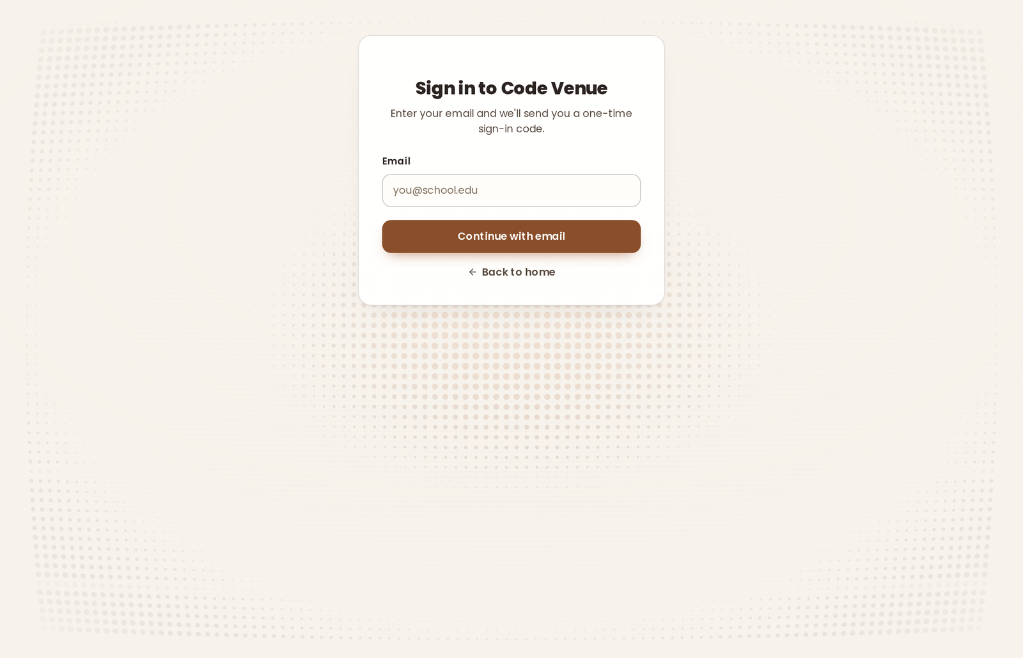 |  | [ Insert screenshot: room creation form ]
Figure 4.1: Examiner sign-in page |  | Figure 4.2: Create room form
[ Insert screenshot: Monitoring tab with student rows, event counts and flags ] |  | [ Insert screenshot: Submissions tab with the read-only viewer and Final/Draft labels ]
Figure 4.3: Monitoring tab during an exam |  | Figure 4.4: Submissions tab with the code viewer
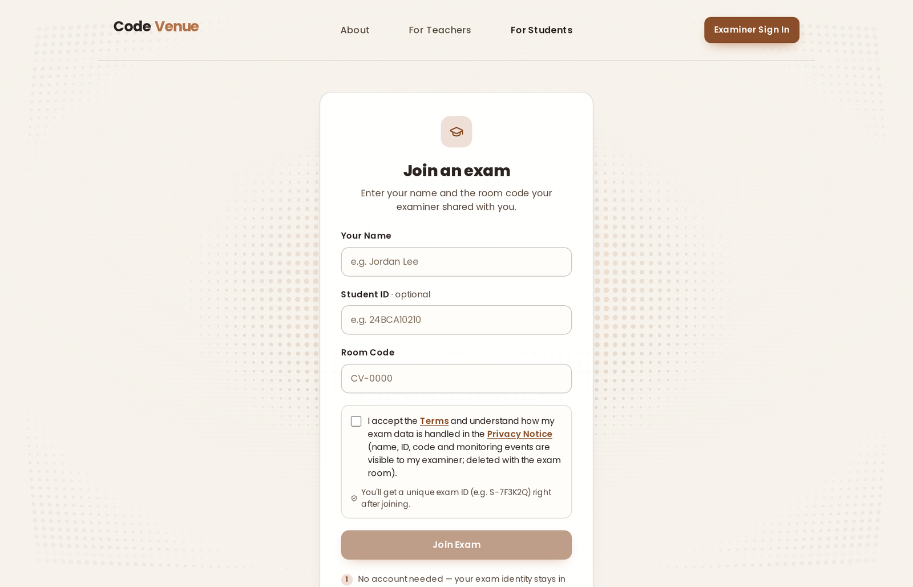 |  | [ Insert screenshot: exam page with question, timer, editor and a warning banner ]
Figure 4.5: Student join page |  | Figure 4.6: Student exam page with a warning banner

CHAPTER 5.
CONCLUSION AND FUTURE WORK

5.1. Conclusion
We set out to give examiners a browser-based way to run a timed coding exam, collect every student’s work and review what happened. Each objective in Section 2.6 has matching code (Table 5.1); the last two columns are for the test results from Table 4.2.
Table 5.1: Objectives, implementation and test outcome
Objective | Implemented in code | Tested | Test outcome
1. Room creation with unique code and limits | Yes | N | Not executed in this pass - creating rooms needs a signed-in examiner session (T02).
2. Join without an account; separate attempts | Yes | Partly | Join validation verified on the deployed backend (T03, 30 Oct 2026); attempt separation not exercised (T06).
3. Autosave and restore after reload | Yes | N | Not exercised (T05) - needs a browser session.
4. Events recorded without clipboard content | Yes | N | Not exercised (T07, T08); the code stores only event type and time, never clipboard content.
5. Automatic submission above the limit | Yes | N | Not exercised (T07) - needs a live room.
6. Downloads matching the stored code | Yes | Partly | Route checks verified - 400/401 and CORS, 30 Oct 2026; the byte-for-byte file comparison needs a signed-in session (T11).
7. Server-side limits and room ownership | Yes | Partly | Unauthenticated callers are refused (“Only examiners can do this”) and inputs are validated (T03, T12, 30 Oct 2026); the second-examiner check needs two accounts.
8. Consent, data-rights requests and erasure | Yes (erasure covers examiners) | N | Not exercised - the privacy pages and the erasure path were not run in this pass.
Where the system differs from what a user might expect.
- The clock starts when the room is created, not when each student joins. A student who joins ten minutes late has ten minutes less, so create the room just before the exam.
- Events are recorded, not blocked, because a web page cannot control tab switching or the clipboard.
- One question and one code buffer per student, to keep the data model small.
There are no automated tests, so claims about correct behaviour rest on the manual tests in Chapter 4. Three of the twelve cases were run against the deployed backend over its HTTP interface on 30 October 2026 - the room-code format message, the no-room message, and the export route's answers of 400 without a ticket and 401 without a session, with the expected CORS headers on the preflight - and examiner-only functions refused an unauthenticated caller. Nothing failed in that pass, so no change to the code was needed. The other nine cases need a signed-in examiner session and a browser, and the measurements in Table 4.3 are still to be taken; both are marked “Not run” in the tables above.

5.2. Future Work
- Per-student start time, worked out from when each student first joins, with a room-level hard stop.
- Longer room codes. Add letters or more digits so that guessing a live room is impractical.
- Automated tests for validation and attempt handling, and end-to-end tests with Playwright.
- More than one question per exam, and optional sandboxed code execution after a security review.
- A study of false alarms, since a system notification can take focus from the exam window, with guidance for examiners on reading the counts.
- Reviews and clean-up: accessibility testing, a DPDP Rules check, removing unused dependencies and a CSV export of events.

REFERENCES
[1] M. Malhotra and I. Chhabra, “Ensuring academic integrity through automated online exam proctoring: a decade-long systematic review,” SpringerLink, 2026. [Online]. Available: https://link.springer.com/article/10.1007/s44217-026-01224-3. [Accessed: Oct. 27, 2026].
[2] E. Heinrich, “A systematic-narrative review of online proctoring systems and a case for open standards,” Open Praxis, vol. 17, no. 3, 2025, doi: 10.55982/openpraxis.17.3.836. [Online]. Available: https://openpraxis.org/articles/10.55982/openpraxis.17.3.836. [Accessed: Oct. 27, 2026].
[3] Government of India, “The Digital Personal Data Protection Act, 2023,” Act No. 22 of 2023, Aug. 2023. [Online]. Available: https://www.meity.gov.in/static/uploads/2024/06/2bf1f0e9f04e6fb4f8fef35e82c42aa5.pdf. [Accessed: Oct. 27, 2026].
[4] Ministry of Electronics and Information Technology, “Digital Personal Data Protection Rules, 2025,” notified Nov. 13, 2025. [Online]. Available: https://www.meity.gov.in/documents/act-and-policies/digital-personal-data-protection-rules-2025-gDOxUjMtQWa. [Accessed: Oct. 27, 2026].
[5] Testlify, “Lockdown browser limitations and what it misses.” [Online]. Available: https://testlify.com/lockdown-browser/. [Accessed: Oct. 27, 2026].
[6] M. Jones, J. Bradley, and N. Sakimura, “JSON Web Token (JWT),” IETF, RFC 7519, May 2015. [Online]. Available: https://www.rfc-editor.org/rfc/rfc7519
[7] OpenID Foundation, “OpenID Connect Discovery 1.0.” [Online]. Available: https://openid.net/specs/openid-connect-discovery-1_0.html. [Accessed: Oct. 27, 2026].
[8] National Institute of Standards and Technology, “Secure Hash Standard (SHS),” FIPS PUB 180-4, Aug. 2015. [Online]. Available: https://csrc.nist.gov/pubs/fips/180-4/upd1/final. [Accessed: Oct. 27, 2026].
[9] F. Yergeau, “UTF-8, a transformation format of ISO 10646,” IETF, RFC 3629, Nov. 2003. [Online]. Available: https://www.rfc-editor.org/rfc/rfc3629
[10] WHATWG, “Fetch Standard,” living standard. [Online]. Available: https://fetch.spec.whatwg.org/. [Accessed: Oct. 27, 2026].
[11] Convex, Inc., “Convex documentation.” [Online]. Available: https://docs.convex.dev. [Accessed: Oct. 27, 2026].
[12] Convex, Inc., “Convex Auth documentation.” [Online]. Available: https://labs.convex.dev/auth. [Accessed: Oct. 27, 2026].
[13] Meta Open Source, “React documentation.” [Online]. Available: https://react.dev. [Accessed: Oct. 27, 2026].
[14] Vite contributors, “Vite documentation.” [Online]. Available: https://vite.dev. [Accessed: Oct. 27, 2026].
[15] CodeMirror, “CodeMirror 6 documentation.” [Online]. Available: https://codemirror.net. [Accessed: Oct. 27, 2026].
[16] Tailwind Labs, “Tailwind CSS documentation.” [Online]. Available: https://tailwindcss.com/docs. [Accessed: Oct. 27, 2026].
[17] Resend, “Resend documentation.” [Online]. Available: https://resend.com/docs. [Accessed: Oct. 27, 2026].
[18] Vercel, “Vercel documentation.” [Online]. Available: https://vercel.com/docs. [Accessed: Oct. 27, 2026].
[19] T. Singh, A. Singh, A. Rangta, and D. Gupta, “Code Venue platform,” GitHub repository. [Online]. Available: https://github.com/Tejveercode/code-Venue-platform. [Accessed: Oct. 27, 2026].
[20] “Code Venue,” deployed application. [Online]. Available: https://codevenue.vercel.app/. [Accessed: Oct. 27, 2026].

APPENDIX

1. Plagiarism Report
Attach the similarity report issued by the university’s plagiarism-checking service. Table A.1 records its details.
Table A.1: Plagiarism report details
Item | Detail
Tool used | [ name of the service ]
Date of check | [ date ]
Overall similarity | [ percentage ]
Report identifier | [ id ]

[ Insert screenshot: first page or summary page of the plagiarism report ]
Figure A.1: First page of the plagiarism report

2. Design Checklist
Table A.2 maps each design consideration asked for in the project format to the place in this report where it is addressed. The team should confirm each row, or replace this table with the department’s own checklist form if one is issued.
Table A.2: Design checklist
Design consideration | Where addressed | Considered (Y/N)
Standards | Section 3.2, Table 3.2; List of Standards | Y
Regulations | Sections 1.1 and 3.2 | Y
Economic and cost | Sections 3.2 and 3.5 | Y
Environmental | Section 3.2 | Y
Health | Section 3.2 | Y
Manufacturability | Section 3.2 | Y
Safety and security | Sections 3.2 and 3.6 | Y
Professional and ethical | Sections 2.5 and 3.2 | Y
Social and political issues | Section 3.2 | Y

USER MANUAL
This manual explains how to use Code Venue at https://codevenue.vercel.app/. Part C is for developers. The pages mentioned appear in Figures 4.1 to 4.6.

Part A. Examiner
- Open the site, choose the examiner sign-in and enter your email address. Type the six-digit code sent to you, which is valid for 15 minutes. First-time users add their name once (Figure 4.1).
- Choose to create a room. Enter a name, the question exactly as students should see it, the duration in minutes, the number of students allowed and the violation limit. Leave the limit blank to flag the first tab switch or copy without a warning (Figure 4.2).
- Save the room and read out the code shown, for example CV-1234. Create the room just before the exam, because the clock starts at creation.
- During the exam, the Monitoring tab shows who has joined, each student’s event count and who is flagged (Figure 4.3). To stop early, end the room. Students’ pages submit automatically and the room cannot be reopened.
- The Submissions tab shows each student’s code, labelled Final or Draft. Download one file, or use Download All (ZIP) (Figure 4.4).
- Use Settings to edit a live room, or to delete a room and everything stored in it.

Part B. Student
- Open the student portal. Enter your name, your student ID if you have one and the room code, tick the consent box after reading the notice, and join (Figure 4.5).
- Write your code in the editor. Work is saved as you type. After a reload, join again with the same name, ID and code to continue the same attempt.
- Stay on the exam page. Switching tabs or windows, pasting and copying are recorded. If a limit is set, a banner counts your warnings and your work is submitted when you pass it (Figure 4.6).
- Watch the timer. When it reaches zero your code is submitted automatically, or you can submit earlier and confirm. The editor then locks.

Part C. Running the project locally (needs Node.js and a Convex account)
- Clone the repository [19], run npm install, then copy .env.example to .env.local and set the Convex address as in the README.
- Run npx convex dev to link a development deployment. Set the email key with npx convex env set RESEND_API_KEY followed by your key, and never store the key in the repository.
- In a second terminal run npm run dev and open the address Vite prints (port 5173 by default).
- For a production build run npm run build. Use npm run lint to check the code style.

