CHANDIGARH UNIVERSITY
Subject: Data Mining

Case Study
Identifying Common Patterns in
Hospital Patient Records
How clustering and classification turn raw clinical records
into patient groups and predictions
Case study topic 3

Submitted by: [Your Name]
Roll number: [Your Roll Number]
Section / Session: [Your Section] / 2026-27
Submitted to: [Teacher's Name]
Date of submission: 10 November 2026

Contents
1. Introduction 2
2. About the dataset 2
2.1 Source and variables 2
2.2 A first look at the records 2
2.3 What the numbers look like 2
3. Preparing the data 2
4. How we approached the problem 2
4.1 Why clustering, and why K-means 2
4.2 Why classification, and why a decision tree 2
4.3 Reproducing these results 2
5. Finding the patient groups 2
5.1 Choosing the number of groups 2
5.2 The two groups side by side 2
5.3 The groups line up with the diagnoses 2
6. Predicting heart disease 2
6.1 How well the tree performs 2
6.2 What the tree actually learned 2
7. Two worked examples, step by step 2
7.1 Assigning a patient to a group (clustering) 2
7.2 Classifying a test patient (decision tree) 2
8. How classification and clustering help the hospital 2
9. Limitations 2
10. Conclusion 2
11. References 2

1. Introduction
Hospitals sit on records that nobody has time to read one by one. A cardiology department keeps, for every admission, the patient's age, resting blood pressure, cholesterol, how fast the heart recovered during exercise, and eventually a diagnosis. Piled up over years these rows become hard to interpret: too many to eyeball, and a diagnosis column on its own says nothing about who the patients are as groups.
This case study answers a simple assignment question:
“A hospital wants to analyze patient records to identify common patterns. Explain how classification or clustering can help.” (Case study topic 3)
We work with real clinical data rather than an invented example, and we run both families of methods the question mentions. Clustering groups the patients without ever looking at their diagnoses, which suits the phrase common patterns: it asks what structure exists in the data, not who fell ill. Classification then learns from past diagnoses and judges new patients one at a time. Every number reported below came out of the accompanying code in this repository, so any table can be checked or re-run.
By the end of the report the reader should be able to:
- describe the dataset, how it was cleaned, and why each preprocessing step was needed;
- explain in plain words how K-means and a decision tree work, and why these two were picked;
- read the two patient groups the algorithm found and say what they mean clinically;
- evaluate the classifier honestly, including the cases it gets wrong, and
- translate both results into concrete hospital use, which is the actual assignment question.

2. About the dataset

2.1 Source and variables
The data is the processed Cleveland set from the UCI Machine Learning Repository, collected at the Cleveland Clinic Foundation and first described by Detrano and colleagues in 1988 [2, 3]. It contains 303 patient records, 13 clinical variables and one diagnosis column. The diagnosis is stored as 0 to 4; following the usual convention we treat any value above 0 as heart disease present, which gives a clean yes/no target: 164 patients without disease, 139 with it. The set is small enough to reason about line by line and openly available, which is exactly what a course project needs.
Table 1. The fourteen variables recorded for each patient.
Attribute | Meaning | Range / values in this data
age | Age of the patient | 29 to 77 years
sex | Sex | 1 = male, 0 = female (206 male, 97 female)
cp | Chest pain type | 1 typical, 2 atypical, 3 non-anginal, 4 asymptomatic
trestbps | Resting blood pressure | 94 to 200 mm Hg
chol | Serum cholesterol | 126 to 564 mg/dl
fbs | Fasting blood sugar > 120 mg/dl | 1 = true, 0 = false
restecg | Resting electrocardiogram | 0, 1, 2
thalach | Maximum heart rate achieved | 71 to 202 bpm
exang | Exercise-induced angina | 1 = yes, 0 = no
oldpeak | ST depression from exercise | 0.0 to 6.2
slope | Slope of peak exercise ST segment | 1, 2, 3
ca | Major vessels seen by fluoroscopy | 0 to 3 (4 missing values)
thal | Thalassemia test result | 3 = normal, 6 = fixed, 7 = reversible
num | Diagnosis of heart disease | 0 = no, 1-4 = yes (target)

2.2 A first look at the records
The first ten records, already cleaned, look like this. One detail worth noticing early: the last column is the answer we want to predict, and in a real workflow it would stay hidden while the model is applied.
Table 2. The first ten patient records after cleaning.
Age | Sex | Chest pain | BP | Chol | Max HR | Disease
63 | M | typical angina | 145 | 233 | 150 | No
67 | M | asymptomatic | 160 | 286 | 108 | Yes
67 | M | asymptomatic | 120 | 229 | 129 | Yes
37 | M | non-anginal | 130 | 250 | 187 | No
41 | F | atypical angina | 130 | 204 | 172 | No
56 | M | atypical angina | 120 | 236 | 178 | No
62 | F | asymptomatic | 140 | 268 | 160 | Yes
57 | F | asymptomatic | 120 | 354 | 163 | No
63 | M | asymptomatic | 130 | 254 | 147 | Yes
53 | M | asymptomatic | 140 | 203 | 155 | Yes

2.3 What the numbers look like
Five variables are continuous and carry most of the physiological signal, so we summarise them first. Cholesterol has the widest spread and one obvious outlier at 564 mg/dl; maximum heart rate varies by more than 130 beats per minute across patients. Such differences in scale matter later, because K-means measures distance.
Table 3. Descriptive statistics of the five continuous variables used for clustering.
Variable | Mean | Std. dev. | Min | Max
age | 54.4 | 9.0 | 29 | 77
resting BP | 131.7 | 17.6 | 94 | 200
cholesterol | 246.7 | 51.8 | 126 | 564
max heart rate | 149.6 | 22.9 | 71 | 202
ST depression | 1.0 | 1.2 | 0 | 6

3. Preparing the data
Raw records rarely arrive ready for mining, and the steps taken here are deliberately ordinary: nothing clever, only the changes a careful analyst would make anyway.
- Missing values. Six cells are empty: ca (vessels seen by fluoroscopy) is missing in 4 records and thal in 2. That is 0.15% of all cells. We fill them with the median of each column (ca = 0, thal = 3). The median is robust to the cholesterol outlier, and dropping six rows out of 303 would throw away real patients for no gain.
- Duplicates. Exactly 0 duplicate rows were found, so nothing was removed.
- Encoding categories. Variables such as chest pain type or thalassemia result are categories, not numbers that can be averaged. One-hot encoding expands the 13 variables into 25 binary columns, so a split like chest pain is asymptomatic becomes a yes/no test.
- Standardisation. For clustering each variable is rescaled to z-scores, (x − mean) / std. Without this, cholesterol (mean 247) would dominate age (mean 54) purely because of its units, and distance would mean the wrong thing.
- Train/test split. The labelled data is split 70/30 into 212 training and 91 test records, stratified so both halves keep the same disease proportion, with random_state=42 so the numbers in this report reproduce exactly. The test set is touched only at the end, to report honest performance.

4. How we approached the problem
The work follows the usual CRISP-DM sequence [5]: understand the question, understand the data, prepare it (sections 2 and 3), model, then evaluate. The modelling phase uses two algorithms, chosen because they answer two different halves of the assignment question.

4.1 Why clustering, and why K-means
Clustering is unsupervised learning: the algorithm never sees a diagnosis. It partitions the patients into k groups so that points inside a group sit close to their group's centre, repeating two steps until nothing moves: assign each patient to the nearest centroid, then recompute each centroid as the mean of its members [1, 6]. K-means was picked over hierarchical clustering because the hospital's question is “what groups exist” rather than a full family tree of every pair of patients, and over DBSCAN because these physiological measures form broad clouds rather than the tight, unevenly-dense blobs DBSCAN expects. The only real decision is k, and it is made from data: we sweep k = 1 to 8, watch how within-cluster inertia drops (the elbow), and confirm with the silhouette score, which averages how similar each patient is to its own group versus the neighbouring group [4]. Values near 1 mean crisp groups; near 0, overlapping ones.

4.2 Why classification, and why a decision tree
Classification is supervised: the tree reads past patients whose diagnoses are known and learns a chain of yes/no questions that separates the two classes, much like a doctor's rule of thumb. Each split picks the question that makes the resulting boxes as pure as possible (Gini impurity), and recursion stops at depth 4 or once a box holds fewer than 8 patients, which keeps the tree from memorising noise in only 212 training rows [1, 7]. We chose a tree over naive Bayes because clinical variables are strongly correlated (age, blood pressure, maximum heart rate) and naive Bayes assumes they are not, and over logistic regression mainly because a tree hands the hospital readable rules instead of coefficients to interpret. Its straightforward weakness is also worth stating up front: a single tree is unstable around its training data, so we report 10-fold cross-validation alongside the single test score.

4.3 Reproducing these results
Everything lives in this repository: data/raw/ holds the UCI download, src/analyze.py performs the whole pipeline and writes reports/results.json plus four figures, and src/build_report.py turns those results into this document. Running the two scripts in that order regenerates every table and number here; seeds are fixed, so the output is identical on any machine.

5. Finding the patient groups

5.1 Choosing the number of groups
Sweeping k from 1 to 8, inertia drops sharply when going from one group to two (from 1515 to 1142) and then flattens into a slow decline, the classic elbow shape. The silhouette score agrees: it peaks at k = 2 with 0.24, marginally above k = 3 (0.23) and clearly above k = 8 (0.17). So two groups it is. The score of 0.24 is honest to report as modest: these are tendencies in the data, not two sharply separated species of patient, and section 5.3 shows why the split is still useful.
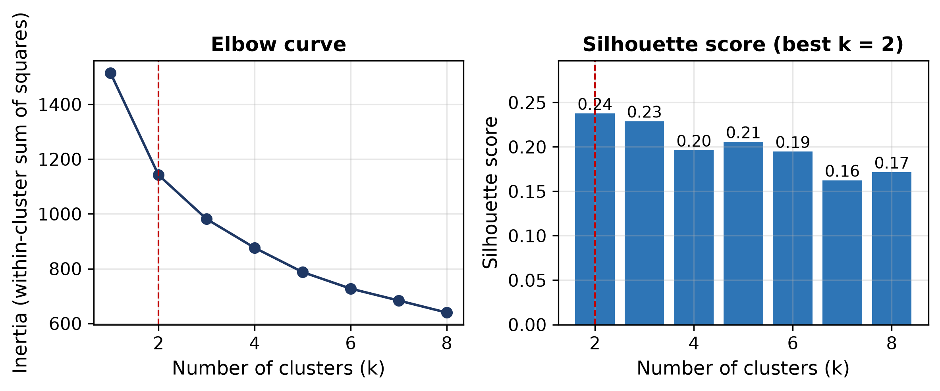
Figure 1. Elbow curve (left) and silhouette score (right) for k = 1 to 8. Both point at k = 2.

5.2 The two groups side by side
With two groups fixed, the profiles below are just the mean of each group. The contrast is easy to state in one sentence: group 1 is the older, more stressed heart; group 2 the younger, quieter one.
Table 4. The two groups K-means found. The diagnosis column was not used to build the groups; it is shown afterwards to interpret them.
Group | n | Age | Resting BP | Chol | Max HR | ST dep. | Diagnosed
Group 1 | 132 | 60.8 | 139.5 | 263.0 | 134.2 | 1.72 | 68.9%
Group 2 | 171 | 49.5 | 125.7 | 234.1 | 161.5 | 0.52 | 28.1%

5.3 The groups line up with the diagnoses
Here is the part that answers identify common patterns. Group 1 (132 patients) averages 11 years older, runs about 14 mm Hg higher at rest, carries more cholesterol, reaches 27 bpm less during exercise, and shows roughly three times the ST depression (1.72 against 0.52). After the fact, and without the algorithm ever seeing a diagnosis, 68.9% of group 1 turns out to have heart disease against only 28.1% of group 2. That gap is the pattern the hospital was looking for: a risk profile described purely from measurements.
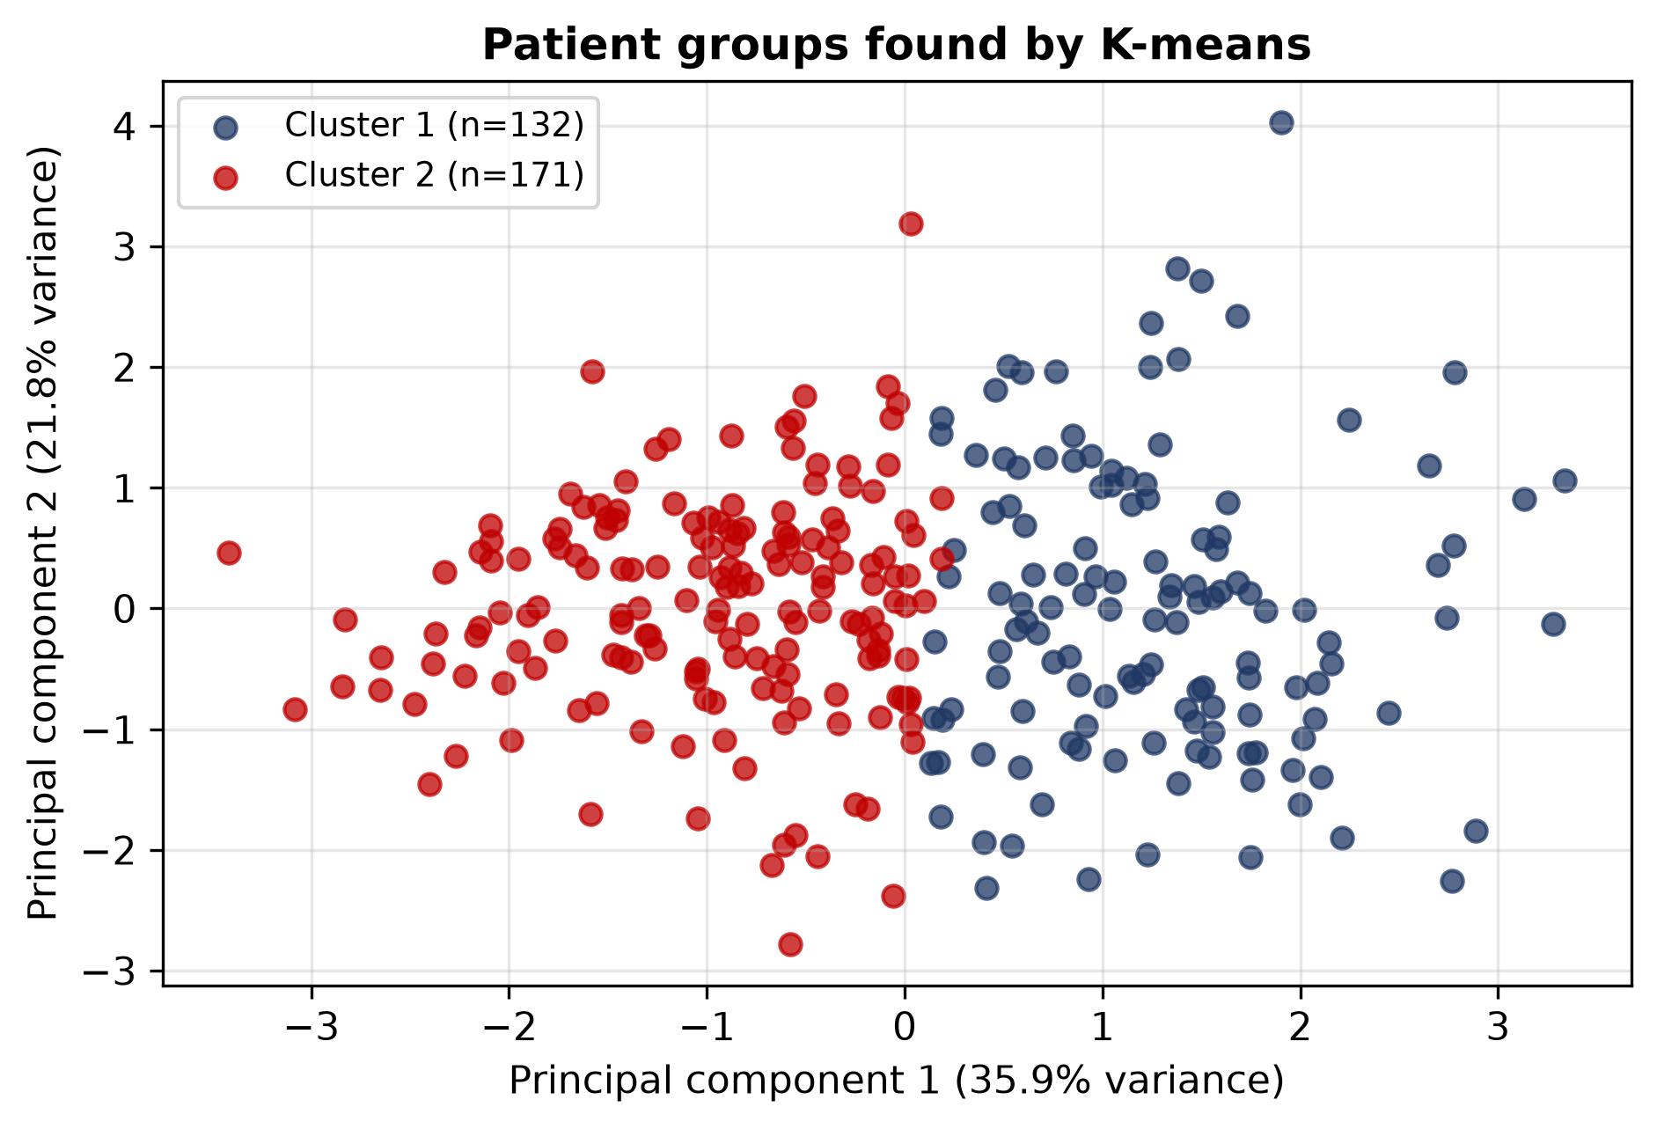
Figure 2. The same 303 patients projected onto the first two principal components (35.9% + 21.8% of the variance), coloured by group. The clouds overlap, which is why the silhouette score is modest.

6. Predicting heart disease

6.1 How well the tree performs
The tree was trained on 212 records and evaluated on the 91 it had never seen. It answers correctly 76.9% of the time, against 53.8% for a lazy model that always guesses the majority class, so the tree earns its keep. Precision and recall split that headline number in the two directions a hospital cares about: of the patients the tree flags, 75.6% really have the disease, and of the patients who really have it, 73.8% are caught. Ten-fold cross-validation on the full set gives 79.8% ± 7.3%, a spread that honestly reflects how much the score moves with a different split.
Table 5. Decision tree performance on the 91 held-out test patients.
Metric | Value | What it means
Accuracy | 76.9% | 70 of 91 patients judged correctly (baseline 53.8%)
Precision | 75.6% | Of 41 flagged patients, 31 truly have the disease
Recall | 73.8% | Of 42 actual cases, 31 were caught; 11 were missed
F1 score | 74.7% | Balance of precision and recall
10-fold CV | 79.8% | Average over 10 re-splits: ±7.3%
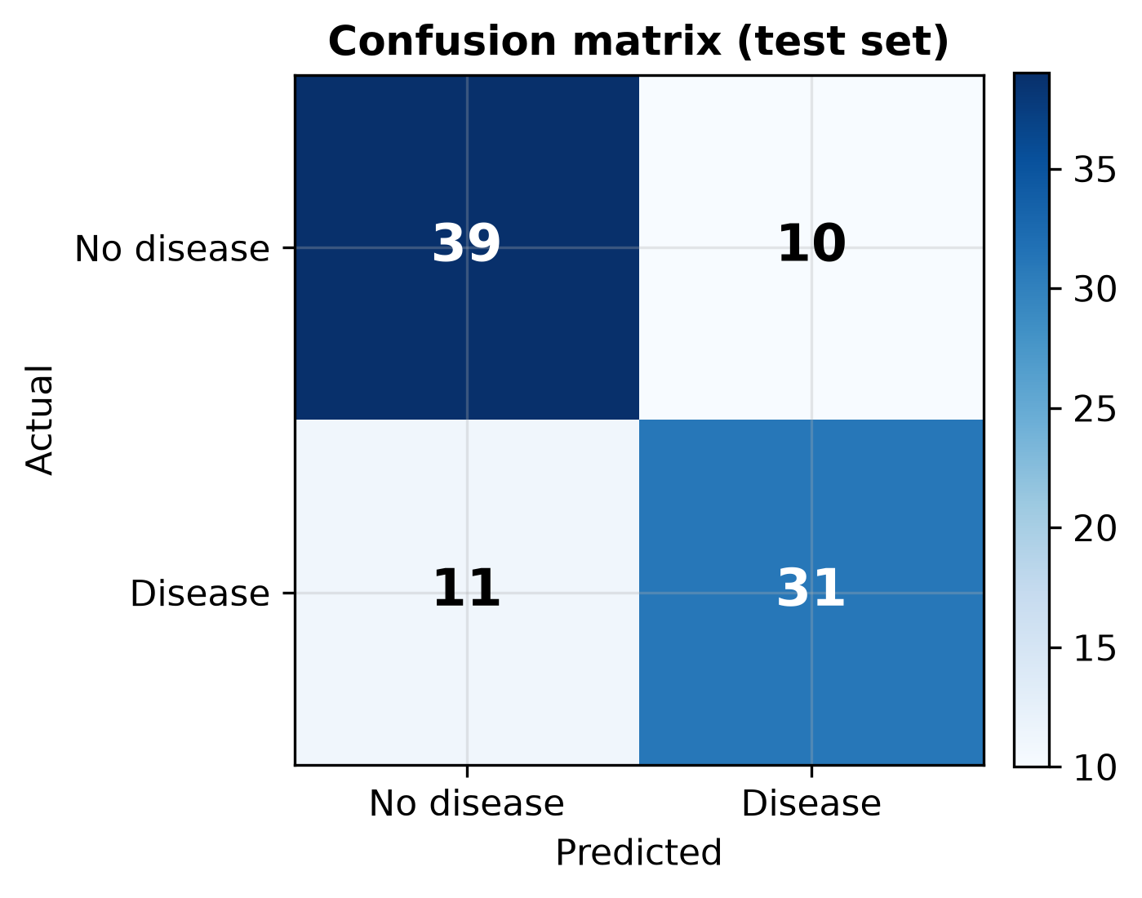
Figure 3. Confusion matrix on the test set: 39 correct “no disease”, 31 correct “disease”, 10 false alarms, 11 missed cases.
The 11 missed cases and 10 false alarms deserve a sentence each. A missed case means a sick patient sent home; a false alarm means an extra test. A hospital that prefers the first error over the second would later tune the decision threshold towards recall, but at this stage the honest reading is: useful signal, not a verdict.

6.2 What the tree actually learned
Feature importances show where the tree's decisions came from. The thalassemia result alone accounts for almost half of them, followed by the chest pain type and the number of visible vessels:
Table 6. Features the tree relied on most (importances sum to 1 across all features).
Feature | Importance | In plain words
thal_3.0 | 45% | Whether the thalassemia scan was normal
cp_4.0 | 21% | Whether chest pain was asymptomatic
ca_0.0 | 13% | Whether fluoroscopy saw any major vessel
age | 10% | Patient age in years
oldpeak | 5% | Exercise-induced ST depression
thalach | 5% | Maximum heart rate reached in exercise
Read as rules rather than percentages, the tree says things a doctor would recognise:
IF thalassemia abnormal AND chest pain asymptomatic -> disease
IF thalassemia normal AND pain NOT asymptomatic -> no disease
IF thal normal AND asymptomatic AND a vessel visible -> disease
IF thal normal AND asymptomatic AND no vessel AND age <= 59 -> no
...but disease if older than 59
That is the practical form of the assignment answer: the classifier converts 212 past patients into a page of rules that can be applied to the next admission in milliseconds.

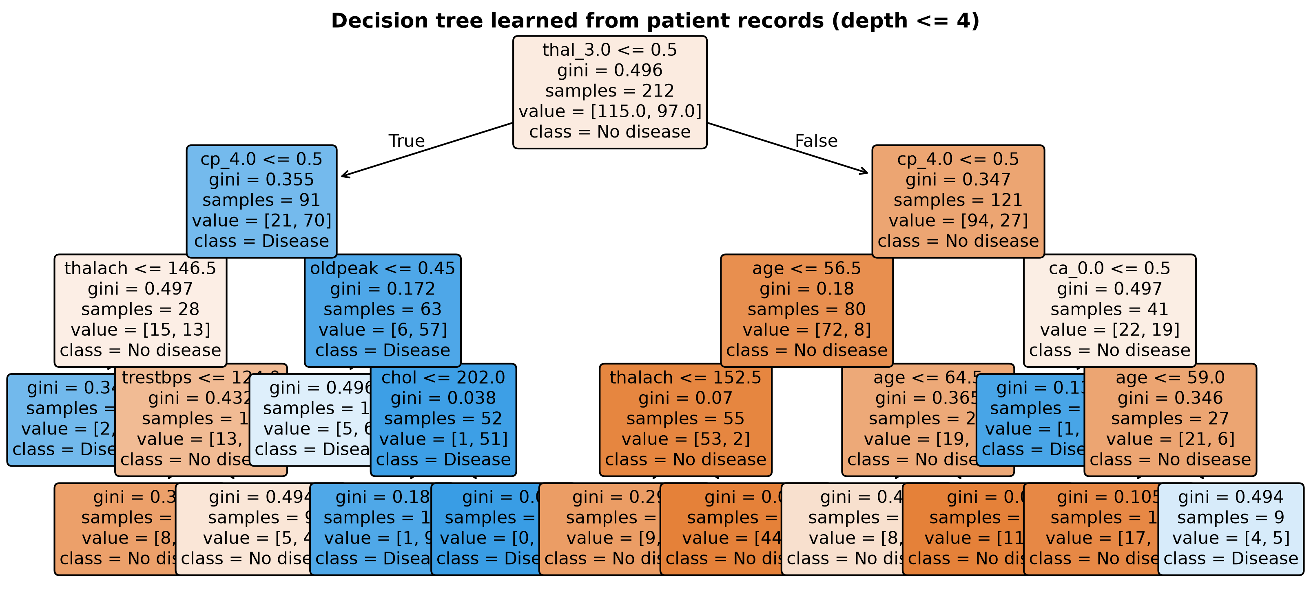
Figure 4. The full learned tree (depth 4, 13 leaves). Orange nodes lean towards “no disease”, blue towards “disease”; each node shows Gini impurity, patient count and class.

7. Two worked examples, step by step

7.1 Assigning a patient to a group (clustering)
Take the very first patient in the file: a 63-year-old man with resting BP 145, cholesterol 233, maximum heart rate 150 and ST depression 2.3. Each value is standardised with the mean and standard deviation of the data set, then the Euclidean distance to each group centre is taken:
z(age ) = (63 - 54.44) / 9.02 = +0.95
z(resting BP ) = (145 - 131.69) / 17.57 = +0.76
z(cholesterol ) = (233 - 246.69) / 51.69 = -0.26
z(max HR ) = (150 - 149.61) / 22.84 = +0.02
z(oldpeak ) = (2.3 - 1.04) / 1.16 = +1.09
Table 7. Distance of the standardised patient to each group centre (squared terms; z rounded to 2 dp).
Term | Patient z | Centre z (G1) | (z−c1)² | Centre z (G2) | (z−c2)²
age | 0.95 | 0.707 | 0.059 | -0.546 | 2.238
resting BP | 0.76 | 0.444 | 0.100 | -0.343 | 1.217
cholesterol | -0.26 | 0.316 | 0.332 | -0.244 | 0.000
max HR | 0.02 | -0.674 | 0.482 | 0.521 | 0.251
oldpeak | 1.09 | 0.585 | 0.255 | -0.452 | 2.378
distance |  |  | 1.107 |  | 2.463
(The distance is the square root of the sum of the squared columns.) The patient is 1.107 from the centre of group 1 and 2.463 from group 2, so he lands in group 1, the older and higher-risk one. Note what this does not mean: group 1 is 68.9% diagnosed, not 100%, and this particular patient was in fact healthy. A group is a tendency, which is precisely why the hospital also wants the classifier for individual judgement.

7.2 Classifying a test patient (decision tree)
For the second example we deliberately pick a patient the tree never trained on (record 76 of the test set): a 60-year-old man with asymptomatic chest pain, resting BP 125, cholesterol 258, maximum heart rate 141, ST depression 2.8, 1 visible vessel and a reversible thalassemia defect. The tree walks four tests and stops at a leaf:
Table 8. The four tests the tree applies to the test patient.
 | Test | Comparison | Result
Step 1 | thal 3.0 | 0 ≤ 0.5 | go left
Step 2 | cp 4.0 | 1 > 0.5 | go right
Step 3 | oldpeak | 2.8 > 0.45 | go right
Step 4 | chol | 258 > 202 | go right
Leaf | prediction | — | Disease (actual: Disease) — correct
The reasoning is clinical rather than statistical: the thalassemia scan was not normal, the pain was asymptomatic, the ST depression of 2.8 far exceeds the 0.45 threshold, and cholesterol above 202 pushes the final branch to disease. Four questions, one answer, well under a millisecond — that is the form in which classification helps.

8. How classification and clustering help the hospital
The assignment asks one direct question, so here is the direct answer, grounded in what the previous sections actually produced.
Clustering helps by describing the population without needing labels. The two groups it found are a usable segmentation: a higher-risk cohort of 132 patients averaging 61 years with a reduced exercise heart rate, where 68.9% already show heart disease, and a lower-risk cohort of 171. A hospital can aim a screening camp at the profile of group 1 before any diagnosis exists, plan cardiology capacity around the expected split, or compare next year's admissions against these baselines. Because clustering needs no diagnosis column it also works in departments where labels are expensive, delayed, or missing altogether.
Classification helps by judging the individual patient. Once diagnoses exist, the tree converts them into rules that score a new admission at 76.9% accuracy (79.8% under cross-validation), far above the 53.8% of guessing. Used as a triage aid it can flag high-risk arrivals for an earlier test, rank referrals for a specialist's limited time, or prompt a second look when the record says low risk but the tree says otherwise. Its recall of 73.8% means roughly three in four actual cases are caught at admission.
The two answer different halves of one question. Clustering explains what the patient population looks like (the common patterns); classification says what to expect from the next individual. Used together, the group structure can even be fed back as an extra feature to the classifier, which is the natural next step if this project were extended. Both remain decision support: with roughly one prediction in four wrong, no result here overrides a cardiologist, and any real deployment would be validated on the hospital's own current patients first.

9. Limitations
- Data age and size. 303 patients from a single clinic in 1988 is a small, dated sample; modern populations, equipment and treatment may shift every relationship in this report.
- Soft groups. A silhouette of 0.24 means the two groups overlap noticeably. They are a summary, not a diagnosis, and some patients sit between them.
- Honest error rate. At 76.9% accuracy the tree is wrong about 1 patient in 4, including 11 missed disease cases in a test set of 91. That bounds its role to supporting, never replacing, a clinician.
- Simplified preparation. Median imputation for the six missing values and one random 70/30 split are defensible but crude; the ±7.3% cross-validation spread shows how much a single split can move the numbers.
- No causation, no history. The variables are snapshots without medication, lifestyle or family history, so the tree correlates rather than explains, and no claim here is causal.

10. Conclusion
The hospital's question has two answers and we ran both on the same 303 real records. K-means split the patients into an older, higher-stress group and a younger one; the diagnosis rates of 68.9% against 28.1% appeared afterwards, confirming that the pattern the algorithm found is the clinically meaningful one. The decision tree turned the labelled history into 4 levels of yes/no rules that classify unseen patients with 76.9% accuracy against a 53.8% baseline. Together they cover the assignment question end to end: clustering tells the hospital what its patient population looks like, classification tells it what to expect about the next patient, and the limitations section marks where both stop being decision support and start needing a doctor's judgement.

11. References
Han, J., Kamber, M., Pei, J. Data Mining: Concepts and Techniques, 3rd ed. Morgan Kaufmann, 2012.
Detrano, R., Janosi, A., Steinbrunn, W., et al. “International application of a new probability algorithm for the diagnosis of coronary artery disease.” American Journal of Cardiology, 62(8), 1988, pp. 504-510. (Source of the UCI Heart Disease data)
UCI Machine Learning Repository: Heart Disease. https://archive.ics.uci.edu/dataset/45/heart+disease
Rousseeuw, P. J. “Silhouettes: A graphical aid to the interpretation and validation of cluster analysis.” Journal of Computational and Applied Mathematics, vol. 20, 1987, pp. 53-65.
Wirth, R., Hipp, J. “CRISP-DM: Towards a process model for data mining.” Proceedings of the 4th International Conference on Knowledge Discovery and Data Mining, 2000.
MacQueen, J. “Some methods for classification and analysis of multivariate observations.” Proceedings of the 5th Berkeley Symposium on Mathematical Statistics and Probability, vol. 1, 1967, pp. 281-297.
Breiman, L., Friedman, J. H., Olshen, R. A., Stone, C. J. Classification and Regression Trees. Wadsworth, 1984.
Pedregosa, F., et al. “Scikit-learn: Machine Learning in Python.” Journal of Machine Learning Research, vol. 12, 2011, pp. 2825-2830.

