Linear Regression algorithms:

Attempts to find a best fit line to the data points, it is used usually when X and Y points are close together and the two data (for example student IQ and student Grade) **Have a strong corrolation**

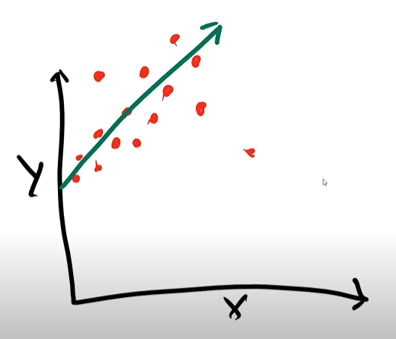

Here the line finds the path with the most data points in it.

Linear regression may not always be the best algorithm method to choose. We can have data that are more randomized which will not be very good to draw the best fit line.



Here it would be difficult to find the line that crosses these points

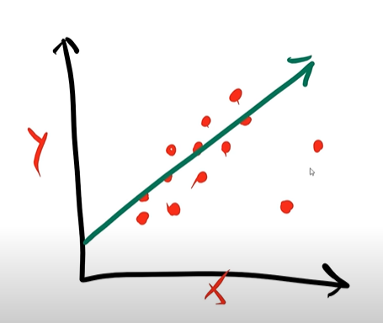 The best fit line can be determined by an equation.

This equation is famous, it is :

**y = ax+b**

We can find “y” by manipulating a and b.

**a** is the slope of this line

**a** is found by calculating:

$$a= \frac{y2-y1}{x2-x1}$$

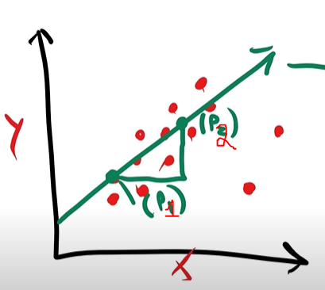

**b** is the y intercept of the line

**b** is basically when the line intercepts the y axis

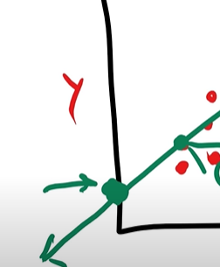

That is if we only have 2 variables,