2017-11-21 Code Dev Notes

Continuation of

<https://github.com/TekMason/gitworkflow/raw/master/20171120_Code_Dev_Notes.docx>

cd /var/www/gitworkflow

git pull origin master

*updates local with github master*

chown -R www-data:www-data gitworkflow/

*sets the owner and group for all files folders to www-data*

chmod -R 775 gitworkflow/

*set permissions so that www-data group members have RW*

Make edits

git status

git add .

git commit

git push

touch /var/www/gitworkflow/.gitignore

nano /var/www/gitworkflow/.gitignore

**Mark’s GIT Notes Document**

<https://docs.google.com/document/d/1hagNOVEyBFW-l2Hmk0Vakd-EP3dE2G2HGr0HZ408ffQ/edit?ts=5a110c45>

git pull

if there are conflicts

git stash

git pull

Edited a file in my GitHub repo and did another PR to fusion/fusion

*Update app/yealink/app_config.php #2919*

app/yealink/app_config.php

**change**

$apps[$x]['default_settings'][$y]['default_setting_name'] = "integer";

to

$apps[$x]['default_settings'][$y]['default_setting_name'] = "numeric";

---END----

Old doc

**MUST READ Simple guide to forks in GitHub and Git**

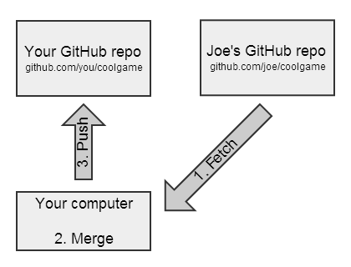<http://www.dataschool.io/simple-guide-to-forks-in-github-and-git/>

Figure 2 - Synching a Fork

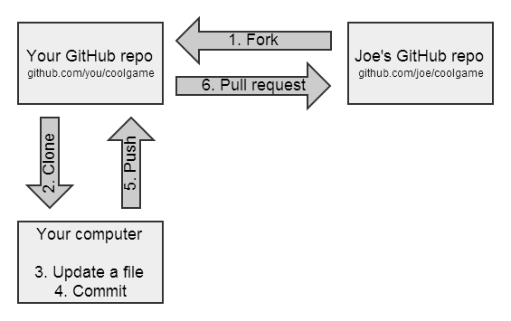

Figure - Forking and Updating a Repo

**git status**

On branch yealinktemplates

Your branch is up-to-date with 'origin/yealinktemplates'.

nothing to commit, working directory clean

**git checkout master**

Switched to branch 'master'

Your branch is up-to-date with 'origin/master'.

**git status**

On branch master

Your branch is up-to-date with 'origin/master'.

nothing to commit, working directory clean

**git checkout spectralink**

Branch spectralink set up to track remote branch spectralink from origin.

Switched to a new branch 'spectralink'

**git status**

On branch spectralink

Your branch is up-to-date with 'origin/spectralink'.

nothing to commit, working directory clean

*https://github.com/TekMason/fusionpbx* says master is  
“This branch is 2 commits ahead, 4 commits behind fusionpbx:master.”

Summary of a sync

1. Fetch changes from fusionpbx/fusionpbx
2. Merge the changes into TekMason/fusionpbx  
   *Note: Steps 1 and 2 are often combined into a single Git operation called a "pull."*
3. Push the updates to GitHub repo TekMason/fusionpbx

References

[Syncing a fork](https://help.github.com/articles/syncing-a-fork/) > [Configuring a remote for a fork](https://help.github.com/articles/configuring-a-remote-for-a-fork/)

**git remote –v**

origin https://github.com/TekMason/fusionpbx.git (fetch)

origin https://github.com/TekMason/fusionpbx.git (push)

**git remote add upstream https://github.com/fusionpbx/fusionpbx.git**

**git remote -v**

origin https://github.com/TekMason/fusionpbx.git (fetch)

origin https://github.com/TekMason/fusionpbx.git (push)

upstream https://github.com/fusionpbx/fusionpbx.git (fetch)

upstream https://github.com/fusionpbx/fusionpbx.git (push)

Back to [Syncing a fork](https://help.github.com/articles/syncing-a-fork/)

**git fetch upstream**

remote: Counting objects: 17, done.

remote: Compressing objects: 100% (6/6), done.

remote: Total 17 (delta 11), reused 11 (delta 10), pack-reused 1

Unpacking objects: 100% (17/17), done.

From <https://github.com/fusionpbx/fusionpbx>

* [new branch] 4.0 -> upstream/4.0

* [new branch] 4.2 -> upstream/4.2

* [new branch] master -> upstream/master

**git checkout master**

Switched to branch 'master'

Your branch is up-to-date with 'origin/master'.

**git merge upstream/master**

Merge made by the 'recursive' strategy.

app/extensions/extensions.php | 41 +++++++++++++++++++++++++----------------

app/xml_cdr/xml_cdr_statistics_inc.php | 3 ++-

2 files changed, 27 insertions(+), 17 deletions(-)

**git push**

My repo says synch process didn't bring my github repo in synch with fusionpbx/fusionpbx. It says "This branch is 3 commits ahead of fusionpbx:master."

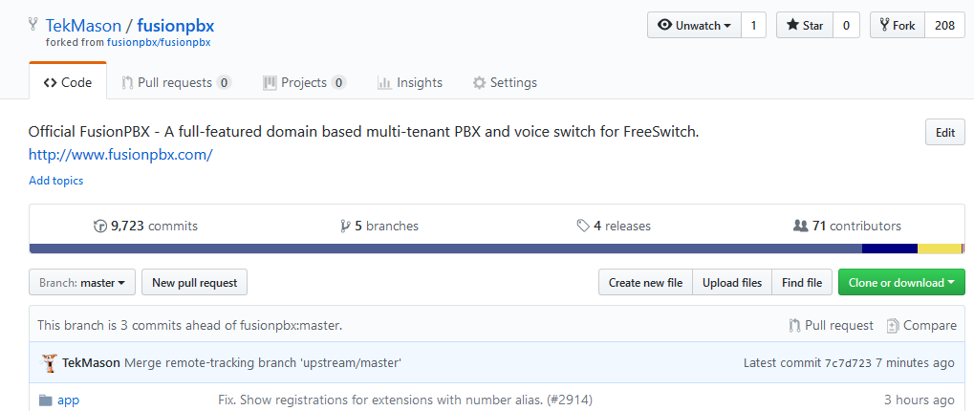

From Hopper

<https://www.atlassian.com/git/tutorials/comparing-workflows>

<https://www.atlassian.com/git/tutorials/comparing-workflows/feature-branch-workflow>

## 20:30

Mark did a new commit to fusion/fusion

tekmason/fusion master now shows:

*This branch is 3 commits ahead, 1 commit behind fusionpbx:master.*

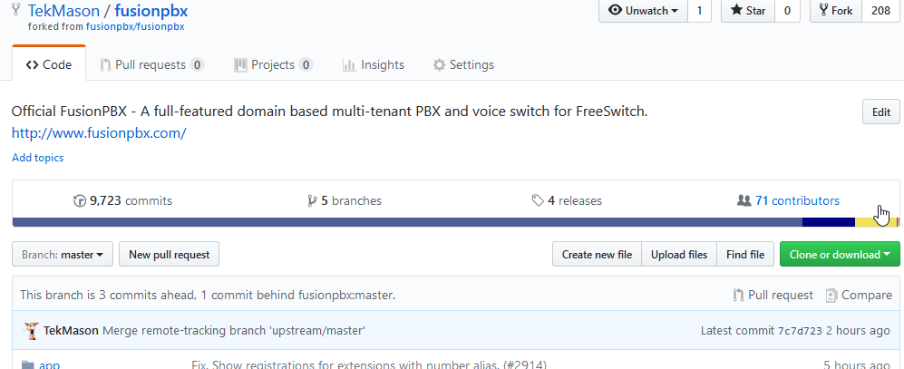

Start the synch process again.

**git status**

On branch master

Your branch is up-to-date with 'origin/master'.

nothing to commit, working directory clean

**git fetch upstream**

remote: Counting objects: 16, done.

remote: Compressing objects: 100% (14/14), done.

remote: Total 16 (delta 3), reused 0 (delta 0), pack-reused 0

Unpacking objects: 100% (16/16), done.

From https://github.com/fusionpbx/fusionpbx

eea1f54..f8284ca 4.2 -> upstream/4.2

9cb0e37..ef3f99a master -> upstream/master

**git checkout master**

Already on 'master'

Your branch is up-to-date with 'origin/master'.

**git merge upstream/master**

Merge made by the 'recursive' strategy.

resources/templates/provision/snom/7xx/{$mac}.xml | 10 +++++-----

1 file changed, 5 insertions(+), 5 deletions(-)

**git push**

warning: push.default is unset; its implicit value has changed in

Git 2.0 from 'matching' to 'simple'. To squelch this message

and maintain the traditional behavior, use:

git config --global push.default matching

To squelch this message and adopt the new behavior now, use:

git config --global push.default simple

When push.default is set to 'matching', git will push local branches

to the remote branches that already exist with the same name.

Since Git 2.0, Git defaults to the more conservative 'simple'

behavior, which only pushes the current branch to the corresponding

remote branch that 'git pull' uses to update the current branch.

See 'git help config' and search for 'push.default' for further information.

(the 'simple' mode was introduced in Git 1.7.11. Use the similar mode

'current' instead of 'simple' if you sometimes use older versions of Git)

Username for 'https://github.com': TekMason

Password for 'https://TekMason@github.com':

Counting objects: 9, done.

Delta compression using up to 4 threads.

Compressing objects: 100% (8/8), done.

Writing objects: 100% (9/9), 1.21 KiB | 0 bytes/s, done.

Total 9 (delta 6), reused 0 (delta 0)

remote: Resolving deltas: 100% (6/6), completed with 6 local objects.

To https://github.com/TekMason/fusionpbx.git

7c7d723..ba3fe12 master -> master

tekmason/fusion master now shows:  
*This branch is 4 commits ahead of fusionpbx:master.*

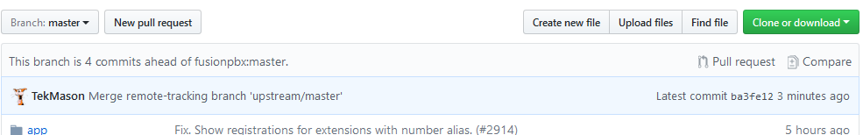

Compare shows

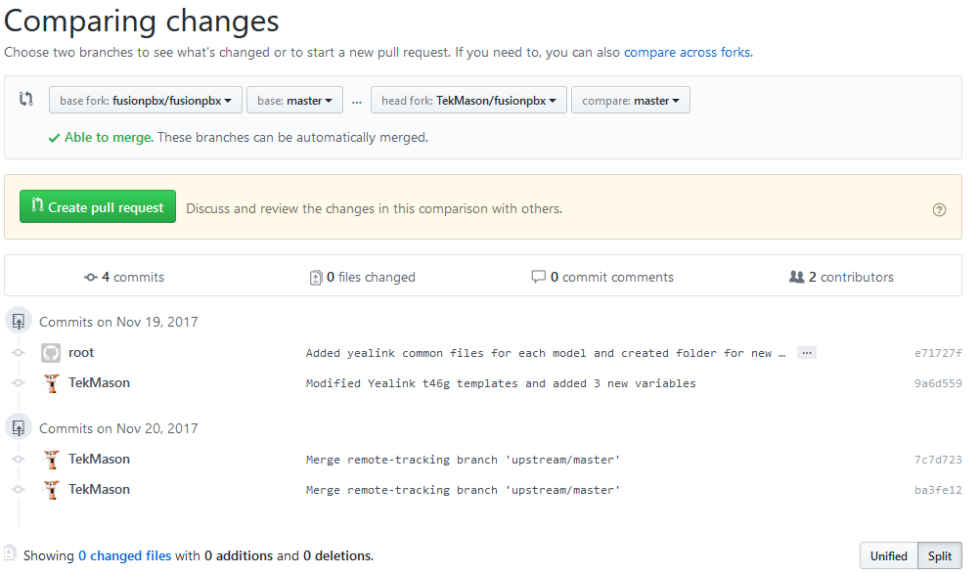

(20:48:46) **TekMason:** Can someone help me out with a githut/git workflow issue I am trying to figure out?  
(20:48:46) **TekMason:** I am trying to develop a git workflow process like this <http://www.dataschool.io/simple-guide-to-forks-in-github-and-git/>  
(20:49:30) **fission6 left the room (quit: Quit: My MacBook has gone to sleep. ZZZzzz…).**  
(20:50:56) **TekMason:** The detailed steps I have done to do a sync are here <https://github.com/TekMason/gitworkflow/raw/master/2017-11-20%20Code%20Dev%20Notes.docx> but after completing the sync twice my github says "This branch is 4 commits ahead of fusionpbx:master." It should be in sync!

Post to <http://www.dataschool.io/simple-guide-to-forks-in-github-and-git/>

Thanks for the excellent article.  I've been searching for something that makes sense to me for weeks on how to do this and finally found this.  I have been sharing the link with others ever since.  
  
I have tried the workflows you diagrammed but I am having an issue that I hope you can help me out with.  
The detailed steps/commands I have used to do a sync are here <https://github.com/TekMason/gitworkflow/raw/master/2017-11-20%20Code%20Dev%20Notes.docx> but after completing the sync twice my github says "This branch is 4 commits ahead of fusionpbx:master." It should be in sync!

Thanks,

TekMason