Simple guide to forks in GitHub and Git

**MUST READ Simple guide to forks in GitHub and Git**

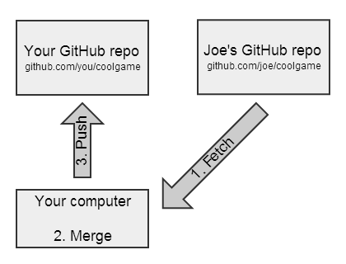<http://www.dataschool.io/simple-guide-to-forks-in-github-and-git/>

Figure 2 - Synching a Fork 1

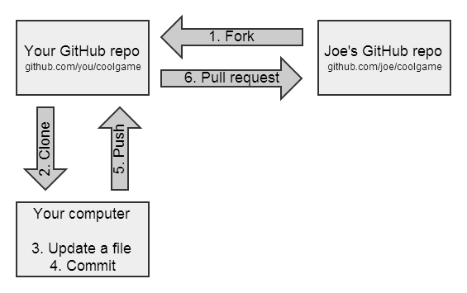

Figure 1 - Forking and Updating a Repo

# Install FusionPBX on your device

# Forking and updating a Repo

One Time

## 1-Fork

Go to <https://github.com/fusionpbx/fusionpbx> and click Fork (upper right)

## 2-Clone

On your local device:

**cd /var/www/**

**git clone** [**https://github.com/TekMason/fusionpbx.git**](https://github.com/TekMason/fusionpbx.git)

Configure git so it doesn’t commit file permission changes

**nano /var/www/fusionpbx/.git/config**

filemode = false

Set Permissions

**chown -R www-data:www-data /var/www/fusionpbx**

**chmod -R 775 /var/www/fusionpbx**

## 3.Update a file

edit files

## 4.Commit

**git status**

**git add .**

**git commit -m "Summary of what is in this commit "**

**git push**

GO to your repo and do a pull request

Repeat steps 3 and 4

# Synching a Fork

**One time**

**git remote –v**

origin https://github.com/TekMason/fusionpbx.git (fetch)

origin https://github.com/TekMason/fusionpbx.git (push)

**git remote add upstream https://github.com/fusionpbx/fusionpbx.git**

**git remote -v**

origin https://github.com/TekMason/fusionpbx.git (fetch)

origin https://github.com/TekMason/fusionpbx.git (push)

upstream https://github.com/fusionpbx/fusionpbx.git (fetch)

upstream https://github.com/fusionpbx/fusionpbx.git (push)

**git config --global push.default simple**

**-v**

**Repeat with each sync**

**git fetch upstream**

**git merge upstream/master**

**git reset upstream/master**

**git push --force**

**git checkout -- .**

getting a uuid for

app/yealink/app_config.php

advanced -> commmand -> php command

echo uuid();

# Branching

create branch on github “t54stemplate”

**git pull**

**git checkout t54stemplate**

modify files

**git commit –am “branch update”**

**git push**

do a github PR

after PR accepted

**Sync**

**git checkout master**

**git fetch upstream**

**git merge upstream/master**

**git reset upstream/master**

**git push**

**github shows**

master - This branch is even with fusionpbx:master.

t54stemplate - This branch is 1 commit ahead, 1 commit behind fusionpbx:master.

Click branches (middle)



Delete branch

If there are open pull requests you cannot delete. Must close pull request (not merge) and then you can delete branch