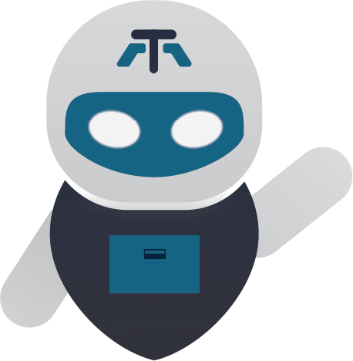
White Paper
by
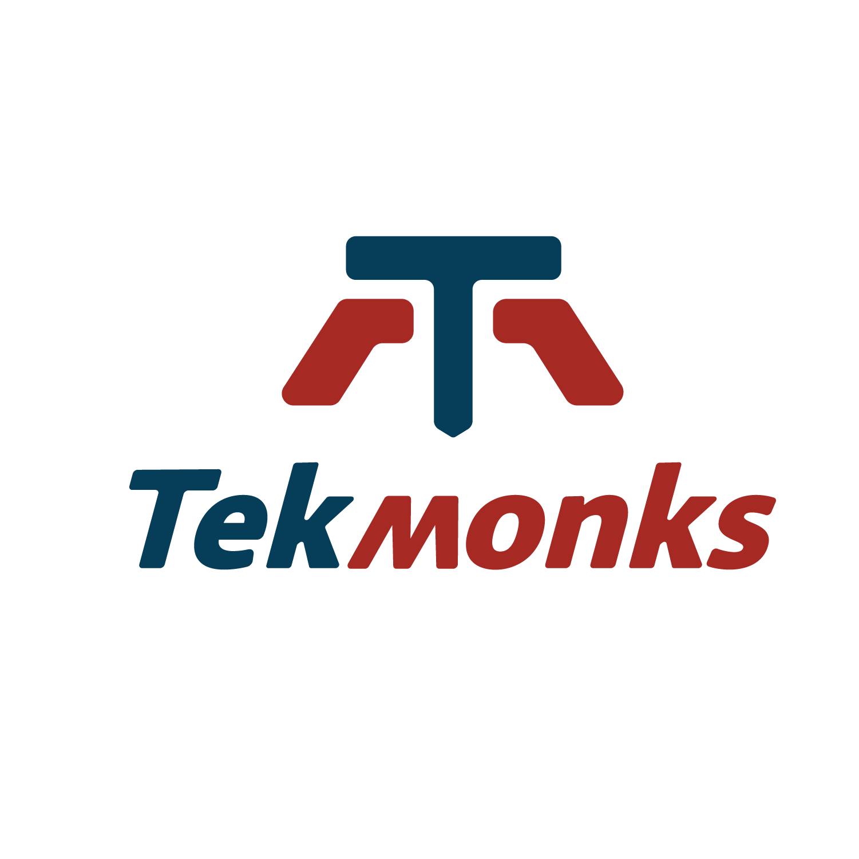

TRADEMARKS: TekMonks, the TekMonks logo are trademarks or registered trademarks of TekMonks Corporation in the United States, other countries, or both.
All rights reserved.
PATENTS: US Patent Pending
IMPORTANT PRIVACY INFORMATION: If you would like to request access to or correction of your details, or if you would prefer you or your organization not to receive further information on TekMonks products and services please contact us at: privacy@tekmonks.com
© Copyright TekMonks UK Ltd 2024
© Copyright TekMonks Corporation 2024
All Rights Reserved
TekMonks Ltd.

Kemp House, 152 City Road
London. EC1V 2NX. UK.

About TekMonks
- We blend innovation with reliability for smarter technology.
- Proudly based in the Washington DC Metro Region.
- Serving a global clientele, including Fortune 500 and government agencies.
- Committed to tech innovation and staying ahead of trends.
- Partnerships with AWS, Azure, and Google cloud.
- Financially stable: A profitable zero-debt company.
- Proven track record with a 98% repeat business rate.
- ISO 9001:2015 QMS certified for top quality assurance.
More than a tech firm, we're partners in your digital journey.
Let's connect and create tech magic together—
After all, at Tekmonks, we don't just follow trends; we set them..

Vision Statement
To continue bringing cutting edge solutions and impeccable service to our global clients while becoming one of the top 3 independent end to end enterprise software vendors in the world.

TekMonks operates across 8 countries and 11 major cities.
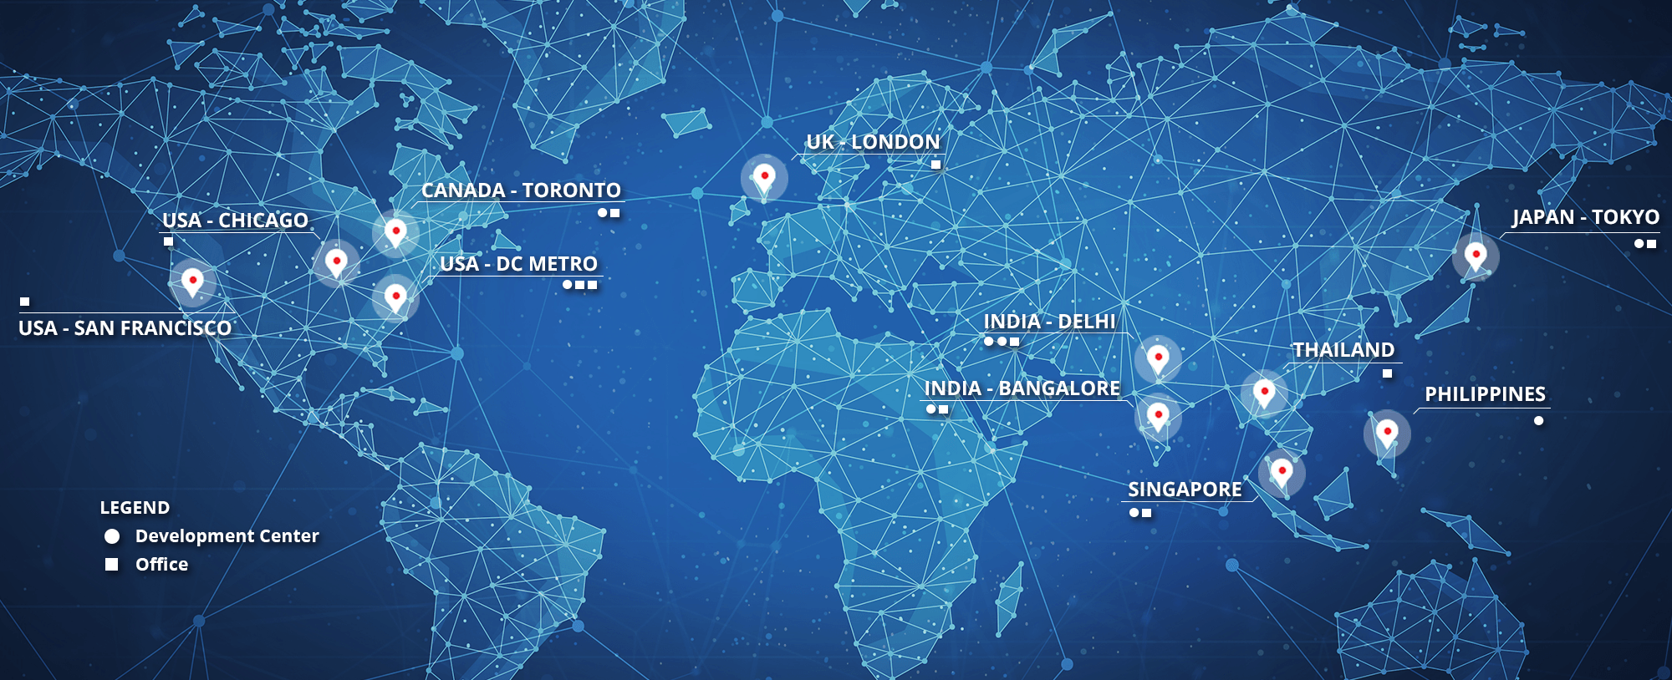
TekMonks Pte. Ltd.  Singapore | 7 Straits View, Marina One East Tower, #05-01, Singapore 018936
Deep LogicTech (I) Pvt. Ltd.  India - Business Partner | 359 Aggarwal Metro Heights  New Delhi 110034
TekMonks株式会社  Japan | 〒130-0013  東京墨田区錦糸4-6-7  万正オンダビル401号
TekMonks Corp.  USA | 1666 Connecticut Avenue, NW  Washington, DC 20009
TekMonks Ltd.  UK | Kemp House, 152 City Road, London EC1V 2NX  +44 (0)2036 958 554

Table of Contents

About TekMonks 2
Vision Statement 2
Table of Contents 4
Chapter 1 Overview 5
XBIN.APP – SHARING AND MANAGEMENT 6
Chapter 2 Key Features 8
Security and Compliance 8
Chapter 3 Benefits 10
Chapter 4 Advantages 11
Technical Support 11
Security Operations Center 12
Market beating pricing 13
Contact information 13

Overview
The Challenges of Modern Enterprise Content
Content and digital assets management is a primary concern for organizations especially to those pursuing digital transformation. Effective information management is central to business strategy hence it is not only an issue for the IT department alone. They are hyper-connected, and social with business partners, associates, contractors, employees, spread across the globe for creation and sharing of content.
The modern enterprise is online, shared across geos, and cloud repositories. It is mobile scattered across clouds, accessible from anywhere that makes it difficult to track content.
Enterprises are having a hard time controlling their content that is spread across Network Attached Storage (NAS) drivers, shared folders, online file storage services like Dropbox, Google drive, Web Distributed Authoring and Versioning (WebDAV), SharePoint, Dropbox links, shared files over chats, emails, and data residing on partner’s systems.
Compliance is another concern with audits and standards. Payment Card Industry (PCI), Health Insurance Portability and Accountability Act (HIPAA), and General Data Protection Regulation (GDPR) require the Enterprise data to be secured and encrypted. However, part of the challenge is how to make it available instantly to the employees and applications.
The future of digital content and big data requires proper Enterprise Content platform to manage content

XBIN.APP – SHARING AND MANAGEMENT

Enterprises need a solution to unify all data sources. One that allows sharing of data between employees, partners, and collaborators – across devices, including social platforms yet applies Enterprise controls, and cloud level controls over the data.
TekMonks has a solution called XBin, the only Enterprise Content Platform built ground-up to meet the sharing and management requirements.
It includes the “OneView” feature, which combines data across applications, cloud and on-prem into a single, unified controlled storage solution. Yet applies the same access controls no matter where the data resides or is downloaded to allow modern cloud-based access sharing across devices, people, and geos.

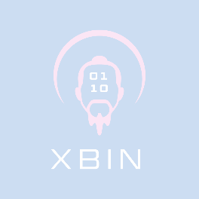
Key Features
The following are the key features of XBIN:
- Unify all data sources from Server Message Block (SMB), WebDav, Network DFile System (NFS), SSH File Transfer Protocol (SFTP) support for legacy applications, and Windows servers.
- Integrate Dropbox, Box.com, Gdrive, OneDrive, and SharePoint
- Transparent integration with Amazon S3 and Azure Storage for terabytes of data storage and objects.
- Integration with NAS and Storage Area Network (SAN) for internal storage.
- Has an in-built workflow engine which can provision pre-built workflow templates, e.g. approval flows, or create custom workflows.
- Data controls, including data expiry policies for securely sharing files and data with remote employees and business Partners.

Security and Compliance
- Define rich access control policies including Team level access, Departmental access, User level access, to sharing policies
- Makes cloud level access controls possible with other platforms with check and balance on who can:
  - View only
  - Upload or download
  - Rename, edit, or modify
- Provide remote access and solve the last mile Data Loss Prevention (DLP).
- Full compliance with PCI, HIPAA, GDPR and many other government regulations with Advanced Encryption Standard (AES) 256 encryption
- Widest support across platforms from Windows, Mac, iPhone, iPad, Android, Linux, and Chrome.

Benefits

Share data across platforms, devices, and partners

Flexibility

Unifies Enterprise Content retention, encryption and sharing policies, no matter where the content resides.

Security

unifies the view of the content, into a single view, by integrating content storage platforms into a modern, cloud enabled, content sharing platform.

OneView

on streaming I/O support and Rsync allow for data scalability, even if the network itself is slow.

Very HIgh Scalability

custom or pre-built workflows over content and files, for example, approval workflows.

Workflow Engine

application, encryption, and virus definition policies no matter where the content resides, or where it is shared or downloaded to.

Data Loss Prevention (DLP)

Advantages

Technical Support
User support in the TekMonks website, email, and/or via telephone are available with up to 24x7 Service Level Agreement (SLA).
Website: https://tekmonks.zendesk.com/
A Submit a request form in the TEKMONKS website can be populated to launch a support ticket.
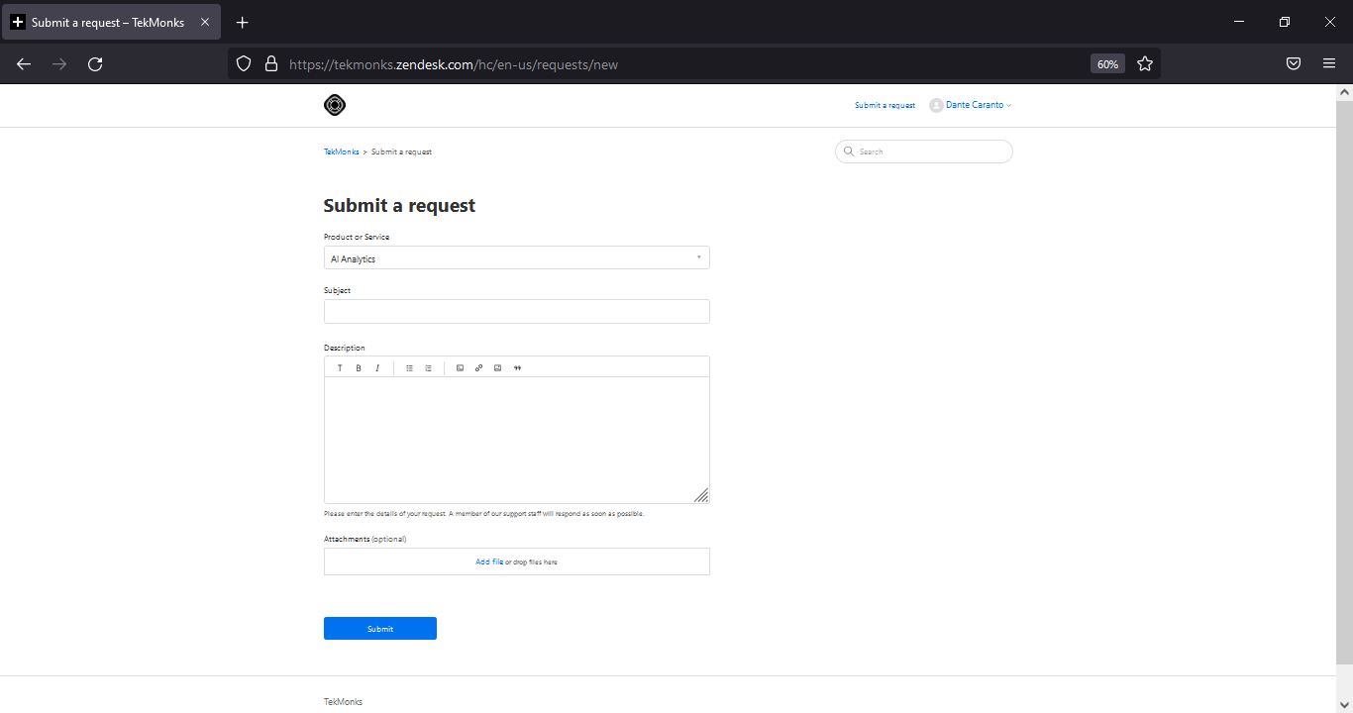
Email: support@tekmonks.zendesk.com
Every email is equivalent to a ticket. Email sender is required to at least identify the product name in the subject.
Telephone (Japanese supported): +1 (229) 269-4753
All calls are recorded and treated as tickets.
Fastest and Most Efficient Resolution
It is highly recommended to submit a request via Website or send an Email to open a ticket.
- Sufficient information is captured (including attached files and screenshots) for accurate documentation.
- Routed across the world to the appropriate TEKMONKS consultant who is online and available to assist.

Security Operations Center
Added monitoring of Security Operations Center (SOC) ensures the security of your connection, capable of the following:
- Alerts are raised on unauthorized access – Administrators are made aware which user’s laptop or phone is compromised
- Alerts are also raised on rouge IP - external hackers are identified and banned
- All events are logged with the following user information:
  - User login
  - User accessing an application
  - User logout
  - User abusing authority
- All alerts are reliable and actionable – not hundreds of alerts an hour like typical SIEMs
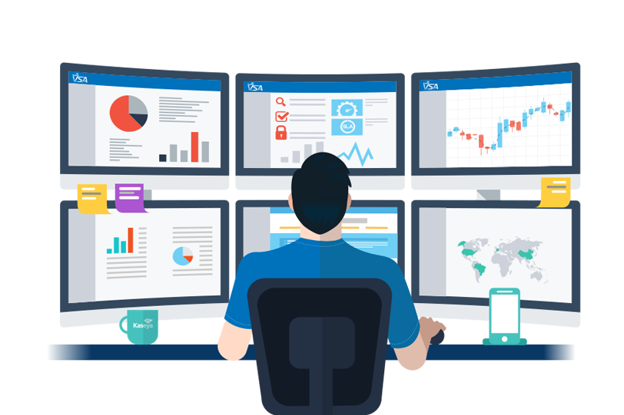

Market beating pricing
The price is of big consideration apart from its capabilities. Cost effective while fully stacked with lots of features and more. It is not just a mishmash of applications designed exclusively for institutions.

Contact information

- To request for a demo and pricing, email sales@tekmonks.com
- For general inquiries, email info@tekmonks.com
- To send a message online, click TekMonks to Message Us






Produced/Printed in the UK

