Component Interaction:-

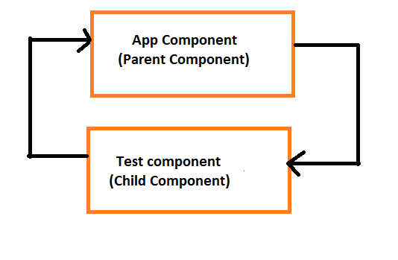

Parent to child

public name="Tekesh";

<app-test parantName="{{name}}"></app-test>

import { Component, OnInit, Input } from '@angular/core';

@Component({

selector: 'app-test',

templateUrl: './test.component.html',

styleUrls: ['./test.component.scss']

})

export class TestComponent implements OnInit {

@Input("parantName") name;

constructor() { }

ngOnInit() {

}

}

<h2>

{{name}}

</h2>

Child to parent

@Output() childEvent=new EventEmitter();

fireEvent(){

this.childEvent.emit('Data from child component')

}

<button (click)="fireEvent()">Sent Event</button>

Inside app.component.html

<app-test parantName="{{name}}" (childEvent)="message=$event"></app-test>

{{message}}

public message;