**What is Service?**

Service is a class for a specific purpose. Service is a responsible to provide data to multiple components.

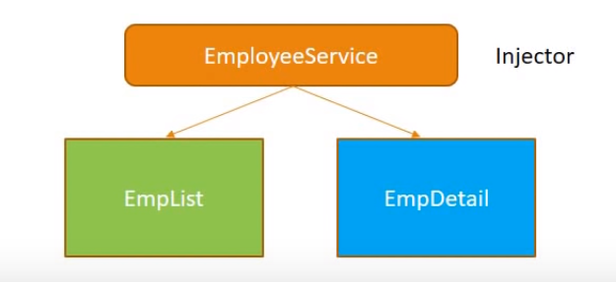

**Naming Convention:** - .service.ts

**Why we need service?**

* Implement DRY (Do not repeat yourself).
* Single responsibility.
* Share data across the component.
* Implement application logic (Exp: - based on DOB calculate age and share to all component. No need to write logic in view).
* External interaction (connection to a DB).

**Three steps to implement to service: -**

1. Define the service class (ng g s employee).
2. Register with injector.
3. Declare as a dependency in components class (emp and empDetails).

Where should we need to register to service? 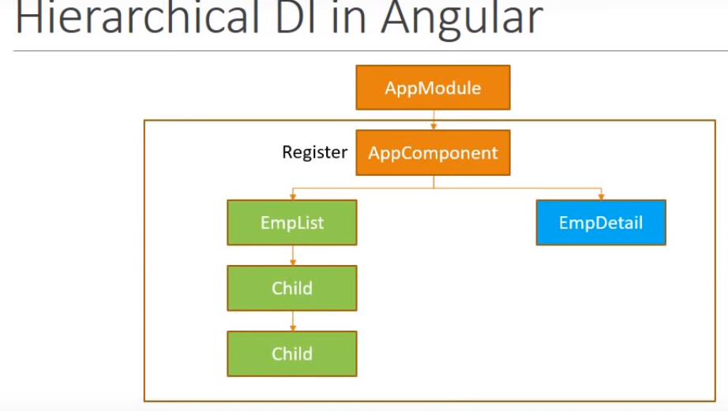

Batter solution to register to service at App Module level

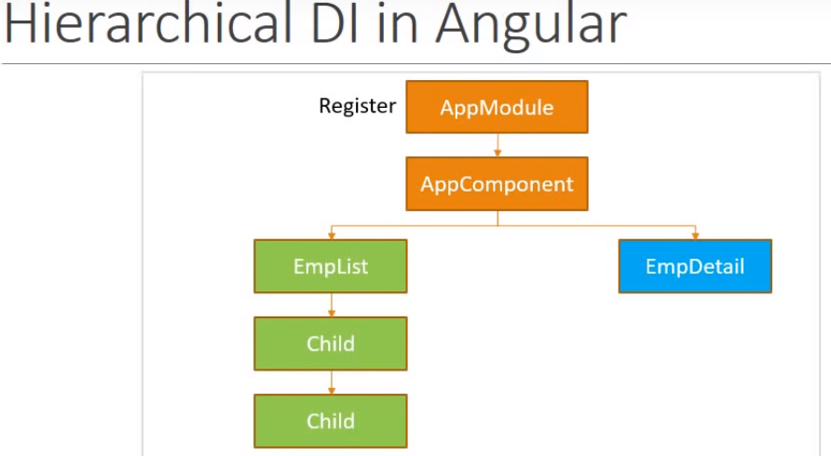

Need to register in appmodule.ts file

import {EmployeeService} from './services/employee.service';

providers: [EmployeeService]

Now third step is to consume service in our component

export class EmployeeService {

constructor() { }

public getEmployees() {

return [

{ id: 1, name: 'Tekesh', Sal: 100 },

{ id: 2, name: 'Ashok', Sal: 200 },

{ id: 3, name: 'sunil', Sal: 300 },

{ id: 4, name: 'avinash', Sal: 300 }

];

}

}

import { EmployeeService } from '../../services/employee.service';

@Component({

selector: 'app-emp',

templateUrl: './emp.component.html',

styleUrls: ['./emp.component.scss']

})

export class EmpComponent implements OnInit {

public employee=[];

constructor(private _employeeservice:EmployeeService) { }

ngOnInit() {

this.employee=this._employeeservice.getEmployees();

}

}

Same for Empdetails component

import { EmployeeService } from '../../services/employee.service';

@Component({

selector: 'app-empdetail',

templateUrl: './empdetail.component.html',

styleUrls: ['./empdetail.component.scss']

})

export class EmpdetailComponent implements OnInit {

public employee = [];

constructor(private _employeeService: EmployeeService) { }

ngOnInit() {

this.employee = this._employeeService.getEmployees();

}

}

**Why @Injectable () is required?**

Injectable decorator talks to angular this service might itself have injected dependency. So if aver you want inject another service injectable decorator is must. As currently we don’t have any dependency in this service so we don’t need. But CLI uses best practice to add @Injectable decorator.