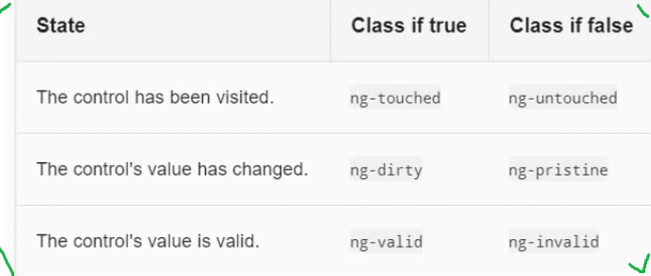

To verify classes that are apply on form load

<input type="text" #name class="form-control" name="name" [(ngModel)]="userModel.name">

{{name.className}}

And output:-

*form-control ng-untouched ng-pristine ng-valid*

**ng-pristine: -** value has not change of controller.

**Ng-dirty: -** value has changed.

To check validity of control add required attribute.

<input type="text" required #name class="form-control" name="name" [(ngModel)]="userModel.name">

**Validat input controller**

<label>Name</label>

<input type="text" required #name="ngModel"

[class.is-invalid]="name.invalid && name.touched"

class="form-control" name="name" [(ngModel)]="userModel.name">

<span class="text-danger" [class.d-none]="name.valid || name.untouched">Name is required</span>

**Validate mobile number**

<label>Cell</label>

<input type="tel" #cellno="ngModel" name="cellno" [(ngModel)]="userModel.cellno"

[class.is-invalid]="cellno.invalid && cellno.touched"

required pattern="^[6-9]\d{9}$" class="form-control">

<div *ngIf="cellno.errors && (cellno.invalid || cellno.touched)">

<span *ngIf="cellno.errors.required" class="text-danger">Cell no is required</span>

<span *ngIf="cellno.errors.pattern" class="text-danger">Cell no must be 10 digites</span>

</div>

**Validate selection type**

<label>I am intrested in</label>

<select (blue)="validateTopic(topic.value)" (click)="validateTopic(topic.value)"

#topic="ngModel" required [class.is-invalid]="topicHasError && topic.touched" class="custome-select" [(ngModel)]="userModel.topic" name="topic">

<option value="default">---Select topic---</option>

<option *ngFor="let topic of topics">{{topic}}</option>

</select>

<span class="text-danger" *ngIf="!topicHasError && topic.untouched" >Please select topic</span>

topicHasError = true;

validateTopic(value) {

if (value === 'default') {

this.topicHasError = false;

} else {

this.topicHasError = true;

}

}