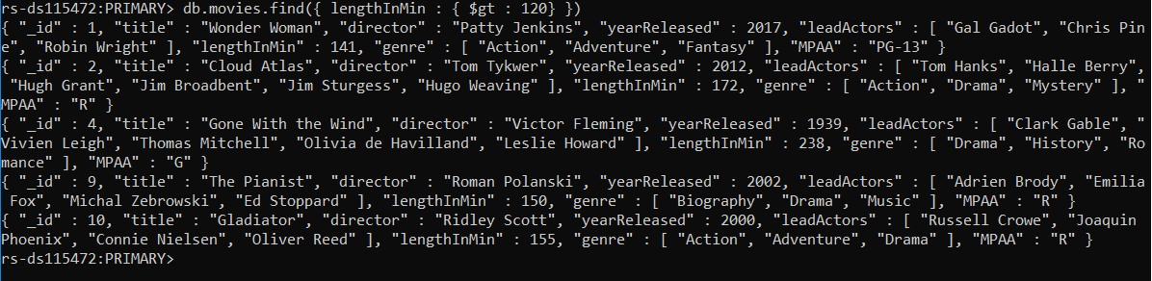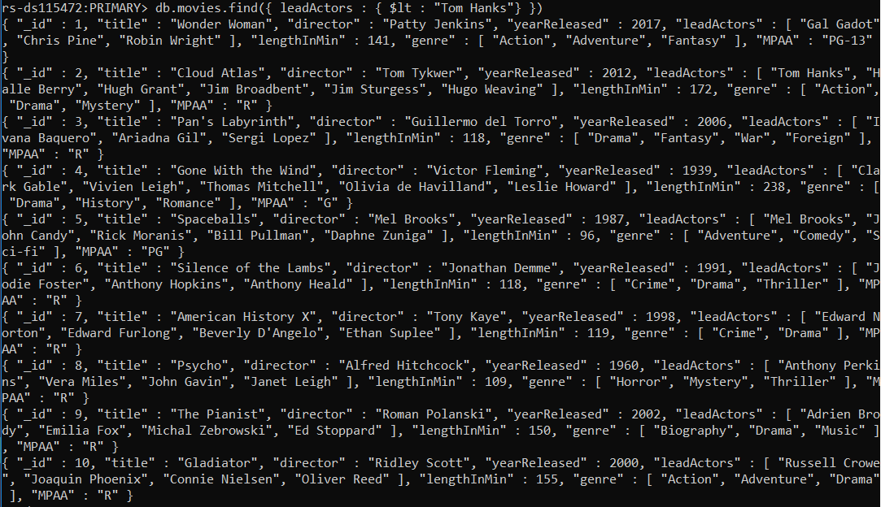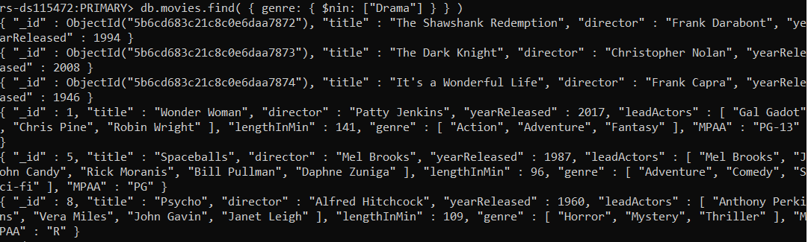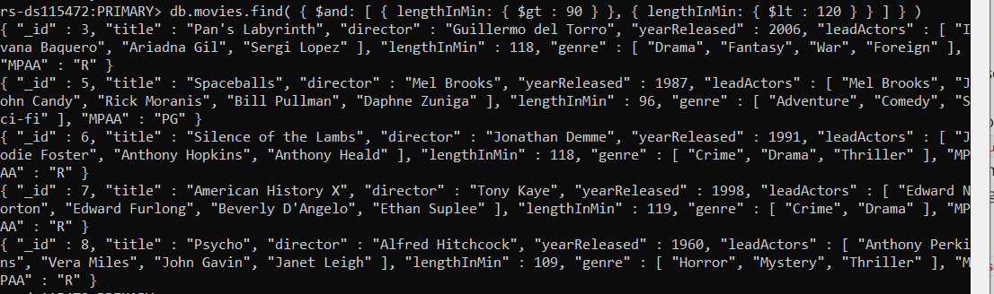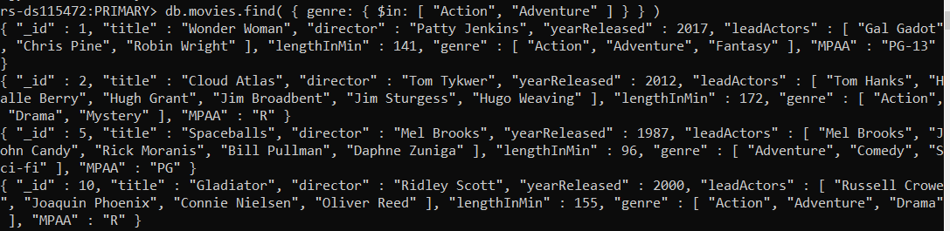

Part 2

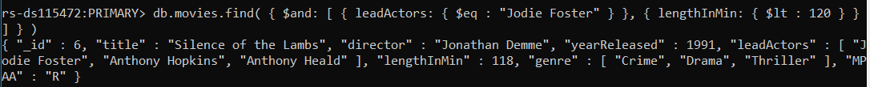

Silence of the Lambs lenghtInMins = 118 mins